Occurrence of mecA, SCCmec IV, pvl, lukED Genes in Community Acquired Methicillin Resistance Staphylococcus aureus (CA-MRSA) from Hilla/Iraq

Huda H. Al-Hassnawi Alaa H. Al-Charrakh Jawad K. Al-Khafaji
Dept. of Microbiology, College of Medicine, University of Babylon, Hilla, Iraq.

M J B

Abstract
Twenty four (24) MRSA isolates were obtained from clinical specimens and subjected to genetic study in Babylon Province in a period from July to January2011. Polymerase Chain Reaction was used for detection the genes that responsible for methicillin resistance (mecA, SCCmec type IV) and genes that responsible for toxin production (pvl, lukED). It was found that 24 (100%) isolates have positive result for mecA gene. The MRSA isolates were also SCCmec typed to differentiate between HA-MRSA and CA-MRSA isolates by using a uniplex PCR assay, 23 (95%) were found to be carrying SCCmec type IV, 19 (79%) had positive result for pvl toxin gene, 20 (83%) had lukED toxin gene.
الخلاصة
تم اخذ 24 عزلة من المكورات العنقودية الذهبية المقاومة للمثيسيلسن واجريت عليها دراسة جينية في محافظة بابل للفترة من تموز الى كانون الثاني. تم استخدام تقنية تفاعل انزيم البلمرة للكشف عن الجينات المقاومة للمثيسيلين وكاسيت المكورات الكروموسومي النوع الرابع والجينات المسؤولة عن انتاج السموم. وقد وجد ان 24 (100%) عزلة اعطت نتيجة موجبة للجين المسؤول عن المقاومة للمثيسيلين. ان العزلات المقاومة للمثيسيلين صنفت اعتمادا على كاسيت المكورات العنقودية الكروموسومي للتمييز بين عزلات المجتمع والمستشفى با ستخدام تقنية تفاعل انزيم البلمرة الاحادي. وجد ان23 (95%) عزلة اعطت نتيجة موجبة لجين كاسيت المكورات العنقودية الكروموسومي باستثناء عزلة واحدة. وجد ان 19 (79%) عزلة اعطت نتيجة موجبة لجين pvl و20 (83%) عزلة اعطت نتيجة موجبة لجين lukED.
ــــــــــــــــــــــــــــــــــــــــــــــــــــــــــــــــــــــــــــــــــــــــــــــــــــــــــــــــــــــــــــــــــــــــــــــــــــــــــــــــــــــــــــــــــــــــــــــــــــــــــــــــــــــــــــــــــــــــــــــــــــــــــــــــــــــــــــــــــــــــــــــــــــــــــــــــــــــــــــــــــــــــــــــــــــــــــــــــــــــــــــــــــــــــــــــــــــــــــــــــــــــــــــــــــــــــــــــــــــــــــــــــــــــــــــــــــــــــــــــــــــــــــــــــــــــــــــــــــــــــــــــــــــــــــــــــــــــــــــــــــــــــــــــــــــــ

Introduction
Methicillin-resistant Staphylococcus aureus (MRSA) infections have been recognized for decades as hospital acquired or healthcare associated MRSA [1]. The possibility of transmission of healthcare associated MRSA (HA-MRSA) to the community was unavoidable [2]. Nowadays, MRSA is also recognized as a worldwide emerging community-acquired pathogen (CA-MRSA) [3]. It was shown, that PVL positive MSSA are a likely reservoir for the development of PVL positive MRSA [4] via integration of Staphylococcus cassette chromosome mec (SCCmec) elements including the mecA gene conferring methicillin resistance. MRSA strains that have been clinically identified as CA-MRSA have been shown to be more virulent with a high degree of severity of disease when compared to HA-MRSA [5].This is due to the production of the Panton-Valentine leukocidin toxin (PVL). Panton-Valentine leukocidin is a toxin associated with deep skin and soft tissue infections, such as furunculosis and abscesses, but necrotizing tissue infections and lethal hemorrhagic pneumonia, even in previously healthy individuals, have recently been described as well. Most CA-MRSA strains have a common virulence factor: Panton-Valentine leucocidin (PVL). However, the prevalence rate of the PVL toxin in CA-MRSA strains varies with different studies and countries [6]. Some studies reported a prevalence of between 77% to 100% for the PVL toxin in Minnesota, USA in 2000 whilst a prevalence of less than 5% were reported in Western Europe.
The presence of PVL toxin in CA-MRSA strains can be confirmed by co-amplification of the lukS/F-PV genes [7].In comparison to previous detection methods such as Southern blotting and pulsed-field gel electrophoresis (PFGE), PCR assays such as multiplex-PCR (M-PCR), uniplex PCR techniques can provide a rapid amplification, detection and typing tool for MRSA strains. CA-MRSA infections spread easily by direct skin-to-skin contact. Outbreaks in closed living communities, as with jail inmates, military recruits, and gay men, have been reported in the United States [8]. The spread of PVL-positive S. aureus has also been described within families and among healthcare staff [9].
The aim of this study was to determine the molecular characterization of HA-MRSA and CA-MRSA isolates obtained from clinical specimens in Hilla/Iraq. The MRSA strains were also SCCmec typed to differentiate between HA-MRSA and CA-MRSA strains using a using a uniplex PCR assay. Furthermore, uniplex PCR method was evaluated to detect the PVL genes in MRSA isolates.

Materials and Methods
Bacterial Isolates
Twenty four (24) MRSA isolates were obtained from clinical specimens. These bacterial isolates were identified as S. aureus based on their morphology, Gram-staining and catalase properties. Coagulase test was performed to identify S. aureus isolates. Twenty four isolates were selected for genetic study, In the light of antibiotics results that mentioned in previous study [10], Out of 46 S. aureus isolates, 13 CA-MRSA isolates were obtained and identified as CA-MRSA. They were oxacillin and cefoxitin resistant which occupied the primacy in the resistance of antibiotics, phenotypic detection of virulence factors also detected previously [12]. other isolates (No.11) were selected from specific skin infections (abscesses, boils)for genetic study to detect other genes that considered as a marker for CA-MRSA isolates. All these 24 isolates were divided in to two groups: 9 isolates from hospital (inpatient) and 15 isolates from community (outpatient).
DNA extraction and PCR assay
Chromosomal DNA was extracted from twenty four clinical strains. One colony of each strain cultured on solid medium was inoculated into 5 mL of BHI (Broth Heart Infusion) and grown overnight at 37ºC. From these strain cultures, DNA was purified from bacterial cells using Genomic DNA Mini kit supplemented by the manufacturing company (Geneaid, UK). Chromosomal DNAs obtained were used as templates for all PCR experiments. The PCR reactions were carried out in a Thermal Cycler. Before PCR assay, DNA profiles were performed by using bacterial DNA and loading buffer without thermal cycling conditions, and according to the manufacturer.

Table 1 PCR thermocycling conditions
Monoplex  Gene | Temperature (ºC )/ Time |  |  |  |  | Cycle No.
Monoplex  Gene | Initial denaturation | Cycling condition |  |  | Final extension | Cycle No.
Monoplex  Gene | Initial denaturation | denaturation | annealing | Extension | Final extension | Cycle No.
Pvl | 95/5min | 94/30 sec | 55/30 sec | 72/1 min | 72/10 min | 35
lukED | 95/5 min | 95/2min | 58/1min | 72/2 min | 72/10 min | 30
mecA | 94/5 min | 94/1 min | 58/1 min | 72/1 min | 72/10 min | 35
SCCmec | 94/5 min | 94/1 min | 55/1 min | 72/1.5min | 72/1.5 min | 35

Table 2 Primers of antibiotic resistance genes used in present study/Bioneer
Primer | Primer Sequence (5'_3^{')} | Product size (bp) | Reference
mecA-F | GTG GAA TTG GCC AATACA GG  TGA GTT CTG CAG TAC CGG AT | 1339 | 18
mecA-R | GTG GAA TTG GCC AATACA GG  TGA GTT CTG CAG TAC CGG AT | 1339 | 18
SCCmec typeIV-F | TTTGAATGCCCTCCATGAATAAAAT  AGAAAAGATAGAAGTTCGAAAGA | 450 | 26
SCCmec typeIV-R | TTTGAATGCCCTCCATGAATAAAAT  AGAAAAGATAGAAGTTCGAAAGA | 450 | 26

Table 3 Primers of Toxin genes used in present study/Bioneer.
Reference | Product size (bp) | Primer Sequence (5'_3^{')} | Primer
29 | 433 | ATCATTAGGTAAAATGTCTGGACATGATCCA | Luk-pvl- F
29 | 433 | GCATCAASTGTATTGGATAGCAAAAGC | Luk-pvl- R
26 | 269 | TGAAAAAGGTTCAAAGTTGATACGAG | LUKDE-F
26 | 269 | TGTATTCGATAGCAAAAGCAGTGCA | LUKDE-R

Results and Discussion
Detection of mecA and SCCmec IV genes by PCR:
One of the most important questions in the molecular evolution of S. aureus and MRSA development is the possible role of horizontal gene transfer. Monoplex polymerase Chain Reaction (PCR) was used in the present study for detection of mecA gene. A major finding in this study was the high frequency of mecA gene (100%) among all S. aureus isolates (Figure 4). All hospital 9:9 (100%) and all community isolates 15:15 (100%) were carrying mecA gene (Table 4).
In the present study a total 13 out of 24 isolates were determined previously as MRSA by [10], so these isolates confirmed as MRSA by genotype. Identification of MRSA is based on phenotypic and genotypic investigations. the mecA gene responsible for mediating methicillin resistance in staphylococci [11]. These results indicated that there is a large dissemination of MRSA in the community (62%) and not restricted to the hospitals as expected [12] and as reported by several authors who found that most MRSA isolates were associated with nosocomial infections such as [18] who detected mecA gene in MRSA isolated recovered from hospitals in Najaf and Al-Diwaniya respectively. This high prevalence of mecA gene in the community may be due to horizontal gene transfer (HGT) from MRSA to MSSA isolates by transduction [11]. mecA gene carried on the Staphylococcal Cassette Chromosome mec (SCCmec). SCCmec is inserted into the S. aureus chromosome near the origin of replication [14]. Most of antibiotic resistance are transferred by plasmids, while methicillin resistance is chromosomal transferred by transduction.
In a local study in Iraq, the presence of mecA gene in isolates of CA-MRSA from holy shrine in Najaf city was detected [15], In Europe, MRSA strains account for less than 5% of S. aureus isolates in the community setting [16] and for less than 11% of isolates from SSTI patients in France. Resistance to methicillin, is independent of β-lactamase production. The mecA gene for methicillin resistance resides on the chromosome. Accurate detection of mecA mediated resistance to methicillin and other penicillinase stable penicillins (PSPs), i.e., oxacillin, nafcillin, cloxacillin, dicloxacillin, flucloxacillin, and mecillinam is necessary to ensure appropriate antimicrobial chemotherapy of staphylococcal infections, particularly those from community associated infections. Oxacillin has been the agent recommended by [17] for phenotypic tests to predict resistance to PBPs because of its stability and superior sensitivity over other PBPs for susceptibility tests. However, antimicrobial susceptibility tests using oxacillin are often difficult to read despite changes in techniques to improve the discrimination between oxacillin susceptible and resistant results [18].

Table 4 Numbers and percentages of genes among HA-MRSA and CA-MRSA isolates
Genes | HA no.(%) | CA no.(%) | total positive | Negative | P value
mecA | 9 (37.5%) | 15 (62.5%) | 24 | 0 | p˃0.05
Sccmec IV | 9 (39.1%) | 14 (60.8%) | 23 | 1 | p˃0.05
Pvl | 8 (42.1%) | 11 (57.8%) | 19 | 5 | p˃0.05
lukED | 9 (45%) | 11 (55%) | 20 | 4 | p˃0.05

Since conventional identification and antibiotic resistance detection often take more than 48 h, molecular based detection techniques, including conventional PCR, have been developed for the rapid and accurate identification and characterization of MRSA isolates [13]. Molecular techniques are often applied for the routine diagnostic MRSA detection along with antimicrobial susceptibility testing methods [19].

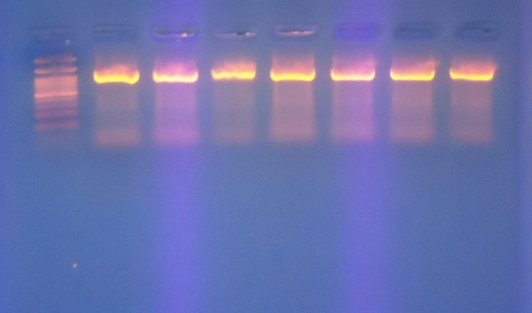
L
S2
S3
S7
S8
S13
S15
S17
3000bp
500bp
100bp
1339bp
Figure 1 Gel electrophoresis of PCR of mecA amplicon product: Lane L: Ladder (3000-bp ladder), Lane (S2, 3, 7, 8, 13, 15, 17, 22, 23, 26, 28, 29, 31, 32) No. of isolates from skin.

SCCmec typing is one of the most important molecular tools available for understanding the epidemiology and strain relatedness of MRSA [20]. In the present study, One set of primers were used in an attempt to differentiate between MRSA isolates.
In the present study, Staphylococcus Cassette Chromosome type IV (SCCmec IV) was also detected which is a stable marker of Community Aquired MRSA (CA-MRSA) [3]. All MRSA isolates (no.24) were carrying SCCmec IV (95%) except one isolate, 1 (4.1%) (Figure 2). Although this SCCmec IV negative isolate was recovered from the community, the lack of this gene from this isolate may be due to that patient from which this isolate was recovered, was newly discharged from hospital and this isolate may be HA-MRSA, but marker genes SCCmec type I, II and III of HA-MRSA were not determined in the present study. The results showed that out of 23 MRSA isolates,9 (39.1%) were HA-MRSA carrying this gene and 14 (60.8%) for CA-MRSA isolates (Table 4). It is clear that all HA-MRSA (100%) were carrying SCCmec IV gene.
The high prevalence of SCCmec IV type in our hospitals 9:9 (100%) in the present study (which are traditionally attributed to CA-MRSA isolates and considered as a marker for CA-MRSA), this is may be due to dissemination of CA-MRSA in the hospitals of the area of the study as the SCCmec IV had smaller size, compared with type II and III elements, may serve as an evolutionary advantage by making them more amenable to horizontal spread among a bacterial population [21].This also interpreted as replacement of HA-MRSA with CA-MRSA. However, community acquired MRSA strains

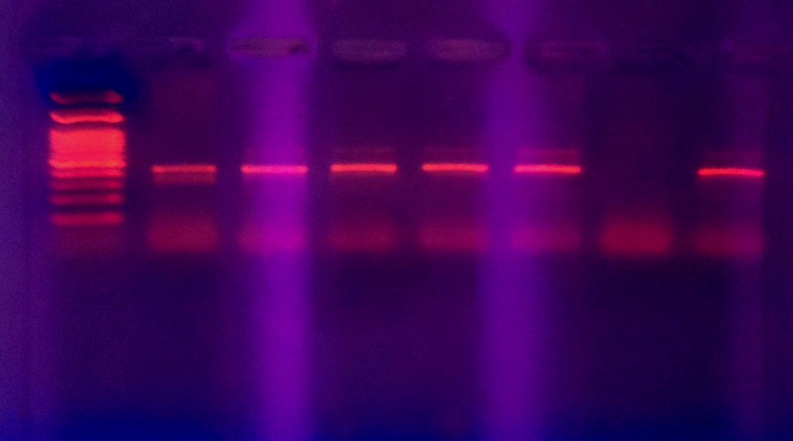
S22
L
S23
S26
S28
S29
S32
S31
3000bp
500bp
100bp
450bp

Figure 2 Gel electrophoresis of PCR of SCCmec IV amplicon product: Lane L: Ladder (3000-bp ladder), Lane (S2, 3, 7, 8, 13, 15, 17, 22, 23, 26, 28, 29, 31) no. of isolates from skin, Lane (S32) show negative result.

have now been found in association with nosocomial infections [22]. Irrespective of the characteristics of the population or the setting, community-onset MRSA carrying the SCCmec type IV element poses a real threat and will likely continue to emerge as a major public-health concern. Several studies suggest that community-acquired MRSA strains harboring the smaller SCCmec type IV element grow faster and achieve higher infection burdens than nosocomial MRSA strains [23] This property has been attributed to the extra metabolic burden that multi-resistant bacteria have secondary to the synthesis of extra proteins during replication, and may provide a selective advantage to community-acquired MRSA. Despite these studies it should be noted that community-acquired MRSA would likely compete mostly with MSSA strains in the outpatient setting. Such high proportions of SCCmec IV were found in present study have not been reported before.
These results confirm a tendency seen in previous studies from the University Hospitals of Zurich (45%; type IV) and Basel (58%; type IV) and in other studies that reported the spread of CA-MRSA SCCmec type IV strains in hospital settings in both Europe and the United States [24]. The carriage of SCCmec IV in community acquired infections is reportedly due to the lack of antibiotic pressure outside of the hospital environment as well as the lack of resistance plasmids or transposons downstream of mecA . It is believed that the community strains acquired the SCCmec IV from a Methicillin-susceptible S. aureus rather than an evolution of a healthcare associated isolate that had been carried into the community [20]. Staphylococcal cassette chromosome mec typing is essential because it can distinguish between HA-MRSA and CA-MRSA [25]. As a result of the different antibiotic susceptibility profiles between HA-MRSA and CA-MRSA, discrimination of these two MRSA strains is important in patient and antibiotic management [25]. Rapid and accurate identification and characterization is needed for the detection of these strains, as they are ecologically fit to reside both in the community and health-care facilities. Molecular methods evaluated in this study proved to be useful rapid tools that can be implemented for screening and monitoring these strains to ensure outbreaks are prevented by the correct infection control principles such as isolation of infected patients.
Molecular Detection of Virulence Genes by PCR:
Polymerase chain reaction was used to determine the bi-component leukocidin pvl gene in all 24 MRSA isolates. However, pvl gene by PCR was seen in 19 (79.1%) isolates. pvl gene was not detected in 5 (20.8%) isolates (Figure 3-3). All these isolates were mec A gene positive and identified as MRSA by (12) and genotypic test (Figure3-1). The results also showed that mecA: pvl ratio was 24:19 mecA is a peptidoglycan transpeptidase, this protein is expressed at the external surface of cytoplasmic membrane, where it could interact with the extracellular protein pvl. In this case we can give the name community acquired MRSA (CA-MRSA) to our MRSA isolates, as these isolate harbored pvl and SCCmec IV genes because the two genes above considered a stable markers for CA-MRSA isolates [3].
The high rate of pvl gene in the present study was due to involvement of purulent skin infections (boils, abscesses) because there is a close correlation between this gene and suppurative infections [26]. Out of these 19 positive isolates 8 (42.1%) were found in HA-MRSA while 11 (57.8%) were found in CA-MRSA isolates. Not surprisingly, horizontal transfer of virulence genes involved toxin genes, including the pvl genes [27]. For comparable, in Iraq, there is a little attention has been paid to the prevalence of

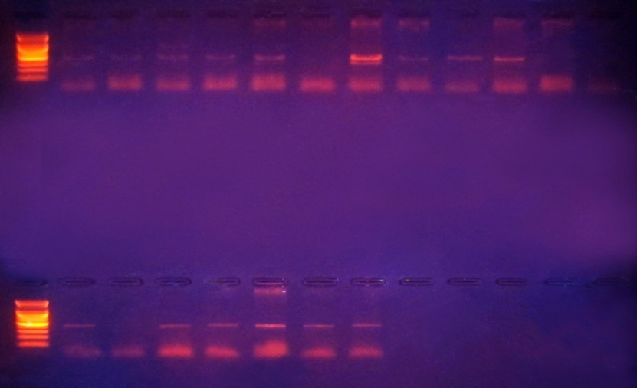
L
S23
S26
S29
S22
S2
S3
S28
S8
S13
S15
S7
S17
500bp
2000bp
100bp
433bp

L
S32
S31
S57
S59
UL60
S36
W79
2000bp
100bp
500bp
433bp

Figure 3 Gel electrophoresis of PCR of pvl amplicon product: Lane L: Ladder (3000-bp ladder), Lanes (S2, 3, 8, 13, 15, 17, 26, 28, 32, 22, 37, 41, 57, 59) no. of isolates from skin, Lane (Ul60) no. of isolate from ulcer, Lane (W79) no. of isolate from wound.

pvl gene in MRSA isolates, except some reports from Najaf city [15]. and there is also no professional center for studying or research about prevalence, distribution and purification of this toxin. The results of present study (79%) were more than that obtained by, who found that pvl gene were detected in 27.2% of CA-MRSA isolates. However, the high prevalence of pvl gene in our study was due to high numbers of selected skin samples in present study.
[26] showed an association between pvl genes and cutaneous infections (85%), confirming earlier findings by other workers [28]. In other studies [29], found that MRSA isolates harbored pvl gene were more prevalent in cutaneous MRSA isolates (83%), and he also found that 70% of mecA positive isolates, harbored pvl gene, that closely correlated with our results.
It has been suggested that the reason for this is that only a few S. aureus strains are susceptible to infection with PVL-converting phages. [30] showed that the temperate phage -SLT infected only 5% of clinical PVL-negative S. aureus strains, leading to PVL production. Different strains of S. aureus have been shown to harbor different PVL-carrying phages [30]. While PVL is rarely produced by S. aureus (less than 5% of strains), the PVL gene is detected at high rates (more than 50%) in isolates from community-acquired skin infections [26], which was in accordance with our results (57.8%). An interesting finding of our study was the presence of PVL genes in MRSA isolates separated from urine isolates, because in the previous studies, such isolates were not found [31] but in another study [32] found that MRSA isolates recovered from urine samples harbored the pvl gene. In recent years, the increased prevalence of CA-MRSA has become a major public health concern. In contrast to HA-MRSA, CA-MRSA strains are commonly susceptible to many non β-Lactam antibiotics. Also CA-MRSA appears to have a distinct exotoxin PVL, which has been associated with severe infections [23]. However, the result of present study showed that PVL-containing MRSA did not only exist in the community 11 (57.8%) but they were also found in hospitals 8 (42.1%) (Table 3-9). The differences were statistically not significant.
Recently it has been shown that pvl is not universally present in CA-MRSA isolates [33]. However, [32] found that 61.8% of HA-MRSA isolates had pvl genes. This is may be due to dissemination of CA-MRSA isolates in the hospitals that more virulent than hospital type and due to acquisition of gene by phage infection and integration into the chromosome of hospital isolates. It has been well established that PVL genes (lukS- and lukF-PV) of CA-MRSA are harbored by a bacteriophage, these toxin genes may be transmitted easily to other HA-MRSA strains. It is possible that the PVL- strain originated from the PVL+ strain via loss of prophage from the genome of the latter. Alternatively, the PVL+ strain may have descended from the PVL- strain by acquiring prophage [30]. Further studies are necessary to reveal the biological and evolutionary relationships between and the significance of these 2 strains Studies. MRSA isolates carrying PVL genes have also been carried out in hospitals of Florida, Germany, France, Minnesota, Latvia, Austria, Belgium, the Netherlands and Middle Tennessee [34].
Figure (3-4) showed determination of the bi-component leukotoxin gene (lukED) in all 24 MRSA isolates by PCR. However, lukED gene was detected in 20 (83%) of MRSA isolates recovered from all S. aureus infection types, but it was not detected in 4 (16.6%) MRSA isolates. Out of 20 positive MRSA isolates, 9 (45%) and 11 (55%) isolates were detected from hospital and community respectively (Table 3-1), the differences between hospital and community were statistically not significant (p˃ 0.05).
The results also revealed that all HA-MRSA isolates (9:9,100%) were harboring lukED gene. This result was in agreement with results obtained by [35], who found that lukED gene was found in most HA-MRSA isolates (95%). However, PVL and LukED positive MRSA isolates in hospital were (42.1%, 45%) respectively (Table 3-1). From these 20 positive isolates for lukED, 17 (85%) MRSA isolates shared both genes (pvl and lukED) [35], found that 40% of MRSA isolates produced simultaneously the PVL and LukED from isolates with antibiotic associated diarrhea. [36] found that prevalence was (33.3%) for both genes (pvl, lukED ). It seems that MRSA isolates comprising LukED and PVL genes are more important in the disease process and associated with severe skin diseases with high morbidity and mortality, also these MRSA isolates seem to be more virulent than other MRSA isolates.
However, the vast majority of cases of S. aureus disease cannot be explained by the action of a single virulence determinant and it is likely that a number of factors act in combination during the infective process. However, in Iraq, little or no studies are available relating to the presence of lukED gene in MRSA isolates. The prevalence rate of lukED gene in MRSA isolates is varied dramatically worldwide. In retrospective study by [37] found that 78% of 131 retrospective cases with skin infections, harbored LukED gene, [50] found that lukED gene was detected from different MRSA infections with a prevalence rate 73.8%, [36] found that the prevalence of LukED gene in MRSA strains isolated from burn patients in Taleghani hospital, was (66.26%). Also LukED gene was detected in 56% of S. aureus isolates harboring mecA gene [35], these isolates recovered from antibiotic associated diarrhea (AAD). In other study found that 48.9% of LukED gene harboring isolates were mecA positive, these isolates recovered from AAD.

Conclusions
Molecular characterization of the MRSA isolates revealed that the majority of isolates (95%) belonged to SCCmec IV, suggesting that new isolates, which are likely to be imported from the expanding community. High prevalence of MRSA isolates carrying a community acquired genotype enabled us to test the adequacy of current hospital hygiene measures to control outbreaks of in-hospital CA-MRSA isolates. Given the ability of PVL-producing MRSA isolates to cause life-threatening disease, and more prevalent in cutaneous MRSA isolates, the absence of any rapid non-molecular tests for PVL, the crucial role of awareness cannot be overemphasized and recommended that For tracking CA-MRSA rates in a systematic manner, continuing research, to detect the novel molecular markers and genotype of CA-MRSA may be beneficial. A rapid detection systems, direct tests, simple, cost-effective will contribute to reducing MRSA infections, is needed to make this a useful measurement.

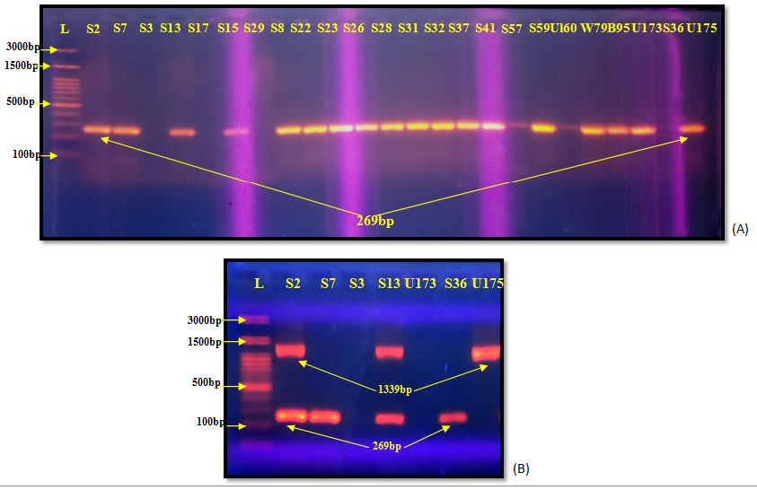
Figure 4 (A) Gel electrophoresis of PCR of lukED amplicon product. Lane (S7, 8, 13, 15, 2, 22, 23, 26, 28, 31, 32, 36, 37, 41, 57, 59, S3, 17, 29, 36), Lane (B95), Lane (Ul60) isolate from ulcer, Lane (W79) isolate from wound. (B) Gel electrophoresis of Multiplex PCR of mecA and lukED amplicon product. Lane (S2, 7, 3, 13, 36) no. of isolates from skin, Lane (U173, U175) no. of isolates from urine, isolate from burn,

References
1- Aires de Sousa, M., Bartzavali, C. Spiliopoulou, I. Sanches, I. S. Crisostomo, M. I. and de Lencastre, H. (2003). Two international methicillin-resistant Staphylococcus aureus clones endemic in a university hospital in Patras, Greece. J. Clin. Microbiol., 41: 2027–2032.
2- Kluytmans-Vanden, B. and Kluytmans, J. A. (2006). Community-acquired methicillinresistant Staphylococcus aureus: current perspectives. Clinical Microbiology and Infection, 12:9-15.
3- Zetola, N., Francis, J. S., Nuermberger, E. L. and Bishai, W. R. (2005). Community-acquired meticillin-resistant Staphylococcus aureus: an emerging threat. Lancet Infect. Dis., 5: 275–286.
4- Schaumburg, F, Ko¨, R., Friedrich, A. W., Soulanoudjingar, S. and Ngoa, U. A. (2011). Population Structure of Staphylococcus aureus from Remote African Babongo Pygmies. PLoS Negl. Trop. Dis., 5(5): 1150.
5- Shukla, S. K., Stemper, M. E., Ramaswamy, S., Conradt, J. M., Reich, R., Graviss, E. A. and Reed, K. D. (2004). Molecular characteristics of nosocomial and Native American community-associated methicillin-resistant Staphylococcus aureus clones from rural Wisconsin. J. Clin. Microbiol., 42: 3752-3757.
6- McClure, J, Conly, JM and Lau, G. (2006). Novel multiplex PCR assay for detection of the staphylococcal virulence marker Panton-Valentine leukocidin genes and simultaneous discrimination of methicillin-susceptible from resistant staphylococci. J. Clin. Microbiol., 44:1141-1144
7- Deresinski, S. (2005).Review of MRSA. Clin. Infect. Dis., 40:562-573
8- Diep, B. A., Sensabaugh, G. F., Somboona, N. S., Carleton, H. A. and Perdreau-Remington, F. (2004). Widespread skin and soft-tissue infections due to two methicillin-resistant Staphylococcus aureus strains harboring the genes for Panton-Valentine leucocidin. J Clin Microbiol., 42: 2080–2084.
9- Scottish center for infection and environmental health (SCIEH) (2002). Community MRSA and Panton-Valentine leukocidin. SWCIEH Wkly., 36: 298.
10- Al-Hassnawi, H.H., Al-Charrakh, A.H., Ai-Khafaji, G.K.(2012). Prevalence of Antimicrobial susceptibility and virulence factors of community-acquired methicillin resistant Staphylococcus aureus (CA-MRSA) from Hilla/Iraq.vol.No.j-----,(in press).
11- Fluit, AD, Visser, MR and Schmitz, FJ. (2001). Molecular detection of antimicrobial resistance. Clin. Microbiol. Rev., 14:836-871
12- CDC.(2008).MRSA. Retrieved June 1, from www.cdc.gov/ncidod/dhqp/ar_mrsa Invasive _FS.html
13- Corkill, J. E., Anson, J. J., Griffiths, P. and Hart, C. A. (2004). Detection of elements of the staphylococcal cassette chromosome (SCC) in a methicillin susceptible (mecA gene negative) homologue of a fucidin-resistant MRSA. J. Antimicrob. Chemother., 54: 229–231.
14- Kuroda, M., Ohta, T., Uchiyama, I., Baba, T., Yuzawa, H. and Kobayashi, I. (2001). Whole genome sequencing of meticillin-resistant Staphylococcus aureus. Lancet, 357(9264): 1225–1240.
15- Al-Mohana, A., M., Al-Kudhieri M., K., Al-Charrakh, A.H.(2012).Community-Acquired Methicillin-Resistant Staphylococcus aureus Carrying mecA and Panton-Valentine lukocidin PVL Genes That Isolated From Holy shrine In Najaf, Iraq.J.Bacteriol.Res. (in press)
16- Del Giudice, Blanc, P., V., Durupt, F., Bes, M., Martinez, J. P., Counillon, E., Lina, G., Vandenesch, F., and Etienne, J.(2006). Emergence of two populations of methicillin-resistant Staphylococcus aureus with distinct epidemiological, clinical and boilogical features, isolated from patients with community-acquired skin infections. Br. J. Dermatol., 154:118–124.
17- Clinical and Laboratory Standards Institute (CLSI). (2012). Performance standards for antimicrobial susceptibility testing. Approved standard M100-S22. Vol.32, No. 3. National Committee for Clinical Laboratory Standards, Wayne, Pa.
18- Skov R, Smyth R, Clausen M. (2003). Evaluation of a cefoxitin 30 µg disc on Iso-Sensitest agar for detection of methicillin-resistant Staphylococcus aureus. J. Antimicrobiol. Chemother., 52 : 204-207
19- Trindade, PA, McCulloch, JA and Oliveira, GA. (2003). Molecular techniques for MRSA typing: current issues and perspectives. The Brazil J. Infect. Dis., 7:32-43
20- Zhang, K., McClure, J., Elsayed, S., Louie, T. and Conly, J. M. (2005). Novel mulitplex PCR assay for characteriszation and concomitant subtyping of the staphylococcal cassette chromosome mec Types I to V in methicillin-resistant Staphylococcus aureus, J. Clin. Micro., 43: 5026-5033.
21- Daum, R. S., Ito, T., Hiramatsu, K., Hussain, F. and Mongkolrattanothai, K. (2002). A novel methicillin resistance cassette in community-acquired methicillin-resistant Staphylococcus aureus isolates of diverse genetic backgrounds. J. Infect. Dis., 186: 1344–1347.
22- Gonzalez, B. E., Rueda, A. M., Shelburne, S. A.III, Musher, D. M., Hamill, R. J. and Hulten,K.G.(2006).Community-associated strains of methicillin-resistant Staphylococccus aureus as the cause of healthcare-associated infection. Infect. Control Hosp. Epidemiol., 27: 1051–1056.
23- Okuma, K., Iwakawa, K. and Turnidge, J. D. (2002). Dissemination of new methicillin-resistant Staphylococcus aureus clones in the community.J Clin Microbiol., 40: 4289–4294
24- Strande´n, A., R. Frei, H. Adler, Flu¨ckiger U., and Widmer ,A. (2009). Emergence of SCCmec type IV as the most common type of methicillin-resistant Staphylococcus aureus in a university hospital. Infection 37:44–48.
25- Kilic, A, Guclu, AU and Senses, Z. (2008). Staphylococcal cassette chromosome mec (SCCmec) characterization and Panton-Valentine leukocidin gene occurrence for methicillin-resistant Staphylococcus aureus in Turkey from 2003-2006. Antonie van Leeuwenhoek, 94:607-614
26- Lina, G., Piemont, Y. and Godail-Gamot, F. (1999). Involvement of Panton-Valentine leukocidin–producing Staphylococcus aureus in primary skin infections and pneumonia. Clin Infect Dis., 29: 1128–1132.
27- Diep, B., Carlton, H., Chang, B.,Senabaugh, G. and Predreau-Remington,F.(2011). Roles of 34 Virulence Genes in the Evolution of Hospital- and Community-Associated Strains of Methicillin-Resistant Staphylococcus aureus. J. Infect. Dis., (193): 1495-1503
28- Holmes, A., Ganner, M., McGuane, S., Pitt, T. L., Cookson, B. D. and Kearns, A. M. (2005). Staphylococcus aureus isolates carrying panton-valentine leucocidin genes in England and Wales:frequency, characterization, and association with clinical disease, J. Clin. Microbiol., 43(5): 2384–2390.
29- Badiou, C., Dumitrescu, O.,George, N., Forbes, A., R., Drougka, E.(2010). Rapid detection of Staphylococcus aureus Panton-Valentine Leukocidin in clinical specimens by Enzyme-Linked Immunosorbent Assay and Immunochromatographgic Tests. J.Clin.Microbiol.,48(4): 1384-1390.
30- Narita, S., Kaneko, J., Chiba, J., Piemont, Y., Jarraud, S., Etienne, J. and Kamio, Y. (2001). Phage conversion of Panton-Valentine leukocidin in Staphylococcus aureus: molecular analysis of a PVL-converting phage, phiSLT. Gene, 268:195-206.
31- Reichert B, Birrel G (2005). Severe non pneumonic necrotizing infections in children caused by Panton-Valentine Leukocidin producing Staphylococcus aureus Strains. J. Infect., 50(5): 438-442.
32- Havaei, S.A., Moghadam, S. O. , Pourmand , M.R. Faghri, J.(2010). Prevalence of Genes Encoding Bi-Component Leukocidins among Clinical Isolates of Methicillin–Resistant Staphylococcus aureus. Iran. J. Publ. Health, Vol. 39, No.18-14
33- Diep BA, Carleton HA, Chang RF, Sensabaugh GF, Perdreau-Remington F.( 2006). Roles of 34 virulence genes in the evolution of hospital and community-associated strains of methicillin-resistant Staphylococcus aureus. J Infect Dis., 193:1495–503.
34- Nashev, D., Bizeva, L. and Toshkova, K. (2007). First cases of infections caused byPanton-Valentine leukocidin positive community-acquired methicillin-resistant Staphylococcus aureus in Bulgaria. Eurosurveill,12: 3225.
35- Baba-Moussa, L., Ahissou, H., Azokpota, P., Assogba, B., Atindéhou, M. M., Anagonou, S. (2009). Toxins and adhesion factors associated with Staphylococcus aureus strains isolated from diarrhoeal patients in Benin. Afri. J. Biotech., Vol. 9 (5): 604-611.
36- Khosravi,A. D., Hoveizavi, H. and Farshadzadeh, Z.(2011). The prevalence of genes encoding leukocidins in Staphylococcus aureus strains resistant and sensitive to methicillin isolated from burn patients in Taleghani hospital, Ahvaz, Iran. Infec. and Trop. Dis. Res., Cent., 14: 219-245
37- Gravet, A., Couppie P. ´, Meunier O., Clytie. , Moreau B. , Pradinaud R. , Montiel H. and Prevost G. (2007). Staphylococcus aureus Isolated in Cases of Impetigo Produces Both Epidermolysin A or B and LukE-LukD in 78% of 131 Retrospective and Prospective Cases. J. Clin. Microbiol., Vol. 39, No. 12 p. 4349–4356

