Synthesis of N-(4-Chlorophenyl)-2-methoxy-4-methylbenzamide
and Spectrofluorometric Study

Abbas N. M. Al-Sharify, Nadhir N. A. Jafar, Ammar K. Madlool*
Dep. of Chemistry College of Science Babylon University, Iraq
*Ammar.madlol@gmail.com

(NJC)
(Received on 13/1 /2015) (Accepted for publication 12/2/2015)

Abstract
N-(4-Chlorophenyl)-2-methoxy-4-methylbenzamide (3) is synthesized from reacting carboxylic acid (1) with 4-chloroaniline (2) by using N,N’-dicyclohexylcarbodiimide (DCC) and 1-hydroxybezotriazole (HOBt) as coupling reagent. The product is confirmed by IR, ¹H-NMR and elemental analysis . The conditions of fluorescence behaviours are studied such as solvent, pH, temperature, time, concentration effect and binding constant at λ_{ex}340 nm and λ_{em} 380 nm. The best fluorescence intensity is obtained at pH = 5 and temperature 25 ⁰C, while the fluorescence intensity remains stable with increasing of time. The LOD, LOQ, S.D and R.S.D% of compound 3 are found 0.2691 mg.L⁻¹, 0.898 mg.L⁻¹, 0.591 and 1.369 respectively.
Keywords: DCC, coupling reagent, fluorescence intensity, pH and binding constant.
الخلاصة
تم تحضير N-(4- كلورو فنيل)-2- ميثوكسي- 4- مثيل بنزمايد (3) من خلال مفاعلة الحامض الكاربوكسيلي(1) مع 4- كلورو انيلين(2) بأستخدام داي سيكلو هكسايل داي امايد (DCC)وهيدروكسي بنزوترايازول HOBt)) كعوامل مساعده للارتباط مابين مجموعة الكاربوكسل والامين. المركب الناتج تم التأكد منه بتقنية IR, ¹H-NMR وتحليل العناصر. كما درسة العديد من الظروف وتأثيرها على شدة الفلوره وهذه الظروف هي المذيب،الدالة الحامضية، درجة الحرارة، التركيز وثابت الارتباط بطول موجي للاثاره 340 نانومتر وطول موجي لللانبعاث 380 نانومتر. المركب الناتج يعطي أفضل شدة فلوره عنده PH=5 وبدرجة حرارة ºC25 بينما لا تتغير شدة الفلوره عند زيادة الوقت. كما درسةLOD ،LOQ ،S.D ،R.S.D % ، للناتج وكانت تساوي (1.363, 0.591, 0.898, 0.269) mg/ L⁻¹ على التوالي.
الكلمات المفتاحية: .عامل الارتباط، شدة الفلورة، الدالة الحامضية، ثابت الارتباط ،DCC

Introduction
Amides are an important compounds in organic chemistry because they are presented in numerous natural products such as peptides and proteins. It’s also used in different areas of industry such as plastic, rubber and paper industry¹. The most known drugs contain more than 25% of carboxamide according to information from medicinal chemistry² such as loperamide³, lidocaine⁴ and acetaminophen⁵. Amide bond is formed by reacting carboxylic acid with amine, to achieve this formation, carboxylic compound should be activated so that there are many methods and strategies are to activate carboxylic compounds, the first is using thionyl chloride (SOCl₂)^{6,7} or COCl₂^{8,9} to form acyl chloride, the second is using coupling reagents (DCC) and (HOBt) to form active ester and followed-up by nucleophile attack by amine^{10,11}.
Experimental
Apparatus and materials
The melting point was determined by a Stuart melting point apparatus (SMP 30, England) and is uncorrected. Infrared (FT-IR) spectra was examined by IRPrestige-21 Shimadzu Spectrophotometer as KBr disk. The fluorescence spectra was examined by Spectrofluorophotometer Rf-5301PC Shimadzu. NMR data were obtained 500 MHz (¹HNMR) spectrometers (Avance III, Bruker, Iran) with TMS as internal standard and on scale in ppm. All NMR spectra were measured in dimethyl sulfoxide d₆. Thin layer chromatography (TLC) was carried out using TLC-Silica plates GOF254 (0.2mm) of the Merck company. Column chromatography was performed using Silica gel (0.040-0.063 mm). All materials were purchased by Sigma-Aldrich.
Procedure
1. Synthesis of N-(4-Chlorophenyl)-2-methoxy-4-methylbenzamide
The synthesis of compound 3 was carried out by mixing 2-methoxy-4-methylbenzoic acid 1 (500mg, 3.01mmole) dissolving in acetonitrile (CH₃CN) (30 ml), N,N’-dicyclohexylcarbodiimide (DCC) (621mg, 3.01 mmole), 1-hydroxybezotriazole (HOBt) (404mg, 3.01mmole) and 4-chloroaniline 2 (3.01mmole, 380 mg). The mixture reaction was cooling and the time period of stirred was -5 ºC at 1h, 0 ºC at 1h, 5 ºC at 1h and 23 ºC at 33h respectively . Dicyclohexylurea (DCU) was filtered, and the filtrate was evaporated. the residue was dissolved in ethyl acetate. The filtered was washed successively with saturated NaCl solution, 5% NaHCO3 solution, 1.0M HCl, followed-up by washing with saturated NaCl solution and then with water. The residue was dried by (MgSO₄)¹² and evaporated. The residue was purified with decantation and recrystllization with acetonitrile. yield 332.2mg (40%), M.P = (123-126), phase = crystalline solid, color = colorless, R_{f} = 0.67 (ethyl acetate: hexane) (4:2). IR, N-H = 3346.61 cm⁻¹, C-O = 1236.4 cm⁻¹, Cl =1087.9 cm⁻¹, C=Oamide = 1664 cm⁻¹, CH aliphatic = 2939.61 cm⁻¹, CH aromatic = 3039.91 cm⁻¹ as shown figure.1 . ¹H NMR (DMSO-d₆): δ 10.15 (s, 1H, NH), 7.88 (dd, 1H, J = 2.3Hz, 2.5Hz, H5_{arom} + H5'_{arom}), 7.57 (d, 1H,j = 2.4Hz, H4_{arom}), 7.39 (dd, 2H, J=2.5Hz, 2.5Hz, H3_{arom} + H3'_{arom}) , 7.01 (s, 1H, H2_{arom}), 6.89 (d, 1H, J = 7.6Hz, H1_{arom}), 3.89 (s, 3H, OMe), 2.36 (s, 3H, Me) as shown in figure 2 . Elemental analysis, Anal. Calcd for C₁₅H₁₄NClO₂ (275.73): C, 65.34; H, 5.12; N, 5.08. Found C, 65.24; H, 5.02; N, 5.06.

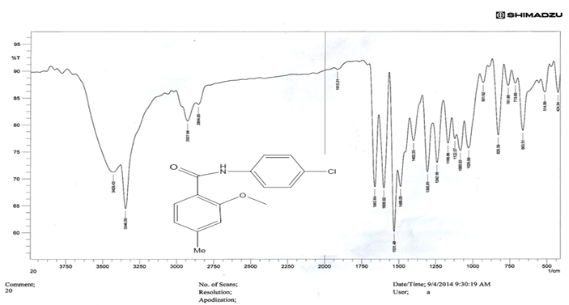

Figure.1 IR spectra of compound 3

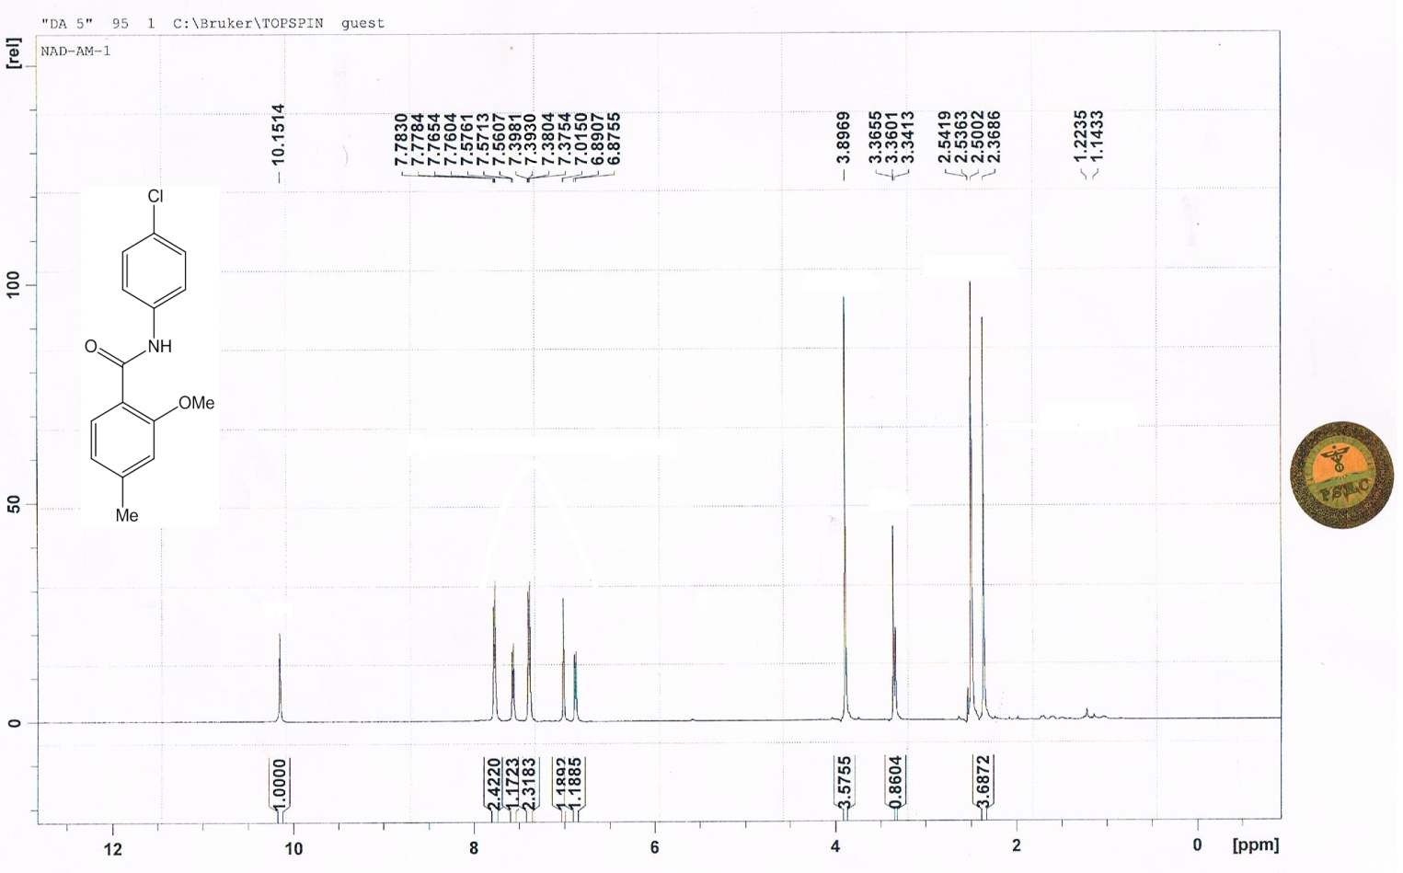
Figure.2 1H-NMR spectra of compound 3.

2. Solvent effect
The concentration of compound 3 is 1x10⁻³ mole.L⁻¹ that was prepared by dissolving in 50 ml ethanol. The fluorescence intensity was measured at at λ_{ex}340 nm and λ_{em} 380 nm then the effect of solvent on the fluorescence intensity was also measured. The used solvents are methanol, acetonitrinle, acetone and n-propanol in the ratio 1:1 (V/V) with ethanol as essential solvent.
3. pH effect
The effect of pH on the fluorescence intensity of the complex forming between compound 3 and Pb²⁺ was studied at different pH values ranging from 2.7 to 10.1 by using 0.1M HCl and 0.1M NaOH.
Results and discussion
In this study, 2-methoxy-4-meyhylbenzoic acid 1 was chosen as a starting material. N-(4-Chlorophenyl)-2-methoxy-4-methylbenzamide 3 was synthesized by reacting carboxylic acid 1 with 4-chloroaniline 2 and the performing strategy for the formation of compound 3 is coupling reagent by using N,N’-dicyclohexylcarbodiimide (DCC) and 1-hydroxybenzotriazole (HOBt)¹³. This reaction occurs at a low temperature of -5 ⁰C at 1 hour, 0 ⁰C at 1hour, 5 ⁰C at 1 hour and 23 ⁰C at 33 hour. DCC was used to activate carboxylic acid 1 to form potent intermediate so-called O-isoacyliorea but this intermediate undergoes racemization and converts to inactive result as calling N-acylurea. HOBt was added to decrease racemization and formation active ester which reacts with compound 2 to form amide bond and side product DCU. The essential of this reaction is shown in scheme 1.

Scheme.1 Synthesis of compound 3.

1. The effect of solvent
The fluorescence spectra of compound 3 in ethanol as organic solvent exhibited λ_{ex} and λ_{em} at 340 nm and 380 nm respectively. When mixing other organic solvents with ethanol at the ratio 1:1(V/V) , wavelength of excitation and emission were not significantly change, but the enhancement and quenching were occurred in the fluorescence intensity. The effect solvent on fluorescence intensity were examined by using methanol, acetonitrile, acetone and n-propanol as other solvents with ethanol . Acetone gave enhancement in the fluorescent intensity. The main reason for the increasing of the fluorescence intensity was due to the weakness of the intramolecular hydrogen bonding and increasing intermolecular hydrogen bonding between solute-solvent¹⁴. Methanol gave the same fluorescent intensity of control (ethanol) while n-propanol and acetonitrile were exhibited quenching in the fluorescence intensity as shown in figure.3. This quenching can be attributed to the change in medium polarity that may occur in some types of physical interaction between these solvents and the excited singlet state of the compound 3 molecules¹⁵.

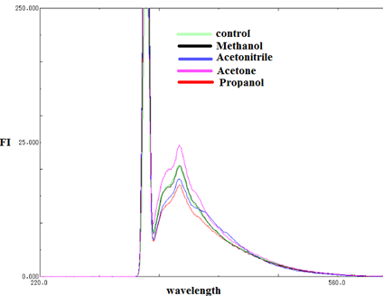
Figure.3 Solvent effect of compound 3.

2.The effect of pH
The influence of pH on the fluorescence intensity of compound 3 was studied by using 0.01M HCl and 0.01M NaOH. The pH range was 2.7-10.1. The greatest fluorescence intensity was found at pH= 5 (control) . At the beginning, the fluorescence intensity was low when pH ˂ 5 because it greatly affected by the acidity of the medium as explained in figure.4. This decrease in the fluorescence intensity was due to following reason: as known delocalization give fluorimetric properties, when solution was acidity, the lone pair of nitrogen was used to join to hydrogen ion (supplied by buffer solution) so that delocalization between lone pair nitrogen and carbonyl amide will disrupt. When pH ˃ 5, the fluorescence intensity also reduces and this decreasing can be attributed to the decomposition of compound 3¹⁶.

Figure.4 pH effect of compound 3.

3. The effect of temperature
The effect of temperature on the fluorescence intensity (FI) was studied in the range 20-60 ºC of compound 3 by using a thermostatically control water bath as explained figure.5. It found that with increasing the temperature, the fluorescence intensity will gradually decrease. This decreasing was due to higher internal conversion as the temperature increasing, facilitating non-radiative deactivation of excited singlet state and increasing of the loss of energy by collision with solvent molecules¹⁷.

Figure 5. Temperature effect of compound 3.

4. The effect of time
The influence of time on the fluorescence intensity of compound 3 was also studied. It found that the fluorescent intensity was remained stable for more than six hours as shown in figure.6.

Figure 6. Time effect on the fluorescent intensity.

5. The effect of concentration
The effect of concentration of Pb(II) on the fluorescence intensity of compound 3 was studied by using different concentrations of Pb(II) from 1ppm to 5ppm at pH = 5 and temperature 25 ºC . The fluorescence intensity will be quenched by increasing the concentration of Pb²⁺ . This decrease in the fluorescence intensity can be attributed to the delocalization effect caused by [Pb²⁺]¹⁸ on the compound 3 as explained in figure.7.

Figure 7. Concentration effect of Pb²⁺ on compound 3.

6. Mole ratio
Mole ratio was studied of complex formed between compound 3 and Pb²⁺ by the plot ∆F against Vm/Vm+Vl as shown figure.8, where can be noted from figure.8 The mole ration was calculated by the intersection of two straight lines of the complex and it equals to 1:1 that indicates the number of binding between components of complex.

Figure 8. Mole ration of complex (compound 3 with Pb²⁺).

7. Binding constant
The binding process between compound 3 and Pb²⁺ was calculated by applying Stern-Volmer equation 1.
Log = logK+ n log [Pb²⁺] …………1
Fo-F
F

Where K is the binding constant, n is number of binding sites, F_{o} and F are the fluorescent intensity of compound 3 in the absence and presence of Pb²⁺ respectively. The number of sites were calculated from figure.9 that displays the linear plot log F_{o}-F/F against log [Pb²⁺]. The value of binding constant and number of sites were listed in table 1. From value of binding constant, it can be noted that the interaction compound 3 and Pb²⁺ was very strong where the force acting between them includes hydrogen bonds, van der Waals force, electrostatic force and hydrophobic interactions¹⁹⁻²¹. Also LOD, LOQ, S.D and R.S.D% of compound 3 were calculated (table 1).

Figure 9. The plot of number of sites between compound 3 and Pb²⁺.

Table 1. Information about compound 3.
comp | n | Kx10⁻³(L.mole⁻¹) | S.D | R.S.D% | LOD (mole.L⁻¹) | LOQ (mole.L⁻¹)
3 | 1.0871 | 160.871 | 0.591 | 1.369 | 0.261 | 0898

Conclusion
The fluorescence intensity of compound 3 decreases by increasing the concentration Pb²⁺ and the temperature while it is stable by increasing the time. The best value of fluorescence intensity of compound 3 is at pH 5. The binding between compound 3 and Pb²⁺ was confirmed by the number of binding sites and mole ratio that equal to ≈ 1and 1:1 respectively. This binding proved by binding constant.

References
1. Bettelheim, F. A.; March, J. Introduction to General, Organic and Biochemistry, 5th Ed.; Sounders College Publishing: Fort Worth. 1998, 492–508.
2. Christian, A. G. N. M.; Virginie, F. Tetrahedron. 2005, 61, 10827–10852.
3. Xiaofeng, B.; Duliang, L.;Yanyan, J.; Yao,Y. Molecules. 2012, 17, 14288-14297.
4. Thomas, J. R. J. Chem. Educ. 1999, 76, 1557.
5. Roxan, J.; Nicolas, D.; Estelle M.; Amadéo, F.; Marc L. J. Roy. Soc. Chem. 2014, 1-12.
6. Fátima C. T.; Inês F. A. M.; João. M.; Curto, M. N.; António, P.S. T. ARKIVOC. 2009, 69-84.
7. Josef, S.; Jan, O.; Ales, I.; Josef, J.; Pavel, B. Synth. Org. Chem. 2011,1-10. 8. Kent, E. P.; Gerald, W.; Shipps, J.; David, A. S.; Julis, R. J. Tetrahedron. 1998, 54, 4107-4124. 9. Wilds, A. L.; Cliffrodh, H. S. J. Am. Chem. Soc. 1948, 70 , 2427–2428. 10. Lai ,C. C., Brian, G. C. J. Org. Chem. 2007, 72, 8863-8869.
11. Janak, S.; Theodor, W. D.; Rita F. T. P.; Kissick, R.; Joseph, W.; Peter, S.; Chris, G.; Papaioannou, J. L.; Moniot, R. H. M.; and Christopher M. C. Org. Pro. Res & Dev. 2002, 6, 863-868.
12. Najim, A. A.; Nawar S. H.; Shahid, H. ARKIVOC. 2010, 242-253.
13. Hasan, T.; Yaseen A.; Ahmed, M.; Mohanad, S.; Mahmoud, A. Jord. J. Chem. 2007, 2, 11-20.
14. Huang, Z.; Liu, Z.; Cai, R.; Zeng; Y. J. Nat. Sci. 1988, 3,123-125.
15. Mihaela, H.; Anton, A.; Dana, O. D. J. Adv. Res. Phys. 2011, 2, 1-9.
16. Hassina, F.; Nadjia, B.; Nabila, D. J. Inc. Phen. Macr. Chem. 2012, 73, 369–376.
17. Mohamed, I.W.; Fathalla, B.; Nahed, E.; Manal, E.; Rania, N. E. J. Fluoresc. 2011, 21, 1659–1667.
18. Chunwei, Y.; Jun, Z.; Jinhua, L.; Ping, L.; Peihai W.; Lingxin, C. J. Microchimica. Acta. 2011, 174, 247–255.
19. Mote, U. S.; Bhattar, S .L.; Patil, S. R.; Kolekar, G. B. J. Sol. Chem. 2009, 38, 619–628.
20. Beena, M.; Atanu, B.; Kindira, P.; Hari, M. J. Chem. Soc. 2005, 117, 641–647.
21. Xi-Zeng, F.; Zhang, L.; Lin-Jin, Y.; Chen,W.; Chun-li, B. Talanta. 1998, 47, 1223–1229.

