**Lec-5- Parasitology**

**TRYPANOSOMES**

Trypanosomes are hemoflagellate protozoa; they belong to the family trypanosomatidae. It is

- Require more then one host to complete their life cycle

- Transmitted through blood feeding invertebrates (insects).

- Mostly live in blood tissue but can be found in different locations in the host

- Uses antigen variation, or variation of the protein coat, to avoid detection by the body

- The complex *Trypanosoma brucei* have two subspecies that are morphologically indistinguishable cause distinct disease patterns in humans: *T. b. gambiense* causes West African sleeping sickness and *T. b. rhodesiense* causes East African sleepingnsickness. The parasite, *Trypanosoma cruzi*, causes America typansosmiasis (or Chagas' disease).

- These species may have amastigote, epimastigote, and trypomastigote stages in their life cycle.

- Typical trypanosome structure is an elongated spindle-shaped body, a centrally situated nucleus, a kinetoplast posterior to nucleus, an undulating membrane arising from the kinetoplast and proceeding forward along the margin of the cell membrane and a single free flagellum at the anterior end. The amastigote is oval to suboval and contains a nucleus and rod-shaped kinetoplast.

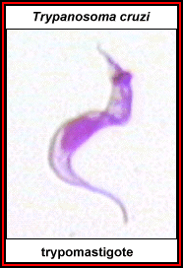  ***T. rhodesiense***

***T.gambiense*  and *T.rhodesiene***

**Morphology**

*T.gambiense* and *T.rhodesiene* are causative agents of the African typanosomiasis, transmitted by insect bites of tsetse fly. These organisms multiply in blood early in disease; later in lymph nodes and in the CNS.

*T. b. gambiense* and *T. b. rhodesiense* are morphologically similar. Various forms are recognized and its flagellated. Epimastigote is the developmental form in flies; trypomastigote is the infective stage. It is present in the salivary gland of the fly and is the stage seen in the human bloodstream. and other vertebrate. Trypommatigote exhibit pleomorphism. They vary greatly in their size and shape. Two types are recognized: Dividing long and slender trypomastigote with a long free flagellum and nondividing short, thick and stumpy trypomastigotes

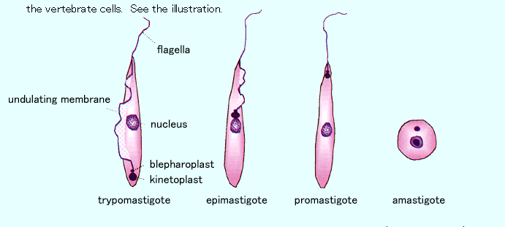

**Life cycle**

*T. brucei* complex complete their life cycle in vertebrate and insect host. Vertebrate host include man and domestic animals. Insect host are **tsetse Fly** of *Glossina*. Man and other vertebrate hosts acquire infection by bite of tsetse fly. These flies inoculatemetacyclic trypomastigotes (infective forms) in skin during the blood meal. These metacyclic forms are immediately transformed into long slender bloodstream trypomastigotes and begin to multiply in the blood, lymphatic system or in tissue. Trypomastigotes invade heart and connective tissue, bone marrow and in later stage, invade the central nervous system. The trypomastigotes convert to non-dividing stumpy trypomastigotes. The tsetse fly becomes infected with bloodstream short stumpy trypomastigotes when taking a blood meal on an infected mammalian host. In the fly’s midgut, the parasites transform into procyclic trypomastigotes, multiply by binary fission, leave the midgut, and transform into epimastigotes. The epimastigotes reach the fly’s salivary glands and continue multiplication by binary fission. After then the epimastigotes are transformed into metacyclic trypomastigotes. The cycle in the fly takes approximately 3 weeks. Seines’, humans are the reservoir for *T.gambiense*, whereas *T. rhodesiense* has reservoirs in both domestic animals(especially cattle) and wild animals

**Pathogenesis**

Trypanosomes of *T. brucei* are multiplyat the site of inoculation to cause variable induration andswelling (the primary lesion), which may progress to form atrypanosomal chancre. The African forms multiply extracellularlyas trypomastigotes in the blood as well as in lymphoidtissues. They spread to lymph nodes, to the bloodstream, and,in terminal stages, to the central nervous system (CNS), where they produce the typical sleeping sickness syndrome: lassitude, inability to eat, tissue wasting, unconsciousness, and death. CNS involvement is most characteristic of African trypanosomiasis. *T.rhodesiense* appears in the cerebrospinal fluid in about 1 month and *T gambiense* in several months, but both are present in small numbers. *T. gambiense* infection is chronic and leads to progressive diffuse meningoencephalitis, with death from the sleeping syndrome usually following in 1–2 years. The more rapidly fatal *T. rhodesiense* produces coma only during the final weeks of a terminal infection. The African trypanosomes of the *T brucei* complex are undergo antigenic variation through change surface glycoproteins that coat the organism and can escape the host immune

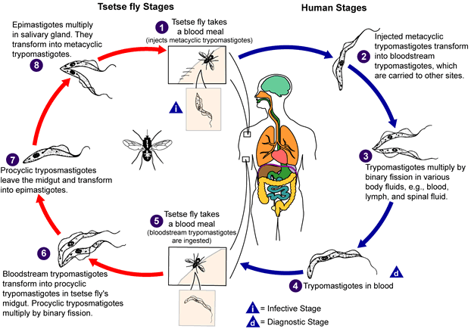

**Life cycle of *T.gambiense* and *T.rhodeiense***

**Clinical features**

Although both species cause sleeping sickness, the progress of the disease is different. *T.gambiense* induced disease runs a chronic course over a few years, whereas *T.rhodesiense c*auses a more acute, rapidly progressive disease that, if untreated, is usually fatal within several months. The initial lesion is an indurated skin ulcer(trypanosomal chancre) at the site of the fly bite. After the organism enter the blood, intermittent weekly fever and lymphadenopathy develop. Enlargement of the posterior cervical lymph nodes(Winterbottom`s sign) is commonly seen. Chronic disease progresses to CNS involvement. The encephalitis is characterized initially by headache, insomnia, and mood changes, followed by muscle tremors, slurred speech, and apathy that progress to somnolence and coma.

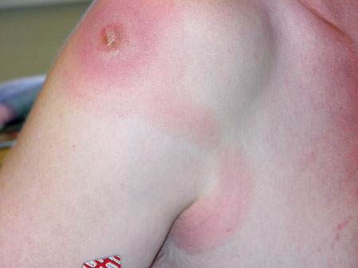

**Chancre**

**Epidemiology**

*T.burcei gambiense* is limited to tropical west and central Africa, correlating with the range of the tsetse fly vector. People who work in such areas are at greatest risk of infection. *T.burcei rhodeseinse* is found primarily in East Africa, especially the cattle-raising countries.

**Laboratory diagnosis**

During the early stages, microscopic examination of the blood (either wet films or thick or thin smears) reveals trypomastigotes. An aspirate of the chancre or elongated lymph node can also demonstrate the parasites. The presence of trypanosomes in the spinal fluid, coupled with an elevated protein level, indicates that the patient has entered the late, encephalitic stage. Serologic tests, especially the ELISA for IgM antibody, can be helpful.

**Treatment**

Treatment must be initiated before the development of encephalitis, because suramin, the most effective drug, does not pass the blood-brain barrier well. Suramin will effect a cure if given early. Pentamidine is an alternative drug. If central nervous system symptoms are present, suramin( to clear the parasitemia) followed by melarsoprol should be given.

***Trypanosoma cruzi* (American trypanosomiasis)**

*T.cruzi* causes american trypanosomiasis(Chagas' disease). The vector for transmission are reduviid bugs (Triatoma, conenose or kissing bug, It bites preferentially around the mouth or eyes). Trypanosoma *cruzi* can also be transmitted through blood transfusions, organ transplantation and transplacentally.

*T.cruzi* is a pleomorphic has three developmental stages. Trypomastigote is blood stage and amastigote stage is a tissue stage; the epimastigote is the developmental stage in the bug. Unlike African trypanosomiasis, the antigenic variation is less common in *T.cruzi* infection

**Life cycle**

The life cycle involve the reduviid bug as the vector and both humans and animals as reservoir hosts. When an infected insect vector takes a blood meal and releases trypomastigotes in its feces. Trypomastigotes enter the host through the bite wound or through intact mucosal membranes, such as the conjunctiva. Inside the host, the trypomastigotes invade cells, where they differentiate into intracellular amastigotes. The amastigotes multiply by binary fission and differentiate into trypomastigotes, and then are released into the circulation as bloodstream trypomastigotes. The bloodstream trypomastigotes do not replicate. Replication resumes only when the parasites enter another cell or are ingested by another vector. The “kissing” bug infects when feeding on human or animal blood that contains parasites. The ingested trypomastigotes transform into epimastigotes in the vector’s midgut. The parasites multiply and differentiate into infective metacyclic trypomastigotes in the hindgut. Within 8-10 days, these trypanomastigotes are excreted in the faeces of the bug and the cycle is continued.

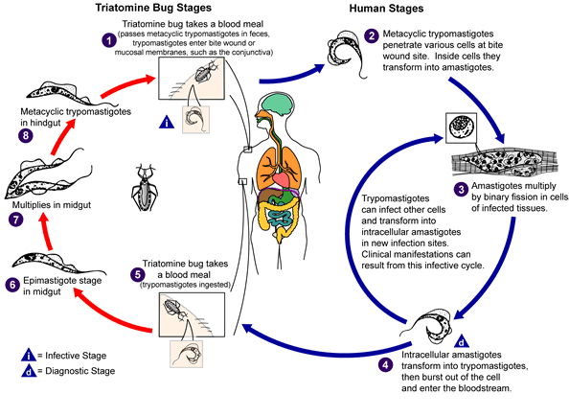

**Life cycle of *T.cruzi***

**Pathogenesis**

During the acute phase, the organism occurs in blood as a typical trypomastigote and intracellularly as a typical amastigote. The amastigotes can kill cells and cause inflammation, consisting mainly of mononuclear cells. Cardiac muscle is the most frequently and severely affected tissue. In addition, neuronal damage leads to cardiac arrhythmias and loss of tone in the colon (megacolon) and esophagus (megaesophagus). In the chronic phase, the organism persists in the amastigote form.

**Clinical features**

Chagas’ disease may be asymptomatic, acute or chronic disease. One of the earliest signs is development at the site of the bug bite of an erythematous and indurated area called a chagoma. This is often followed by a rash and edema around the eyes and face; in young children frequently an acute process with CNS involvement may occur. Acute infection is also characterized by fever, lymphadenopathy, chills, malaise and fatigue. The chronic Chagas’ disease is characterized by hepatosplenomegaly, myocarditis, and enlargement of the esophagus and colonas a result of the destruction of nerve cells. Death from chronic Chagas’ disease results from tissue destruction in the many areas invaded by the organisms, and sudden death results from complete heart block and brain damage.

** Chagoma**

**Epidemiology**

*T.cruzi* occurs widely in both reduviid bugs and reservoir animals in North, Central, and South America. Human disease is found most often among children in South and Central America, where there is direct correlation between infected wild animal reservoir hosts and the presence of infected bugs whose nests are found in human dwellings.

**Laboratory diagnosis**

1- Examine thin or thick stained preparations for trypomastigotes.

2- Biopsy of lymph nodes, liver, spleen, or bone marrow may demonstrate amastigote

3- Culture of the organism on special medium

4- Serologic tests can be helpful also

**Treatment**

The drug of choice for the acute phase is nifurtimox, which kills trypomastigotes in the blood but is much less effective against amastigotes in tissue. Benznidazoleis an alternative drug. There is no effective drug against the chronic form.

**Prevention**

• Insects control and use of insecticides.

• Treatment of human cases to reduce transmission to flies.

• Avoiding insect bite by wearing protective clothing and use of bed netting and insect repellants