**GLYCOGEN METABOLISM**

Glycogen is a branched homopolysaccharides made exclusively from a-D-glucose.

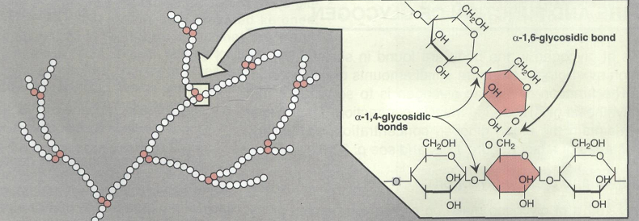

The primary glycosidic bond is an alpha-1,4 glycosidic linkage. After an average of eight to ten glucosyl residues (glucose), there is a branch containing an alpha-1,6 glycosidic linkage .

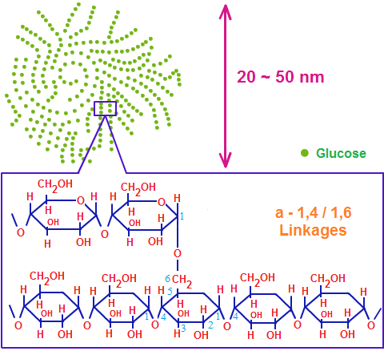

Glycogen is the storage form of carbohydrates in the human body. The major sites of storage are liver and muscle. The major function of liver glycogen is to provide glucose during fasting. when blood glucose level falls, liver glycogen is broken down and helps to maintain blood glucose level. After taking food, blood glucose tends to rise, which causes glycogen deposition in liver. About 5 hours after taking food, the blood glucose tends to fall, but, glycogen is lysed to glucose so that the energy needs are met. After about 18 hours fasting, most of the liver glycogen is depleted, at this time depot fats are hydrolysed and energy requirement is met by fatty acid oxidation.The function of muscle glycogen is to act as reserve fuel for muscle contraction.

**DEGRADATION OF GLYCOGEN (GLYCOGENOLYSIS)**

**1. Glycogen Phosphorylase**

Glycogen phosphorylase removes glucose as glucose-1-phosphate from glycogen. It removes glucose units one at a time. Enzyme sequentially hydrolyses alpha-1,4 glycosidic linkages, till it reaches a glucose residue, 3-4 glucose units away from a branch point. It cannot attack the 1,6 linkage at branch point. If glycogen phosphorylase alone acts on a glycogen molecule, the final product is a highly branched molecule; it is called limit dextrin. PLP (pyridoxal phosphate) is an essential cofactor in the glycogen phosphorylase reaction.

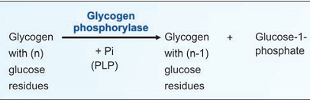

**2. Debranching by bifunctional two Enzymes**

Then a block of 3 glucose residues (trisaccharide unit) are transferred from the branching point to another branch by enzyme alpha-1,4 → alpha-1,4 glucan transferase. Now the branch point is free. Then alpha-

1,6- glucosidase(debranching enzyme) can hydrolyse the remaining glucosyl unit held in alpha-1,6 linkage at the branch point. This glucose residue is released as free glucose. At this stage, the ratio of glucose-1-

phosphate to free glucose is about 8:1.The transferase and alpha-1,6-glucosidase will together convert the branch point to a linear one. With the removal of the branch point, then phosphorylase enzyme can proceed with its action.

**3. Phosphoglucomutase**

Phosphorylase reaction produces glucose-1- phosphate while debranching enzyme releases glucose. The glucose-1-phosphate is converted to glucose-6-phosphate by phosphoglucomutase

**4. Glucose-6-phosphatase in Liver**

Next, hepatic glucose-6-phosphatase hydrolyses glucose-6-phosphate to glucose. The free glucose is released to the blood stream.

**5. Muscle Lacks Glucose-6-phosphatase**

Muscle will not release glucose to the blood stream, because muscle tissue does not contain glucose-6-phosphatase. Instead, in muscle, glucose-6-phosphate undergoes glycolysis to produce ATP for muscle contraction.

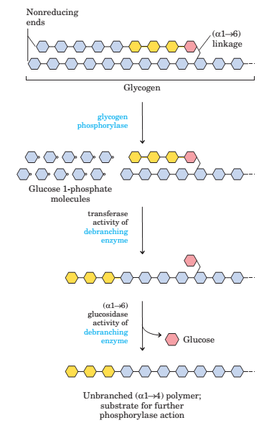

**GLYCOGEN SYNTHESIS (GLYCOGENESIS)**

Glycogen is synthesized from molecules of a-D-glucose. The process occurs in the cytosol. Glycogen synthesis takes place in virtually all animal tissues but is especially prominent in the liver and skeletal muscles. The starting point for synthesis of glycogen  
is glucose 6-phosphate. This can be derived from free glucose in a reaction catalyzed by hexokinase (glucokinase) ,To initiate glycogen synthesis, the glucose 6-phosphate is converted to glucose 1-phosphate. The glycogen synthesis occurs by a pathway different from the reversal of glycogenolysis. The steps are:

1**. Activation of Glucose**

UDP glucose is formed from glucose-1-phosphate and UTP (uridine triphosphate) by the enzyme glucose-1-uridyltransferase.

**2. Glycogen Synthase**

The glucose moiety from UDP-glucose is transferred toglycogenin (a glycogen primer molecule which is essential to accept the glycosyl unit), The primer is made up of a protein-carbohydrate complex.

Glycogen synthase

Glycogen primer (n) + UDP glucose ————→ Glycogen (n+1) + UDP

In this step, activated glucose units are sequentially added by the enzyme glycogen synthase .The glucose unit is added to the non-reducing (outer) end of the glycogen primer to form an alpha-1,4 glycosidic linkage and UDP is liberated.

**3. Branching Enzyme**

The glycogen synthase can add glucose units only in alpha-1,4 linkage. A branching enzyme is needed to create the alpha-1,6 linkages. When the chain is lengthened to 11 – 12 glucose residues, the branching enzyme will transfer a block of 6 to 8 glucose residues from this chain to another site on the growing molecule. The enzyme amylo-[1,4]→[1,6]-transglucosidase (branching enzyme) forms this alpha-1,6 linkage .To this newly created branch, further glucose units can be added in alpha-1,4 linkage by glycogen synthase.

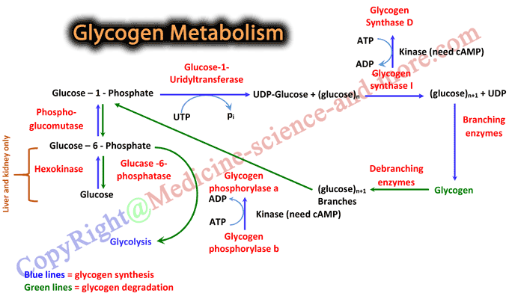

**Regulation of Glycogen Metabolism**

Glycogen metabolism is regulated by coordinated regulation of glycogen synthase and glycogen phosphorylase. The regulatory mechanisms include:

|  |
| --- |
|  |

* [**Allosteric regulation of glycogen synthase and phosphorylase**](http://watcut.uwaterloo.ca/webnotes/Metabolism/glycogenRegulation.html#sec179)

The allosteric activators and inhibitors of phosphorylase and synthase are listed below.

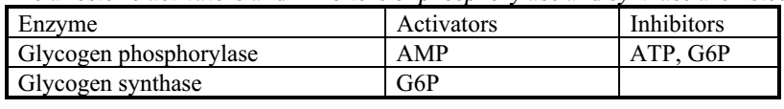

* **Covalent modification (phosphorylation and dephosphorylation) of enzymes by hormonal control**

Glycogenolysis and glycogenesis pathways are reciprocally regulated to prevent futile cycles.

Glycogen phosphorylase is activated by phosphorylation by kinase that adds phosphate group to a specific serine residue of phosphorylase while phosphorylase inactivated by dephosphorylation by phosphatase .The active form of phosphorylase is referred to as ‘a’ (active, phosphorylated) and the relatively inactive dephosphorylated form as ‘b’.

The same protein kinase, which phosphorylates the phosphorylase, would also phosphorylate glycogen synthase. The activity of the glycogen synthase is markedly decreased on phosphorylation; Glycogen synthase is active in the dephosphorylated state. So, the active glycogen synthase (a) is dephosphorylated and phosphorylated (b) is relatively inactive.

Insulin and glucagon are the major regulatory hormones, although epinephrine has stimulatory effect on glycogenolysis in both liver and muscle. Insulin promotes glycogen synthesis in muscle and  
liver by favoring dephosphorylation of enzymes. Glycogen phosphorylase is activated in response to glucagon or epinephrine, which converts glycogen phosphorylase (b) to its active (a) form .

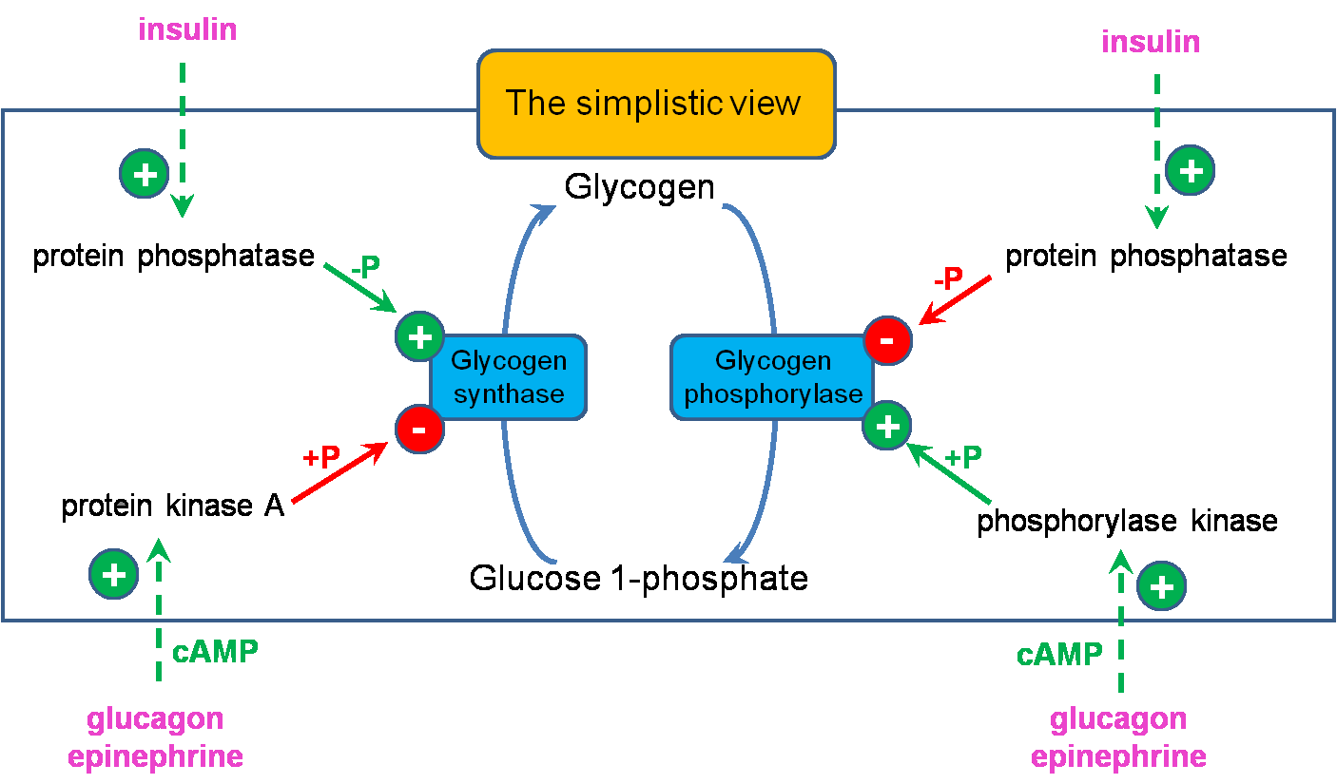

**GLYCOGEN STORAGE DISEASES**

Inherited deficiencies in specific enzymes of glycogen metabolism in both liver and muscle are the causes of glycogen storage diseases. These are **inborn-errors** of metabolism.

**Glycogen Storage Disease Type-I**

It is also called **Von Gierke's Disease.** Most common type of glycogen storage disease is type I. Incidence is 1 in 100,000 live births. In this disease Glucose-6-phosphatase is deficient, fasting hypoglycemia that does not respond to stimulation by adrenaline. The glucose cannot be released from liver during overnight fasting, Hyperlipidemia, lactic acidosis and ketosis. Glycogen gets deposited in liver. Massive liver enlargement may lead to cirrhosis. Children usually die in early childhood. Treatment is to give small quantity of food at frequent intervals. **Other glycogen storage diseases (type II to X)**; they are very rare, incidence being 1 in 1 million births.