M J B

Investigation on Colanic acid and Molecular Detection of Cytotoxic Necrotizing Factor in Bacteria Associated with Post-Operative Wound Infections

Mohammad Sabri A. Razzaq Mohammad A. K. Al saadi
Rafeef A. Saeed Al-Amean
Babylon university, Collage of Medicine, Hilla, Iraq.

Abstract
A total of 60 samples from patients with postoperative wound infection were included in this study. Only 50 (83%) patients with positive bacterial culture and 10 (17%) patients with negative culture. Different types of bacteria were isolated from post-operative wound infections. The predominant bacteria for gram negative was E. coli. In this study (13) isolates of E. coli were identified (37.14%) followed by (6) isolates of Proteus vulgaris (17.14%), while (5) isolates of Enterobacter cloacae (14.28%) were found, (4) isolate of both Klebsiella pneumoniae (11.42%) and Pseudomonas aeruginosa (11.42%) were found, (2) isolates Acinetobacter spp. (5.7%), and (1) isolated of Citrobacter spp. (2.85%) were isolated. All isolates were subjected to produce colanic acid extracellularly. It was found that colanic was produced at high level by Klebsiella pneumoniae (97 µg\ml); followed by E. coli (82 µg\ml) and then Enterobacter cloacae (73 µg\ml), whereas Acinetobacter and Citrobacter produced this acid sugar at low level (16 µg\ml) and (4 µg\ml) respectively, on contract to Proteus vulgaris which failed to produce it extracellularly. Cytotoxic necrotizing facter-1 gene obtained from E. coli was used as PCR marker for detection of CNF-1 in E. coli and other gram negative bacteria which are isolated in the present study. Besides, this factor was detected in whole DNA genome and also in DNA plasmid. It was observed that amplicons were found in all bacterial DNA extracted from E. coli, Klebsiella, Enterobacter and Proteus. At the same time, amplicons were detected in plasmids extracted from Enterobacter and Proteus.
الخلاصه
من مجموع 60 عينة اخذت من اشخاص مصابين بخمج الجروح، فان 50 عينة (83%)كانت موجبة الزرع البكتيري. تم عزل انواع مختلفة من بكتريا من هذه الجروح، كانت 13 عزلة E. coli (37.14%) هي البكتريا السائده لمجموعه سالبة كرام، تليها 6 عزلات لبكتريا Proteus vulgaris وبنسبة (17.14%) بينما شخصت 5 عزلات لبكتريا Enterobacter cloacae بنسبة (14.28%) و4 عزلات لكل من بكتريا Klebsiella pneumoniae وبكتريا Pseudomonas aeruginosa بنسبه (11.42%) اما بكتريا Acinetobacter spp. شخصت لها عزلتان (5.7%) وعزله واحده فقط تابعه لبكتريا Citrobacter spp. بنسبة (2.85%). درست قابلية هذه العزلات على انتاج colanic acid خارج الخلايا ، وجد ان هذا الحامض انتج بمستوى عالي من قبل بكتريا Klebsiella pneumoniae (97 µg/ml) الحاويه على محفظة ، تليها بكتريا E. coli (82 µg/ml) وبكتريا Enterobacter cloacae تنتج هذا الحامض بنسبة(73 µg/ ml) ، بينما بكتريا Acinetobacter وبكتريا Citrobacter تنتج هذا الحامض بمستوى اقل ml) (4 µg/ml), (16µg/ بالتتابع وبالمقارنة مع بكتريا Proteus vulgaris التي لاتتج الحامض خارج الخلايا. ايضا تم الكشف عن جين CNF-1 بأستخدام تقنية تفاعل البلمره المتسلسل في بكتر يا E. coli والعزلات الاخرى السالبة كرام والمعزولة ضمن هذه الدراسة. وتم الكشف عن هذا العامل في DNA وبلازميد جميع العزلات ، ولوحظ ان هذا الجين موجود في DNA عزلات E. coli Klebsiella, , ,Enterobacter Proteus وفي نفس الوقت تم الكشف عن هذا الجين في بلازميد Enterobacter و. Proteus
ـــــــــــــــــــــــــــــــــــــــــــــــــــــــــــــــــــــــــــــــــــــــــــــــــــــــــــــــــــــــــــــــــــــــــــــــــــــــــــــــــــــــــــــــــــــــــــــــــــــــــــــــــــــــــــــــــــــــــــــــــــــــــــــــــــــــــــــــــــــــــــــــــــــــــــــــــــــــــــــــــــــــــــــــــــــــــــــــــــــــــــــــــــــــــــــــــــــــــــــــــــــــــــــــــــــــــــــــــــــــــــــــــــــــــــــــــــــــــــــــــــــــــــــــــــــــــــــــــــــــــــــــــــــــــــــــــــــــــــــــــــــــــــــــــــــــــــــــــــ

Introduction
Postoperative wound infection is an infection in the tissues of the incision and operative area. It can occur from 1 day to many years after an operation but commonly occurs between the fifth and tenth days after surgery [1].
There are a number of ways in which microorganisms can gain access to a wound: Direct contact, airborne dispersal, and self-contamination. Whilst there is no definitive evidence to identify the most common route of entry for a microorganism into a wound, direct contact and poor hand-washing techniques of healthcare practitioners during pre-and post-operative phases of patient care are considered to be significant factors [2].
However, there are predisposing factors associated with the development of post-operative wound. These include some general factors such as general factors (age, obesity, malnutrition, endocrine and metabolic disorders, hypoxia, anaemia, malignant disease, and immunosupression); local factors (necrotic tissue, foreign bodies, tissue ischaemia, haematoma formation, and poor surgical technique) and microbiological contamination (type and virulence of organism, size of bacteriological dose, and antibiotic resistance) [3].
Materials and Methods
Patients
Wound swaps and blood samples were collected from (60) patients who suffering from wound infection after surgical operation with the age range between (3-60) years old from both sexes. The period of collection were extended from October 2010 to January 2011.the bacteria obtained from infected wounds were subjected to identification according to Braoks et al (2007).
Colanic acid production: It was done according to [4]. The colometric method was used to detect the quantity of colanic acid produced extracellularly.
Detection of colonization factor antigen: it was done according to [5].
Detection of Cytotoxic necrotizing factor: primer was used for detection of CNF-1 in all isolates obtained by using PCR. The primer forward sequence (5'to3') CNF-1-F (AAGATGGAGTTTCCTATGCAAGGAG) and the primer reversed sequence (5' to 3') CNF-1-R (CATTCAGATCCTGCCCTCATTAT). The reaction was performed in a PCR thermal cycler apparatus. After several trials and according to the manufacture’s troubleshooting guide (promega kit).

Results
A total of 60 samples from patients with postoperative wound infection were included in this study, only 50 (83%) patients with positive bacterial culture and 10 (17%) patients with negative culture. These results were show in Figure (1).

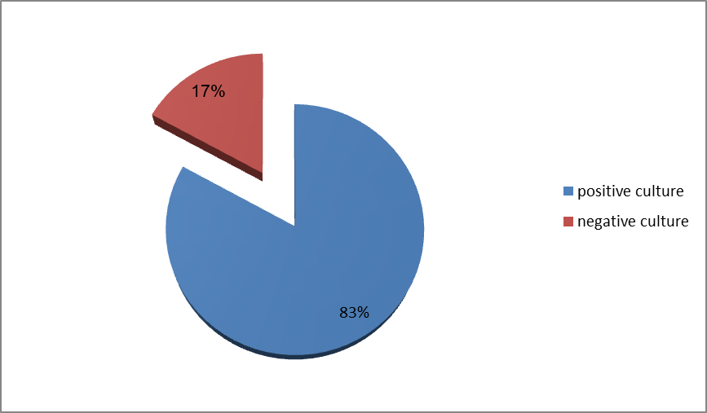
Figure 1 Percentage of bacterial culture for patients with post-operative wound infection

Different types of bacteria were isolated from post-operative wound infections. The predominant bacteria of gram negative was E. coli. The results show in Table (1) and Table (2).

Table 1 Biochemical tests for bacterial types isolated from postoperative wound infection

Type of bacteria | catalase | Oxidase | Motility | urease | indole | MR | VP | citrate
E. coli | + | _ | + | _ | + | + | _ | _
Klebsiella pneumoniae. | + | _ | _ | + | _ | _ | _ | +
Enterobacter cloacae. | + | _ | + | _ | _ | _ | + | +
Pseudomonas aeruginosa. | + | + | + | _ | _ | + | _ | +
Proteus vulgaris. | + | _ | + | + | + | + | _ | +
Citrobacter spp. | + | _ | + | _ | + | _ | _ | +
Acinetobacter spp. | + | _ | _ | _ | + | _ | _ | +

Table 2 Gram-negative bacterial types isolated from postoperative wound infection

percentage | No. of isolates | Bacterial isolates
37.14% | 13 | Escherichia coli
17.14% | 6 | Proteus vulgaris
14.28% | 5 | Enterobacter cloacae
11.42% | 4 | Pseudomonas aeruginosa
11.42% | 4 | Klebsiella pneumoniae
5.7% | 2 | Acinetobacter spp.
2.85% | 1 | Citrobacter spp.
100% | 35 | Total

Bacterial isolates were subjected to produce colanic acid extracellularly. It was found that colanic was produced at high level by Klebsiella pneumoniae (97 µg\ml); followed by E. coli (82 µg\ml) and then Enterobacter cloacae (73 µg\ml), whereas Acinetobacter and Citrobacter produced this acid sugar at low level (16 µg\ml) and (4 µg\ml) respectively, on contract to Proteus vulgaris which failed to produce it extracellularly as shown in Table (3).

Table 3 Colonic acid production from bacterial types isolated from postoperative wound infection.

Concentration of colonic acid μg/ml | Bacteria | No
82 | Escherichia coli | 1.
73 | Enterobacter cloacae | 2.
97 | Klebsiella pneumoniae | 3.
0 | Proteus vulgaris | 4.
16 | Acinetobacter spp | 5.
4 | Citrobacter spp | 6.

Discussion
It’s well known that K. pneumoniae have extracellular polysaccharide represented by capsule, which help the bacteria to evade phagocytosis. Colanic acid is derived from the capsular polysaccharide and the amount of this acidic sugar will reflect the size of capsular polysaccharides.
So, the high amount of colanic acid in Klebsiella may be attributed to the large size of its capsule [6].
On the other hand, E. coli also produced large amount of colanic acid although this bacteria have no capsule surrounding the cell wall, however, the high rate production may be attributed to presence of mini capsule and the produce of mega plasmid which contains the genes encoding colanic acid production (rmpA,rmpB), however colanic acid production may have a role in biofilm formation at the site of infection especially in wounds[7].
Cytotoxic necrotizing facter-1 gene obtained from E. coli was used as PCR marker for detection of CNF-1 in E. coli and other gram negative bacteria which are isolated in the present study, this study considered the first record dialing with the study of CNF-1 in Babylon province. Also, this factor was detected in whole DNA genome and also in extract plasmid. It was observed that amplicons were found in all bacterial DNA extracted from E. coli, Klebsiella, Enterobacter and Proteus as shown in Figure (2).
At the same time, amplicons were detected in plasmid DNA of Enterobacter and Proteus as shown in Figure (3). The result of using CNF-1 as a genetic marker will confirm that this factor is distributed among enteric bacteria.

1 2 3 4 5 6 7
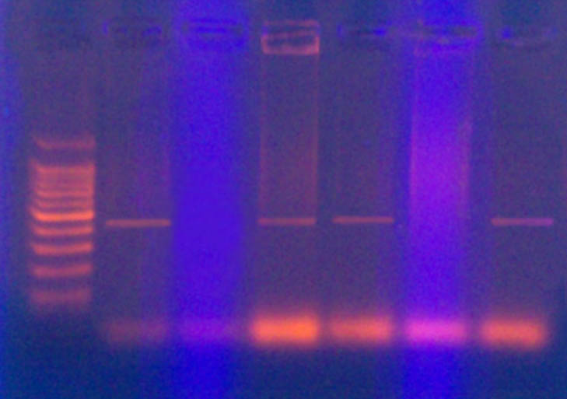
410 bp
Figure 2 Detection of cnf gene in whole DNA of bacterial isolates. 1. Ladder, 2. E. coli, 3. Citrobacter, 4. Klebsiella, 5. Enterobacter, 6. Acinetobacter, 7. Proteus
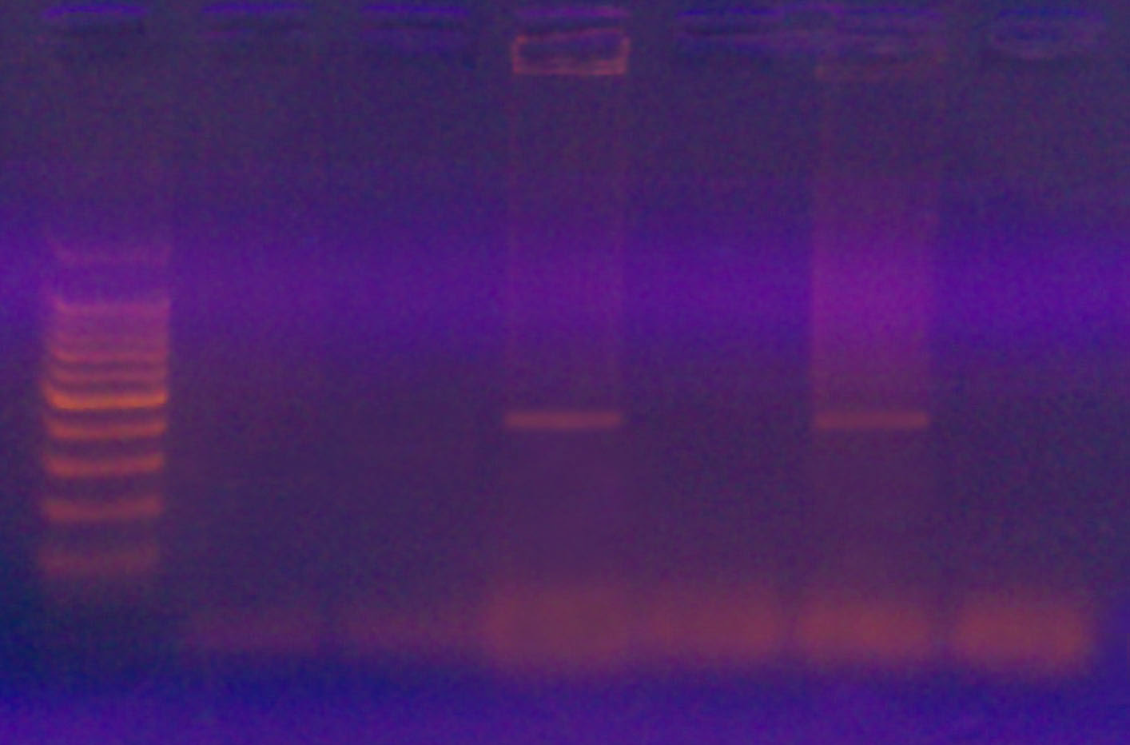
Figure 3 Detection of cnf-1 gene in plasmid DNA. 1. Ladder, 2. E. coli, 3. Klebsiella, 4. Enterobacter, 5.Citrobacter, 6. Proteus, 7. Acinetobacter

The presence of cnf gene of E. coli in other gram negative cells may be attributed to horizontal gene transfer in which the genetic markers are transferred through may mechanisms such as congication, transformation and transduction.
So, according to that the production of CNF-1 will render such bacteria to grow and survive at the site of infection due to CNF-1 ability to prevent the healing of wounds through its effect on PMNL.
The production of CNF-1 by the bacteria associated with post-operative wound infection was seen to be important that rendering this factor as virulence factor through its ability to increase the functional features of PMNL such as superoxide generation and adherence on epithelial cells but significantly decrease their phagocytic features [8; 9].
So, the present study may suggest that the source of bacteria associated with post-operative wound infections may be intestinal or from urinary source.
CNF-1play an important role in the pathogenicity of E. coli strains by overcoming host defense mechanisms to cause the disease [10].
In addition to the promotion cell spreading, CNF-1 protects cell from experimentally induced rounding up and detachment and improves the ability of cells to adhere to each other and to extracellular matrix by modulating the expression of proteins related to cells adhesion [11].

References
- Singhal, H. and Charles, Z. (2002). Wound Infection. J. Infect. Dis. 3(7): 22-29.
- Garvin, J. (1995). Escherichia coli O157:H7 J. Bone. Joint. Bacterial and Mycotic Diseases Surg. 77:1576 – 88.
- Hogardt, M., Hoboth, C. and Schmoldt, S. (2007). Stage-specific adaptation of hypermutable Pseudomonas aeruginosa isolates during chronic pulmonary infection in patients with cystic fibrosis. J. Infect. Dis. 195:70.
- Falbo, V., M. Famiglietti, and A. Caprioli. (1992). Gene block encoding production of cytotoxic necrotizing factor 1 and hemolysin in Escherichia coli isolates from extraintestinal infections. Infect. Immun. 60:2182–2187.
- Smith, H. W. (1982). The hemolysin of E. coli. J. Path. Bact. 85: 197-211.
- Takeda, S., Fujsawa, M., Matsubara, H. and Mizuno, T. (2001). A novel feature of multistep phosphorelay in E. coli a revised model of RcsC, YojN, RcsB signaling pathway implicated in capsular synthesis and swarming behavior. Mol. Microbiol. 40: 440-450.
- Clarke, D., Joyce, S., Toutain, C. and Holland, I. (2002). Genetic analysis of RcsC sensor kinase from E. coli K-12. J. Bacteriol. 184: 1204-1208.
- Hoffman, P., G. Le Negrate, B. Mograbi, V. Hofman, P. Brest, A. Alliana-Schmid, G. Flatau, P. Boquet, and B. Rossi. (2000). Escherichia coli cytotoxic necrotizing factor-1 (CNF-1) increases the adherence to epithelia and the oxidative burst of human polymorphonuclear leukocytes but decreases bacteria phagocytosis. J. Leukoc. Biol. 68: 522–528.
- Boquet, P., B. Mograbi, V. Hofman, A. Loubat, B. Rossi, P. Auberger, and P. Hofman. (2003). Rho GTPase is activated by cytotoxic necrotizing factor 1 in peripheral blood T lymphocytes: potential cytotoxicity for intestinal epithelial cells. Infect. Immun. 71:1161–1169.
- Fournout, S., C. M. Dozois, M. Odin, C. Desautels, S. Pe´re`s, F. He´rault, F. Daigle, S. Segafredo, J. Laffitte, E. Oswald, J. M. Fairbrother, and I. P. Oswald. (2000). Lack of a role of cytotoxic necrotizing factor 1 toxin from Escherichia coli in bacterial pathogenicity and host cytokine response in infected germfree piglets. Infect. Immun. 68:839–847.
- Mackay, D. J. G., Esch, F., Furthmayr, H., and Hall, A. (1997). Rho- and Rac-dependent assembly of focal adhesion complexes and actin filaments in permeabilized fibroblasts: an essential role for ezrin/radixin/moesin proteins. J. Cell Biol. 138, 927-938.

