Cardiovascular Manifestations of Hypothyroidism

Mahmood Shakir Alzaidy
Department of Medicine, Al-Nahrain University, College of Medicine, Baghdad, Iraq. P.O Box: 14222, E-mail: mah_shakir@yahoo.com

M J B

Abstract
Background: In hypothyroidism the heart muscle is weakened in both its contraction phase, and also its relaxation phase. This means that the heart cannot pump as vigorously as it should, and the amount of blood it ejects with each heart beat is reduced. In addition, because heart muscle does not relax normally in between heart beats, a potentially serious condition called diastolic dysfunction may result.
Aim: To evaluate the Prevalence of cardiovascular disorders in patients with primary hypothyroidism, and the relationship between these disorders and other factors like Age, Sex, BMI, and thyroid function status.
Methods: From January 2010 to April 2010, 43 patients were involved in the study, (39 females and 4 males), aging from 41 to 77 years. They were known to have primary hypothyroidism and were randomly chosen from the attendants of the unit of endocrinology at Al-Kadhmyia Teaching Hospital-Baghdad. They approved to participate by filling a questionnaire form involved age, sex, weight, first TSH reading, history of IHD, occurrence of hypertension, ECG, Arrhythmias, Chest X-ray, Echocardiogram, and lipid profile. The collected data were statistically analyzed by using SPSS and Chi-square test to compare discrete variables.
Results and Discussion: Patients participated in the study were of age ranging from 41-77 years (mean 56) which indicates the occurrence of hypothyroidism in old age group. They were 4 males and 39 females which suggests that hypothyroidism is a female disorder rather than of male. The patients of the study were of body mass index ranging from 26-28 which refer to the overweight characteristic of the disease. 79.1% of the patients were having mild elevation in TSH level (6.1-9.2mIU/L), and 20.9% of them were having marked TSH elevation (10.4-12.8mIU/L). Hypertension occurred in 44.2% of patients, 68.4% of them were of diastolic type due to that in hypothyroidism, the smooth muscles of the blood vessels are contracted forcing the heart to push the blood through smaller openings in the vessels resulting in raising the diastolic blood pressure. Hypothyroidism can results in worsening of coronary artery disease, as 23.3% of patients were having history of IHD. By examining the ECG of patients involved in the study, 32.6% of them showed atrial fibrillation as hypothyroidism prolongs the cardiac action potential resulting in ventricular irritability, premature beats and bradycardias. Examination of Chest X-ray and Echocardiogram of patients of the study reveals that 30.2% of them were having Cardiomegaly and pericardial effusion respectively due to increased capillary permeability, impaired lymphatic drainage and enhanced avidity for salt and water. Lipid profile for all patients of the study showed elevation in the levels of total cholesterol and triglycerides over the normal ranges, and normal level of HDL.
Conclusion: Primary hypothyroidism occurred in old, overweighed females, and associated with cardiovascular manifestations which may be the only manifestations of thyroid dysfunction.
المظاهر القلبية الوعائية في مرض نقص التدرقن
الخلاصة
خلفية الدراسة: يتميز مرض نقص التدرقن بضعف عضلة القلب في ادوار التقلص والانبساط ، هذا يعني إن القلب يصبح غير قادر على الضخ بصورة صحيحة كما وتقل كمية الدم المتدفق في كل ضربة قلب، يضاف إلى ذلك، إن عدم قدرة القلب على الانبساط بصورة طبيعية بين الضربات يؤدي إلى حدوث حالة ذات خطر كامن تسمى الاعتلال الانبساطي.
أهداف الدراسة: تهدف هذه الدراسة إلى تقييم نسبة حدوث الإمراض القلبية الوعائية في مرضى نقص التدرقن، وعلاقة هذه الأمراض بعوامل أخرى مثل العمر، الجنس، الوزن والحالة الوظيفية للغدة الدرقية.
المرضى والطرق: في الفترة بين كانون الثاني 2010 و حتى نيسان 2010، اشترك في هذه الدراسة 43 مريضا، 39 أنثى و4 ذكور، أعمارهم تتراوح بين 41 و77 سنة. جمع المرضى مشخصين كمرضى بنقص التدرقن الابتدائي وقد تم اختيارهم عشوائيا من بين المراجعين لوحدة الغدد الصم في مستشفى الكاظمية التعليمي في بغداد. بعد إعلامهم بالدراسة، تم أخذ موافقتهم على الاشتراك فيها عن طريق إملاء استمارة معلومات صممت خصيصا لهذه الدراسة وتشمل العمر، الجنس، الوزن، مستوى هرمون محفز الغدة الدرقية، وجود أمراض القلب التاجية، وجود ارتفاع ضغط الدم، اضطرابات دقات القلب، أشعة الصدر، فحص الايكو، مستوى الشحوم في الدم. تم جمع المعومات وتحليلها إحصائيا باستعمال نظام اس بي اس اس ومربع كاي.
النتائج : إن أعمار المرضى المشاركين في الدراسة تراوحت بين 41 و77 سنة مما يشير إلى حدوث المرض في الفئة العمرية المتقدمة. كما إن وجود 4 ذكور و 39 أنثى بين المرضى له دلالة على حدوث المرض في الإناث أكثر منه في الذكور. تراوح مؤشر كتلة الجسم بين 26 و 28 مما يدل على اكتساب الوزن في مرضى الدراسة. سجل 79.1 % من المرضى ارتفاع بسيط في مستوى الهرمون المحفز للغدة الدرقية، في حين اظهر 20.9 % ارتفاعا ملحوظا في مستوى هذا الهرمون. اظهر 44.2 % من المرضى ارتفاعا لضغط الدم، 68.4 % منهم كان من النوع الانبساطي وذلك لأنه في مرض نقص التدرقن تتقلص العضلات الملساء للأوعية الدموية مما يجبر القلب على استعمال قوة اكبر لضخ الدم عبر الفتحات الصغيرة للأوعية مما يؤدي إلى ارتفاع الضغط الانبساطي. كما يزيد مرض نقص التدرقن من سوء حالة أمراض الشرايين التاجية كما في 23.3 % من المرضى. من خلال فحص تخطيط القلب، فإن 32.6 % من المرضى لديهم ارتجاف أذيني، سبب ذلك هو إن هذا المرض يعمل على إطالة فعل القلب الكامن مما يؤدي إلى حدوث تهيج بطيني وتسارع في ضربات القلب. كما إن فحص أشعة الصدر الايكو لمرضى الدراسة يكشف إن 30.2 % منهم يعاني من تضخم في القلب والتنضاح ألشغافي بسبب زيادة التنافذية الشعرية وعجز البزل اللمفاوي وزيادة الشره للملح و الماء. سجل قياس نسبة الشحوم في الدم لمرضى الدراسة ارتفاعا في مستوى كل من الكولسترول الكلي والدهون منخفضة الكثافة والشحوم الثلاثية.
الاستنتاج : مرض نقص التدرقن الابتدائي يحدث أكثر في الإناث، كبار السن، ذوات الأوزان الكبيرة. يصاحب هذا المرض مظاهر قلبية وعائية والتي قد تكون هي المظاهر الوحيدة لمرض نقص التدرقن.
ــــــــــــــــــــــــــــــــــــــــــــــــــــــــــــــــــــــــــــــــــــــــــــــــــــــــــــــــــــــــــــــــــــــــــــــــــــــــــــــــــــــــــــــــــــــــــــــــــــــــــــــــــــــــــــــــــــــــــــــــــــــــــــــــــــــــــــــــــــــــــــــــــــــــــــــــــــــــــــــــــــــــــــــــــــــــــــــــــــــــــــــــــــــــــــــــــــــــــــــــــــــــــــــــــــــــــــــــــــــــــــــــــــــــــــــــــــــــــــــــــــــــــــــــــــــــــــــــــــــــــــــــــــــــــــــــــــــــــــــــــــــــــــــــــــــــــ

Introduction
Thyroid hormone is very important for normal cardiovascular function, so when not enough thyroid hormone is present neither the heart nor the blood vessels function normally[1]. In hypothyroidism the heart muscle is weakened in both its contraction phase, and also its relaxation phase [2]. This means that the heart cannot pump as vigorously as it should, and the amount of blood it ejects with each heart beat is reduced [3]. In addition, because the heart muscle does not relax normally in between heart beats, a potentially serious condition called diastolic dysfunction may result [7]. Furthermore, hypothyroidism reduces the amount of nitric oxide in the lining of the blood vessels, causing them to stiffen[6].
Common cardiac symptoms of hypothyroidism include:
- Shortness of breath on exertion and poor exercise tolerance due to weakness in the skeletal muscles; but in patients with heart disease, the symptoms may be due to worsening heart failure [10, 14].
- Slow heart rate, as heart rate is modulated by thyroid hormone, so that in hypothyroidism the heart rate is typically 10 - 20 beats per minute slower than normal [11,13]. Especially in patients who also have heart disease, however, hypothyroidism may worsen the tendency for premature beats and even tachycardias such as atrial fibrillation [9,10].
- Diastolic hypertension. One might think that, because a lack of thyroid hormone slows down the metabolism, people with hypothyroidism might suffer from low blood pressure [3,6]. Usually the opposite is true - the arteries are stiffer in hypothyroidism, which causes the diastolic blood pressure to rise.
- Worsening of heart failure, or the new onset of heart failure [4, 8].
- Edema, as a result of worsening heart failure. In addition, hypothyroidism itself can produce a type of edema called myxedema, caused by an accumulation of abnormal proteins and other molecules in the interstitial fluid [2, 11, 13].
- Worsening of coronary artery disease. While the reduction in thyroid hormone can actually make angina less frequent in patients who have angina, the increase in LDL cholesterol (bad cholesterol) and in C-reactive protein seen with hypothyroidism can accelerate any underlying coronary artery disease [1,5].

Patients and Methods
This prospective study was carried out on 43 patients, from January 2010 to April 2010; and all of them were newly diagnosed to have primary hypothyroidism. They were 4 males and 39 females with age ranging from 41 to 77 years, and they were chosen randomly out of the attendants of the endocrinology unit of Al-Kadhmyia Teaching Hospital-Baghdad. Those patients have no previous history of any cardiovascular disease. Patients were informed about the study, and their approval to participate was taken.
Patients involved in the study were known to have primary hypothyroidism. They were involved in the study by filling a questionnaire form that concerned with Age, sex, BMI, first TSH reading, hypertension, history of IHD, arrhythmias, chest X-ray, lipid profile, and Echo findings, as in the sample of the questionnaire form in the next page. The method used for hormonal analysis is Vidas.
Methods of Statistical Analysis
All data were collected and analyzed by using SPSS. Statistical analysis was performed using Chi-squared test to compare discrete variables.

Results
Forty three patients were participated in this study; they were newly diagnosed to have primary hypothyroidism, chosen randomly out of the attendants of the endocrinology unit of Al-Kadhmyia Teaching Hospital-Baghdad from January 2010 to April 2010. They were involved in the study by filling a questionnaire form that concerned with Age, sex, BMI, first TSH reading, hypertension, history of IHD, arrhythmias, findings of chest X-ray, lipid profile, and Echo findings.
Age, Sex and BMI
Thirty nine females (90.7%) and four males (9.3%) were involved in the study with age ranging from 41 to 77 years and body mass index ranging from 26-28±0.9 as seen in tables 1, 2 and figure 1.
First TSH reading
Table 3.3 deals with the first reading of TSH of all patients of the study. It indicates that 79.1% of the participants (34 patients) had mild elevation in their first reading of TSH (6.1-9.2 mIU/L), while 20.9% of them (9 patients) had marked elevation (10.4-12.8 mIU/L), this is also can be shown in figure 2.
Hypertension
Table 4 and figures 3 and 4 showed that 19 patients (44.2%) were having hypertension, and that 68.4% of them (13 patients) were having diastolic hypertension, while 31.6% (6 patients) were having systolic type.
History of IHD
Only 10 patients (23.3%) were having history of ischemic heart disease, while 33 patients (76.7%) showed no such thing. This can be shown in table 5 and figure 5.
Arrhythmias
By examining the ECG of the patients participating in the study, one can see that 14 patients (32.6%) are having atrial fibrillation, while 29 patients (67.4%) are free from that sign. This can be seen in table 6 and figure 6.
Chest X-ray findings
Chest X-rays of 34 participants of the study showed that 13 one of them (30.2%) were have Cardiomegaly, and 30 one (69.8%) have no such sign, as shown by table 7 and figure 7.
Echocardiogram findings
Echocardiogram examinations of the patients of the study shows that 13 patients (30.2%) were having pericardial effusion, and 30 patients (69.8%) were not having such thing. As shown in table 8 and figure 8. ECHO machine type is PHILLIPS .
Lipid profile
Ranges of Lipid profile of the patients of the study are shown in table 9 that indicates elevation in total cholesterol, LDL and triglycerides levels over the normal ranges.

Discussion
From January 2010 to April 2010, 43 patients well known to have primary hypothyroidism were randomly chosen from the attendants of the unit of endocrinology at Al-Kadhmyia Teaching Hospital-Baghdad. As they were informed about the study, they approved to participate by filling a questionnaire form prepared specially for this research, involving age, sex, weight, history of IHD, occurrence of hypertension, ECG, Chest X-ray, Echocardiogram, lipid profile, and first TSH reading.
Concerning with Age, Sex and BMI, results in tables 1, 2 and figure 1 showed that the participants were of age ranging from 41 to 77 years with mean of 56 years ( S.E =13) which refers to the occurrence of hypothyroidism in older age group rather than younger one, as suggested by other studies [2,12]. On the other hand, the presence of 39 females (90.7%) versus 4 males (9.3%) (P value ≤ 0.001), suggests that primary hypothyroidism is a disease of older women rather than men [1, 12]. Also one can notice the relationship between this disease and the elevated BMI that ranged from 26 to 28 (S.E 0.9) that indicates the overweight factor as a potential risk or as a result of correlation of hypothyroidism and cardiovascular disorders [11, 14].
Regarding the First TSH reading, table 3 and figure 2 indicate that 34 patients (79.1%) were having mild elevation in TSH level (6.1-9.2mIU/L), and 9 patients (20.9%) were having marked TSH elevation (10.4-12.8mIU/L). The fact that hypothyroidism is associated with elevated TSH levels was suggested by other studies [6,7], which indicate that people with moderately elevated TSH levels had elevated risks for subsequent heart disease [13].
Regarding Hypertension, results seen in table 4 and figures 3 and 4 showed that 19 patients (44.2% ) were having hypertension, while the other 24 one(55.8%) were clear(P value = 0.446). And that 68.4% of them (13 patients) were of diastolic hypertension, while 31.6% (6 patients) were of systolic type (P value = 0.108). One might think that, because a lack of thyroid hormone slows down the metabolism, people with hypothyroidism might suffer from low blood pressure. Usually the opposite is true, as the arteries are stiffer in hypothyroidism, combined with the increase in vascular resistance. The smooth muscles of the blood vessels are contracted forcing the heart to use more force (pressure) to push the blood through smaller openings in the vessels [1,3,6]. This elevation in the cardiac afterload and cardiac work results in raising the diastolic blood pressure [2, 12].
Regarding History of IHD, table 5 and figure 5 showed that only 10 patients (23.3%) were having history of IHD and the other 33 one (76.7%) have not such history (P value ≤ 0.001), as hypothyroidism can results in worsening of coronary artery disease [7,16,20]. Although the reduction in thyroid hormone can actually make angina less frequent in patients who have angina, the increase in LDL cholesterol and C- reactive protein seen with hypothyroidism can accelerate any underlying coronary artery disease, as supported by other studies [9, 10].
Concerning with the Arrhythmias, table 6 and figure 6 revealed that 32.6% (14 patients) of the participants showed atrial fibrillation in their ECG, while the other 29 patients (67.4% ) were free from that sign (P value = 0.022). One of the most common cardiac symptoms of hypothyroidism is the bradycardia, as heart rate is modulated by thyroid hormone, so that in hypothyroidism the heart rate is typically 10-20 beats per minute slower than normal. However, hypothyroidism prolongs the cardiac action potential and QT interval which predisposes the patient to ventricular irritability and may worsen the tendency for premature beats and tachycardias (AF)[ 3,14].
Regarding the Chest X-ray findings, examination of the Chest X-ray of the patients in our study reveals that 13 patients (30.2%) were having Cardiomegaly, and 30 patients (69.8%) have no such sign (P value = 0.01). This is shown in table 7 and figure 7. Simultaneously, these results can be shown in table 8 and figure 8 that concerned with the Echocardiogram findings that indicates the presence of pericardial effusion. This occurred because the sign of Cardiomegaly in Chest X-rays is actually because of the presence of pericardial effusion that was detected by echocardiogram. This is due the fact that pericardial effusion has been attributed to increase capillary permeability, impaired lymphatic drainage and enhanced avidity for salt and water [5, 6]. The fluid is rich in proteins and glycosaminoglycans. The fluid also has a high cholesterol concentration and is often viscous [5, 9]. Incidence of pericardial effusion is reported to be 30% to 80% in patients with overt hypothyroidism [2]. Effusions are more common and their volume greater in patients with long standing and severe disease [7, 10]. The prevalence of pericardial effusion has declined because of prompt diagnosis of hypothyroidism during its early mild stage or even in absence of minimal symptomatology [6, 8].
Concerning the Lipid profile, table 9 dealt with the ranges of the lipid profile for all of the patients in the study including levels of total cholesterol, LDL, HDL, and triglycerides. The result indicates elevation in the levels of total cholesterol (6.7-7.1 mmol/L ± 0.3), LDL (4.4-4.6 mmol/L ± 0.22) and triglycerides (2.7-2.9 mmol/L ± 0.09) over the normal ranges, and normal level of HDL (1.2-1.4 mmol/L ± 0.4). The correlation of hypothyroidism to elevated levels of total cholesterol, LDL and triglycerides is suggested by many other studies [4, 8].
From all of the above, one can conclude that hypothyroidism is an important cause of IHD and Primary hypothyroidism is associated with cardiovascular manifestations as diastolic hypertension, elevated plasma levels of total cholesterol, LDL and triglycerides, atrial fibrillation, pericardial effusion. Although patients of hypothyroidism are usually old aged, overweighed females, cardiovascular manifestations may be the only manifestations of thyroid dysfunction.

References
- Bengel FM, Nekolla SG, Ibrahim T, Weniger C, Ziegler S, Schwaiger M. Effect of thyroid hormones on cardiac function, geometry, and oxidative metabolism assessed noninvasively by positron emission tomography and magnetic resonance imaging. J Clin Endocrinol Metab 2000;85:1822-1827.
- Gonzalez Vilchez F, Castillo L, Pi J, Ruiz E. Cardiac manifestations of primary hypothyroidism. Determinant factors and treatment response. Rev Esp Cardiol. 1998 Nov;51(11):893-900
- Iervasi, G., et al. A. (2007). Association Between Increased Mortality and Mild Thyroid Dysfunction in Cardiac Patients. Arch Intern Med 167: 1526-1532.
- Klein I. Thyroid hormone and the cardiovascular system. Am J Med 1990; 88:631-637.
- Klemperer J, Ojamaa K, Klein I. Thyroid hormone therapy in cardiovascular disease. Prog Cardiovasc Dis 1996; 38:329-336.
- Ladenson PW. Recognition and management of cardiovascular disease related to thyroid dysfunction. Am J Med 1990 Jun;88(6):638-41
- Ojamaa K, Klemperer JD, Klein I. Acute effects of thyroid hormone on vascular smooth muscle. Thyroid 1996;6:505-512.
- Pantos, C., etal. D. V (2007). Thyroid hormone is a critical determinant of myocardial performance in patients with heart failure: potential therapeutic implications. Eur J Endocrinol 157: 515-520.
- Polikar R, Burger AG, Scherrer U, Nicod P. The thyroid and the heart. Circulation 1993;87:1435-1441.
- Ripoli, A., et al. (2005). Does subclinical hypothyroidism affect cardiac pump performance?: Evidence from a magnetic resonance imaging study. J Am Coll Cardiol 45: 439-445.
- Rodondi, N., Newman, A. B., Vittinghoff, E., de Rekeneire, N., Satterfield, S., Harris, T. B., Bauer, D. C. (2005). Subclinical Hypothyroidism and the Risk of Heart Failure, Other Cardiovascular Events, and Death. Arch Intern Med 165: 2460-2466.
- Tielens E, Visser TJ, Hennemann G, Berghout A. Cardiovascular effects of hypothyroidism. Ned Tijdschr Geneeskd. 2000 Apr 8;144(15):703-6.
- Vanderpump MPJ, Tunbridge WMG. The epidemiology of thyroid diseases. In: Braverman LE, Utiger RD, eds. Werner and Ingbar's . the thyroid: a fundamental and clinical text. 8th ed. Philadelphia: Lippincott Williams and Wilkins, 2000:467-73.
- Vargas, F., Moreno, J. M., Rodriguez-Gomez, I., Wangensteen, R., Osuna, A., Alvarez-Guerra, M., Garcia-Estan, J. (2006). Vascular and renal function in experimental thyroid disorders. Eur J Endocrinol 154: 197-212.

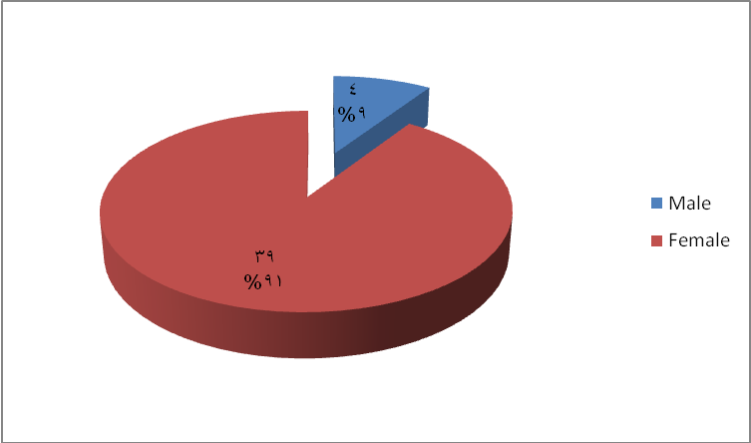
Figure 1 Gender percentage of the patients

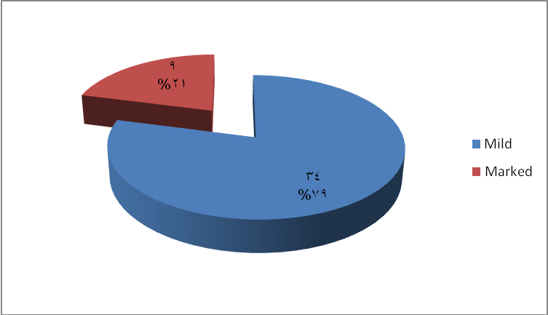
Figure 2 Percentage of mild and marked elevation of TSH in patients of the study

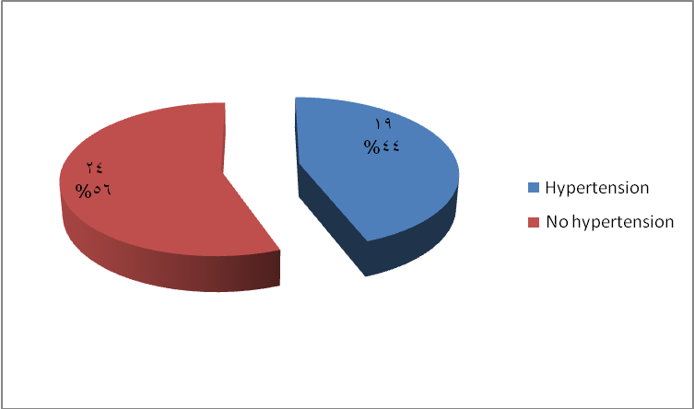
Figure 3 Percentage of hypertension in patients involved in the study

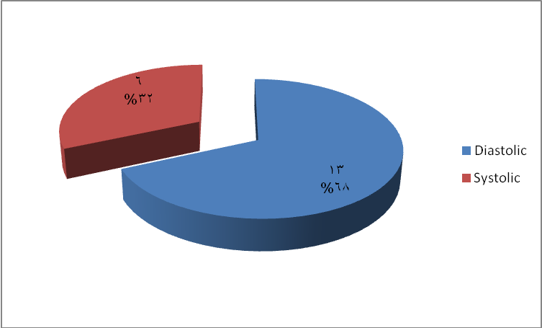
Figure 4 Percentage of types of hypertension in patients involved in the study

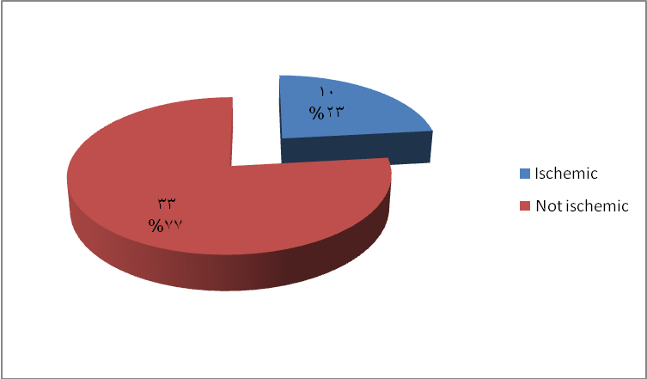
Figure 5 Percentage of IHD in patients of the study

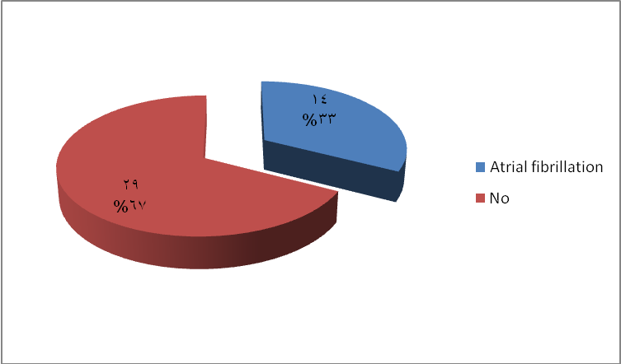
Figure 6 Percentage of AF in ECG of the patients of the study

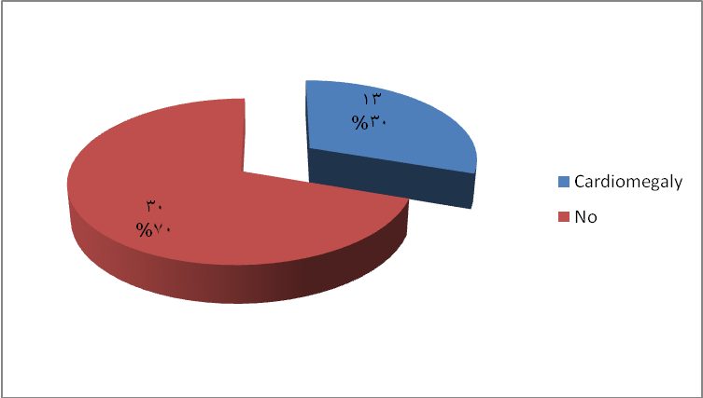
Figure 7 Percentage of Cardiomegaly in chest X-ray of patients of the study

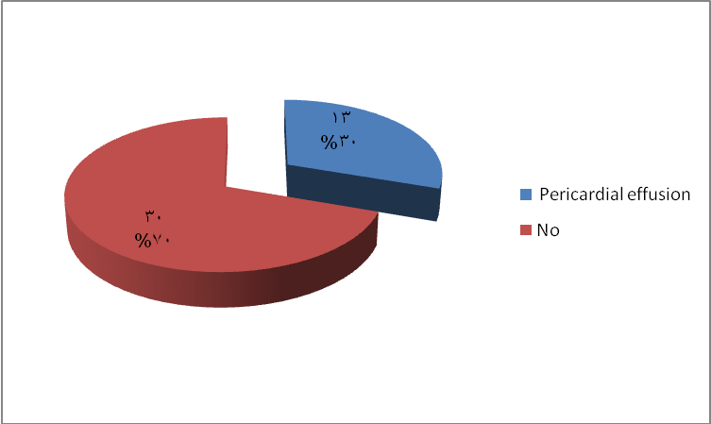
Figure 8 Percentage of pericardial effusion in echocardiogram of patients of the study

Table 1 Age range of patients and their BMI

 | Mean | S.E. | Range
Age | 56 years | 13 | 41-77 years
BMI | 27 | 0.9 | 26-28

Table 2 Gender percentage among the patients of the study

Gender type | Count | Percentage | P value
Male | 4 | 9.3% | ≤0.001
Female | 39 | 90.7% | ≤0.001

Table 3 Percentage of mild and marked elevation of TSH in all patients of the study

1st TSH reading | Count | Percentage | P value
Mild elevation | 34 | 79.1% | ≤0.001
Marked elevation | 9 | 20.9% | ≤0.001

Table 4 Percentage of hypertension and type in patients of the study

Hypertension | Count | Percentage | P value
Yes | 19 | 44.2% | 0.446
No | 24 | 55.8% | 0.446
Type of Hypertension |  |  | 0.108
Diastolic | 13 | 68.4% | 0.108
Systolic | 6 | 31.6% | 0.108

Table 5 Percentage of IHD in patients of the study

History of IHD | Count | Percentage | P value
Yes | 10 | 23.3% | ≤0.001
Not | 33 | 76.7% | ≤0.001

Table 6 Percentage of AF in ECG of the patients of the study

Atrial fibrillation | Count | Percentage | P value
 | 14 | 32.6% | 0.022
No | 29 | 67.4% | 0.022

Table 7 Percentage of Cardiomegaly in chest X-ray of the patients of the study

Cardiomegaly | Count | Percentage | P value
Yes | 13 | 30.2% | 0.01
No | 30 | 69.8% | 0.01

Table 8 Percentage of pericardial effusion in echocardiogram of patients of the study

Pericardial effusion | Count | Percentage | P value
Yes | 13 | 30.2% | 0.01
No | 30 | 69.8% | 0.01

Table 9 Ranges of Lipid profile in patients of the study

Type of lipid | Mean mmol/L | S.E | Range  mol/L
Total Cholesterol | 6.9 | 0.3 | 6.7-7.1
LDL | 4.5 | 0.22 | 4.4-4.6
HDL | 1.3 | 0.4 | 1.2-1.4
Triglycerides | 2.8 | 0.09 | 2.7-2.9

