Role Epstein Barr Virus in Chronic Tonsillitis in Karbala City

Mohammed A.Muhsin Aliaa Mohammed Hammod
Al-Hussain General Teaching Hospital, Karbala, Iraq.

M J B

Abstract
Ninety five tonsil specimens and blood samples were collected from patients suffering from chronic tonsillitis who had attended Al-Hussain General Teaching Hospital in Karbala during the period from October 2010 to January 2011.The age of the patients ranged from (2 to 37) years. The biopsies were immediately kept in 10% formalin. Blood samples (2-5)ml were separated into 2 parts for serological analysis and lymphocyte studies.
Results of cytological test were revealed that from 80 tonsils biopsy,30 samples showed EBV pathogenic changes (infectious mononucleosis)IM characterized by large nuclei in the lymphocytes as the main characteristics of EBV infection, While 50 samples showed no IM.
Results of serological tests were included the ELISA technique which used IgA kit revealed that the immune response to EBV showed each response to primary exposure during early childhood and continued with life due to continuous activation of latent virus that was possibly related to recurrent tonsillitis.
الخلاصة
تضمنت الدراسة الحالية جمع 95 عينة من القطع النسيجية لللوزتين من مرضى يعانون من التهاب اللوزتين المزمن ممن راجعوا مستشفى الحسين التعليمي العام في مدينة كربلاء خلال الفترة من تشرين الثاني 2010 الى كانون الثاني 2011. عمر المرضى تراوح ما بين 2-37 سنة. حفظت القطع النسيجيه مباشرة في (10% )من محلول الفورمالين في جار معقم لتجنب التلوث.
اظهرت نتائج الاختبار السايتولوجي ان من مجموع 80قطعة نسيجية للبلعوم 30منها لوحظ فيها التغيرات المرضية الذي تسببها الاصابة الفايروسية (الابشتاين بار فايروس)و50 قطعة نسيجية لا اثر للتغيرات المرضية فيها أي انه من المحتمل ان تكون الاصابات البكتيرية لها دور في التهاب اللوزتين المزمن.
اظهرت نتائج الفحص السيرولوجي التي تضمنت فحص الالايزا باستعمال IgAاظهرت ان الاستجابة المناعية للفايروس كانت خلال التعرض البدائي للفايروس خلال فترة الطفولة المبكرة وتستمر مع الحياة لتفعيل الفايروس والذي من المحتمل ان يرتبط مع الاصابة المتكررة لالتهاب اللوزتين المزمن.
ـــــــــــــــــــــــــــــــــــــــــــــــــــــــــــــــــــــــــــــــــــــــــــــــــــــــــــــــــــــــــــــــــــــــــــــــــــــــــــــــــــــــــــــــــــــــــــــــــــــــــــــــــــــــــــــــــــــــــــــــــــــــــــــــــــــــــــــــــــــــــــــــــــــــــــــــــــــــــــــــــــــــــــــــــــــــــــــــــــــــــــــــــــــــــــــــــــــــــــــــــــــــــــــــــــــــــــــــــــــــــــــــــــــــــــــــــــــــــــــــــــــــــــــــــــــــــــــــــــــــــــــــــــــــــــــــــــــــــــــــــــــــــــــــ

Introduction
Chronic tonsillitis is a persistent infection of the tonsils and can cause tiny stone formation. A persistent tonsillar infection can lead to enlargement of tonsils. Despite antibiotic treatment, the tonsillar area can remain infected [1].
In chronic cases (generally definedas seven episodes of tonsillitis in the preceding year, five episodes in each of the preceding two years or three episodes in each of the preceding three years[2].
The human palatine tonsils and the nasopharyngeal tonsil are lymphoepithelial tissues located in strategic areas of theoropharynx and nasopharynx, although most commonly the term "tonsils" refers to the palatine tonsils [that can be seen in the back of the throat]. These immunocompetent tissues represent the defense mechanism of first line against ingested or inhaled foreign pathogens. However, the fundamental immunological roles of tonsils have yet to be addressed [3].
Tonsils can become enlarged or inflamed (tonsillitis) and may be surgically removed in tonsillectomy. This may be indicated if they obstruct the airway or interfere with swallowing. In older patients, asymmetric tonsils (also known as asymmetric tonsil hypertrophy(TH)) may be an indicator of virally infected tonsils, or tumors such as lymphoma or squamous cell carcinoma [4].
Some physician who are not ear, nose and throat (ENT) specialists are conservative on recommending the removal of tonsils, because the tissue cannot be put back, and some claim that removal decreases the power of the immune system. ENT specialists generally recommend removal if there are frequent recurrent tonsillitis (RT), adenotonsillar hyperplasia causing symptomatic partial upper airway obstruction or asymmetry. Tonsil enlargement can affect speech, making it hypernasal and giving it the sound of velopharyngeal incompetence [5].
Epstein –Barr virus (EBV) causes acute pharyngitis as a part of infection mononucleosis syndrome. It is common in children and young adults, is transmitted by oral contact, and manifests as fever, generalized malaise, Lymphoadenopathy, hepato-spleenomegaly, and pharngitis. EBV is a member of herpesviridae family with a double strand DNA core , in the form of a toroid ,surround by protein coat that exhibits icosahedral symmetry and has 162 capsomeres .The nucleocapsid is surrounded by an envelope that is derived from the nuclear membrane of the infect cell and contain viral glycoprotein about 8nm long[6].

Epstein-Barr can cause infectious mononucleosis, also known as 'glandular fever', 'Mono' and 'Pfeiffer's disease'. Infectious mononucleosis is caused when a person is first exposed to the virus during or after adolescence [7].

Infectious mononucleosis has a prodromes that includes headache, malaise, and fatigue for 4–5 days. Following the prodrome, there is usually a triad of symptoms—fever, pharyngitis, and lymphadenopathy [8]. Most young children with infectious mononucleosis are asymptomatic; symptoms are more pronounced in previously uninfected young adults [9].

Materials and Methods
Ninty five patients. 80 suffering from chronic tonsillitis who were subjected to tonsilactomy in AL-Hussain General Teaching Hospital in Kerballa during the period of three months from (October 2010 to January 2011) and 15 patients were control. The patient’s age ranged from (2-37) years. Tonsils biopsy and blood were collected from each of them as.
Methodes: Cytological test
Tonsils specimens were sectioned in preparation specific room and put in Thermo Auto processor which were treated the specimens by…
- Formalin overnight 10%.
- Alcohol preparation 70%, 80%, 90%, 100%.
- Xylene.
- Paraffin wax.
After that, Specimens were prepared to make waxy block.
The block section by use microtome technique to make cytology section, (2-4µm) thickness over sterile slides.The slide were diped in water bath for dewaxing of slides by temperature and xylin,then stained with (Hematoxylin and Eosin)as follows:-
- Alchohol according to the following concentration sequence, 100%,90%,80%,70% and washed with tap water.
- Hematoxylin stain for 5 minutes and washed the slides by running tap water.
- Eosin stain at time 5 minutes and washing the slides by running tap water.
- Alchohol according to the following concentration sequence, 70%, 80%, 90%, 100% and washed with tap water.
- Xyline for cleaning after 30 minutes.
- Add canada balsam (oil) and cover- slide and examine by light micrscope, with oil immersion.
Serological techniques:
ELISA Assay Procedure
The following are the steps recommended by the kit producer [19]
A-preparation of Reagents
Washing Solution:dilute befor use 1+9 with distilled water. If during the cold storage crystals precipitate, the concentration should be warmed up at 37ºC for 15 minutes.
-All reagents and sample were brought to (23-25ºC) before use,but should not be left at this temperature longer than necessary.
-Standards and samples were assayed in duplicates.
-A standard curve was established with each assay.
-The unusual microtiter strips were returned to the plastic bag and stored at 2-8ºC.
B-Assay Steps
1.A sufficient number of microtiter wells for 80 serum samples as well as standards and controls in duplcate were assigned.
2-A100µL serum from each of the diluted (1:101) samples and the ready and controls-to-use standards were pipetted respectively in the assigned wells. One well was left empty for the substrate blank
3. The plates were covered with the re-usable plate cover and incubated at (23-25ºC) for 60 minutes.
4. The wells of the plate were emptied and 300µL of diluted washing solution was added .This procedure is repeated totally three times, After removing the third repetition of wash buffer, always remove residual moisture by inverting the microtiter plate and repeatedly tap forcefully on a filter paper.
5. One handred µL was left each of ready –to-use conjugate and pipeted into each well and one well was left empty for the substrate blank.
6. The plate was covered with the re-usable plate cover and incubated at (23-25ºC) for 30 minutes.
7. The wells of the plate were emptied and the step was repeated 4 times entirely.
8. A one hundred µL from each of the ready –to-use substrate were pipetted into the assigned wells.
This time also the substrate was also pipetted in the blank well.
9. Plate was covered with there-usable plate –cover and incubated at (23-25ºC) for 20 minutes.
10. The substrate reaction was terminated by pipetting 100µL stop solution into each of the used wells including the blank substrate.
11. After mixing and wiping the bottom, the plate was read at450 nm wave length. The color is stable for at least 60 minutes.

Results
Hematoxylin and Eosin staining

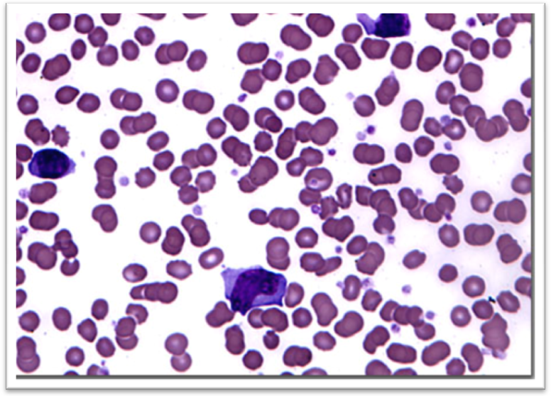

Figure1 Infectious mononucleosis (IM)

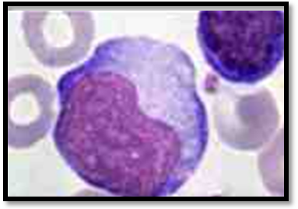
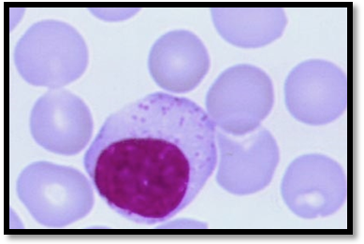

Figure 2 Atypical lymphocyte Figure 3 typical lymphocyte

In figure (1) cytological test revealed that from 80 tonsils of biopsy, 30 (37.5) samples showed EBV pathogenic parameter i.e. infectious mononucleosis (IM). While 50 (62.5%) samples showed no IM. The presence of atypical lymphocytes is probably the earliest indication of EBV infection. Atypical lymphocytes can be seen in patients with IM [13].
In figure (2) atypical lymphocytes. They are atypical because they are larger (more cytoplasm) and have nucleoli in their nuclei. These cell characterized by an often irregular monocyte-like nucleus which may stretch the length of the cell, with chromatin strands that parallel the length of the nucleus, nucleoli and azurophilic granules may be present.
As with comparison with Figure (3)typical lymphocyte has a large, dark-staining nucleus with little to no eosinophilic cytoplasm. In normal situations, the coarse, dense nucleus of a lymphocyte is approximately the size of a red blood cell (about 7 micrometres in diameter).Some lymphocytes show a clear perinuclear zone (or halo) around the nucleus or could exhibit a small clear zone to one side of the nucleus.
Serological techniques:-
ELISA study:-of the total eighty patients, the results of show specific Ab against EBV are shown in figure (4). In figure (1) cytological test revealed that from 80 tonsils of biopsy, 30 (37.5) samples showed EBV pathogenic parameter i.e. infectious mononucleosis (IM). While 50 (62.5%) samples showed no IM. The presence of atypical lymphocytes is probably the earliest indication of EBV infection. Atypical lymphocytes can be seen in patients with IM [13].
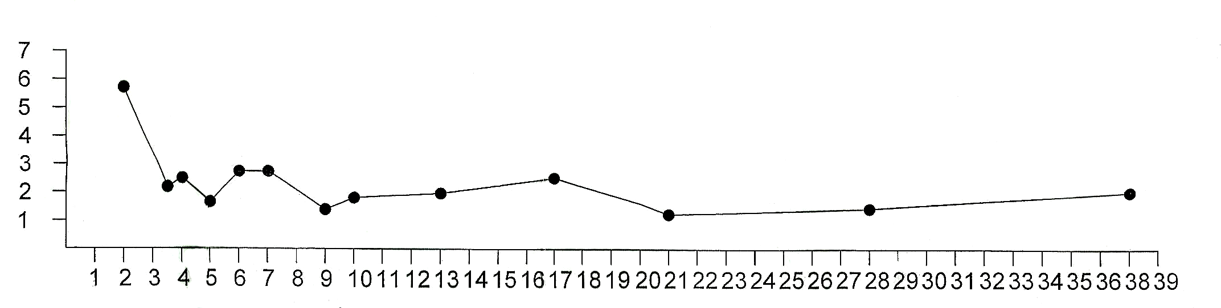
In figure (2) atypical lymphocytes. They are atypical because they are larger (more cytoplasm) and have nucleoli in their nuclei. These cell characterized by an often irregular monocyte-like nucleus which may stretch the length of the cell, with chromatin strands that parallel the length of the nucleus, nucleoli and azurophilic granules may be present.
As with comparison with Figure (3) typical lymphocyte has a large, dark-staining nucleus with little to no eosinophilic cytoplasm. In normal situations, the coarse, dense nucleus of a lymphocyte is approximately the size of a red blood cell (about 7 micrometres in diameter).Some lymphocytes show a clear perinuclear zone (or halo) around the nucleus or could exhibit a small clear zone to one side of the nucleus.
Serological techniques:-
ELISA study:-of the total eighty patients, the results of show specific Ab against EBV are shown in figure (4).

Mean
of IgA
Value

Age of patients
Figure 4 The mean of IgA titer and the age of patients

Discussion
In figure (1) cytological test revealed that from tonsils biopsy (37.5) samples showed EBV pathogenic parameter i.e. infectious mononucleosis(IM) these results match with the results in [14] and [15] that demonstrated the viral infection (EBV) comprise about 30-80% of all infectious of chronic tonsillitis.And the other samples comprise (62.5) may be the bacterial or other agents play main role in chronic tonsillitis these results were in agreement with the description in [16] and [17] who demonstrated the second most common causes of chronic tonsilliti are bacterial.
In figure (2) the presence of atypical lymphocytes are often associated with IM. These results match with [18] who demonstrated infectious mononu-cleosis were diagnosed through screening for atypical lymphocytes
In Figure (4) the study of the immune response to EBV show each response to primary exposure during early childhood and continue with life due to continuous activation of latent virus that is possibly related to recurrent tonsillitis. Many times those patients may succumb to other infections (common cold virus and/or bacterial infection) that possibly results in reactivation of latent EBV that had result in increase in titer in patients of 6-7 years of age as well as in 17 years of age, or may be in later aged people. These results are match with the description of [20] that demonstrated Epstein-Barr virus (EBV) is a human herpesvirus which infects B-cells almost all of the world's population subclinically during childhood and thereafter remains in the body for life.

References
- Loganathan, A.U.D. Arumaina-than and R. Raman. (2006). Comparative study of bacteriology in recurrent tonsillitis among children and adults. Singapore Med J. 47(4):271-5.
- Wolfensberger, M. and M.T. Mund. (2004). Evidence based indications for tonsillectomy. (in German). Ther Umsch 61 (5): 325–8.
- Lee, K.L. (2008). Essential Otolaryngology: Head and Neck Surgery, Ninth Edition. McGraw-Hill Professional.
- Centor, R.M. (2009). "Expand the pharyngitis paradigm for adolescents and young adults". Ann Intern Med 151 (11): 812–.
- Mora, R.,B. Jankowska,F. Mora,B. Crippa, M. Dellepiane and Salami A. (2009). Effects of tonsillectomy on speech and voice. J .Voice. 23 (5):614-8.
- Janet,S., Butel and PhD. (2010). Herpesvirus: Epstein-Barr Virus.In25th ed.Jawetz et al. 2010. Medical Microbiology. Lange Medical Books. Mc Graw-Hill. Pp 428-451.
- Bennett, N.J .(2008). Mononucleosis and Epstein-Barr Virus Infection eMedicine http://www.emedicine.com/ped/topic705.htm. Retrieved 2008-10-05.
- MurrayP.R., K.S. Rosenthal, and M.A. Pfaller. (2009). Medical Microbiology. 6th Edition. Philadephia.pg. 529-534.
- Jensen, Hal B. (2000). "Acute complications of Epstein-Barr virus infectious mononucleosis". Current Opinion in Pediatrics (Lippincott Williams & Wilkins, Inc.) 12 (3): 263–268.
- Milnone,M.C.(2005). Treatment of primary Epstein-Barr vir celldirected us infection in patients with X-linked lymphoproliferative disease using B- celldirected therapy.Blood 105:994.
- Kiernan, J.A. (2008). Histological and Histochemical Methods: Theory and Practice. 4th ed. Bloxham, UK: Scion. ISBN 9781904842422.
- Llewellyn, B.D .(2009) .Nuclear staining with alum-hematoxylin. Biotech. Histochem. 84: 159-177.
- Cunha, B.A(2002). Infectious Mononucleosis eMedicine. com http: //emedicine .medscape.com/article /222040 -overview.
- Thuma, P. (2001). Pharyngitis and tonsillitis. In:Hoekelman, Robert A. (2001). Primary pediatric care. St. Louis: Mosby.
- Simon, H.B .(2006). Bacterial infections of the upper respiratory tract. ACP Medicine, 2006 Edition (Two Volume Set) (Webmd Acp Medicine). WebMD Professional Publishing.
- Bisno ,A.L. (2001). Acute pharyngitis. N Engl . J. Med 344 (3): 205–11.
- Bansal, A., J Miskoff and R.J. Lis. (2003) Otolaryngologic critical care. Crit Care Clin 19 (1): 55–72.
- Taga, K., M.Yoshida and M. Kaneko.(2000). Contribution of automated hematology analysis to the detection of apoptosis in peripheral blood lymphocytes. Cytometry .42:209-14.
19. Dopatka,H.D.et al.(1996).Compact Epstein-Barrr virus diagnosis based on a defined antigen mix and specific IgA.Res.Virol.147:53
20. Crawford,D.H.(2001).Biology and disease associations of Epstein-Barr virus. 356 (1408): 461–473.

