Prevalence and Associated Factors of Suicidal Behavior among Secondary School Students in Kut City

Issam S. Ismail* Khalida Abdulsatar** Hassan A. Baey***
*Health Directorate of Wasit Province, Ministry of Health, Iraq. E-mail: issam_health@yahoo.com
**Dep. of Community Health, College of Medical and Health Technologies, Baghdad, Iraq. E-mail: dr.khalida@yahoo.com
*** Dep. of Community Medicine, College of Medicine, University of Babylon, Iraq. E-mail: hassanbaey@yahoo.com

M J B

Abstarct
Background: Adolescent suicidal behavior is a neglected public health issue especially in middle and low-income countries.
Objectives: The objectives of this study were to examine the prevalence of suicidal behavior among secondary school students in Kut City and to identify some variables that might be associated with suicidal behavior.
Methodology: A cross-sectional school-based study of 1067 students. Data were collected using the supervised self-administered questionnaire based on a Global School-based Student Health Survey ‘‘GSHS’’ questionnaire.
Results: 8.3% (89 out of 1067) of the students had suicidal behavior (suicidal ideation and attempts). Factors significantly related to adolescents’ suicidal behavior are [depression includes : feeling of loneliness, felt sad or hopeless], anxiety, poor school grade, and subjected to corporal punishment at home.
Conclusion: The suicidal behavior of adolescents may be influenced by psycho-social, educational factors such as poor mental health, poor school grade, and subjected to corporal punishment.
انتشار السلوك الانتحاري بين طلبة المدارس الثانوية في مدينة الكوت والعوامل المرتبطة به
الخلاصة
السلوك الانتحاري لدى المراهقين مظهر صحي عمومي مهمل خصوصاً في الدول متوسطة ومنخفضة الدخل. تهدف الدراسة إلى معرفة مدى انتشار السلوك الانتحاري بين طلبة المدارس الثانوية في مدينة الكوت ومعرفة بعض المتغيرات التي قد ترتبط بالسلوك الانتحاري. دراسة مقطعية معتمدة على المدرسة شملت 1067 طالب وطالبة. جُمعت البيانات باستعمال استمارة استبيان تملئ ذاتياً وبدون ذكر الاسم وتحت إشرافنا اعتماداً على استمارة المسح العالمي لصحة الطالب في المدرسة. أظهرت النتائج بأن 8,3% (89 من أصل 1067) من الطلبة لديهم سلوك انتحاري ( التفكير بمحاولة انتحار أو محاولة انتحار). العوامل المرتبطة معنوياً بالسلوك الانتحاري للمراهقين تشمل الكآبة (الشعور بالوحدة, والشعور بالحزن) والقلق, وانخفاض المستوى الدراسي, والتعرض للعقوبة البدنية في البيت. السلوك الانتحاري للمُراهقين قَدْ يتأثّرُ بعوامل تربوية وإجتماعية-نفسية مثل اضطراب الصحة النفسية، انخفاض المستوى الدراسي، والتعرض للعقاب البدني.
ــــــــــــــــــــــــــــــــــــــــــــــــــــــــــــــــــــــــــــــــــــــــــــــــــــــــــــــــــــــــــــــــــــــــــــــــــــــــــــــــــــــــــــــــــــــــــــــــــــــــــــــــــــــــــــــــــــــــــــــــــــــــــــــــــــــــــــــــــــــــــــــــــــــــــــــــــــــــــــــــــــــــــــــــــــــــــــــــــــــــــــــــــــــــــــــــــــــــــــــــــــــــــــــــــــــــــــــــــــــــــــــــــــــــــــــــــــــــــــــــــــــــــــــــــــــــــــــــــــــــــــــــــــــــــــــــــــــــــــــــــــــــــــــــــــــــــــــــــــ

Introduction
Suicidal behavior is an important public health problem worldwide. The World Health Organization (WHO) reports that in 2000, more than 800,000 people died of suicide around the world [1]. Worldwide, about 4 million adolescents attempt suicide annually, resulting in at least 100,000 deaths [2]. Suicidality in young people encompasses a full range of behaviours, including ideation, deliberate self-harm, attempts, and completed suicide [3]. Suicidal thoughts (ideation) are common in children and adolescents of both genders and are by no means always associated with other features of psychopathology. Suicide attempts are considerably less common than suicidal ideas [4].
Results from the 2005 national Youth Risk Behavior Survey (YRBS) in USA indicated that nationwide, 16.9% of students had seriously considered attempting suicide (suicidal ideation) during the 12 months preceding the survey and 13.0% of students had made a plan about how they would attempt suicide (suicidal attempt) during the 12 months preceding the survey [5]. In a Malaysian school survey, 7% (312 out of 4454) of the adolescent students (age 12-19 years) had suicide ideation, and 4.6% had attempted suicide at least once during the 12 months preceding the survey [6]. In Lebanon, overall, 16.0% of high school students seriously considered attempting suicide during the past 12 months and 11.1% of students made a plan about how they would attempt suicide during the past 12 months [7], this is very similar to the prevalence reported by Sibai & Kanaan for Lebanon older students 15.2% whereas the Sibai & Kanaan prevalence of making a plan was much lower 4.8% [8].
There are several risk factors related to suicidal ideation and attempt among in-school adolescents. For both genders, higher levels of depression are associated with the increased probability of suicidal ideation [9] and suicide attempt [4]. Anxiety disorders increase the risk of suicidal ideation and attempt for both genders [4]. Findings reported by Liu X et al, (China, 2005) showed that depression was significantly associated with increased risk for suicidal ideation, while poor academic performance, depression, and aggression were related to suicide attempts among high school students [10].
Feeling of loneliness and sadness, significant worry and lack of parental supervision [11-12] and low parental care [13] were associated with suicidal ideation among school students. Also, association has been found between suicidal behaviour and several types of violence, including child maltreatment [1]. Suicidality is common in runaway youth, who often have a history of previous child abuse. Hawton and colleagues reviewed 3 studies that showed an association between physical abuse and suicidal behavior [3]. However, there is paucity of data on suicidal ideation, attempted suicide and suicide among adolescents in Iraq. Hence, the objectives of this study were to assess the prevalence and some associated factors of suicidal behavior (suicidal ideation and attempt) among adolescent students in Kut City.

Methodology
Study design and sampling technique
A school-based cross-sectional comparison study was conducted on school students in 7th through 11th grades in Kut City/Iraq at 2007, by using a self-completed anonymous questionnaire as a part of the Global School-based Student Health Survey GSHS questionnaire. A multistage, probability sampling technique stratified by urban and rural settings, school type and gender, in which schools, classrooms and students selected randomly. The overall response rate was 90% (N = 1067).
Instruments
Our main outcome variable was self-reported history of suicidal ideation and attempt within the past 12 months. Study participants were asked the questions: During the past 12 months, did you ever seriously consider attempting suicide? During the past 12 months, did you make a plan about how you would attempt suicide? responses were dichotomous (yes, no) (Cronbach α .79).
Data were also collected on age, gender, depression, anxiety, corporal punishment at home, and poor school grade. Depression-related questions: During the past 12 months, how often have you felt lonely? During the past 12 months, did you ever feel so sad or hopeless almost every day for two weeks or more in a row that you stopped doing your usual activities? Anxiety-related questions: During the past 12 months, how often have you been so worried about something that you could not sleep at night? During the past 12 months, how often have you been so worried about something that you could not eat or did not have an appetite? Each question has 5-point Likert scale (never to always) (Cronbach α .80). Responses were collapsed into three level for final analysis. Corporal punishment: Were you subjected to the corporal punishment (hitting, slapping, punching, kicking, pinching, shoving) by hand or use of various objects (belts, sticks, or others) at home? Poor grade level: How many years you have reset? Response; (never, 1-year, 2-3 years).
Procedure
Written consent was sought from the General Directorate for Education in Wasit Province and school management and verbal consent from all study participants. Students were briefed about the purpose of the study, encouraged to participate and to express their experiences.
Statistical analysis
Data was entered and analyzed by using SPSS (Statistical Package for Social Sciences) Version 10.0 for Windows. Descriptive statistics and the Pearson χ² were used. P-value <0.05 was considered Statistically Significant.

Results
The overall prevalence of suicidal behavior among secondary school students in our sample was 8.3% (89 out of 1067) [Tables 1, 2].

Table 1 frequency distribution of suicide behavior among secondary school students

Suicide Behavior | Frequency | %
No-suicide behavior | 978 | 91.7
Suicide behavior | 89 | 8.3
Total | 1067 | 100

Table 2 frequency distribution of students engaged in suicidal ideation, attempt and both
Suicide Behavior | Frequency | %
Ideation | 8 | 9
Attempt | 36 | 40.5
Both (ideation & attempt) | 45 | 50.5
Total | 89 | 100

Association of suicidal behavior with our explanatory variables was highly significant. Results shows that students who felt loneliness were more likely involved in suicidal behavior [Fig. 1], students who felt sad or hopeless were more likely involved in suicidal behavior [Fig. 2], our findings indicated that students who have sleep and appetite disturbances were more likely involved in suicidal behavior [Fig. 3], [Fig. 4] respectively. This study shows that students who were subjection to corporal punishment were more likely involved in suicidal behavior [Fig. 5]. Furthermore, we found that in-school adolescents who have poor grade level were more likely involved in suicidal behavior [Fig. 6].

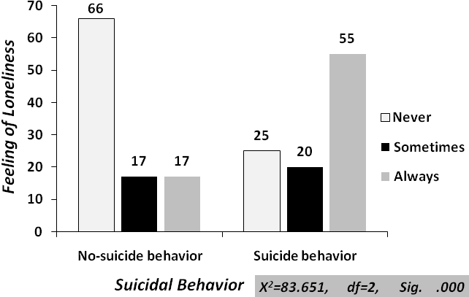

Figure 1 Association of suicidal behavior with feeling of loneliness
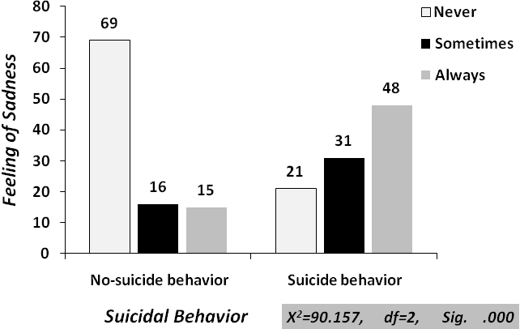

Figure 2 Association of suicidal behavior with feeling of sadness and hopelessness

Figure 3 Association of suicidal behavior with loss of sleep due to worry

Figure 4 Association of suicidal behavior with loss of appetite due to worry
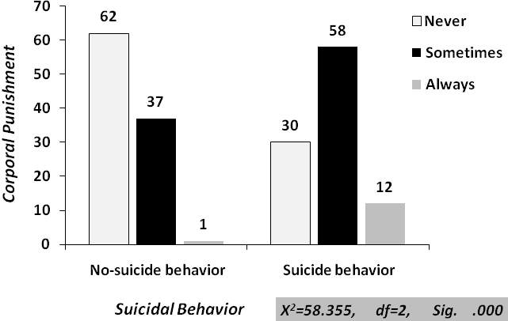

Figure 5 Association of suicidal behavior with subjection to corporal punishment at home
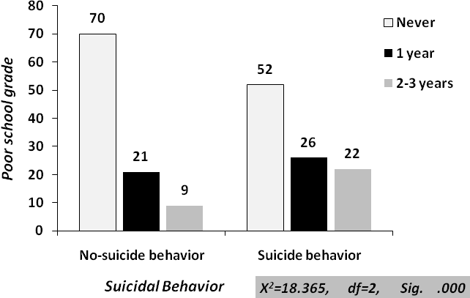

Figure 6 Association of suicidal behavior with poor school grade (repeat year)

Discussion
Our study found that overall 1 out of 12 of school adolescents had suicidal behavior in the last 12 months. Our estimates are much lower than the prevalence of suicidal ideation and attempt among school adolescents in previous studies [5-6,11-12], but similar to percentage of suicidal attempt in China [10]. Furthermore, percentage of attempt suicide in our sample was more likely than percentage of it in Lebanon [8], and Malaysia [6]. However, brief comparison shown in Table 2.

Table 2 Comparison of the prevalence of suicidal ideation and attempt among secondary school students

Year | Country | Study sample | Reference | Suicidal behavior
 |  |  |  | Ideation | Attempt
 |  |  |  | % | %
2003 | Uganda | 1506 | 12 | 21.6 | ---
2004 | Guyana | 1197 | 11 | 18.4 | ---
2005 | USA | 13917 | 5 | 16.9 | 13
2005 | Lebanon | 5115 | 8 | 16 | 11.1
1997 | Lebanon | --- | 8 | 15.2 | 4.8
2005 | China | 1362 | 10 | 19 | 7
2005 | Malaysia | 4500 | 6 | 7 | 4.6
2007 | Iraq | 1067 | --- | 5 | 7.6

In consistency with previous studies, analysis of our data suggested a positive association between suicidal behavior and depression the same results reported by David Shaffer et al [4], Allison et al [9], Liu X et al [10] and Emmanuel et al [11-12]. Correlation of suicidal behavior and anxiety documented by David Shaffer et al [4], and Emmanuel et al [12]. Previous works suggested the association of suicidal behavior with poor academic performance [10], and physical abuse [1,3]. Unfortunately, our findings suggests that the suicidal attempts were reported more than suicidal ideas in contrast to David Shaffer et al, who said that suicide attempts are considerably less common than suicidal ideas [4], also conversely with other studies [5-6, 8, 10], this may be due to devastating socio-economic, political conditions that made those adolescents end their life by suicide. However, interpretation of these findings is out of our knowledge, hence; large-scale, and long term studies are needed to explain this variation.
Our study has several limitations. Firstly, due to the cross sectional nature of the design, the factors that have been identified as associated with suicidal behavior cannot be described in causative terms. Secondly, the findings of the study may also be limited by not controlling for unmeasured confounders and effect measure modifiers. Thirdly, the study recruited only school going adolescents in the study area, the findings may therefore be representative of the in-school adolescents in Kut but not those out of school adolescents. Finally, our study was based on self report and therefore subject to respondent recall and deliberate misreporting. However the use of standardized terms and classifications will help ensure that the data collected are both valid and reliable.

Conclusion
Considerable number of students have suicidal behavior (suicidal ideation and attempt) in our study sample. Suicide attempts are considerably more common than suicidal ideas. Factors associated with the outcome were including : depression, anxiety, poor school grade and subjection to physical punishment at home. The clustering of multiple unhealthy lifestyles and co-morbid conditions such as poor mental health, low achievement at school and maltreatment are of public health concern. Public health intervention aimed to reduce adolescent suicidal behaviors should factor in the psycho-social correlates of suicidal behavior.

Acknowledgements
We thank all adolescents who participated in this study. We also thank the General Directorate for Education in Wasit Province, school management, and teachers who helped our to make this work.

References
- Krug EG, Dahlberg LL, Mercy JA, Zwi AB, Lozano R: World health report on violence and health. Geneva: World Health Organization; 2002.
- World Health Organization. Global School-based Student Health Survey (GSHS) 2004 Core Questionnaire Module Rationale. Geneva: World Health Organization; 2005.
- Margaret M Steele, and Tamison Doey. Suicidal Behaviour in Children and Adolescents. Part 1: Etiology and Risk Factors. The Canadian Journal of Psychiatry 2007 Vol. 52, :21S–33S.
- David Shaffer et al. Practice Parameter for the Assessment and Treatment of Children and Adolescents with Suicidal Behavior. American Academy of Child and Adolescent Psychiatry. 2001.
- Centers for Disease Control and Prevention. Youth Risk Behavioral Surveillance-United States, 2005. MMWR, Surveillance Summaries 2006 ;55(no. SS-5).
- Chen PC, Lee LK, Wong KC, Kaur J. Factors relating to adolescent suicidal behavior: a cross-sectional Malaysian school survey. J Adolesc Health. 2005 Oct; 37(4):337.
- World Health Organization. Lebanon Global School-based Student Health Survey (GSHS). A country report 2005.
- Nutting PA, Dickinson LM, Rubenstein LV, Keeley RD, Smith JL, Elliott CE. Improving detection of suicidal ideation among depressed patients in primary care. Annals of Family Medicine, 2005; 3(6): 529-536.
- Allison, S., Roeger, L., Martin, G., & Keeves, J. Gender differences in the relationship between depression and suicidal ideation in young adolescents. British Journal of Psychiatry, 2001; 35, 498-503.
- Liu X, Tein JY, Zhao Z, Sandler IN. Suicidality and correlates among rural adolescents of China. J Adolesc Health. 2005 Dec; 37(6):443-51.
- Emmanuel Rudatsikira, Adamson S Muula and Seter Siziya. Prevalence and associated factors of suicidal ideation among school-going adolescents in Guyana: results from a cross sectional study. Clinical Practice and Epidemiology in Mental Health 2007, 3:13
- Rudatsikira et al. Suicidal ideation and associated factors among school-going adolescents in rural Uganda. BMC Psychiatry 2007, 7:67.
- Heider D, Bernert S, Matschinger H, Haro JM, Alonso J, Angermeyer MC. Parental bonding and suicidality in adulthood. Aust N Z J Psychiatry 2007, 41:66-73.

