M J B

Impact of Contributing Factors that Effect Duodenal Ulcer Patients with Some Variables
Abdulmahdi A. Hasan
University of Babylon College of Nursing, Hilla, Iraq.

Abstract
The etiology of duodenal ulcer (D.U.) is completely Unknown; however .Gastric acid secretion plays an important role in pathogenesis of the disease. The study is planned to find out the relationship between the contributing factors of D.U. and some variables, such as age, sex; level of education . It was a descriptive study was conducted in Baghdad teaching hospital. Reviewing (30) D.U. patients who were admitted to the surgical world of Baghdad teaching hospital. Data were collected though the use of the questionnaire (interview) with the patients.
The results have revealed that the majority of the samples were from heavy smokers of alcoholic male. It was recommended that an educational program for duodenal ulcer patient should be developed regarding Duodenal ulcer.
ألخلاصة
أن أسباب حصول قرحة الاثني عشر غير محددة لحد الان ولكن زيادة افراز الحامض المعدي او العصارة المعدية له دور في حدوث قرحة المعدة خططت هذة الدراسة لغرض ايجاد العلاقة بين العوامل المساعدة في قرحة الاثني عشر وبعض المتغيرات مثل العمر , الجنس , المستوى العلمي , شملت الدراسة الوصفية 30 ثلاثون مريضا مصابا بقرحة الاثني عشر ممن ادخل الردهة الجراحية في مستشفى بغداد التعليمي , جمعت المعلومات عن طريق استخدام تقنيات التقييم التمريضي وشملت الأسئلة الاستبيانية (المقابلة الشخصية) وكان من بين أهم النتائج التي توصلت إليها الدراسة ان العدد الأكبر من العينة كانوا من المدمنين على التدخين والكحول من الذكور ، أوصت الدراسة على ضرورة استخدام برامج تثقيفية حول مرضى قرحة الاثني عشر وتهيئة الوسائل التعليمية بذلك.
ـــــــــــــــــــــــــــــــــــــــــــــــــــــــــــــــــــ

Introduction
Gastrointestinal (Gl) is a major cause of illness in young adults. About 20% in the Duodenum [1] .
Duodenal ulcer (D.U) occurs only in the areas of the gastrointestinal tract that are exposed to hydrochloric acid and pepsin. Ulcer disease relatively happens in the United State; it has been estimated that about (1) in every (10) men will have duodenal ulcer during course of his life .Ulcer disease is some what less common in women that in men, about (1) in (25) women can be expected to develop an ulcer [2].
Brunner and Suddarth 2001 [3] mentioned that the etiology of Duodenal ulcer. is poorly under stood; it is know the D.U. occur only in the areas of gastrointestinal tract which are exposed to hydrochloric acid of pepsin[4] Bmnner and suddarth 2001[4] reported that to deal successfully with disease, the patient must understand his situation and factors that will help him to aggravate his condition, so the Nurse can offer simple education for D.U. patients to help them. The objective of the study was to evaluate the effectiveness of contributing factors of duodenal ulcer patient on some variable such as, age, sex and level of education[5].

Patient and Method
Type of the study
A descriptive study design research was conducted to find out effectiveness of contributing factors of duodenal ulcer patient on the some variable factor such as level education , age and sex.
Setting for study including one hospital , Baghdad teaching hospital, An arbitrary sample of 30 Duodenal ulcer patients who was chosen from the surgical ward in Baghdad teaching hospital. The data was collected through the use of a questionnaire and means of interview with the subjects who performed from the beginning of October 2000 until the April 2001. In order to construct the questionnaire, the research had renewed the literature related to the study , which investigate the contributing factors of Duodenal ulcer and their occurrence in such patients. The questionnaire was developed in this study consists of 11 items. The first section includes 6 items which were concerned with demographic data such as sex, age, educational level and occupation while second part of questionnaire was focused on the contributing factors such as family history, occupational stress, emotional stress alcohol over stimulation seasoning irregular , hurried eating and smoking excessively. The items were rated on scale of close ended responses (Yes, No) were scored as 1 for yes (stand for factors contributing of D.U.) and 2 for No( stands for non factors contributing of D.U.).
In order to determine the validity of the instrument in these research (5) experts (three doctors from Baghdad teaching Hospital and two nurses from college of nursing) who have more than 10 years of experience in their Job – before starting the final collection of data a pilot study carried out the following purposes:
- To prepare a suitable , clear instrument for data collection of deudenal ulcer patients.
- To estimate the average time required for the interview .
- To enhance validity of the questionnaire format.
The results show that the reliability coefficient was 0.78 that was statically acceptable [6].
Statistical Analysis
1-t-test
2- kolmogrove- semirnove test for one simple C.S comparative signification
N.S. non. Signification
H.S Highly signification
S. signification

Results
The exact cause of D.U. is unknown, the result of this study indicated that there is increase in incidence of D.U. in a mean age 38 years (table-1).
These increasing in prevalence due to increase responsibility in the family and work environment among this age. Supported of this study. (Bnmner and Suddarth 2006) [7] mentioned that the disease occurs with great frequency between ages of 20-60 years. Table-2 shows (S) the difference in emotional stress relation to educational levels, the majority of sample from secondary and above (table one ). This result means that patients in secondary school and above were exposed to anxiety and emotional stress than others due to increase needs and demands which supported by( solowary 2006) [8] mentioned that each patient Must interact with the environment in order to maintain a dynamic equilibrium for the preservation and promotion of health society.
This equilibrium is challenged during life span and the results may be deviation from the state of health-From the results of this study, it was concluded that the majority of the sample in smoking excessively is male table (3) statistically (S), difference in alcohol factors in male than female. There is (H.S.) difference in alcoholic over stimulating seasoning irregular and hurried eating in age 21-40 years table (4). Based on the result of this study the investigator recommended the following:
Establishing standardized educational program for the patient. With D.U. that provide health professional with an education mode to teach the patient. The knowledge necessary for her or his to assume an optimal level of self-management within the parameter of her disease process.

Conclusions
Based on the present results and the discussion the study has concluded:
- Patient having the minimum level of experiences in factors that effect duodenal ulcer, so they need a specific education programs and training sessions.
- The educational program is found to be an effective education device by which patients at the duodenal ulcer, can improve knowledge base.
- The study group has shown that the education level of patient has significant contribution to their understanding of the educational program.

Recommendations
This study lead to the following recommendations:
- Although the sample was closely gender equitable it was by pure luck that this occurred. When sending out the questionnaires the researcher only had a mailing list of parent name(s) and addresses. It was unknown at the time of the mailing the gender and the age of the patients. This added a limitation to the study and could have been determinant to the results.
- A specific education can be designed and presented to patients who have minimum level of knowledge in order to improve their level of knowledge.
- Nurse care providers can assist the patients and families who struggle with the problem of duodenal ulcer in various ways.

Table 1 Characteristics of the sample
 | 1. sex
15 | Male
15 | Female
 | 2.AGE
18 | 21-40
12 | 41-60
38 | Mean age
 | 3.EDUCATIONAL LEVEL
2 | No read & write
7 | Read & write
7 | Primary school
4 | Intermediate
10 | Secondary & above
 | 4.Occupatinal
8 | Government
9 | Other
3 | Retained
10 | Housewife

Table 2 Relationship between contributing factors of duodenal ulcer and educational leve
Smoking Excessivly | Irregular Hurried Eating | Over Stimulation Seasoning | Alcoholic | Emotional Stress | Occupation Stress | Family History | Educational Level
0 | 1 | 3 | 0 | 2 | 1 | 1 | No read & write
0 | 0 | 2 | 2 | 1 | 1 | 0 | Read & write
2 | 4 | 5 | 2 | 6 | 6 | 1 | Primary
5 | 2 | 4 | 1 | 10 | 4 | 4 | Intermediate
5 | 6 | 10 | 1 | 10 | 5 | 4 | Secondary & above
N.S | N.S | N.S | N.S | S | N.S | N.S | C.S

Table 3 Relationship between contributing factors of duodenal ulcer and sex

Smoking Excessively | Irregular Hurried Eating | Over Stimulation Seasoning | Alcholic | Emotinal Stress | Occupation Stress | Familay History | Varible Sex
12 | 7 | 12 | 6 | 15 | 10 | S | Male
1 | 6 | 13 | 0 | 14 | 7 | S | Female
H.S | N.S | N.S | H.S | N.S | N.S | N.S | C.S

Table 4 Relationship between contributing factors of duodenal ulcer and age
Smoking Excessively | Irregular Hurried Eating | Over Stimulation Seasoning | Alcholic | Emotinal Stress | Occupation Stress | Familay History | Varible  Age Group
6 | 10 | 16 | 5 | 16 | 9 | 1 | 21-40
7 | 3 | 9 | 1 | 13 | 8 | 9 | 41-60
N.S | H.S | S | H.S | H.S | H.S | H.S | C.S



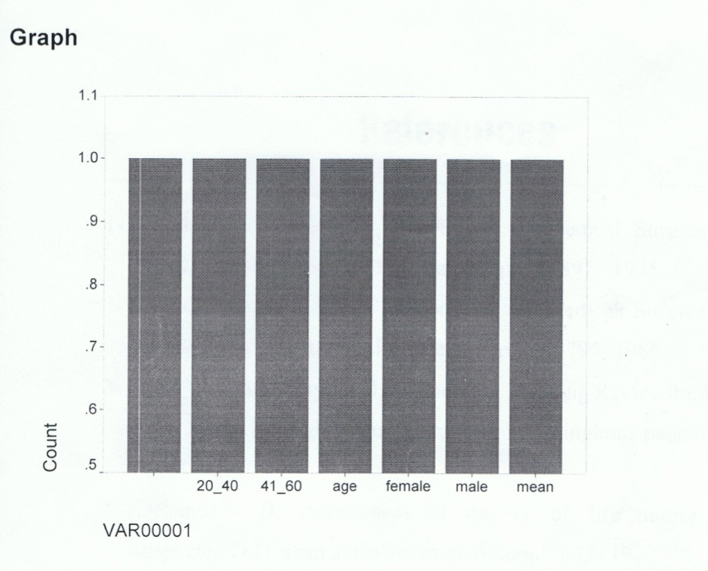

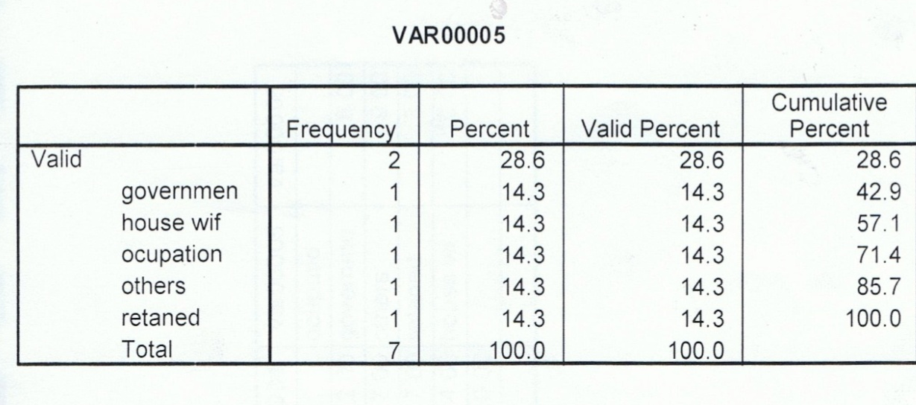
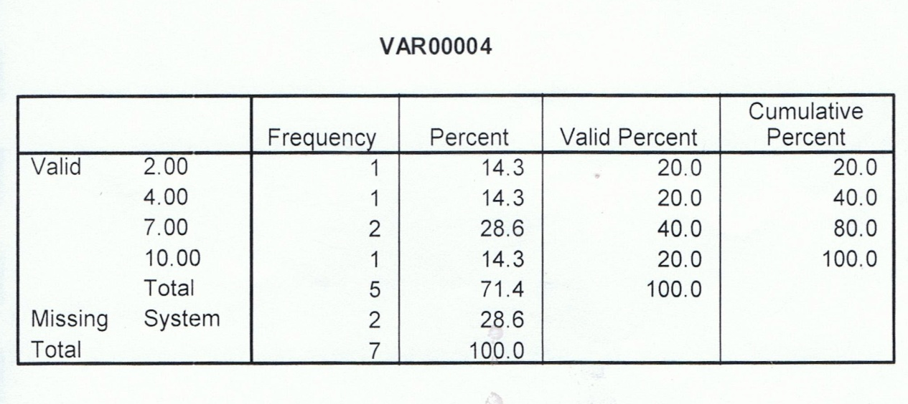
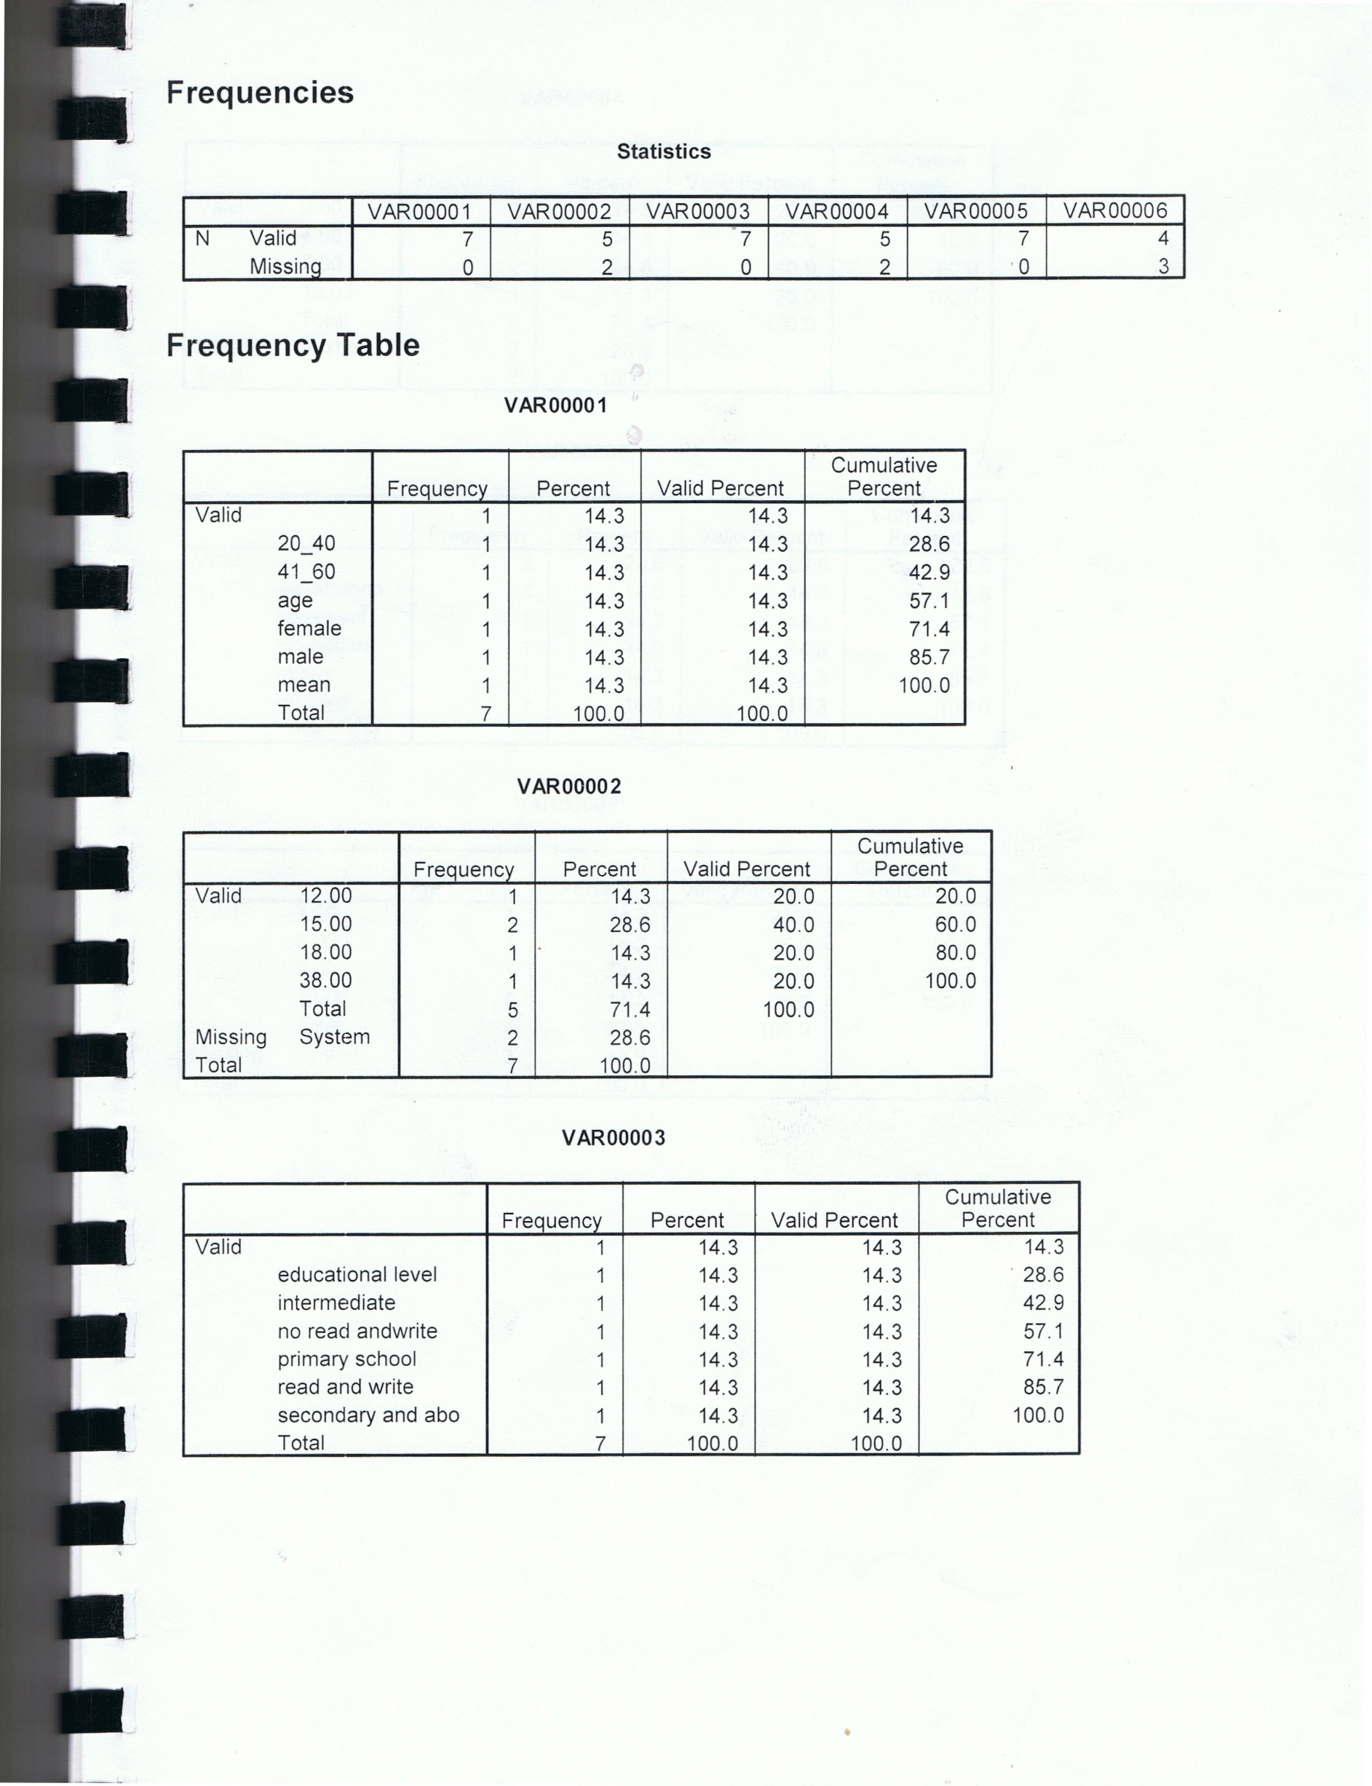

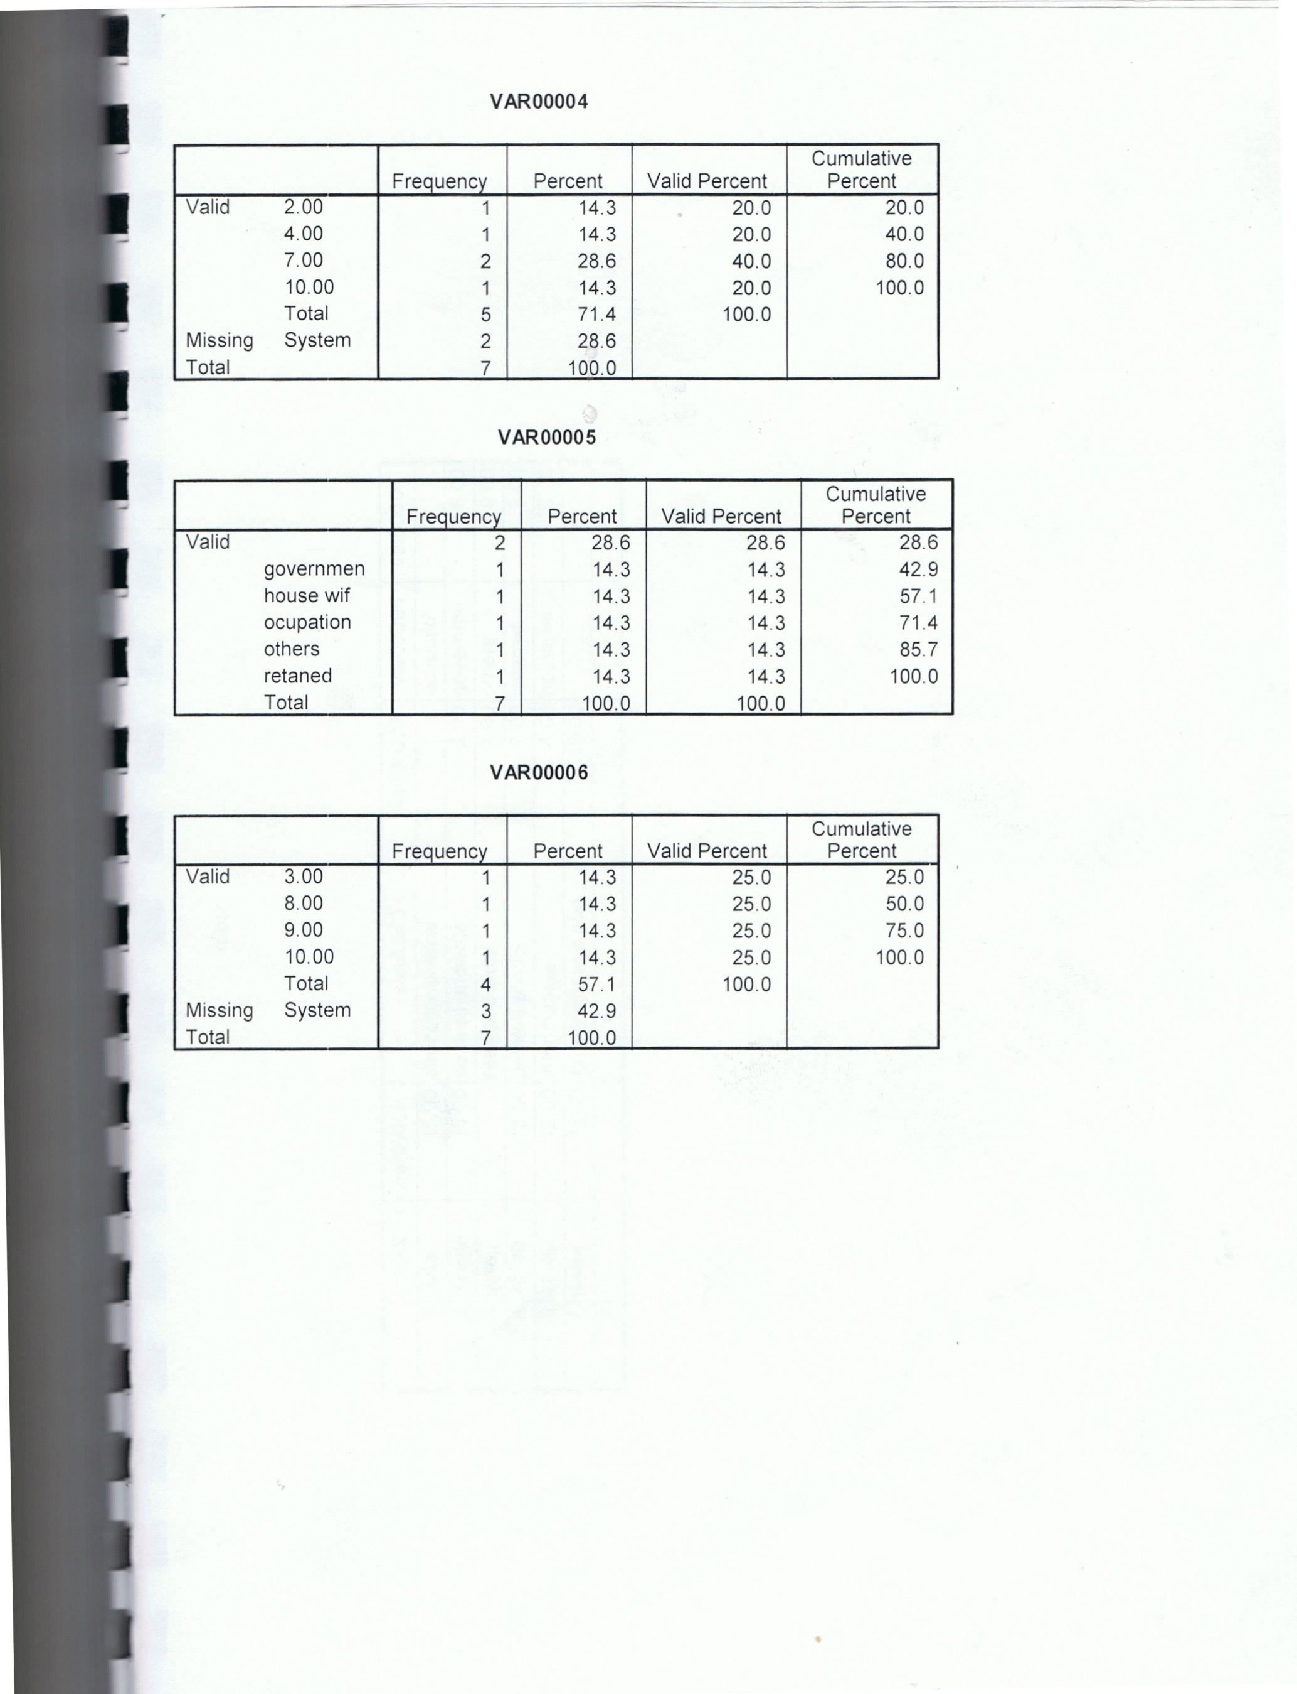


References
1. Carol J.b. and Phyllis H: American Nursing Reviewing for nclex RN- 2thed Springh Hous. Corporation, Springhons Pennsyl vanig pp 630- 2007.
2. Grossman –M.1: peptic ulcer chin caco medical puplisheriinc P.1 2004.
3. Spiro. H: clinical Gastroentrology Macmillan – Co. P. 230-245- 2007.
4. Brunner , land suddarth , Text book of medical surgical nursing 5thed.J.b Lippincott. Co Philadelphia pp88- 2001.
5. Hernandiz – B: Assessment of quality of life among pt;s with suspected D.U. scan- J Gastro eternal suppl- p32- 2003.
6. Pilot and Hingler , B.P, Nursing research principals and methods Ised J.P1999 Lippincott company, PP 359-373, 2007.
7. Brunner, land suddarth D, Textbook of medical surgical nursing 5thedl J.b. Lippincott Co. Philadelphia pp 190- 2006.
8. Soloway R.D. Peptic ulcer diseases edited by sidnory Cohen New York P. 168 – 2006.

