Dorsal Adipofascial Turnover Flap for Dorsal Defects of Finger Injury
Sabah Hassan Naji
Al-Wasiti Teaching Hospital, Baghdad, Iraq.
Email:sabahhassan71@yahoo.com, Mobile: 07901682079.

M J B

Abstract
Deep dorsal defects of fingers are common problems which often seen in emergency units, and there are several methods of treatments for reconstruction. In our prospective study composed of seven patients with dorsal defects of fingers in different sites at Al-Wasiti hospital in which reconstruction were performed by the use of dorsal adipofascial turnover flaps. By this technique we use this flap from the dorsal aspect of the finger which is raised from the base of the base of the proximal phalanx to cover the full thickness defect as a one stage procedure. Our results were good the flaps survived completely, the mean follow up was 6 months. This technique proved to be simple, did not require the use of distant flap or a flap from adjacent digits, ready availability & it s Single and simple procedure with no significant donor site morbidity. Our results and complications were comparable with other studies which were carried for reconstruction of deep dorsal defects of the fingers.
الخلاصة
الجروح العميقة والظهرية لأصابع اليد والتي تحدث نتيجة لشدة خارجية او حرق شديد قد تؤدي إلى ظهور المفاصل او العظم او الاوتار وهي من الحوادث الشائعة فى ردهات الطوارئ فى المستشفيات وحيث يحتاج علاجها الى خبرة جراحية وعلاج مبكر وسريع للحد من حصول الالام المتكررة والفقدان الوظيفي للأصبع.
في هذه الدراسة تم الاعتماد على علاج سبعة مرضى مصابين بجروح عميقة وظهرية في الأصابع (اربعة ذكور وثلاثة نساء ) في مستشفى الواسطي التعليمي في قسم الجراحة التقويمية حيث تم علاجهم باستخدام سدلة دهنية لفافة تحويلية مع ترقيع جلدي لغطاء الخلل العميق وتم مقارنة هذه الدراسة مع دراسات اخرى تم علاجهم بنفس الطريقة وتمت مقارنة النتائج بينهم .
هدف البحث
١. ان العلاج المبكر والطارئ للجروح العميقة لأصابع اليد ضروري جدا للتقليل من نسبة العوق الوظيفي للاصابع وتجنب الالام المتكررة للمرضى .
٢. ان استخدام السدلة الدهنية اللفافة التحويلية هي من الطرق المثلى لعلاج الجروح الظهرية والعميقة للأصابع لكون هذه الطريقة تجرى لمرحلة واحدة ومن نفس الاصبع ومن دون الحاجة لاستخدام سدلات بعيدة من الأصابع الاخرى او البطن او الصدر وباقل ضرر وتشوه للمنطقة الواهبة .
ــــــــــــــــــــــــــــــــــــــــــــــــــــــــــــــــــــــــــــــــــــــــــــــــــــــــــــــــــــــــــــــــــــــــــــــــــــــــــــــــــــــــــــــــــــــــــــ

Introduction
Deep dorsal defects of the fingers represent the most common hand injuries seen in emergency room [1]. These injuries may occur after thermal or traumatic accidents which may result in full thickness tissue loss with exposure of bone, joint or tendon and this type of injury should be covered by flap, and it required great surgical experience because inadequate management cause time loss from work, persistent pain and functional loss .There are many flaps which can be used for reconstruction of dorsal defects of fingers for example cross finger flaps , flag flap and distant flaps from the abdomen or chest wall [2,7] ,in our technique we used local adipofascial flap from the dorsal surface of the same injured digit, this flap depends on its vascularity on the arterial anastomosis between the branches of the dorsal digital arteries which are branches of the dorsal metacarpal artery and the dorsal branches of the palmer digital arteries, and as we know there are a dorsal venous and arterial network which lie in the subcutaneous plane between the dermis and the paratenon of the extensor tendons, and based on anatomical study which had been done by MR.jefferson Braga at 2003 he confirmed the presence of two constant dorsal branches originating from the proper palmer digital artery over the proximal and middle phalanges. Our aim of study is to represent a simple and reliable method for reconstruction of the deep dorsal defects of finger injuries with the use of dorsal adipofascial turnover flap which provides functional criteria which are Stable and durable skin coverage, Minimal donor site morbidity and rapid healing with early return to work.
Patients and Methods
In our prospective study we evaluated a total number of seven patients with dorsal defects of seven fingers of different causes in AL-Wasiti teaching hospital treated by using adipofascial turnover flaps, from November 2008 to March 2010. Patient's details are provided in the following table, the cause was mostly due to direct trauma in five patients, one patient had chemical injury and one patient had electrical injury. Four males and three females, the age ranged from2-35 years old. All the defects were deep down to the bone and joints. The adipofascial flap was used to cover these defects. All patients were operated by using general anesthesia & under pneumatic tourniquet control, the skin graft was taken from the inner aspect of the thigh. The mean follow up was about 6 months .

Table 1
Patient No. | Age(year) | sex | Pathology
1 | 2 | male | Deviated DIP joint of the right digit due to trauma
2 | 37 | male | exposed PIP joint of the right middle finger( electrical injury)
3 | 20 | female | Exposed distal phalanx of the left ring finger
4 | 35 | male | Exposed middle phalanx of the right index finger
5 | 30 | male | Exposed DIP joint of the right thumb
6 | 18 | female | Exposed distal phalanx of the left middle finger
7 | 15 | female | Exposed PIP joint of the left index finger (chemical injury)
DIP = distal interphalangial , PIP = proximal interphalangial

Operative technique:
Under general anesthesia and pneumatic tourniquet control above elbow design of adipofascial flap done by measuring the size of the defect, the length of the flap should be two times larger than the length of the defect, with its sides extended to mid lateral lines to insure a wide base for good blood supply. The procedure started by skin incision in a shape of lazy S and begins from the proximal edge of the defect to the base of proximal phalanx of the finger, the thin dorsal skin is elevated with care from the fascia underneath and the dissection done for the adipofascial layer in u shape pattern from the underlying paratenon of extensor tendons in proximal to distal direction, after that we release the tourniquet to confirm the viability of the flap and to secure hemeostasis , the flap is turned distally to cover the defect and sutured with the subcutaneous tissue layer of the distal edge of the defect by 4-0 Vicryl , then the adipofascial flap was covered by split thickness skin grafting taken from the inner aspect of thigh. the graft was sutured with3-0 silk and fixed securely with tie over dressing to assure mechanical stability of the graft on adipofascial flap. The skin incision was closed with 4-0 silk. The finger is immobilized in a splint for 14days. After that active mobilization begun.

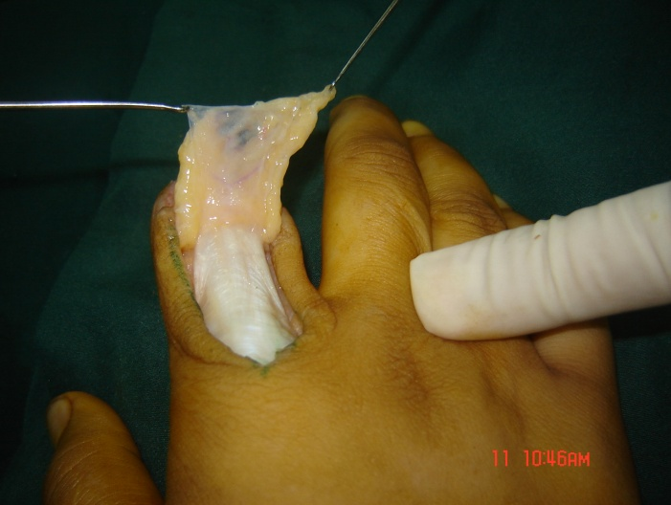
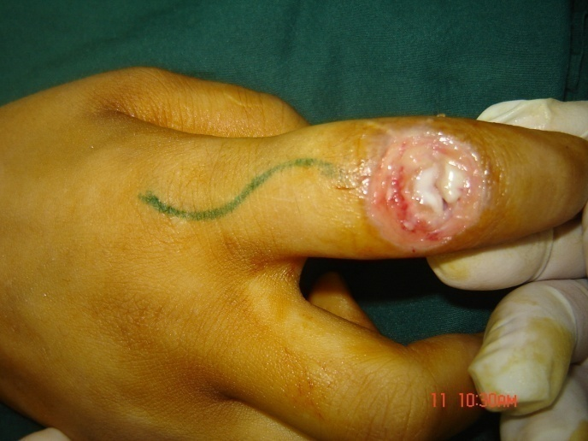

( A) (B)
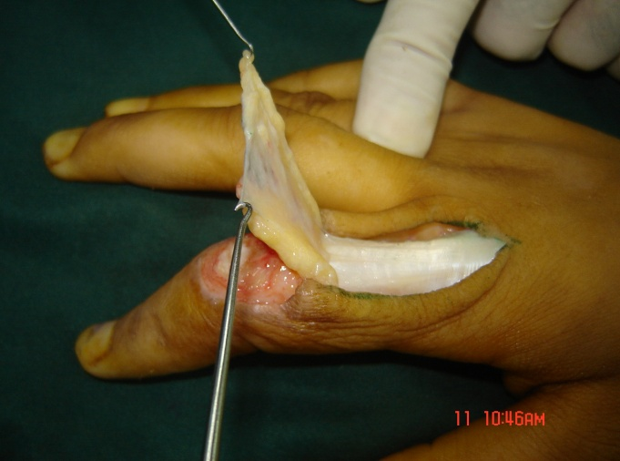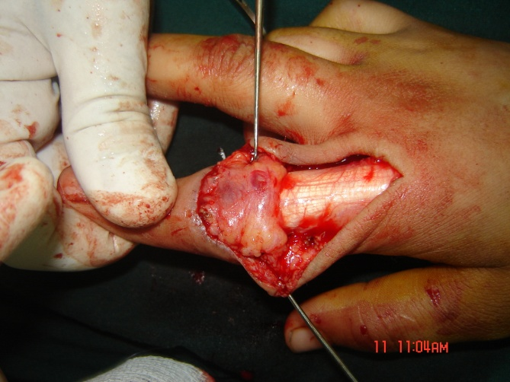
(C) (D)
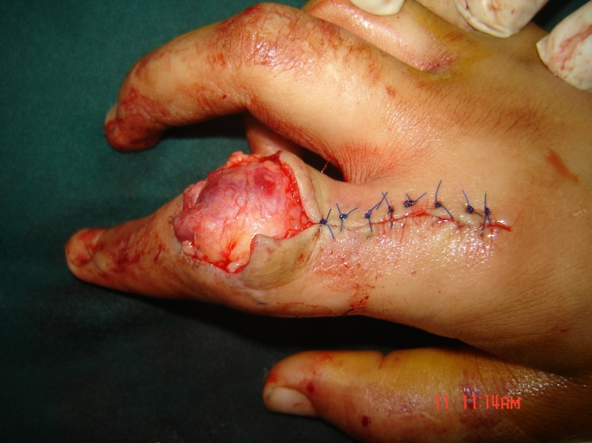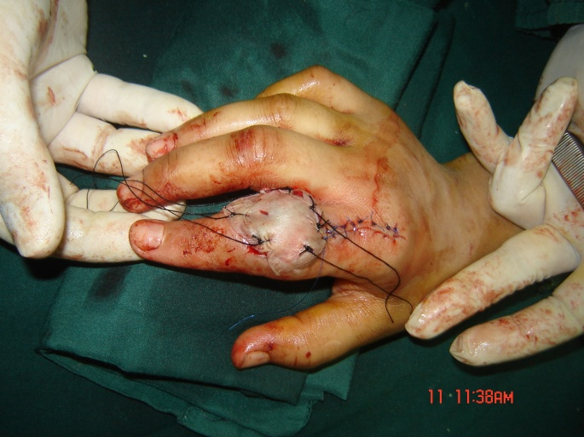
( E ) (F)
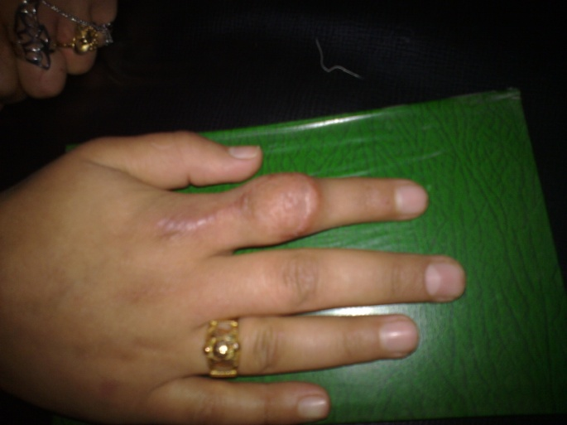
(G )

Figure 1 (operative technique) demonstrate a 15 years old female(patient No 7 in the table), had full thickness wound with exposed PIP joint of right index finger following chemical injury with silver nitrate used locally to treat a wart. (A) Lazy- s skin incision. (B, C) show the adipofascial flap elevated (D) The flap covers the exposed PIP joint. (E) The flap cover the defect with suturing of the donor area (F) flap was covered by split thickness skin graft taken from inner thigh with preparation for tie over. (G) The coverage of the injured finger six months post- operatively.

Results
Our prospective study evaluated Seven patients (4 males and 3 female), with age ranged from2-35 years old with dorsal defects of the seven fingers at different sites were treated by using dorsal adipofascial turn over flap which provided us successful results in all of the patients. All flaps and grafts survived with good viability after of six months of follow up and the sensation is similar to any area that has received partial thickness skin graft.. No significant complications occurred as no infection or flap necrosis, and in four patients were the joints were exposed the mobility of the joints after coverage with this flap regained the same ranged of mobility as before the operation.

Discussion
Full thickness dorsal defects of the digits with exposure of the bone, tendon, or joint represent one of the difficult problems which need early coverage to preserve the exposed tissue to prevent complications and early return to work. There are many flaps were described for reconstruction of such defects as cross finger flap, flag flap, local transposition or rotation flaps, and distant flaps as abdominal, chest, or groin , these flaps has many disadvantages namely long period of immobilization with joint stiffness especially in old age patients, they usually need two stage technique and significant donor site scar. Comparing the adipofascial flap with the other mentioned flaps it proved to be simpler, more reliable as it is accomplished by single procedure with no significant donor site morbidity or distant scars.
Our results were comparable to several works present in the literatures as a study done in 2005 by MR.A.Karacalar in which he used the adipofascial turn-over flap to resurface finger defect in seven cases, the flaps survived completely except one which had a 20% loss. MR. Jefferson Braga-Silva in which proved that this flap is reliable with rich 2004 used adipofascial flaps on forty patients and based his work on sound anatomical study of vascular supply of the flap blood supply and his result is highly successful. Other study done by D.Nicole Deal at 2009, he presented 13 patients with complex hand wounds of different types of injuries treated by adipofascial flap as random flap based on the same anatomical principle of blood supply and have100% success. Dr.Muhittin Ulker 1n 2000 have used this flap to cover deep dorsal tissue loss of fingers in nine patients ands he added one step to re innervate the flap by epineurIal anastomosis between the dorsal digital branch and volar digital nerves with the aid of loupe magnification and he claimed that it becomes full sensory flap in comparison to the sensation of our flaps in which it developed as any sensation in skin graft. So it appears from all these works that there is a consensus in the grade, merits of this procedure as being simple, one stage, no distant or other site morbidity and provides good coverage and preservation of exposed tendon, joint,or tendon and resulting in preservation of the mobility of the joint with high successful rate in almost all the cases and it proved to be a good option for reconstruction of deep dorsal defect in the fingers and hands in our patients.

Conclusion
Dorsal adipofascial turnover flap provides reliable covering for composite tissue defects at the dorsal surface of the fingers with exposed bone, tendon or joint. It provides good functional results by single procedure without the presence of distant donor site morbidity with no added complications.

Acknowledgment
I would like to thank Dr.Mohammed Ali Fadel ,Dr.Mohammed Breesam and Dr.Ahmad Nowras for their efforts and guidance to finish this study.

References
1. McCarthy Plastic surgery , Editor Joseph G. McCarthy M.D , V6 , part one, the hand.
2. Campells operative orthopedics , Edited by S.Terry Canale ,James .H. Beaty eleventh edition 2008.
3. Rob&Smiths operative surgery, General Editors Hugh Dudely and David Carter, the hand,4rth edition.
4. Grabb &Smiths ,Plastic surgery . Editor in chief Charles .H. Thorne, 6th edition v2 , chapter 79, 2007.
5. Braga- silva J, Kuyven CR, Fallopa F, Albertoni W. An anatomical study of the dorsal cutaneous branches of the digital arteries. J Hand Surg 2002;27B:577-579.
6.Strauch B, de Moura W. Arterial system of the fingers. Hand Surg 1990;15A;148-154.
7. Dr.Muhittin Ulker, Ankara, Turkey. Innervated dorsal adipofascial turn over flap for fingertip amputations,2000.
8.Jefferon Braga-Silva, MD, PhD, Carlos R. Kuyven, MD, Porto Algera, Brazil. The adipofascial turn-over flap for coverage of the dorsum of the finger: modified surgical technique, J Hand surg 2004.
9 .Karacalar and M. Ozcan. The adipofascial turn-over flap for coverage of finger defects. Europian Journal of Plastic Surgery , V17,NO 4, 189.190,DOI. 1007/BF00188558urg 2004.
10.Deal DN Barnwell J,Liz.Soft tissue coverage of complex dorsal and finger using the turn over adipofascial flap. American society for hand surgery and hand therapirt, 2009.
11. .Lai C-S, Lin S-D, Yang C-C, Chou C-K. The adipofascial turn-over flap for complicate dorsal skin defects of the hand and finger.Br J Plast Surg 1991; 44:165-169.
12. Y. Bhatt, N. Panse, K. Vyas,M. Tandale& S. Sule: A homodigital two stage reverse dorsal adipofascial flap for fingertip reconstruction. Journal of Hand Surgery. 20009 volume 2 Number
13. .Unlu,R. E., Mengi, A. S., Kocer, u., and Sensoz,O. Dorsal adipofascial turnover flap for fingertip amputation. Hand Surg. (Br) 24: 525, 1999.
14. Dimitrios H Laoulakos, Constantinos H Tsetsonis, Aggelos A. Michail, Olga S. Kaxira, and Phillipos H. Papatheodorakis, The Dorsal Reverse Adipofascial flap for fingertip reconstruction.9Plast. Reconstr Surg. 112: 121, 20003).
15. .Gumener R, Montandon D, MARTY F, Zbrodowski A. The subcutaneous tissue flap and the misconception on fasciocutaneous flaps. Scand J Plastic Responsive Surg 1986; 20:61-65A.

