M J B

Dental Arch Dimensions of Patients with Class III Malocclusion of Iraqi Sample Aged (14-24)
(A comparative study)

Thaer Jaber Al-Khafaji

University Of Babylon / College Of Dentistry, Hilla, Iraq.

Abstract
Information regarding arch dimensions in human populations is important to clinicians in orthodontics, prosthodontics, and oral surgery. It also is of interest to anthropologists and other students of human oral biology. The aim of this study was to compare the transverse dimensions of the dental arches of Class III groups with a group of untreated normal occlusion subjects. This study was performed using measurements of dental casts of 41 Class III malocclusion (21 males and 20 females) and 50 normal Class I occlusion (25 males and 25 females), of Iraqi adult samples aged (14-24 )in Hilla city. The dental and arch width dimensions measured were intercanine, intermolar, and molar alveolar in both arches were taken and independent-samples t-test was applied for comparing the groups. The finding from this investigated indicated that,(1) there are no significant differences in all measurements between Class I and Class III overall samples except for the maxillary molar alveolar width (UA6-6) are found to be significantly larger in Class I than in Class III overall samples and the mandibular intercanine width (L 3-3) are found to be significantly larger in Class III than in Class I overall (2) there are no significant differences in all measurements between Class I and Class III male samples except for the mandibular intercanine width (L 3-3) are found to be significantly larger in Class III than in Class I males (3) the lower intermolar width (L6-6) and the lower molar alveolar width (LA6-6) are significantly larger in Class III than in normal Class I female samples while the Class I are significantly larger than Class III females in the upper intercanine widths (U3-3) and in the upper molar alveolar width (UA6-6), whereas the lower intercanine widths (L3-3) and the upper intermolar width (U6-6) show no significant difference between normal Class I and Class III female samples (4) the upper intercanine widths (U3-3) ; the upper intermolar width (U6-6); and the lower intercanine widths (L3-3) are significantly larger in males than in females of Class III samples while the upper molar alveolar width (UA6-6); the lower intermolar width (L6-6) ; and the lower molar alveolar width (LA6-6) show no significant difference between males and females of Class III samples.

الخلاصة
إن المعلومات بخصوص أبعاد الفكيين في المجتمعات الإِنسانية مهمة إلى الأطباء السريريين في تقويم الأسنان و صناعة الأسنان وجراحة الفم. هو أيضاً مِنْ اهتمامات علماءِ الإنسانيات والطلابِ الآخرينِ في عِلْمِ أحياء الفم البشري. هدف هذه الدراسةِ هو مقارنةَ الأبعادَ المستعرضةَ لأقواسِ أسنانَ الصنفِ الثّالثة من سوء الإطباق مَع مجموعة الأشخاص ذوي الإطباق الطبيعيِ للأسنان الغير مُعالجةِ. هذه الدراسةِ أنجزت باستعمال مقاييسَ لقوالبِ الأسنانِ (41) من الصنف الثّالثة من سوء الإطباق (21)ذكر و(20) أنثى و(50) الصنف الإطباق طبيعي (25) ذكر و(25)أنثى ، مِنْ عيناتِ العراقيين البالغين بعمرِ (14-24)سنة في مدينةِ الحله. أبعاد العرضِ المستعرضةَ لأقواسِ الأسنانَ المستخدمة كانت لما بين النيبان وما بين الأضراس وما بين الحويصلي الضرسي في كلتا الفكيين لمقارنة الأبعاد المستعرضة للأسنان وحويصلي الفكي للصنف الثالث من سوء الإطباق مع الصنف الأول للإطباق الطبيعي باستخدام اختيار الإرجاع المقترن المستقل للنموذجيين المتساويين بالتباين ( t-test) لمقارنة المجاميع. الإيجاد مِنْ هذا تَحرّى أشارَ بأنّ، (1) ليس هناك اختلافات هامّة في كُلّ المقاييسِ بين الصنفِ الأول للإطباق الطبيعي وصنفِ الثّالث عينات عامّة ماعدا عرضِ الضرسي الحويصلي للفك الأعلى تَبَيَّن بأنه كَانَ أكبر جداً في الصنفِ الأول للإطباق الطبيعي مِنْ الصنفِ الثّالث عيّنة عامّة وعرض ما بين النيبان للفك الأسفل تَبَيَّن بأنه كَانَ أكبر جداً في الصنفِ الثّالث مِنْ الصنفِ الأول للإطباق الطبيعي عموماً (2) ليس هناك اختلافات هامّة في كُلّ المقاييسِ بين الصنفِ الأول للإطباق الطبيعي وصنفِ الثّالث عينات الذكور ماعدا عرضِ ما بين النيبان للفك الأسفل تَبَيَّن بأنهم كَانَ أكبر جداً في الصنفِ الثّالث مِنْ الصنفِ الأول للإطباق الطبيعي عند الذكورِ (3) عرض ما بين الأضراس للفك الأسفل والعرض الحويصلي الضرسي للفك الأسفل كَانتْ أكبر جداً في الصنفِ الثّالث مِنْه في الصنفِ الأول الطبيعيِ للعيناتِ النسائيةِ بينما الصنفِ الأول للإطباق الطبيعي أكبر جداً مِنْ الصنفِ الثّالث إناث في عرضِ ما بين النيبان للفك الأعلى وفي العرضِ الحويصليِ الضرسيِ الأعلى. بينما عرض ما بين النيبان للفك الأسفل وعرض ما بين الأضراس الأعلى لا اختلاف هامَّ بين الصنفِ الأول الطبيعيِ وصنفِ الثّالث عينات إناث (4) عرض ما بين النيبان للفك الأعلى ؛ عرض ما بين الأضراس للفك الأعلى ؛ و عرض ما بين النيبان للفك الأسفل كَانتْ أكبر جداً في الذكورِ مِنه فيْ الإناث الصنفِ الثّالث بينما العرضَ الحويصليَ الضرسيَ الأعلى ؛ عرض ما بين الأضراس للفك الأسفل ؛ والعرض الحويصلي الضرسي للفك الأسفل لا اختلافات هامَّة بين الذكورِ والإناث الصنفِ الثّالث من سوء الإطباق.
ـــــــــــــــــــــــــــــــــــــــــــــــــــــــــــــــــــ

Introduction
The dimensions of a dental arch which include arch length and arch widths can have profound implications in orthodontic diagnosis and treatment planning, affecting the space available, dental aesthetics, and stability of the dentition.[1,2,3] The size and shape of the dental arches could be affected by many factors such as heredity, growth of the bone, eruption & inclination of the teeth, racial background and environmental factors such as muscle forces and function.[4,5,6] Every orthodontist’s goal is to successfully treat patients of malocclusion ensuring that treatment plan and orthodontic techniques are properly carried out. Orthodontic diagnosis and treatment planning requires the patients thorough history, extra and intra oral examination, analysis of diagnostic records comprising of orthodontic photographs, necessary radiographs and properly trimmed study casts. A great advantage of study cast analysis is that the degree of malocclusion can be diagnosed in three dimensions.[7,8] Class III malocclusion is a difficult anomaly to understand.[9] The dentofacial disharmony associated with Class III malocclusion is challenging from both the diagnostic and the treatment aspects. An understanding of craniofacial growth behavior in Class III patients will help in determining treatment timing and mechanics.[10] Studies conducted to identify the etiologic features of Class III malocclusion showed that the deformity is not restricted to the jaws but involves the total craniofacial complex.[11,12] Most subjects with Class III malocclusions have combinations of skeletal and dentoalveolar components.[13] The factors contributing to the anomaly are complex. They can act synergistically or in isolation, or they might cancel each other.[12] The occurrence of class III malocclusion is believed to be hereditary although environmental factors such as habits and mouth breathing may play a important role.[14] Investigators have recommended strongly the early detection of all Classes of malocclusion.[15] Furthermore, they endorse preventive and interceptive orthodontics and dentofacial orthopedics for young patients to avoid, or at least to minimize the occurrence of Class III malocclusion at the adult stage.[16] Class III malocclusion is result of development of mandible and undevelopment of maxilla.[18] Most studies measured the transverse dimensions of the dental arches and investigated the differences between Class I normal occlusion and different malocclusions.[16,18,19,20] According to these studies, in both males and females, mean maxillary and mandibular intercanine widths showed small variations in Class I normal occlusions, and III malocclusions. The main differences were seen in the premolar and molar areas. Maxillary intercanine width tended to be similar in Class III and similar or larger in Class I malocclusion. Compared with Class I normal occlusions, mandibular intercanine width was similar or narrower in Class III subjects. Maxillary intermolar width is deficient in Class III, and mandible intermolar width is similar in Class I normal occlusions and Class III, or is increased in Class III.[16,18,19] Herren and Jordi-Guilloud [21] compared the arch widths of 30 Class III and 30 ideal occlusion subjects, all were white Germans with permanent dentitions including erupted second molars. The researchers found that the maxillary intermolar width of Class III subjects was slightly smaller (minimally significant) than those with ideal occlusion, other arch widths were similar in the two groups. Uysal et al. [16] compared arch widths in a large sample of Class III Turkish subjects with an average age of 15 years with subjects with normal occlusions who averaged 21 years of age. They reported that the maxillary intercanine widths were similar in Class III malocclusions and Class I normal occlusions. The maxillary intermolar and molar alveolar widths were smaller in Class III than in Class I normal occlusions. In the mandible, Class III malocclusions had larger intercanine and intermolar widths than Class I normal occlusions, and the two groups had similar molar alveolar widths. Al-Khateeb and Abu Alhaija [19] compared arch widths in 13- to 15-year-old Jordanian students with Class I crowded (CICR) and Class III malocclusions. They reported that maxillary and mandibular intercanine and intermolar widths were similar in both groups. Chen et al. [33] reported that The main transverse deficiencies in the Class III group were maxillary deficiencies in both skeletal and dental widths. The deviations in molar differences appear to become larger from age 10 to age 14. The results of kuntz et al. [18] study showed that the growth and etiology of Class III malocclusions involves narrower than normal maxillary intermolar and alveolar arch widths. According to the study of Slaj et al. [22] that in Class III subjects, the maxillary dental arch is insufficient in transverse and sagittal dimensions, and the mandibular arch dominates in the transverse but not in the sagittal dimension.

Aims of the study to determine
(1) The dental and alveolar arch widths in normal occlusion and in Class III malocclusion.
(2) The differences in the dental and alveolar arch widths between:-
(a) Class I and class III malocclusion in overall samples.
(b) Class I and class III malocclusion with each sex.
(c) Males and females Class III.

Materials and Methods
All subjects were Iraqi adult sample with no history of orthodontic treatment. Records for 89 subjects included plaster casts with fully erupted permanent incisors, canines, premolars, and first molars. A sample of 50 subjects, 25 male and 25 female, with Class I normal occlusion was selected from the Department of Orthodontics in the college of dentistry of Babylon university and specialized center of orthodontic in Hilla city. The following inclusion criteria were used to collect this sample[2,16,18,22,23] : (1) Teeth well aligned within the dental arches with less than 3 mm of crowding or spacing. (2) Overjet not more than 4 mm. (3) First molars bilaterally Class I in centric occlusion. (4) No teeth in crossbite. (5) Normal growth and development. (6) All teeth present except third molars. (7) Good facial symmetry determined clinically. (8) No significant medical history. (9) No history of trauma, and no previous orthodontic, prosthodontic treatment, maxillofacial or plastic surgery. (10) All casts were of good quality with no evidences of air bubbles, no tooth fractures, no abnormal shape. and (11) No caries, and no attritions. A sample of 41 Class III subjects, 21 male and 20 female, was selected from the records of patients who were came to the Department of Orthodontics in the college of dentistry of Babylon university and specialized center of orthodontic in Hilla city. The following inclusion criteria were used to select this sample[8,9,16-19,22,24,25]: (1) Bilateral Class III molar relationship in centric occlusion with the cups tip of the maxillary second premolar within the range of one mm (anterior or posterior) from the buccal groove of the mandibular first molar. (2) Class III permanent canine relationship. (3) All subjects having all anterior teeth overlapped by lower anterior teeth. (4) All teeth were present except third molar. (5) All permanent teeth fully erupted to the occlusal plane. (6) No history of trauma, or maxillofacial surgery, or any previous orthodontics or any post-orthodontic treatment. (7) No medical history. (8) All casts were of good quality with no evidences of air bubbles, no tooth fractures, no abnormal shape. (9) No caries, and no attritions. The minimum age of the subjects chosen for this study was based on evidence reporting no significant change in the first molar and canine arch widths after age 13 in females and 16 in males.[18,26-28]. The ages of the subjects are shown in table (1). Six arch width measurements were taken on the dental casts of each subject: [2,16-18,29]
- maxillary intercanine width between the cusp tips (U 3-3).
- maxillary intermolar width between the tips of the mesiobuccal cusps of the first molars (U6-6).
- maxillary molar alveolar width at the mucogingival junctions above the mesiobuccal cusp tips of the first molars (UA 6-6).
- mandibular molar alveolar width at the mucogingival junctions below the buccal grooves of the first molars (LA6-6).
- mandibular intermolar width between points on the main buccal grooves located vertically at the middle of the buccal surfaces of the first molars(L 6-6).
- mandibular intercanine width between the cusp tips (L 3-3).
Arch widths were measured with a dial calipers to the nearest 0.05 mm. Two measurements were taken at separate times for each variable measured. The intra-examiner correlations between first and second measurements for the six variables ranged from r = 0.98 to r = 0.99. The average of the first and second measurements was used for data analysis. Interexaminer correlations averaged r = 0.95. Computer software SPss © Vs. 17.0 (statistical package for the Social Science, Inc. 2010 Copyright) was used to analyze the statistical data obtained from this study. Descriptive statistics were computed and the Independent-samples t-test was applied to compare the transverse dimensions of the dental arches and alveolar widths of Class III malocclusion groups with the transverse measurements of untreated normal occlusion subjects.

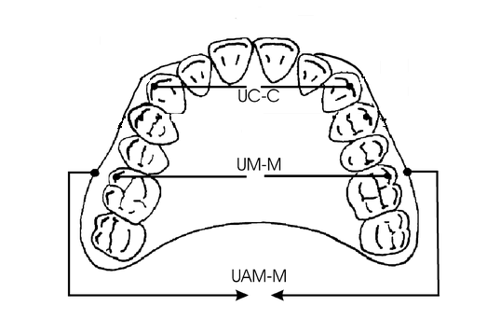
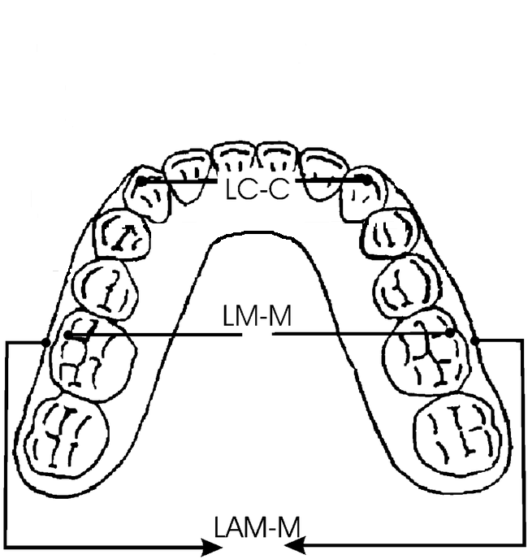
Maxilla Mandible

Result
The sample of this study is 91 subjects consisting of 50 Class I mean age (22.38 years), 25 males the mean age (22.41 years) and 25 females the mean age (22.33 years ) and 41 Class III the mean age (18.86years), 41 males the mean age (19.28 years) and 20 females the mean age (18.50 years) as demonstrated in Table (1).
The descriptive statistic, including mean, standard deviations, minimum and maximum value of all variables for the total sample of class I and Class III, both the males and females groups of Class I and Class III are present in tables (2), (3), (4) and (5).

Comparison of the dental and alveolar arch widths measurements between normal Class I and Class III overall samples : (Table 2)
The comparison of measurements between normal Class I and Class III overall samples demonstrated in table (2). indicated that there are no significant differences between them except for the lower intercanine widths (L3-3) are significantly larger in Class III than in normal Class I overall samples and maxillary molar alveolar width (UA 6-6) are significantly larger in normal Class I than in Class III overall samples at P < 0.05. Whereas the other measurements show no significant difference between normal Class I and Class III overall samples at P> 0.05.
Comparison of the dental and alveolar arch widths measurements between normal Class I and Class III male samples: (Table 3)
The comparison of measurements between normal Class I and Class III male samples demonstrated in table (3), indicated that there are no significant differences between them except for the lower intercanine widths (L3-3) are significantly larger in Class III than in normal Class I male samples at P < 0.05. Whereas the other measurements are smaller in Class III than in Class I male samples but these differences are not significant at P> 0.05.
Comparison of the dental and alveolar arch widths measurements between normal Class I and Class III females samples: (Table 4)
The comparison of measurements between normal Class I and Class III female samples demonstrated in table (4) indicated that the lower intermolar width (L6-6) and the lower molar alveolar width (LA6-6) are significantly larger in Class III than in normal Class I female samples at P < 0.05. and normal class I females are significantly larger than Class III females at P < 0.05 in the upper intercanine widths (U3-3) and in the upper molar alveolar width (UA6-6). Whereas the lower intercanine widths (L3-3) and the upper intermolar width (U6-6) show no significant difference between normal Class I and Class III female samples at P> 0.05.
Comparison of the dental and alveolar arch widths measurements between males and females samples of Class III: (Table 4)
The comparison of measurements between males and females samples of Class III demonstrated in table (5) indicated that the lower intercanine widths (L3-3); the upper intercanine widths (U3-3); and the upper intermolar width (U6-6) are significantly larger in males than in females at P < 0.05. Whereas the other measurements are larger in males than in females but these differences are not significant at P> 0.05.

Discussion
Study and determination of criterion for different ethnic groups is essential to promote accurate diagnosis and planning for orthodontic treatment. Each ethnic group has certain characteristics that should not be taken as standards for other areas with different developmental and ecological foundation [30] So the differences that have been observed in this study of arch width in Class I & Class III with the findings of other studies may be attributed to the following factors [ Ethnic variations, sample size, method of study, age of subjects and gender dimorphism]
In spite of many studies in Iraq deal with these measurements, the present study adds new information about the dental and alveolar arch widths in Class I normal occlusion and Class III malocclusion. The measurements, that available in the present study are specified for age and sex for Iraqi population in Hilla city in an attempt to provide a data for orthodontic diagnosis and treatment planning. malocclusions. However, there is little information regarding this issue among the Iraqi population in Hilla city where there is a relatively large demand for orthodontic treatment. Investigators, who studied growth changes in the arch widths, found that inter-canine and inter-molar widths did not change after the age of thirteen years in females and sixteen years in males while some have indicated that molar and canine arch widths were mostly stabilized after 13 years of age with very little or no changes thereafter.[31,32] Therefore the minimum age of the subjects included in this study was chosen on the basis of these previous studies and it was considered that the arch widths of the subjects studied, were fully developed. Therefore, it was assumed that inter-canine and inter-molar widths of the subjects selected in the present study were stable . In the normal occlusion sample only subjects with minor or no crowding were included, whereas the absence of crowding was not a criterion in the Class III groups. If a Class I group with crowding would be compared with a Class I group without crowding, most probably narrower arches would be found in the Class I group with crowding. For that reason, group differences in this study may be the result of differences concerning crowding as well and our results must be interpreted carefully.

Comparison between overall sample Class I and C1ass III
Generally the comparison of measurements between overall normal Class I and Class III samples is present in table (2).

(I) Maxillary dental and alveolar arch widths
In this present study, there are no significant differences were found in maxillary intercanine width [U 3-3] between Class I and Class III overall sample at P>0.05, this finding were similar to the finding of [2,16,18,21] but disagree with the finding of [17] who founds that maxillary intercanine widths were significantly larger in the Class I than in Class III overall sample.
The maxillary intermolar width (U 6-6) in this present study are no significant differences between Class I and Class III overall sample at P > 0.05 as similar to the finding of [2] but in contrasting to the finding of [16-18,21] who founds that the maxillary intermolar width were significantly larger in Class I than in Class III overall sample,and [33] who founds that the maxillary intermolar width were significantly larger in Class I than in Class III overall sample were determined on posteroanterior cephalograms at annual intervals between the ages of 10 and 14 years.
The maxillary molar alveolar width (UA6-6) in this present study are found to be significantly larger in Class I than in Class III overall sample at P < 0.05, this finding were similar to the finding of [2,16,18] . According to 21 that the growth and etiology of Class III malocclusions involves narrower than normal maxillary intermolar and alveolar arch widths.

(II) Mandibular dental and alveolar arch widths
The mandibular intercanine width (L 3-3) in this present study are found to be significantly larger in Class III than in Class I overall sample at P < 0.05, this finding were similar to the finding of [14,16,17], but disagree with the finding of [2,18,21] who founds that mandibular intercanine widths were no significant differences between Class I and Class III overall sample. A possible explanation for the increased the mandibular intercanine width (L 3-3) associated with Class III dental arches is that the size and shape of the dental arches could be affected by many factors such as heredity, growth of the bone, eruption & inclination of the teeth, racial background and environmental factors such as muscle forces and function.[4-6]
The mandibular intermolar width (L 6-6) in this present study are no significant differences between Class I and Class III overall sample at P > 0.05 as similar to the finding of [2,18,21] and also similar to the finding of [33]who founds that the mandibular intermolar width were no significant differences between Class I and Class III overall sample were determined on posteroanterior cephalograms at annual intervals between the ages of 10 and 14 years, but in contrasting to the finding of [16,17] who founds that the mandibular intermolar width were significantly larger in Class III than in Class I overall sample.
In this present study, there are no significant differences were found in mandibular molar alveolar width (LA6-6) between Class I and Class III overall sample at P>0.05, this finding were similar to the finding of [2,16,18].
In general the comparison of the most of measurements between normal Class I and Class III overall samples indicated that there are no significant differences between them except for the maxillary molar alveolar width (UA6-6) are found to be significantly larger in Class I than in Class III overall sample and the mandibular intercanine width (L 3-3) are found to be significantly larger in Class III than in Class I overall indicated that the result of Class III may referring to the anteroposterior skeletal discrepancy and the fact that the mandibular arch is advanced relative to the maxillary arch.

Comparison between Class I and Class III Male samples

Generally the comparison of the measurements between Class I and Class III male samples is present in table (3).

(I) Maxillary dental and alveolar arch widths :
In this present study, there are no significant differences were found in maxillary intercanine width (U 3-3) between Class I and Class III male samples at P>0.05, a similar the result has been shown by [18] but disagree with the finding of [17,22] who founds that maxillary intercanine widths were significantly larger in the Class I than in Class III male samples, which follows a similar pattern of the overall sample.
The maxillary intermolar width (U 6-6) in this present study are no significant differences between Class I and Class III male samples at P > 0.05 in contrasting to the finding of [17,18,22] who founds that the maxillary intermolar width were significantly larger in Class I than in Class III male samples, which follows a similar pattern of the overall sample.
In this present study, there are no significant differences were found in maxillary molar alveolar width (UA6-6) between Class I and Class III male samples at P>0.05, this finding were disagree with the finding of [18] who found that the maxillary molar alveolar width were significantly larger in Class I than in Class III male samples.

(II) Mandibular dental and alveolar arch widths :
The mandibular intercanine width (L 3-3) in this present study are found to be significantly larger in Class III than in Class I male samples at P < 0.05, this finding were similar to the finding of [17,22], but disagree with the finding of [18] who founds that mandibular intercanine widths were no significant differences between Class I and Class III male samples, which follows a similar pattern of the overall sample.
No significant difference was noticed in the mandibular intermolar width (L 6-6) in this present study between Class I and III male samples at P>0.05, this finding were similar to the finding of [18], but disagree with the finding of [17,22] who founds that the mandibular intermolar width (L 6-6) were significantly larger in Class III than in Class I male samples, which follows a similar pattern of the overall samples.
The mandibular molar alveolar width (LA6-6) show no significant difference between Class I and III male samples at P>0.05, this finding were similar to the finding of [18], which follows a similar pattern of the overall sample.
In general the comparison of the most of measurements between normal Class I and Class III male samples indicated that there are no significant differences between them, except for the mandibular intercanine width (L 3-3) are found to be significantly larger in Class III than in Class I males, indicated that the result of Class III may referring to the anteroposterior skeletal discrepancy and the fact that the mandibular arch is advanced relative to the maxillary arch, which follows a similar pattern of the overall sample.

Comparison between Class I and Class III Female samples

Generally the comparison of the measurements between Class I and Class III female samples is present in table (4).

(I) Maxillary dental and alveolar arch widths :
The maxillary intercanine width (U 3-3) in this present study are found to be significantly larger in Class I than in Class III female samples at P < 0.05, this finding were similar to the finding of [22] in contrasting to the finding of [17,18] who founds that the maxillary intercanine width (U 3-3) were no significant differences between Class I and Class III females.
The maxillary intermolar width (U 6-6) in this present study are no significant differences between Class I and Class III female samples at P > 0.05, this finding were disagree with the finding of [17,18,22] who founds that the maxillary intermolar width were significantly larger in Class I than in Class III female samples, which follows a similar pattern of the overall samples and male samples.
The maxillary molar alveolar width (UA6-6) in this present study are found to be significantly larger in Class I than in Class III female samples at P < 0.05, but disagree with the finding of [18] who founds that The maxillary molar alveolar width (UA6-6) were no significant differences between Class I and Class III female samples, which follows a similar pattern of the overall samples.

(II) Mandibular dental and alveolar arch widths :
The mandibular intercanine width (L 3-3) in this present study are found to be no significant difference between Class I and III female samples at P>0.05, this finding were similar to the finding of [18,22] in contrasting to the finding of [17] who founds that the mandibular intercanine width (L 3-3) were no significant differences between Class I and Class III female samples.
The mandibular intermolar width (L 6-6) in this present study are found to be significantly larger in Class III than in Class I female samples at P < 0.05, this finding were similar to the finding of [17], but disagree with the finding of [18] who founds that mandibular intermolar width (L 6-6) were no significant differences between Class I and Class III female samples.
The mandibular molar alveolar width (LA6-6) in this present study are found to be significantly larger in Class III than in Class I female samples at P < 0.05, in contrasting to the finding of [18] who founds that the mandibular molar alveolar width (LA6-6) were no significant differences between Class I and Class III female samples.
In general the comparison of the most of measurements between normal Class I and Class III female samples indicated that there are significantly differences between them, a possible explanation for the these significantly differences between the arch width associated with Class III dental arches is that the sum of all the mesiodistal widths of the dental units around an arch represents a specific dimension [(16]. Sperry et al [34]showed that the Class III group with mandibular prognathism more commonly had mandibular tooth size excess for the overall ratio than the Class I and Class II groups. Similarly, Lavelle [35] and Nie and Lin [36] showed that Class III cases are characterized by smaller maxillary tooth dimensions and bigger lower teeth. Hnat et al [37] also reported that, when the mandibular tooth size is increased, mandibular arch length and arch width increase occurs, and subjects with Class III malocclusion tend to have the maxillary teeth inclined to the lingual and mandibular teeth inclined to the buccal direction because of the restriction of maxillary growth and development. [16], and these suggestions supports our results. Because the posterior segment of the mandibular dental arch are wider in Class III female samples, in the treatment of Class III malocclusions, special attention must be taken to not expand the posterior segment of the mandibular dental arch in Class III female patients for stability reasons [22]while the rapid maxillary expansion may be considered before or during the treatment of a Class III patient with or without face-mask therapy.[16]

Comparison between Males and Females samples of Class III
Generally the comparison of the measurements between males and females samples of Class III is present in table (5).

(I) Maxillary dental and alveolar arch widths :
The maxillary intercanine width (U 3-3) in this present study are found to be significantly larger in males than in females of Class III samples at P < 0.05, this finding were disagree with the finding of [18] who founds that the maxillary intercanine width (U 3-3) were no significant differences between males and females of Class III samples.
The maxillary intermolar width (U 6-6) in this present study are found to be significantly larger in males than in females of Class III samples at P < 0.05, this finding were similar to the finding of [18].
The maxillary molar alveolar width (UA6-6) in this present study are found to be no significant difference between males and females of Class III samples at P>0.05, in contrasting to the finding of [18] who founds that the maxillary molar alveolar width (UA6-6) were found to be significantly larger in males than in females of Class III samples.

(II) Mandibular dental and alveolar arch widths :
The mandibular intercanine width (L 3-3) in this present study are found to be significantly larger in males than in females of Class III samples at P < 0.05, this finding were disagree with the finding of [18] who founds that the mandibular intercanine width (L 3-3) were no significant differences between males and females of Class III samples.
The mandibular intermolar width (L 6-6) and the mandibular molar alveolar width (LA6-6) in this present study are found to be no significant difference between males and females of Class III samples at P>0.05, in contrasting to the finding of [18] who founds that the mandibular intermolar width (L 6-6) and the mandibular molar alveolar width (LA6-6) were found to be significantly larger in males than in females of Class III samples.
In general the comparison of the most of measurements between males and females of Class III samples indicated that most of these measurements are significantly larger in males than in females of Class III samples except for the maxillary molar alveolar width (UA6-6), the mandibular intermolar width (L 6-6) and the mandibular molar alveolar width (LA6-6). Although these measurements (UA6-6), (L 6-6) and (LA6-6) are higher in males, this difference is not statistically significant, and this may be due to the fact that in any case, growth in males continues longer than it is in females; therefore, the final size is larger [38].

Conclusion
1- There are no significant differences in all measurements between Class I and Class III overall samples except for the maxillary molar alveolar width (UA6-6) are found to be significantly larger in Class I than in Class III overall sample and the mandibular intercanine width (L 3-3) are found to be significantly larger in Class III than in Class I overall.
2- There are no significant differences in all measurements between Class I and Class III males samples except for the mandibular intercanine width (L 3-3) are found to be significantly larger in Class III than in Class I males.
3- The lower intermolar width (L6-6) and the lower molar alveolar width (LA6-6) are significantly larger in Class III than in normal Class I females while the Class I are significantly larger than Class III females in the upper intercanine widths (U3-3) and in the upper molar alveolar width (UA6-6). Whereas the lower intercanine widths (L3-3) and the upper intermolar width (U6-6) show no significant difference between normal Class I and Class III female samples.
4- The upper intercanine widths (U3-3) ; the upper intermolar width (U6-6); and the lower intercanine widths (L3-3) are significantly larger in males than in females of Class III samples while the upper molar alveolar width (UA6-6); the lower intermolar width (L6-6) ; and the lower molar alveolar width (LA6-6) show no significant difference between males and females of Class III samples.

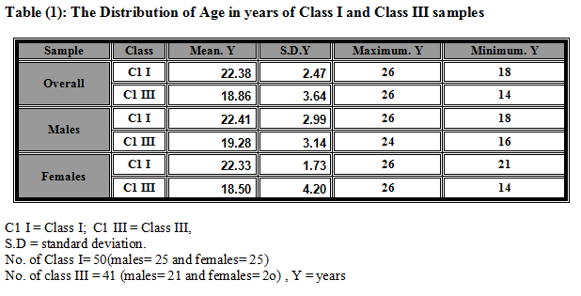

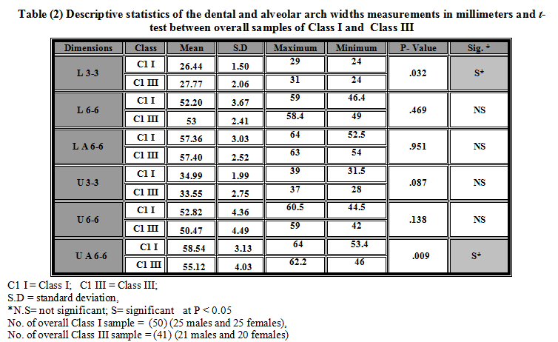

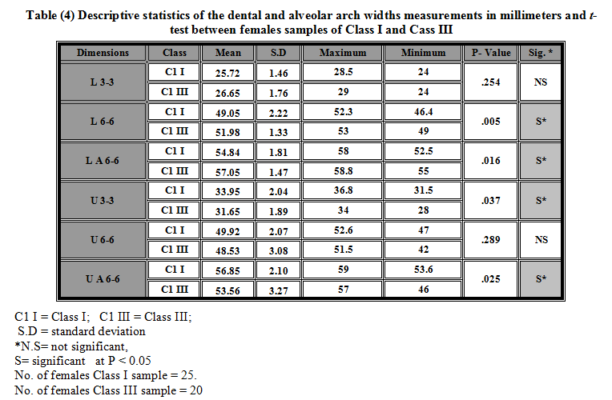
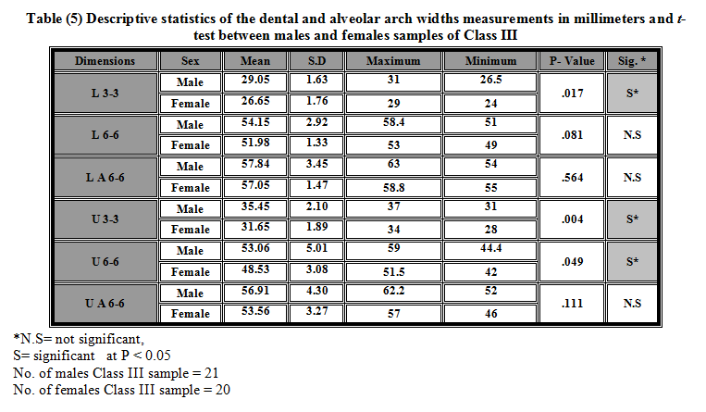
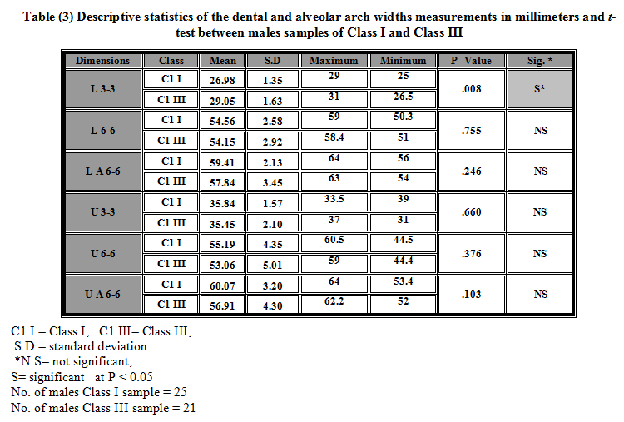

References
1. Lee RT. : Arch width and form: a review. Am J Orthod Dentofacial Orthop 1999; 115: 305-13.
2. Rasool G; and Ibadullah K.: Comparison of dental arch dimensions among various malocclusion classes. J. Med. Sci. (Peshawar, Print) July 2009, Vol. 17, No. 2: 71-77.
3. Al-Zubair N.M.M.: Maxillary and mandibular dental arch dimensions and forms in a sample of Yemeni population aged (18-26) years with class I normal occlusion. 2002; Master Thesis, Baghdad University.
4. Lavelle CL; Foster TD; and Flinn RM. : Dental arches in various ethnic groups. Angle Orthod 1971; 41: 293-99.
5. Bjork A; Brown T; and Skieller V. : Comparison of craniofacial growth in Australian Aboriginal and Danes, illustrated by longitudinal cephalometric analysis. Eur J Orthod 1984; 6: 1-14.
6. Hassanali J; and Odhiambo W. : Analysis of dental casts of 6–8 and 12-year old Kenyan children. Eur J Orthod 2000; 22: 135-142.
7. Rakosi TM; Jonas I; and Graber T. : Color atlas of dental medicine, orthodontic diagnosis. New York: Thieme Publishing,1993.
8. Batool I. ; Abbas A. ; Rizvi S.A.A. ; and Abbas I. : Evaluation of tooth size discrepancy in different malocclusion groups. J Ayub Med Coll Abbottabad 2008;20(4).
9. Janson M. ; Janson G. ; Sant’Ana E. ; Tibola D. ; and Martins D.R. : Orthognathic treatment for a patient with Class III malocclusion and surgically restricted mandible. Am J Orthod Dentofacial Orthop 2009;136:290-8.
10. Chen F. ; Terada K. ; Wu L. ; and Saito I. : Dental arch widths and mandibular-maxillary base width in class III malocclusions with low, average and high MP-SN angles. Angle Orthodontist, Vol 77, No 1, 2007.
11. Guyer E.C. ; Ellis E.E. 3rd; McNamara J.A. Jr. ; and Behrents R.G.: Components of Class III malocclusion in juveniles and adolescents. Angle Orthod 1986;56:7-30.
12. Battagel J.M. : The aetiological factors in Class III malocclusion. Eur J Orthod 1993;15:347-70.
13. Mackay F. ; Jones J.A. ; Thompson R. ; and Simpson W. : Craniofacial form in Class III cases. Br J Orthod 1992;19:15-20.
14. Rokosi T. ; and Schilli W. : Class 3 anomalies: a coordinated approach to skeletal, dental and soft tissue problems. Journal of Oral Surgery 39:860-870, 1981.
15. El-Mangoury N.H. ; and Mostafa Y.A. : Epidemiologic panorama of dental occlusion. Angle Orthod. 1990;60:207–214.
16. Uysal T. ; Usumez S. ; Memili B. ; and Sari Z. : Dental and alveolar widths in normal occlusion and Class III malocclusion. Angle Orthod. 2005;75:809–813.
17. Filipović G. ; Janošević M. ; Stošić M. ; Stojanović D. ; and Tričković-Janjić O. : Arch widths in class III malocclusion. Acta stomatologica naissi. June 2009 • Volume 25 • Number 59.
18. Kuntz T. R. ; Staley R.N. ; Bigelow H.F. ; Kremenak C.R. ; Kohout F.J. ; and Jakobsen J. R. : Arch widths in adults with Class I crowded and Class III malocclusions compared with normal occlusions. Angle Orthod 2008. 78:597–603.
19. Al-Khateeb S.N. ; and Abu Alhaija E.S.J. : Tooth size discrepancies and arch parameters among different malocclusions in a Jordanian sample. Angle Orthod 2006. 76:459–465. (20)12+(8)21+13+(21)1
20. Ling, J.Y.K. ; and Wong R.W.K. : Dental arch widths of southern Chinese. Angle Orthod 2009. 79:54–63. [Abstract]
21. Herren P. ; and Jordi-Guilloud T. : Quantitative determination of the dental arch by polygon measurement in the ideal and anomalous arch. Schweiz Mschr Zahnheilk. 1973;83:682–709.

22. Slaj M. ; Spalj S. ; Pavlin D. ; Illes D. ; and Slaj M. : Dental archforms in dentoalveolar Class I, II and III. Angle Orthod: September 2010, Vol. 80:No. 5, pp. 919-924.
23. Bishara S. E. : Textbook of orthodontics. 2001; W. B. Saunder Company.
24. Câmara C.A. : Angle Class III malocclusion with severe anteroposterior discrepancy. Dental Press J. Orthod. v. 15, no. 2, p. 122-137, Mar./Apr. 2010.
25. Hong Q. ; Jun T. ; ShresthaS. ; Enxin Z. ; bo T. ; Shimizu T. ; Nakano K. ; Takagi S. ; Takamata T. ; and Okafuji N. : Study and comparison of tooth size and arch length in angle class III malocclusion between nepalese and Chinese population. Journal of Hard Tissue Biology 2008. 17[2] p69-76.
26. Moorrees C.F.A. : The Dentition of the Growing Child. Cambridge, Mass: Harvard University Press; 1959.
27. Knott V.B. : Size and form of the dental arches in children with good occlusion studied longitudinally from age 9 years to late adolescence. Am J Phys Anthropol. 1961;19:263–284.
28. Sillman J.H. : Dimensional changes of the dental arches: longitudinal study from birth to 25 years. Am J Orthod. 1964; 50:824–842.
29. Hashim H. A. ; and Al Ghamdi H. S. : Arch dimensions in class I, II and III malocclusion: A pilot study. Pak J Orthodont Ped and Comm Dentistry Jun 2002;1(1):21-6.
30. Borgan, B.E. : Dental arch dimensions analysis among Jordanian school children. 2001; Master Thesis. Cairo University-Egypt.
31. Snodell S.F. ; Nanda R.S. ; and Currier G.F. : A longitudinal cephalometric study of transverse and vertical craniofacial growth. Am J Orthod Dentofacial Orthop 1993; 104: 471-83.
32. Cortella S. ; Shofer F.S. ; and Ghafari J. : Transverse development of the jaws: norms for the posteroanterior cephalometric analysis. Am J Orthod Dentofacial Orthop 1997; 112: 519-522.
33. Chen F. ; Terada K. ; Yang L. ; and Saito I. : Dental arch widths and mandibular-maxillary base widths in Class III malocclusions from ages 10 to 14. Am J Orthod Dentofacial Orthop. 2008 Jan;133(1):65-9.
34. Sperry T.P. ; Worms F.W. ; Isaacson R.J. ; Speidel T.M. : Tooth size discrepancy in mandibular prognathism. Am J Orthod. 1977;72:183–190.
35. Lavelle C.L.B. : Maxillary and mandibular tooth size in different racial groups and in different occlusion categories. Am Orthod. 1972;6:29–37.
36. Nie Q. ; and Lin J. : Comparison of intermaxillary tooth size discrepancies among different malocclusion groups. Am J Orthod Dentofacial Orthop. 1999;116:539–544.
37. Hnat W.P. ; Braun S. ; Chinhara A. ; and Legan H.L. : The relationship of arch length to alterations in dental arch width. Am J Orthod Dentofacial Orthop. 2000;118:184–188.
38. Sinclair, P. M.; and Little, R. M.: Dentofacial maturation of untreated normals Am. J. Orthod. 1985 ; 88: 146 - 156.

