Correlates of Current Cigarette Smoking Among In-School Adolescents in Kut City

Issam S. Ismail Khalida Abdul-Sattar* Hassan A. Baey**
Health Directorate of Wasit Province, Department of Public Health, E-mail: issam_health@yahoo.com
* Foundation of Technical Education, College of Health and Medical Technologies/ Baghdad, Dep. of Community Health, E-mail: d.khalida@yahoo.com
**Babylon University, College of Medicine, Head of Community Medicine Department, E-mail : hassanbaey@yahoo.com
M J B

Abstract
Background : Cigarette smoking is a major ‘preventable’ cause of morbidity and mortality worldwide. Most adult smokers start smoking regularly some time before 18 years of age.
Objectives : This study aimed at identify the prevalence of, and determine some of socio-demographic correlates of current cigarette smoking among in-school adolescents in Kut City.
Methodology : We carried out a cross-sectional survey of 1067 students in classes 7th to 11th (ages: 13 to 20 years) in 14 intermediate and secondary schools in Kut City, Wasit Province in 2007, by using multistage probability sampling technique (stratified – simple), an anonymous self-completion questionnaire as a part of Global School-based Student Health Survey ‘GSHS’ questionnaire was used.
Results : Results shows that cigarette smoking prevalent among male school students only, where 22.6% (140 student of 619) stated that they had smoked at least once and (13.4%, 83 student of 619) stated that they were currently smoking, so the data analysis involve male students only (sample size = 619). The percentage of students who were currently smoking increased gradually with age: 7% in 13-14 years old, 16% in 15-17 years old to 29% in 18-20 years old. Findings indicates that adolescents who had parents who smoked, were more likely to be smokers compared to adolescents who did not have parents who smoked ‘P <0.05’ this suggests that parents imitation plays an important role in initiation of smoking in adolescents. Fortunately, students who perceived parental supervision were less likely involved in smoking behavior ‘P <0.05’.
Conclusion : Smoking is highly prevalent among secondary school male students in Kut City, while, there are no smokers among female students, and this is due to the behavior of a socially acceptable habit of smoking for men only and is not acceptable for women, and this gives immunity against the prevalence of smoking among female students. The smoking behavior of adolescents influenced by complicated interactions of varying sets of factors such as age, gender, parental smoking and parental supervision.
تدخين السيجارة الحالي وارتباطاته لدى طلبة المدارس المراهقين في مدينة الكوت
الخلاصة
تدخين السيجارة هو السبب الرئيسي’القابل للوقاية‘ للمراضة والوفاة في جميع أنحاء العالم. أكثر المدخنين البالغين يبدءون التدخين بانتظام قبل الثامنة عشر من العمر. تهدف هذه الدراسة إلى معرفة نسبة انتشار تدخين السيجارة الحالي وتحديد بعض العوامل الاجتماعية - السكانية المرتبطة به لدى طلبة المدارس المراهقين في مدينة الكوت. أجرينا دراسة مقطعية شملت 1067 طالب وطالبة في المراحل الدراسية من الأول متوسط إلى الخامس الإعدادي (الأعمار : 13- 20 سنة) في 14 مدرسة متوسطة وثانوية في مدينة الكوت/ محافظة واسط لعام 2007, باستعمال طريقة العينة العشوائية متعددة المراحل (الطبقية – البسيطة), واستخدمت استمارة استبيان تملئ ذاتياً وبدون ذكر الاسم كجزء من استمارة المسح العالمي لصحة الطالب في المدرسة. بينت النتائج بأن تدخين السيجارة منتشر لدى الطلبة الذكور فقط إذ أن 22,6% (140 طالب من619) قد دخنوا السيجارة مرة واحدة على الأقل في حياتهم, و 13,4% (83 طالب من 619) بينوا بأنهم لازالوا يدخنون السيجارة, لذا فأن تحليل النتائج شمل الذكور فقط (حجم العينة = 619) طالب. نسبة الطلبة المدخنين تزداد مع تقدم العمر: 7% بعمر 13-14 سنة, 16% بعمر 15-17 سنة, إلى 29% بعمر 18-20 سنة. أظهرت النتائج بأن المراهقين الذين لديهم أباء يدخنون السيجارة هم أكثر عرضة للتدخين مقارنة بأولئك الذين لا يمارس أبائهم عادة التدخين وبفارق معنوي إحصائـي (P <0.05), هذا يوضح بأن تقليد الآباء يلعب دور مهم في ابتداء التدخين عند المراهقين. لحسن الحظ, الطلبة الذين يُراقبون (يُتابعون) من قبل أوليائهم هم أقل عرضة لممارسة عادة التدخين وبفارق معنوي إحصائي (P <0.05 ). ينتشر تدخين السيجارة بنسبة كبيرة بين طلبة المدارس الثانوية الذكور في مدينة الكوت, بينما لا توجد طالبات مدخنات, وهذا يرجع إلى أن سلوك التدخين مقبول اجتماعياً كعادة للرجال فقط وغير مقبول للنساء وهذا يعطي مناعة ضد انتشار التدخين في صفوف الطالبات, وأن سلوك التدخين لدى المراهقين يتأثر بتداخل معقد لمجموعات مختلفة من العوامل مثل العمر, تدخين الأبوين, مراقبة (متابعة) الأبوين.
ـــــــــــــــــــــــــــــــــــــــــــــــــــــــــــــــــــ

Introduction
About one in three or 1.1 billion people worldwide smoke. Among these, about 80% live in low and middle-income communities. By 2020, the tobacco epidemic is expected to kill more people than any single disease. By 2020, tobacco use will cause about 18% of all deaths in developed countries and about 11% of all deaths in developing countries. Tobacco use is a known or probable cause of about 25 diseases including : heart disease, cancer, stroke, and chronic obstructive pulmonary disease [1]. Cigarette smoking is considered the single most significant cause of preventable mortality and morbidity [2]. Tobacco smoking among adolescents is of public concern because of the immediate and long-term health sequel such as asthma, chronic cough, cancers, chronic obstructive airways disease and cardiovascular diseases [3]. If regular cigarette smoking is started at a very young age, e.g. in early teens, there is a 50% chance of early death as a result of cigarette-related mortality. Smokers who cease smoking at a younger age are safe from all smoking-related complications [4].
It is notable that, the younger the age at which smoking is initiated, the greater is the chance of becoming a heavy smoker, dying of cigarette-related diseases and suffering from stroke or lung cancer at a younger age. It has been noted that young individuals become addicted to cigarettes after only few cigarettes (for example less than 5 cigarettes). It has been demonstrated in different studies that young people consider smoking as a way of fighting and overcoming their problems and increasing their self-assurance and self-confidence [4].
Many studies have shown significant association between smoking habit of family members especially that of the father’s smoking habit on a student’s smoking habit [5-8]. Furthermore, adolescents who have their peers or parents who also smoke may be living in environments that is more tolerant towards smoking [9]. Parental smoking could influence the availability and access to cigarette by the adolescent as well as affect tolerance to smoking by the parent. Adolescents who have parents who are less tolerant to smoking are less likely to smoke themselves [10]. Current smoking in youths was independently associated with parental smoking [11].
It is recognized that as the life expectancy of societies improve, the prominence of non-communicable chronic diseases, many of which are associated with cigarette smoking, will gain greater prominence. About 25% of all adolescents who experiment with cigarette smoking become regular smokers, and among the smokers, about one-third will die from a smoking-related health disease [12]. This study aimed at identify the prevalence of, and determine some of socio-demographic correlates of current cigarette smoking among in-school adolescents in Kut City.

Methodology
Study Setting and Sampling Technique
A school-based cross-sectional study was conducted on school students in 7th through 11th classes (ages: 13 to 20 years) in 14 intermediate and secondary schools in Kut City/Iraq in 2007, by using a self-completed questionnaire. A multistage, probability sampling technique was used, in which schools, classrooms and students selected randomly. The overall response rate was 90% (N = 1067), few students refused participation, while the most were excluded because of missing values.
Instrument
The questionnaire used in this study was the Arabic version of Global School-based Student Health Survey ‘GSHS’ questionnaire. The students were asked about their age, and smoking status : How old were you when you first tried a cigarette? coded as (0=I have never smoked cigarettes to 6= 16 years old or older). The second question was about current cigarette smoking: During the past 30 days, on how many days did you smoke cigarettes? coded as (0= 0 day to 6=all 30 days), (Cronbach α .69). These codes were collapsed into dichotomous categories for purpose of analysis), and the smoking status of their parents (Parents cigarette smoking present : no, yes). Perceived parental supervision: During the past 30 days, how often did your parents or guardians really know what you were doing with your free time? This question has 5-point Likert scale coded as (0=never, 1=rarely, 2=sometimes, 3=most of times, 4=always). Responses were collapsed into three levels for final analysis.
Data collection
Written consent was sought from The General Directorate for Education in Wasit Province and school management and verbal consent from all study participants. Students were briefed about the purpose of the study, encouraged to participate and to express their experiences. After the students were informed about the anonymity of the survey, the questionnaire was administered to the students in their classrooms.
Statistical analysis
Data were entered into SPSS version 10.0 software for analysis. Descriptive statistics, and the chi-squared test to analyze the correlation between variables, were used. P-value of less than 0.05 was considered significant.

Results
Results shows that cigarette smoking prevalent among male school students only, so the data analysis involve male students only (sample size = 619). Of the 619 male students aged 13-20 years who answered the questionnaire, 22.6% (140 student of 619) stated that they had smoked at least once in their life [Table 1], and 13.4% (83 student of 619), (59.3% of smokers) stated that they were currently cigarette smoking [Table 2].

Table 1 Frequency distribution of smoking behavior among in-school adolescents

Smoking Behavior | Frequency | %
Non-smoker | 479 | 77.4
Smoker | 140 | 22.6
Total | 619 | 100
Table 2 Frequency distribution of current cigarette smoking among in-school smokers
Smoker | Frequency | %
smoker | 57 | 40.7
Currently smoker | 83 | 59.3
Total | 140 | 100

The percentage of students who were currently smoking increased gradually with age: 7% in 13-14 years old, 16% in 15-17 years old to 29% in 18-20 years old [Fig. 1]. Our findings indicates that adolescents who had parents who smoked, were more likely to be smokers compared to adolescents who did not have parents who smoked ‘P <0.05’ [Fig. 2].

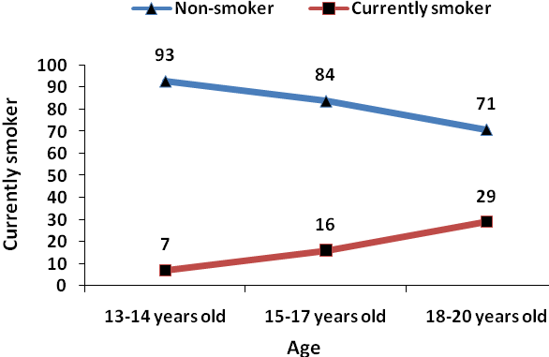
Figure 1 The percentage of currently smoker students distributed according to their ages
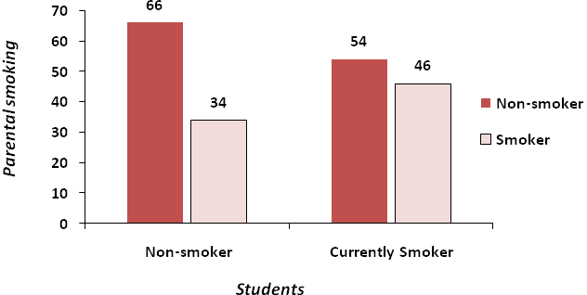
Figure 2 Association of currently smoked students with parental smoking

Also, there was a significant statistical relationship between current cigarette smoking and perceived parental supervision ‘P <0.05’. However, students who perceived parental supervision were less likely involved in smoking behavior [Fig.3].

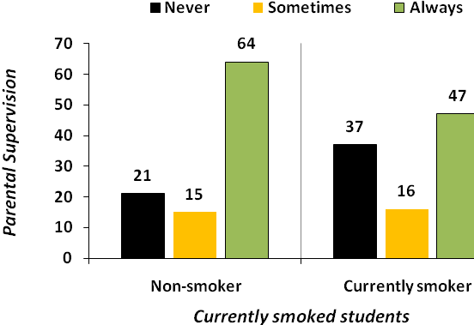

Figure 3 Association of currently smoked students with parental supervision

Discussion
Prevalence of current cigarette smoking among the male school students in Kut City was 13.4%. Our estimates are greatly different from those reported by Seter et al. in the Kurdistan-Iraq as a part of Global Youth Tobacco Survey, so the prevalence of current cigarette smoking was 25.1% among male school adolescents [10].
Our prevalence is much lower than the prevalence of current cigarette smoking in USA, 22.9 % of male students had smoked cigarettes, a nationwide survey [14]. Emmanuel et al. indicates that of the Thai male school adolescents 22.0% reported being current smokers[9]. Also, Mehmet et al. suggests that of the 1113 Turkish high-school students, aged 12-18 years, the prevalence of male current cigarette smokers was 19.6% [2].
On the other hand our estimate were more higher than other settings, in Punjab, 3.3% (67 out of 2014) of Indian in-school adolescents were current cigarette smokers [3]. Current cigarette smoking among Ethiopian in-school adolescents was 4.5% among boys in 2003 [15]. Of 1872 school-age adolescents in Kafue, Zambia, 10.4% of males were current cigarette smokers [7]. This varying in prevalence suggests that socioeconomic, cultural factors impact on smoking may be different from one setting to another. Also, some methodological disparity must be considered in interpretation of these results.
In our study with increasing age, the prevalence of cigarette smoking is also increasing, the same findings were suggested by N. Al-Haddad and R.R. Hamadeh. in their study in Bahrain where: the prevalence of cigarette smoking was 20.4%, 24.3% and 37.8% for those aged 13-15, 16-17 and 18-20 years respectively [12], the USA nationwide survey shows an increasing in smoking behavior with increasing age among school adolescents [14], also smoking behavior among Irish schoolchildren were increased with increasing the student’s age [16]. Unfortunately, and as has been consistently demonstrated elsewhere [3-11, 13], analysis of this study indicates that parental smoking was associated with current smoking status among in-school adolescents. This suggests that imitation plays an important role in initiation of smoking in adolescents. In addition, parental smoking could influence the availability and access to cigarette by the adolescent as well as affect tolerance to smoking by the parent.
Analysis shows significant negative association between good parental supervision and student’s smoking. Non-smokers perceived their parents knew of their where about more often than smokers. Perceived strong parental supervision will decrease their chances of being involved in smoking, our results supported by previous study [5].
Limitations of the study
Our study has several limitations. Firstly, due to the cross sectional nature of the design, the factors that have been identified as associated with current cigarette smoking cannot be described in causative terms. Secondly, findings of the study may also be limited by not controlling for unmeasured confounders and effect measure modifiers. Thirdly, the study also recruited only school going adolescents in the study area, findings may therefore be representative of the in-school adolescents in Kut but not those out of school adolescents. Fourthly, our study was based on self report and therefore subject to respondent recall and deliberate misreporting. However the use of standardized terms and classifications will help ensure that the data collected are both valid and reliable.

Conclusion
Current cigarette smoking is highly prevalent among secondary school students in Kut City. Parental smoking increases the risk of current cigarette smoking among school students, whilst parental supervision was a protective factor against cigarette smoking. Smoking behavior was increased with age. In this study it was observed that smoking may start as early as seven years of age and this shows us efforts to prevent smoking must be started in the preschool period and continued in schools from primary school in a regular program. Large-scale studies are needed to estimate smoking behavior among school students according to residency (urban vs. rural). Annual surveillance is very important to make a base-line data and to evaluate the effective of any preventive programs or interventions.

Acknowledgement
We are thankful to the General Directorate for Education in Wasit Province and school management for permission to conduct the study and special thanks to the study participants and teachers. We recognize that our study would not have been possible without the consent and cooperation of them.

References
- World Health Organization. Global School-based Student Health Survey (GSHS) 2004 Core Questionnaire Module Rationale. WHO, Geneva ; 2005.
- Mehmet Ünlü, Ayfle Orman, Tolga Altu fien, Nurhan Doan, Gurbet Zehra Tuncer. Factors Affecting the Cigarette Smoking Habits Among Students in Afyon-Turkey. Archieves of Pulmonary: 2004; 1: 15-19.
- Seter Siziya, Adamson S Muula, and Emmanuel Rudatsikira. Correlates of current cigarette smoking among school-going adolescents in Punjab, India: results from the Global Youth Tobacco Survey 2003. BMC International Health and Human Rights 2008, 8:1.
- G. Heydari, H. Sharifi, M. Hosseini and M.R. Masjedi. Prevalence of smoking among high-school students of Tehran in 2003. Eastern Mediterranean Health Journal 2007 ; Vol. 13, No. 5.
- K Shamsuddin, M Abdul Haris. Family Influence on Current Smoking Habits Among Secondary School Children in Kota Bharu, Kelantan. Singapore Med J 2000 Vol. 41(4) : 167-171.
- Adamson S Muula, Seter Siziya and Emmanuel Rudatsikira. Cigarette smoking and associated factors among in-school adolescents in Jamaica: comparison of the Global Youth Tobacco Surveys 2000 and 2006. BMC Research Notes 2008, 1:55.
- Seter Siziya, Emmanuel Rudatsikira, Adamson S. Muula. Cigarette smoking among school-going adolescents in Kafue, Zambia. Malawi Medical Journal; June 2007; 19(2):75-78.
- Jindal SK, Aggarwal AN, Gupta D, Kashyap S, Chaudhary D. Prevalence of tobacco use among school going youth in North Indian States. Indian J Chest Dis Allied Sci. 2005 Jul-Sep; 47(3):161-6.
- Emmanuel Rudatsikira, Adamson S Muula, Seter Siziya and Ronald H Mataya. Correlates of cigarette smoking among school-going adolescents in Thailand: findings from the Thai global youth tobacco survey 2005. International Archives of Medicine 2008, 1:8.
- Seter Siziya, Adamson S Muula, and Emmanuel Rudatsikira. Correlates of current cigarette smoking among in-school adolescents in the Kurdistan region of Iraq. Conflict and Health 2007, 1:13.
- Bindu Kalesan , Joan Stine , Anthony J. Alberg. The Joint Influence of Parental Modeling and Positive Parental Concern on Cigarette Smoking in Middle and High School Students. Journal of School Health , 2006 Vol. 76 Issue 8, Pages 402 – 407.
- N. Al-Haddad and R.R. Hamadeh. Smoking among secondary-school boys in Bahrain: prevalence and risk factors. Eastern Mediterranean Health Journal, January 2003 Vol. 9, Nos 1/2.
- Rudatsikira E, Dondog J, Siziya S, Muula A S. Prevalence and determinants of adolescent cigarette smoking in Mongolia. Singapore Med J 2008; 49 (1) : 57.
- Centers for Disease Control and Prevention. Youth Risk Behavioral Surveillance-United States, 2005. MMWR, Surveillance Summaries 2006;55(no. SS-5).
- Rudatsikira E, Abdo A, Muula AS: Prevalence and determinants of adolescent tobacco smoking in Addis Ababa, Ethiopia. BMC Public Health 2007, 7:176.
16. Michal Molcho and Saoirse Nic Gabhainn. Smoking behaviour among Irish schoolchildren. Research Factsheet No. 1
- ,

- HBSC Ireland 2002.

