Treatment of Recalcitrant Lichen Planus with Low Molecular Weight Heparin (Enoxaparin): A Case Series Study among Iraqi Patients
Wisam Ali Ameen Zena Saeed Alfadhily
College of Medicine / University of Babylon,Hilla, Iraq.

M J B

Abstract
Lichen planus (LP) is a unique, common, pruritic, inflammatory disease of the skin, mucous membranes and hair follicles. The exact pathogenesis of LP is unknown, but it is evident that immunologic mechanisms almost certainly mediate the development of LP. Cell mediated immunity plays the major role in triggering the clinical expression of the disease. Both CD4 and CD8 T-cells are found in lesional skin of LP. Low dose, low molecular weight heparin (enoxaparin) has been proven effective in various types of Lp. Enoxaparin has been shown to inhibit the expression of heparanase enzyme that is produced by CD4 lymphocytes (this enzyme is crucial in T-cell migration to target tissue).
The Aim: is to evaluate the efficacy of low-dose enoxaparin in treatment of Iraqi patient with recalcitrant LP that is unresponsive to traditional courses of topical and systemic steroid therapy.
Methods: Fifteen patients with recalcitrant LP were included in this study Enoxaparin was given to each patient in a dose of 3mg subcutaneous injection every week for a period of 20 weeks. Assessment of response to treatment was done for each patient every two weeks by assessment of the severity of itching and reduction in the number of lesions. VAS score used to assess improvement of itching. Patients divided into 3 groups (mild LP, moderate LP, and severe LP) according to the number of lesions at initial presentation. Response to treatment classified for 4 grades (no response, mild response, moderate response, dramatic response).
Results: There was dramatic reduction in VAS score in 13 patients of the 15 patients (86.6%). This reduction is considered statistically significant in the end of the 1st month of treatment (p-value 0.0002). The number of patients that respond to therapy in the end of treatment course was 12 patients (80%), this include all grades of improvement (mild 26.6%, moderate 20%, and dramatic 33.33%). patients with mild type LP showed a response of (83.33%) which is higher than the response rate of moderate type LP (71.42%).
Conclusions: Enoxaparin is effective, safe, simple and good alternative therapy for acute and chronic recalcitrant lichen planus, specially those who complain from severe itching, those who use prolonged courses of steroid therapy without benefit and those with hypertrophic type LP.
ـــــــــــــــــــــــــــــــــــــــــــــــــــــــــــــــــــــــــــــــــــــــــــــــــــــــــــــــــــــــــــــــــــــــــــــــــــــــــــــــــــــــــــــ

Introduction
Lichen planus (LP) is a unique, common, pruritic, inflammatory disease of the skin, mucous membranes and hair follicles [1]. It occurs throughout the world in all races and it represented about 1.2% of all new patients in clinical practice [2].
At least two thirds of cases occur between the ages of 30 and 60 years of age. No sexual predilection is evident [3].
The exact pathogenesis of LP is unknown, but it is evident that immunologic mechanisms almost certainly mediate the development of LP. Cell mediated immunity plays the major role in triggering the clinical expression of the disease. Both CD4 and CD8 T-cells are found in lesional skin of LP [3]. The majority of lymphocytes in the infiltrate of LP are CD8 and CD45RO (memory) positive cells. These cells are considered responsible for the development of the most characteristic change observed in the lichenoid reaction namely, apoptosis (cell death) [2, 3].
T-cells may become activated via antigen presenting cells such as langerhans cells which recognize unknown foreign antigen (could be virus, drug or contact sensitizer), then process and present this antigen to the T-lymphocytes. Activated lymphocytes both helper subset (Th1 and Th2) and cytotoxic suppressor cells release soluble mediators (cytokines and chemokines) such as interleukins IL2, IL4, IL10, interferon-γ and TNF-α which stimulate the accumulation of more lymphocytes. The infiltrate is epidermotropic and attacks keratinocytes, this process leads to the destruction of the epidermis referred as the lichenoid tissue reaction [3, 4].
Histologically, the upper dermis has a band-like infiltrate of lymphocytic and histiocytic cells which is very close to the epidermis and often disrupts the dermo-epidermal junction [4].
Clinically, the primary lesions of LP are characteristic, almost pathognomonic small, violaceous, flat-topped polygonal papules covered with dry, scant adherent scales. There is a predilection for the flexor wrist, trunk, medial thighs, shins, dorsal hands and glans penis. Pruritus is often prominent in LP; the intensity of itch may seem out of proportion to the amount of the skin disease (1, 5). It may be almost intolerable in acute cases [1].
Cutaneous LP usually persists for months, but in some cases for years. Hypertrophic LP on the shins and oral LP often stay for decades [5, 6]. Recurrences are common (relapse of disease occurs in 15-20% of cases and tends to occur in the same area as the initial episode [6].
Management of LP can be challenging and discouraging for both the patient and physician as the disease may cause considerable discomfort and disability. Various drugs have been proposed for the treatment of oral and cutaneous form of the disease. Many of the advocated treatment lack conclusive evidence of efficacy [2, 3].
Low dose, low molecular weight heparin (enoxaparin) has been proven effective in various types of LP [1- 3, 6- 8]. Enoxaparin has been shown to inhibit the expression of heparanase enzyme (endoglycosidase) that is produced by CD4 lymphocytes, allows them to penetrate into subendothelial basal lamina of the epidermis (crucial in T-cell migration to target tissue). It can also inhibit delayed type hypersensitivity response at very low doses [4, 9, 11].
The aim of this study is to evaluate the efficacy of low-dose enoxaparin as a single therapeutic agent for treatment of Iraqi patient with recalcitrant LP that is unresponsive to traditional courses of topical and systemic steroid therapy.

Patients and Method
This is a case series study done in outpatient department of dermatology and veneriology in Merjan Teaching Hospital for a period extended from January 2008 to January 2010.
Fifteen patients with recalcitrant LP were included in this study their ages ranged from 17 to 53 years with a mean age of 35 years.
All of them did not take any topical or systemic treatment for at least one month before they start enoxaparin therapy.
They were fully interviewed regarding other medical diseases. Exclusion criteria where: uncontrolled hypertension, haemostatic defect, active peptic ulcer, chronic liver diseases and simultaneous treatment with NSAID.
The following laboratory investigations were done for each patient before starting medication and every month during the course of therapy: complete blood picture, ESR, renal function test, liver function test, coagulation profile.
Oral consent was taken from each patient before trial after a full explanation of method of treatment and duration of follow up.
Enoxaparin was given to each patient in a dose of 3mg subcutaneous injection every week for a period of 20 weeks.
Assessment of response to treatment was done for each patient every two weeks by assessment of the severity of itching and reduction in the number of lesions.
The severity of itching was assessed by the patients themselves by using a visual analogue scale (VAS) which is a measurement instrument that tries to measure a characteristic or attitude that is believed to range across a continuum of values and cannot easily be directly measured. For example, the amount of pain or itching that a patient feels ranges across a continuum from none to an extreme amount of pain). The patient record the severity of their Pruritus every two weeks on this scale which consists of a 10 cm horizontal line marked from 0 (denoting no itch) to 10 (denoting worst possible imaginable itch) as appear in the diagram below:

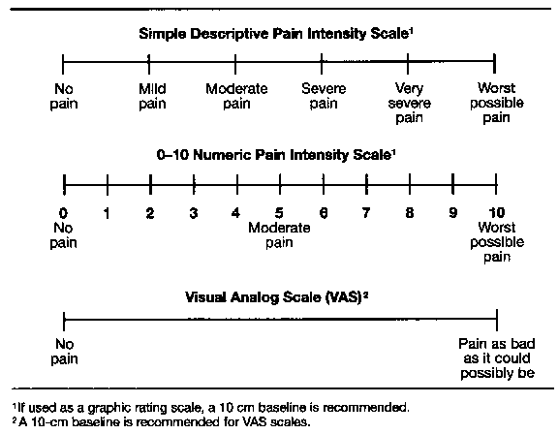
No itch worst possible itch
Visual analogue scale (VAS)

Grading of response to treatment by measuring reduction of skin lesions as follows:
Grade 0 (no response): same number of lesions
Grade I (mild response): less than one third of lesions reduction.
Grade II (moderate response): more than one third and less than two thirds reduction.
Grade III (dramatic response): more than two third of lesion reduction.
The patients were divided into 3 groups as follows:
Group 1: those patients with initial skin lesions less than 10.
Group 2: those patients with initial skin lesions between 10-20.
Group 3: those patients with lesions more than 20 or with hypertrophic LP.
Follow up of patients for recurrence was done for 3 months after the last session.
Any side effects of enoxaparin appeared during the period of study was also recorded.
Statistical analysis
All data coded and computerized using SPSS 7.5 (statistic package for social science). Response to treatment was measured by using paired and unpaired t-test, chi-square test and analysis of variance (ANOVA) test. P value <0.05 was considered significant.

Results
Eighteen patients with Lp were included in this study. Three patients did not complete the treatment and considered as default for unknown reasons.
The remaining 15 patients who completed the study were 9 males and 6 females (male: female ratio is 3:2). (Figure1).
Patient’s age ranged from 17 to 53 years with a mean + SD of 34.13 + 12.01 years. (Figure 2).

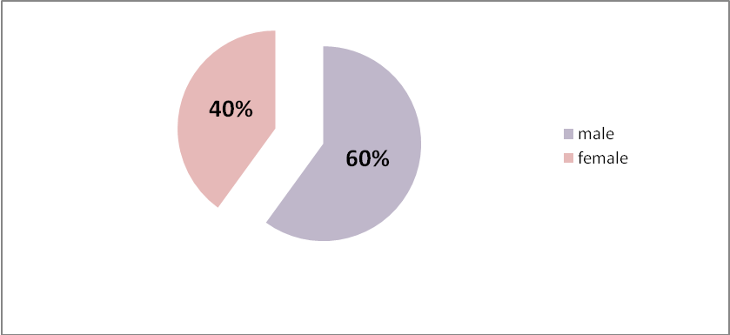
Figure 1 Sex distributation of Lp patients

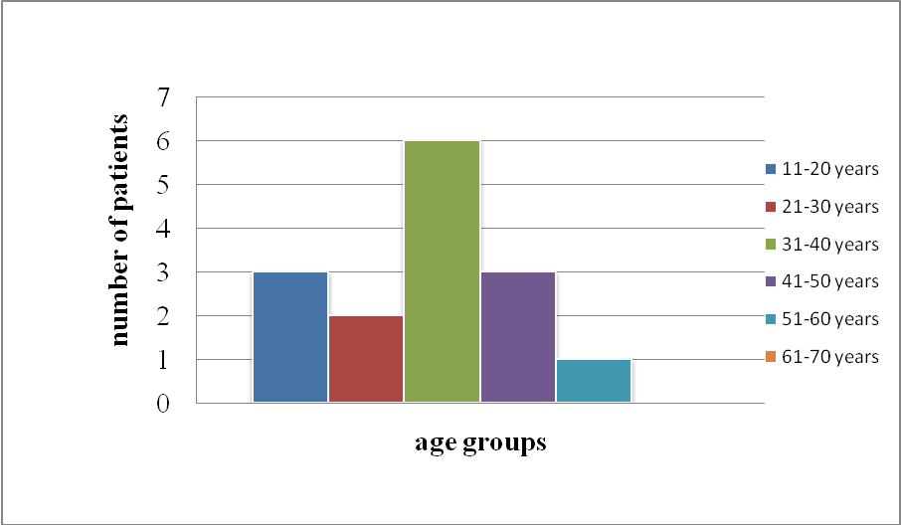
Figure 2 Age distribution of Lp patients

The severity of itching was assessed by visual analogue scale (VAS) as follows:
Before treatment mean score + SD was 8.93+ 1.16, this score decreased to 8.133+1.24 in the second week of treatment (statistically not significant). Table (1).
The score continue to decrease to reach 6.53+1.84 in the end of the 1st month (table2) and became 3.2+3.42 in the end of 2nd month (statistically significant). Table (3).
The VAS score was 2 +3.33 and finally decreased to 1.8+3.42 at the end of the 5th month of treatment.
The gradual reduction in VAS score for all fifteen patients over the period of 5 months was illustrated in table (4).

Table 1 VAS score before treatment and after 2 weeks.

 | Patients number | Mean VAS score | SD | p-value
Before treatment | 15 | 8.93 | 1.16 | 0.078  Not significant
After 2 weeks | 15 | 8.13 | 1.24 | 0.078  Not significant

Table 2 VAS score before treatment and after 1 month.

 | Patients number | Mean VAS score | SD | p-value
Before treatment | 15 | 8.93 | 1.16 | 0.0002  significant
After 1 month | 15 | 6.53 | 1.4 | 0.0002  significant

Table 3 VAS score before treatment and after 2 months.

 | Patients number | Mean VAS score | SD | p-value
Before treatment | 15 | 8.93 | 1.16 | <0.0001  significant
After 2 month | 15 | 3.2 | 3.42 | <0.0001  significant

Table 4 VAS score of all patients over 5 months of treatment.

Patient No. | 0 week | 2 weeks | 1 month | 2 month | 3 month | 4 month | 5 month
1 | 10 | 8 | 5 | 2 | 1 | 1 | 0
2 | 10 | 10 | 8 | 3 | 3 | 1 | 0
3 | 9 | 7 | 6 | 1 | 0 | 0 | 0
4 | 8 | 8 | 8 | 8 | 8 | 8 | 8
5 | 10 | 10 | 7 | 0 | 0 | 0 | 0
6 | 7 | 7 | 5 | 0 | 0 | 0 | 0
7 | 7 | 6 | 4 | 1 | 1 | 1 | 0
8 | 10 | 9 | 7 | 2 | 0 | 0 | 0
9 | 7 | 7 | 7 | 3 | 1 | 0 | 0
10 | 9 | 8 | 5 | 0 | 0 | 0 | 0
11 | 10 | 8 | 4 | 0 | 0 | 0 | 0
12 | 9 | 7 | 5 | 3 | 2 | 0 | 0
13 | 10 | 10 | 10 | 10 | 8 | 8 | 8
14 | 9 | 8 | 8 | 6 | 4 | 2 | 2
15 | 9 | 9 | 9 | 9 | 9 | 9 | 9
mean | 8.933333 | 8.133333 | 6.533333 | 3.2 | 2.466667 | 2 | 1.8
SD | 1.162919 | 1.245946 | 1.84649 | 3.426785 | 3.270357 | 3.338092 | 3.426785

Assessment of response according to the reduction in the number of lesions for the three groups of patients was as follows:
Group I (patients with mild LP): they were 6 patients.
The results of mild type LP treated with enoxaparin are shown in table (5). The mean number of lesions before treatment was 8+ 0.81, after one month became 7+ 1.37, this number continue to decrease to 5+ 2.42 at the end of 2nd month, then 4+ 2.42 at 3rd month, 3+ 3.1 in the 4th month and finally 3+ 3.03 at the end of the 5th month. P-value was 0.0029 which is statistically significant.
The response grading was as follows at the end of 20 weeks of treatment:
Grade 0: one patient (16.66%).
Grade 1: one patient (16.66%).
Grade 2: two patients (33.33%).
Grade 3: two patients (33.33%).
Total response rate of group I patients with mild LP (grade1+2+3) was 83.33%.
The gradual reduction in the number of lesions of group I patients over the 5months of therapy is shown in table (6).

Table 5 Response to treatment of group I patients with mild LP.

time | Patients no. | Mean number of lesions | SD | p-value
Before treatment | 6 | 8 | 0.81
1 month | 6 | 7 | 1.37
2 months | 6 | 5 | 2.42
3 months | 6 | 4 | 2.63
4 months | 6 | 3 | 3.14
5 months | 6 | 3 | 3.03
Before treatment | 6 | 8 | 0.81 | 0.0029  significant
After 5 months | 6 | 3 | 3.03 | 0.0029  significant

Table 6 The gradual reduction in the number of lesions of group I patients over the 5 months of therapy.

Patient no. | Number of lesions |  |  |  |  |  | grading
Patient no. | Before  therapy | 1ST month | 2ND month | 3RD month | 4TH month | 5TH month | grading
1 | 9 | 7 | 3 | 1 | 0 | 0 | 3
2 | 8 | 6 | 2 | 2 | 1 | 0 | 3
3 | 9 | 9 | 7 | 5 | 5 | 4 | 2
4 | 7 | 6 | 5 | 3 | 1 | 2 | 2
5 | 9 | 9 | 7 | 6 | 5 | 4 | 1
6 | 8 | 8 | 8 | 8 | 8 | 8 | 0
mean | 8.333333 | 7.5 | 5.333333 | 4.166667 | 3.333333 | 3
SD | 0.816497 | 1.378405 | 2.42212 | 2.639444 | 3.141125 | 3.03315

Group II (patients with moderate LP): they were 7 patients.
The results of moderate type LP treated with enoxaparin are shown in table (7). The mean number of lesions before treatment was 15+ 2.73, after one month became 14+ 2.73, this number continue to decrease to 12+ 4.30 at the end of 2nd month, then 10+ 4.34 at 3rd month, 9+ 5.59 in the 4th month and finally 8+ 6.16 at the end of the 5th month. P-value was 0.0175 which is statistically significant.
The response grading was as follows at the end of 20 weeks of treatment:
Grade 0: two patient (28.57%).
Grade 1: two patient (28.57%).
Grade 2: one patients (14.28%).
Grade 3: two patients (28.57%).
Total response rate of group II patients with moderate LP (grade1+2+3) was 71.42%.
The gradual reduction in the number of lesions of group II patients over the 5months of therapy is shown in table (8).

Table 7 Response to treatment of group II patients with moderate LP.

time | Patients no. | Mean number of lesions | SD | p-value
Before treatment | 7 | 15 | 2.70
1 month | 7 | 14 | 2.73
2 months | 7 | 12 | 4.30
3 months | 7 | 10 | 4.34
4 months | 7 | 9 | 5.59
5 months | 7 | 8 | 6.61
Before treatment | 7 | 15 | 2.70 | 0.0175  significant
After 5 months | 7 | 8 | 6.61 | 0.0175  significant

Table 8 The gradual reduction in the number of lesions of group II patients over the 5 months of therapy.

Patient no. | Number of lesions |  |  |  |  |  | grading
Patient no. | Before  therapy | 1ST month | 2ND month | 3RD month | 4TH month | 5TH month | grading
1 | 15 | 15 | 15 | 14 | 14 | 14 | 0
2 | 18 | 18 | 18 | 18 | 18 | 18 | 0
3 | 16 | 14 | 9 | 8 | 4 | 3 | 3
4 | 12 | 11 | 7 | 5 | 2 | 0 | 3
5 | 15 | 13 | 10 | 8 | 8 | 7 | 2
6 | 18 | 17 | 17 | 12 | 12 | 10 | 1
7 | 11 | 11 | 10 | 10 | 9 | 8 | 1
mean | 15 | 14.14286 | 12.28571 | 10.71429 | 9.571429 | 8.571429
SD | 2.708013 | 2.734262 | 4.309458 | 4.347961 | 5.593363 | 6.16055

Group III (patients with severe LP): they were 2 patients.
This group consist of only two patients. One of them had severe LP (lesions were more than 20) showed only mild improvement, and the other had hypertrophic type lichen planus and he showed dramatic complete response of his chronic lesion with only residual hyperpigmentation.
The treatment with enoxaparin was safe and there were no side effects recorded during the period of treatment.
There was no recurrence of LP recorded after 3 months following the last session of treatment in all patients.

Discussion
Lichen planus is one of the common dermatological problems which can affect any age group but specially people more than 30 years old, it affects both sexes equally [1, 2]. In our study, mean age of patient was 34 years which is comparable to what’s written in literature. Male: female ratio was 3:2 which is probably due to small sample size.
Small number of patients was included in this study (only 15 patients over a period of two years), this small sample size because we choose only recalcitrant cases of LP who are not responsive to topical or systemic steroid therapy, many patients could not follow the prolonged course of therapy (poor compliance) and also because of exclusion criteria.
Treatment of LP has routinely consisted of prescription strength topical steroid creams or ointments and oral antihistamines to stop itching. However, these treatments rarely help the rash itself and in many instances it is unsatisfactory. Other treatment options which show efficacy in steroid resistant cases like; cyclosporine, oral retinoid, immunosuppressive agents, antimalarials, PUVA, thalidomide all have serious side effects beside relapse rate after discontinuation of the drug is a common problem. [2, 3]
Although spontaneous remission may occur in LP, the natural history is highly variable and dependent on the site of involvement and clinical pattern [1].
Enoxaparin is a low molecular weight heparin that is widely used to prevent and treat thromboembolic disorders. It shows less ability to prolong the activated partial thromboplastin time and less microvascular bleeding than standard commercial grade heparin [12]. The recommended daily dose of enoxaparin in these diseases range from 20-80mg/ day subcut. injection.
The mechanism by which enoxaparin improve LP is unknown. Very low subcutaneous doses of enoxaparin inhibited the traffic of sensitized lymphocytes to a graft site and prolonged skin allograft survival in mice [13]. In vitro and in vivo studies in animals showed that low dose heparin suppressed the expression of T-lymphocytes heparanase activity and concurrently inhibit T-cells migration and delayed type hypersensitivity reaction [13, 14]. It also appears that the immunomodulatory molecules in heparin might be sulfated disaccharides which seem to inhibit the production of TNF-α [15].
Previous studies have shown that a small dose of enoxaparin (3mg) weekly subcut. injection is effective in treatment of LP [4, 6, 7, 8].
We try the same regime among our patients with Lp to evaluate the efficacy of the drug and its safety among our population.
Enoxaparin found to be very effective in reducing the severity of Pruritus in LP patients as there was dramatic reduction in VAS score in 13 patients of the 15 patients (86.6%).
This reduction is considered statistically significant in the end of the 1st month of treatment. The result is comparable with other studies [4, 7, 16]. It appears obviously that enoxaparin can omit the most annoying symptom in lichen planus in relatively short time.
The number of patients that respond to therapy in the end of treatment course was 12 patients (80%), this include all grades of improvement (mild 26.6%, moderate 20%, and dramatic 33.33%). This end result is also comparable with other studies [4], but more than response rate of other studies which shows 72% and 71% respectively [8, 9]. A study was done in Istanbul city in 2004 using the same treatment program showed that 14 patients out of 15 respond to treatment (93.3%), including 60% complete response and 33.3% partial response [16].
In our study, patients with mild type LP showed a response of (83.33%) which is higher than the response rate of moderate LP (71.42%). The latest group may need more treatment sessions.
We had a solitary case of hypertrophic LP which showed a complete response within 18 weeks of treatment leaving only residual hyperpigmentation. This result makes enoxaparin a good choice for patient with chronic hypertrophic LP.
We found that enoxaparin is a safe harmless drug in this very low weekly doses as there were no side effects reported during treatment course, this is also the same result found in previous studies [4, 7, 8, 9, 16].
Recurrences after treatment are not recorded 3 months following the last treatment taken. This is comparable with some previous studies [4, 12].

Conclusions
Enoxaparin is effective, safe, simple and good alternative therapy for acute and chronic recalcitrant lichen planus, specially those who complain from severe itching, those who use prolonged courses of steroid therapy without benefit and those with hypertrophic type LP.

Recommendations
- We recommend putting enoxaparin in the list of effective therapies for LP and to test its efficacy in other types of LP especially that involves the mucous membranes and scalp.
- Try to use enoxaparin for other refractory skin diseases that involve the activation of T-lymphocytes in its pathology or have the same histopathological picture like lichen planus (lichenoid disorders).
References
- William D.J., Timothy G.B., Dirk M.E. Lichen planus and related conditions. In: Andrew’s diseases of the skin clinical dermatology, 10th edition, volume 1, chapter 12, Canada, Elsevier Saunders company 2006: 217-229.
- Breathnach S.M., Black M.M. Lichen planus and lichenoid disorders. In: Tony B., Stephen B., Neil C., Christopher G. (Eds.). Rook’s textbook of dermatology, 7th edition, volume 3, chapter 42, Oxford, Blackwell science 2004: 42.1-42.19.
- Mark R.P., Mazen S.D. lichen planus. In: Klaus W., Goldsmith L.A., Katz S.I., Gilchrest B.A., et al. (Eds.). Fitzpatrick’s dermatology in general medicine, 7th edition, volume 1, chapter 26, New York, McGraw-Hill Company 2008: 243-256.
- Akdeniz S., Harman M., Atmaca S., Yaldiz M. The management of lichen planus with low molecular weight heparin (enoxaparin). Int J Clin Pract 2005 november, 59 (11): 1268-1271.
- Habif T.P. Psoriasis and other papulosquamous diseases. Clinical dermatology: a color guide to diagnosis and therapy, 4th edition, chapter 8, Philadelphia, Mosby inc. 2004: 250-256.
- Klaus W., Richard A.J., Dick S. Lichen planus. In: Fitzpatrick’ color atlas and synopsis of clinical dermatology, 5th edition, part 1, section 7, New York, McGraw-Hill 2005: 123-127.
- Hodak E., Yosipovitch G., David M., Ingber A. et al. low-dose low-molecular weight heparin (enoxaparin) is beneficial in lichen planus: a preliminary report. Journal Am Acad Dermtol 1998; 38: 564-568.
- Stefanidou M.P., Loannidou D.J., Panayiotides J.G., Tosca A.D. Low molecular weight heparin; a novel alternative therapeutic approach for lichen planus. Br J Dermatol 1999 Dec; 141(6): 1040–1045.
- Neville J.A., Hancox J.G., Williford P.M., Yosipovitch G. Treatment of severe Cutaneous ulcerative lichen planus with low molecular weight heparin in a patient with hepatitis C. Cutis 2007 Jan; 79(1): 37-40.
- Pacheco H., Kerdel F. Successful treatment of lichen planus with low molecular- weight heparin: a case series of seven patients. J Dermatolog Treat 2001; 12(2): 123–126
- Ingber A, Trattner A, Cohen IR, Mekori YA. Low doses of low molecular weight heparin in vivo inhibits the elicitation of contact hypersensitivity. Acta Derm Venereol 1994; 74:454-6.
- Hirsh J, Levine M. Low molecular weight heparin. Blood 1992;19: 1–17.
- Gorski A., Makula J., Morzycka-Michalik M., Lao M., Gradowska L. Low-dose heparin: a novel approach in immunosuppression. Transpl Int 1994; 7:567–569.
- Lider O, Mekori YA, Miller T et al. Inhibition of T lymphocyte heparanase by heparin prevents T cell migration and T cell mediated immunity. Eur J Immunol 1990; 20: 493–495.
- Cahalon L., Lider O., Schor H., Avron A., Gilat D., Hershkovis R., et al. Heparin disaccharides inhibit tumor necrosis factor–α production by macrophages and arrest immune inflammation in rodents. Intern Immunol 1997; 9: 1517-1522
16. Şirin Y., Tülin M., Fatih G., Kürşat Y., Selvinaz Ö. The clinical and histopatho- logical evaluation of the efficacy of enoxaparin in lichen planus. Turkiye klinikleri Dermatol 2004;14(3):136-141

.

