Superficial Temporal Artery Aneurysm
Two Case Reports
Mohammed Jaber Al-Mamori
Department of Neurosurgery, Hilla Teaching Hospital, Babylon, Iraq.
Case Report
M J B

Abstract
Aneurysms of the superficial temporal artery (STA) are a rare and potentially critical cause of facial masses. Usually, these aneurysms are Pseudoaneurysm and occur following blunt or penetrating trauma to the head or following surgery in the temporal region. Most cases (about 75%) are the result of blunt head injury. Only 11 cases of spontaneous aneurysms were reported. These aneurysms are assumed to have been congenital or arteriosclerotic. Pseudoaneurysm has occurred mainly in the anterior branch of the STA. The first case of a STA Pseudoaneurysm was described by Thomas Bertholin in 1740 and since then about 400 cases have been published in the literatures. I present two cases of traumatic pseudoaneurysm of the STA and I discuss pertinent diagnosis and treatment options, as well as provide a brief review of the anatomy and histopathology of pseudoaneurysms.
Case Reports
Case (1):

A 36-year-old gentleman is admitted to the Neurosurgery department of our hospital as victim of road traffic accident with severe head injury. He had large cutting wound on the left parietal region of the scalp. The patient presented in shock state due to severe bleeding from scalp wound and has left side facial palsy. CT-Scan of brain: shows; (1) Right parietal hemorrhagic contusion (2) Subarachnoid hemorrhage (3) Right parietal linear fracture extending to the left parietal region (4) huge left sided subgaleal hematoma. Scalp wounds have been sutured and shock state has been corrected. He stays in the hospital for two weeks and discharged well to home. Chief complain: About 3 weeks after discharge, the patient noticed a solitary, painless, progressively increasing swelling in the left temple accompanied by a persistent throbbing headache (Figure 1-1). The patient complains from posttraumatic partial seizure proved by electroencephalogram and treated by phenytion. Examination: shows a swelling that is well defined, pulsatile, non-tender, no thrill or bruit and measured about (2 cm x 2 cm).The pulsations in the mass diminish when pressure is applied proximally over the STA. MRI, MRA & MRV of brain: shows the previous brain insult but no visible abnormality related to complaint. Diagnostic cerebral angiography: shows ; normal left common carotid artery, normal bifurcation, selective cannulation of the left external carotid artery shows; an aneurysm (2.0 x 2.5 cm) of STA in the temporal fossa at the point of bifurcation between anterior and posterior divisions (Figures 2-2 and 1-3). No evidence of intracranial extension. Conservative treatment: trial of continuous repeated compression of the lesion has been attempted in the hope of inducing spontaneous thrombosis of aneurysm has been failed. Surgical Operation: under general anesthesia, question- mark incision around the mass is done. Delicate dissection of the aneurysm from its surroundings and exposure of the main trunk of STA and its anterior and posterior branches is done. Ligation of the main artery near the aneurysm and its anterior and posterior branches, then excision of the STA aneurysm is performed (Figures 3-3 and 1-4). After surgery the patient refuses to do a histopathological study of the specimen.

Case (2):

A 37-year-old policeman is admitted to the respiratory care unit of our hospital as victim of blast injury. He has multiple shell injuries two of them in the left and right temporal region of the scalp extracranially. He was unconscious GCS=6/15 with right sided hemiparesis and he depend on mechanical ventilator for about two weeks. CT-Scan of brain: (immediately after injury) shows; Subarachnoid hemorrhage, extracranial shells in the left and right temporal region but no skull fracture. There is complete resorption of subarachnoid hemorrhage on CT-scan two weeks later. One month later the patient returns gradually his consciousness, memory and normal motor power. Chief complain: The patient presents in the clinic 6 months after blast injury with pulsating headache on the right side. Examination: there is small pulsating compressible mass in the right temple, non-tender, no thrill or bruit. CT-Scan of brain: (6 months after injury) shows; normal brain parenchyma and there is small extracranial hyperdense mass over the temperalis muscle in the right side of the scalp with metallic sell nearby on the anterior edge of it (Figure 2-1). Diagnostic cerebral angiography: (7 months after injury) shows; there is small false aneurysm of the anterior division of the right STA measured (1 cm x 1 cm). No evidence of intracranial extension (Figure 2-2). Management: because of small size of the aneurysm conservative management with analgesics and monthly-based examination of the patient for any increase in the size of aneurysm is done.
Discussion
Anatomy: The external carotid artery splits to form three anterior, three posterior, and two terminal branches. The terminal branches (superficial temporal and internal maxillary) and one of the anterior branches (facial artery) are the vessels most susceptible to injury. Although generally protected from trauma by surrounding soft tissue, the branches of the STA sometimes approach the skin’s surface in bony facial regions. At such locations, the branches are susceptible to injury by external forces. STA first winds posterior to the temporomandibular joint (TMJ), making it vulnerable to injury during surgical exploration of theTMJ. As STA exits the parotid gland, it superficially crosses the bony zygomatic arch, dives deep under the thick, sheltering temporal skin, and then emerges again at the superior temporal line of the skull where it is re-exposed to potential trauma.
Histopathology: An aneurysm may be classified as true, false, or dissecting. True aneurysms involve three intact arterial wall layers and account for most aneurysms. Pseudoaneurysms of the STA are rare and account for less than 1% of all aneurysms, they are dissimilar histologically from true aneurysms as they do not contain all three layers of the arterial wall and 95% of these lesions are traumatic in origin, which develop as a result of complete or incomplete disruption of arterial intima, possibly due to trauma-induced necrosis of a section of the arterial wall. This disruption allows for extravasation and the formation of a blood-filled balloon that is encapsulated only by arterial adventitia or subcutaneous tissue. A fibrous pseudocapsule consisting of mucopolysaccharide-rich connective tissue replaces the arterial wall as the hematoma undergoes cavitation due to infiltrating leukocytes. As this tissue reorganizes, the hematoma can recanalize because of lysis and destruction of the luminal thrombus and extramural clot. This, in turn, allows substantial flow through the damaged artery and, thereby, expansion of the artery. Progressive dilatation of the weak hematoma capsule explains the delayed appearance of a pulsating mass. The majority of these aneurysms were found in males.
Mechanism of injury: Traumatic STA aneurysms are mainly associated with sporting injuries. Most STA aneurysms involve the anterior branch of the STA rather than the proximal STA or its posterior branch. Iatrogenic causes of STA aneurysms have been reported.
History and physical examination findings: In the primary care setting, a brief examination of a patient with a Pseudoaneurysm may yield a presumptive diagnosis of an abscess or cyst. However, a detailed history and careful palpation can narrow the differential diagnosis considerably. A diminution or disappearance of pulsation with compression of the proximal STA is meaningful finding; however, this might be possible in a case of arteriovenous malformation too. Most of these pseudoaneurysms tend to present 2 to 6 weeks following initial injury but the reported time between trauma and diagnosis of aneurysm is ranged from just a few hours to as long as 10 years. Most complain of a single or multiple painless swellings occurring in the distribution of the STA with or without associated pulsations, headache and ear discomfort, or buzzling, dizziness, hemorrhage if the pseudoaneurysm leaks or ruptures and unacceptable cosmesis. The mass may enlarges and compress adjacent arteries and nerves, causing cranial nerve palsies, numbness and paresthesia and vascular compromise. Luminal thrombus could theoretically embolize to a main vessel, although the later event is unlikely. A thrill or bruit may or may not be appreciable. STA pseudoaneurysm sizes have varied from 0.5cm to 5.7cm, with the most common size being 1 to 1.5cm. Although there are several reports of multiple lesions, most patients had single lesion (approximately 90% of cases).
Diagnostic evaluation: Skull x-rays are poorly sensitive. Echo-Doppler may reveal a waveform of turbulent flow and high peripheral vascular resistance, which would eliminate consideration of an arteriovenous fistula. Contrast computed tomography or magnetic resonance imaging may find extracranial masses and intracranial pathology. Arteriography is the diagnostic study of choice, but selective angiography with subtraction technique may better demarcate small aneurysms.
Differential diagnosis: Temporal artery Pseudoaneurysm may mimic epidermal inclusion cysts, lipomas, hematomas, abscesses, sebaceous cysts, and aneurysms, arteriovenous fistulas of the middle meningeal artery, vascular and soft tissue tumors, lymphadenopathy and encephalocele.
Treatment options: Conservative treatment such as repeated compression of the lesion has not been recommended because the aneurysm may cause discomforting headaches and cosmetic disfiguration to the patient. Treatment is indicated to prevent a potentially lethal hemorrhage, relieve symptoms and for cosmetic purposes. STA pseudoaneurysm has the risk of rupture and hemorrhage, and may cause bony erosions in the long term. The treatment of choice is ligation and resection of the aneurysm that provides a better cosmetic result, which can be performed under local or general anesthesia. General anesthesia may be necessary for the surgical excision of the STA Pseudoaneurysm if the aneurysm is located in proximity to the facial nerve or parotid gland for safe access. Embolization has become a popular mode of treatment of vascular abnormalities, and successful occlusion of the STA Pseudoaneurysm was reported in the literature. However, possible complications such as occlusion of the underlying artery and ischemic stroke following no target embolization should be considered. Other limitation of embolization is the elapsed time, which takes longer than surgical repair to resolve the mass effect created by thrombosed aneurysm.

Conclusions
Although rare, STA aneurysm should be considered when a temporal head mass is evaluated. This condition is almost always a result of blunt or penetrating head trauma. Clinical examination is sufficient to predict the diagnosis. Simple elective ligation and excision of the aneurysm is curative.
Abbreviations
STA: Superficial temporal artery

Figures
Photographs, angiographies, CT-scan of case (1) and case (2) are showing in the following figures:

Case (1):
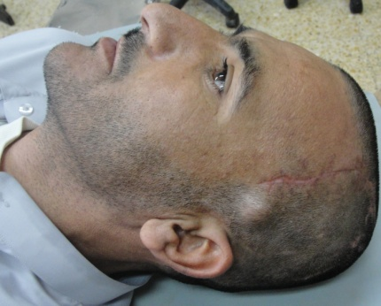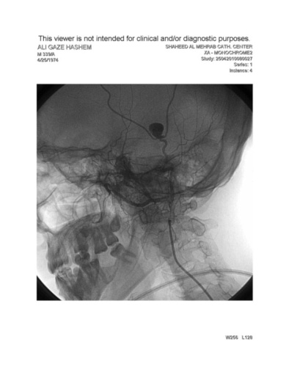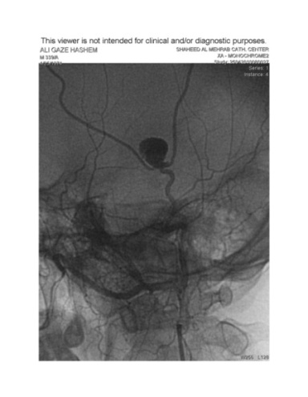
Figure 4-1 Figure 5-2 Figure 6-3
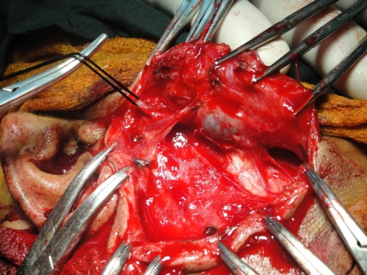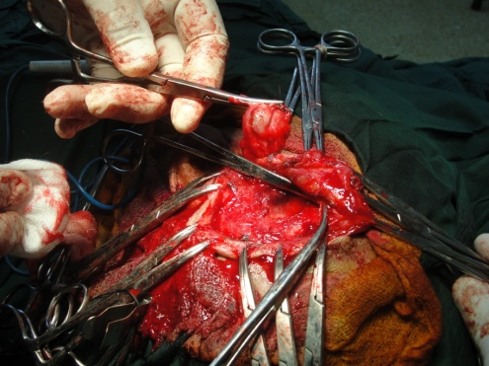

Figure 7-3 Figure 8-4

Case (2):
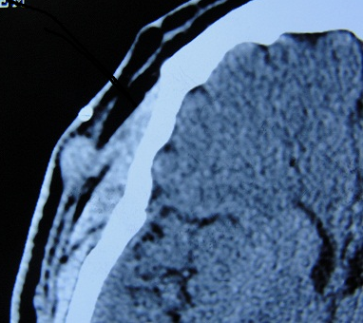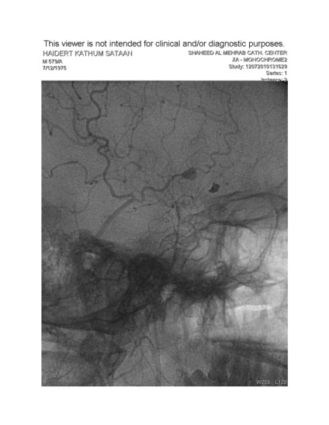

Figure 2-1 Figure 2-2

References
- Peick A, Nicholas W. Curtis J, et al. Aneurysms and pseudo aneurysms of the superficial temporal artery caused by trauma. JVasc Surg 1988; 8:606.
- Bailey IC, Kiryabwire JW. Traumatic aneurysms of the superficial temporal artery. Br J Surg 1973; 60:530.
- Schechter MM, Gustein RA. Aneurysm and arteriovenous fistulas of the superficial temporal vessels. Radiology 1970; 97:549-57.
- Giele H, Robbins P, Smith C. False aneurysm of the superficial temporal artery: a surgical complication. Ann Plast Surg 1996; 36:219-206.
- Vengsarkar US, Rovit RL, Damany BJ. Traumatic Aneurysm and A.V. Fistula of the Superficial Temporal Artery. Neurology India 1972; 20:233-7.
- Bole PV, Munda R, Purdy RT, et al. Traumatic pseudoaneurysm: a review of 32 cases. J Trauma 1976; 16:63-70.
- Angevine PD, Connolly ES. Pseudoaneurysm of the superficial temporal artery secondary to placement of external ventricular drainage catheters. S Neurol 2002; 58:258-260.
- Fernández-Portales I, Cabezudo JM, Lorenzana L, Gómez L, Porras L, Rodríguez JA. Traumatic aneurysm of the superficial temporal artery as a complication of pin-type head-holder device: case report. Surg Neurol 1999; 52:400-403.
- Chad H, Rod JR, and Richard AP: Traumatic aneurysm of the face and temple; a patient report and literature review, 1644 to 1998. Ann Plast Surg 41 : 321-326, 1998
- Caroline MW, Gary GW, Richard GB: Pseudoaneurysm of the superficial temporal artery; Report of a case. J Oral Maxillofac Surg 55 : 166-169, 1997
- James TF, Paul RC, Bryon CG: Traumatic aneurysm of the superficial temporal artery; Case report. J Trauma 36 : 562-564, 1994
- Lee CD, Jung HT, and Kang JK, Doh JO: Traumatic false aneurysm-Two cases of traumatic false aneurysm of the superficial temporal artery. J Korean Neurosurg Soc 23 : 816-820, 1994
- Choo MJ, Yoo IS, Song HK. A traumatic pseudoaneurysm of the superficial temporal artery. Yonsei Med J 1998; 39:180-183.
- Pipinos II, Dossa CD, Reddy DJ: Superficial temporal artery aneurysms. J Vasc Surg 27 : 374-377, 1998
- Vince AP, Joseph C, Raphael G: US-guided percutaneous thrombin injection: A new method of repair of superficial temporal artery pseudoaneurysm. J Vasc Intervent Radiol 11 : 461-463, 2000
- Jeffrey LZ: Pseudoaneurysm after penetrating trauma in children and adolescents. J Ped Surg 33 : 1574-1577, 1998
- Lalak NJ, Farmer E. Traumatic pseudoaneurysm of the superficial temporal artery associated with facial nerve palsy. J Cardiovasc Surg 1996; 37:119-123.
- Merkus JWS, Nieuwenhuijzen GAP, Jacobs PPM, van Roye SFS, Koopman R, et al. Traumatic pseudoaneurysm of the superficial temporal artery. Injury 1994; 25:468-471.
- Pennington C, Lewis JV. Traumatic pseudoaneurysm of the superficial temporal artery. Tennessee Medicine 1997; 90:284.

