Spirometric and Haemodynamic Changes after Therapeutic Thoracocentesis
Falah A Deli Haider Jabbar kadum Hasan Saleh
Al Sader Teaching Hospital, Al-Najaf ,Iraq.

M J B

Abstract:
Objective: Pleural effusion is accumulation of plural fluid by different mechanisms. Thoracocentesis is associated with subjective improvement in many patients. The results of spirometric and haemodynamic changes after this procedure are controversial.We aimed to study the effect of therapeutic thoracocentesis on patients with pleural effusion by assessment of spirometric values and haemodynamic changes (blood pressure assessment).
Materials and methods: This is a prospective study done in the medical ward, at Al Sader teaching hospital from 1st march to the end of September 2008. Pleural effusions were documented clinically and by CXR. Pulmonary function was performed with a computed Spirometric analyzer. Spirometric measurements for forced expiratory volume in the first second (FEV1), forced vital capacity (FVC), forced expiratory volume in the first second percent (FEV1)%, and peak expiratory flow rate (PEF) were performed according to the American Thoracic Society criteria and blood pressure measurements were also done. The lung function test (spirometric assessment) and blood pressure measurement were repeated 24 hours after thoracocentesis. The data were analyzed by using the SPSS Version l0, X² (Chi square) and a (p-value of <0.05) was regarded as statistically significant.
Results: The study population consisted of 20 patients 10(50%) male and 10(50%) female with a mean age of 59.25 years , average weight 58.15 Kg, average height 154.85cm and average of pleural aspirate 1367.5cc, Pulmonary function (spirometer) before thoracocentesis ( FVC/1.47,FEV1/1. 21, FEV1%84.92,PEF2.52)and pulmonary function (spirometer) post-thoracocentesis (FVC/1.841,FEV1 1.503 ,FEV1%82.845,PEF2.9)
Conclusion: Statistically significant improvement in spirometric values following thoracocentesis was observed in patients with pleural effusion while no changes in blood pressure measurements

Introduction
Pleural effusion is accumulation of fluid in pleural cavity of different etiological causes ,it is divided in three grades of severity; mild, moderate and severe according to the amount of fluid and degree of obliteration of lungs field through clinical examination and chest x ray findings [1,2].
Pleural effusion is suspected when there is blunting and medial displacement of the sharp costophrenic angle on posterior-anterior view chest x ray.sometimes this view fails to demonstrate the effusion whereas the lateral decubitus view did.[1,2]
Therapeutic thoracocentesis involves removing a considerable amount of fluid but no more than 1000-1500ml should be apirated at one time because of pulmonary edema that may occur in the re-expansion of the underlying lung.[1,2]
Lung function changes associated with the presence of pleural effusion include restrictive lung volumes and decreased lung compliance [3,4,5]. Patients with large pleural effusions often experience rapid relief from dyspnoea after removal of the pleural effusion. The physiological explanation of the subjective improvement is still unclear. When a pleural effusion is removed from a hemithorax, either the lung must expand to fill the space or the hemithorax must get smaller. Previous studies have shown either no definite improvement[3,6,7] in pulmonary function test and blood pressure changes or a relatively small improvement [8,9] in pulmonary function after therapeutic thoracocentesis.

Patients and Methods
This is a prospective study done in the medical ward, at Al Sader teaching hospital from 1st march to the end of September 2008
Study population
Inpatients in the medical ward, a large pleural effusion documented by CXR and the ability to perform pulmonary function test. A large pleural effusion was defined as obliteration of more than half the hemidiaphragm. At the time of investigation, all patients were clinically stable and each patient gave informed consent for the procedure, patient with longstanding pleural effusion and repeated aspirations were excluded.
Pre-thoracocentesis assessment
All patients were examined in an upright seated position, Spirometry was performed with a pulmonary function analyser (computed spirolap 11). Spirometric measurements for FEV1, FVC, FEV1%,PEF were performed according to the American Thoracic Society which defines acceptable spirometry as an expiratory effort that shows(1)minimal hesitation at the start ,(2)no cough in the first second of forced exhalation,and(3)meets 1of 3 criteria that define a valid end-of-test:(a)smooth curvilinear rise of the volume-time tracing to a plateau of at least 1-second duration;(b)if a test fails to exhibit an expiratory plateau, a forced expiratory time of 15 seconds;or(c)when the patient cannot or should not continue forced exhalation for valid medical reason. Blood pressure measure also done, the lying and sitting readings were taken and the mean was obtained for every patient, using mercury type sphygmomanometer.
Thoracocentesis procedure
Immediately after the assessment a therapeutic thoracocentesis was commenced and continued until one of two events occurred: no more fluid could be obtained or the patient developed symptoms such as chest pain, cough, or shortness of breath. The pleural effusion was aspirated slowly using a wide pore needle through the eighth or ninth intercostal space while the patient was seated, no more than 1.5 litter was aspirated.
Post-thoracocentesis assessment
lung function (spirometer) test and blood pressure meassrement, were repeated 24/ hour after thoracocentesis.. There were no post thoracocentesis complications such as pneumothorax, pulmonary oedema ,chest wall pain that could interfere with assessments.
Statistical analysis
Lung function test, blood pressure were compared before and after thoracocentesis.The data were analyzed by using the SPSS Version 10,X² and A p-value of <0.05 was regarded as statistically significant

Results
The study population consisted of 20 patients 10(50%) male and 10(50%) female with a mean age of 59.25 years , mean weight 58.15 Kg, mean height 154.85cm and average of pleural aspirate 1367.5cc As in table -1

Table-1 show demographic and Clinical Characteristics of patients

Patients Characteristic |  | Items
mean age |  | 59.25 yr
Sex | Male | 10(50%)
Sex | Female | 10(50%)
Mean Weight |  | 58.15 Kg
Mean Height |  | 154.85 Cm
Mean Amount of Pleural effusion aspirate |  | 1367.5 cc

Pulmonary function (spirometry) before thoracocentesis (FVC/1.47, FEV1/1. 21 ,FEV1%84.92,PEF2.52)and pulmonary function (spirometer) post-thoracocentesis (FVC/1.841,FEV1 1.503 ,FEV1%82.845,PEF2.9) (Table -2).

Table 2 Pulmonary function (spirometer) test before and after thoracocentesis
Pulmonary function test | Pre-thoracocentesis | Post-thoracocentesis | p-value
FVC | 1.47 | 1.841 | <0.05
FEV1 | 1. 21 | 1.503 | <0.05
FEV1 % | 84.92 | 82.845 | <0.05
PEF | 2.52 | 2.9 | <0.05

The hemodynamic state ( blood pressure) show no significant changes after thoracocentesis p value = >0.05 in systolic B.p and p value = >0.05 in diastolic B.p as in figure -1 and figure -2

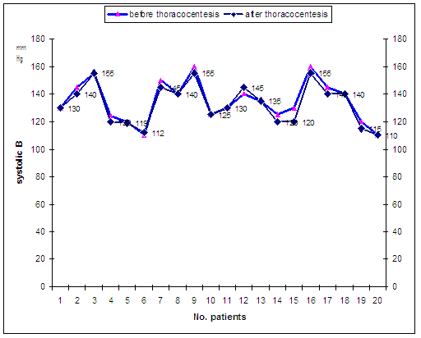
Figure 1 show systolic B.p before and after thoracocentesis ( P = 0.39)

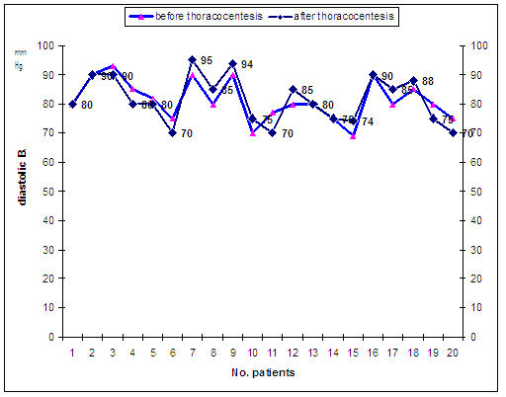
Figure2 Diastolic B.p before and after thoracocentesis

Discussion
Previous studies have shown that pleural effusions are associated with restrictive impairment and hypoxaemia[4,5] and that any increase in lung volume after thoracocentesis is in proportion to the amount of fluid withdrawn.[8] The small increases in lung volumes reported are associated with a mild increase in static expiratory pulmonary compliance, and a shift of the pressure-volume curve of the lung so that the lung recoil pressure decreases at any comparable lung volume. The mechanism may be either a generalized decrease in the surface tension of the alveolar lining layer due to breathing at a higher lung volume [10] or decompression of the lung with reopening of some air spaces[8]. The improvement in dyspnoea in patients after thoracocentesis cannot be explained completely by the improvement in the pulmonary function test results, which is small relative to the amount of fluid withdrawn .
Following thoracocentesis there will be either a decrease in the size of the thoracic cavity or an increase in pulmonary volume or both. The relative changes in pulmonary volume compared with the size of the thoracic cage will depend upon the compliance of the lung compared with the compliance of the chest wall/diaphragm. The more compliant the lung, the greater will be the change in pulmonary volume. If the chest wall/diaphragm is more compliant, then the size of the thoracic cage will have a greater change.Breathing at a higher than normal chest wall volume leads to the inspiratory muscles operating with abnormally low gain in converting a given neural input into a mechanical output[11] and respiratory discomfort would arise from the recognition that the volume displacement achieved is inappropriately small for the sense of effort made.
The decrease in the volume of the chest cavity after removal of pleural fluid is associated with a lengthening of the inspiratory muscles at end-expiration[8] placing these muscles on a more advantageous portion of their length-tension curve and allowing them to generate more pressure for the same or lesser neural input.
In contrast to the findings in the current study, some studies have failed to show an improvement in pulmonary function after therapeutic thoracocentesis.[6] Ideally, the underlying diseases of the study participants should be similar across studies. The rate of pleural effusion reaccumulation may differ with disease states causing differing impact on lung function measurement. The length of time the effusion has been present and the volume aspirated may also affect the response. There may be increased interstitial capillary permeability[12] or an alteration of surfactant synthesis in the compressed lung that increases with time and volume[13] Some studies have demonstrated significant improvement after removal of as little as 800 mL pleural fluid[14] Uniform and slow withdrawal of the pleural fluid is essential. The incidence of re-expansion pulmonary oedema is increased by rapid removal of large volumes of fluid.

Conclusions
Statistically significant improvement in pulmonary function following thoracocentesis was observed in patients with pleural effusion while no changes in B.P

References
1.Bartolome R. :Diseases Of The Diaphragm,Chest Wall,Pleura,And Mediastinum;from Golgman L, Ausiello D Cecil Medicine 22nd ed. Saunders 2004;100:697-702.
2 .Thomas M. Habermann, M .Pleural effution.Mayo Clinic Internal Medicine Review 2006-2007;22:853-855.
3. Ahmed SH, Ouzounian SP, Dirusso S, Sullivan T, Savino J, Del Guercio L. Hemodynamic and pulmonary changes after drainage of significant pleural effusions in critically ill, mechanically ventilated surgical patients. J Trauma. 2004 Dec;57(6):1184-8
4 Yoo OH, Ting EY. The effects of pleural effusion on pulmonary function. Am. Rev. Respir. Dis. 1964; 89: 55–63.
5 Kokkola K. Pulmonary function in exudative pleurisy. Ann. Clin. Res. 1972; 4: 219–22.
6 Brown NB, Zamel N, Aberman A. Changes in pulmonary mechanics and gas exchange following thoracocentesis. Chest 1978; 74: 540–2.
7 Karetzky MS, Kothari GA, Fourre JA, Khan AU. Effect of thoracentesis on arterial oxygen tension. Respiration 1978; 36: 96–103.
8 Estenne M, Yernault JC, De Troyer A.Mechanism of relief of dyspnea after thoracocentesis in patients with large pleural effusion. Am. J. Med. 1983; 74: 813–19.
9 Perpina M, Benlloch E,Marco V, Abad F,Nauffal D. Effect of thoracentesis on pulmonary gas exchange. Thorax 1983; 38: 747–50.
10 Young SL, Tierney DF, Clements JA. Mechanism of compliance change in excised rat lungs at low transpulmonary pressure. J. Appl. Physiol. 1970; 29: 780–5.
11 Campbell EJM, Howell JBL. The sensation of breathlessness.Br. Med. Bull. 1963; 19: 36–40.
12 Brandstetter RD, Cohen RP. Hypoxemia after thoracentesis.JAMA 1979; 242: 1060–1.
13Trapnell DH, Thurston JOB. Unilateral pulmonaryoedema after pleural aspiration. Lancet 1970; 1: 1367–9.
14Light RW, Stansbury DW, Brown SE. The relationshipbetween pleural pressures and changes in pulmonary function after therapeutic thoracentesis. Am.Rev.Respir.Dis. 1986; 133: 658–61.

