M J B

Lower Esophageal and Gastroesophageal Junction Mucin Histochemical Changes in Patients with Gastroesophageal Reflux Disease
Esraa A. AL-Dujaily Rehab H.Al-Mudhfer Hadeel A. Kerbel
Liwaa H. Al-Kelabi

Abstract
Background: Gastro esophageal reflux disease (GERD) is a common entity worldwide including Iraq, where by 8% of normal population described typical symptoms of GERD. About 14% of patients with dyspepsia referred for upper GI endoscopy were found to have GERD. It is associated with complications including higher incidence of lower esophageal adenocarcinoma. Many studies have clearly demonstrated that this risk is directly related to the occurrence of IM in the lower esophagus so-called (Barrett esophagus) because of injurious effect of regurgitated acid peptic secretion over a long duration the squamous epithelium become replaced by columnar epithelium which is more resistant for acidic content of gastric juice and serve as a protection for the lower esophagus. Mucin histochemistry has been found a useful method to define type and distribution of glycoprotein in the GIT, and thus to define GERD patients at risk of neoplasia.
Aims of the study:
- To show the histopathological changes of lower esophagus and GEJ in patients with GERD.
- To study the mucin histochemical changes in GEJ and lower esophagus and tackle the controversy concerning the nature and significance of mucin profile in this area.
Patients and methods: The study was conducted on 30 patients suffering from symptoms suggestive of GERD as study group, with additional 10 patients taken as a control group who suffered from symptom other than GERD. Endoscopic biopsies were taken from GEJ and lower esophagus about 2 cm proximal to GEJ. The histopathological features of all cases were reviewed with emphasize on squamous epithelial changes (including intra epithelial eosinophiles , basal cell hyperplasia > 20% of mucosal thickness , papillary elongation > 70% of mucosal thickness) and metaplastic , dysplastic and carcinomatous changes. PAS diastase and combined alcian blue-aldehyde fuchsin stains were used to detect Mucin histochemical changes in the studied groups.
Results: Our study revealed the presence of intra epithelial eosinophiles with basal cell hyperplasia > 20% of mucosal thickness were significantly associated with GERD in 70% of patients. By using special Mucin stains incomplete IM type IIB was found in 5 patients (16.7%) with GERD.
Conclusions: Basal cell hyperplasia and intraepithelial eosinophiles are frequent histological findings in biopsies of patients with GERD. Mucin histochemistry is a useful method to define IM in esophageal and junctional biopsies. However the presence of IM type IIB does not correlate with the severity of endoscopic findings in GERD.
Key wards: GERF. Gastroesophageal reflux disease, intra epithelial eosinophiles, basal cell hyperplasia
تغيرات المخاطين الكيميانسيجية لاسفل المرئ والأتصال المريئي المعدي في مرضى الأرتداد المعدي المريئي
الخلاصة
خلفية البحث: إن مرض الارتداد المعدي ألمريئي شائع الحدوث في العالم و بضمنه العراق ، حيث إن 8% من السكان يعانون من أعراض قياسية لهذا المرض, ان حوالي 14% من المرضى المحالين إلى وحدة الناظور العلوي للقناة الهضمية و الذين يعانون من عسر الهضم مصابين بهذا المرض بعد التشخيص الناظوري له. إن هذا المرض يحمل الكثير من المضاعفات والتي منها الورم السرطاني الغدي. اثبتت الدراسات المتعددة ان هذا الخطر متعلق بالحؤول المعوي في اسفل المرئ و هو ما يسمى بمرئ باريت.إن دراسة المخاطين الكيميانسيجية تعتبر طريقة مفيدة للتعرف على نوع و توزيع الغليكوبروتين في القناة الهضمية و كنتيجة لذلك يمكن التعرف على مرضى الارتداد المعدي ألمريئي المعرضين لخطر التنؤ.
هدف الدراسة:
- بيان التغيرات النسيجية المرضية المصاحبة لمرض الارتداد المعدي ألمريئي.
- دراسة تغيرات المخاطين الكيميانسيجية في أسفل المرئ ومنطقه الاتصال ألمريئي لمعالجة الجدل المتعلق بطبيعة و خصوصية مظهر المخاطين في هذه المنطقة.
المرضى و طرائق العمل: أجريت الدراسة على 30 مريضا يعانون من أعراض مقترحة لمرض الارتداد المعدي ألمريئي و 10 مرضى لا يعانون من هذا المرض بل من أعراض أخرى في القناة الهضمية كمجموعة سيطرة و باستخدام الناظور العلوي للقناة الهضمية أخذت خزعتين من منطقة الاتصال ألمريئي المعدي و خزعتين أخرى من مسافة 2 سم أعلى منطقة الاتصال و اعيد الفحص النسيجي للخزع مع التأكيد على التغيرات الحاصلة في الخلايا الحرشفية والتي تشمل وجود الكريات البيضاء الحمضية بين الخلايا الطلائية، فرط تنسج للخلايا القاعدية أكثر من 20% ، تطاول حلمي لأكثر من 70% من سمك الغشاء المخاطي ، حؤول و سرطان غدي. استعملت (صبغة الالشين الأزرق الممزوجة مع صبغة الالديهايد فيوسين، و صبغة الحامض الدوري مع كاشف شفس) للكشف عن التغيرات الكيميانسيجية في مجموعة الدراسة.
النتائج: وجدت الدراسة و بأهمية إحصائية إن هناك 70% من الحالات المرضية المأخوذة تظهر وجود الخلايا الحمضية في داخل خلايا النسيج الظهاري الحرشفي في أسفل المرئ مع وجود فرط نمو طبقة الخلايا القاعدية و باستعمال الصبغات الخاصة بالمخاطين(الميوسين) وجد إن هناك 16.7% (5 مرضى ) من مختلف درجات مرض الارتداد المعدي ألمريئي يعانون من حالة الحؤول المعوي لأسفل المرئ من نوع 2ب غير الكامل.
الاستنتاجات: يعتبر فرط النمو القاعدي ووجود الخلايا الحمضية بين خلايا النسيج الظهاري الحرشفي ظاهرة متكررة في الاستكشافات النسيجية لخزع المرضى المصابين بالارتداد المعدي ألمريئي.
يعتبر الفحص الكيميانسيجي للمخاطين طريقة مفيدة لتحري الحؤول المعوي في الخزعات المريئية و الخزعات المأخوذة من منطقة الاتصال المعدي ألمريئي. بالرغم من ان وجود الحؤول المعوي نوع 2ب غير الكامل لا يرتبط مباشرة بخطورة نتائج فحص الناظور لمرضى الارتداد المعدي ألمريئي.
ــــــــــــــــــــــــــــــــــــــــــــــــــــــــــــــــــــــــــــــــــــــــــــــــــــــــــــــــــــــــــــــــــ

Introduction
Gastro esophageal reflux disease is a common entity worldwide. It is common in our country as well were by 8% of normal population described typical symptoms of GERD [1]. About 14% of patients with dyspepsia referred for upper GI endoscopy were found to have GERD [2].The importance of such an entity comes from the facts that it could be associated with many complications. An important one being adenocarcinoma of lower esophagus [3]. Many studies have emphasized that risk blaming the occurrence of Intestinal metaplasia in the lower esophagus so-called (Barrett’s esophagus) as a predisposing factor [3,4].
Because of injurious effect of regurgitation of acid peptic secretion over along duration; the squamous epithelium become replaced by columnar epithelium which is naturally more resistant to gastric juice. It serves as a protective mechanism to lower esophagus [5]. Mucin histochemistry has been found a useful method to define type and distribution of glycoprotein in the GIT [5]. As types of Mucin can be differentiated to acid and neutral mucin, with different normal localization, they can be used to define GERD patients at risk of neoplasia once they can localize intestinal metaplasia [6].Reflux induced damage to the esophageal mucosa can be visualized directly by esophagoscopy. The endoscopic findings of erosions and ulcerations in the distal esophagus strongly support the diagnosis of reflux esophagitis. The endoscopist can obtain biopsy specimens through the instrument to confirm the presence of esophagitis [7].The endoscopic diagnosis of lesser degree of esophagitis is based on the subjective findings of mucosal hyperemia and fold thickening. Other tests for GERD may be required in such cases[8]. The context and severity of GERD are assessed using the modified Savary – Miller classification of esophagitis [9, 10]
- Grade I: single or multiple erosions, on single fold. Erosions may be erythematous or erythmato – exudative.
- Grade II: multiple erosions affecting more than one longitudinal fold. Erosions may be confluent.
- Grade III: circumferential erosion.
- Grade IV: ulcers, stricture(s)
Therefore, mucosal changes in gastro – esophageal reflux disease are:-
- Acid – induced "non mutational; reversible" changes
  - squamous epithelium changes
  - cardiac mucosal changes
- mutational "irreversible changes "
- intestinal metaplasia
- dysplasia and adenocarcinoam [11]
Dysplasia in GERD arises in a setting of Barrett's esophagus; Dysplasia is a neoplastic change of the lining epithelium without invasion into lamina properia and without the potential for metastasis. Dysplasia is the acknowledged precursor of Barrett's cancer but with unknown time course. If a dysplastic cells penetrate the basement membrane into the lamina properia then the process has become intramucosal carcinoma. In turn, if the neoplasia process penetrates the muscularis mucosa into the submucosa but remains limited to that zone it is referred to as early cancer. Cardiac cancer behaves epidemiologically like Barrett's associated adenocarcinoma of the esophagus, namely increasing in the west, primarily affecting white males and not predominantly associated with helicobacter pylori [12].
Dysplasia in GERD is graded as ; 1- Negative 2 – indefinite 3 – low grade 4 – high grade. The cytologic changes of low grade dysplasia include gland crowding with lining epithelial cells showing mucin depletion nuclear enlargement, hyperchromatism and irregularity, while Indefinite dysplasia category is recommended when a decision between reactive type and low grade dysplasia cannot be made. This diagnosis should be used sparingly. The criteria for high grade dysplasia are the presence of severe cytologic abnormality characterized by almost complete mucin depletion and marked nuclear enlargement, pleomorphism, hyperchromasia, irregularity, and presence of mitosis including atypical mitotic changes or gland complexing characterized by luminal bridging and cribriform changes [13].
Types of Mucins:-
- Neutral mucins: it is found to some degree in most alimentary and respiratory tract goblet cells. It is epithelial in type and most abundant in gastric lining cells and Brunner's glands. No acidic reactive groups are present in this type which consist of various hexose amines associated with free hexose groups.[14]
- Acidic mucins: - have been found in different tissues.
Aims of the study
- To show the histopathological changes of lower esophagus and GEJ in patients with GERD.
- To study the Mucin histochemical changes in GEJ and lower esophagus and tackle the controversy concerning the nature and significance of Mucin profile in this area.

Patients, Material and Methods
A total of 30 patients complaining of sign and symptoms suggestive of GERD and undergoing endoscopic examination were taken as a study group. Ten patients complaining of GIT symptoms other than GERD were regarded as a control group. Four endoscopic biopsies were taken from each patient, 2 from the GEJ and 2 from the lower esophagus about 2 cm proximal to the GEJ. The type of endoscope used was fibro – optic endoscopy (Pentax Company). All biopsies were fixed in10% neutral buffered formalin solution for 24 hr and paraffin embedded. Three sections were made from each block each of them was 5 µm thick. One section was stained with routine Hematoxylin & eosin stain. The remaining 2 slides were subjected to each of the following staining procedure:
(1)periodic acid Schiff stain + diastase reaction
(2)combined Alcian blue (pH 2.5) with aldehyde fuchsin stain.
The histochemical technique used to characterize GIT Mucin are listed in table 1.

Table 1 The histochemical technique used to characterize gastro intestinal mucins in this study.
Method | Color | interpretation
PAS diastase* | Magenta | Neutral mucin, some sialo-mucin
Alcian blue (pH2.5)/aldeyde fuchsin | Blue / purple | Carboxylated mucin / sulphated mucin (acidic mucin )
*PAS – Periodic Acid Schiff's stain

Statistical analysis:-All clinical data were presented as range, mean and standard deviation. Chi – square used to study the significance difference between the study groups. P value less than 0.05 was considered statistically significant. Statistical analyses were done using SPSS version 11 for windows XP.
Results
Endoscopic grades of GERD, among the study group 10 patients (33.3%) revealed GERD I , 9 patients (30%) revealed GERD II , 10 patients (33.3%) revealed GERD III and only 1 patient (3.3%) revealed GERD IV. Regarding age and sex distribution, the age range of patients was 19- 79 yrs with a mean of 47.2 +/-11.14. Females were 8 (26.6%) and male were 22 (73.3%) with male to female ratio of 3:1. Control group included 6 males (60%) and 4 females (40%) their age ranged from 20 – 82 yrs with a mean of 39.3+/-16.62.Table 2 illustrated age and sex distribution of patients with GERD in comparison with the control group.
Histopathological Findings: The type of epithelium and all esophageal biopsies in this study was stratified squamous epithelium Fig (1), submucosal glands are a normal finding. However metaplastic glandular epithelium (intestinal type) IIB were seen in 5 patients Fig (2).While the types of epithelium of the GEJ were more variable Fig (3) as shown in Table (3).Regarding the histopathological findings in GERD: Basal cell hyperplasia; whereby basal cell thickness >20% of mucosal thickness was seen in 21 esophageal biopsies (70%) Fig(4). Whereas control group biopsies didn't show this finding. The difference was statistically significant (p value <.001).Papillary elongation forming >70% of mucosal thickness was seen in 15 biopsies (50%) with GERD, compared to 8 biopsies (80%) of control group. The difference was not significant. Intraepithelial eosinophiles were seen in 21 cases (70%) of GERD group Fig (5) compared to only 1 case (10%) of control group. The difference was significant (p value <.001). Intraepithelial neutrophils were found in only 2 cases of GERD (6.7%) and absent in all control group but the difference was of no statistical significance. Columnar cell metaplasia was seen in 5 cases (16.7%) of GERD Fig(6) and absent in all control group again the difference was not significant. Intestinal metaplasia was seen in 5 cases of GERD (16.7%) and absent in all control groups with no significant difference. None of cases of GERD revealed dysplasia nor carcinoma as well as those of control group. All the previous findings are demonstrated in Table-4.Regarding the relation of GERD duration to intestinal metaplasia (IM): The duration of GERD types presentation ranged from 1-42 months, with a mean of 9.65 +/- 5.2.The duration of GERD showing IM ranged from 12-30 months with a mean of 20.4 months +/- 12. For those without IM the duration ranged from 1-12 months with a mean of 6.68 +/-3.25 as shown in Table (5).
Regarding the types of intracellular mucin :
1) PAS-diastase stain: Glandular epithelium in esophageal biopsies reveal positivity for PAS-diastase stain in all cases (100% )as in Fig(7).Those of junctional biopsies revealed positivity in all cases (100%).While control group in all cases of esophageal biopsies and junctional biopsies show positivity for PAS-diastase stain Fig (8).
2) combined alcian blue – aldehyde fuchsin stain: Glandular epithelium in both esophageal and junctional biopsies were positive to these stains in 5 cases of GERD (16.6%) as in Fig (9a-b).Biopsies of control group were all negative for these stains as Fig (10a-b).One esophageal biopsy in patient with GERD I was positive for combined alcian blue – aldehyde fuchsin stain (3.3%), 3 biopsies with GERD II (10%) were positive , 1 biopsy with GERD III (3.3%) was positive and the only case of GERD IV was negative for these stains. There was a significant difference regarding positivity with combined alcian blue – aldehyde fuchsin stain between different groups of GERD as shown in Table(6).according to Table (7) there were significant differences between each group of GERD on one hand and the use of both mucin stains on the other hand (p-value <0.05).

Table 2 Age and sex distribution of patients with GERD types in comparison to control group
Groups | Number | Mean of age | SEX  Male female |  | Standard deviation
GERDI | 10 | 39.6 | 7 | 3 | 13.36
GERD II | 9 | 49.3 | 7 | 2 | 13.85
GERD III | 10 | 50.2 | 7 | 3 | 17.37
GERD IV | 1 | 50 | 1 | 0 | 0
Normal | 10 | 39.3 | 6 | 4 | 16.62
Total | 40 | 44.6 | 28 | 12 | 15.5

Table 3 The types of epithelium in junctional biopsies in patients with GERD compared to control group.
Type of epithelium | Endoscopic grades of GERD |  |  |  | total
Type of epithelium | I | II | III | IV | total
Squamous | 10 | 10 | 9 | 1 | 30
Columnar | 10 | 10 | 9 | 1 | 30
Gastric oxyntic | 1 | 0 | 1 | 0 | 2
Intestinal metaplasia | 1 | 3 | 1 | 0 | 5

Table 4 Squamous epithelial changes as criteria for GERD in study group compared to control group.
Histopathological features | Result variable (+,-) | GERD | Control | P value
Basal cell hyperplasia >20% of mucosal thickness * | Positive | 21(70%) |  | .001
Basal cell hyperplasia >20% of mucosal thickness * | Negative | 9(30%) | 10(100%) | .001
Papillary elongation >70% of mucosal thickness | Positive | 15(50%) | 2(20%) | .145
Papillary elongation >70% of mucosal thickness | Negative | 15(50%) | 8(80%) | .145
Intraepithelial eosinophils* | Positive | 21(70%) | 1(10%) | .001
Intraepithelial eosinophils* | Negative | 9(30%) | 9(90%) | .001
Intraepithelial neutrophil | Positive | 2(6.7%) |  | 1
Intraepithelial neutrophil | Negative | 28(93.3%) | 10(100%) | 1
Columnar cell metaplasia | Positive | 5(16.7%) |  | .306
Columnar cell metaplasia | Negative | 25(83.3%) | 10(100%) | .306
Intestinal metaplasia | Positive | 5(16.7%) |  | .306
Intestinal metaplasia | Negative | 25(83.3%) | 10(100%) | .306
Dysplasia | Positive
 | Negative | 30 | 10
carcinoma | Positive
carcinoma | Negative | 30 | 10
*P value is of statistical significant.

Table 5 The mean time duration of GERD with and without IM.
GERD | Mean time | number
With intestinal metaplasia | 20.4 | 5
no intestinal metaplasia | 6.68 | 25
P value=0.02
Table 6 the comparison between different groups of GERD biopsies and control group on the bases of combined alcian blue – aldehyde fuchsin stain.

Biopsy types | combined alcian blue – aldehyde fuchsin stain |  | Total no. %
Biopsy types | Positive % | Negative % | Total no. %
GERD I | 1 3.3 | 9 30 | 10 33.3
GERD II | 3 10 | 7 23.3 | 10 33.3
GERD III | 1 3.3 | 8 26.6 | 9 30
GERD IV | 0 0 | 1 3.3 | 1 3.3
control | 0 0 | 10 100 | 10 100
p-value <0.05
Table 7 the mucin patterns in different endoscopic grades of GERD as evident by special stains.
Biopsy type | PAS diastase stain | alcian blue – aldehyde fuchsin stain | Total
GERD I | 10 | 1 | 10
GERD II | 10 | 3 | 10
GERD III | 9 | 1 | 9
GERD IV | 1 | 0 | 1
control | 10 | 0 | 10
p-value <0.05

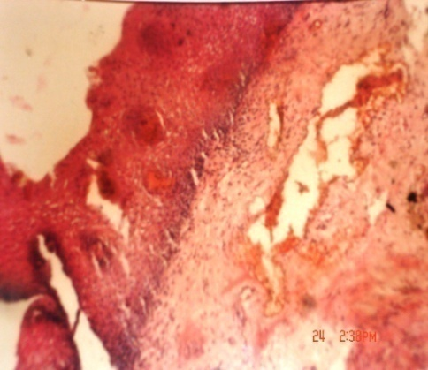
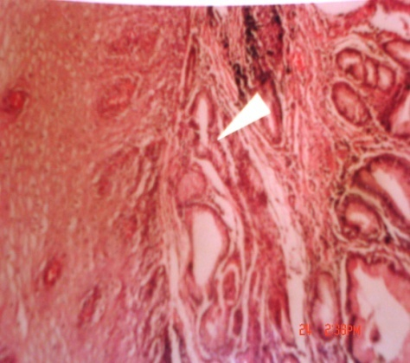
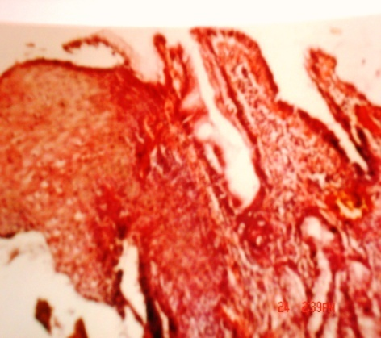

Fig(3))
Fig(2)
Fig(1)
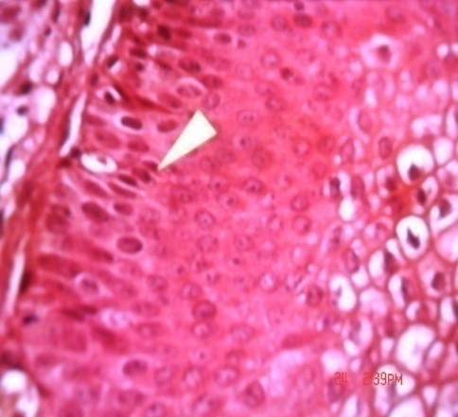
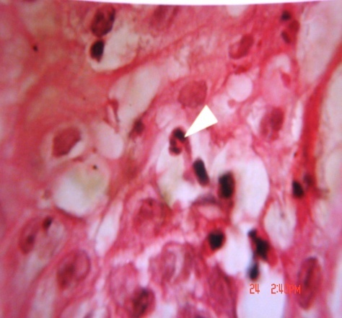
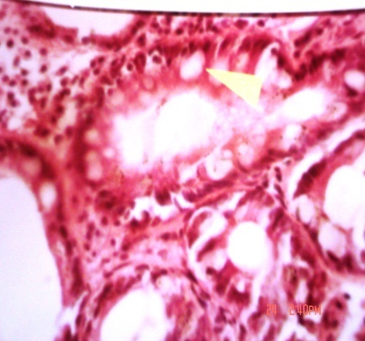

Fig(4)
Fig(5)
Fig(6)
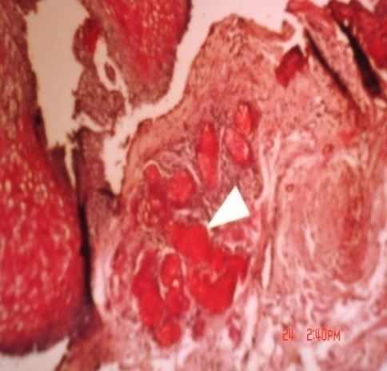
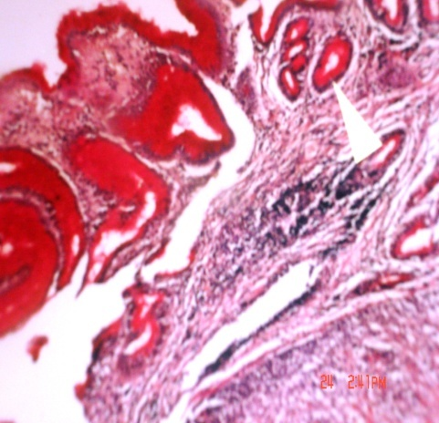
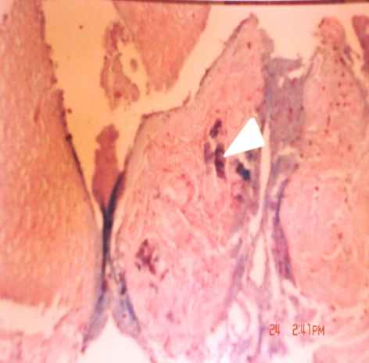

Fig(7)
Fig(8)
Fig(9a)
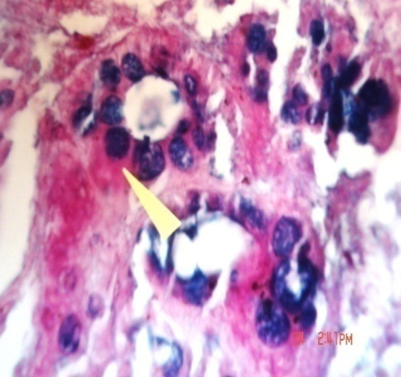
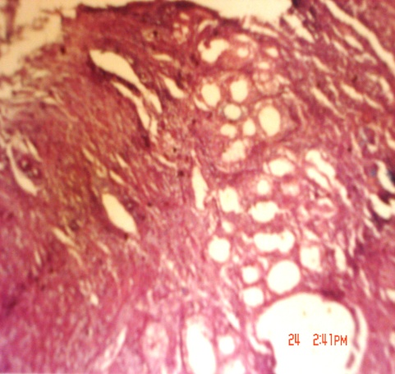
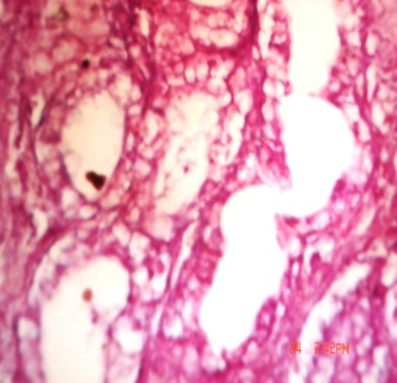

Fig(9b)
Fig(10a)
Fig(10b)
Fig1 Esophageal biopsy(GERD)of lower esophagus showing normal stratified squamous epithelial lining.H&E.(X100). Fig(2): Esophageal biopsy(GERD) showing metaplastic glandular epithelium (intestinal type) IIB ,goblet cells are seen (arrow). H&E.(X200).Fig(3):GEJ biopsy (GERD) showing variable types of epithelium (sequmous, columnar and gastric oxyntic). H&E.(X100)Fig(4): Esophageal biopsy showing basal cell hyperplasia (arrow). H&E.(X400). Fig(5): Esophageal biopsy(GERD) showing Intraepithelial eosinophiles (arrow). H&E.(X1000). Fig(6): Esophageal biopsy(GERD) showing Intestinal metaplasia , goblet cells are seen (arrow). H&E.(X400). Fig(7): Esophageal biopsy(GERD) panoramic view showing positive PAS-diastase stained submucous glands (arrow) (PAS-diastase X100 ). Fig(8): junctional biopsy(normal control ), panoramic view, showing positive PAS-diastase submucous glands(arrow) (PAS-diastase X100) .Fig(9a): Esophageal biopsy(GERD), panoramic view showing positive combined alcian blue – aldehyde fuchsin submucous glands(arrow) (X100).Fig(9b): same biopsy as in (A) showing positive combined alcian blue – aldehyde fuchsin in goblet cells(arrow) (X400). Fig(10a): normal control junctional biopsy panoramic view showing submucous glands negative for combined alcian blue – aldehyde fuchsin stains (X100). Fig(10b):The same biopsy as in (A)(high power view X400 ).

Discussion
GERD is a clinical problem manifests with variable clinical severity. This is commonly reflected in the endoscopic findings and grades of inflammation.In this study all grades of GERD were found with different percentage where by GERD I consisted 33.3% , GERD II 33.3% , GERD III 30%, GERD IV 3.3%. This is matching other studies performed on similar patients. An Iraqi study by Juereidini.Z and Jarallah.S [15] found that these types consisted GERD I (29.1%), GERD II (35.4%), GERD III (35.4%) and no GERD IV found in their study. Other Iraqi study by Al-Karboli and Kassir ZA.[1] Found that these types consisted GERD I,II,III and IV as 44.7, 25.4, 15.2, 3.7% respectively. Asker B. et al [2] found that these types consisted GERD I,II,III and IV as 20.4,47.7,22.7 and 9% respectively.
In our study the age of patients with GERD ranged from 19-79 years, with a mean of 47.2+/-11.145. In comparison to other studies were by Al-Hilli. H and Al-Numman. G[16] found that the mean age was 39 years, Juereidini.Z and Jarallah.S [15] found the mean age to be 40.16+/-15.62 , in Al-Karboli and Kassir ZA.[1 the age ranged from 2-77 years ( mean 39.6 yrs) and by Asker B. et al [2] the age ranged from 14-80 yrs (mean 47yrs).Male predominance was noted in this study with male : female ratio of 3:1 , this result is matching other studies as by Al-Hilli. H and Al-Numman. G [16], the ratio of male : female was 1.3:1 and by Juereidini.Z and Jarallah.S [15] was 2.1:1, and by Al-Karboli and Kassir ZA.[1] was 1.3:1 , and by Asker B. et al [2] was 2.1:1, Spechler et al [18] found that the male : female ratio was 1.9:1 and this was explained by increased the smoking habits , alcohol consumption, the presence of hiatus hernia and the use of non steroidal anti inflammatory drugs by males patients.In the hostile environment of regurgitated acid peptic secretions the mucosa at the GEJ would react by undergoing columnar metaplasia. Several studies have described a sequence of zonation starting with cardiac type mucosa, into oxyntocardiac and intestinal type of mucosa [19,20]. However the risk of malignancy was found to be increased only with intestinal metaplasia type IIB. In our study the variable types of epithelium at SCJ demonstrated in table-4 confirm the active pathological process at this zone in GERD patients and not worthy IM type IIB as clearly high lightened by the special stains were demonstrated in 5 patients (16.7%), which segregates this group as possible candidates for neoplastic progression[6]. Chen et al [22] showed that in patients withcolumner epithelium lined oesopgaus CELO demonstrate that acid mucin in 62% of patients with goblet cells compares with 10% of patients without goblet cells (p-value <0.001). Unfortunately due to the limited size and number of biopsies, the process of zonation was not successfully demonstrated. Two other changes that were demonstrated in this study to be significantly associated with GERD biopsies namely hyperplasia of squamous epithelium and increased intraepithelial eosinophiles. These findings have also been stressed in variable studies where by Asker B. et al [2] found that squamous epithelium covering esophageal biopsies, in GERD patients constituted about 50% of cases which is not matching our results. The same glandular epithelium(cardiac type) in junctional biopsies constituted 50% as well. Jass JR et al [23] they found such changes in 75% of their study group. Intra epithelial eosinophiles had gained an interest of researchers in the field who concluded its significance in GERD patient as a criteria for diagnosis [24]. Thus it is important in routine evaluation of lower esophageal biopsies in GERD patients to seek these changes for they could suggest histopathological confirmation. Biopsies of all patients with GERD in this study demonstrated neutral mucins by the application of PAS- diastase stain. However, only 5 patients yielded sulphomucins by combined alcian blue-aldehyde fuchsin stain and although there was no statistical difference in different endoscopic grades of GERD, this special stain has clearly demonstrated the patients with IM type IIB. Gastric intestinal metaplasia is characterized by goblet cell and columnar cell. The complete type of intestinal metaplasia (I) consist of mature absorptive and goblet cell; the incomplete type (IIA and IIB) consist of few or absent absorptive cells, goblet cell and columnar cell(intermediate cell), in various stages of differentiation [6]. The columnar intermediate cells can secret neutral mucins, sialo-or sulphomucins. Type IIB intestinal metaplasia(secreting sulphamucin) which is the type usually associated with adenocarcinoma of stomach [6,25]. On the other hand a mucin histochemical study of columnar epithelial lined esophagus (CELO) has suggested a similar histogenic relation between type IIB intestinal metaplasia and well differentiated adenocarcinoma of esophagus [26], Jass [6] found type IIB intestinal metaplasia (IM) in 3 of 10 cases ( focal only ) and type IIA IM in 5 of 10 cases usually extensive, in another prospective study of pathologic changes in GERD patients that include 1460 gastric biopsies specimens, Filip et al [27] showed 8.7% incidence of type IIB IM in 272 biopsies with IM.Although neither dysplasia nor carcinoma were seen in our patients (owing to small sample size and short duration of the study) it remains a general consensus that type IIB IM has a precancerous role in CELO patients, Thompson et al [3] have demonstrated sulphomucins in patients with reflux esophagitis whether above or at the level of endoscopically normal GEJ, and thus the pathogenesis of adenocarcinoma of lower esophagus and that arising in lower cardia could be identical. Other study by Shah KA et al [5] demonstrate the the aldehyde fuschin stain show that a sensitivity of 85%, a specificity of 100% for sulphomucin.Similar observation were made by other study [2, 4, 28, 29].
In conclusion; basal cell hyperplasia and intraepithelial eosinophiles are frequent histological findings in biopsies of patients with GERD. Mucin histochemistry is a useful method to define IM in esophageal and junctional biopsies. However the presence of IM type IIB does not correlate with the severity of endoscopic findings in GERD.

References
- Kassir Z, Al – Karboli T. Evalution of gastro – esophageal reflux disease in Iraq. A thesis submitted to the Iraqi board for medical specialization, Baghdad, 1999.
- Asker B et al. Diagnosis of Barrett’s esophagus in Iraqi samples with symptoms of Gastro esophageal reflux disease. A thesis submitted to the Iraqi board for medical specialization, Baghdad, 2002.
- Thompson JJ, Zinssor KR, Interline HT. Barrett’s metaphase and adenocarcinoma of the esophageal and gastro esophageal junction. Hum pathol. 1983; 14:42-61.
- Johnston – MH et al. the prevalence and clinical characteristics of short segments of specialized intestinal metaplasia in the distal esophagus. In routine endoscopy. AM J Gastroenterol. 1996 Aug; 91(8):1507-11.
- Shah KA, Deacon AJ, Dunscombe P, Price AB. Intestinal metaplasia sub typing: evaluation of Gomari’s aldehyde Fuschin for routine diagnostic use. Histopathology. 1997 suppl; 31(3):277-83.
- Jass JR. Mucin histochemistry of the columnar epithelium of esophagus. A retrospective study. J Clin pathol 1981; 34:866-70.
- Goldman LP and Weigert J. microrresive substance ingestion: a review. Am. J Gastroenterol. 1984; 79:85.
- Goyal RK and Rottan SN. Neurohormonal and drug receptors for the lower esophageal sphincter. Gastroenterology, 1979; 74:598.
- Parakrama Chandrasoma. Non-neoplastic diseases of the esophagus. In: Gastrointestinal pathology. 1st ed. Vol.1 Stanford 1999.
- Schindelbeck NE, Wiebeck B, Klavser AG et al. Diagnostic value of histologyin non- erosive gastro esophageal reflux disease. Gut 1996; 151 – 154.
- Chandrasoma P. Pathophsiology fo Barret’s esophagus semin thorac cardio vasc surg 1997; 9:270-278.
- Wolf BS. Sliding Hiatul Hernia: the need for redefinition AMJ. Nucl Med. 1973;117:231-47
- Wright TA, Myskow M, Kingnorth AN. H. pylori colonization of BE and it's progressive to cancer. Dis Esophagus. 1997; 10:196-200.
- Antonioli DA. Esophagus. In Henson DE, Albers – Saavedra J"ed.": pathology of incipient neoplasia, ed2, Philadelphia, WB Saunders, 1993, pp64-84.
- Juereidini Z, Jarallah S. GERD clinical and endoscoplic correlates. A thesis submitted to Iraqi board in medical GE, Baghdad , 2003.
- Al-Hilli H, Al-Numan J. GERD a correlation of symptoms, endoscopic and histologic findings. A thesis submitted to Iraqi board for medical specialization, Baghdad , 1999.
- Csendes A, Maluendo F, Braghetto I, et al. location of the lower esophageal sphincter and the squamous columnar mucosa junction in 109 healthy controls and 778 patients with different degree of endoscopic esophagitis. Gut 1993; 34:21-27.
- Spechlar SJ et al. prevalence of metaplasia at the gastro esophageal junction. Lancet. 1994 Dec 3; 344(8936):1533-6.
- Spechlar SJ, Zeroogain JM et al. The frequency of specialized intestinal metaplasia at the squamous columnar junction varies with the extent of columnar epithelium lining the esophagus. Gastroenterology 1995; 108:A244.
- Weinstein WM. Precursor lesion for gastric cardiac cancer. Gastrointestinal Endosc. Clin North Am. 1997; 7:19-28.
- Chen YY, Wang HH, Autoniol DA, Spechlar SJ et al. significance of acid – mucin positive non goblet columnar cells in distal esophagus and gastro esophageal junction: Hum Pathol. 1999. Dec; 30(12):1488-95.
- Pereria AD et al. short segment of Barrett’s epithelium and intestinal metaplasia in normal appearing esophagogastric junction: the same or two different entities. Gut 1998 May; 42(5):659-62.
- Jass JR. Role of intestinal metaplasia in the histogenesis of gastric carcinoma. J. Clin Pathol 1980; 33:801-10.
- Obery S, Peters JH, Demester TR et al. inflammation and specialized intestinal metaplasia fo cardiac mucosa is a manifestion of GERD. Ann surg. 1997; 226:522-532.
- Matsukura N, Suzuki K, Kawachi T et al. Distribution of marker enzymes and mucin in intestinal metaplasia in human stomach and relation of complete and incomplete types of intestinal metaplasia to minute gastric carcinoma J. National cancer inst. 1980;65:231-40.
- Filipe MI , Bogomeoletz W, Dawson P,Fabiani B, Potet F. intestinal metaplasia in the assessment of gastric cancer risk. A multicentric prospective study (abstract). Gut 1983; 24:974-5.
- Peuchmiur. M, Potet F, Gold Fain.D et al. Mucin histochemistry of the columnar epithelium of the esophagus (Barrett’s esophagus): a prospective biopsy study. J Clin Pathol 1984; 371:607-610.
- Johannow et al. intestinal metaplasia of the esophagus or esophago gastric junction, evidence of distinct clinical, pathologic, and histochemical staining features ; a prospective study. Am J Clin Pathol 2002; 117:117-125?
- Hennekens CH, Buring JE. Epidemiology in medicine. 1st edition. 1987. Litre brown and company. Boston.

