Immunohistochemical Study of CEA and BCL2 Expression in Colorectal Adenocarcinoma and its Correlation with Some Pathological Parameters
Maather Baqer Hussein Al-Harmooshy

Faculty of Medicine , Al-Qadisiya University, Iraq.
M J B

Abstract

Background :- Colorectal cancer is the second most prevalent cancer and the fourth leading cause of death[1]. In Iraq and according to the Iraqi cancer registry reports in 2002 , the incidence of colorectal carcinoma was 4.55% of whole body malignancy, & it is the seventh cause of death from cancer[3]. Immunohistochemical studies have revealed that CEA is a product of normal as well as cancerous colonic cell and that the difference in CEA content between the cancerous and the normal colorectal mucosa is quantitative and not qualitative[9-11], Expression of bcl-2 has been studied in a number of human tumors, including colorectal carcinoma. Non-small-cell lung carcinomas[18] breast carcinomas[19,20] and neuroblastomas[21] all express bcl-2, and studies have been published correlating expression with survival. Similarly, a number of studies[22-26] have been published evaluating the clinical use of bcl-2 immunohistochemical expression as a prognostic factor.

Aim of the study :- The aim of our study was to estimate possible correlations between the CEA and BCL-2 immunohistochemical expression and some pathological parameters in colorectal adenocarcinoma like grade , stages and site of tumor
Material and method: - thirty nine patients of colorectal carcinoma studied in Al- Diwanyia teaching hospital during a three years period (July 2008 - December 2010) were studied. There were 30 males and 9 females with a median age of 58 years (range 26-90 years). A manual avidine-biotin-peroxidase complex procedure was used in the immunohistochemical analysis (DakoCytomation, Copenhagen, Denmark).
Result :- all the studied cases were positive for CEA (100%) and out of 39 cases there were only 23(58.9%) cases positive for BCL2 expression , also this study showed significant relationship between expression of CEA and grades and site of tumor while BCL2 significantly correlated with grades and stages of the tumor.
Conclusion :- From the present study we may conclude that CEA and BCL-2 have a similar pattern of expression in primary colorectal adenocarcinoma although BCL-2 expression

in colorectal adenocarcinoma is more restricted than CEA expression

الخلاصة
الهدف من البحث هو دراسة التعبير المناعي النسيجي الكيميائي لجيني أل BCL-2وCEA كمؤشر للتغييرات الطارئة في الخلايا السرطانية لأورام القولون والمستقيم و معرفة ترابط هذا التغير مع درجة تمايز الورم ودرجة انتشاره و موقع الورم . تمت دراسة 39 عينة من سرطان القولون في مختبرات مستشفى الديوانية التعليمي لمرضى أجرو استئصال القولون للفترة من تموز 2008 إلى كانون الثاني 2010 . أظهرت الدراسة إن التعبير النسيجي لجين ال- CEA(100%) كان أكثر من التعبير النسيجي لجين ال- BCL2 (58.9%) مع وجود ترابط في التعبير النسيجي لجين أل- CEA مع مجموعات تمايز المرض وموقع انتشاره بينما كان التعبير النسيجي لجين ال- BCL2 مترابطا مع درجتي تمايز المرض وانتشاره , مما يدل على أن لهذين ألجينيين دورا اساسيآ في تقيم سرطان القولون والمستقيم المستقبلية وانتشاره وتحديد أهمية استجابته للعلاج.
ــــــــــــــــــــــــــــــــــــــــــــــــــــــــــــــــــــــــــــــــــــــــــــــــــــــــــــــــــــــــــــــــــــــــــــــــــــــــــــــــــــــــــــــــــــــــــــــــــــ

Introduction
Colorectal cancer is the second most prevalent cancer and the fourth leading cause of death[1].
In Iraq and according to the Iraqi cancer registry reports, the colonic cancer represented about 4.7% of all malignant primary tumors registered during the period from 1995-1997, while rectal malignancy represented about 3.4% [2]. In 2002, the incidence of colorectal carcinoma was 4.55% of whole body malignancy, & it is the seventh cause of death from cancer[3]. Also the distribution of colorectal cancer according to the race in Iraq was 86.6% Arabs &13.3% Kurds with a ratio of Arabs: Kurds 6.6:1[4-5].
CEA is an in completely defined glycoprotein 180000 Daltons[6], it was first isolated from human fetal intestine and adult colon cancer tissue by Gold and Freedman in 1965 [7,8]. It was originally found in colorectal carcinomas[6], Immunohistochemical studies have revealed that CEA is a product of normal as well as cancerous colonic cell and that the difference in CEA content between the cancerous and the normal colorectal mucosa is quantitative and not qualitative[9-11]. More recently, abnormality in surface expression of CEA was shown to be a characteristic of the colonic and gastric neoplastic cells[12].
Bcl-2 (B-cell lymphoma/leukemia-2) was initially identified at a breakpoint in a chromosomal translocation (t14:18) that occurs in human B-cell lymphomas. Bcl-2 is a known inhibitor of apoptosis[13,14], and has also been shown to block chemotherapy-induced apoptosis[15]. The ability of bcl-2 to inhibit apoptosis depends on the intracellular balance among a number of its family members, including BAG1, Bad, Bax, bcl-xL and bcl-xS. Bcl-xL, like bcl-2, functions as an inhibitor of apoptosis, whereas bcl-xS serves as a dominant negative inhibitor of bcl-xL and bcl-2 [16]. The bcl-2 binding protein (BAG1) inhibits apoptosis whereas the Bad and Bax proteins promote apoptosis[17]. Expression of bcl-2 has been studied in a number of human tumors, including colorectal carcinoma. Non-small-cell lung carcinomas[18] breast carcinomas [19,20] and neuroblastomas[21] all express bcl-2, and studies have been published correlating expression with survival. Similarly, a number of studies [22-26] have been published evaluating the clinical use of bcl-2 immunohistochemical expression as a prognostic factor.

Material and Method
Thirty nine consecutive patients undergoing potentially curative resection of a colorectal adenocarcinoma in a single unit who had referred to Al-Diwaniya Hospital during a three years period (July 2008 - December 2010) were studied. There were 30 males and 9 females with a median age of 58 years (range 26-90 years).
On histopathological and surgical assessment and according to Modified Dukes staging system [27], five (12.8%) of the tumors were classified as Dukes stage A, 19 (48.7%) as Dukes stage B and 15 (38.5%) as Dukes stage C. Twenty (51.2%) cases were graded as well differentiated, 17(43.5%) moderately differentiated and two (5.1%) poorly differentiated. Ten (25.6%) of the primary tumors were in the right colon (caecum, ascending and right transverse), 29 (74.3%) in the left colon (left transverse, descending, sigmoid and rectum).
A manual avidine-biotin-peroxidase complex procedure was used in the immunohistochemical analysis (Dako Cytomation, Copenhagen, Denmark). Positive control sections were colonic cancers known to express both antigens. Negative control sections consisted of either no first antibody (anti-CEA or anti-BCL2) or neither first nor second antibodies being applied.
The BCL2 and CEA expression was evaluated relative to the percentage of the tumor cells with cytoplasmic reaction ( usually brown) , based on the proportion of the total number of tumor cells: as fallow < 25% = score 1 , 25˗ 49% = score 2, 50 ˗ 75%= score 3 and > 75% = score 4 ⁽²⁸⁾. Data were analyzed using the SPSS verge 17 software and the chi-square was used where P value ≤ 0.05.

Result
The staining pattern was similar for both the anti- CEA and anti-BCL2 antibodies, being most pronounced on the cytoplasmic , but few cases express CEA at the luminal cell membrane in areas of tumor with gland formation [figure 1]. All 39 colorectal cancer sections stained positively for CEA whereas 23/39 sections stained positively for BCL2 (58.9%).
The score 3 and 4 of immunohistochemical staining of the tumors was higher with anti-CEA than anti-BCL2 as (10.3%) of anti-CEA and (5,1%) of anti-BCL2 in score 3 while (56.4%) of anti-CEA and (30.7%) of anti-BCL2 in score 4 (table 1).
Score 3 and 4 CEA expression were more in well rather than moderately differentiated cases (16 of 20 versus 9 of 17) (table2). While BCL2 expression were more in poor rather than well differentiated cases (100% versus 25%) and the scores 3 and 4 BCL2 expression were more in poor rather than well differentiated cases (50% versus 35% versus 25%) , with statistically relationship fore the both markers with the grades of the tumor (table 3 ).
CEA expression immunohistoch-emically varied with the site of the primary tumor, right sided colonic tumors showing less intensity of CEA expression than the left sided, Six of the 10 right sided lesions were score 3 and 4 whereas 20 cases of the 29 lesions in the left colon were score 3 and 4 with statistically relationship (P = 0.0222) (table 2 ), for BCL2 expression were 5 of 10 in the right colon and 9 of 29 in the left colon are graded in score 3 and 4 with no significant relationship (P ˃ 0.05) (table 3).
CEA expression immunohistoch-emically were more intensity in Dukes C than A and B (score 4 is as 80% in C, 60% in A and 36.8% in B) with no statistically significant relationship (P = 0.2119) (table 2 ), while in BCL2 expression there is a statistically significant relation ship with the stages of the tumor in spite of that its expression is zero in A , 52.6% in B and 13.3% in C (P = 0.0019) (table 3).

Table 1 Expression of CEA and BCL2 in colorectal cases.

Marker | Scores |  |  |  |  | Total
Marker | 0 | +1 | +2 | +3 | +4 | Total
CEA | 0 | 6 (15.4%) | 7 (17.9%) | 4 (10.3%) | 27 (56.4%) | 39
BCL2 | 16 (41%) | 2 (5.1%) | 7 (17.9%) | 2 (5.1%) | 12 (30.7%) | 39
Χ² = 21.6078
P = 0.00009

Table 2 Scoring system of expression of CEA in relation to the pathological parameters of colorectal carcinoma
Features | CEA (-Ve) | CEA (+Ve) |  |  |  | Χ² | P
Features | 0 | +1 | +2 | +3 | +4 | Χ² | P
Grades  GI  GII  GIII | 0  0  0 | 0  5(29.4%)  1(50%) | 3(15%)  3(17.6%)  1(50%) | 4(20%)  0  0 | 13(65%)  9  0 | 13.2773 | 0.0387
Sites  Left  Right | 0  0 | 2(6.8%)  4(40%) | 7(24.3%)  0 | 2(6.8%)  2(20%) | 18(62%)  4(40%) | 9.5972 | 0.0222
Stages  Dukes A  Dukes B  Dukes C | 0  0  0 | 0  4(21%)  2(13.3%) | 1(20%)  5(26.3%)  1(6.7%) | 1(20%)  3(15.7%)  0 | 3(60%)  7(36.8%)  12(80%) | 8.3728 | 0.2119(NS)

Table 3 Scoring system of expression of BCL2 in relation to the pathological parameters of colorectal carcinoma
Features | Bcl-2 (-Ve) | Bcl-2 (+Ve) |  |  |  | Χ² | P
Features | 0 | +1 | +2 | +3 | +4 | Χ² | P
Grades  GI  GII  GIII | 15(75%)  1(5.8%)  0 | 0  2(11.7%)  0 | 4(20%)  3(17.6%)  0 | 1(5%)  1(5.8%)  0 | 0  10(58.8%)  2(100%) | 28.299 | 0.0003
Sites  Left  Right | 12(41.3%)  4(40%) | 1(3.4%)  1(10%) | 7(24.1%)  0 | 1(3.4%)  1(10%) | 8(27.5%)  4(40%) | 4.0345 | 0.4013(NS)
Stages  Dukes A  Dukes B  Dukes C | 3(60%)  6(31.5%)  7(46.6%) | 0  1(5.2%)  1(6.6%) | 0  2(10.4%)  5(33.3%) | 2(40%)  0  0 | 0  10(52.6%)  2(13.3%) | 24.325 | 0.0019

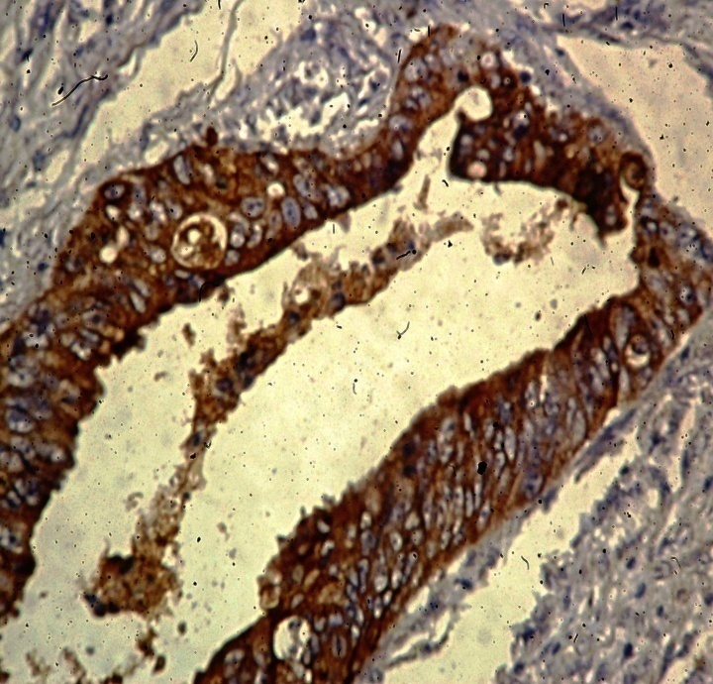  A | 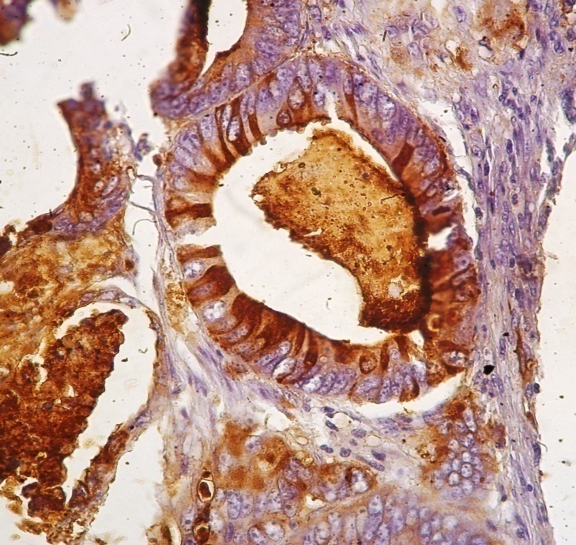  B
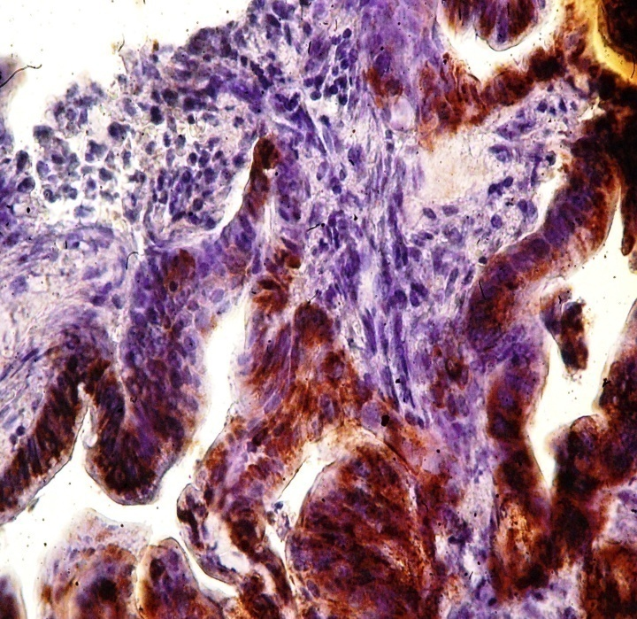  C | 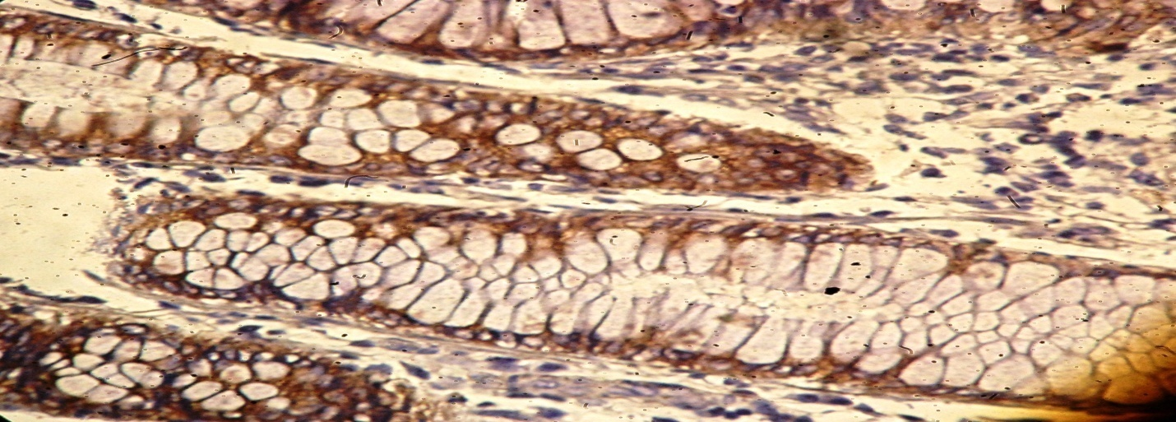  D
Figure 1 Colonic Adenocarcinoma, 1- CEA Staining in grade I adenocarcinoma , (A) Cytoplasmic , (B) luminal cell membrane 2- BCL-2 Staining (C) Cytoplasmic in grade I adenocarcinoma (D) grade II adenocarcinoma, 40X

Discussion
The identification of molecular markers that provide an insight into the potential behavior or aggressiveness of tumors is a necessary step for the improvement of cancer treatment. Bcl-2 protein product seems to be one of the most promising members of molecular markers to evaluate cancer malignant behavior. The BCL-2 gene is a protooncogene whose protein product inhibits apoptosis. Its role is associated with keeping cells alive, but not by stimulating them to proliferation, as other protooncogenes do. CEA is considered as one of the most clinically significant tumor marker for colorectal cancer, providing information on prognosis, tumor recurrence and metastasis, In colorectal cancer however, its concentration is increased and the general distribution of the molecule on the cell and cell surface is altered [10-11].
In present study the staining pattern was similar for both the anti- CEA and anti-BCL2 antibodies, being most pronounced on the cytoplasmic but few cases express CEA at the luminal cell membrane in areas of tumor with gland formation in addition to cytoplasmic expression, this in agreement with Davidson B R et al [29] who studied the CEA expression in normal colon, adenomas and adenocarcinoma of the colon and rectum and Contup. C. et al [30] who studied the expression of BCL2 in rectal cancer . They conclude that cytoplasmic staining pattern is more pronounced than the luminal cell membrane in areas of gland formation while Eadie Hydriman et al [31] conclude that CEA cytoplasmic staining expression in poor differentiated cancer and luminal cell membrane is with well and moderately differentiated cancer.
In present study, 58.9% of the colorectal adenocarcinomas were BCL-2 immunohistochemically positive. The prevalence of BCL-2 protein immunocytochemical expression in colorectal cancers varies greatly from one study to another: 16.7% [32], 24% [33], 27% [34], 28.1% [35], 29% [36], 29.5% [30], 43% [37], 45% [38], 46.7% [39], 51.9% [40]. With respect to the location, BCL-2 could not be significantly correlated with the locations, this in agreement with Petrisor .O. et al whose studied the expression of Ki-67 , P53, and BCL-2 in colonic cancer versus rectal cancer and concluded that BCL-2 has no correlation with site of tumor [41]. Also there were a significant correlation between the BCL-2 expression and the grade and stage of the tumor, A significant association between BCL-2 expression and tumor stage and grade was demonstrated in Schwandner. O. et al whose research was about the P53 and BCL-2 as a significant predictors of survival in rectal cancer [36]. The result pleading, as in the case of the proliferation index, for the support of the general mechanism of colorectal carcinogenesis, without differentiations depending to the intestinal segment involved.
A few reports suggested that the use of CEA as an indicator of second look surgery resulted in complete removal of recurrent colorectal cancer , and some indicated 5-year cures after CEA- direct resection . But strong opposition to the concept of both second look surgery and the use of CEA as an indicator of recurrent cancer has persist, especially in the medical literature [45].
Present immunohistochemistry results of CEA expression in 100% of studied cases further support the findings of previous studies which conclude that CEA is expressed by all primary colorectal cancers[29,31, 42-44]. Also Peter Isacsoon et al demonstrate 100% expression of CEA in all colorectal carcinoma studied cases by using immunoflurecence technique[25]. Also CEA expression were more in well rather than poorly differentiated cases and in left sided than right sided cases and in metastasized tumor than non metastasized tumor . A correlation between CEA expression in colonic carcinomas and their degree of differentiation has previously been suggested and the association between CEA expression and tumor differentiation is controversial, with some studies showing greatest CEA expression in well differentiated colorectal carcinoma [28,47-48] and others conclude more expression in poorly differentiate colorectal carcinoma [49, 50]. Moreover although Gold P et al conclude that CEA expression of cancers increases from proximal to distal in the gastrointestinal tract [50] and Yoshinoory Hamada who was studied the immunohistochemical CEA expression in colorectal cancer correlated with CEA level conclude that there is a strong relation ship for the marker tissue expression and elevated serum level with staging of cancer with more expression and high serum level in the metastasis tumor rather than non metastasis one [25].
From the present study we may conclude that CEA and BCL-2 have a similar pattern of expression in primary colorectal cancers and their nodal mtastases although BCL-2 expression is more restricted than CEA. This pattern of antigen expression is of clinical significance. Monoclonal antibodies to CEA or BCL-2 selected for an individual patient or tumour based on immunohistochemical staining of biopsies may allow a greater antibody uptake in tumour tissue and improved tumour targeting for imaging or therapy in patients with colorectal cancer.

Conclusion
From the present study we may conclude that CEA and BCL-2 have a similar pattern of expression in primary colorectal adenocarcinoma although BCL-2 expression in colorectal adenocarcinoma is more restricted than CEA expression. So these genes can be used in determination of the prognosis of colorectal adenocarcinoma and larger epidemiological studies of colorectal carcinoma are warranted for further elucidate the effect of CEA and BCL-2 gene mutation on both the survival rates & the response to treatment in Iraq.

References
- Parkin DM, Bray F, Ferlay J, Pisani P. Global Cancer statistics 2002. CA Cancer J Clin Cancer 2005; 55: 74-108.
- Result of Iraqi Cancer Registry 1995-1997, Iraqi Cancer Board, Ministry of health, Baghdad-Iraq 1999.
- Result of Iraqi Cancer Registry 2000-2002, Iraqi Cancer Board, Ministry of health, Baghdad-Iraq 2005.
- Al-Sammak F.F. Colorectal Carcinoma: A Seroprevalence of Helicobacter pylori CagA in association with immunohistochemical staining of C-Myc and MUC-2. A thesis submitted to the College Of Medicine of Al-Nahrain University in partial fulfillment of the requirements for the Master of Science in Medical microbiology (2004).
- Satya N. and Deodutta R. Role of APC and DNA mismatch repair genes in the development of colorectal cancers. Molecular Cancer 2003; 2: 41-46.
- Gold P , Freedman SO. Demonstration of tumor specific anti gens in human colonic carcinoma by immunological tolerance and absorption techniques. J Exp Med 1965;121:439-62.
- Gold P. Freedman SO. Specific carcinoembryonic antigens of the human digestive system. J Exp Med 1965; 122:467-481.
- Huitric E, Laumoniec R. Burtin P, von Kleist S, Chavonel G.An optical and ultrastructural study of the localization of carcinoembryonic antigen (CEA) in normal and cancerous human rectocolic mucosa. Lob Inve.~i 1976; 34:97-107. 4.
- Wagener C. Csaszar H, Totovic V, Breuer H. A highly sensitive method for the demonstration of carcinoembryonic antigen in normal and neoplastic colonic tissue. Ilisrocherni.~rr.v 1978; 58: I- I I.
- Fritsche R. Mach JP. Isolation and characterization ofcarcinoem- bryonic antigen (CEA) extracted from normal human colon mucosa. Immunochemisrrv 1977; 14:l 19-127.
- Ahnen DJ. Nakane PK. Brown WR. Ultrastructural localization of carcinoembryonic antigen in normal and colon cancer: Abnormal distribution of CEA on the surface of colon cancer cells. Cancer 1982; 49:2077-2090.
- Korsmeyer SJ. Bcl-2 initiates a new category of oncogenes: regulators of cell death. Blood 1992;80:879–86.
- Hockenberry DM, Zutter M, Hickey W ,et al.Bcl-2 protein is topographically restricted in tissues characterized by apoptotic cell death .Proc Natl Acad Sci USA 1991;88:6961 5.
- Muyashita T, Reed JC. Bcl-2 oncoprotein blocks chemotherapy induced apoptosis in a human leukemia cell lines. Blood 1993;81:151–7.
- Boise LH, Gonzalez-Garcia M, Postema CE . Bcl-xL, a bcl-2 related gene that functions as a dominant regular of apoptotic cell death. Cell 1993;74:597– 608.
- Takayama S, Sato T, Krajewski S, Cloning and functional analysis of BAG-1: a novel bcl-2 binding protein with anti-cell death activity. Cell 1995;80:2279–84.
- Pezzella F, Turley H. Kuzu I, Bcl-2 protein in non-small-cell lung carcinoma. N Engl J Med 1993;329:690–4.
- Doglioni C, Dei Tos AP, Laurno L. The prevalence of bcl-2 immunoreactivity in breast carcinomas and its clinicopathological correlates with particular reference to estrogen receptor status. Virchows Archiv 1994;424:47–51.
- Leek RD, Kaklamanis L, Pezzella F, Bcl-2 in normal human breast carcinoma, association with estrogen receptor-positive, epidermal growth factor receptor-negative tumors and in-situ cancer. Br J Cancer 1994;69:135–9.
- Castle VP, Heidelberger KP, Bromberg J, Expression of the apoptosis suppressing protein bcl-2 in neuroblastoma is associated with unfavorable histology and N-myc amplification. Am J Pathol 1993;143:1543–50.
- Ofner D, Riehemann K, Maier H, Immunohistochemically detectable bcl-2 expression in colorectal carcinoma: correlation with tumor stage and patient survival. Br J Cancer 1995;77:981–5.
- Baretton GB, Diebold J, Christoforis G, Apoptosis and immunohistochemical bcl-2 expression in colorectal adenomas and carcinomas. Aspects of carcinogenesis and prognostic significance. Cancer 1996;77:255– 64.
- Bhatavdekar JM, Patel DD, Ghosh N, Coexpression of bcl-2, c-myc and p53 oncoproteins as prognostic discriminants in patients with colorectal carcinoma. Dis Colon Rectum 1997;40:785–90.
- Bosari S, Moneghini L, Graziani D, Bcl-2 oncoprotein in colorectal hyperplastic polyps, adenomas and adenocarcinomas. Human Pathol 1995;26:534–40.
- Sinicrope FA., Hart J, Michelassi F, Lee JJ. Prognostic value of bcl-2 oncoprotein expression in stage II colon carcinoma. Clin Cancer Res 1995;1:1103–10.
- Bankfalivia, N H, et al . Wet autoclave pretreatment for antigen retrieval in diagnostic immunohistochemistry. J. a'thol. 1994, 174,232-238
- DukesCE and Bussey HJR.. The spread of rectal cancer and its effect on prognosis. Br. J. Cancer 1958:12,309-320.
- Ellis 10, Hinton CP, MacNay J, Immunocytochemical staining of brcast carcinoma with the monoclonal antibody NCRC-1 1: a new prognostic indicator. Br Med J 1985; 290: 881-3.
- Davidson B R , Sams V R , Styles J , Dean C , Boulos P B, Comparative study of carcinoembryonic antigen and epithelial membrane antigen expression in normal colon, adenomas and adenocarcinomas of the colon and rectum. From the Departments of Surgery and Histopathology, University College and Middlesex School of Medicine, London and The Institute of Cancer Research, Sutton, Surrey, Gut, 1989, 30, 1260-1265
- Contup. C., Contu S. S., Moriel L. F., Bcl-2 expression in rectal cancer, Arq Gastroenterol, 2006, 43(4):284–287.
- Heyderman E,Brown B, Richardson TC. Epithelial markers in prostatic, bladder and colorectal cancer; an immunoperoxidase study of epithelial membrane antigen, carcinoembryonic antigen & prostatic acid phosphatase. J Clin Pathol 1984; 37: 1363
- Goussia A. C , Iochim E, Agnantis N J ,Tsianos E V, Bcl-2 expression in colorectal tumours. Correlation with p53, mdm-2, Rb proteins and proliferation indices, Histol Histopathol, 2000, 15(3):667–672.
- Zlobec I., Steele R, Michil R.P ,Compton C.C , Scoring of p53, VEGF, Bcl-2 and APAF-1 immunohistochemistry and interobserver reliability in colorectal cancer, Modern Pathol, 2006, 19(9):1236–1242.
- Zavrides H., Zizi- Sermpetzoglou. Elmenclou I, Papthiofanis I, Immunohistochemical expression of bcl-2 in Dukes’ stage B and C colorectal carcinoma patients: correlation with p53 and ki-67 in evaluating prognostic significance, Pol J Pathol, 2005,56(4):179–185.
- Kim Y. H., Lee J. H.Park J.K., Yang W.I. ,Yun W.I.,, Apoptosis and its correlation with proliferative activity in rectal cancer, J Surg Oncol, 2002, 79(4):236–242.
- Schwandner. O., Schiedeck. T. H.Brouch H.P., p53 and Bcl-2 as significant predictors of recurrence and survival in rectal cancer, Eur J Cancer, 2000, 36(3):348–356.
- Hilska M . Collan. Y. U., Laine V.J., Kossi J., The significance of tumor markers for proliferation and apoptosis in predicting survival in colorectal cancer, Dis Colon Rectum, 2005, 48 (12): 2197–2208.
- Changa. H.J., Jung K.H., Kim D.Y.,J eong S.Y., Bax, a predictive marker for therapeutic response to preoperative chemoradiotherapy in patients with rectal carcinoma, Hum Pathol, 2005, 36(4):364–371.
- Theodoropoulos.G.E, , Hypoxia, angiogenesis and apoptosis makers in locally advanced rectal cancer, Int J Colorectal Dis, 2006, 21(3):248–257.
- Saleh H. A., Jackson H. Banerjee M. , Immunohistochemical expression of bcl-2 and p53 oncoproteins: correlation with Ki67 proliferation index and prognostic histopathologic parameters in colorectal neoplasia, Appl Immunohistochem Mol Morphol, 2000, 8(3):175–182.
- Petrisor . O. ,Simona E.G.,Maria S..,G ioconda D..,Ki-67, p53 and bcl-2 analysis in colonic versus rectal adenocarcinoma; Romanian Journal of Morphology and Embryology 2008, 49(2):163–171.
- Pinkus GS, Kurtin PJ. Epithelial membrane antigen – A diagnostic discriminant in surgical pathology. Hum Pathol 1985; 16: 929-40.
- Davidson BR, Yiu CY, Styles J, Ormerod M, Clark CG, Dean C. A comparison of carcinoembryonic antigen (CEA) and epithelial membrane antigen (EMA) in human colorectal cancer. Int J Cancer 1988; suppl 3: 56-60.
- Hamilton S. R., Rubio C. A. Vogelstein B. , Tumors of the colon and rectum. In, World Health Organization Classificatio of Tumours. Pathology and genetics of tumours of the digestive system, IARC Press, Lyon, 2000, 103–145.
- Denk H. Tappeiner G, Eckerstorfer R, et al. Carcinoembryonic antigen (CEA) in gastrointestinal and extragastrointestinal tumors and its relationship to tumour cell differentiation. Int J Cancer 1992; 10: 262-72.
- Peter Isaacson .Helen Patercia Le Van. the demonstration of carcinoemberyonic antigen in colorectal carcinoma and colonic polyp using an immunoperoxidase technique. Cance 38:1348-1356,1976.
- Goldenberg DM, Sharkey RM, Primus FJ. Carcinoembryonic antigen in histopathology: Immunoperoxidase staining of conventional tissue sections. J Natl Cancer Inst 1996: 57: 11-22.
- Rognum T, Elgjo K, Brandtzaeg P, Orjasaeter H, Bergan A. Plasma carcinoembryonic antigen concentrations and immunohistoch-emical patterns of epithelial marker antigens in patients with large bowel carcinoma. J Clin Pathol 1982; 35: 922-33.
- Bordes M, Michaels R, Martin F. Detection by immunoflourescence of carcinoembryonic antigen in colonic carcinoma, other malignant or benign tumours, and non-cancerous tissues. Digestion 1973; 9: 106-15.
- Gold P, Freedman SO. Demonstration of tumour specific antigens in human colonic carcinoma by immunological tolerance and adsorption techniques. J Exp Med 1965; 121: 439-62.
Yoshinoory Hamada. Immunohistoch-emical carcinoemberyonic antigen in colorectal cancer correlation.

