HER-2/neu Expression in Colorectal Carcinoma and its Correlation with Pathological Parameters by Immunohistochemistery

Shoroq Mohamed Abas Al-Temimi

College of Medicine, Qadissia University, Iraq.

M J B

Abstract
This study was conducted to estimate the expression of her2/neu oncoprotein in human colorectal carcinoma and to show its possible correlation to the pathological parameters. Thirty five patients of colorectal carcinoma were studied in Al- Diwanyia teaching hospital and some private hospital in a period from January 2007 to Juan 2010 , out of 35 cases there were only 20cases positive for her2/neu oncoprotein. The rate of her2 was high in colorectal carcinoma and the important feature of her2/neu expression was the membranous-

cytoplasmic pattern , it was prominent in Grade III ,and stages C and D , so this pattern indicates poor prognosis of the tumor.
الخلاصة
الهدف من البحث هو دراسة التعبير المناعي النسيجي الكيميائي لبروتين (HER-2/neu )كمؤشر للتغيرات الطارئة في الخلايا السرطانية للأورام القولون والمستقيم.تمت دراسة 35 عينة من سرطان القولون والمستقيم في المختبرات مستشفى الديوانية التعليمي وبعض المستشفيات الخاصة للفترة من كانون الاول 2007 الى حزيران 2010 ,أظهرت الدراسة وجود ترابط في التعبير النسيجي لجين ) HER-2/neu ) مع سرطان القولون والمستقيم وخاصة موقع ألبروتين في جدار الخلية والسايتوبلازم وخاصة في التمايز الضعيف والمنتشر في جدران القولون والمستقيم,وكان لهذا الموقع دلالة على التقدم السىء للمرض , مما يدل على أن لهذا ألجين دور أساسي في تقيم سرطان القولون والمستقيم المستقبلية وانتشاره وتحديد أهمية استجابته للعلاج.

ـــــــــــــــــــــــــــــــــــــــــــــــــــــــــــــــــــــــــــــــــــــــــــــــــــــــــــــــــــــــــــــــــــــــــــــــــــــــــــــــــــــــــــــــــــــــــــــــــــ

Introduction
Colorectal cancer (CRC) is one of the most common malignancies in the western world [1].
The development of new cytotoxic agents (e.g. oxaliplatin and irinotecan) and surgical techniques have improved survival of patients with CRC. Once a patient becomes refractory to modern chemotherapeutic regimens no further treatment options are available. Recently the therapeutic armamentarium has been improved by the availability of monoclonal antibodies against the vascular endothelial – and epidermal growth factor receptor[2]. Her-2/neu oncogene is also a member of the tyrosine kinase family similar to the epidermal growth factor receptor (EGFR), HER-1, HER-3 and HER-4. HER-2 is located on chromosome 17q21 and encodes a 185 kD transmembran protein that lacks a natural ligand. HER-2 activation initiates signal cascades including the MAPK and PI3K/AKT pathways that are essential for cell proliferation and differentiation[3]. While the tyrosine kinase family receptors are found on normal cells, there is evidence that they are overexpressed in many types of tumours[4-6]. Clinically, c-erbB-2 amplification and/or overexpression has been associated with poor prognosis in a number of tumour types such as breast and ovarian cancer [4,7]. Pathologic specimens from the National Surgical Adjuvant Breast and Bowel Project protocol B-06 were reviewed and correlated with patients' outcome. Overall survival was decreased in all HER-2/neu-positive patients, and those patients having HER-2/neu overexpression with a good nuclear Grade had a five-fold increase in mortality rate[8]. Overexpression of the HER-2/neu receptor is detected in 25–35% of human breast cancer patients [4,7]. Treatment of these patients with Herceptin®, an anti-HER-2 monoclonal antibody, has been shown to reduce tumour volume,to augment the effects of chemotherapy and to increase survival in primary and metastatic breast cancer[9,10]. The success of HER-2/neu directed therapy in breast cancer has lead to evaluations of protein expression and gene amplification in multiple tumour types, colorectal cancer among others. Herceptin® has been shown to inhibit colony formation of the HCA-7 colon cancer cell line and HCA-7 tumour xenografts [11].Conflicting data exist about the prevalence of HER-2/neu overexpression in colorectal cancer, which ranges from 0 to 83 % [12-16] as well as the relationship between HER-2/neu overexpression and clinic-pathologic features like Dukesclassification and survival.

Aim of Study
The aim of our study was to determine the frequency, pattern ,intensity and percent of staining cells of HER-2/neu positivity in colorectal cancers.
Material and Methods
This study included thirty five cases of colorectal carcinoma studied prospectively, collected randomly in a period from January 2007 to Juan 2010 from AL-Diwanyia Teaching Hospital as well as private hospitals. Their samples including excisional biopsies were collected from AL-Diwanyia Teaching Laboratories as paraffin embedded blocks. Clinical information were collected from hospital reports including age, sex, site of tumor, histological type, stage & grade of the colorectal carcinoma and patient with colorectal carcinoma were grouped according to (15 rectal carcinoma ,20 colonic carcinoma, 20 male, 15 female ,mean age 52.5 years ranging from (30-83) years, according to grades there were 21 cases in grade I,7 cases in grade II, 7 cases in grade III, according to Dukes staging system there were 14 cases in Dukes A, 12 in Dukes B, 5 in Dukes C and 4 in Dukes D for detailed patients characteristics see (table 1). Tumor tissues were routinely processed (formalin-fixed and paraffin-embedded) and were classified according to Dukes' classification[17], with an added D-stage for patients with distant metastases, TNM staging system[18] and WHO grading system[19]. A manual avidine-biotin-peroxidase complex procedure was used in the immunohistochemical analysis (Dako Cytomation, Copenhagen, Denmark);the expression is appeared as cytoplsmic staining and membranous-cytoplasmic staining[20].
Semi quantitative assessment of immunohistochemical staining patterns:-The staining was categorized as follows:
- Intensity of her-2 /neu staining are[21] :-
Negative when no or < 10% of immunoreactive cells detectable
Positive ( weak to strong when ≥ 10% of immunoreactive cells detectable)
- Location of her-2/neu[20] as
positive (cytoplasmic or membranous) or negative
3. Percent of positive cells as fallow [10_40%=1+, 41-70%2+, >70% 3+][20].
Data were analyzed using the SPSS software and the chi-square was used.

Table 1 Patients characteristic

Gender
Male 20
Female 15
Age (years)
Median 52,5 years
Range (range 30–83)
Dukesstage
A 14
B 12
C 5
D 4
Tumour location
Colon 20
Rectal 15

Histological Grade
Well 21
Moderate 7
Poor 7

Result
Out of this 35 colorectal carcinoma cases, 15 ( 42.9%) were her2/neu negative staining and 20(57.1%) were positive staining for her2/neu oncoprotein, 6 (30%) cases had membranous (predominant) and cytoplasmic staining pattern [figure 1] and 14(70%) cases had cytoplasmic staining pattern [figure 2], there was no case with pure membranous staining. we also evaluate intensity and percent of staining cells by her2/neu oncoprotein.

Table 2 characteristics of her2/neu staining in colorectal carcinoma.

Expression | Negative  15(42.9%) | Positive  20(57.1%) |  | Total
Expression | Negative  15(42.9%) |  |  | 35
Pattern | Cytoplasmic  14(70%) | Membranous and cytoplasmic  6(30%) |  | 20(100%)
Intensity | Weak  9(45%) | Moderate  7(35%) | Sever  4(20%) | 20(100%)
Percent | +1  8(40%) | +2  7(35%) | +3  5(25%) | 20(100%)

In our study, according to grades of tumors ,there was positive her2/neu staining in 14(66.7%) of grade I, and in 3(42.9%) of both grades I and II. So there was decrease in rate of her 2/neu oncoprotein in grade II and grade III but no statistically significance difference ( p=0.3782 )as show in (table3).

Table 3 Her2/neu staining in different grade of colorectal carcinoma
P | χ | Total | +Ve | -Ve | Grade
0.3782 | 1.9444 | 21 | 14(66.7%) | 7(33.3%) | I
0.3782 | 1.9444 | 7 | 3(42.9%) | 4(57.1%) | II
0.3782 | 1.9444 | 7 | 3(42.9%) | 4(57.1%) | III

The membranous – cytoplasmic staining was increased from (14.3%) in grade I to 3(100%) in grade III ,so there was statistically significance difference between grades of tumors and pattern of staining of her2/neu oncoprotein (p=0.0130) as show in (table 4).

Table 4 pattern of her 2/neu expression in different Grades of colorectal carcinoma
P | χ | total | Membranous & Cytoplasmic | Cytoplasmic | Grades
0.0130 | 8.6621 | 14 | 2(14.3%) | 12(85.7%) | I
0.0130 | 8.6621 | 3 | 1(33.3%) | 2(66.7%) | II
0.0130 | 8.6621 | 3 | 3(100%) | 0 | III

Also in our result, noticed no statistically significant correlation between Grades of tumours , intensity and percent of cells staining by her2/neu oncoprotein (p=0.8604, p=03790 ) respectively, as show in (table 5,6).

Table 5 the intensity of her2/neu expression in different Grades of colorectal carcinoma
P | χ | Total | Sever | Moderate | Weak | Grades
0.8604 | 1.3057 | 14 | 3(21.4%) | 5(35.7%) | 6(42.9%) | I
0.8604 | 1.3057 | 3 | 1(33.4%) | 1(33.3%) | 1(33.3%) | II
0.8604 | 1.3057 | 3 | 0 | 1(33.3%) | 2(66.7%) | III

Table 6 The percent of cells staining by her2/neu expression in different Grades of colorectal carcinoma.
P | χ | Total | +3 | +2 | +1 | Grades
0.3790 | 4.2041 | 14 | 2(14.2%) | 6(42.9%) | 6(42.9%) | I
0.3790 | 4.2041 | 3 | 2(66.7%) | 0 | 1(33.3%) | II
0.3790 | 4.2041 | 3 | 1(33.3%) | 1(33.3%) | 1(33.3%) | III

According to stages of tumors, in our study ,there was positive her2/neu staining in 9(64.3%) of stage A, in 7(58.3%) of stage B , in 2(40%) of stage C, and in 2(50%) of stage D . So there was no statistically significant difference (p=08056) as show in (table 7).

Table 7 The her2/neu expression in different stages of colorectal carcinoma
P | χ | Total | +Ve | -Ve | Stages
0.8056 | 09819 | 14 | 9(64.3%) | 5(35.7%) | A
0.8056 | 09819 | 12 | 7(58.3%) | 5(41.7%) | B
0.8056 | 09819 | 5 | 2(40%) | 3(60%) | C
0.8056 | 09819 | 4 | 2(50%) | 2(50%) | D

While the membranous- cytoplasmic staining was increase from 1(11.1%) in stages A and B to 2(100%) in stages C and D, so there statistically significant difference between stages of tumors and pattern of staining of HER-2/neu oncoprotein (p=0.0084) as show in ( table 8).

Table 8 The pattern of the her2/neu expression in different stages of colorectal carcinoma
P | χ | Total | Membranous-Cytoplasmic | Cytoplasmic | Stages
0.0084 | 11.6856 | 9 | 1(11.1%) | 8(88.9%) | A
0.0084 | 11.6856 | 7 | 1(14.3%) | 6(85.7%) | B
0.0084 | 11.6856 | 2 | 2(100%) | 0 | C
0.0084 | 11.6856 | 2 | 2(100%) | 0 | D

According to the stages there were no statistically significant correlation of it with the intensity and percent of cells staining by HER-2/neu oncoprotein (p=0.9623 ,p=0.8881 ) respectively, as show in (table 9,10 ).

Table 9 The intensity of the her2/neu expression in different stages of colorectal carcinoma
P | χ | Total | Sever | Moderate | Weak | Stages Stages
0.9623 | 1.4563 | 9 | 2(22.2%) | 3(33.3%) | 4(44.5%) | A
0.9623 | 1.4563 | 7 | 2(28.6%) | 2(28.6%) | 3(42.8%) | B
0.9623 | 1.4563 | 2 | 0 | 1(50%) | 1(50%) | C
0.9623 | 1.4563 | 2 | 0 | 1(50%) | 1(50%) | D

Table 10 The percent of cells staining by her2/neu expression in different stages of colorectal carcinoma.
P | χ | Total | +3 | +2 | +1 | Stages
0.8881 | 2.3192 | 9 | 2(22.2%) | 3(33.3%) | 4(44.5%) | A
0.8881 | 2.3192 | 7 | 2(28.6%) | 2(28.6%) | 3(42.8%) | B
0.8881 | 2.3192 | 2 | 1(50%) | 1(50%) | 0 | C
0.8881 | 2.3192 | 2 | 0 | 1(50%) | 1(50%) | D

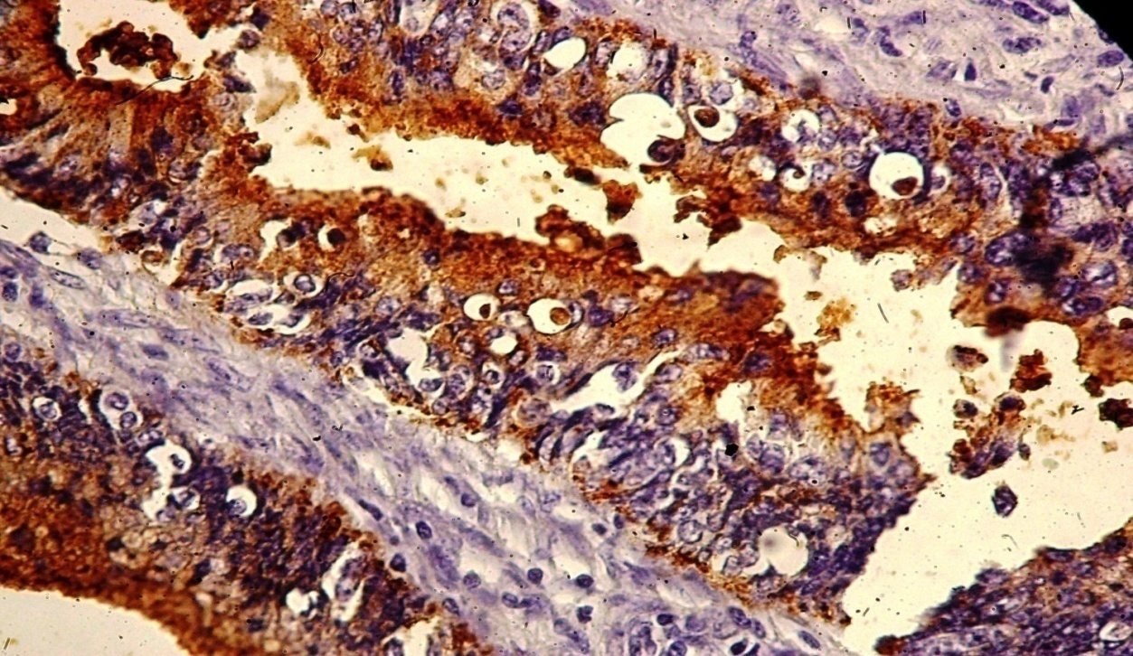

Figure 1 Colorectal Adenocarcinoma , HER-2/neu Staining Membranous and Cytoplasmic , Score 3, 40X

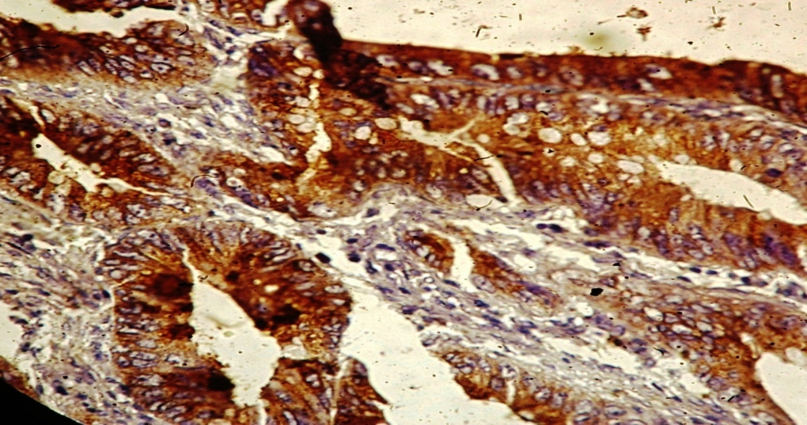
Figure 2 Colorectal Adenocarcinoma , HER-2/neu Staining Cytoplasmic , Score 3, 40X

Discussion
As far as we know, there are only a few studies about HER-2/neu expression in colon adenocarcinoma. In breast carcinoma the role of HER-2/neu has been recognized and is one of the routine tests in breast cancer cases especially with the introduction of effective agents targeting HER2, most importantly Trastuzumab. HER-2/neu is dramatically amplified (from 2- fold to greater than 20-fold) in 30% of breast cancer tumors [2], and amplification of the HER-2/neu gene is an independent predictor of a shorter overall survival and time to relapse in patients with breast cancer. In addition, HER-2/neu status predicts outcome in patients with ovarian [13], and gastric cancer [14].
In the present study, the important features of HER-2/neu staining in colorectal carcinoma were analysed as followed: according to rate of HER-2/neu staining in colorectal carcinoma was relatively high and no correlation between rate of HER-2/neu staining ,Grades and stages of tumors ,similar results were described in the study of K. Ghaffarzadegan et al[20] ,those found there is a high rate of HER-2/neu staining 41 (59.4%) in colorectal carcinoma and no correlation between HER-2/neu staining ,Grades and stages of tumors. Also our results are similar to Delektorskaya et al[22] , studied the NM23 and C-erbB-2 expression in primary tumors and metastases of colorectal adenocarcinoma and showed expression of c-erbB2 in 59% of colorectal carcinoma with liver metastases, They concluded that, expression of these proteins may reflect biological behavior of the tumor and may appear to be an important factor in development of colorectal cancer metastases. Also our results agree with Ross J.S. et al [12], that studied the HER2/neu oncogene in tumors of the gastrointestinal tract, They found wide range of HER2/neu expression in esophageal, gastric and colon carcinoma, They concluded that either HER2 protein over expression or gene amplification is associated with one – forth of all gastrointestinal malignancies and strategies designed to employ the marker in therapy selection appear warranted, while our results disagree with B .Schuell et al[23], those found a very low rate of HER-2/neu staining positivity ( 29.9%) and no correlation between rate of HER-2/neu staining ,Grades and stages of tumors. Also our results disagree with Nathanson et al[24], those found HER2/neu expression and gene amplification in colon cancer, They used quantitative PCR/ligase detection reaction (LDR) technique, FISH, and also immunohistochemistry, They found that among 139 cases evaluated by immunohistochemistry (IHC), HER2/neu overexpression was seen in 5 (3.6%) cases only. We guess, they considered membranous staining as overexpression and they concluded that the low prevalence of HER2/neu gene amplification and protein overexpression suggests that oncogene plays an infrequent role in the development and progression of colon cancer and that the primary mechanism of dysregulated HER 2/neu expression in colon cancer, as in breast cancer, is gene amplification.
Our results disagree with Park et al[25]. who was study the clinical significance of HER2/neu expression in colon cancer, They examined the HER2/neu expression by immunohistochemistry and they found overexpression of HER2/neu in 12.5% of patients, and tumors with positive HER2 showed higher rates of nodal metastases and poor mean survival.
The second feature in our study ,which is most important feature s of HER-2 staining is the pattern of staining, where the high rate of membranous-cytoplasmic staining of HER-2 /neu oncoprotein was 3(100%) in Grade III while 2(14.3%) in Grade I , these results agree with Half et.al[26], They analyzed protein expression in relation to mRNA levels, HER2 amplification, and clinico-pathological variables by PCR technique, There was strong membranous staining in 5% of primary colorectal carcinomas and cytoplasmic staining was found in 63.5% of primary tumors. Membranous was strongly associated with HER-2/neu gene amplification, They found a significant correlation between HER2 cytoplasmic staining and tumor differentiation. Their results are very similar to our results, especially correlation with Grades. Also our results agree with K.Ghaffarzadegan et. Al[20] they found high rate of membranous-cytoplasmic staining of HER-2 /neu oncoprotein in Grade III, more than Grade I. while our results disagree to B. Schell et al[23] whose found no correlation between membranous-cytoplasmic staining of HER-2/neu and Grades of tumors.
According to stages of tumors in our study, the high rate of membranous-cytoplasmic staining of HER-2/neu oncoprotein was more prominent in stage C and D than stages A and B , these results similar to B. Schuell et al[23] they found that there was significant correlation between membranous-cytoplasmic staining of HER-2/neu and higher stages of tumors, that indicate poor prognosis. Also our results agree with K. Ghaffarzadegan et al[20] , they found that high rate of membranous-cytoplasmic staining of HER-2/neu oncoprotein was 2(100%) in stage D which more prominent than stages A,B and C , because of more membranous staining in higher grades and stages, drugs that targeting HER2 may be helpful in these cases. for example Hercepten and 2C4.

Conclusion
The rate of HER2/neu expression in colon carcinoma is high and most of the cases has cytoplasmic staining, few cases has prominent membranous- cytoplasmic staining and no cases has pure membranous staining , the prominent membranous- cytoplasmic staining was more in higher stages and grades of the tumor, that indicate poor prognosis in patient with colorectal carcinoma. However, further research is necessary with include larger number of sample and correlation with other tumor markers.

References
1. Landis SH, Murray T, Bolden S, Wings PA: Cancer statistics. CA Cancer J Clin 1999, 49:8-13.
2. Saltz LB, Meropol NJ, Loehrer PJ, Needle MN, Kopit J, Mayer RJ: Phase II Trial of cetuximab in patients with refractory colorectal cancer that express the epidermal growth factor receptor. J Clin Oncol 2004, 22:1201-1208.
3. Schlessinger J: Cell signaling by receptor tyrosine kinase. Cell 2000, 103:211-25.
4. Slamon DJ, Clark GM, Wong SG, Levin WJ, Ullrich A, McGuire WL: Human breast cancer: correlation of relapse and survival with amplification of HER-2/neu oncogenes. Science 1987, 234:177-182.
5. Saranath D, Panchal RG, Nair R, Metha AR, Sanghavi VD, Deo MG: Amplification and overexpression of epidermal growth factor receptor gene in human oropharyngeal cancer. Eur J Cancer 1992, 28B:139-143.
6. Rusch V, Baselga J, Cordon-Carlo , Orazem J, Zaman M, Hoda S, McIntos J, Kurie J, Dmitrovsky E: Differential expression of the epidermal growth factor receptor and its ligand in primary non-small cell lung cancers and adjusent benign lung. Cancer Res 1993, 53:2379-2385.
7. Slamon DJ, Godolphin W, Jones LA, Holt JA, Wong SA, Keith DE, Levin WJ, Stuart SG, Udove J, Ullrich A, Press MF: Studies of the HER-2/neu proto-oncogene in human breast and ovarian cancer. Science 1989, 244:707-712.
8. Paik S, Hazan R, Fisher ER, Sass RE, Fisher B, Realmond C, Schlessinger J Lippman ME, King CR: Pathologic findings from the National Surgical Adjuvant Breast and Bowel Project: prognostic significance of erbB-2 protein in primary breast cancer. J Clin Oncol 1990, 8:103-112.
9. Slamon DJ, Leyland-Jones B, Shak S, Fuchs H, Paton V, Bajamonde A. Survival according to Her-2/neu status. ---- HER-2/Neu neg. HER-2/Neu pos. Use of chemotherapy plus monoclonal antibody against HER2 for metastatic breast cancer that overexpress HER2. N Engl J Med 2001, 344:783-92.
10. Vogel CL, Cobleigh MA, Tripathy D, Gutheil JC, Harris LN, Fehrenbacher L, Salamon DJ, Murphy M, Novotny WF, Burchmore M, Shak S, Stewart SJ et, Press M: Efficacy and safety of trastuzumab as a single agent in first-line treatment of HER2-overexpressing metastatic breast cancer. J Clin Oncol 2000, 20:719-26.
11. Mann M, Sheng H, Shao J, Williams CS, Pisacane PI, Sliwkowski MX, DuBois RN: Targeting cyclooxygenase 2 and HER-2/neu pathways inhibits colorectal carcinoma growth. Gastroenterology 2001, 120:1713-9.
12. Ross JS, McKenna BJ: The Her-2/neu oncogene in tumors of the gastrointestinal tract. Cancer Invest 2001, 19:554-68.
13. Caruso ML, Valentini AM: Immunhistochemical p53 overexpre-ssion correlated to c-erbB-2 and cathepsin D proteins in colorectal cancer. Anticancer Res 1996, 16:3813-8.
14. Osako T, Miyahara M, Uchino , Inomata M, Kitano S, Kobayashi M: Immunohistochemical study of c-erbB-2 protein in colorectal cancer and the correlation with patients survival. Oncology 1998, 55:548-55.
15. Kapitanovic S, Radosevic S, Kapitanovic M, Andelinovic S, Ferencic Z, Tavassoli M, Primorac D, Sonicki Z, Spaventi S, Pavelic K, Spaventi R: The expression of p185(HER-2/neu) correlates with the stage of disease and survival in colorectal cancer. Gastroenterology 1997, 112:1103-13.
16. McKay JA, Loane JF, Ross VG, Ameyaw MM, Murray GI, Cassidy J, McLeod HL: C-erbB-2 is not a major factor in the development of colorectal cancer. Br J Cancer 2002, 86:568-573.
17-DukesCE and Bussey HJR.. The spread of rectal cancer and its effect on prognosis. Br. J. Cancer 1958:12,309-320.
18-Spiessl B, et al . TNM Atlas: Illustrated Guide to the TNM/pTNM Classification of Malignant Tumors, Vol. 2nd revision Colon and Rectum. Springer: New York, 1992
19-Morson BC and Sobin LH. International istological Classification of Tumors, Histological Typing of Intestinal umours. WHO: Geneva. 1976:15
20-K.Ghaffarzadegan,N.Sharifi,H.Vosooghynia,T.Shakeri,T.Ghias Moghadam, Sh.Ghanad Kafi,S.Lari,G.Nassiri. HER-2/neu expression in colon adenocarcinoma and its correlation with clinicopathologic variables .IJBMS, 2006. 9 , 1.
21-Moch H, Saauter G, Moor D, Mihatsch MJ.p35 and erbB-2 protein overexpression are associated with early invasion and metastasis in bladder cancer .Virchows Archiv A P athol Anat 1993; 423:329-34.
22-Delektorskaia V. V., Perevoshchikov A. G., Kushlinskii N. E. Expression of nm23 and c-erbB-2 proteins in cells of primary colorectal cancer and its metastases, Arkh. Patol., 2003,65:11-5
23-B. Schull . et al . HER2/neu protein expression in colorectal cancer , BMC Cancer . 2006,6:123.
24-Nathanson D. R., Culliford A. T., Shia J., et al. HER 2/neu expression and gene amplification in colon cancer, Int. J. Cancer, 2003,105: 796-802.
25-Park D. I., Oh S. J., Park S. H., Yun J. W., et al. Clinical significance of HER-2/neu expression in colon cancer, Korean J. Gastroenterol.2004, 44:147-52.
26-Half E., Broaddus R., Danenberg K. D., Danenberg P. V., Ayers G. D., Sinicrope F. A., HER2 receptor expression, localization,and activation in colorectal cancer cell lines and human tumors, Int. J. Cancer, 2004,108: 540-8.

