Extraction and Immobilization of Hemoysin A Produced by Uropathogenic Escherichia coli
Muhammad Sabri A. Razzaq Ilham A. Bnyan Hiyam Faez Ahmed Al-Hasson Microbiology Dept., College of Medicine, University of Babylon, Hilla, Iraq.

M J B

Abstract
Out of the 300 urine samples, only 47(15.7%) isolates were identified as Escherichia coli. The hemolysin produced by E.coli was studied, and it was found that 19(40.4%) out of the 47 isolates of E.coli were able to produce hemolysin extracellularly on human and rabbit blood agar. Hemolysin extraction was done and five hemolysin filtrates were subjected to purification, which was treated with ammonium sulfate to obtain 20-40% saturation in phosphate buffer (0.05 M, pH: 6.8). It was found that all of these filtrates contained hemolytic activity at a level higher than that before purification. Immobilization of both hemolysin producing bacteria and free purified hemolysin was also done. It was seen that immobilization by sodium alginate had no effect on hemolysin productivity and activity and the immobilized hemolysin retained its activity after re-using twice or more on blood agar. The effect of purified hemolysin on WBCs in human blood samples and urine blood samples was also studied. It was seen that there were significant effects of hemolysin samples on WBCs count which caused reduction in the number of these cells in both blood samples and in urine samples.
الخلاصة
تم في هذه الدراسة عزل و تشخيص 47 عزلة عائدة إلى بكتريا الاشريشيا القولونية من مجموع 300 عينة إدرار. أظهرت النتائج أن 19(40,4%) عزلة تمتلك القابلية على إنتاج الهيمولاسين خارج الخلية على وسط اﮕار دم الإنسان و الأرنب. أظهرت الدراسة إن راشح الهيمولاسين الذي تم تنقيته بواسطة كبريتات الامونيوم عند درجة تشبع 20-40% اظهر فعالية تحليلية أعلى مما هو عليه قبل التنقية. وأظهرت نتائج الهيمولاسين المنقى الحر والمقيد بواسطة sodium alginat بأن الفعالية الإنتاجية و التحليلية لا تتأثر , وان فعالية الهيمولاسين المقيد تبقى بعد اعاده استخدامه لأكثر من مرتين على وسط اﮕار الدم. بالإضافة إلى ذلك، تم دراسة تأثير الهيمولاسين المنقى على خلايا الدم البيضاء لعينات دم الإنسان إذ وجد إن الهيمولاسين المنقى ذو تأثير مهم في انخفاض واختزال عدد هذه الخلايا, وكما إن لهذا الهيمولاسين المنقى تأثير على الخلايا القيحية في الإدرار عند إضافته إلى العينات الحاوية على خلايا قيحية حيث أظهرت النتائج إن له تأثيرا" مباشرا" على تلك الخلايا.
ـــــــــــــــــــــــــــــــــــــــــــــــــــــــــــــــــــــــــــــــــــــــــــــــــــــــــــــــــــــــــــــــــــــــــــــــــــــــــــــــــــــــــــــــــــــــــــــــــ

Introduction
Hemolysins are pore-forming proteins; they cause destruction of red blood cells, with subsequent release of hemoglobin that can occur by any one of the numerous substances such as a bacterial hemolysin that appears to aid the invasive power of bacteria [1]. The hemolysins are produced by quite divergent species of bacteria, including Escherichia coli [2]. Escherichia coli produces many types of hemolysins; the most common type of which is alpha-Hemolysin. It non-specifically adheres to the cell membrane [3,4]. Alpha-hemolysin can be lethal in a variety of animal systems. The hemolysin has a number of effects on the host, largely due to the formation of unregulated pores for ion transmission across the membranes of a variety of cell types [4,5]. E.coli can produce extracellular hemolysin, which is responsible for extraintestinal infections, and is also an important virulence factor [6].

Aims of the study
Isolation of uropathogenic E.coli isolates from samples of patients with UTI, and detection of hemolysin produced by them. Extraction and purification of alpha-hemolysin by salting out and dialysis. Study the effect of purified hemolysin in urine containing pus cells. Show the effect of immobilization on hemolysin productivity and activity.

Materials and Method
Patients: 134 males and 160 females who attended to Hilla Teaching Hospital suffering from urinary tract infections through a period of four Months from October 2009 to January 2010).
Hemolysin production: It was done according to [7].
Extraction of hemolysin produced by uropathogenic E.coli. It was done according to [8].
Partial purification of extracellular hemolysin by salting out using ammonium sulfate: It was done according to [9].
Estimation of hemolytic activity quantitatively: It was done according to [9].
Immobilization of Bacterial cell and partial purified hemolysin filtrate: It was done according to [10].
Immobilization of partial purified Hemolysin filtrates: It was done according to [10].
Effect of purified hemolysin on White blood cells and urine samples: According to the method of [11].

Results and Discussion
Isolation of Escherichia coli: Out of the 300 urine samples, only 47(15.7%) isolates were identified as Escherichia coli.
Screening of E.coli isolates for producing hemolysin on blood agar (human and rabbit).
Hemolysin production by E.coli was studied, and it was found that 19 (40.4%) out of 47 isolates of E.coli were able to produce hemolysin on human and rabbit blood agar, 18 of them (38.3%) were found to be β-hemolytic and one (2.1%) was α-hemolytic. Other isolates of E.coli 28(59.6%) had no ability to produce hemolysin. The results are shown in Table (3-1). These results agreed with the results obtained by [12] who found that many strains of E.coli elaborate a hemolysin, responsible for the zone of β-hemolysis surrounding bacterial colonies on blood agar. The hemolysin was usually synthesized as precursor proteins, it was covalently modified to yield an active hemolysin, and it was secreted via specific export systems that differ for various types of hemolysins [13]. The present study also showed that E.coli can produce hemolysin on rabbit blood agar and the results obtained are similar to those obtained on human blood agar. These results will prove that the receptors present on human RBCs and rabbit RBCs are identical. The results obtained resemble those obtained by [14] who found that the ability of certain strains of E.coli to lyse erythrocytes of different mammalian species, and were cause hemolysis after 24 hours of growth at 37ºC.

Table 3-1 Hemolysin production of E.coli isolates on human and rabbit blood agar

Number of isolates (%) |  | Type of hemolysis | No. of Hemolysin producer | No. of isolate
Rabbit | Human | Type of hemolysis | No. of Hemolysin producer | No. of isolate
18(38.3%) | 18(38.3%) | β - Hemolysis | 19(40.4%) | 47(15.7%)
1(2.1%) | 1(2.1%) | α- hemolysis | 19(40.4%) | 47(15.7%)
28(59.6%) | 28(59.6%) | No - hemolysis | 19(40.4%) | 47(15.7%)

Partial purification of extracellular hemolysin by salting out using ammonium sulfate: purification: In this study, five hemolysin filtrates were subjected for purification, and they were treated with ammonium sulfate to obtain 20-40% saturation in phosphate buffer (0.05 M, pH: 6.8). It was found that all of these filtrates were purified (20-40%) with this salt. After purification, hemolysin activity was higher than before purification in all hemolysin filtrates used in this study as shown in Table (3-2), and this was shown in Figure (3-2). After purification by ammonium sulfate had been done, it was followed by dialysis. The activity of hemolysin after dialysis also increased when compared with activity before dialysis because hemolysin molecules became free from the salt as shown in Figure (3-3), and the results were maintained in Table (3-2). This results were agreed with these obtained by [9] who found that hemolysin filtrates of E.coli might be purified by ammonium sulfate and give high levels of hemolytic activity at pH: 8.0 with saturation 50%. Extracellular hemolysin could be purified by salting out, and when detecting on enrichment media, the hemolytic activity increased[15].

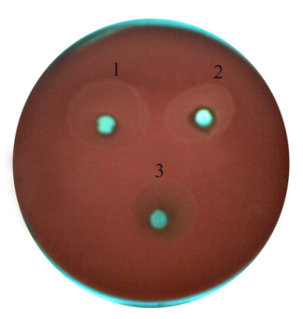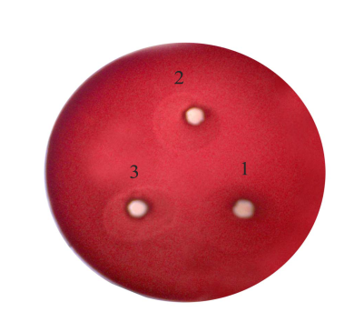
Figure (3-2) Figure (3-3)

Figure 3-2 Detection of hemolytic activity of hemolysin purified by ammonium sulfate
Figure 3-3 Detection of purified hemolysin after dialysis (1/320)

Estimation of hemolytic activity quantitatively. Hemolytic activity was also estimated quantitatively by using serial dilution in which 1% of erythrocytes were used. It was found that, hemolytic activity was observed in dilution factor 1\320, which reflected the concentration of hemolysin to be 320 Hu\ml. The results were shown in Table (3-2). These results were in agreement with local study carried out by [16] that showed that, hemolytic activity was 320 Hu\ml when serial dilution technique was used. Another study found that the hemolytic activity of hemolysin A gave 320 Hu\ml when serial dilution technique was also used [17]. This means that hemolytic activity can be done in solid media (blood agar) and also in liquid media containing the erythrocytes which explains that hemolysin is a protein containing enzyme-like activity when present in liquid media. However, the estimation of hemolytic activity quantatively by serial dilution technique was needed to estimate hemolysin in units, but the primary detection was mainly depended on direct method on blood agar plates.

Table 3-2 Partial purification of extracellular hemolysin produced from UPEC by salting out method
E.coli Isolate | Hemolysin filtrates |  | Purified hemolysin with ammonium sulfate  20% 40% |  | After Dialysis zone diameter | Hemolytic activity u\ml
E.coli Isolate | activity | zone diameter of hemolysis |  |  | After Dialysis zone diameter | Hemolytic activity u\ml
1  2  3  4  5 | +  +  +  +  + | 10.5 mm  10.4 mm  10.2 mm  10.0 mm  10.1 mm | 14.1 mm  12.5 mm  12.3 mm  12.3 mm  12.2 mm | 17.8 mm  14.6 mm  14.4 mm  14.4 mm  14.3 mm | 21.5 mm  19.7 mm  18.3 mm  18.6 mm  18.8 mm | 320  320  160  320  320

Immobilization of bacterial cell and partial purified hemolysin with Calcium alginate:
In this study, the entrapment method was used in the immobilization of bacterial cell that produced hemolysin A as well as purified hemolysin respectively by using Ca-alginate as carrier. The results showed that Ca-alginate was very efficient in the immobilization of both bacterial cells and purified hemolysin. The beads of bacterial cells were shown to have the ability to produce extracellular hemolysin on blood agar. This could mean that immobilization had no effect on bacterial productivity of hemolysin. These results were shown in Figure (3-4). The beads of purified hemolysin were detected on blood agar. It was found that the beads retained hemolysin activity, and gave hemolytic zone similar to free purified hemolysin A. The results shown in Figure (3-5). The beads of both bacterial cell and purified hemolysin were washed by CaCl₂. This process was repeated twice or more and the activity of hemolysin was detected again on blood agar media. It was seen that hemolysin activity remained stable. This mean that immobilization of hemolysin was very important since this process retained this productivity and activity of hemolysin.

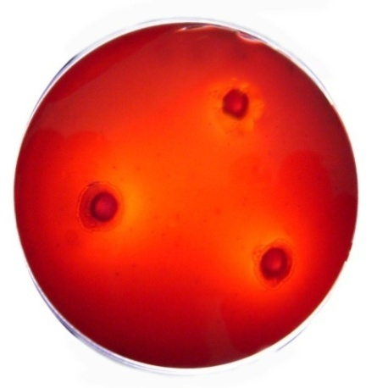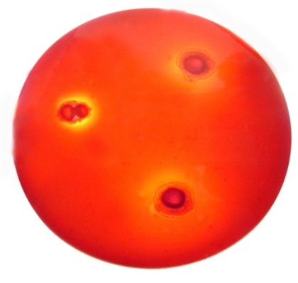
Figure 3-4 Figure 3-5
Figure 3-4 Detection of hemolytic activity from beads of immobilized bacterial cells in wells on blood agar
Figure 3-5 Detection of hemolytic activity from beads of immobilized purified hemolysin in wells on blood agar

Effect of purified hemolysin on white blood cells: In this study, four blood samples have been taken to estimate WBCs count prior and post – treated with purified hemolysin. The results indicated that hemolysin could effect on WBC count in fresh blood after mixing for one and two hours. The results are shown in the Table (3-3). From these results, it is obvious that there is a reduction in WBCs number when mixing with hemolysin for one or two hours. This may be due to that hemolysin has a cytolytic activity against other blood cells and this also means that hemolysin has a receptor on WBCs identical to that in RBCs. The activity of hemolysin is not limited to red cells since alpha hemolysin of E.coli also lyses leukocytes[18, 19].

Table 3-3 Effect of purified hemolysin on WBCs count.
WBCs count after hemolysin addition |  |  |  | WBCs count ×10⁹\L |  | Blood sample No.
After 2hr.  Number % |  | After 1hrs.  Number % |  |  |  | Blood sample No.
41.8%  37.9%  43.9%  43.2% | 3600  2200  3600  3200 | 72.0%  68.9%  75.6%  75.6% | 6200  4000  6200  5600 | 100%  100%  100%  100% | 8600  5800  8200  7400 | 1.  2.  3.  4.

In vitro study the effect of purified hemolysin on pus cells in urine sample:
The effect of hemolysin on pus cells in urine samples has been studied. It has been shown that hemolysin reduced the number of pus cells when incubated with each samples for (1, 2, 3, and 4 hours) respectively. The results are shown in Table (3-4).

Table 3-4 Effect of purified hemolysin on pus cells in urine at different times.
Sample No. | Sample characteristics |  |  | Pus cells count in the presence of purified hemolysin after
Sample No. | Albumin | Glucose | Esterase | with No hly | 4hrs. % of remaining | 3hrs. % of remaining | 2hrs. % of remaining | 1hr. % of remaining
1.  2.  3.  4. | +  +  -  - | +  +  -  - | +  +  +  + | 100%  100%  100%  100% | 88.6%  88.0%  75.0%  63.5% | 61.3%  52.0%  70.3%  44.0% | 37.3%  43.3%  41.1%  33.0% | 15.6%  22.0%  27.3%  10.0%

From the results obtained in this table, it is observed that, hemolysin has an effect on pus cell number when incubated together at different times. This may explain why the bacteria are sometimes present in the urine but with low number of pus cells or completely absent in the urine sample. However, many infectious bacteria export soluble proteins which can damage plasma membrane of eukaryotic cell, most often, they are directed against leukocytes [18, 20] have seen that α-hemolysin is prepared in a way that retains its leukotoxic activity, and when incubating with leukocyte in vitro, these cells are lysed. The mechanism of treated α-hemolysin with leukocytes is unknown.

References
- Christine, S., Alexander, Z., Berit, S., Arnd, G., Peter, S., Colin, H. and Michael, P. (2004). Interaction of E.coli hemolysin with biological membrane. J. Biochem. 268(3): 800-808.
- Chester, J. P. and Kyung, D.L. (2000). Bacterial pore-forming hemolysins and their use in the Cytosolic delivery of macromolecules. Advanced drug delivery reviews. 41: 209–221.
- Hildebrand, A., Roth, M. and Bhakdi, S. (1991). Staphylococcus aureus alpha-toxin: dual mechanisms of binding to target cells. J. Biol Chem. 266:17195–17200.
- Gemmell, C.G. and Shibl, A.M. (1983). Effect of four antibiotics on hemolysin production and adherence to human uroepithelium cells by E.coli. J. Med. Microbiol. 16:341-349.
- Seeger, W., Bauer, M. and Bhakdi, S. (1990), Staphylococcal alpha-toxin induced vascular leakage in isolated perused rabbit lungs. Lab. Investig. 63:341–349.
- Todar, K. (2008). Microbial world. Pathogenic E.coli. University of Wisconsin- Madison.: 375-390.
- De Boy, J., Wachsumth, K. and Davis, B. (1980). Hemolysin activity in enterotoxogenic and non-enterotoxogenic strains of E.coli. J.Clin. Microbiol.12:193-198.
- Wyndham, W.L., Lassa, B., Barah, E.W., Nicole, T.P. and Rodney, A.W. (2003). Acquisition of stcE and C1 esterase inhibitor metallo protease, during evolution of E.coli O157:H7. J. Infec. Dis. 14:187-1907.
- Figuriredo, P., Catani, C. and Yano, T. (2006). Serum high-density lipoprotein (HDL) inhibits in Vibrio enterohemolysin (Ehly) activity produced by enteropathogenic E.coli. FEMS Immnol. Med. Microbiol. 38:53-57.
- Gutierrez, M.C., Zaira, Y.G., Maria, J. and Hortigǘela, A. (2007). Biocompatible MWCNT scaffolds for immobilization and proliferation of E.coli. J. Royal Soc. Chem.
- Baker, F. and Silverton, R. (1980). Introduction to medical laboratory technology.5th ed. Butter worth, London.
- Bhakdi, S., Mackman, N., Menestrina, G., Fray, L., Hugo, F., Segar, W. and Hollabd, I.B. (1988). The hemolysin of E.coli. European J. Epid. 4(2): 135-143.
- Kenneth, D.C., Derek, A.M. and Nathony, W.C. (2007). Transmembrane pore size and role of cell swelling in cytotoxicity caused by Pasturella hemolytica leukotoxin. Infect. Immun. 57(2): 420-425.
- Lucia, M.L., Sandra, H., Antonio, J. Maria, A., Jone, M. and Isabel, C. (2005). Heterogeneity among strains of diffusely adherent E.coli isolate in Brazil. J.Clin. Microbiol. 43(4): 1968-1972.
- Springer, W. and Goebel, W. (1980). Synthesis and secretions of hemolysin by E.coli. J. Bacteriol. 144(1): 53-59.
- Al-hemidawi, T. F. (2005). Hemolytic activity of E.coli isolated from urinary tract infections and its resistance to antibiotics. Ph D. Almustansyriah univer. Thesis.
- Jorgensen, S., Short, E., Kuetz, J., Mussen, H. and Wu, G. (1976). Study on the origin of the hemolysin produce by E.coli. J. Med. Microbiol. 19: 173-189.
- Gianfranco, M., Mauro, D., Cecilia, P. Monica, B. and Franco, G. (1995). Bacterial hemolysins and leukotoxin affect target cell by forming large exogenous pores in to their plasma membrane E.coli hemolysin a as a case example. Bioscience Reports. 15(6):543-551.
- Gadeberg, O., Orskav, T., and Rhodesjoa, N. (1983). Cytoxic effect of α-Hemolytic E.coli strain on human blood monocytes and granulocytes in vitro. Infect. Immun. 41(1):358-364.
- Cavalieri, S. and Snyder, I. S. (1982).Effect of E.coli alpha-hemolysin on human peripheral leukocyte function in vitro. Infect. Immun. 37(3):966-974.

