M J B

Comparative Evaluation of Saline –Sonograghy Hystro-Salpingograghy and Laprascopy in Determination of Tubal Patency
Bushra Jabber Al-Rubaii
College of Medicine, University of Babylon, Hilla, Iraq.

Abstract
Objective: To compare diagnostic accuracy of saline-sonography ,hystro-salpingography and laparoscopy in assessment of tubal pathology in infertility in women.
Study Design: Prospective study on one hundred infertile women in Babylon Maternity and Pediatrics Teaching Hospital had undergone tubal patency assessment with saline-sonography ,hystro-salpingography and laparoscopy from June2008 till June 2009,their ages between 18-43 years.
Results: Hystrosalpingography has sensitivity of 83.6 percent and specificity of 66 percent in predicting tubal pathology and saline-sonography has sensitivity of 89.4 percent and specificity of 90.6 percent for detecting tubal patency. Laparoscopy been of choice for tubal pathology as detection and treatment, but initial assessment of tubal patency for infertile women using saline-sonography as safe , noncosty,with-outradiationhazards.
الخلاصة
اجريت الدراسة فى مستشفى بابل للولادة والاطفال التعليمى للفثرة من حزيران 2008 الى حزيران 2009االهدف منهااحراء مقارنة بين اشعة الرحم والانابيب الملونة وفحص الامواج فوق الصوتية مع المادة مع ناظور البطن فى تقييم امراض الانابيب لدى النساء اللواتى يعانين من العقم واظهار اهمية الناظور فى تشخيص امراض الانابيب واعضاء الحوض الاخرى لدى النساء0شملت الدراسة مئة من النساء تتراوح اعمارهن بين 18-43 سنة جميع النساء اجرى لهن فحص الاشعة الملونة للانابيب وفحص الامواج فوق الصوتية مع المادة فى النصف الاول من الدورة الشهرية ويجرى فحص الناظور فى النصف الثانى من الدورة التى تليها اثبتت الدراسة ان لفحص الاشعة القابلية على تشخيص سلامة الانابيب بنسبة 836% وعدم وجود حالة مرضية 66% وفحص الامواج فوق الصوتية مع المادة القابليةعلى تشخيص سلامة الانابيب بنسبة 894% مقارنة بناظور البطن وله القابلية على تشخيص عدم وجود حالة مرضية بنسبة 906% نظرا لكون فحص الامواج فوق الصوتية باستعمال المادة هى طريقة سهلة وغير مكلفة وبدون مضاعفات يمكن استعمالها كفحص اولى للتاكد من الانابيب عند اللواتى يعانين من االعقم كبديل للاشعة الملونة وبامكان الناظور تشخيص الحالات المرضية بوجود خلل فى فحص الامواج مع المادة والاشعة الملونة .
ــــــــــــــــــــــــــــــــــــــــــــــــــــــــــــــــــــــــــــــــــــــــــــــــــــــــــــــــــــــــــــــــــــــــــــــــــــــــــــــــــــــــــــــــــــــــــــــــــــــــ

Introduction
Infertility causes great distress to many couples causing increasing number of them to seek special fertility care.
Tubal disease accounts for 15-20 percent of cases of primary infertility and approximately40 percent o secondary infertility. It represents the after-math of pelvic infection, endometriosis or surgery resulting in tissue damage, scarring and adhesions formation. This can affect tubal function and results in either partial or total tubal occlusion. A single episode of pelvic inflammatory disease causes up to 10 percent risk of future tubal factor infertility[1].
Hystrosalpingography is simple radiological technique to demonstrate uterine cavity and Fallopian tube using radiographic liquid dye instilled through the cervical canal [2]. It is less invasive and can be helpful in women at low risk of pelvic pathology .As a test of tubal obstruction, has sensitivity of 95 percent [3]. Disadvantages of hystrosalpingo-graphy are risk of radiation particularly to the ovaries, hypersensitivity to iodine, granuloma formation and extravasation of the dye [4,5]. Laparoscopy is direct visualization of the abdominal and pelvic organs, performed under general anesthesia and a uterine cannula used to inject methylene blue dye to check for tubal patency [6]. The use of ultrasound along with injection of a son reflective contrast medium through the cervix been described [1]. The trans-vaginal technique was introduced in 1989 by Diechart ,et al [7] who used echogenic medium to assess tubal patency and offer structural informations.Tufecki etal developed easier technique using isotonic saline solution [8]. Preliminary studies comparing it with lap. And dye or hystrosalpingography shown good concordance [9].

Aim of the Study
To compare diagnostic accuracy of three methods SSG,HSG and laparoscopy in assessing tubal factor of infertility and whether SSG is an easy and safe alternative to HSG.

Materials and Methods
Our study involved one hundred women having primary and secondary infertility attending Babylon Maternity and Pediatrics Teaching Hospital ,over a period of one year from June 2008 till June 2009 .Their ages ranged between 18-43 years .Patients detailed history was taken ,clinical exam and investigations was done ovulation was normal and no cervical factor. For evaluation of male partner semen analysis performed to exclude male cause of infertility. For tubal patency saline-sonography was done on day seven or eight of the cycle, hystro-salpingography on day nine or tenth of the cycle. The procedure of saline-sonography explained to the patient and informed consent obtained. The vulva and the vagina were cleansed with antiseptic solution then sterile speculum introduced into the vagina special well fitted cannula been fixed in the cervix through which pediatrics feeding tube of 5 F was inserted into the uterus up to the fundus, the feeding tube pre-filled with saline prior insertion, the speculum removed and trans-vaginal transducer of the ultrasound introduced then after checking the site of the feeding tube, sterile saline injected slowly through the tube under continuous sonographer control. A course of antibiotics as prophylaxis given subsequently. Hystrosalpingogram performed using the same well fitted cannula in the cervix and injection of urographine and an X-ray taken. Laparoscopy was performed under general anesthesia, the patient in Trendlenberg position after cleansing the abdomen and the vagina intra umbilical incision and secondary port and chromo-tuba ion using Methylene blue dye through well fitted cannula in the cervix. Statistical analysis by chi-square.

Results
Our study included one hundred women complaining of infertility 66 with primary infertility and 34 with secondary infertility subjected to examination of tubal patency by saline-sonography, hystro-salpingography, and laparoscopy belong to age groups between 18-43 years old (mean age 31.21±4.66)
On saline-sonograghy 53 women with patent tubes ,21 with right tubal block, 13 patients had left tubal blockage and 13 had bilateral obstruction while hystro-salpingography showed 38 women with bilateral spillage ,15 with right tubal blockage 16 women with left tubal blockage and 31 women with bilateral tubal obstruction. On laparoscopy 53 women showed bilateral patent tubes, 22 women with right tubal blockage, 17 women with left tubal blockage and 8 women with bilateral obstruction.(Table 1).
In Table 2 shows the correlation between saline-sonography (SSG) and laparoscopy as bilateral tubal obstruction by SSG was in 13 patients while by laparoscopy was in 8 patients. Right tubal blockage by SSG was in 21 patients while by laparoscopy was in 22 patients .Left tubal blockage by SSG was in 13 patients while in laparoscopy was in 17 patients. Bilateral patent tubes in SSG and laparoscopy was in 53 patients. The sensitivity of SSG for detection of bilateral tubal obstruction was 75% and 72.7% for right tubal blockage,64.7% for the left tubal blockage and the specificity was90.6%.In Table no.3 correlation between hystro-salpingography(HSG) and laparoscopy ,bilateral tubal obstruction by HSG was in31 while in laparoscopy was in 8, right tubal blockage by HSG 15 while by laparoscopy in 22 patients. Left tubal obstruction by HSG was in 16 while in laparoscopy in 17 patients. Bilateral patent tubes by HSG was in 38 patients while in laparoscopy was in 53 patients. HSG was sensitive for detecting of bilateral tubal obstruction was 87.5% and 27.3% for right tubal blockage, and 35.3% for left tubal blockage. The specificity was66%.In Table no.4 SSG having positive predictive value for bilateral blockage was46.2%, for right tubal blockage was76.2%, for left tubal blockage was 84.6% while the negative predictive value was90.6%. In Table no.5 the positive predictive value for HSG in detection of bilateral tubal blockage was 22.6% ,for detecting right tubal blockage was40% and for left tubal blockage was37.5% while the negative predictive value was92.1%. In Table no.6,7 the sensitivity of SSG was 89.4% and specificity was 90% while the sensitivity of HSG was 83.6% and specificity was 66%. In Table no. 8,from 47 women with tubal obstruction 5 of them revealed to be with patent tubes by laparoscopy and from 53 women with patent tubes by SSG 5 women had tubal obstruction, so the positive predictive value for SSG was89.4% and negative predictive value was 90.6% P- value less than o.001 which is highly significant. And for HSG Table no.9 from 62 with tubal obstruction 18 women shown to have bilateral patent tubes and from 38 women with patent tubes 3 women shown to have tubal obstruction so the positive predictive value was 71% and negative predictive value was 92% P-value less than 0.001 which is highly significant.

Table 1 Findings On SSG,HSG ,Lap.
Bilateral Tubal Obstruction | Left Tubal Block | Right Tubal Block | Bilateral Patent Tubes | Technique
13 | 13 | 21 | 53 | SSG
31 | 16 | 15 | 38 | HSG
8 | 17 | 22 | 53 | Lap.
P- Value < 0.001
Table 2 Correlation of SSG & Laparoscopy

Laparoscopy |  |  |  |  |  |  |  | SSG
Bilateral Patent |  | Lt. Block |  | Rt. Block |  | Bilateral Obstruction |  | SSG
% | No. | % | No. | % | No. | % | No. | SSG
- | - | 23.5% | 4 | 13.6% | 3 | 75 % | 6 | Bilateral Obstruction
5.6% | 3 | - | - | 72.7% | 16 | 25% | 2 | Rt. Block
3.8% | 2 | 64.7% | 11 | - | - |  |  | Lt. Block
90.6% | 48 | 11.8% | 2 | 13.6% | 3 | - | - | Bilateral Patent
100% | 53 | 100% | 17 | 100% | 22 | 100% | 8 | Total
P-Value < 0.001

Table 3 Correlation of HSG & Laparoscopy

Laparoscopy |  |  |  |  |  |  |  | HSG
Bilateral Patent |  | Lt. Block |  | Rt. Block |  | Bilateral Obstruction |  | HSG
% | No. | % | No. | % | No. | % | No. | HSG
- | - | 64.5% | 11 | 59.1% | 13 | 87.5% | 7 | Bilateral Obstruction
17% | 9 | - | - | 27.3% | 6 | - | - | Rt. Block
17% | 9 | 35.3% | 6 | - | - | 12.5% | 1 | Lt. Block
66% | 35 | - | - | 13.6% | 3 | - | - | Bilateral Patent
100% | 53 | 100% | 17 | 100% | 22 | 100% | 8 | Total
P-Value < 0.001

Table 4 Positive & Negative Predictive Value For SSG

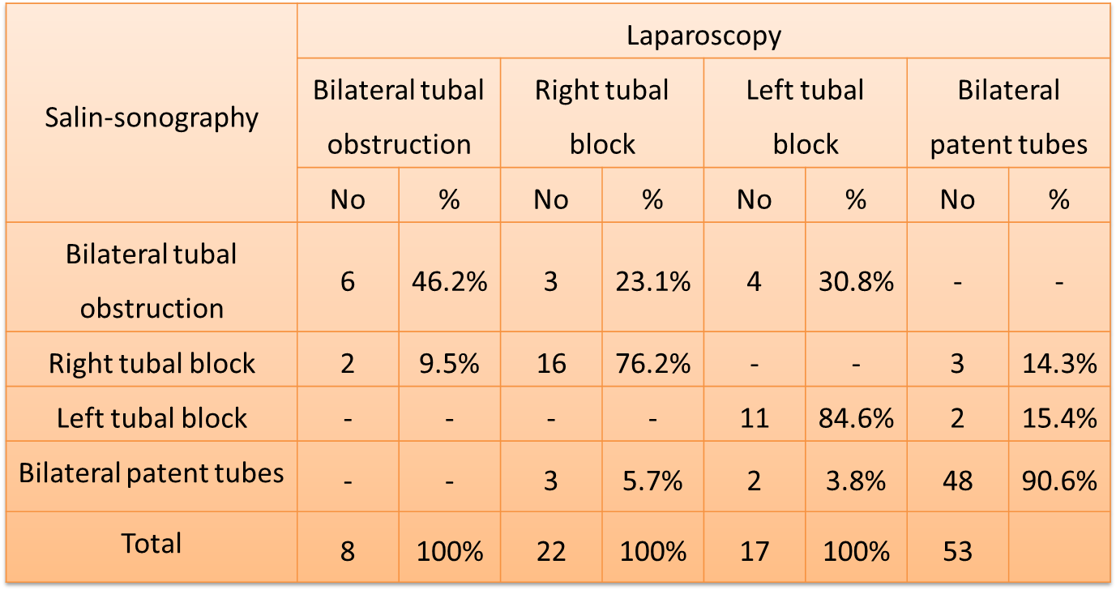
P- Value < 0.001

Table 5 – Positive & Negative Predictive Value For HSG
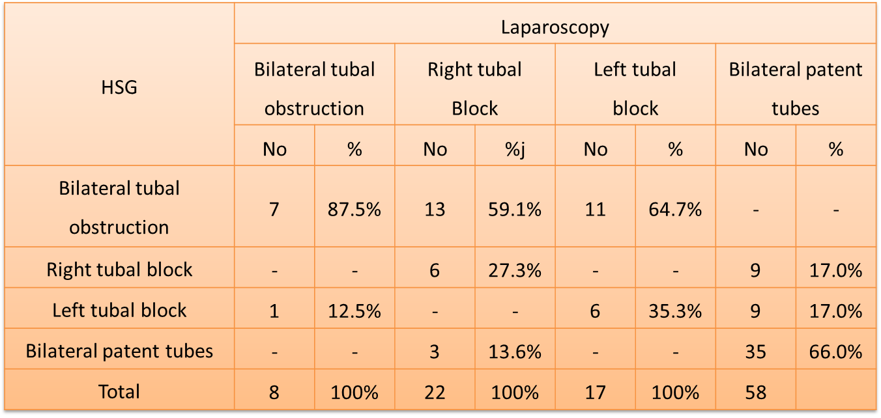
P- Value < 0.001

Table 6 The Sensitivity & Specificity of SSG
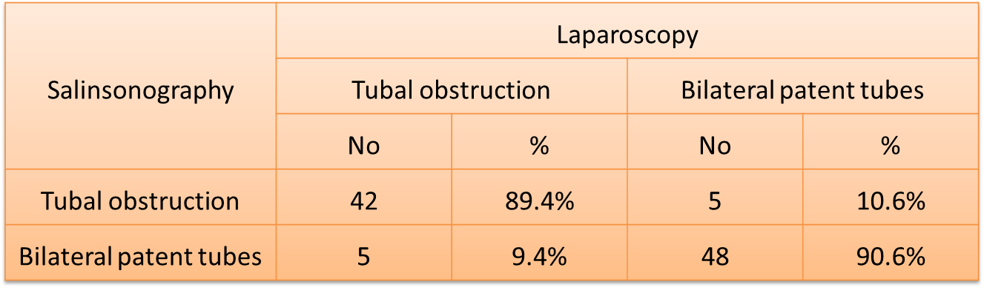

Table 7:The Sensitivity & Specificity of HSG
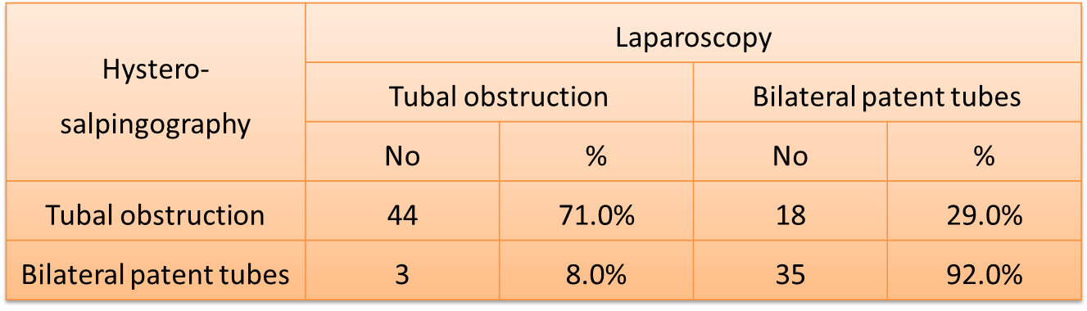

Table 8 Positive & Negative predictive value of SSG
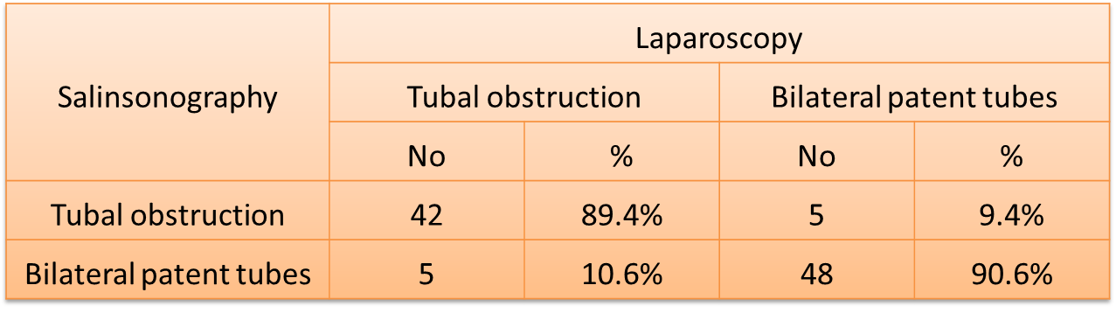
P –Value < 0.001

Table 9 Positive &Negative predictive value of HSG
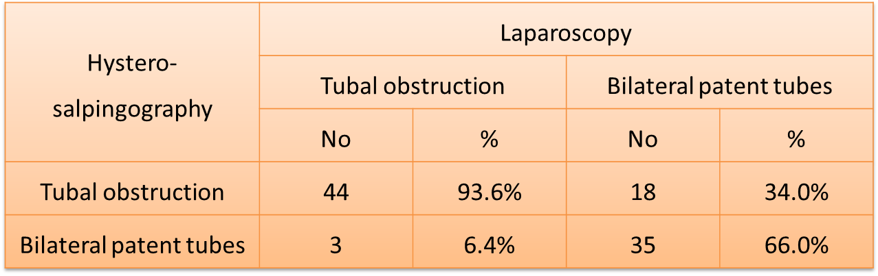
P –Value < 0.001

Discussion
In the last years there is increasing number of women seeking infertility evaluation. Tubal factor accounts 15 percent of female infertility, It is better to be less invasive in our management in such cases.Laproscopy, hystrosalpingog-raphy, saline-sonography target the correct diagnosis regarding tubal factor causing infertility when comparing the results of saline-sonography,hystro-salpingography and laparoscopy we found that the SSG was superior to HSG for assessment of tubal patency ,it lacks ionizing radiation and better tolerability by the women who were been examined .In our study the patients who have bilateral patent tubes by HSG was in 38 patients and obstructed tubes was in 62 patients while by SSG 53 patients who had bilateral patent tubes and the obstructed tubes was 47patients. Of those 62 patients with positive HSG showed obstruction of tubes by SSG only 47 of them had the obstruction this may be due to spasm in the tubes. By HSG 15 patients had right tubal blockage while by SSG 21 patients, so the six patients who had false negative results(right tube patent on HSG but blocked on SSG) this may be due to tubo-cornual spasm, mucus plug blocking the tube or technical error. In HSG 16 patients had left tubal blockage while on SSG was 13 patients ,so in three patients who had false positive results(tube was blocked by HSG and patent by SSG) this due to hydrosalpinix which may itself be the reason since the turbulence of the flow of the saline through the dilated tubes may simulate spillage on ultrasound scan [10,11]. In our study the SSG was sensitive for detection of bilateral tubal blockage was 75% while HSG was 87.5%. SSG was sensitive for detection of right tubal block was 72.7% while HSG was 27.3%.SSG was sensitive for detection of left tubal block was 64.75% while HSG was 35.3%.The specificity for SSG in comparison with laparoscopy was90.6% while for HSG in comparison with laparoscopy was 66%.Kore, et al (2000)[12] also found that when results of SSG were compared with those of laparoscopy 97% correlation was noted whereas there was 93% correlation between results of HSG and laparoscopy. There is agreement between our study and a study performed by Allahbadia 1992,1993 [13,14] who reported more than 90% compatibility between SSG and laprascopy .Valopi, et al ,1994 [15] reported 87.3% compatibility between HSG and laparoscopy, Heikknen et al 1995 [16] reported 85% compatibility between SSG and laparoscopy and Inki et al 1998 [17] reported 88.7% compatibility of the cases of SSG compared with laparoscopy. Katja Maarit et al ,2009 [18] reported the sensitivity of SSG was 95% and the specificity was 73%.P.Jeanty et al ,2000[19] reported the sensitivity of SSG was 85.7% and specificity was 77.2%.In our results the positive predictive value for SSG in detection bilateral tubal obstruction was46.2% and for HSG was 22.6% ,for right tubal blockage was76.2%and for HSG was40%and for left tubal blockage was 84.6%and for HSG was 37.5%.
The negative predictive value for SSG was 90.6% for HSG was 92.1%. In general positive predictive value for SSG in correlation with laparoscopy was 89.4% and negative predictive value was 90.6%. While in comparison of HSG and laparoscopy, the positive predictive value for HSG was 70.1%and negative predictive value was92%.Our study agree with study by Sarwat et al 2006 [20] reported the sensitivity and specificity of SSG was 90.9% and 89.4% respictively with positive predictive value was 83.3%and negative predictive value was 55.55%.Also our study was agreed with results obtained by Mona et al,2010 [21] reported no significant difference between SSG and HSG and laparoscopy sensitivity of HSG was 87% in correlation with laparoscopy and SSG 94.1% the difference was statically insignificant ,according to the site of obstruction, the sensitivity ,specificity and diagnostic accuracy of SSG were insignificant higher than that of HSG.Mitri et al 1991[22] and Tufekii et al 1992 [23] reported in their study similar conclusion regarding the accuracy of SSG in diagnosis the site of tubal obstruction.G.Cimen et al 1999 [24] reported concordance of SSG and laparoscopy was 86% and HSG with laparoscopy was 77%.

Conclusion
SSG offer much less invasive method of diagnosis of tubal patency while maintaining high sensitivity and specificity similar to HSG .SSG also can be performed initially to infertile patient .It is safe avoiding un-necessary x-ray exposure ,associated with less pain ,discomfort, with rare side effect and inexpensive.

References
1-Siladilya Bhattacharya: infertility Dewhurst's text.of obestet.and gynae.7th ed.(2007) chap. 45,p.444.
2-Niloofar Eskandari,MD,and Mary Cadieux,MD: Infertility Current Obestet. And Gynae, (2005) chap.53,p. 985.
3- Swart P.,Mol BW ,Van Beurdeum. Vander Veen F,RedekopWK and Bossut PM(1995).The accuracy of HSG in the diagnosis of tubal pathology a metanalysis Fert.Ster. 64: 486-91.
4-James R,Scott, Infertility Danforth Obstet.&Gynae. ,6th ed.1991,p.807.
5-Arther I,Herbst :Infertility Comperhensive Gynae.: 2ed.1991, p. 1189- 1242.
6-Pranay Shah:Laprascopy in Infertility (2007): chap. 8,p.92-97.
7-Diiechert V.Evaluation of tubal patency by HSGin Kusis,S Zeiger D,Ultrasound & infertility NewYork the Parthenon Publishing group, 2000: 263-284.
8-Tufekii EL ,Durmosoghi F,Girits S,Yalli: Evaluation of tubal patency byTrans-vaginal ultrasound ,Fert. Ster. ,1992:87(2):336-40.
9-Dijkman B,Mol BW,Vander Veen F, Bossuyt PM&Hogerzeil HV(2000) Can Hystro-salpingo contrast-sonography replace HSG in the assessment of tubal subfertility? Eur.J.Radiol. 35:44-48.
10-Seigler AM ,Kontopoulos V.An analysis of macrosurgical & microsurgical techniques in the management of tuboperitoneal factor infertility.Fertile-sterile,1997.
11- Seigler AM:Endoscopy in infertility In Progress in infertility Ed:Behrman SJ,Kistner RW,Patton GW 3rd ed. Little Brown Company,Boston 1988,p.71.
12- Kore S,Hedge A,Nair S,sonography assessment of tubal patency J.Obstet.& Gyne. India.2000.
13-Allahbadia GN,Fallopian tubes &ultrasonography : the sion experience ,fert.ster., 1992.58(5),901-7.
14- Allahbadia.GN,Fallopian tubes patency using color Doppler ,Gynae. Obestet. 1993. 40(3):241-4.
15- Volpi E,De Grandis T,Rustichellis S, A new tequnique to tubal patency test & transvaginal U!Scontrol.Acta Obestet.Gyne.Scand.1984,Nov.,731(10):797-801.
16- Heikkienen H, Teky A ,Volpy E, Transvaginal sonography for assessment of tubal patency in infertile women, methodological& clinical experiences, Fert. Ster. 1995:Aug.: 64(2):293-8.
17-Ink; P ,Paio P,Aittrila L,:Vaginal sonography in the evaluation of tubal patency .Acta Obestet. &Gyne. Scan, 1992:77(10) :978-82.
18- Kataja ,Marrit Aninko-Hakamaa, Heini Hutala,Confermation of tubal patency in HSG by transvaginal Hydroscopy,2009. Acta Obest. Gyne.Scand March2009(88)286-290
19- P Jeanty, S .Besnard, A.Arnold ,Air contrast sonography as first step assessment of tubal patency.J. Ultrasound Med.2000: 19,519-527.
20- Sarwat Rizvi, Fozia umber,Sad AF Zahra Seyd , Assessment of tubal patency of infertile women , Can Hycosy be performing in the place of HSG,2006. Dec.:12(4):509-11.
21- Mona ZVANCA,Radu, Cristain, ANDRE I: Infertility investigation through saline infusion,Journal of Clinical Medicine,2010. 2(1): 1-11.
22- Mitri F F,Androniko AD,Perp ingal S-Hofmeyer GJ,A clinical Comparison of sonography hydrotubation & HSG,British J. Obestet.&Gyne. 1991:98(10):131-36.
23- Jonathan S,Bereck :Infertility Novak's Gynecology,12th edition,1996 .
24- G.Cimen,B. Trak,GEIpek,:The efficiency of HSG contrast sonography in evaluation of tubal patency, 1999,19(5):516-518.

