Determination of Salbutamol by Spectrophotometric Method in Pure and Pharmaceutical Preparations Using Jones Oxidation

Omer A. Hasan Huda M. Ali
Polymer Research Unit, College of Science, Al-Mustansiriyah University, Baghdad, Iraq.
College of pharmacy, Al-Mustansiriyah University, Baghdad, Iraq
Omer_abas@yahoo.com

M J B

Abstract
A simple sensitive and reproducible spectrophotometric method have been developed for the determination of Salbutamol in pure form or in a tablet. The proposed method is based on the oxidation of hydroxyl group of Salbutamol with chromic acid. The green blue color of reduced Cr⁺³ ion were measured at λ_{max} 582 nm. Linearity was observed from 20 to 250 µg/ml with detection limit 10 µg/ml. the method is successfully employed for determination of salbutamol in pharmaceutical formulation. The proposed method offers the advantages of simplicity, reproducibility, rapidity and sensitivity without the need for extraction or chemical derivatization. The method described could be applied to routine quality control of tablets contain salbutamol. Statistical comparison of the results with the reference method shows an excellent agreement, and indicates no significant difference in accuracy and precision. The reliability of the methods has been ascertained by recovery studies.
تقدير دواء السالبيتيمول بطريقة طيفية في المادة النقية و المستحضرات الصيدلانية باستخدام كاشف جونز
الخلاصة
تم في هذا البحث استخدام طريقة طيفية بسيطة و دقيقة وسريعة لتقدير دواء السالبيتيمول في عينات محضرة مختبريا و كذلك الادوية المتوفرة في السوق الصيدلانية. الطريقة المقترحة تعتمد على اساس اكسدة مجموعة الهيدروكسيل في الدواء بواسطة حامض الكروميك و قياس ايون الكروم (Cr³⁺) المتولد من التفاعل بطول موجي مقداره 582 نانومتر. تم الحصول على منحني معايرة لمجموعة تراكيز من المحاليل القياسية للدواء بمدى خطي من 20 الى 250 مايكرومتر/ مل و بحد كشف 10 مايكرومتر/مل . و يمكن استخدام هذه الطريقة في التحاليل الروتينية لتقدير السالبيتيمول حيث اعطت الطريقة المقترحة نتائج ممتازة عند مقارنتها مع الطرق المعتمدة عالميا.
ــــــــــــــــــــــــــــــــــــــــــــــــــــــــــــــــــــــــــــــــــــــــــــــــــــــــــــــــــــــــــــــــــــــــــــــــــــــــــــــــــــــــــــــــــــــــــــــــــــــــ

Introduction
Salbutamol [1-(4-hydroxy-3-hydroxy-methyl phenyl) -2- (t - butylamino) ethanol] Is a β2 adrenergic receptors agonist is a direct sympathomimethic with beta-adrenergic activity, used in treatment of bronchial asthma and other forms of allergic airways disease. It is also used as premature labor in pregnancy [1] and obstetrics for the preventation of premature labour and as nasal decongestant [2].
There are several different methods that have been proposed for the determination of Salbutamol in pharmaceutical dosage form[3]. Also it has been assayed by visible spectrophotometric methods based on oxidation[4,5], reduction[6], oxidative coupling[7], nitration[8], charge transfer complex formation[9], liquid chromatography[10], mass spectrometry [11], and flourometry[12] technique were also used.
In the present study, experimental conditions were established for the spectrophotometric determination of Salbutamol by employing Jones reagent[13] solution (CrO₃ in H₂SO₄) as oxidizing agent. The Jones oxidation was used to detect the presence of hydroxyl substituent that is on a carbon bearing at least one hydrogen. As the alcohol is oxidized, the solution changed from an orange-red color form to a blue to green color for the Cr³⁺ ions.
The proposed method have the advantages of being rapid, simple, less time consuming and with a minimum amount of reagent have been used. Furthermore they do not use costly instrumentation.
Experimental
Apparatus:
An T80 UV-Visible double beam spectrophotometer with 1 cm quartz cell was used for recording spectra and absorbing measurements.
Chemicals:
All reagents were of analytical grade, Salbutamol were supplied from Sammara Co. , Salbutamol tablets were purchased from a local market. All water used was double distilled.
Jones reagent:
25 g of chromic anhydride (CrO₃) was poured slowly in 25 ml concentrated sulfuric acid with stirring in 75 ml of water. The deep orange solution was then cooled to room temperature[13].
Construction of calibration curve:
100 mg of Salbutamol was accurately weighted and dissolved in 100 ml of water to form a stock solution (1000 µg/ml). the stock solution was further diluted suitably with water to give a working standard solution of concentration (100 µg/ml). different aliquots of the working standard solution were taken in a series of 10 ml volumetric flasks containing 1 ml of Jones reagent and volume up with water to obtain standard solution contains 15 to 300 µg of Salbutamol. The standard solution and blank (1ml of Jones reagent diluted with water to 10 ml) was placed in water bath at 50 ᵒC for 10 min. the absorbance of these solutions were carries out against blank at 582 nm.
A calibration curve of Salbutamol was plotted. The concentration of the unknown was read from the calibration graph or computer from the regression equation.
Determination of Absorption Maxima:
Standard solution containing 150 µg was prepared as described above were scanned In the range 200 to 800 nm to determine the wavelength maxima absorption the solution showed absorbance maxima at 582 nm corresponding to Cr³⁺ ions.
Preparation of Dosage Form:
Fifty tablets were weighted and finely powdered. A powdered amount equivalent to 50 mg was dissolved in water and filtered. The filtrate was made up to 100 ml and appropriate aliquots of the tablets solutions were treated as described in the recommended procedure for the pure sample.

Results and Discussions
Determination of the Absorption Maxima:-
Salbutamole oxidized with Jones reagent at room temperature to give blue colored solution due to the formation of Cr³⁺ ions. The reaction is rapid and color development is completed within 10 min. the intensity of the colored solution is completely stable and its absorbance did not significantly vary during 24 hr. the λ_{max} of reaction products lies at 584 nm.

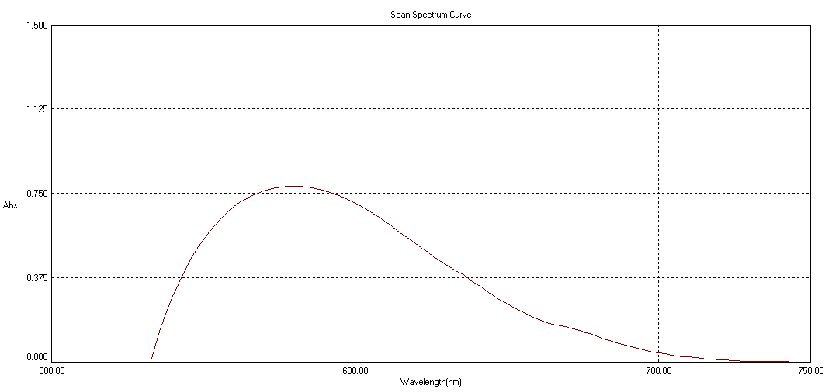
Figure-1: Scan spectrum Curve of reaction mixture

Effect of Temperature
The color development was found to perform at room temperature 25ᵒC within 4-8 min depending on the concentration of the solution. The intensity of the colored developed was measured each 2 min. It was found that the intensity of the color remained constant after 8 min. therefore the optimum reaction time was fitted to 10 min.
Calibration Graph
Calibration graphs were constructed by plotting the absorbance against the concentration of Salb. Beer's law obeyed in the range 20 to 250 µg/ml with molar absorption coefficient of 0.00329 ml. µg⁻¹. cm⁻¹. Table 1 summarizes the characteristics and the results of statistical analysis of the experimental data.

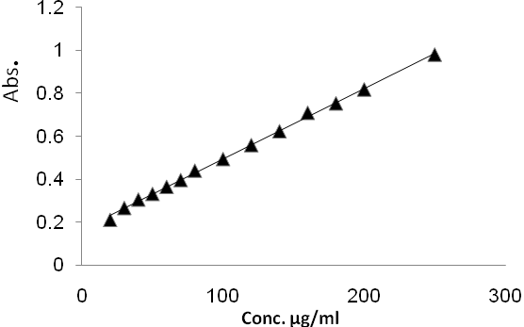
Figure 2 Calibration curve of Salbutamol

Table 1 Optical and regression characteristics of the proposed method
Parameter | Value
λ_{max} (nm) | 582
Beer's Law Limit (µg/ml) linear range | 20-250
Molar Absorptivity (ml. µg⁻¹. cm⁻¹) | 0.00329
Linear Regression equation | A= 0.16557 + 0.00329 C
Correlation Coefficient (r) | 0.999238
Detection Limit (µg/ml) | 0.037
Quantitation Limit (µg/ml) | 0.112
Relative Standard Deviation RSD % | 1.5

The limit of detection (LOD) and quantitation (LOQ) were calculated using the following relation described by Ermer ⁽¹⁴⁾.
LOD = 3.3 S₀/b
LOQ = 10 S₀/b
Where S₀ is the standard deviation of the calibration curve and b is the slope.

Analytical Recovery
The accuracy of the proposed methods was also checked using recovery experiments through standard addition method by adding known amount of pure Salbutamol to preanalyzed dosage form. The mean recovery and RSD % values were in the range 99 to 104 and 0.6 - 3.2 %. The lower values of RSD % indicate the good precision and reproducibility of the method.
The RSD % values for the reproducibility and recovery studies shows that the method is precise and accurate.

Table 2 Results obtained in determination of Salbutamol in synthetic samples and tablets
Sample | Salb. Sulphate  content (µg/ml) | Proposed Method |  |  | Official Method¤
Sample | Salb. Sulphate  content (µg/ml) | Found (µg/ml) | % RE ^{Ф} | Recovery  ±% RSD | Found (µg/ml) | % RE^{Ф} | Recovery ±% RSD
1 | 20 | 20.8 | 4 | 104 ± 3.2 | 19.7 | 1.5 | 98.5 ± 1.9
2 | 50 | 49.5 | 1 | 99 ± 0.8 | 49.7 | 0.6 | 99.4 ± 2.1
3 | 80 | 82.0 | 2.5 | 102 ± 1.5 | 79.1 | 1.1 | 98.9 ± 0.9
4 | 120 | 121 | 0.8 | 100.8 ± 0.6 | 122.5 | 2.1 | 97.9 ± 0.8
Tablet | 100 | 101 | 1 | 101 ± 0.6 | 99.4 | 0.6 | 99.4 ± 0.2
¤British Pharmacopeia ¹⁵
^{Ф} RE=Relative Error

Conclusion
The proposed spectrophotometric method for the determination of Salbutamol is found to be simple, economical, precise, and sensitive. The proposed do not require any pretreatment of the drug and extraction procedure prior to its analysis and the color reaction does not require to any reagents or solvents with less reaction time. The statistical analysis show that the data from the proposed method are in good agreement with those of the reported method with good reproducibility and accuracy of the method.

References
- Eurpean Pharmacopea, 5th ed., Vol. II, EDQM, Strasbour, 2005, p.3611.
- A.G. Gilman, L.S. Goodman, T.W. Rall, and F. Murad, \Goodman and Gilman's the Pharmacological Basis of Therapeuticus" 7th Ed., pp.172-173, MacMillan Publishing Company, New York, 1985.
- H. Y. Abduol-Enein, A. A. Al-Badr, S. E. Ibrahim, in: K. Flory (Ed.) "Analytical profiles of drug substances", Vol. 10, Academic Press, 1981, pp. 665-689.
- D. Satinsky, R. Karlicek and A. Svaboda, Using on-line solid phase extraction for flow injection spectrophotometric determination of salbutamol, Anal. Chim. Acta 455 (2002) 103–109.
- K. Basavaiah, B. Chikkaswamy, and V. Ramakrishna,"Rapid titrimetric and spectrophotometric methods for Salbutamol Sulfate in pharmaceuticals using N-Bromosuccinimide" Actapharm, 57(2007) 87-98.
- M. N. Reddy, D. G. Sankar, G. D. Rao and K. Sreedhar, Spectrophotometric determination of salbutamol and terbutaline, East. Pharm. 34 (1991) 127–128.
- M. Basu and B. Pathak, Estimation of salbutamol sulphate in pharmaceutical formulations, Indian Drugs 28 (1990) 109–110.
- N. M. Sanghavi and J. T. Vyas, Use of nitrating agent in the colorimetric estimation of drugs –Part II, Indian Drugs 34 (1997) 463–466.
- G. G. Mohammed, S. M. Khalil, M. A. Zayed and M. Abd El-Hamid El-Shall, 2,6-Dichloroquinone chlorimide and 7,7,8,8-tetracyanoquino-dimethane reagents for the spectrophotometric determination of salbutamol in pure and dosage forms, J. Pharm. Biomed. Anal. 28 (2002) 1127–1137.
- R.N. Gupta, H.D. Fuller, and M.B. Dolovich,” Optimization of a column liquid chromatographic procedure for the determination of plasma salbutamol concentration” J. Chromatogr. B., 654, 205-211 (1994).
- M.P. Montrade, B. LeBizec, F. Monteau, B. Siliart and F. Andre, “Multi-residue analysis for β-agonistic drugs in urine of meat-producing animals by gas chromatography—mass spectrometry
“Anal. Chim. Acta., 275, 253-268 (1993).
- H.L. Rau, A.R. Aroor and P.G. Rao,” Fluorimetric estimation of terbutaline sulphate in dosage forms” Indian J. Pharm. Sci., 54, 79-81 (1992).
- R. L. Shriner, C. K. F. Hermann, T. C. Morrill, D, T, Curtin, and R. C. Fuson "The Systematic Identification of Organic Compounds", 8th edition, Jhon Wiley & Sons , 2004.
- Ermer J (2001) Validation in pharmaceutical analysis. Part I: An integrated approach. J Pharm Biomed Anal 24: 755-767.
British Pharmacopoeia 2009, Volume I & II.

