Cortical and Gyral Thickness in Pre-central and Post-central Human Brain Cortex of Patient with Headache: MRI Findings

Mohammed Ubaid Hamza Mohammed abd kadhim**
Mohammed Mohammed Jawad Abass**

College of Medicine, University of Babylon, Hilla, Iraq.
*Collage of Medicine, AL-Nahrain University, Baghdad , Iraq.
**Al-Kadhimyia Teaching Hospital, Baghdad , Iraq.

M J B

Abstract
Headache is one of the man's most common affection. The frequency of disabling headache is explain in part by rich nerve supply to the head (including afferent nerve fibers from trigeminal, glossopharngyal, vagus and upper three cervical nerves), and in part psychological implication of head pain, causing anxiety about even modest headache, head pain can be result of either intra or extra-cranial disease in the distribution of any of above nerves. The aim is To study the effect of headache on cortical and gyral thickness in the pre-central and post-central regions.This prospective study was done in the MRI unit of AL-kadhimyia teaching hospital from the period of April 2009 to September 2009. The study included 2 groups: group 1 included 28 patients (17 females and 11males) suffering from headache of variable duration, while group 2 included 28 normal subjects as a control. Measurements of the cortical thickness of the pre-central and post-central regions as well as the thickness for the 2 groups were done from the sagittal T1 weighted spine echo image. Statistical significance was indicated by a p value of less than 0.05.
A statistically significant Increase in cortical thickness of the post-central region was found in headache patients (4.03± 0.77mm) compared with normal subjects .In patients suffering from headache a statistically significant increase in cortical thickness of the post-central region (4.03± 0.77mm) when compared with that of the pre-cenral region. the cortical thickness in pre- and post-central regions is proportionally increased with the increased duration of headache.

سمك قشرة الدماغ في المناطق التي تقع امام وخلف الشق الوسطي للدماغ للمرضى المصابين بالصداع: مظاهر الرنين المغناطيسي
الخلاصة
يعتبر الم الرأس (الصداع) في الانسان من الآفات (العلل) الشائعة.وان تكرار الصداع يمكن تفسيره من جهة نتيجة وفرة (كثرة)الاعصاب التي تزود الرأس (وتشمل الاعصاب الحسية من العصب التوأمي الثلاثي , والعصب اللساني البلعومي ,والعصب التائه والاعصاب الثلاثة الاولى للرقبة) . ومن جهة اخرى يمكن تفسيره نتيجة الضغط النفسي لالم الرأس الذي يسبب قلقا. ان الم الرأس ناتج من الامراض الخارجية والداخلية للقحف فيما يخص توزيع الاعصاب المذكورة اعلاه.ان الهدف من البحث هو لدراسة تأثير الصداع على المادة الرمادية والتلافيف الموجودة امام وخلف الاخدود المركزي (الوسطي) من الدماغ . هذه الدراسة تمت في وحدة الرنين المغناطيسي في مستشفى الكاظمية التعليمي من الفترة المحصورة بين الشهر الرابع والشهر التاسع من سنة 2009.وتشمل مجموعتين : المجموعة الاولى من المرضى وعددها 28 مريض (17 مريض انثى و11 مريض ذكر) جميعهم يشكون من الصداع وبفترات مختلفة . اما المجموعة الثانية فتشمل 28 شخص (اصحاء) لايشكون من الصداع كمجموعة ضبط (اختبار).تم قياس تثخن المادة الرمادية للدماغ في المنطقة امام وخلف الاخدود المركزي (الوسطي) للدماغ بواسطة فحص مقاطع الرنين المغناطيسي,وتم استعمال الاحصائيات المعنوية .وكانت النتائج تشير الى ان المرضى الذين يعانون يمتلكون زيادة في تثخن المادة الرمادية والتلافيف في منطقة خلف الاخدود الوسطي للدماغ مقارنة مع الاشخاص الاصحاء.كما ان زيادة التثخن في المادة الرمادية والتلافيف الموجودة في منطقة قبل الاخدود المركزي ليس لها اهمية احصائية عند مقارنتها مع الاشخاص الطبيعيين وان زيادة التثخن في المادة الرمادية والتلافيف الموجودة في منطقة خلف الاخدود المركزي للدماغ تتناسب تناسبا طرديا مع زيادة مدة الصداع.
ـــــــــــــــــــــــــــــــــــــــــــــــــــــــــــــــــ

Introduction
From the anatomical point of view the pre central gyrus lies immediately anterior to the central sulcus and is known as the motor area; large motor nerve cells in this area control voluntary movement on the opposite side of the body. In this motor area the body represented in an invested position that the feet is located in the upper part and those controlling the movement of face and hand in the lower part. The post central gyrus lies immediately posterior to the central sulcus, and is known as the sensory area. The small nerve cells in this area receive the interpret sensation, temperature, touch and pressure from opposite side of the body [1]. The motor area is the region from which most of cortico-spinal and cortico-nuclear nerve fibers arise, and the region where low intensity stimulation most readily elicits movements of the contra-lateral side of the body. Sensory area is the region to which the ascending impulses in the medial lemniscus and spino-thalamic tracts are transmitted[2].
Headache is one of the man's most common affection. The frequency of disabling headache is explain in part by rich nerve supply to the head (including efferent nerve fibers from trigeminal, glossopharngyal, vagus and upper three cervical nerves), and in part psychological implication of head pain, causing anxiety about even modest headache, head pain can be result of either intra or extra-cranial disease in the distribution of any of above nerves [3].
Headache is very widespread disease, and according to the WHO, migraine is the most common type of this CNS disorder. Migrain affects 15-25% of women and 6-8% of man [4-7]. The pathophysiology of migrain is not yet fully understood, and the available treatment to prevent and to cure attacks is not optimal [8]. Migrain patients have visual symptom in 94% of cases [9], but symptoms may involve sensory and speech deficits [10].

Aims of the study
To study the effect of headache on cortical and gyral thickness in the pre-central and post-central region.

Patient and Methods
This prospective study was done between April 2009 to September 2009. The study included 2 groups: group 1 included 28 patients (17 females and 11males) with a mean age of 37.8 years (range 14-66years) suffering from headache of variable duration, while group 2 included 28 normal subjects as a control.
MRI examination were done in the MRI unite of Al-Kadhimyia teaching hospital, Baghdad, Iraq. Examinations were performed with MRI unit (gyroscan 1.5 tesla; philips medical system).
MRI examination was done with the following sequences: T2 weighted spine echo image in axial plane, T1 weighted spine echo image is sagital plane and T2 weighted FLAIR image in coronal plane. Measurements of the cortical thickness of the pre-central and post-central gyri as well as the thickness of the whole pre-central post-central gyri for the 2 groups were done from the sagittal T1 weighted spine echo image (each one of these parameters are measured 3 times and the average readings were taken), the readings were done by 2 independent radiologists to decrease the inter-observer error.
Statistical analysis using the program SPSS (version 15 for Microsoft Windows). The cortical thickness and the whole thickness of the pre-central and post central gyri for those patients suffering from headache were compared with that of the control group. Statistical significance was indicated by a p value of less than 0.05. The cortical thickness and gyral thickness of the pre- and post-central regions were calculated and expressed as mean ± SD. The percentage of difference between the cortical thicknesses of the pre and post-central gyri was calculated as percentage of change in thickness.

Results
The 56 patients included in the study comprises 28 patients (17 females and 11males) with a mean age of 37.8 years (range 14-66years) suffering from headache of variable duration, and another 28 normal subjects as a control.
Table 1, 2, and 3 summarizes the means, standard deviation, minimum and maximum values of cortical and gyral thickness of the pre-and post-central region and the mean of percentage of cortical thickness difference in pre- and post- central region.
Regarding cortical thickness of the post-central gyrus, a statistically significant difference was found between the normal subjects (2.46± 0.27mm) and those patients suffereing from headache (4.03± 0.77mm) (p < 0.05). Similarly the gyral thickness of the post-central gyrus was thicker in patients with headache (17.2± 2.72mm) when compared with normal subjects (12.47± 0.77 mm) (p < 0.05).
In patients suffering from headache a statistically significant difference in cortical thickness of the post-central gyrus (4.03± 0.77mm) when compared with that of the pre-cenral gyrus (3.07± 0.65mm) (P < 0.05). No signiicant difference in the cortical thickness of the post-central gyrus (2.46± 0.27mm) and pre-central gyrus (2.42± 0.35mm) in normal subjects (p = 0.160).
An increase in cortical and gyral thickness of the pre-central region in headache patients (3.07±0.65mm and 14.53±2.56mm respectively) was observed but this increase is statistically insignificant compared with normal subjects (2.42±0.35mm & 12.05±0.73mm) (P=0.150 P=0.200) respectively.
Figure 1 show the relationship of the cortical and gyral thickness of the pre- & post-central gyri in patients suffering from headache, generally cortical thickness is proportionally increased with the increased duration of headache.
Figures 2 and 3 shows an MRI images showing cortical and gyral thickness of the pre-central and post central gyri in selected patients with headache and in slelected normal subjects.

Discussion
MRI studies have shown functional abnormalities in the brain in patients with headache [11,12]. It is possible that such an altered function of brain structures might be associated to structural changes [13]. Migraine patients with T2-visible hyperintense lesions have significant reductions of GM density of several brain regions when compared with healthy controls. Such changes were bilateral[14]. A number of recent studies in migraineurs show subclinical structural brain changes, going from progressive cellular damage in nociceptive systems to diffuse WM loss, multifocal WM lesions, and ischemic stroke [15,16].
The somatosensoary cortex is one of the thinnest areas in the brain, usually around 2mm [17].
In our study increased cortical thickness in the post-central gyrus of patients suffering from headache .
4.03± 0.77mm) when compared with normal subjects (2.46± 0.27mm) (p < 0.05). Similarly the gyral thickness of the post-central gyrus was thicker in patients with headache (17.2± 2.72mm) when compared with normal subjects (12.47± 0.77 mm) (p < 0.05). These results are comparable with that noticed in previously reported study were the most significant thickness changes were in the caudal somatosensory cortex in migraineurs, where the brain processes pain signals coming from the head and face [17]. Anatomical changes underlying increases in cortical thickness may include an increase number and\or density of neuronal and\or glial cells in certain part of the cortex. This focal dysplasia may render the cortex more excitable, one of the leading hypotheses in migrain pathophysiology is indeed that the brain of migraineurs is hyper excitability [18-20].
In our study the cortical thickness of the post-central gyrus is increased by 36.2%, this result was greater than that observed by Hadijikhani N et al [21] where they found that somatosensory was an average of 21% thicker in migraine sufferer. it could be the result of long-term stimulation of sensory fields in the cortex, caused by the pain from frequent headaches [17].
In normal people although the cortical thickness of the post-central gyrus (2.46± 0.27mm) slightly exceeding the cortical thickeness of pre-central gyrus (2.42± 0.35mm) this difference is statistically insignificant (p = 0.160) and these results were approximately comparable to that noted in the reported literature where the mean cortical thickness measurements of 2.70 mm and 1.86 mm for motor and sensory cortices, respectively [22].
In headache patients the cortical thickness of the post-central gyrus (4.03± 0.77mm) is more than that of the pre-central gyrus (3.07± 0.65mm) (p <0.05), this observation was not seen in normal subjects. Granziera C. et at [23] showed thickening of the visual areas involved in motion processing in migraineurs. An increased thickness of visual cortical areas could be the result of a focal dysplasia leading to exaggerated excitability of neurons in these regions [20,24,25]. Dasilva AF. Et al [17] reported increased thickness of the somatosensory cortex in migraineurs, especially in the area of the head and face representation.
In headache sufferers an increased in the cortical and gyral thickness of the pre-central gyrus was found when compared with normal subjects but this observation was statistically insignificant.
In general the cortical and gyral thickness of the pre- and post-central gyri in patients suffering from headache is increased with the duration of the headache. This observation can be explained by the fact that GM changes might be the consequence of repeated brain insults during the headache attacks, the repetition of the attacks over time might result in a damage of selected cortical structures [14]. The increase in cortical thickness observed could be due to repeated glial activation following repeated episodes of hypoperfusion [26], Moreover we can only speculate on the nature of the pathological changes underlying increased GM density in brain regions of migraine patients. First, a synaptic and neuritis size increase related to an experience-dependent plasticity can be advocated. The repetition of migraine attacks with the continuous activation of pain-related pathways might drive the formation of synapses, and these changes might lead to adaptive remodeling of neural circuits, as suggested for sensory experience [27] and learning [28]. Second, increased GM density might be the consequence of neuronal loss and secondary reactive gliosis in those brain regions that experience significant functional changes during the migraine attacks. Finally, preapoptotic osmotic changes associated to early neuronal and glial pathology secondary to the vascular changes observed during the migraine attacks might also play a role in this context [14].

Conclusions
1. Patients with headache have increased cortical and gyral thickness of the post central gyrus when compared with normal subjects.
2. Although patients with headache have increased cortical and gyral thickness of the pre central gyrus but this increase in statistically insignificant when compared with normal subjects.
3. The cortical and gyral thickness of the post central gyrus is proportionally increased with the duration of headache.

References
1. Richard S. Snell. Clinical anatomy, 7th ed . Lippin cott. William and Wilkins. 2004: 810-815
2. Romanes G.J. Cunninghams manual of practical anatomy, 15th ed. Oxford Newyork Tokyo oxford university press. (1986): 252-256.
3. Kors EE., Melberg A, Vanmolkot KR. Childhood epilepsy, familial hemiplegia migrain , cerebellar ataxia, and a new CACNAIA mutation . Neurology (2004); 63(6):1136-1137
4. Lipton RB, Stewart WF. Migraine headaches: Epidemiology and comorbidity. Clin Neurosci. 1998;5:2–9.
5. Roncolato M, Fabbri L, Recchia G, Cavazzuti L, Visona G, et al. An epidemiological study to assess migraine prevalence in a sample of Italian population presenting to their GPs. Eur Neurol. 2000;43:102–106.
6. Warshaw LJ, Burton WN. Cutting the costs of migraine: Role of the employee health unit. J Occup Environ Med. 1998;40:943–953.
7. Stewart WF, Lipton RB, Celentano DD, Reed ML. Prevalence of migraine headache in the United States. Relation to age, income, race, and other sociodemographic factors. JAMA. 1992;267:64–69.
8. Nouchine Hadjikhani, relevance of cotical thickness in migraine sufferers. Neurotherapeutics, 2008; 8(3):327-329.
9. Jensen K, Tfelt- Hansent p, olesenj. Classic migraine, A prospective recording of sympotoms. Acta Neurol . Scans. (1986);73(4): 359-362.
10. Vincent. MB, Hadjikhani N. Migrain , aura and related pheuomena . beyond scotomata and scintillations,cephalagia. ,(2007) ; 27(12):1368-1377
11. Weiller C, May A, Limmroth V, Juptner M, Kaube H, Schayck RV, Coenen HH, Diener HC. Brain stem activation in spontaneous human migraine attacks. Nat Med. 1995; 1: 658–660.
12. Bahra A, Matharu MS, Buchel C, Frackowiak RS, Goadsby PJ. Brainstem activation specific to migraine headache. Lancet. 2001; 357: 1016–1017.
13. Ashburner J, Friston KJ. Voxel-based morphometry–the methods. NeuroImage. 2000; 11: 805–821.
14. Maria A. Rocca; Antonia Ceccarelli; Andrea Falini; Bruno Colombo; Paola Tortorella; Luca Bernasconi; Giancarlo Comi; Giuseppe Scotti, Massimo Filippi. Brain Gray Matter Changes in Migraine Patients With T2-Visible Lesions. Stroke. 2006;37:1765.
15. Kruit MC, van Buchem MA, Hofman PA, Bakkers JT, Terwindt GM, et al. Migraine as a risk factor for subclinical brain lesions. JAMA. 2004;291:427–434.
16. Lipton RB, Pan J. Is migraine a progressive brain disease? JAMA. 2004;291:493–494.
17. Alexandre FM, DaSilva DDS, Hadjikhani N, et al. Thickening in the somatosensory cortex of patients with migraine. Neurology 2007;69:1990-1995.
18. Battelli L, Black KR, Wray SH. Transcranial magnetic stimulation of visual area V5 in migraine. Neurology. 2002;58:1066–1069.
19. Aurora SK, Welch KM, Al-Sayed F. The threshold for phosphenes is lower in migraine. Cephalalgia. 2003;23:258–263.
20. Welch KM. Contemporary concepts of migraine pathogenesis. Neurology. 2003;61:S2–8.
21. Hadijikhani N, Sanchez Del Rio M. Mechanism of Migrain aura revealed by function MRI in human visual cortex proe. Natl Acad .Sci. USA. (2001); 98 (8):4687-4692
22. Joel R. Meyer, Sudipta Roychowdhury, Eric J. Russell, Cathy Callahan, Darren Gitelman, and M. Marsel Mesulam. 1703Location of the Central Sulcus via Cortical Thickness of the Precentral and Postcentral Gyri on MR. Am J Neuroradiol, 1996, 17:1699–1706.
23. Granziera C, Dasilva AF, Synder J, Tuch DS, Hadjikhani N. Anatomical alterations of the visual motion processing network in migrain with and without aura plos med. 2006; 3(10):E 402.
24. Welch KM, D'Andrea G, Tepley N, Barkley G, Ramadan NM. The concept of migraine as a state of central neuronal hyperexcitability. Neurol Clin. 1990;8:817–828.
25. Avoli M, Louvel J, Pumain R, Kohling R. Cellular and molecular mechanisms of epilepsy in the human brain. Prog Neurobiol. 2005;77:166–200.
26. Petito CK, Morgello S, Felix JC, Lesser ML. The two patterns of reactive astrocytosis in postischemic rat brain. J Cereb Blood Flow Metab. 1990;10:850–859.
27. Trachtenberg JT, Chen BE, Knott GW, Feng G, Sanes JR, Welker E, Svoboda K. Long-term in vivo imaging of experience-dependent synaptic plasticity in adult cortex. Nature. 2002; 420: 788–794.
28. Draganski B, Gaser C, Busch V, Schuierer G, Bogdahn U, May A. Neuroplasticity: changes in grey matter induced by training. Nature. 2004; 427: 311–332.

Table 1 Thickness of post-central cortex (mm) in patients with headache and in control group.
 | Normal subjects | Headache patients | % of thickened cortex | P value
Minimum | 1.80 | 2.8 | 12.1 | P < 0.05
Maximum | 2.90 | 5.4 | 55.2 | P < 0.05
Mean | 2.46 | 4.03 | 36.2 | P < 0.05
Std. Deviation | 0.27 | 0.77 | 12.27 | P < 0.05
Total | 28 | 28 | 28 | P < 0.05

Table 2 Thickness of pre-central cortex (mm) in patients with headache and in control group.
 | Normal subjects | Headache patients | % of thickened cortex | P value
Minimum | 1.80 | 2.0 | 2.8 | P =0.150
Maximum | 3.10 | 5.1 | 5.4 | P =0.150
Mean | 2.42 | 3.07 | 4.03 | P =0.150
Std. Deviation | 0.35 | 0.65 | 0.77 | P =0.150
Total | 28 | 28 | 28 | P =0.150

Table 3 Gyral thickness of pre-central and post-central gyri (mm) in patients with headache and in the control group.
 | Pre-central gyrus |  |  | Post-central gyrus
 | Normal subjects | Headache patients | P value | Normal subjects | Headache patients | P value
Minimum | 10.80 | 10 | P=0.200 | 10.10 | 13 | P < 0.05
Maximum | 13.50 | 20 | P=0.200 | 14.00 | 24 | P < 0.05
Mean | 12.05 | 14.53 | P=0.200 | 12.47 | 17.2 | P < 0.05
Std. Deviation | 0.73 | 2.56 | P=0.200 | 0.77 | 2.72 | P < 0.05
Total | 28 | 28 | P=0.200 | 28 | 28 | P < 0.05

B
A
Figure 1 A: relationship of the cortical thickness of the pre- and post-central gyri in patients with headache. B:relationship of the cortical thickness of the pre- and post-central gyri in patients with headache
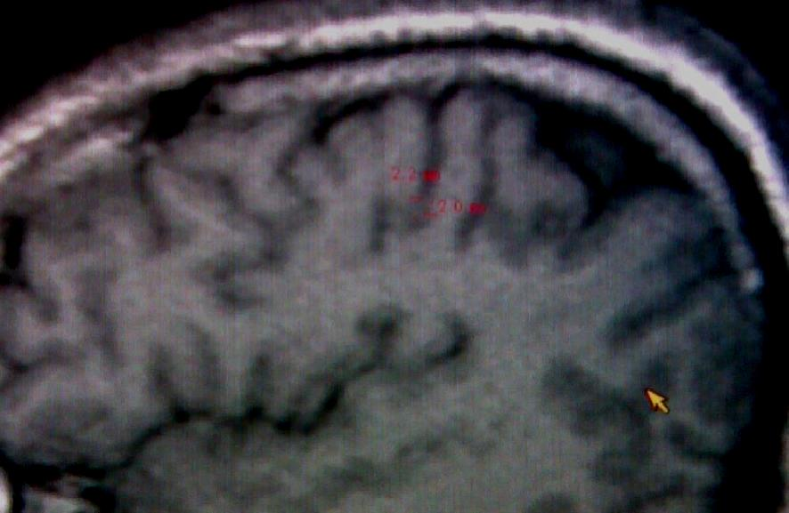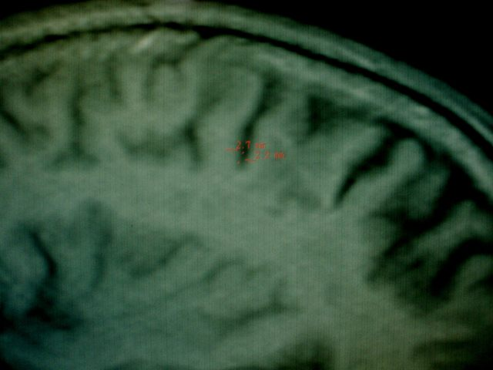
A
B
Figure 2 A: T1 weighted MRI of a normal person, age 40 year, has no headache showing normal pre central and post central cortical thickness (2.2mm and 2mm respectively). B: T1 weighted MRI of a normal person, age 44 year, has no headache showing normal pre central and post central cortical thickness (2.7 mm and 2.2mm respectively).
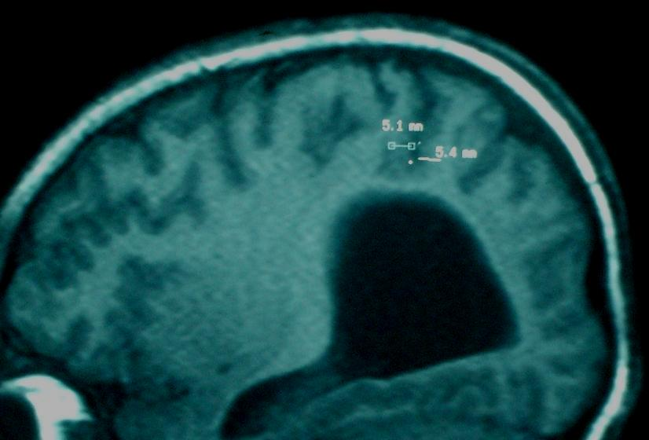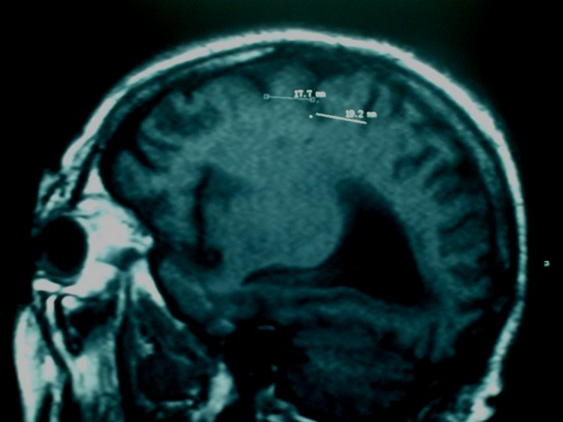
A
BA
Figure 3 A: T1 weighted MRI of a patient ,age 36 years has headache of 10 years duration showing increasing cortical thickness in pre central and post central gyri (5.1mm and 5.4mm respectively). B: T1 weighted MRI of a patient, age 42 years has headache of 7 years duration showing increasing gyral thickness in pre central and post central gyri (17.7mm and 19.2mm respectively).

