M J B
Experimental Work in Vascular Microsurgery :
Redha Ali and Abdulkhaliq Sahib

Abstract
This is a preliminary experimental study on 30 human placentas as a model for microvascular practice . two types of vascular anastamotic techniques were practiced , end – to end and – to – side anastamoses on 78 vessels including both arteries and veins . vessels of different sizes where divided and reanastamosed under the operative microscope . Absence of a dynamic circulation was the main disadvantage of the human placenta when used as an alternative model for microvascular practice, otherwise it was very practical , cheep and has many features in common with the clinical situation .
This study shows that arterial anastamoses is easier and less time consuming than venous anastamoses and shows also that end – to – end anastamoses is technically easier and less time consuming than end – to – side anastamoses using the same suture material and vessels of the same size group .
الخلاصة
يمثل هذا البحث دراسة مختبرية ( دراسة تجريبية في الجراحة المجهرية للاوعية الدموية ) اولية لثلاثين مشيمة بشرية استخدمت كنموذج لتطبيق وممارسة مبادئ جراحة الاوعية الدموية المجهرية حيث استخدمت طريقتان مختلفتان هما التحام نهاية مع نهاية والتحام نهاية مع جانب ل ٧۸ وعاء دموي مجهري بين شريان ووريد ثم قطع وتمت اعادة التحام اوعية دموية ذات احجام مختلفة تحت المجهر الجراحي .
ان عدم وجود جهاز دوراني كان المأخذ الرئيسي في استخدام المشيمة البشرية كنموذج للتدريب . فيما عدا ذلك فأن المشيمة البشرية تتصف بكونها عملية ورخيصة ولها صفات عامة مشتركة كثيرة مع الحالات السريرية .
هذه الدراسة تبين سهولة التحام الشرايين وبفترة اقل مقارنة بألتحام الاوردة وكذلك تبين سهولة تطبيق التحام نهاية مع نهاية تقنياً وزمنياً مقارنة بألتحام نهاية مع جانب عند استخدام اوعية دموية متساوية الاحجام وبأستخدام خيوط جراحية متساوية في الحجم ومتشابهة في النوعية .
ـــــــــــــــــــــــــــــــــــــــــــــــــــــــــــــــــ
Basic Anastamotic Techniques
Technique of End – to – End Anastamoses ( 2 , 1 , 3 ) :
1 – Anterior – wall – first microvascular anastamotic technique .
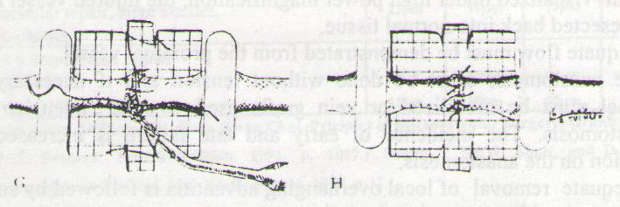
Figure 1 End – to – End anastamoses
2 – Posterior – wall – first microvascular anastamotic technique [4]:
3 – The Lauritzen technique of microvascular anastamoses [5]:
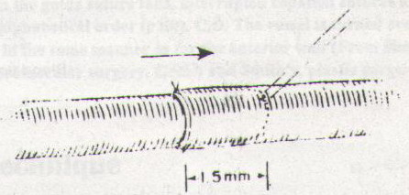

Figure 2 anastamoses technique
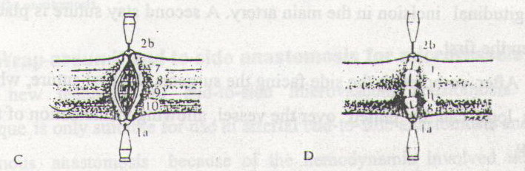
Figure 3 End – to – end venous anastamoses

End – To – Side Anastamoses Technique :
If only a single vessel maintains the viability of an extremity , it can't be sacrificed as the donor vessel for an end – to – end anastamoses , and an end – to – side repair must be used .
Marked size discrepancy also demand this method [1] . An Acland single clamp is placed on the vessel to be transplanted as a lateral branch . Adventoplasty is carried out in the same way as for end – to – end anastamoses . The vessel is then brought to the main artery , which is isolated on a plastic field . An Acland double clamp is put onto the isolated main artery , care being taken to apply the frame to the side of the artery opposite to that to which the lateral branch is to be united , so that the frame can subsequently be removed [2].
The arteriotomy into the donor vessel is the most critical and irreversible step in the procedure [6] . The arteriotomy may be done by excising a ' wedge ' of vessel wall with straight scissors , or it may be started with a microknife and enlarged carefully to an elliptical or circular defect with micro scissors . The arteriotomy must match the size of the vessel to be anastamosed [1] .
With the aid of a counter – loop , a stay suture is inserted , first transfixing the end of the lateral vessel and then attaching it to the proximal end of the longitudinal incision in the main artery . A second stay suture is placed 180 ° from the first .
After completing the side facing the surgeon , the first suture , which was left long can be pulled over the vessel , allowing visualization of the back wall.
The number of stitches will depend on the caliber of the transposed vessel , but a larger number is needed in this procedure than in end – to – end anastamoses . A total of eight stitches is required for vessels with diameters of less than 1.5 mm , as compared to only six stitches in end – to – end anastamoses . The single clamp on the lateral branch is removed first , followed by the distal clamp of the double clamp , after 30 seconds , the proximal clamp is removed and the procedure is then concluded [2].

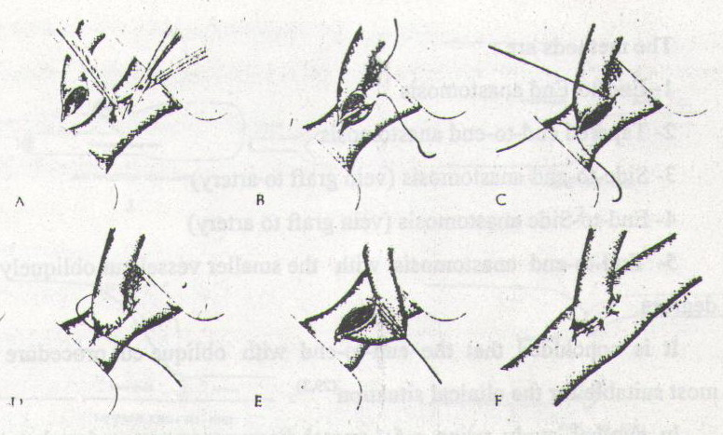
Figure 4 End – to – side anastamoses .

The human placenta has many vessels traversing it's fetal surface . A variety of sizes is available down to vessels of diameter 1 mm . Selection of a suitable artery can provide a vessel that can be satisfactory used for microsurgical practice where other preparation are not available , the human placenta appears to offer a reasonable , cheap and readily available alternative [7] . Human placenta has been investigated in an attempt to develop a non – animal model for microvascular research and practice , with a dynamic artificial circulation [8].
Materials and Methods
Materials
An experimental study is carried out on 30 placentas for training on vascular microsurgery . The study was accomplished in our lab of plastic and reconstructive surgery in AL – Wasity Hospital during 2007 .
All placentas were collected from the obstetric unit from AL – Elweya Hospital for Gyneacology and Obstetrics .
Placenta with obvious damage to the foetal surface were discarded . Seventy – eight vessels of different caliber's were divided and reanastamosed , 45 arteries and 33 veins . Two types of anastamotic techniques were practiced , end – to – end and end – to – side anastamoses . The diameter of the vessels ranged between 1 mm and 2 mm .

Instrumentation
No . 5 Jewelers forceps 1 pair
Angled forceps 1 pair
Curved tip needle holder 1
Westcott scissors 1
Vannous scissors 1
Single microvascular clamps 3 pairs

Method
Using an operating microscope , anastamoses of a number of arteries and veins of different external diameters were performed at varying distances from the insertion of the umbilical cord to the periphery of the human placentas .
8 – 0 , 9 – 0 , 10 – 0 Monofilament Nylon sutures were used for the anastamoses and an average of 9 sutures (range 6 – 12) were required to complete the repairs . These anastamoses were tested by perfusing the vessel with saline or Indian ink in order to observe leaks and by examining the anastamotic line from within by incising the vessel longitudinally at the site of the anastamoses .
With all placentas , the chorion was incised and reflected of the fetal surface to expose the vessels . The whole placenta is then washed in warm water and gently and repeatedly squeezed from the periphery inwards toward the insertion of the cord until no more blood emerges from the lumen of the vein .
Surgical Technique : Microvascular Anastamoses :
a – End - to - end anastamoses :
b – End – to – side anastamoses :

Results
Table 1 Represents the Number of anastamosed Vessels
Types of the vessel  anastamosed | Number | Percentage
Artery | 45 | 57.69 %
Vein | 33 | 42.31 %
Total | 78 | 100 %

Table 2 The anastamotic techniques used
Anastamotic  Technique | Type of the vessel | No. of the vessels | Percentage
End – to - end | Artery | 40 | 51.28 %
End – to - end | Vein | 29 | 37.18 %
End – to - side | Artery | 5 | 6.41 %
End – to - side | Vein | 4 | 5.13 %

Table 3 The diameters of the anastamosed vessels
Diameter of the vessel | Artery | Vein
2 mm | 11 | 11
1.5 mm | 18 | 11
1 mm | 16 | 11
Total | 45 | 33

Table 4 Represents the suture size used in the anastamotic techniques
Suture size | Diameter of the vessel | Number of the vessels
8 – 0 | 2 mm | 22
9 – 0 | 1.5 mm | 29
10 – 0 , 11 - 0 | 1 mm | 27

Table 5 Represents the maximum and minimum time needed for anastamoses
Maximum period of time needed for  anastamoses |  | Minimum time needed for  anastamoses
End – to – End | End – to – side | End – to – End | End – to – side
45 min | 50 min | 20 min | 30 min

Both maximum and minimum time needed for end – to – side anastamoses are more than that needed for end – to – end anastamoses . This time represents the period counted from the beginning of insertion of the first stitch to the time of insertion of the last stitch.

Table 6 Represents the patency rate of anastamosed vessels according to the diameter of each vessel
Diameter of the vessel | Type of the vessel | Number | Patent | % | Not patent | %
2 mm | Artery | 11 | 9 | 81.8 | 2 | 18.2
 | Vein | 11 | 8 | 72.8 | 3 | 27.2
1.5 mm | Artery | 18 | 15 | 83.3 | 3 | 16.7
 | Vein | 11 | 7 | 63.6 | 4 | 36.4
1 mm | Artery | 17 | 13 | 76.5 | 4 | 23.5
 | Vein | 10 | 6 | 60 | 4 | 40

Patent arteries are more than patent veins after performance of anastamoses in all sizes of the vessels .

Type of the vessel | Diameter | Anastamoses | Number | Average time of anastamoses
Artery | 2 mm | End – to – end | 6 | 25 min
Artery | 1.5 mm | End – to – end | 18 | 30 min
Artery | 1 mm | End – to – end | 17 | 35 min
Vein | 2 mm | End – to – end | 7 | 30 min
Vein | 1.5 mm | End – to – end | 11 | 35 min
Vein | 1 mm | End – to – end | 10 | 40 min
Artery | 2 mm | End – to – side | 5 | 35 min
Vein | 2 mm | End – to – side | 4 | 45 min
Table 7 Represents the average time needed for End – to – end and End – to – side anastamoses of the vessels with different diameters
∗ The smaller the size of the vessel , the smaller the size of the stitch , and the more the period of time needed for anastamoses .
Table 8 Represents the average period of time needed for anastamoses
Type of anastamises | Type of the vessel | Average period of time needed for anastamoses
End – to – end | Artery | 30 min
End – to – end | Vein | 35 min
End – to – side | Artery | 35 min
End – to – side | Vein | 40 min
The mean |  | 35 min

End – to – side anastamoses is more time consuming than end – to – end anastamoses in both arteries and veins . Venous anastamoses is more time consuming than arterial anastamoses in both end – to – end and end – to – side anastamoses .
Discussion
Microsurgery is fast gaining importance in many fields of surgery . However , it is still technically demanding and time consuming procedure . The basic techniques of End – to – end and End – to – side anastamoses using interrupted sutures are well established . The aim of this study is creation of a group of medical staff and substaff capable of dealing with this fine and delicate branch of surgery . Although , this will be very slow and gradual and need practice and insistence from all members of the team . The relatively large size of the placental vessels has been sited as a major disadvantage . However , by using vessels on the periphery of the placenta having an approximate diameter of 1 mm, a reasonable simulation is proved and if a good microvascular techniques can be learned on vessels of this size , it is relatively straight – forward to apply them to smaller vessels . Vessels of this range are appropriate for learning the skills of dissecting the vessels , applying microvascular clamps and anastamotic techniques. The major criticism of placenta as a model for microvascular anastamoses technique is the difficulty of assessing the quality of the anastamoses. Observing the suture from within certainly provides informations about the spacing and the depth of bite but does not necessarily indicate that the anastamoses would be patent or leak proof. Similarly, the information obtained by perfusing the anastamoses with saline or dye is also limited and may be misleading . Large leaks rapidly flood the operative field and are difficult to differentiate from smaller leaks which, in clinical practice, may spontaneously stop. Exposure of an artery and vein requires incision and reflection of chorionic membrane, followed by elevation of a segment of vessel from the underlying placental stroma . This is more difficult in the case of veins because these vessels have more delicate walls and have a more intimate fusion with the placenta. Arteries are thus easier to use for microsurgical practice and vessels of the order of 1 mm in diameter can , if desired, be dissected out. Larger vessels have thicker and more convoluted walls, this does not prevent useful practice. Suture anastamoses of small vessels is time consuming and tedious and demands long and continuous training if high patency rates to be regularly achieved . 30 human placentas with 45 arteries and 33 veins of different calibers had been included in this study in a random way. We think that selection of these vessels in a systematic way makes our results more informative and more applicable. End – to – end anastamotic technique was used in a total of 69 vessels, while end – to – side anastamoses was used in a total of 9 vessels only , this difference made the results of end – to – side anastamoses less informative . Larger number of end – to – side anastamoses will be more reliable for making a comparison between the two techniques . Nylon was the only suture material used in this study in order to achieve the same effect on the final results. The vessels included in this study were of three size groups , 2 mm , 1.5 mm and 1 mm in external diameter. Positive results in the patency rate related directly to the diameter of the vessels and suture size in both end – to – end and end – to – side anastamoses. These results explained by the easier manipulation and handling specially in the arterial anastamoses , and this is similar to results achieved by other studies . The difference in the maximum and minimum time needed for both end – to – end and end – to – side anastamoses due to long operative time (50 minutes) needed for performance of our early trials in microvascular anastamoses , and the short operative time (20 minutes) in our last trials after months of training, indicating the importance of a regular and continuous training on the final results.
Conclusions
1 – The increasing use of microsurgical techniques in clinical work is inseparably linked withregular experimental laboratory work to learn the basic techniques of microsurgery , to test the clinical applications of new manoevres and to extend the frontiers of transplantation and replantation surgery .
2 – The human placenta is usually freely obtainable from a nearby obstetric unit and has a large number of easily accessible vessels on it's foetal surface . The variety of sizes and number of vessels readily available on the placental surface make this organ a very reasonable alternative to other preparations such as cadaveric tissues , sheaps brain or even fresh dead chickens .
3 – Handling of the vessels is more difficult in the case of veins . Arteries are easier for microsurgical practice .
4 – As step towards performing clinical microvascular surgery , it is mandatory to practice and acquire skill in the use of microscope , microinstruments and tissue handling under magnification .
5 - Both end – to – end and end – to – side anastamoses should be practiced and mastered in any experimental study in order to apply it safely in the clinical work .
6 – Other aspects of microsurgery training can not be practiced in non living models like postoperative occlusion of the anastamosed vessel by various causes which may occur later on , and management of such cases , so experimental animals are preferred in these situations .
References
1 – Dash – H ; Kononov – A ; Maloney – J3d ; Browne – E . , A simple arteriotomy method for microsurgical end – to – end anastamoses : Technical aspect of use in training and laboratory applications . J – Reconstr – Microsurgery . 1993 Sept ; 9 (5):
381 – 4 MEDLINE ( 1/94 – 1/95 ) .
2 – Dessapt B . , Microvascular Anastamoses , Service de Chirugie plastique / Microchrirurgie , Hospital Saint – Luc , Lyon , France , Microsurgery Scientific Reports , No. 1 March 1981 .
3 – Harris Gerald D. , Finseth Frederick and Buncke Harry J . , Posterior Wall – first microvascular Anastamotic Technique . Brit J . Plast . Surg . 1981 , 34 , 47 – 49 .
4 – Hyland William T ., Botens Stevens R., and Minasi John S., A re – appraisal and modification of the lauritzen technique of microvascular anastamoses , Brit J . Plast . Surg . 1981 , 34 , 451 – 453 .
5 – McGregor J.C. , Wyllie F.J. and Grigor K.M. , Some anatomical observation on the human placenta as applied to microvascular surgical practice . Brit . J. Plast . Surg . 1983 , 36 , 387 -391 .
6 – Ohmori Kitaro M.D. , Restoration of skin cover by free flap transfer (microvascular technique) , Rob and Smith's Operative surgery , Plastic Surgery , Fourth Edition . 1983 . page 87 – 111 .
7 – Shaw William W., Tark Kwan Chul , Principles of Microvascular Surgery , Grabb and Smith's , Plastic Surgery , Fourth Edition , 1991 , page 1015 – 1027 .
8 – Waterhouse N., Mass A.L.H., and Townsend P.L.G.,The development of a dynamic model for microvascular research and practice using human placenta : a preliminary report ., Brit . J. Plast . Surg . 1985 , 38 , 389 -393 .
9 - Mustafa E D, et al. (2003) . reconstructive microsurgery 2003 : Experimental study .
10 - Babak PA , et al. ( 2003 ) . End-to-side vascular repair: An experimental study in rabbits .

