Evaluation of Treatment of Neuronal Damage with Extracranial Magnetic Field in A Rabbit Model of Stroke

Hussein A. Abdul Hussein
College of Pharmacy, Kufa University, Iraq.

M J B

Abstract
Brain neuronal disorders have the least outcomes to therapeutic response due to their complex and delicate integration and lack of drug response upon damage in addition to difficult surgical approach to CNS. These properties of brain cortical diseases elaborate more trials of finding an effective and safe alternative treatment. Making a full use of the high responsiveness of neurons to the electrical currents induced with magnetic fields allows an appreciable therapeutic approach to be evaluated. In a trial of assessment of the neuronal repair effects of a time varying external magnetic field, rabbit model of stroke was arranged with 10 minutes occluding the left middle cerebral artery of the anesthetized rabbit. A follow up with right hind limb spasticity, EEG and eosin histopathological assessment of neuronal reconnections in response to applying a 1000 Hz and 1000 gauss magnetic flux density provided by an external solenoid magnet in comparison with untreated control group along 30 days of daily applying the field on the left frontal lobe over the scalp for 30 minutes. There was a significant reduction of spasticity score from 2.76 +/- 0.1 to 1.33 +/- 0.2 obtained with extracranial magnetic stimulation ECM; P< 0.05 as compared with untreated group. Similar improvements in EEG criteria were also recorded in ECM treated group in form of an increase in EEG amplitude from 4 microV to 32 microV whereas brain frequency over the affected area had significantly increased from 2 Hz to 9 Hz at P< 0.05. Histopathological assessment of the number of neuronal reconnections revealed 355 +/- 21 per high power field in comparison with just 105 +/- 19 in untreated group. In conclusion there
was a promising neuronal repair enhancement by applying a suitable extracranial magnetic field that could improve the therapeutic outcomes of different treatments.
Keywords: Stroke, extracranial magnetic stimulation ECM, neurogenesis

تقييم العلاج بالحقل المغناطيسي لإمراض تحطم الخلايا العصبية في نموذج الجلطة المحدثة في الأرانب

الخلاصة
تعد امراض خلايا المخ من الامراض ذات الاستجابة العلاجية الاقل نتيجة لتركيبها الدقيق المتكامل وفقدان الاستجابة الدوائية عندما تتحطم فضلا عن صعوبة المسلك الجراحي للمخ مما دعى الى محاولات ايجاد طريقة علاج بديلة مؤثرة وسليمة وقد امكن استغلال مبدا تاثر الخلايا العصبية بالتيارات الكهربائية المحدثة بالمجال المغناطيسي كوسيلة علاج جديدة. وكمحاولة لتقييم اثر المجال المغناطيسي المتردد في اصلاح الخلايا العصبية فقد استعملت الارانب لاحداث نموذج الجلطة الدماغية بواسطة غلق الشريان الدماغي الاوسط الايسر لمدة 10 دقائق بعد تخدير الارانب. لقد تم تقييم تشنج الساق الايمن للارانب مع التخطيط الكهربائي للدماغ والتحليل النسيجي لتقدير الوصلات العصبية بعد تصبيغها بالايوسين لايجاد الاستجابة العصبية للحقل المغناطيسي المطبق بتردد 1000 هرتز و1000 كاوس بالمقارنة مع المجموعة الغير معالجة ولمدة 30 يوم من العلاج اليومي لمدة 30 دقيقة يوميا بوضع المغناطيس على الفص الجبهوي الايسر. لقد انخفض معدل مقدار التشنج في الساق الايمن للمجموعة المعالجة بصورة معتدة بحسب مقياس التشنج من 2.76 الى 1.33 كاستجابة للعلاج المغناطيسي عند معامل الثقة 95% بالمقارنة مع المجموعة الغير معالجة. كما اظهرت الدراسة تحسنات مماثلة في معايير التخطيط الكهربائي للدماغ من حيث مقدار فولتية الموجة وترددها حيث زاد مقدار الفولتية من 4 مايكروفولت الى 32 مايكروفولت وزيادة التردد من 2 هرتز الى 9 هرتز في المجموعة التي تم علاجها بالفيض المغناطيسي. اما استجابة الوصلات العصبية الظاهرة في مقطع الدماغ بعد قتل الارانب فقد كان معدل الوصلات العصبية 355 في المجموعة المعالجة مقارنة ب105 في المجموعة الغير معالجة وهو فرق معتد به عند معامل الثقة 95%. وكاستنتاج عام فان هنالك اثر واعد للمجال المغناطيسي كوسيلة علاج للامراض العصبية حيث يمكن من خلاله تعضيد علاج الامراض العصبية.
ـــــــــــــــــــــــــــــــــــــــــــــــــــــــــــــــــ

Introduction
Magnetic field had long been verified to induce energy in different materials. Conductive silks had widely been applied in interchanging magnetic and electrical energy. Living system has a special form of electrochemical circuits especially in excitable tissues like neurons [1]. These cells being connected in the brain in form of biological integrated circuits that are composed of connectors (the axonal and dendtritic processes), capacitors (the lipid bilayer of cell membranes), resistors (the chemical resistance of cellular and extracellular fluids) in addition to electrical generators which are the electrolytes pumps in cell membranes [2]. When an external alternating magnetic field is applied on neurons it will interfere with their electrochemical properties. Magnetism generates a voltage in
tissue according to the equation:
V = n * a * dB/dt
V = Voltage: n = number of turns in the electromagnetic coil: a = area of the loop: dB/dt = the rate of change of magnetic field with respect to time, with B representing the strength of the
magnetic field (in Teslas) [3].
According to right hand rule anions like CL, HCO₃ ions and free electrons will respond to that magnetic field in an alternative dissociations from protons, Na, K, Ca or magnesium cations [4].
Variations of these electrolytes across the excitable neuronal cell membrane will trigger a phenomenon called cell membrane plasticity which become more noticeable even histologically if exposed for prolong time depending on the magnetic field intensity and frequency [5,6]. Plasticity is characterized by rearrangement of neuronal membrane components [7] with contribution of elastin, actin, spectrin and myosin structural proteins in addition to changing gene expression of ion channels like Na and Ca channels and enzyme activity like proteases [8] lipases that will change level of neuronal membrane sphingolipids and cholesterol [9]. These modulations in neurons lead to exvagination of the neuronal membrane and according to the period of applied magnetic field processing will continue toward the direction of the applied field until a new complete neuronal process is formed. This process is called dendrogenesis if dendrocyte is synthesized or axonogenesis in case of axonal connection. These responses are controlled and induced form of functional neurogenesis otherwise neurogenesis is the main intended mechanism
upon treating any neuronal damage like ischemic stroke [10].

Materials and Methods
Instrumentation included
1- Electroencephalograph of (Physiograph EEG MK III. US version) set at 10 microVolts/small square sensitivity, 1cm/min. with 4 channels. 2- Dissecting set
3- Microtome and histopathological set with eosin stain technique.
4- Computerized extracranial magnetic stimulator.
The research had been conducted in pharmacology laboratory of College of Pharmacy in Kufa University.
Animals
Eighteen local domestic rabbits were divided into 3 groups, N = 6 for each. They were males aging 3-4 months and 1-1.5 kg average body weights. All rabbits were bred in standard breeding cages with supplement of water and standard oxoid diet freely.
Under general anesthesia with intraperitoneal phenobarbital 100 mg/kg, two of these groups were prepared for induction of stroke. The skull bones over the left frontal lobes were incised to expose the meninges and brain through which the origin of the middle cerebral artery is clamped with a small forceps for 10 minutes a period during which an ischemic stroke is established [11,12]. The skull bone then ligated with 4 small steel clips whereas scalps is ligated with silk stitches. This process was completely done under aseptic condition with fucidic acid and 20% iodine. Spasticity of fore and hind limbs
were obvious by examination one day after induction of stroke.
The electroencephalography EEG was monitored for the left FC portion (the wave of the stoked brain area) soon after induction to measure the frequency (in Hz) and amplitude (in microV) as a prognostic indicator of the neurogenesis process after neuronal insult with the induced ischemia and once weekly measured then after with concomitant
assessment of the clinical severity of right hind limb spasticity [13,14].
The later sign was graded to normal = 0, mild = 1, moderate = 2 and severe = 3
Extracranial alternating magnetic ECM field was applied over the ischemic left frontal motor gyri of the brain for 30 minutes once daily for 30 days. It was guided under computer program for provision of higher frequencies of alternation and adjusted to 1000 guass of 1000 Hz from a solenoid magnet and amplifier. The magnetic probe was set directly over the scalp with heat monitoring. Control group of rabbits were giving nothing
apart from clinical, EEG and histopathological assessment.
After the 30 days of treatment with ECM all rabbits were submitted to autopsy histopathological sectioning and examination. The staining used to evaluate neuronal connections was silver impregnation procedure to reveal the dendrites and axons under
high power field light microscopy.

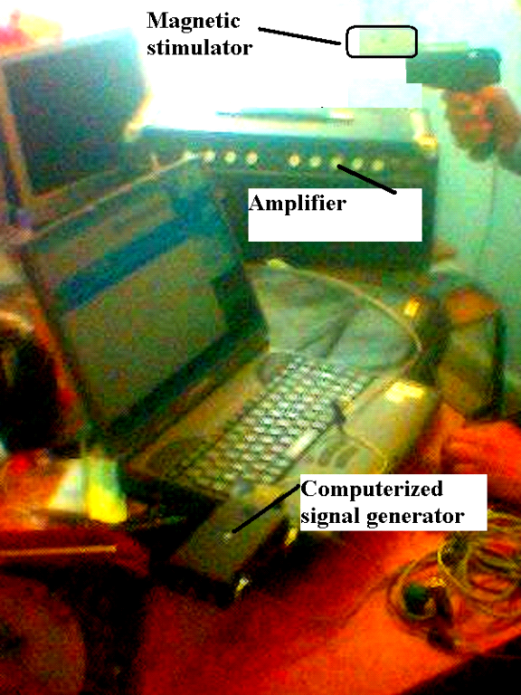

Figure 1 the complete set of extracranial magetic stimulator with output computerized signal generator.
Results
Table 1 the mean spasticity score of the rabbits left hind limbs. A comparism between the untreated group and ECM treated group.

Groups | The mean rabbits hind limb spasticity score of clinical assessment |  | Statistical t test of  significance
Groups | Day 1 | Day 30 | Statistical t test of  significance
Healthy control | 0 | 0 | -
Induced untreated | 2.86 +/- 0.1 | 2.66 +/- 0.2 | -
Magnetic field treated | 2.86 +/- 0.2 | 1.33 +/- 0.3 | Significant reduction of spasticity score

A significant decrease in spasticity score was noticed upon treating stroked rabbits with 1000 Hz, 1000 gauss solenoid magnet extracranially for 30 days at P< 0.05.

Figure 2,the EEG wave amplitude response of treatment with magnet. There was a significant increase in amplitude from 4 microV to 32 microV when stroke rabbits were treated with ECM for 30 days.

Figure 3 the response of EEG frequency to ECM treatment.

A significant increased in the treated group from 2 Hz theta wave to 9 Hz alpha wave at the left frontal gyri was obtained.

Table 2 the mean number of neuronal connections estimated per high power field among the magnetic field treated and the control group.

Groups | The mean number of neuronal connections per high power field at the left frontal gyrus after autopsy histopathological examination at day 31 | Statistical t test of significance  at P< 0.05
Healthy group | 1025 +/- 130 | -
Untreated group | 105 +/- 19 | -
ECM treated | 355 +/- 21 | significant

Figure 4 the number of neuronal connections estimated under HPF with silver impregnation as an indicator of neuronal repair mechanism enhanced with ECM.
There was a significant reconnection upon treatment with ECM 355 +/- 21 as compared with control untreated 105 at P< 0.05.

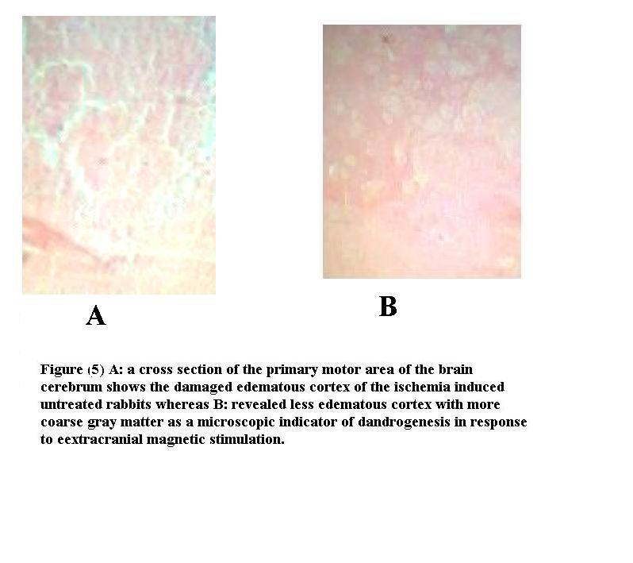

Discussion
Central neuronal damages whether arise from stroke, tumor, distress, toxin, trauma or infection, all are chacterized by distortion of the highly integrative neuronal functions and structures that interventions with conventional antiplatelet, vasodilator or thrombolytic drugs have unreliable curative outcomes [15] at the same time surgery has just a narrow space of application except in subarachnoid hemorrhages and tumors. On the other hand neurons although not practically replicating, they have latent capacity of dandrogenesis and axonogenesis over the impaired region to replace 20-40% or even more of the damaged area [16]. Moreover, this neurogenesis is highly responding to any electrical activity so that the rate of repair will be significantly accelerated upon an interneuronal electric currents induced from external electric or magnetic fields [17]. This principle was considered in many studies to treat many higher CNS lost functions like autism, hearing loss, dysphasia, hemiplagia and even schizoaffective disorders by applying a time varying (alternative) magnetic field with promising improvements [18,19) and safety. Many studies have shown acceptable assurance regarding mutagenicity and side effects of externally applied magnetic field [20] to the level that different magnets become commonly applied in the orthopedics wards to promote bone fractures healing. However, in CNS, different frequencies (upto handreds of kilohertz) and intensities (10 gauss to fraction of tesla) are required to achieve effectiveness and safety [21]. Other requirements of application include magnets direction and duration of stimulation. The most common forms of treatment with magnetic field include setting of a specific form (mainly solenoid measured in henry) magnet extracranially over the affected region with power supply of specific frequency[22].
In this current study, different parameters of motor neuronal damage were considered. Spasticity reflect the sufficiency of cortical inhibitory neuronal function that will be lost upon stress [23] giving rise to lead pipe spasticity and could be scored to mild, moderate and severe in order to quantitatively assess the curatve activity of different treatments [24]. There was a significant reduction in spasticity score upon treatment with 30 minutes of 1000 gauss solenoid magnet at 1000 Hz applied on the left frontal region of the stroked rabbits in comparison with untreated control group at P< 0.05 (t test ) that decreased spasticity score from mean of 2.66 +/- 0.2 to 1.33 +/- 0.2 after 30 days of treatment similar findings regarding the improvement of spasticity score were obtained in other study on 38 patients
with multiple sclerosis[25].
In regard to EEG records, the infarcted damaged neurons lose their electrical wave characters in EEG records so that frequency mode will decrease from beta or alpha to theta or delta at about 4 hertz as well as, amplitude will also decrease down to few micrVolts. Magnetic field treated group showed a significantly regaining brain frequency from 2 Hz to 9 Hz in comparison with the untreated stroked rabbits P< 0.05; figure (2). Similar findings were obtained in evaluating the EEG amplitude which have been significantly rised from 4 microV to 32 microV at the end of extracranial magnetic ECM stimulation at P< 0.05 (standard t test); figure (3). One study that correlated the EEG findings in human exposed to transcranial magnetic stimulation has disagreed with EEG results of this study in that slowing of EEG waves have been obtained from magnetic stimulation of human motor cortex, however, this contradiction may be attributed to application on normal human in comparism with stroked rabbits in this study [26]. The most reliable definite finding of ECM treatment is the significant increase in number of reconnections (dandrogenesis and axonogensis) estimated after silver impregnation staining of the autopsy histopathological slides for the damaged left frontal areas in comparison with the healthy and control untreated groups at P< 0.05 table (2), that ECM stimulation enhance neuronal reconnections 355 +/- 21 in the ECM treated group as compared with 105 +/- 19 connection in the untreated group. A study on estimating the rat supraventricular zone neurogenesis stimulation with magnetic field stimulation have showed that there was a significant neuroproliferative effect in the group exposed to magnetic stimulation [27] a result nearby rabbit cortical neurogenesis finding of this study.

Conclusion
Extracranial time varying magnetic stimulation is a beneficial therapeutic alternative of treating different neuronal damages that could be applied specifically as an adjuvant treatment for many CNS diseases in human.

Recommendation
A further evaluation of effectiveness and safety of different intensities, frequencies and wave forms of magnetic field is to be tried in different neuronal and systemic human diseases.

References
1- Jansen,-R-F; Pieneman,-A-W; ter-Maat,-A. Spontaneous switching between ortho- and antidromic spiking as the normal mode of firing in the cerebral giant neurons of freely behaving Lymnaea stagnalis. J-Neurophysiol. 1996 Dec; 76(6): 4206-9.
2- Jiang,-Z-G; Yang,-Y-Q; Allen,-C-N.Tracer and electrical coupling of rat suprachiasmatic nucleus neurons.Neuroscience. 1997 Apr; 77 (4) : 1059-66.
3- Milstead, K, David, J and Dobelle, M. Quackery in the medical device field. Proceedings of the Second National AMA/FDA Congress on Medical Quackery. Washington, D.C., Oct. 25-26, 1963.
4- Adair, R.K. Sterling Professor Emeritus of Physics, Yale University, New Haven, CT. Personal Communication.Tectonic Magnets, Riviera Beach, FL. 371, 1997.
5- Ieran, M., et al. Effect of Low Frequency Electromagnetic Fiedls on Skin Ulcers of Venous Origin in Humans: A Double-Blind Study. J Orthop Res 8(2): 276-282, 1990.
6- Kort, J., Ito, H. and Basset, C.A.L. Effects of pulsing electromagnetic fields on peripheral nerve regeneration. J Bone Jt Sug Orthop Trans 4: 238, 1980.
7- Doetsch,-G-S; Harrison,-T-A; MacDonald,-A-C; Litaker,-M-S
Short-term plasticity in primary somatosensory cortex of the rat: rapid changes in magnitudes and latencies of neuronal responses following digit denervation.
Exp-Brain-Res. 1996 Dec; 112(3): 505-12.
8- Gschwend,-T-P; Krueger,-S-R; Kozlov,-S-V; Wolfer,-D-P; Sonderegger,-P Neurotrypsin, a novel multidomain serine protease expressed in the nervous system. Mol-Cell-Neurosci. 1997; 9(3): 207-19.
9- Lombardi,-G; Leonardi,-P; Moroni,-F. Metabotropic glutamate receptors, transmitter output and fatty acids: studies in rat brain slices.Br-J-Pharmacol. 1996; 117(1): 189-95.
10- Milstead, K, David, J and Dobelle, M. Quackery in the medical device field. Proceedings of the Second National AMA/FDA Congress on Medical Quackery. Washington, D.C., Oct. 25-26, 1963.
11- Dogan,-A; Temiz,-C; Turker,-R-K; Egemen,-N; Baskaya,-M-K Effect of the prostacyclin analogue, iloprost, on infarct size after permanent focal cerebral ischemia. Gen-Pharmacol. 1996 Oct; 27(7): 1163-6.
12- AU: Gu,-W; Yang,-Q; Ou,-Y. Regional brain calcium change in rabbit cerebral ischemia. Zhonghua-Yi-Xue-Za-Zhi. 1996 Oct; 76(10): 771-3.
13- Decq,-P; Filipetti,-P; Feve,-A; Saraoui,-A. Neurotomies peripheriques selectives des collaterales pour les muscles ischio-jambiers dans le traitement de la spasticite en flexion du genou. A propos d'une serie de 11 patients. Neurochirurgie. 1996; 42(6): 275-80.
14- Decq,-P; Filipetti,-P; Feve,-A; Djindjian,-M; Saraoui,-A; Keravel,-Y. Peripheral selective neurotomy of the brachial plexus collateral branches for treatment of the spastic shoulder: anatomical study and clinical results in five patients. J-Neurosurg. 1997 Apr; 86(4): 648-53.
15- Anonymous.The International Stroke Trial (IST): a randomised trial of aspirin, subcutaneous heparin, both, or neither among 19435 patients with acute ischaemic stroke. International Stroke Trial Collaborative Group. Lancet. 1997 May; 349(9065): 1569-81.
16- Schallert-T; Woodlee-MT. Brain-dependent movements and cerebral-spinal connections: key targets of cellular and behavioral enrichment in CNS injury models... "Translational Research in Spinal Cord Injury: Avoiding Potential Pitfalls", 3 April 2003 in Miami, Florida. Journal-of-Rehabilitation-Research-and-Development 2003 Jul-Aug; 40(4): 9-17.
17- Cho, M., et al. Reorganization of microfilament structure induced by ac electric fields. FASEB J 10: 1552-1558, 1996.
18- Weissman-JD; Epstein-CM; Davey-KR. Magnetic brain stimulation and brain size: relevance to animal studies. Electroencephalogr-Clin-Neurophysiol. 1992; 85(3):215-9.
19- Muller-K; Homberg-V; Aulich-A; Lenard-HG. Magnetoelectrical stimulation of motor cortex in children with motor disturbances. Electroencephalogr-Clin Neurophysiol. 1992 Apr; 85(2): 86-94.
20- Fiorani-M; Cantoni-O; Sestili-P; Conti-R; Nicolini-P; Vetrano-F; Dacha-M. Electric and/or magnetic field effects on DNA structure and function in cultured human cells.. Mutat-Res. 1992 May; 282(1): 25-9.
21- Rusovan-A; Kanje-M; Mild-K. Exp-Neurol.The stimulatory effect of magnetic fields on regeneration of the rat sciatic nerve is frequency dependent. 1992 Jul; 117(1): 81.
22- Mills-KR; Boniface-SJ; Schubert-M. Magnetic brain stimulation with a double coil: the importance of coil orientation. Electroencephalogr-Clin-Neurophysiol. 1992 Feb; 85(1): 17-21.
23- Dabney,-K-W; Lipton,-G-E; Miller,-F Cerebral palsy. Curr-Opin-Pediatr. 1997 Feb; 9(1): 81-8.
24- Becker,-R; Alberti,-O; Bauer,-B-L.Continuous intrathecal baclofen infusion in severe spasticity after traumatic or hypoxic brain injury. J-Neurol. 1997 Mar; 244(3): 160-6.
25- Nielsen,-J-F; Sinkjaer,-T; Jakobsen,-J. Treatment of spasticity with repetitive magnetic stimulation; a double-blind placebo-controlled study. Mult-Scler. 1996 Dec; 2(5): 227-32.
26- Izumi,-S; Takase,-M; Arita,-M; Masakado,-Y; Kimura,-A; Chino,-N. Transcranial magnetic stimulation-induced changes in EEG and responses recorded from the scalp of healthy humans. Electroencephalogr-Clin-Neurophysiol. 1997 Aug; 103(2): 319-22.
27- Arias-Carrion , L. Verdugo-Dيaz , A. Feria-Velasco , D. Milln-Aldaco , A.A. Gutiérrez , A. Hernلndez-Cruz , R. Drucker-Colيn . Neurogenesis in the subventricular zone following transcranial magnetic field stimulation and nigrostriatal lesions. Journal of Neuroscience Research.

