Evaluation of Epineural Repair of Acute Sciatic Nerve Injury
Redha Ali Abdulkhaliq Sahib

M J B

الخلاصة
هذه الدراسة تم اجراؤها على ۲۰ مريض يعانون من اصابات شديدة في العصب النسوي بسبب الاطلاقات النارية او الانفجارات للفترة من كانون الثاني ۲۰۰۲ الى تشرين الاول ۲۰۰٧ . خضع جميع المرضى الى تداخل جراحي لاستكشاف العصب النسوي (٥ – ۸ ) اشهر بعد الاصابة. ان الغرض من الطرق المختلفة لاعادة توصيل العصب هو لارجاع التوصيل العصبي الحسي والحركي لانجاز اعلى درجة وظيفية ممكنة للطرف السفلي وهنالك طرق عديدة لانجاز هذا الغرض ولكن ليس هناك اية طريقة تنفرد بالافضلية في العلاج . ان اختيار الطريقة يعتمد على عوامل تشريحية مختلفة ومتداخلة . في هذه الدراسة تم اعتماد طريقة خياطة الغشاء العصبي الخارجي فقط للعصب وتبين بأنها الطريقة الابسط والانجع من حيث النتائج الجيدة نسبياً التي تم الحصول عليها .
ــــــــــــــــــــــــــــــــــــــــــــــــــــــــــــــــــــــــــــــــــــــــــــــــــــــــــــــــــــــــــــــــــــــــــــــــــــــــــــــــــــــــــــــــــــــــــــــــــ
The following grading system used in the evaluation of acute nerve injury
British Medical Research Council Grading System
Grade Description
M5 complete recovery
M4 All synergetic and independent movements
are possible
M3 All important muscles act against resistance
M2 Return of perceptible contractions in both proximal and
distal muscles
M1 Return of perceptible contractions in proximal muscles
Mo No contraction
From Sedon H ) : Surgical Disorders of the peripheral nerves , 2nd ed . Edinburgh , Churchil
Livingstone . 1975 [6]

British Medical Research Council system of assessment of sensory Recovery
Grade Description
S4 complete recovery
S3+ some recovery of two point discrimination
Within the autonomous area
S3 return of superficial cutaneous pain and ttactile
sensibility throughout the cutaneous area with
disappearance of any previous overreaction
S2 return of some degree of superficial cutaneous pain
and tactile sensibility within the autonomous area
of the nerve
S1 recovery of deep cutaneous pain sensibility within
the autonomous area of the nerve
S0 Absence of sensibility in the autonomous

area

From Sedon H ) : Surgical Disorders of the peripheral nerves , 2nd ed . Edinburgh , Churchil
Livingstone . 1975 [6 ]
Clinically :
Patients with acute peripheral nerve injury usually have nerve conduction defects that can manifest as motor or sensory dysfunction[5]. Acute nerve injury can cause temporary or persisting paralysis [1]. The sensory component and motor component must be evaluated separately to ensure accurate diagnosis. In some cases, the injury does not match the clinical presentation. Operative findings of nerve injury may or may not match clinical findings .
Data exist of gross operative evidence of nerve injury without clinical evidence of neurological dysfunction , such as with sheath hematoma and compression by fracture fragments . Conversely , data exist of intraoperative grossly normal appearing nerves with clinical paresis [1]. These deficits may develop after initially appearing with a normal neurological examination [2]. More specifically, following a traumatic hip dislocation , some patients may develop sciatic nerve deficits even after an initial normal neurological examination [1] hence , when a nerve is damaged, it may continue to appear normal in a neurological examination . In truth damage can be revealed only through diagnostic studies .
In many instances , acute nerve injury associated with complex trauma
complicates a thorough neurological examination .
In many patients , nerve injury may remain undetected because joint and / or bony injury may dominate the clinical picture [5]. Nerve injury may be apparent immediately after injury. For example, immediate paralysis of common peroneal nerve and foot drop with loss of eversion of the foot usually are reported at the time of a stretch / contusion injury without fracture or dislocation at the knee level [4]. Epineural repair is inhanced with the use of magnification either with magnifying loupes or the operating microscope .
In accomplishing the primary epineural suture technique , the surgeon first divides the nerve ends proximal and distal to the injury site until all visible signs of damage have been debrided , fascicles then mushroom from the neural stumps, and the epineurium retracts slightly. The sutures are placed in the external epineurium using non - absorbable sutures. Usually 8 – 0 nylon is used for sciatic nerve injury repair. The nylon is placed through the epineurium proximally and distally, and tied. The epineurium is not closed so tightly that the fascicular ends become mismatched and malaligned by bunching up. It is preferable to leave a small gap in the epineurium held together by a small suture with the fascicular ends in more appropriate alignment. Therefore the suture which is not tied tightly, acts as the guiding suture rather than a retention suture. The second suture is placed opposite the first and then the epineurium is closed by halving the distance on the anterior and posterior of the nerve. If the nerve can not be approximated with 8 – 0 nylon suture , tension is considered excessive and further mobilization or nerve grafting should be performed.[2] Epineural repair is strong and tension - resistant [7]

Materials and Methods

This study carried on 20 patients complaining of acute sciatic nerve injury as a result of shell and bullet injuries. from January 2002 – September 2007 , they underwent surgical intervension for sciatic nerve exploration 5 – 8 months post injury.
Preoperatively they were fully investigated taking in consideration the time of injury and the level of injury, and clinical findings and the motor and sensory deficit . We mainly depend upon the tenile sign and EMG and nerve conducting study finding in evaluation of the nerve status preoperatively and the same parameters were used for postoperative evaluation.
the epineural suture technique was used in all the cases under loup magnification or operative microscope.
Both direct nerve repair and nerve grafting were used in our study depending upon the gap created by the injury itself or by the excision of neuroma during the preparation of the proximal or distal nerve stumps.

Table 1 details of materials and methods .

Age of the patient | 8 – 60 years
Sex of the patient | Male 17  Female 3
Level of injury | 15 middle and lower third  5 upper third and gluteal reagon
Severity of injury  The nerve injured :  C . P . N .  P . T . N .  Both | 20 cases  12 cases  7 cases  5 cases
Direct repair  Nerve graft  ( The gap ) | 15 cases  5 cases  4 – 10 cm

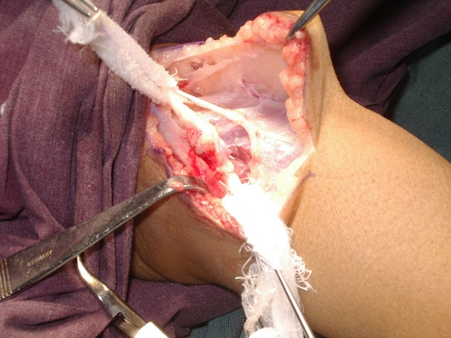
Figure 1 neuroma at the site of nerve injury prior to it’s excision .

- Mobilization of the nerve used in most of the cases of direct repair with placing the joints in flexion position for a period of time using backslabs for this purpose .

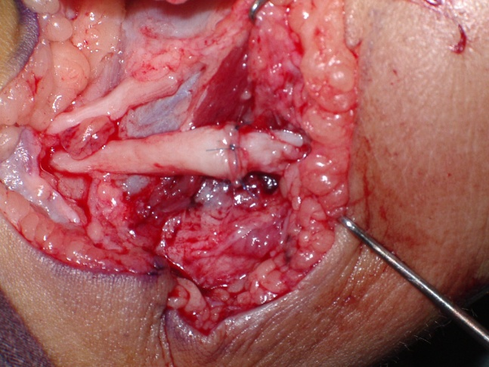
Figure 2 direct epineural repair of sciatic nerve

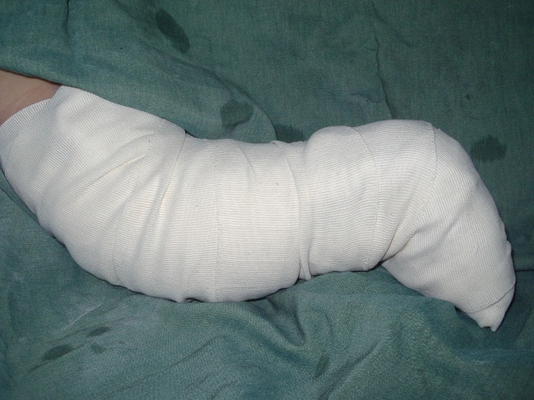
Figure 3 The way of application of back slab with certain degree of knee flexion to minimize tension at the repair site .

8 – 0 nylon suture was used in all our cases for coaptation and the number of stitches varies from case to case according to the diameter of the nerve.
Both common peroneal nerve (C.P.N. ) and posterior tibial nerve (P.T.N.) were delt with in our study aiming sensory improvement at the soles and correction of foot drop.
Sural nerve used as a graft in all our cases who needed nerve grafting .
Pneumatic tourniquet used in some cases with low level nerve
injuries.
Blood prepaired in all our cases who were all underwent surgical repair under general anesthesia.
- Stitches were removed 14 days postoperatively and the backslab maintained for 6 weeks, taking in consideration the degree of the knee joint flexion which we gradually decreased 2 weeks postoperatively.
- We followed up our patients with tenile's test and EMG and NCS in 1 month interval.

Results
After 8 - 12 months of follow up :
- Sensory improvement ------------ protective sensation
- Motor improvement ------------ regain of dorsiflexion and
planterflexion of the foot
- Progression in tenile sign 2 months postoperatively .
- EMG and NCS changes 4 months postoperatively .

Postoperatively  Motor improvement  Sensory improvement  Partial improvement | - 12 cases  - 13 cases  - 7 nerves

- Table ( 2 ) post operative results .

- Evaluation of Motor Function improvement
- Total No . 12 , Grade M5 - 2 , M4 – 2 , M3 – 5 , M2 – 3
- Evaluation of Sensory Function improvement
- Total No . 13 . Grade S3+ - 2 , S3 – 3 , S2 – 5 , S1 – 3

Discussion
The use of magnification in nerve repair makes the results of surgery much more encouraging taking in consideration the level and the type of injury and the time elapse after injury .
As in other studies the age of patients affected by shell injuries the younger age group is more affected , and the male to female ratio is approximately 4 – 1 the same as other studies.
- Regarding the duration of the nerve injury and the time of repair as in other studies the intervention 3 – 4 months post injury has a better result than later repair.
- The more proximal the level of nerve injury the less is the outcome of repair as in other studies .
- Motor function improvement is less than sensory improvement and this is goes with the fact that the time of repair is greatly affect the motor function if performed 3 – 5 months post injury, while the time of repair is opened for sensory status improvement .
- The cases that showed partial improvement were the cases dealt with by nerve grafting and these results goes with results of nerve grafting in other studies.

Conclusion
No breakthroughs are at hand in the treatment of peripheral nerve injuries , but a number of things can be done to optimize the outcome .
1 - in contused nerves , repair should not be undertaken for three months from the time of injury .
further more passage of time , however , reduces the possible benefits , and there is no place for exploration after 12 - 14 months have elapsed since the injury
2 - Recent developments have improved the outcome .
The operating microscope and micro instrumentation facilitate the performance of more precise nerve repair .
3 - Epineural repair is easy and effective method of nerve repair .

References
1 – Adams JH , Duchen LW , eds . Greenfield's Neuropathology . 5th ed . New York ,
NY : Oxford University Press ; 1992 : 1160 – 6 .
2 – Cornwall R , Radomisli TE . Nerve injury in traumatic dislocation of the hip . Clin orthop. Aug 2000 ; ( 377 ) : 84 – 91 . [Medline]
3 – George E . Omer . Jr . Morton Spinner . Allen . Van Beek , special medical illustrator . Mignel A . pirela – Cruz – 2nd ed . Management of peripheral nerve injury problems 2000 .

4 – Kim DH , Kline DG . Management and results of peroneal nerve lesions . Neurosurgery . Aug 1996 ; 39 ( 2 ) : 312 – 9 ; discussion 319 – 20 [ Medline ]
5 – Perlmutter GS . Axillary nerve injury . Clin orthop . Nov 1999 ; ( 368 ) : 28 – 36
[ Medline ]
6 – Seddon HJ : Surgical disorders of the peripheral nerves . 2nd ed . Edinburgh . churchil Livingstone . 1975
7 – Smith JW , Newman FA . Current technique in peripheral nerve repair .
In : Rand RW , ed . Microneurosurgery . 3rd ed . St . Louis : Mosby , 1985 : 727 – 40 .
8 - Robinson LR. Traumatic injury to Peripheral Nerves. Muscle Nerve 2000 23: 863-873.
9 - Kandel, Schwartz, Jessell. Principles of Neuroscience. 4th edition. Mcgraw-Hill;2000 p34
10 - Fitzgerald M.J.T, Folan-Curran J, Clinical Neuroanatomy and related Neuroscience. 4th ed. W.B. Saunders; 2002 p68

