Carcinoma of Larynx A Clinical Study
Study the Relationship between 5'-Nucleotidase Activity and Body Mass Index in Obese Individuals

Sadiq Musa Ahmed Safa Noury Mohammad Ali*
Al-Sadder General Hospital Amarrah-Missan, Alnajef, Iraq.
*Al-Hillah General Teaching Hospital Hillah,Babylon, Iraq.

M J B

Abstract
This thesis is a retrospective study of 270 patients with carcinoma of larynx admitted from January 2, 1991 to May 31, 1995 in E.N.T. - Head and Neck Surgery Center in Medical City in Baghdad. The age ranging between 5th – 8th decades with peak incidence in the 7th decade in males and 6th decade in females.
77.4% were males and 23.4% were females and male: Female ratio was 3.3:1 .The majority of the patients presented with hoarseness. Supraglottic carcinoma was the commonest region.
The incidence of lymph node metastases was 23.5% and it was highest in transglottic carcinoma followed by supraglottic carcinoma.
Stage T1N0M0 was more common than other stages and radiotherapy was the mainstay of treatment of our patients.
الخلاصة
البحث عبارة عن دراسة استرجاعية لبحث 270 مريض يعانون من سرطان الحنجرة ادخلوا الى شعبة جراحة الانف والاذن والحنجرة في مدينة الطب في بغداد ما بين الفترة من 2 كانون الثاني 1991 الى 31 حزيران 1995.
اعمار المرضى تراوح بين العقد الخامس والعقد الثامن ( اعتى نسبة كانت العقد السابع للرجال والسادس للنساء).(77.4%) من الرجال و(23.4) من النساء وكانت نسبة الرجال الى النساء (3.3:1)
اغلب المرضى كانت الشكوى لديهم هي بحة الصوت واكثر المناطق في الحنجرة ثاثرا بالمرض هي المنطقة العليا من الحنجرة.
وجود غدد لمفاوية متضخمة في الرقبة بسبب انتشار المرض عن طريق اللمف هو (23.5) وهو اكثر لدى المرضى المصابين بالورم الذي يعم كل اجزاء الحنجرة متبوعا باورام اعلى الحنجرة.
اغلب المرضى كانوا ضمن التصنيف T1N0M0 وكان العلاج الاشعاعي هوالوسيلة الاساسية في العلاج.
ــــــــــــــــــــــــــــــــــــــــــــــــــــــــــــــــــــ

Introduction
Laryngeal cancer is common in Iraq [1]. It constitutes 5.8% of the cases recorded by the Iraqi Cancer Registry 1989 – 1991, it ranked the 5th commonest cancer in Iraq, and it was the third commonest cancer in males and the tenth commonest cancer in females [2].
In Unites states it constitutes 1.2 percent of all cancers and it is estimated that that about 12,000 new cases are diagnosed annually, and almost 4,000 patients die every year [3].
Laryngeal cancer has a high rate of cure , therefore , places upon the clinician a much greater responsibility than usual , for careful evaluation and treatment bring a probability of cure while , in common with number of other head and neck neoplasms , failure may be followed by relatively uncomfortable and unsavory death [4].The aims of the study:
The aims of the study are to clarify the following points about carcinoma of the larynx:
Clinical presentation.
The commonest region.
(3) Incidence of lymph node metastases.
(4) Stages and the modalities of treatment.

Patients and Methods
A retrospective study of patients who were diagnosed in E.N.T.-Head and Neck Center in Medical City, as having carcinoma of the larynx from January 2, 1991 to May 31, 1995.
Most of the patients came to our centre were referred cases from different areas of Iraq.
They were analyzed with respect to their age, sex, chief complaints, region of the tumor, lymph node metastases and histopathology of the tumor. The diagnosis was according to the clinical E.N.T. examination and direct laryngoscopy which done under general anesthesia and using rigid laryngoscopes to determine the site , extent of the tumors , for biopsy taking and examine for cord mobility .
The types of the tumors and their degrees of differentiation were obtained from histopathological reports.
The stage of the disease was based on the clinical findings utilizing the UICC – TNM classifications of carcinoma of larynx, 1978.

Results
Results were collected in tables and figures have been made by using pie histograms.

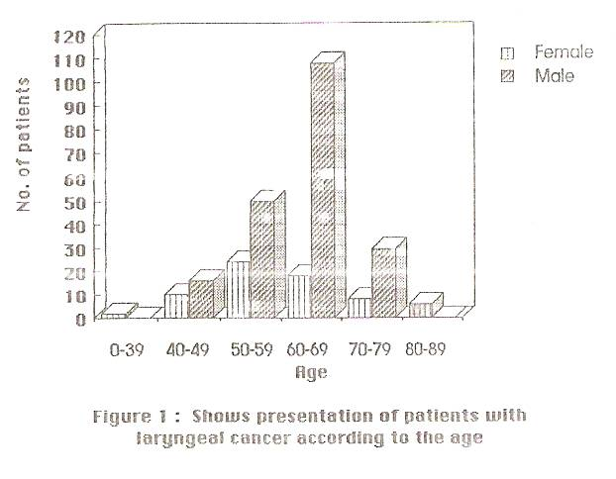

Figure 1: Age distribution

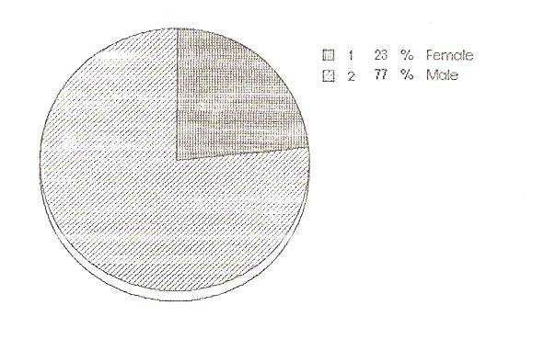

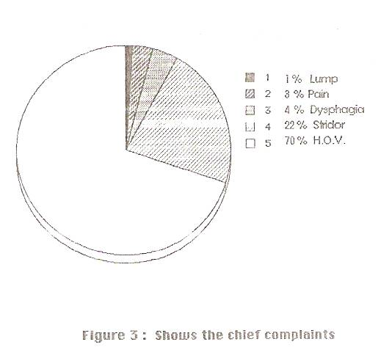
Figure 2 Sex distribution

Figure3 Chief complaint
Table 1 The Chief complaint according to the region.
Region | Hoarseness |  | stridor |  | Dysphasia |  | pain |  | Lump
Region | No. | % | No. | % | No. | % | No. | % | No. | %
Supraglottic Glottic subglottic Transglottic | 95  79  1  14 | 70  70  25  84 | 23  33  2  2 | 17  30  50  8 | 10  =  =  = | 7  =  =  = | 5  =  1  2 | 4  =  25  8 | 3  =  =  = | 2  =  =  =
Total | 189 | 70 | 60 | 22 | 10 | 4 | 8 | 3 | 3 | 1

Table 2: The duration of the chief complaints according to the region of the cancer.
Duration | Supraglottic |  | glottic |  | subglottic |  | transglottic |  | total
Duration | No. | % | No. | % | No. | % | No. | % | No. | %
Less than 2m  2 – 6 months  More than 6m. | 16  35  85 | 12  26  62 | 28  65  19 | 25  58  17 | =  =  4 | =  =  100 | 1  6  11 | 9  36  55 | 45  69  165 | 17  39  44

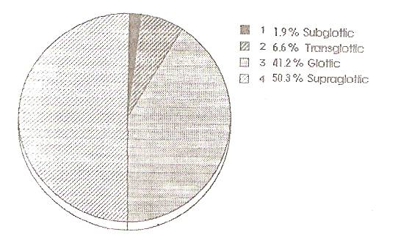

Figure 4 Region of the tumor
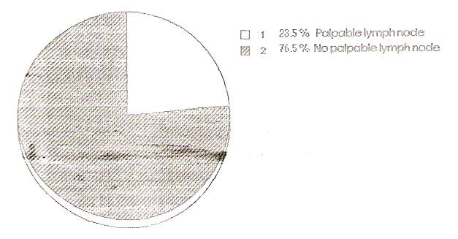

Figure 5 Nodal Status:

Table 3 Shows the percentages of palpable lymph nodes according to the
Region of carcinoma.
Region | No |  | N1 |  | N2 |  | N3 |  | Total
Region | No. | % | No. | % | No. | % | No. | % | No. | %
Supraglottic Glottic subglottic Transglottic | 93  102  4  14 | 68  94  80  64 | 24  5  1  4 | 18  5  20  18 | 10  =  =  2 | 8  =  =  9 | 8  1  =  2 | 6  1  =  9 | 42  6  1  8 | 32  6  20  36
total | 213 | 76.5 | 34 | 15 | 12 | 4 | 11 | 4.5 | 5.7 | 23.5

Table 4 Shows relation of T stage with lymph node.
T stage | NO |  | N1 – N3
T stage | No. | % | No. | %
T1  T2  T3  T4 | 90  33  69  21 | 89  82.5  74.2  59 | 11  7  24  15 | 11  17.5  25.8  41

Table 5 Stages and their managements.
Stage | No. | % | Radiation | Total  Laryngectomy | Radiotherapy  and surgery | Chemotherapyand Radiotherapy
T1NO MO | 90 | 33 | 83 | 5 | ----- | 2
T2NO MO | 33 | 12.2 | 20 | 10 | 3 | -----
T3NO MO | 69 | 25.5 | 54 | 11 | 4 | -----
T4NO MO | 21 | 7.7 | 17 | 1 | 3 | -----
T1N1 MO | 7 | 2.5 | 7 | __ | ----- | -----
T1N3 MO | 4 | 1.4 | 4 | __ | ----- | -----
T2N1 MO | 7 | 2.5 | 5 | 1 Total laryngectomy andradical neck dissection | ----- | 1
T3N1 M0 | 10 | 3.7 | 8 | 2 total laryn- gectomy and radical neck dissection | ----- | -----
T3N2 MO | 8 | 2.9 | 8 | ----- | ----- | -----
T3N3 MO | 6 | 2.2 | 6 | ----- | ----- | -----
T4N1 MO | 5 | 1.8 | 4 | ----- | ----- | 1
T4N2 MO | 5 | 1.8 | 5 | ----- | ----- | -----
T4N3 MO | 5 | 1.8 | 5 | ----- | ----- | -----

Discussion
Chief complaints and duration:
In our study, the most common presenting symptoms were hoarseness of voice (70%) and stridor (22%). Less common symptoms including dysphagia (4%), Pain (3%) and lump (1%). The majority of the patients with glottic, supraglottic and transglottic cancers complained of hoarseness, whereas those with subglottic cancers stridor were the commonest presenting symptom. Saad S. Tahir et al reported that the most common presenting features was hoarseness of voice (86.4%), stridor (27%), odynophagia (16.2%) and earache (5.4%) [1].
"MEREDITH 1987" reported that hoarseness was the predominant presenting symptom at all sites [5].
With regard to the duration of symptoms, 17% of the patients had symptoms for less than 2 months, 39% had symptoms for 2 to 6 months, and 44% had symptoms for over 6 months. 56% of the patients had symptoms for 6 months or less. 83% of patients with glottic cancers had symptoms for 6 months or less. while 62% of patients with supraglottic cancers had symptoms for more than 6 months and this may be due to the majority of our patients were of low educational class, so they delayed in consulting the otolaryngologist or may be due to misdiagnosis by general practioners and because supraglottic cancers which comprised (50%) of our patients are delayed in their presentation.
"Jason 1989 "reported that 49% of the patients had symptoms for less than 2 months, 45% had symptoms for 2-6 months, and 5% had symptoms for more than 6 months [6].
Region of tumor:
Our study showed that the supraglottic region more affected than other regions and it comprised about 50.3%, the glottic was 41.2%, subglottic 1.9% and transglottic was 6.6%.
Many studies reported higher incidence of supraglottic involvement. "Al-Mansouri, A. 1990" reported 51.6% supraglottic, 25.8% glottic, 4.9% subglottic, 9.7% transglottic and 8% epiglottis [7].
"SAAD S. TAHIR et al" reported 39.2% presented with glottic, 59.5% with supraglottic and 1.3% with subglottic [1]. Although in many studies the glottic region has been found to be involved more than others.
"Jason D. Eiband et al 1989" reported 51% were glottic, 42% supraglottic, 6% transglottic and 1% subglottic [6].
"Meredith 1987" reported 51% of tumors involve glottic region, 39% involve supraglottic, and 10% involve the subglottic [5].
Lymph node involvement:
In our study we found that 23.5% of the patient with laryngeal cancer had lymph node metastases at the time of referral and the lymph node metastases was highest in transglottic carcinoma followed by supraglottic carcinoma 32%, whilst 20% in subglottic carcinoma and 6% in glottic carcinoma and the incidence of palpable lymph nodes increases with the extent of the primary tumor.
"Som 1970" reported the high incidence of lymph node metastases for supraglottic carcinoma 32% [8].
" P.M. Stell and A.G.D Maran 1978 " reported 35% lymph node metastases for supraglottic carcinoma , 30% for transglottic carcinoma , 20% for supraglottic carcinoma and rare for glottic carcinoma [9].
"Jason D. Eiband et al 1989" reported lymph node metastases were noted 24% of the patients with supraglottic tumors and in 12% of those with glottic tumors [6].
" B. Morra et al 1987 " reported that a significant increase of clinically suspected node in supraglottic tumors was found while no significant relationship was demonstrated between the extension of the neoplasia and nodal involvement [10].
The incidence of palpable lymph nodes increases with the extent of the primary tumor [4].
Stage and treatment
TINOMO STAGE was the most common stage which comprised 33%, followed by stage T3NOMO which comprised 25.5%. Mainstay of treatment of our patients was radiotherapy and it's indicated for stage I and stage II and total laryngectomy with or without radical neck dissection reserved for patients with failure of radiation and for stage III and stage IV. Chemotherapy was indicated as an adjuvant therapy. But the management of our patients influenced by the choice of the patients because some patients refuse surgery when it was indicated or they prefer surgical treatment.
Tracheostomies were done in 150 patients (55.6%) as emergency tracheostomies for stridolous patients or as elective tracheostomies prior to direct laryngoscopy when tumor interfered with endotracheal intubations. Advances in radiotherapy have made it possible to cure a high percentage of the early glottic tumors (T1 or T2) without sacrificing the voice [11]. Controversy exists, however, regarding the initial treatment of the more advanced stages. Although total laryngectomy with or without neck dissection offers a higher cure rate in the advanced glottic carcinomas than radiotherapy. It is argued that patients pay a heavy price for this increment in cure rate in terms of loss of the voice and a permanent tracheostomy [12]. Proponents of laryngectomy feel that a curative with radiotherapy makes little sense in advanced disease with cord fixation, since the probability for requiring subsequent surgery is so high that only a few patients are likely to benefit by preservation of the larynx [13].
Radiotherapists, on the other hand, strongly favor radiotherapy, with salvage surgery only for persisting or recurring disease. By so doing, they believe they can save some larynges with cure rates comparable with patients initially treated by laryngectomy [14].

Conclusion
The majority of the patients with laryngeal cancer presented with hoarseness.
Supraglottic carcinoma more common than others.
The incidence of lymph node metastases was 23.5% and it was highest in transglottic carcinoma followed by supraglottic carcinoma.
Stage T1N0MO more common than other stages and radiotherapy was the mainstay of treatment of our patients.

References
1. Saad S. Tahir, Muzhir Al- Doury, Mohammed A. Al- Hashimi, Sadeq F. Al - Bayati. Radiotherapy for laryngeal cancer. Iraqi Medical Journal 1991: 41: 112 – 117.
2. Iraqi cancer Board. Results of Iraqi Cancer Registry 1989 – 1991. Baghdad, Ministry of Health of Iraq, 1993:18-20.
3. Ferlito A. Histological classification of larynx and hypopharynx cancers and their clinical implications. Acta otolaryngol 1976: 342: 1-37.
4. Michael Glesson : Malignant Alan G. Kerr . Salivary gland tumors. In: Scott – Brown's otolaryngology, sixth edition, vol.5. London, Butterworth and Heinemann, 1997: 5/11/9.
5. Meredith A.P.DE et al. Advanced Laryngeal cancer: A management perspective. Journal of Laryngology and otology 1987: 101: 1046 – 1054.
6. Jason D. Eiband et al. Prognostic factors in squamous cell carcinoma of the larynx. The American Journal of surgery 1989: 158: 314 – 317.
7. Al - Mansouri A. Incidence of carcinoma of larynx. Iraqi Med. Journal 1990: 2: 36 – 40.
8. Som M.L. Conservation surgery for carcinoma of the supraglottis. Journal of laryngology and otology 1970: 84: 655 – 678.
9. Stell P. M. Dalby J.E., Singh S.D., Ramadan M.F. and Bainton R... The management of glottic T3 carcinoma. Clinical otolaryngology 1982: 7: 175 – 180.
10. Morra B. et al. Relationship between cervical nodal metastases and laryngeal cancer. Journal of laryngology and otology 1987:101:1168-1174.
11. Marks RD Jr, Fitz - Hughs GS, Cox- Stable WC. Fourteen years experience with cobalt - 60 radiation therapy in treatment of early cancer of true vocal cords. Cancer 1971: 28: 571 - 6.
12. Pradhan SA et al. Radical radiotherapy and salvage surgery for T3NOMO glottic cancer: is feasible in Indian population? Indian J. Cancer 1985: 22: 29- 32.
13. De Santo L.W., Lillie JC, Devine KD. Surgical Salvage after radiation for laryngeal cancer. Laryngoscope 1976: 86: 649 - 57.

