M J B
Bupivacaine for Postoperative Wound Pain via Intermittent Wound Perfusion

Abdul Razzaq Al-Salman Rafid Shamkhi
Basrah military hospital, Basrah, Iraq.

Abstract
Sixty male patients were studied with age 18-72 years (mean age 42 years), there weight 55-80 kg (mean 72 kg) in Basrah military hospital(2001--2002) The patients were allocated to receive either 0.5% bupivacaine or none.
- Group A(20 patients) underwent either the renal or bladder surgery with no bupivacaine receive.
While the other 40 patients selected and enrolled in 2 groups(B and C) according to the site of the wound as following:
- Group B(20 patients) with renal surgery .
- Group C ( 20 patients) either bladder surgery or transvesical prstatectomy.
Both B and C are allocated to receive bupivacaine.
The results revealed there is a significant difference of the pain score between group A(7.65+/- 1.56) (not receive) and those received bupivacaine groups BandC,which are 1.25+/-0.2 in group B, and 0.6+/-0.13 in group C of pain score of 10 cm.Thus, wound instillation with bupivacaine should be regarded for routine usage.
ــــــــــــــــــــــــــــــــــــــــــــــــــــــــــــــــــــــــــــــــــــــــــــــــــــــــــــــــــــــــــــــــــــــــــــــــــــــــــــــــــــــــــــــــــــــــ

Introduction
Local anaesthetics are extensively used in practice, undesirable or adverse reactions are uncommon[1]. The direct perfusion of surgical wounds with local anaesthetic was first shown more than 45 years ago to reduced opiate requirements[2]. Intermittent intramuscular opiates provide unsatisfactory control of pain after abdominal surgery[3].The introduction of longer acting local anaesthetic drugs, such as bupivacaine, and the development of bacterial filters has led to renewed interest in this method of postoperative pain relief, and reduction in postoperative narcotic requirement[4]. The modalities of perioperative pain management that require a higher level of expertise and organizational structure than ''as needed" intramuscular or intravenous injections of opiods and that generally provide more effective relief of pain.Examples include (but are not limited to) epidural analgesia(EA), intravenous patient controlled analgesia(PCA), and a number of regional analgesic(RA) techniques[5].

Patients andMethod
Sixty male patients were studied with age 18-72 years (mean age 42 years), there weight 55-80 kg (mean 72 kg) in Basrah military hospital(2001--2002). All patients underwent urological surgery(cutting) in form of renal, bladder,and prostatic surgery.
The patients were allocated to receive either 0.5% bupivacaine or none.
- Group A(20 patients) underwent either the renal or bladder surgery with no bupivacaine receive.
While the other 40 patients selected and enrolled in 2 groups(BandC) according to the site of the wound as following:
- Group B(20 patients) with renal surgery .
- Group C ( 20 patients) either bladder surgery or transvesical prostatectomy.
Both B and C are allocated to receive bupivacaine.
The wound closed in layers and fine catheter(4 french) with side hole,

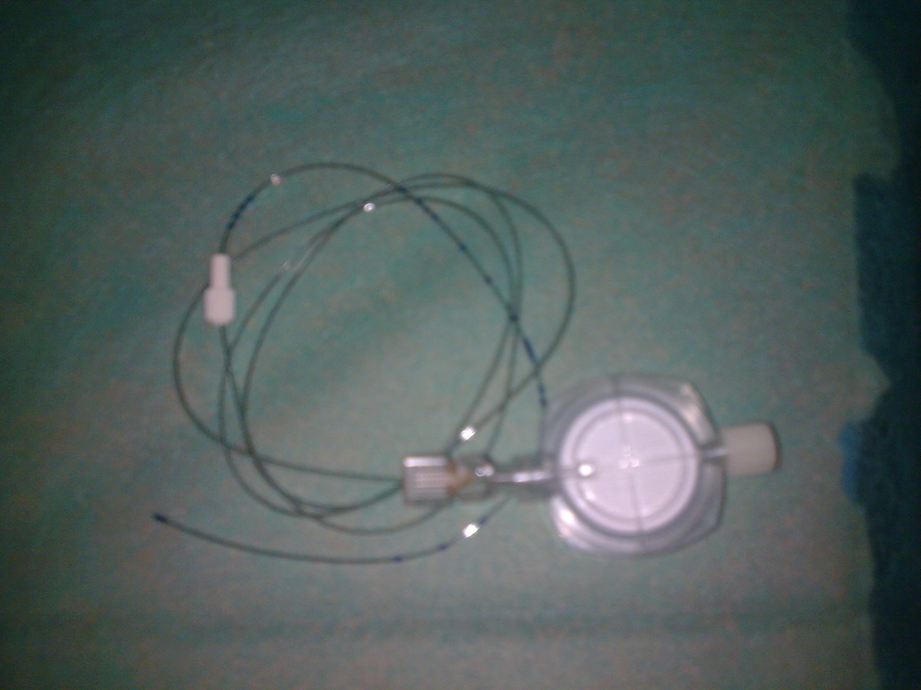

placed just above the approximated outer muscular layer,broughtout through the wound. Patients in both groups BandC were allocated to receive 0.5% bupivacaine which was infused intermittently using sterile syringe over 48 hours.Pain was assessed every 6 hours using a standard 100 mm linear analogue scale[5]. The need of any supplementary systemic analgesics throughout the 48 hours observation period.
The pain assessed by numerical 10 cm pain scores(self reporting by the patient); from 0-1 none, 2-3 a little, 4-6 some, 7-8 a lot, and 9-10 worst possible[4] , as shown below

0
1
2
3
4
5
6
7
8
9
10
Numeric
Categorical
Moderate
Mild
Severe
none

None
Visual analogue scale
Pain Relief scale
No Relief
complete Relief

Worst possible
Worst possible

Results
There is a significant difference of the pain score between group A(7.65+/- 1.56) (not receive) and those received bupivacaine groups BandC, which are 1.25+/-0.2 in group B, and 0.6+/-0.13 in group C of pain score of 10 cm. The pain scores are less in the second day than the first day as showing in table 1.
Highly significant difference in statistical comparison between groups (AandB) and (AandC) 16and11 subsequently and of 0.0001 p value. According to duration between doses 6 hours (40%), 8 hrs(45%), 10 hrs (15%), and 12 hrs no case of group B: While in group C the 6 hrs(10%), 8 hrs(30%), 10hrs(40%) and 12 hrs(20%) as shown in table 3. So the total dose of bupivacaine in 48 hours[2] not reach the maximum doses or toxic level[3].The surgical group C needing less total dose than group B.
Discussion
Wound instillation with bupivacaine should be regarded for routine usage[7].Patients could record their pain severity on his simple descriptive scale and in almost all cases welcomed the task[8].though patients may on the first few occasions find it difficult to express their pain severity within the descriptive limits of a particular scale, performing their own descriptions to those provided, they soon accept, learnt use, and appreciate the value of a standard pain scale, infiltration of the wound using a long-acting local anaesthetic (e.g 0.25 % bupivacaine) provides prolonged postoperative analgesia[9].
Accurate and complete records of pain therapies should be maintained. Reports of pain made by the patient should be the primary source of pain assessment and should be obtained at periodic intervals[5].there is growing conviction that a multimodality approach(i.e., two or more analgesic agents or techniques used in combination) to providing postoperative analgesia has advantages over the use of a single modality[5].

Table 1 pain scores of the three groups for two days (number of patients, range, mean, SD and SE of pain scores)
 | Day 1 |  |  | Day 2
 | Group A | Group B | Group C | Group A | Group B | Group C
Number of patients | 20 | 20 | 20 | 20 | 20 | 20
Range | 5-10 | 0-3 | 0-2 | 5-10 | 0-3 | 0-1
Mean | 7.65 | 1.25 | 0.6 | 7.35 | 1.95 | 0.35
SD | 1.56 | 0.91 | 0.59 | 1.75 | 0.82 | 0.48
SE | 0.35 | 0.2 | 0.13 | 0.39 | 0.18 | 0.11

Group A:patients taking no bupivacaine.
Group B:patients received bupivacaine underwent renal surgery(loin incision).
Group C: patients received bupivacaine underwent bladderandprostatic surgery(lower abdominal incision either transverse or midline incision).
SD: standard deviation.
SE: standard error.

Table2 Comparison between groups (AandB) and (AandC) for the first and second days showing t-test and p-values.
 | Group A-B of the first day | Group A-B of the second day | Group A-C of the first day | Group A-C of the second day
T-TEST | 16 | 11.8 | 18.54 | 17.3
DF | 19 | 19 | 19 | 19
P Value | <0.0001 | <0.0001 | <0.0001 | <0.0001
T test: t-student test.
DF :degree of freedom.

Table 3 The comparison between different groups.
 | Renal surgery |  | Bladderandprostatic surgery
Duration between doses(hours) | No.of cases | percentage | No.of cases | percentage | Total dose of bupivacaine(mg)
6 | 8 | 40% | 2 | 10% | 240
8 | 9 | 45% | 6 | 30% | 180
10 | 3 | 15% | 8 | 40% | <180
12 |  |  | 4 | 20% | 120

References
1-T.N. Calvely and N.E. Williams principles and practice of pharmacology for anaesthetists. Fifth Edition, chapter 4 pp 68-85. 2008 Norman Calvey and Norton Williams.
2-Lewis DL, Thomson WAL: Reduction of postoperative pain. Br Med J 1953; 1: 973-4.
3-Dodson MA: A review of the methods of relief of postoperative pain. Am R Coll Surg Engl 1982; 64: 324-7.
4-Thomas DFM, Lambert WG, Lioyd-Williams K; The direct perfusion of pain? Am R Coll Surg Engl 1983; 65: 226-9.
5-Ronald D.Miller,MD;Anaesthesia, fifth edition,Text book, Churchill Livingstone,2000.
6-Hitchcock M, Ogg TW. Day surgery analgesia. J. one day surg. 1993; 3: 20-21. Pain scoring system.
7-Revill SI, Robinson JO, Rosen M, Hogg MIS: The reliability of a linear analogue for evaluating pain, Anaesthesia 1976; 31:1191-8.
8-Buttmann M; Streich R; Risse A; Falke KJ; Pappert D: postoperative analgesia in children after hernioplasty, wound infiltration with different concentrations of bupivacaine: apilot study. Anaesthesist 1999 Jul; 48(7); 439-43.
9-Rawal, Analgesia for day-case surgery, British journal of anaesthesia 87(9):73-87(2001).

