Aortic Regurgitation in Iraqi Hypertensive Patients
Frequency and Risk Factors

Ali S. Baay
College of Medicine, University of Babylon, Hilla, Babylon, Iraq.

M J B

Abstract
Aortic regurgitation is back flow of the blood from the aorta to the left ventricle, many causes of this relatively common valvular lesion but one of the most important is hypertension a so common medical problem.
Aim of the study: to assess the frequency of, severity and risk factors of aortic regurgitation in hypertensive patients
The results and discussion: show significant No. of hypertensive patients have aortic regurgitation most of them have non significant lesion with the dilatation of aortic root and increasing age are significant risk factors ,this finding consistent with most of the studies
Recommendations: it is wise to assess all hypertensive patients with noninvasive simple test, echocardiography, for evidence of aortic regurgitation.
الخلاصة
عدم كفائة الصمام الابهرهو جريان الدم من الابهر الى البطين الايسربشكل عكسي وهناك اسباب عديدة لهاذا الضرر الصمامي الشائع نسبيأ و واحد من اهم الاسباب هو ارتفاع ضغط الدم الشرياني,المرض الشائع جدأ.
الغرض من الدراسة: لتقييم ظهور,شدة و عوامل الخطورة لعدم كفائة الصمام الابهر لدى مرضى ارتفاع ضغط الدم الشرياني.
النتيجة و المناقشة:هناك فرق معنوي لظهور عدم كفائة الصمام الابهرلدى مرضى ارتفاع ضغط الدم الشرياني و لكن معضمهم ضرر صمامي بسيط مع توسع جذر الابهرو الشيخوخة عوامل خطورة معنوية, وهذة الحقائق متماشية مع معضم الدراسات الاخرى.
التوصيات: من الحكمة دراسة عدم كفائة الصمام الابهرلدى مرضى ارتفاع ضغط الدم بواسطة جهاز الايكو كونة فحص لاتداخلي وبسيط و خاصة لدى مجموعة عوامل الخطورة.
ـــــــــــــــــــــــــــــــــــــــــــــــــــــــــــــــــ

Introduction

Aortic valve insufficiency results from leakage and backflow of blood that is ejected from the left ventricle (LV) into the ascending aorta back into the left ventricle.
Many mechanisms contribute to aortic valve insufficiency. These include abnormalities of the aortic valve leaflets and pathologies of the proximal aortic root. [1]
Mechanisms of aortic regurgitation
Rheumatic heart disease still remains the most common cause of severe aortic regurgitation over the past several decades. [2,18], however, diseases involving the aortic root are becoming more frequent, In fact, more than half of patients who present with pure aortic regurgitation (AR) without any associated cardiac anomalies have aortic valve insufficiency caused by aortic root disease. [3]
Causes of aortic regurgitation include the following: [3]
- Aortic cusp abnormalities
- Perforation (e.g., infective endoca-rditis)
- Cusp shrinkage
- Rheumatic disease
- Rheumatoid disease
- Ankylosing spondylitis
- Bicuspid aortic valve
- Loss of commissural support
- Ventricular septal defect
- Dissection (tears) of the aorta
- Aortic root abnormalities : The usual underlying histopathologic changes in aortic tissue associated with aortic dilatation are summarized as "cystic medial necrosis" and, although qualitatively similar, are variable in severity and include:
- Dilatation
- Familial conditions
- Marfan syndrome
- hypertension
- Ehlers-Danlos syndrome
- Pseudoxanthoma elasticum
- Idiopathic
- Distortion (aortitis)
- Syphilis
- Rheumatoid disease
- Ankylosing spondylitis
- Nonspecific aortitis
Aortic regurgitation can be seen in patients with hypertension frequently and hypertension is one of the most important causes of chronic AR[4]
Although aortic regurgitation of minimal or mild degree is well recognized to occur in patients with systemic hypertension, severe degrees of aortic regurgitation are rare in such patients; aortic valve replacement in such patients has rarely previously been reported. [3]
Early case reports and pathological series suggest that hypertension might directly predispose to aortic regurgitation because of enlargement of the aortic root, but recent pathological and M-mode echocardiographic studies have not found an association between blood pressure and aortic root size when the confounding influence of aging is considered.[ 3,4,5]
Thus, aortic root diameter is strongly related to age, and senescence may result in cystic medial necrosis.
In contrast, other M-mode echocardiographic studies have noted significant relations of aortic root diameter to systolic and diastolic pressures. [4,6,7,8]
Furthermore, severe aortic regurgitation due to idiopathic aortic root dilatation is associated with antecedent hypertension.[ 9,16,19]
there is what called normal regurgitation seen in 3% of the healthy population by color Doppler but most of the study show higher prevalence among hypertensive patients. [10,11,17]
So hypertension is a key point in the etiology of aortic regurgitation
The aim of the study:
To study the frequency of AR in hypertensive Iraqi patients with assessing the aortic root size at sinus of valsalva, age and gender as risk factors.

Patients and Methods
350 hypertensive patients 170 male and 180 female age ranging between 20-65(mean age52.6) were studied with transthoracic echocardiography by 2D ,M mode and Doppler study were done for all by HDI 1500 machine in Babylon/Iraq from September 2007 to feb.2009.
Inclusion criteria:
- Age 20-65 years
- With blood pressure >140/90 in 2 reading 24 hours apart or had being diagnosed as hypertension on treatment since > 6 months [2]
Patients were divided according to the age into 3 groups
20-35 years old
36-50 years old
51-65 years old
Any patient with AR seen by colure Doppler where labeled as +ve.
Those +ve patients are classify into significant and non significant regurgitation by [12]
Significant AR: any of the following:
- LVEDD> 75mm
- Regurgitant jet width/LVOT diameter ratio>60%
- Vena contracta (the smallest neck of the flow at the level of aortic valve) width >6mm
- AR pressure half time(PHT) <250 millisecond
- Dense continuous wave signal
- Diastolic flow reversal in descending aorta: holodiastolic reversal
Non significant AR: any of the following:
- LVEDD<55 mm
- Regurgitant jet width/LVOT diameter ratio<30%
- Vena contracta <3mm
- AR PHT>400 millisecond
- Faint continuous wave signal
- Diastolic flow reversal in descending aorta: early diastolic reversal
The aortic root dimension at the level of sinus of valsalva is measured if >40mm it is enlarged.
332 healthy normotensive persons (175 maleand157 female) are studied similarly as a control group
Statistical analysis
The tests used for the analysis include test for proportion between patients and control and chi square test for the other parameters

Results
The patients group distributed as.

Patients age | male | female | total
20-35 | 40 | 55 | 95
36-50 | 80 | 60 | 140
51-65 | 50 | 65 | 115
total | 170 | 180 | 350

The control group distribution:
Patients age | male | female | total
20-35 | 43 | 48 | 91
36-50 | 79 | 52 | 131
51-65 | 53 | 57 | 110
total | 175 | 157 | 332

There are no statistical significances regarding gender and age between patients and control with P value >0.005.
- Out of 350 patients are involved in the study 86 (24.6%) patient have AR by echocardiography while out of 332 control person only 11(3.3%) have AR with 95% confident interval between the tow proportion.

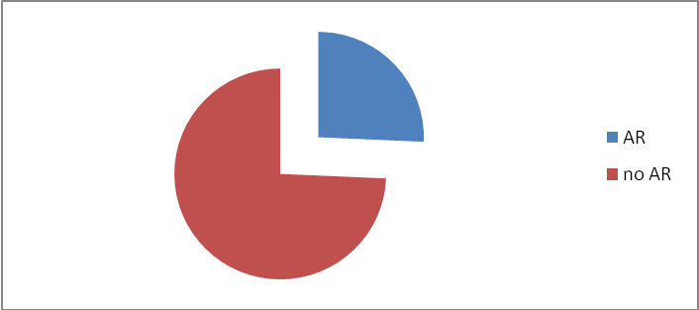

- Out of 86 patients have AR,72 (83.7%)have non significant regurgitation while the minority 14(16.3%)patients have significant lesion
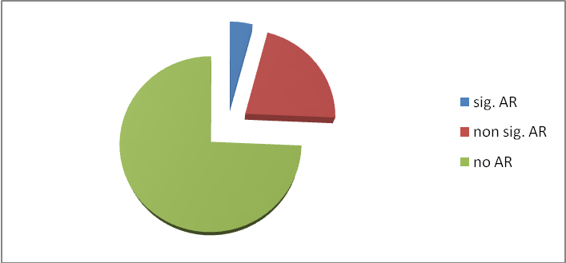
- Regarding control group; only 11 patients (3.3%) have AR all of them are non significant

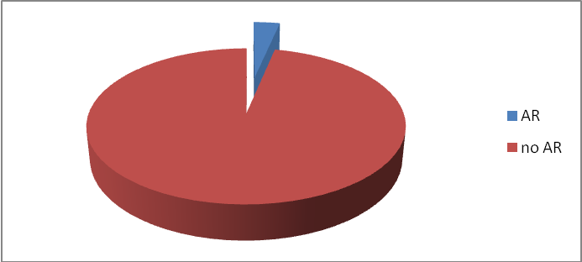
Regarding the risk factors study:
- Age:
For pat.
age | AR | No AR | total | P value
20-35 | 24 | 71 | 95 | 0.49
36-50 | 20 | 120 | 140 | 0.7
51-65 | 42 | 73 | 115 | 0.35
total | 86 | 264 | 350

There is a significant difference between the frequency of AR between young and old age with P valve <0.05(0.026)
For control
Age | AR | No AR | total
20-35 | 2 | 89 | 91
36-50 | 2 | 129 | 131
51-65 | 7 | 103 | 110
Total | 11 | 321 | 332

- Gender:
Gender | AR | No AR | total
Male | 42 | 128 | 170
female | 44 | 136 | 180
total | 86 | 264 | 350

For control
gender | AR | No AR | total
Male | 5 | 170 | 175
female | 6 | 151 | 157
total | 11 | 321 | 332
There is no statistically significant difference in the frequency of AR between male and female with P value 0.83(>0.05)
- Aortic root size:
size | AR | No AR | total
enlarge | 66 | 4 | 70
normal | 20 | 260 | 280
total | 86 | 264 | 350
For the control
size | AR | No AR | total
enlarge | 7 | 2 | 9
normal | 4 | 219 | 323
total | 11 | 321 | 332
There is a statistically significant difference in the frequency of AR between those with dilated aortic root comparing with the normal root

Discussion
The hypertension is a common cause of AR due to dilatation or distortion of the aortic root causing changes in the valve function leading to regurgitation but in most of cases is non significant
The findings in this study show that AR seen more commonly in hypertensives than in normotensive persons.
Most of patients with AR show non significant regurgitation.
The risks factors with significant difference are old age (>50years) and dilated aortic root at the level of sinus of valsalva while the gender show no significant difference
The finding of hypertension as a cause of non significant aortic regurgitation are consistent with other studies as Vittorio Palmieri et al study which show same finding even in the use of larger sample size but differ from Waller BF study which show severe AR in hypertensive patients that need valve replacement. [12,13,14,15.]
J Kontos et al study and Lonati L et Lonati LLonati Lal study show the same findings of age and aortic root size as a risk factors although the former study show relation of aortic root size at any level not only at the sinus of valsalva as in our study

Conclusions
- Hypertension can cause AR but in most cases are non significant
- Echocardiography is a reliable method for assessing the heart in hypertension and predict complications
- The risk increase more in age older than 50 years and in presence of dilated aortic root
- The gender show no difference

Recommendation
It is wise to screen hypertensive patients for cardiac complications with safe non invasive way by echo. To detect AR.

References
- Vasan RS, Larson MG, Levy D. Determinants of echocardiographic aortic root size: the Framingham Heart Study. Circulation. 1995;91: 734–740.
- Kim M, Roman MJ, Cavallini MC, Schwartz JE, Pickering TG, DevereuxRB. Effect of hypertension on aortic root size and prevalence of aortic regurgitation. Hypertension. 1996;28:47–52.
- Pearson AC, Gudipati C, Nagelhout D, Sear J, Cohen JD, Labovitz AJ. Echocardiographic evaluation of cardiac structure and function in elderly subjects with isolated systolic hypertension. J Am Coll Cardiol. 1991;17:422–430.
- Puchner TC, Huston JH, Hellmuth GA. Aortic valve insufficiency in arterial hypertension. Am J Cardiol. 1960;5:758-760
- Palmieri V, de Simone G, Roman MJ, Schwartz JE, Pickering TG, Devereux RB. Ambulatory blood pressure and metabolic abnormalities in hypertensive subjects with inappropriately high left ventricular mass [published correction appears in Hypertension. 2000;36:147]. Hypertension.1999;34:1032–1040.
- Lukaski HC, Johnson PE, Bolonchuk WW, Lykken GI. Assessment of fat-free mass using bioelectrical impedance measurements of the human body. Am J Clin Nutr. 1985;41:810–817.
- Roman MJ, Devereux RB, Kramer-Fox R, O’Loughlin J. Twodimensional echocardiographic aortic root dimensions in normal children and adults. Am J Cardiol. 1989;64:507–512.
- Hahn RT, Roman MJ, Mogtader AH, Devereux RB. Association of aortic dilation with regurgitant, stenotic, and functionally normal bicuspid aortic valves. J Am Coll Cardiol. 1992;19:283-288.
- Vasan RS, Larson MG, Levy D. Determinants of echocardiographic aortic root size. Circulation. 1995;91:734-740.
- Krovetz LJ. Age-related changes in size of the aortic root. Am Heart J. 1975;90:569-574.
- Gerstenblith G, Frederiksen J, Yin FCP, Fortuin NJ, Lakatta EG, Weisfeldt ML. Echocardiographic assessment of a normal aging population. Circulation. 1977;56:273-278.
- Roman MJ, Devereux RB, Niles NW, Hochreiter C, Kligfield P, Sato N, Spitzer MC, Borer JS. Aortic root dilatation as a cause of isolated, severe aortic regurgitation. Ann Intern Med. 1987;106:800-807.
- Virmani R, Avolio AP, Mergner WJ, Robinowitz M, Herderick EE,Cornhill JF, Guo SY, Liu TH, Ou DY, O’Rourke M. Effect of aging on aortic morphology in populations with high and low prevalence of hypertension and atherosclerosis: comparison between occidental and Chinese communities. Am J Pathol. 1991;139:1119 –1129.
- Aortic Root Dilatation at Sinuses of Valsalva and Aortic Regurgitation in Hypertensive and Normotensive Subjects : The Hypertension Genetic Epidemiology Network Study Hypertension, May 1, 2001; 37(5): 1229 – 1235
- Is aortic dilatation an atherosclerosis-related process?: Clinical, laboratory, and transesophageal echocardiogram-phiccorrelates of thoracic aortic dimensions in the populationwith implications for thoracic aortic aneurysm formation J. Am. Coll. Cardiol., September 17, 20 03; 42(6): 1076 - 1083.
- Valvular Heart Disease: Aortic Regurgitation Circulation, July 5, 2005; 112(1): 125 - 134.
- Pulse Pressure Is Inversely Related to Aortic Root Diameter Implications for the Pathogenesis of Systolic Hypertension Hypertension, February 1, 2008; 51(2): 196 – 202
- Aortic Root Diameter and Longitudinal Blood Pressure Tracking
Hypertension, September 1, 2008; 52(3): 473 - 477.

