Arrhythmogenic Right Ventricular Cardiomyopathy/Dysplasia (ARVC/D), Case Presentation and Literature Review

Amar AL Hamdi Falah Al Azzawi* Mohammed Al-Rubiey
Sulaimanya University , College of Medicine, Sulaimanya Center for Heart Diseases, Kurdistan, Iraq.
*Iraqi Centre for Heart Diseases, Baghdad, Iraq.

Case Report

M J B

Abstract
A case of Arrhythmogenic Right Ventricular Cardiomyopathy/Dysplasia (ARVC/D) has been presented . ARVC/D is a disorder of RV myocardium which involves replacement of the myocardium with fibrofatty tissue. The diagnosis was based on the findings of enlarged RV by echocardiography, ECG findings of: a) TWI (T- wave inversion)in V1,V2 & V3. b)Epsilon wave in V1,V2, and more than 500 VEs/24 hour by Holter monitoring .Positive family history of sudden death in first degree relative (mother) was found.
This case supports the first report of 34 Cases of ARVC/D reported in Iraq and attracts the attention of the physicians, echocardiographers and cardiologist to the diagnosis of this fatal disorder where SCD(sudden cardiac death) can be prevented by ICD(implantable cardiac difebrelattor) implantation.
الخلاصة
استعرضنا في هذا التقرير حالة مريضة مصابة باعتلال عضلة البطين الأيمن اللانضمي. أن هذا المرض يتسبب مرضيا نتيجة استبدال انسجة العضلة القلبية للبطين الأيمن بأنسجة دهنية و ليفية . شخصت الحالة استنادا لوجود: توسع شديد في البطين الأيمن. تغيرات في تخطيط القلب شملت:ا, موجة ابسلون في ص1 و ص2 . ب, انقلاب موجة ت في ص1وص2 و ص3 . كذلك وفاة مفاجئة لقريب من الدرجة الأولى (الأم).بالاضافة انها تعاني من خفقان مع سقوط مفاجئ دون فقدان الوعي ولا يوجد أي تاريخ مرض عضوي مثل السكر والضغط.
أن تشخيص هذه المريضة يدعم مانشر سابقا ل 34 مريضا في العراق مصابين بهذا المرض و سيساعد على جلب انتباه الأطباء الباطنيين و اطباء الصدى القلبي و اختصاصيي امراض القلب لوجود هذا المرض المميت في العراق و اللذي يمكن منع الموت المفاجئ فيه بواسطة العلاجات الحديثة و من اهمها جهاز الرجة المزروع.
ــــــــــــــــــــــــــــــــــــــــــــــــــــــــــــــــ

Introduction
Arrhythmogenic right ventricular cardiomyopathy/dysplasia(ARVC/D) is predominantly a genetically determined heart muscle disorder that is characterized pathologically by fibro fatty replacement of the right ventricular (RV) myocardium [1]. It starts in the inflow and outflow tract of the RV then become progressively diffuse and may involve the posterolatreal part of the left ventricle (LV) [2,5].It generally presents in adolescents and young adults, mostly in men [3,4,]. The most accepted prevalence rate is 6/10 000 [2,3,5] .
Clinically patients commonly presents with symptomatologies of palpitation, dizzy spells or syncope due to ventricular arrhythmias mostly sustained ventricular tachycardia (sVT) of LBB pattern (LBB VT) or frequent LBB shape ventricular ectopic beats . Sudden cardiac death (SCD) due to ventricular fibrillation (VF) can occur and may be drastically the presenting feature [5-9,14].
It may be discovered during Echocardiographic examination for assessing patients for different cardiac symptoms [5,10].
ARVC/D is a worldwide disease, but in middle east Arab countries it was first reported from Iraq in 2010 [11]. It is commonly missed disease and needs a high clinical suspicion to fulfill the diagnosis based on the International Task Force Criteria (TFC) [12].
We are reporting this case of ARVC/D in a 32 years female from Mosul region in the north of Iraq.

Case Report
KK is a 30 years old lady from Singar /Mosul presented to Dr Falah Al- Azawi in Baghdad , Iraqi centre for heart diseases, with two months history of recurrent dizzy spells ,pre syncope and palpitation. She is not diabetic or hypertensive and always enjoyed a good health . On physical examination: BP 135/80 , PR=75 bpm regular, chest is clear and the heart showed normal double rhythm heart sounds. ECG : partial RBBB,TWI V1,V2&V3.Epsilon wave at the end of the QRS in V1&V2.Figure 1 & 2. CXR was normal. Echocardiography showed enlarged RV of 4.8 cm at the RVOT region with segmental dyskinetic RV wall and RVEF 35%. Figure 3. Family history revealed three relatives died suddenly; mother at age of 35 years and two cousins at age of 25 and 26 years.
Holter: very frequent unifocal VE reaching to 500/day.
Diagnosis of ARVC/D is made according to the new task force criteria published in February 2010 in the European Heart Journal [12] . In this patient two major criteria were found . 1) Epsiolon wave at V1,V2 . 2) Enlarged dyskinetic RV of more than 3.2cm. Additional criteria also seen: a) T wave inversion (TWI) in V1,V2 and V3 with no complete RBBB (major criteria).b) ventricular ectopics (VE) of more than 500/24 hours in Holter monitor (minor criteria). C) premature sudden death in mother (minor criteria).
According to the fatal family history of SCD in the mother , ICD implantation was advised.

Discussion
ARVC/D is genetically and pathologically a disease of the cardiomyocyte junction and plakophylline-2 is the most frequently targeted gene [10,13]. It presents clinically in many ways; SCD is one of the ways of presentation often in athletes [8,14]. The finding of sVT of LBBB pattern , non sustained VT or frequent VEs, incidental finding of RV dilatation by Echocardiography, and TWI in V1,V2 & V3 or beyond may attract the attention to look for other criteria of ARVC/D to reach a diagnosis based on the TFC [12]. Family survey of patients with the disease may discover other affected family members [7].
Patient may be diagnosed in stable period but may progress slowly or may have bursts of VT /VF and/or deterioration of RV function to show features of right sided heart failure [8,10,14,15].
ARVC/D is a world wide disease , it’s prevalence is more in certain localities like Padua in Italy [2,15].
In the Middle East Arab countries the only report of this disease was from Iraq, where 34 patients has been reported in 2010 ,all those patients presented with LBB pattern VT and fulfilled the TFC for the diagnosis of ARVC/D [11].
This presented case high lights the presence of this disease in Iraq but it needs careful consideration of the diagnosis when patient presents with sustained or non sustained VT of LBB morphology, frequent LBB pattern VE, enlarged RV by Echocardiography, ECG findings of TWI in the precordial leads with or without partial or complete RBBB and Epsilon wave in V1, V2 .

Acknowledgment
The authors do not report any conflict of interest regarding this work.

References
- Basso C, Corrado D, Marcus Fl, Nava A, Thiene G, Arrhythmogenic right ventricular cardiomyopathy. Lancet 2009;373:1289-1300.
- Marcus Fl, Fontaine GH, Guiraudon G, Frank R, Laurence JL, Malergue C, Grosgogeat Y. Right ventricular dysplasia , a report of 24 adult cases. Circulation 1982;65:384-398.
- Richardson PJ, McKenna WJ, Bristow M et al .report of the 1995 world health organization /International society and federation of cardiology task force on the definition and classification of cardiomyopathies. Circulation 1996; 93:841-842.
- McKenna WJ, Thiene G, Nava A, Fontaliron F, Blomstrom-Lunquist G, Fontaine G, Gamerinin F, on behalf of the Task Force of the working group myocardial and pericardial disease of the European Society of Cardiology and of the scientific council on Cardiomyopathies of the International Society and Federation of Cardiology . Diagnosis of arrhythmogenic right ventricular dysplasia cardiomyo-pathy.Br. Heart J 1994; 71: 215-218.
- Marcus Fl, Update of arrhythmogenic right ventricular dysplasia. Cardiac Electrophysiology Rev, 2002;6:54-56.
- Zareba W, Piotrowics K, Turrini P, Electrocardiographic manifestations .In: Marcus Fl, Nava A, Theine G, eds. Arrhythmogenic right ventricular cardiomyopathy/dysplasia .Recent advances .Springer Verlag. Milano 2007;121-128.
- Nava A, Bauce B, Basso C, et al .Clinical profile and long term follow up of 37 families with arrhythmogenic right ventricular cardiomyopathy.J Am Coll Cardiol.2000;36:2226-2233.
- Tabib A, Loire R, Chlabreysse L, et al. Circumstances of death and gross and and microscopic observations in a series of 200 cases of sudden death associated with right ventricular cardiomyopathy and /or dysplasia. Circulation ,2003;108:3000-3005.
- Leclerc JF, Coumel PH, Characteristics, prognosis, and treatment of ventricular arrhythmias of right ventricular dysplasia .Eur Heart J, 1989;10:61-67.
- Corrado D, Basso C, Parei A, Micheili P, Schiavon M, Theine G. Trends in sudden cardiac death in young competitive athletes after implementation of a pre participation screening program .JAMA, 2006; 296: 1593-1601.
- Al-Hamdi A, Al-Kinani T, Al-Khafaji A, Hamed M, Al-Mayahi M, Al-Sudani N. Arrhythmogenic right ventricular cardiomyopathy / dysplasia in Iraq. Cardiology journal,2010;17 no.2:172-178.
- Marcus FI, McKenna WJ, Sherrill d, et al. Diagnosis of arrhythmogenic right ventricular cardiomyopathy/dysplasia. Special report. Euro H J, doi: 10. 1093/ eurheartj/ ehq025.
- Sen Chowdhry S, Syrris P, McKenna WJ. Role of genetic analysis in the management of patients with arrhythmogenic right ventricular dysplasia/cardiomyopathy. J Am Coll Cardiol,2007;50:1813-1821.
- Theine G, Nava A, Corrado D, Rossi L, Pennelli N, Right ventricular cardiomyopathy and sudden death in young people .N Eng J med 1988;318:129-133.
- Corrado D, Basso C, Theine G. Arrhythmogenic right ventricular cardiomyopathy .diagnosis , prognosis, and treatment. Heart , 2000;83:588-595.

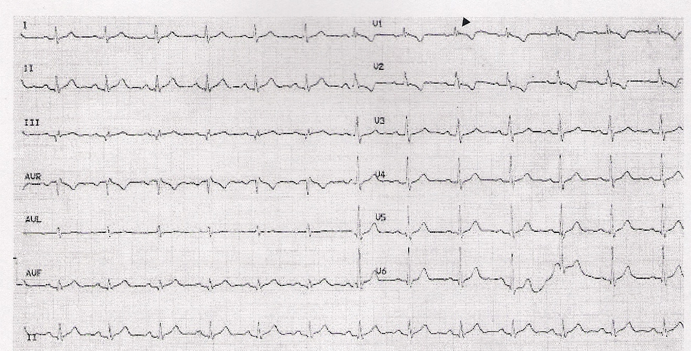
Figure 1 Twelve lead electrocardiogram showing partial RBBB ,T wave inversion in V1, V2 and Epsilon wave in V1 (arrow head).

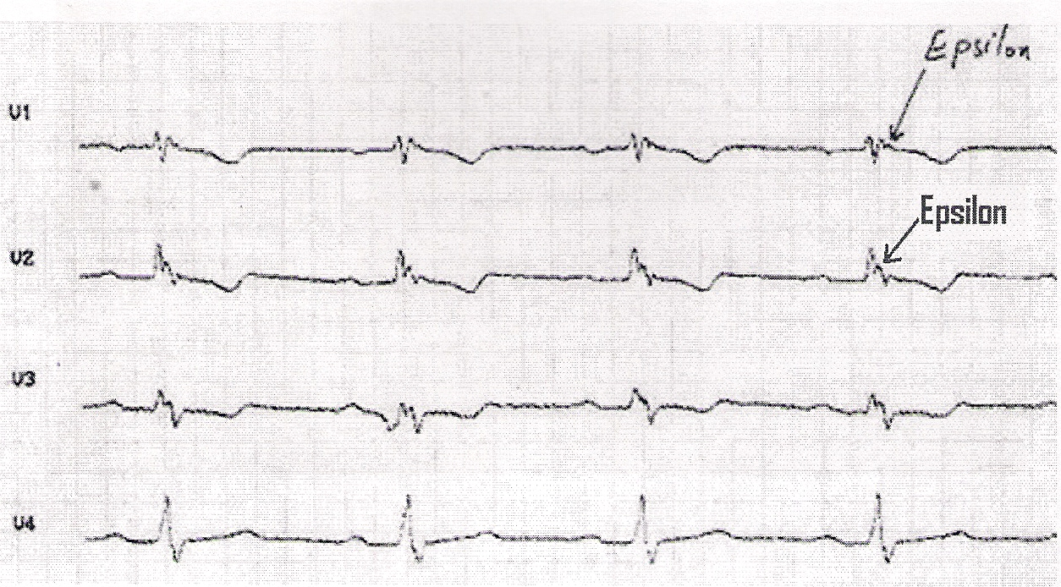
Figure 2 Magnified ECG strips of V1,V2 and V3 showing Epsilon wave (red arrow) at V1 &V2.

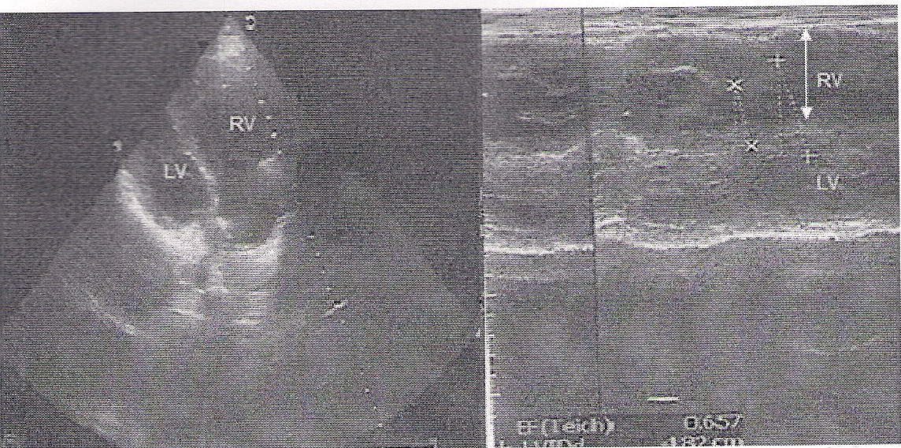
Figure 3 II D and M- Mode echocardiogram showing enlarged dilated RV (double head white arrow) .RV=right ventricle.LV=left ventricle.

