M J B

Hepatoprotective Potentials of Nebivolol and Aliskiren on Methotrexate Induced Liver Toxicity

Bassim Irheim Mohammad
Department of Pharmacology, College of Medicine, Al Qadisiyah University
Email: jumabassim@yahoo.co.uk

Abstract
Background: Oxidative stress has been implicated as important cause of Methotrexate (MTX) induced liver toxicity. Recently nebivolol and aliskiren have been described to posses antioxidant properties.
Objective: This study was designed to investigate the hepatoprotective potentials of Nebivolol and Aliskiren on MTX induced hepatotoxicity.
Materials and methods: A total of 32 rabbits were randomized into 4 equal groups. Group 1 received no treatment (control) while group 2,3 and 4 received MTX, MTX+Nebivolol or MTX+Aliskiren respectively for 8 weeks. At the end of 8th week all animals were sacrificed and liver function tests (SGOT, SGPT, ALP, bilirubin, TSP and PT) were measured. Liver tissues were used for measurement of MDA and GSH levels and for histopathological evaluation.
Results: MTX treatment caused significant impairment in liver function profile. MTX also induced significant increase in MDA and significant decrease in GSH levels in liver tissues. Nebivolol and aliskiren significantly improved liver function profile. Both drugs also reduced MDA levels and elevated GSH levels. Furthermore hisological evaluation of liver sections confirmed the hepatotoxicity of MTX and the improvement with the combination treatment of nebivolol or aliskiren. These findings suggested that both drugs have promising hepatoprotective potential against MTX induced liver toxicity.

ألخلاصة

اثنان و ثلاثون ذكرا من الأرانب استخدمت في هذه الدراسة. هذه الحيوانات قسمت بشكل عشوائي إلى أربع مجاميع متساوية ، المجموعة ألأولى اعتبرت مجموعة ألسيطرة، في حين إن الحيوانات في المجموعة الثانية أعطيت عقار الميثوتركسيت ، الحيوانات في المجموعة الثالثة أعطيت عقار الميثوتركسيت والنبيفولول، الحيوانات في المجموعة الرابعة أعطيت عقار الميثوتركسيت والالسكايرين وفي نهاية الأسبوع الثامن قتلت جميع الأرانب.

وقد أخذت عينات الدم لقياس مؤشرات وضيفة الكبد، وكذالك مؤشرات الاكسده بالنسيج والفحص النسيجي للكبد .أن المعالجة بعقار الميثوتركسيت أدّتْ إلى اضطراب بوظائف الكبد وزيادة بالشد التاكسدي بشكل ملحوظ وان عقارالنبيفولول او لالسكايرين يحسن من وطائف الكبد ويقلل الشد التاكسدي ويمنع التغيرات النسيجيه بشكل ملحوظ وعليه يمكن القول إن العقاقيرين المضافين يبديان حماية ضدّ التأثيرِ السامِّ للميثوتركسيت.

ـــــــــــــــــــــــــــــــــــــــــــــــــــــــــــــــــ

Introduction
Methotrexate (MTX), an antimetabolite drug, acts as a dihydrofolic acid analogue that binds to the dihydrofolic acid reductase enzyme by inhibiting the synthesis of tetrahydrofolate, which is required for DNA synthesis. MTX is effective treatment modality largely used in rheumatoid arthritis, psoriasis, leukemias and some autoimmune disorders [1]. Nowadays it is also used for sarcoidosis, inflammatory bowel diseases, vasculitis and sever refractory asthma [2]. With this enlarged spectrum of clinical use for MTX, its toxicity on the liver has gained much more importance. MTX-associated hepatotoxicity is a significant clinical problem that affect the compliance with MTX-containing treatment regimens. The development of MTX-induced liver toxicity is not rare and mainly depends on the duration and the dose of drug. Renal insufficiency, obesity, alcohol consumption, diabetes, and older age are other contributing factors [3]. Prolonged use of MTX leads to accumulation of polyglutamate forms of the drug in hepatocytes. The presence of higher levels of polyglutamates causes a longer intracellular presence of the drug, and this has been suggested as a mechanism for MTX hepatotoxicity [4]. Recently, hydrogen peroxide molecules were reported to act as mediators both in the therapeutic and toxic effects of MTX [5]. Oxidative stress and lipid peroxidation mediated by oxygen free radicals has been implicated as important cause of MTX induced liver toxicity [6] .
Nebivolol is a long acting β-1-adrenoceptor-blocking agent, newest of third generation beta-blockers. It is a racemic mixture of d/l-enantiomers that displays negative inotropic as well as direct vasodilating activity [7]. Besides these effects, the nitric oxide (NO)-releasing β-blocker, nebivolol has antioxidant activity [8,9]. Interventions to enhance NO activity in liver disease have produced promising results. L-arginine and several NO donors have demonstrated hepatoprotective benefits in animal models of liver injury [10]. These findings suggest that use of NO-modulating therapies may be hepatoprotective.
Aliskiren, the first in a new class of non-peptide orally effective direct renin inhibitors, is approved for the treatment of hypertension. It is effective in reducing blood pressure in the general population of hypertensive patients and in special patient groups such as obese persons, and has a tolerability and safety profile similar to placebo [11,12]. Aliskiren has renoprotective, cardioprotective and anti-atherosclerotic effects in animal models that appear to be independent of blood pressure lowering. Anti-inflammatory, antioxidant and antifibrotic effects of aliskiren have also been demonstrated in some experimental studies [12,13]. This study was designed to investigate the hepatoprotective effects of Nebivolol and Aliskiren on MTX induced hepatotoxicity

Materials and Methods
Animals
This study was conducted in Department of Pharmacology and Therapeutics/ College of Medicine/ Al Qadisiyah University/ Iraq. A total of 32 New Zealand White Male Rabbits aged 3–4 months weighing 1.5 – 2 kg, were used in this study. The rabbits were housed in an isolated room under standard conditions (controlled temperature (25±2 ◦C), ambient humidity and a 12-h light/dark cycle) and had free access to standard food pellets and water throughout the study. They kept for acclimation to the environment for one week before the experiment was started
Drugs
Methotrexate was given i.m to the rabbits in a dose of 0.25 mg/kg/day once daily (EBEWE pharma , Austria) [14]. The tested drugs that used in the study were Nebivolol (Vasoxen tablets, Berlin-Chemie, Turkey, batch no. 92155) and Aliskiren (Rasilex tablets, Novartis, Switzerland, batch no. S0107). Drugs were suspended in 0.25% carboxy methyl cellulose (CMC) in 0.9% saline suspension, and were freshly prepared prior to administration. The dose of nebivolol was 0.5 mg/kg/day orally [15] while the dose of Aliskiren was 40 mg/kg/day orally [16].
Experimental Hepatotoxicity: Induction of hepatotoxicity was carried out by administration of MTX to the rabbit in a dose of 0.25 mg/kg /day i.m for 8 weeks [14].
Experimental protocol:
The animals were randomly divided into 4 equal groups (n=8) and the following processes were performed for 8 weeks:
Group (1): served as a control which received no treatment.
Group (2): served as positive (hepatotoxic) control, which received MTX only
Group (3): received MTX+ Nebivolol
Group (4): received MTX+ Aliskiren
At the end of 8th week all rabbits were sacrificed under ether anesthesia, blood was withdrawn directly from the heart and divided into two parts. Serum was obtained to assay the activities of Glutamate oxaloacetate transaminase (SGOT), Glutamate pyruvate transaminase (SGPT) and alkaline phosphatase (ALP) and to measure the levels of bilirubin and total serum protein (TSP). The plasma was prepared to measure prothrombin time (PT). The livers were isolated for biopsy and kept at －80 ºC until the determination of malondialdehyde (MDA) or reduced glutathione (GSH).
Assessment of liver function: Blood sample was centrifuged at 3 000 r/min at 4 ºC for 10 minutes to obtain the sera. Activities of SGOT, SGPT and ALP and levels of bilirubin and TSP in serum were tested spectrophotometrically by using Roche clinical test kits. PT was measured using kit supplied by Bio-Merieux.
Assessment of tissue Malondialdehyde (MDA) and Glutathione (GSH):
Liver tissue sample was homogenized with ice-cold trichloracetic acid (1 g tissue plus 10 mL 10% TCA) in an Ultra Turrax tissue homogenizer (T25 Janke & Kunkel GMBH, IKA-Labortechnik, Germany). MDA levels were assayed for products of lipid peroxidation by monitoring thiobarbituric acid reactive substance formation as described previously [17]. Lipid peroxidation is expressed in terms of MDA equivalents using an extinction coefficient of 1.56 x105 M-1 cm-1 and the results are expressed as nmol MDA/g tissue. GSH measurements were performed using a modification of the Ellman procedure [18]. Briefly, after centrifugation at 2000 g for 10 min, 0.5 mL of supernatant was added to 2 mL of 0.3 mol/L Na2HPO4.2H₂O solution. A 0.2 mL solution of dithiobisnitrobenzoate (0.4 mg/mL 1% sodium citrate) was added and the absorbance at 412 nm was measured immediately after mixing. GSH levels were calculated using an extinction coefficient of 1.36 x 10⁴ M⁻¹ cm⁻¹. The results are expressed in µmol GSH/g tissue.
Histological examination of the liver
Tissue samples were isolated from each lobe of the liver. The tissue was fixed in 10% neutral formalin, dehydrated with graduating concentrations of ethanol solutions from 50% to 100% and embedded in paraffin, then cut into 5 μm thick sections, stained with hematoxylin-eosin and observed under a photomicroscope [19]. Hepatic damage was classified by assessing the following observations (dilatation of portal tract, inflammatory cell infiltration, necrosis and fibrosis) as no abnormality, mild, moderate and severe.
Statistics
All data are expressed as mean ± SEM. Groups of data were compared with an analysis of variance (ANOVA) followed by LSD test. Chi-square test was also used. Values of P < 0.05 were regarded as significant.

Results
Effects of additive drugs on liver function
As shown in table 1, treating a MTX to rabbits for eight weeks resulted in significant changes in liver function parameters, as compared to the control group. SGOT, SGPT, ALP, and bilirubin were significantly higher than those of the control group (p< 0.001). In addition MTX treatment produced significant (p< 0.01) prolongation in PT. Adding nebivolol or aliskiren to MTX was found to be significantly (p< 0.001) reduced these values. The TSP levels showed a marked reduction in MTX group (P < 0.001) as compared to that of control group. Nebivolol or aliskiren treatment caused significant increase in TSP (P < 0.001).
Effects of additive drugs on oxidative stress
The MDA levels in the liver were found to be significantly higher in the MTX group (72.9 ± 1.32 nmol/g; P < 0.001) compared to that of control group (33.9±1.57 nmol/g). The hepatic GSH level showed a marked reduction in the MTX group (0.8 ± 0.03 µmol/g; P < 0.001) compared to that of the control group (2.8±0.09 µmol/g). Compared to MTX group, significant decreases in MDA levels were found in hepatic tissues of MTX+nebivolol (46.6±1.16 nmol/g; P < 0.01) and MTX+aliskiren (56.6 ± 1.02 nmol/g; P < 0.01) treated groups. On the other hand, GSH levels was significantly higher in livers of MTX+nebivolol (2 ± 0.05 µmol/g; P < 0.001) and MTX+aliskiren (1.5± 0.04 µmol/g; P < 0.01) treated groups. MDA and GSH levels were significantly different between nebivolol, aliskiren and control groups (p<0.01 for both).
Effects of additive drugs on liver histopathology
Histopathological evaluation of liver tissues of the control group revealed a regular morphology of liver parenchyma with intact hepatocytes, sinusoids and portal tract (Fig. 1A). However, in MTX group, liver tissues showed disorganized hepatic cords and significant hepatocyte necrosis. Inflammation and fibrosis was also evident in the form of delicate bands around the acini (Fig 1B). As shown in table 2, the median hepatic change was highest in MTX only group (severe) and lowest in the control group (no abnormality). On the 2 types of additives to MTX, each one was associated with a median hepatic change that is significantly lower than the MTX only group. Though the hepatic changes difference between nebivolol and aliskiren treated groups not reached statistical significance, from the 2 additives nebivolol was associated with the lowest median hepatic change (no abnormality) which was significantly lower than that of aliskiren group (mild).

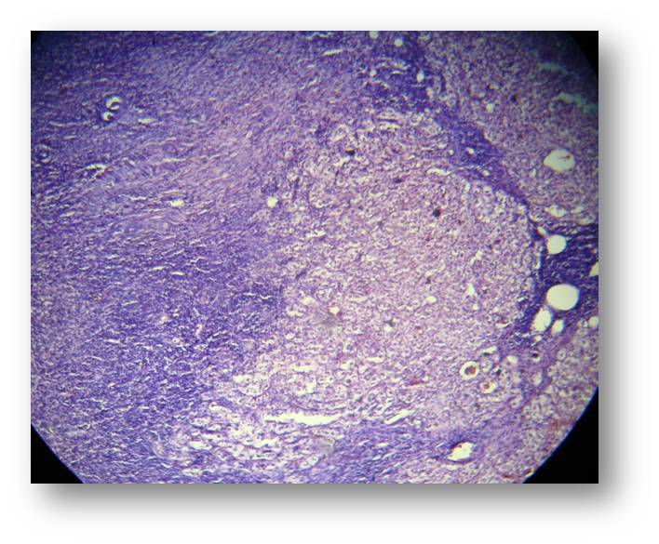
B

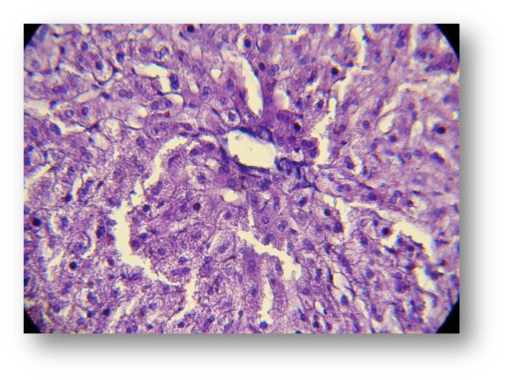
Figure 1 Photomicrograph of liver section of normal findings (no abnormality) (A) and severe findings (portal tract dilatation, inflammatory cell infiltration, sinusoidal dilatation, necrosis and fibrosis) (B). Stained with haematoxylin and Eosin (X 40).
A

Table 1 The difference in mean of selected liver function test parameters between study groups.

Parameters | Groups
Parameters | Untreated control | MTX only | MTX+Nebivolol | MTX+Aliskiren
SGOT U/L | 61±2.28 | 173.5 ± 4.13* | 115.4±3.14** | 136.5 ± 1.24**
SGPT U/L | 50.3±1.96 | 108.5 ± 3.07* | 65.6 ± 1.22** | 78.5± 0.91**
SALP U/L | 19.5±0.93 | 69.9 ± 2.27* | 36.1 ± 0.91** | 42.3 ± 1.31**
TSP g/dl | 7.6±0.38 | 3.5 ± 0.15* | 6.2± 0.1** | 4.3± 0.14**
Bilirubin mg/dl | 0.6±0.05 | 4.9 ± 0.18* | 2.4 ± 0.1** | 2.9 ± 0.04**
PT (sec.) | 11.8± 0.5 | 17.9± 0.55* | 13.9 ± 0.35** | 14.7± 0.3**
* P < 0.05, compared to untreated control;
** P < 0.05, compared to positive control (MTX only)

Table 2 The difference in median histopathologic grading of hepatic damage between the 4 study groups after 8 weeks treatment.
Histopathological Grading of hepatic damage | Untreated control |  | MTX only |  | Nebivolol+MTX |  | Aliskiren+ MTX
Histopathological Grading of hepatic damage | N | % | N | % | N | % | N | %
No abnormality | 8 | 100 | 0 | 0 | 4 | 50 | 3 | 37.5
Mild | 0 | 0 | 0 | 0 | 3 | 37.5 | 4 | 50
Moderate | 0 | 0 | 1 | 12.5 | 1 | 12.5 | 1 | 12.5
Severe | 0 | 0 | 7 | 87.5 | 0 | 0 | 0 | 0
Total | 8 | 100 | 8 | 100 | 8 | 100 | 8 | 100
Median grade | No abnormality |  | Severe |  | No abnormality |  | Mild

Discussion
In this study we found MTX induces significant impairment in the liver function. Serum bilirubin, SGOT, SGPT, ALP levels were significantly raised while serum levels of protein were reduced. Increases in prothrombin time were also noticed. These findings are in agreement with the reports by Suleyman et al., 2008 and Assma [6,20]. Moreover in the present study we demonstrated that MTX treatment causes significant increase in MDA and significant decrease GSH levels in the liver tissue as compared to control. Similar findings were reported by Kaplowitz, 2000 and Suleyman et al., 2008[6,21].The finding of elevated MDA in our study suggesting the presence of enhanced lipid peroxidation due to MTX treatment. However, although the study of Harun et al. [22] reported that GSH levels increased with the administration of MTX, we found that GSH levels decreased. Possible explanation is that MTX decreases intracellular levels of reduced nicotinamide adenine dinucleotide phosphate (NADPH). NADPH is necessary for glutathion reductase, which protects the levels of GSH, key cytosolic antioxidant [23]. Histopathologically, MTX toxicity was observed by disorganized hepatic cords, hepatocyte necrosis, inflammation and fibrosis.
Lipid peroxidation, mediated by oxygen free radicals (ROS), might to be an important cause of hepatic damage and alteration in liver function profile. The lipid peroxidation causes disruption of the memberane bilayer and cell integrity and eventually hepatic necrosis that leads to leakage of liver (cytoplasmic) enzymes into the blood [4,21]. The altered levels of bilirubin and protein are possibly due to increased production of free radicals. The reduction in protein concentration may be due to disruption in protein structures and formation of protein adducts with ROS and also the possible involvement of nephrotoxicity that caused loss of protein through the renal route [24]. In accordance with previous reports, our results also support the notion that oxidative stress is one of the major contributors in MTX induced hepatotoxicity.
In this study we observed that adding nebivolol to MTX was found to produce a significant decrease in liver enzyme activities, bilirubin level and shortening in PT and a significant increase in TSP levels compared to positive control (MTX a lone). We also demonstrated that the combination of MTX and nebivolol significantly decreases MDA and increases GSH in hepatic tissue. Our observations are consistent with previous studies that showed nebivolol attenuates lipid peroxidation and enhances anti oxidant capacity [8,9,15]. A reasonable explanation is the direct free radical scavenging effect and antioxidant properties of the NO-releasing β-blocker, nebivolol [8,9, 25].
This study showed that combination treatment of aliskiren and MTX significantly improved liver function profile. A significant reduction in liver enzyme activities (SGPT, SGOT, ALP), bilirubin level, PT value and significant increase in TSP levels were observed, compared with hepatotoxic group. It was also noted that adding aliskiren to MTX favorably affect tissue oxidative stress indices. While MDA levels were significantly reduced, GSH levels were significantly increased by aliskiren cotreatment. However, one recent study by Azhar et al reported that aliskiren could protect against oxidative stress mediated cardiotoxicity [26], to date, no studies have been announced to describe the hepatoprotective potential of aliskiren. These protective effects of aliskiren could be attributed to the restoration of oxidative status (improved NO availability) as well as anti-inflammatory properties [16]. Furthermore the histological analysis of liver has demonstrated that both nebivolol and aliskiren prevented MTX induced changes. The findings of our present study suggest that nebivolol and aliskiren seem to be a highly promising agents in protecting hepatic tissue against oxidative damage due to MTX.

References
1. Bennett P N and Brown MJ. Clinical pharmacology, 9th edition. Churchill Livingston, 2003.
2. Wu JJ and Schiff KR: Sarcoidosis. Am Fam Physician,2004;70:312–322.
3. Neuman MG, Cameron RG, Haber JA, et al: Inducers of cytochrome P450 2E1 enhance methotrexate-induced hepatocytoxicity. Clin Biochem 1999 32:519–536.
4. Walker TM, Rhodes PC and Westmoreland C: The differential cytotoxicity of methotrexate in rat hepatocyte monolayer and spheroid cultures. Toxicol In Vitro,2000; 14:475–485.
5. Zhang JG, Zhong LF, Zhang M, Xia YX: Protection effects of procaine on oxidative stress and toxicities of renal cortical slices from rats caused by cisplatin in vitro. Arch Toxicol 1992 66:354–358.
6. Suleyman Uraz and Veysel Tahan: Role of Uredodeoxycholic Acid in prevention of methotrexate-induced liver toxicity. Dig Dis Sci. 2008; 53: 1071-1077.
7. Veverka A, Nuzum DS, Jolly JL. Nebivolol: a third-generation beta-adrenergic blocker. Ann Pharmacother 2006; 40: 1353–1360.
8. Sule SS, Frishman W: Nebivolol: new therapy update. Cardiol Rev 2006; 14: 259–264.
9. de Groot AA, Mathy MJ, van Zwieten PA et al : Antioxidant activity of nebivolol in the rat aorta. J Cardiovasc Pharmacol. 2004;43:148 –153.
10. Lukivskaya O, Lis R, Zwierz K, et al.: Effect of the nitric oxide donor and the nitric oxide synthase inhibitor on the liver of rats with chronic hepatitis induced by dimethylnitrosamine. Pol J Pharmacol. 2004;56:599–604.
11. Gradman AH, Schmieder RE, Lins RL et al. Aliskiren, a novel orally effective renin inhibitor, provides dose dependent antihypertensive efficacy and placebo-like tolerability in hypertensive patients. Circulation. 2005;111:1012–1018.
12. Eduardo Pimenta Suzanne Oparil: Role of aliskiren in cardio-renal protection and use in hypertensives with multiple risk factors: Vascular Health and Risk Management 2009:5 453–463.
13. Jun Ino; Chiari Kojima; Hideto Ishii et al: Aliskiren, a Direct Renin Inhibitor, Prevents Leukocyte Recruitment to Mouse Femoral Artery via Blood Pressure-Independent Modulation of Adhesion Molecules and Oxidative Stress. Circulation. 2008;118:S_565.
14. Novaes GS, Mello SB, Laurindo IM et al: Low dose methotrexate decreases intraarticular prostaglandin and interleukin 1 levels in antigen induced arthritis in rabbits. J of Pharm Sci , 1996 Dec;23(12):2092-7.
15. Filomena de Nigris, Francesco Paolo Mancini, Maria Luisa Balestrieri et al : Therapeutic dose of nebivolol, a nitric oxide-releasing β-blocker, reduces atherosclerosis in cholesterol-fed rabbits. Nitric Oxide 2008 Volume 19, Issue 1, August,57-63.
16. Toshio Imanishi; Hiroto Tsujioka; Hideyuki Ikejima: Renin inhibitor Aliskiren improve impaired nitric oxide bioavailability and protect against atherosclerotic changes. Hypertension 2008;52;563-572.
17. Beuge JA, Aust. SD: Microsomal lipid peroxidation. Meth. Enzymol. 1978; 52: 302–11.
18. Beutler E: Glutathione in Red Blood Cell Metabolism. A Manual of Biochemical Methods. New York: Grune & Stratton, 1975; 112–4.
19. Carleton M . Histological Techniques. 4th ed. p. 166. Oxford Press. New York, U. S. A., 1967.
20. Assma A Swadi: Modulation of Methotrexate Induced Hepatotoxicity: MSc thesis, College of Medicine, Kufa University, Iraq, 2009.
21. Kaplowitz N: Mechanisms of liver cell injury. J Hepatol, 2000;32:39–47.
22. Harun C, Ertan B, Ali C et al.: Effects of N-Acetylcysteine on Methotrexate-Induced Small Intestinal Damage in Rats The Mount Sinai Journal of Medicine Vol. 73 No. 8 December 2006.
23. Miyazono Y, Gao F, Horie T: Oxidative stress contributes to methotrexate-induced small intestinal toxicity in rats. Scand J Gastroenterol 39: 1119–1127, 2004.
24. Sallie R, Tredger JM and William R: Drugs and liver.Part,Testing liver function. Biopharm Drug Dis, 1991;12:251-9.
25. Matthias Oelze, Andreas Daiber, Ralf P. Brandes et al: Nebivolol Inhibits Superoxide Formation by NADPH Oxidase and Endothelial Dysfunction in Angiotensin II–Treated Rats. Hypertension 2006;48;677-684.
26. Azhar R, Abdul Kalam, Mohammad Akhtar et al: Protective effects of aliskiren in doxorubicin-induced acute cardiomyopathy in rats Hum Exp Toxicol, first published on April 23, 2010.

