

Medical Journal of Babylon
Vol. 13- No. 1:176 - 183 , 2016
http://www.medicaljb.com
ISSN 2312-6760©2016 University of Babylon

Original Research Article

Carpal Tunnel Syndrome: Comparative Study Between Traditional Incision and Mini Palmar Incision

Sherwan Ahmed Hamawandi^{1*} Injam Ibrahim Sulaiman¹ Salim Mardan Omer²
Ali Hussain Muhammad Al-Tameemi³
¹College of Medicine, Hawler Medical University, Erbil, IRAQ
²College of Medicine, Kirkuk University, Kirkuk, IRAQ
³Hawler Teaching Hospital, Erbil, IRAQ

*E-mail:sherwan.hamawandi@yahoo.com

Accepted 24 February, 2016
Abstract
CTS is the most common peripheral nerve compression disorders. Surgical treatment of CTS involves many procedures ranging from the traditional incision to variety of minimal invasive techniques. The aim of the study is to compare the results of surgical treatment of CTS using traditional incision and 1.5 cm palmar incision regarding postoperative pain, scar tenderness, returning to daily activity and patient satisfactory score. We studied 200 patients, half of them treated with traditional incision of CTS surgical decompression and other half treated with 1.5cm mini palmar incision of CTS surgical decompression. We followed those patients regarding postoperative pain, scar tenderness, returning to daily activity and patient satisfactory score for 3 months period of follow up. We found in this study that mini palmar incision 1.5cm is safe and effective as traditional open release technique with better results regarding postoperative pain, scar tenderness, time needed to return to daily activity and patient satisfaction with the surgery.

Key words:Carpal Tunnel Syndrome, traditional open incision, Mini Palmar incision, scar tenderness, patient satisfactory score.

الخلاصة
انضغاط العصب الوسطي خلال مروره في النفق الرسغي يعتبر اكثر حالات انضغاط الاعصاب المحيطية شيوعاً. هنالك طرق جراحية متعددة لتحرير العصب الوسطي منها بواسطة الجراحة الناظورية ومنها الجراحة المفتوحة والاخيرة يمكن اجراؤها بالطريقة المعروفة سابقاً او باجراء شق جراحي صغير. تهدف هذه الدراسة الى مقارنة نتائج اجراء عملية تحرير العصب الوسطي بالطريقة الجراحية المعروفة سابقاً مع تلك المجراة بواسطة اجراء شق جراحي بطول ١.٥ سنتيمتر. شمل البحث ٢٠٠مريضة يعانين من متلازمة انضغاط العصب الوسطي ولم يستجبن للعلاج التحفظي وقد اجريت عملية تحرير العصب الوسطي لنصف العدد بالطريقة المعرفة سابقاً والنصف الاخر بطريقة اجراء شق جراحي صغير بطول ١.٥ سنتيمتر. لقد اوضحت نتائج متابعة المريضات بان الطريقة الجراحية ذات الشق الجراحي الصغير افضل من الطريقة الاخرى من ناحية الالم بعد العملية ورجوع المريضة لمزاولة اعمالها اليومية ورضاء المريضات عن اجراء العملية.
ــــــــــــــــــــــــــــــــــــــــــــــــــــــــــــــــــــــــــــــــــــــــــــــــــــــــــــــــــــــــــــــــــــــــــــــــــــــــــــــــــــــــــــــــــــــــــــــــــــــــــــــــــــــــــــــــــ

Introduction
CTS is the most common peripheral nerve entrapment disorders. Surgical treatment of CTS involves many procedures ranging from the traditional incision to variety of minimal invasive techniques.

CTS is thought to be due to compression of the median nerve within a space, the carpal tunnel, occupied by flexor tendons and whose roof, the flexor retinaculum, is a ligament between four hand bones. Its incidence peaks between the ages of 40 and 60. There are certain conditions that predispose to the development of CTS, including pregnancy, diabetes, hypothyroidism. It is thought that the prevalence of CTS may be as high as 2 to 3%.
The aim of the study is to compare the results of surgical treatment of CTS using traditional incision and 1.5 cm palmar incision regarding postoperative pain, scar tenderness, returning to daily activity and patient satisfactory score.

Materials and Methods
We studied 200 patients, half of them treated with traditional incision of CTS surgical decompression and other half treated with 1.5cm mini palmar incision of CTS surgical decompression from January 2012 until march 2014. We followed those patients regarding postoperative pain, scar tenderness, returning to daily activity and patient satisfactory score for 3 months. The age of patients ranges between 19 year old and 55 year old. All patients were female.
Exclusion criteria were trauma, previous surgery, associated cervical radiculopathy, DM, those developed infection after surgery and pregnancy.
EMG and NCS were done to all patients and revealed moderate to severe degrees of median nerve compression. Non operative treatment was the initial treatment for all patients and the decision of surgery was done after failure of non-operative treatment for 3 weeks or patient refusal to continue with conservative treatment due to intolerance of symptoms. The surgery done under GA or regional anesthesia in 3 different hospitals; Erbil teaching hospital, Zheen International hospital and PAR private hospital. All surgeries were done as day case and the patients were discharged on the same day of surgery. All patients were examined 5 days after surgery, 14 days for removal of stitches, 6 weeks, 3 months after surgery. During these visits the patients were assessed for postoperative pain, scar tenderness, returning to daily activity and patient satisfactory score
At each visit, every patient was asked for the four parameters to give a number relating her condition as following:-
Postoperative pain score:- zero: no pain, 10: severe pain,
Scar tenderness score: Zero: no tenderness 10: sever tenderness.
Patient satisfactory score: Zero: unsatisfied, 10:Fully satisfied.
Return to daily activity: the day after surgery in which the patient returns to daily activity

Results
The results of the parameters in the traditional incision at each visit (table 1)

Table 1:The results of the Parameters in Traditional incision at each visit

Parameter | 5th Day | 14th Day | 6 Weeks | 3 Months
Postoperative Pain | 6.8 | 4.6 | 1.3 | 0.7
Scar Tenderness | 9.2 | 7.4 | 3.8 | 2.9
Number of patients returned to their daily activity | 0 | 13 | 68 | 19
Patient Satisfactory Score | 6.2 | 7.1 | 7.9 | 8.3

Table 2:The results of the parameters in the mini palmar incision at each visit
Parameter | 5th Day |  | 14th Day | 6 Weeks | 3 Months
Postoperative Pain | 2.7 |  | 0.8 | 0.3 | 0.2
Scar Tenderness | 8.6 |  | 2.3 | 0.7 | 0.2
Number of patients returned to their daily activity |  | 12 | 74 | 11 | 3
Patient Satisfactory Score | 8.3 |  | 8.7 | 9.2 | 9.7

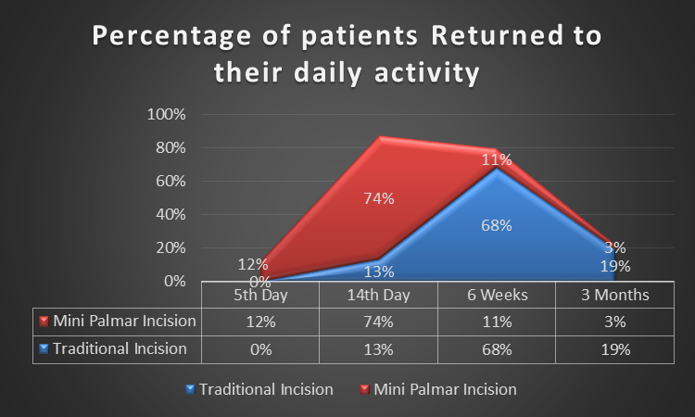
Figure 1: Percentage of patients returned to their daily activity
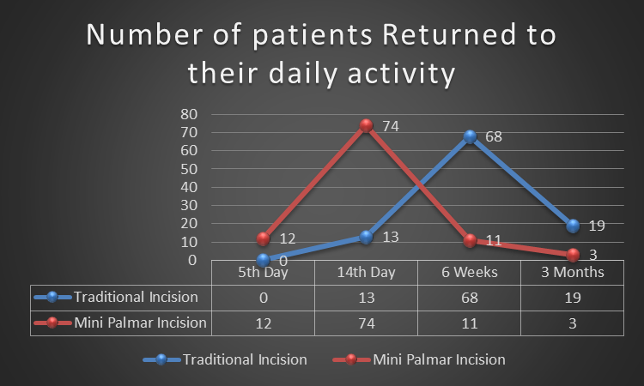
Figure 2:Number of patients returned to their daily activity (Lines)

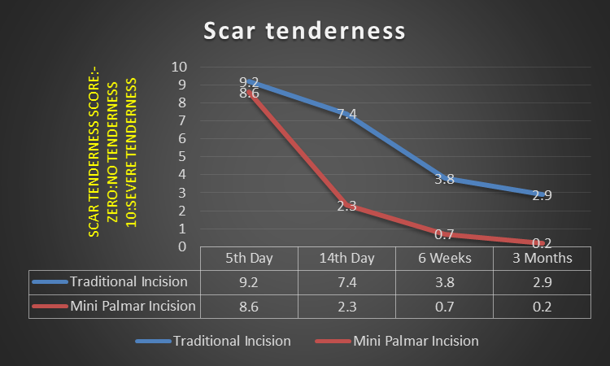
Figure 3 : Scar tenderness score in both incisions

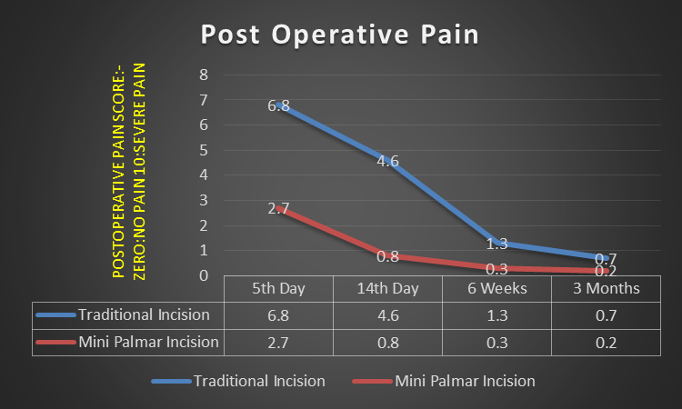
Figure 4 :Postoperative pain score

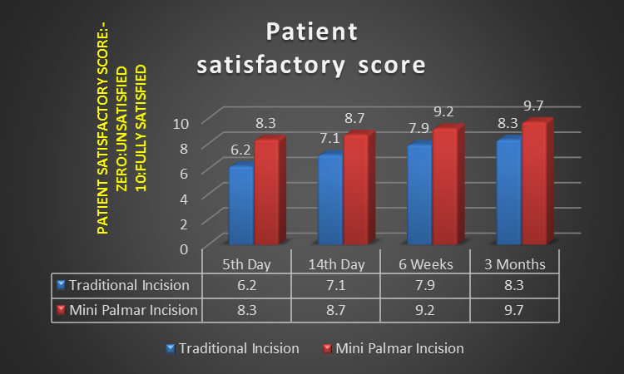

Figure 5: Patient satisfactory score

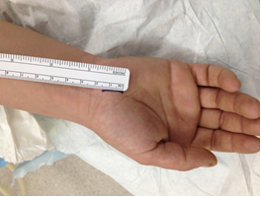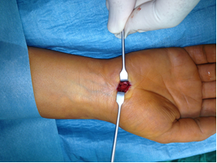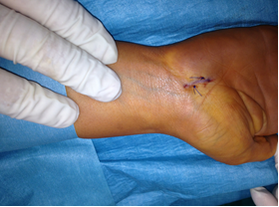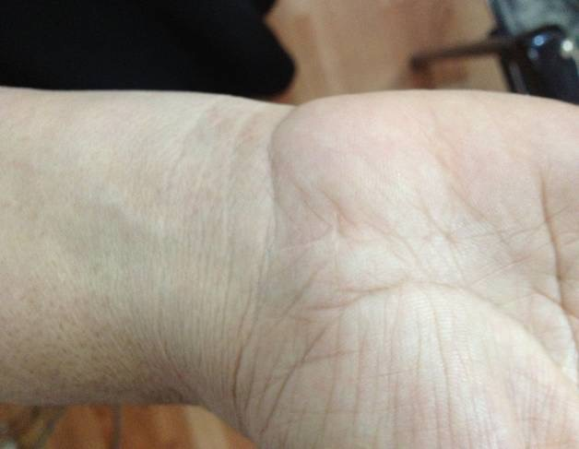
A
B
C
D
Figure 6: Mini-open carpal tunnel release. A, Proposed incision measuring 1.5 cm starting at the distal wrist crease and extending distally in line with the third interspace. B, Intraoperative picture of carpal tunnel release procedure. C, Immediate post operative picture showing the small incision after suturing. D, Site of surgery after one year.

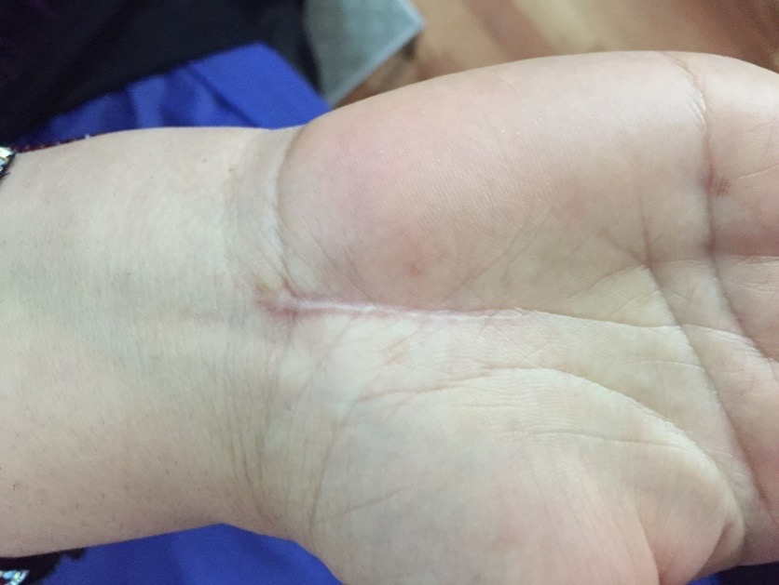

Figure 7: Picture of the scar one year after CTS surgery using the traditional long incision method.

Discussion
Jugovacet et al[1] showed in their study, when comparing a limited palmar incision for carpal tunnel release with a traditional open technique, that intervals between the operation and return to daily activities (median 5 days, range 2-15) were shorter in the limited palmar incision group than in the traditional open technique group (median 10 days, range 2-21; p<0.001), as well as scar tenderness better in the limited palmar incision group.
In our study, on the second week, you can see that total of 86% of the 100 patients with the mini palmar incision have returned to work versus only 13% of the traditional incision patients could return back to their daily activity, this is considered highly significant.
At 6 weeks, you can see that total of 97% of the 100 patients with the mini palmar incision have returned to their daily activity versus only 81% of the traditional incision patients could return back to their daily activity, this shows how superior the mini palmar incision to the traditional incision in the treatment of CTS.
Regarding scar tenderness score in our study was 2.3 in the mini palmar incision group on the 14th day visit while it was 7.4 in the traditional open technique group.
Also Scar tenderness score in our study was 0.7 in the mini palmar incision group on the 6 week visit while it was 3.8 in the traditional open technique group, tenderness of the scar is still significant even in the 3 months visit compared to the mini palmar incision patients.
Our study showed very significant difference between the post-operative pain reported by the traditional versus mini palmar incisions, pain was significantly lower in the later, pain is less even after 6 weeks to 3 months, but the gap starts to be bridged with time, the difference is highest on the 5th day to 2 weeks after surgery.
Cellocco[2] showed that recovery period is significantly shortened in those patients operated by mini open technique as in our study.
Brown [3] et.al showed in their study that 39% of eighty-two hands in the open-release group and 64% of seventy-eight hands in the endoscopic-release group were not tender at 84 days as well as the open method also resulted in a longer interval until the patient could return to work (twenty-eight days, compared with fourteen days for the open-release and endoscopic-release groups). When we compare these results with our study, we found that mini palmar incision has good results as those of endoscopic release technique.
Many studies comparing the results of open release technique and endoscopic release techniques showed that postoperative recovery, return to daily activities and patient satisfaction with endoscopic release technique better than open release technique as reported byseveral authors [4-9].
When we compared our results with these studies, we found that mini palmar incision gave results similar or near to the results of endoscopic release technique in these studies
Aslani et al. [10] compared the results of those operated by mini incision and endoscopic release with those operated by traditional open technique and they found that early patient satisfaction is better with mini incision than traditional incision as in our study.
Cirpar[11] showed in his study that mini incision 3cm for carpal tunnel release is safe and effective as the traditional open while in our study we use 1.5cm mini palmar incision and we found it safe, effective with better results than the traditional open technique.
As we found in our study, Suppaphol[12] showed in his study that the limited open carpal tunnel release is effective comparable to the standard open carpal tunnel release with better cosmetic and improvement in grip strength at the three months postoperative period.
Richter [13] found in his study that the endoscopic method demonstrated no advantages when compared to the short incision. The long incision led to a temporary 10% loss of strength only during the first three weeks.
These results should be kept in mind in the light of occasionally severe neurovascular complications following endoscopic carpal tunnel release. So we found that mini incision takes the advantages of endoscopic technique without its disadvantage and in other hand better results in comparison with traditional open technique.

Conclusions
Mini palmar incision 1.5cm is safe and effective as traditional open release technique with better results regarding postoperative pain, scar tenderness, time needed to return to daily activity and patient satisfaction with the surgery.

References
- Jugovac I1, Burgić N, Mićović V, Radolović-Prenc L, Uravić M, Golubović V, Stancić MF. Carpal tunnel release by limited palmar incision vs traditional open technique: randomized controlled trial.Croat Med J. 2002;43(1):33-6
- Cellocco P1, Rossi C, Bizzarri F, Patrizio L, Costanzo G. Mini-open blind procedure versus limited open technique for carpal tunnel release: a 30-month follow-up study J Hand Surg Am. 2005; 30(3):493-9.
- Brown RA1, Gelberman RH, Seiler JG 3rd, Abrahamsson SO, Weiland AJ, Urbaniak JR, Schoenfeld DA, FurcoloD.Carpal tunnel release. A prospective, randomized assessment of open and endoscopic methods.J Bone Joint Surg Am. 1993;75(9):1265-75.
- Tian Y1, Zhao H, Wang T.Prospective comparison of endoscopic and open surgical methods for carpal tunnel syndrome. Chin Med Sci J. 2007;22(2):104-7.
- Flores LP1.Endoscopic carpal tunnel release: a comparative study to the conventional open technique. ArqNeuropsiquiatr. 2005;63(3A):637-42.

- Palmer DH1, Paulson JC, Lane-Larsen CL, Peulen VK, Olson JD. Endoscopic carpal tunnel release: a comparison of two techniques with open release.Arthroscopy. 1993;9(5):498-508.
- Zhao H1, Zhao Y, Tian Y, Yang B, QiuGX.Comparison of endoscopic versus open surgical treatment of carpal tunnel syndrome.Zhongguo Yi XueKeXue Yuan XueBao. 2004;26(6):657-60.
- Wong KC1, Hung LK, Ho PC, Wong JM.Carpal tunnel release. A prospective, randomised study of endoscopic versus limited-open methods. J Bone Joint Surg Br. 2003;85(6):863-8.
- Skorpik G1, LandsiedlF.Carpal tunnel syndrome. A comparison of endoscopic and open surgical treatment.HandchirMikrochirPlastChir. 1996;28(3):133-7.
- Aslani HR1, Alizadeh K, Eajazi A, Karimi A, Karimi MH, Zaferani Z, HosseiniKhameneh SM. Comparison of carpal tunnel release with three different techniques. ClinNeurolNeurosurg. 2012;114(7):965-8. doi: 10.1016/j.clineuro.2012.02.017.
- Cırpar M1, Arı M, Türker M, Ekşioğlu MF, CetikO.The efficacy and safety of limited incision technique in carpal tunnel release. EklemHastalikCerrahisi. 2011;22(1):33-8.
- Suppaphol S1, Worathanarat P, Kawinwongkovit V, PittayawutwinitP.The comparison between limited open carpal tunnel release using direct vision and tunneling technique and standard open carpal tunnel release: a randomized controlled trial study. J Med Assoc Thai. 2012;95(4):532-6.
- Richter VM1, Brüser P. Surgical treatment of carpal tunnel syndrome: a comparison between long and short incision and endoscopic release. HandchirMikrochirPlastChir. 1996;28(3):160-6

