

Medical Journal of Babylon
Vol. 13- No. 1: 1 - 6 , 2016
http://www.medicaljb.com
ISSN 2312-6760©2016 University of Babylon

Original Research Article

Controversy of Retention after Dento-Alveolar Expansion
(Clinical Study)

Arkan Muslim Al Azzawi
College of Dentistry, University of Babylon, Hilla, IRAQ

E-mail:arkanmarkan@yahoo.com

Accepted 5 January, 2016
Abstract
Maxillary constriction whether unilateral or bilateral still one of the most important problem in orthodontics thus aim of this articleto test hypothesis that Maxillary expansion may be combined with or without retainers for complete treatment due to expansion treatment taken a couple of months while the expander was not removed for several more months to keep teeth from relapse. Twenty patients with an age ranged between 17-22 years old, had posterior bilateral buccal cross bite 5 mm or less based on Angle' classification malocclusion were selected in this study. All of them were white Iraqi Arab in origin and had full permanent dentition regardless the wisdom teeth with minimal crowding (1-2mm). Sample classified in to two groups (A) and (B) of 10 patient and study model was taking preoperatively, after 4 month and after 12 month respectively. Transpalatalbarconstructed and cementedat the same time of hyrax removal, this is procedure prepared for group (B), while for group (A) Hyrax removed and just take impression without TPB and at that time sequence of main arch wire continue and all cases finished with 019*025 mil Nickel Titanium arch wire.Inter-cuspal premolar distance showed significant relapse (1.79 mm) occurred in none retention group (A) between 4 and 12 month this is not present in retention group(B) amount of relapse was none significant (0.05). While there was significant difference in inter-cuspalmolar group A equaled to (1.48mm) and group B equaled to (1.38).Analysis of relapse in group A and group B clarifying that the use of Trans-Palatal arch as retention after hyrax expander didn’t increasedento-alveolar stability.

Key words:Dento-alveolar expansion,bilateralcross bite, Hyrax, Trans-palatal bar, Relapse.

الخلاصة
تضيق الفك العلوي سواء كان من جانب واحد او من الجانبين يبقى واحد من اكثر واهم المشاكل في تقويم الاسنان لذلك الهدف من هذه الورقة هو فحص نضرية توسيع الفك العلوي من الممكن ان تترافق مع او بدون وضع المثبت خلال العلاج بسبب ان العلاج التوسيعي يستغرق عدة اشهر والموسع لايرفع الى عدة اشهر اخرى للحفاظ على الاسنان من العودة. عشرون مريض اعمارهم تتراوح 17-22 سنة لديهم تضيق بالفك العلوي في كلا الجانبين بمقدار 5 ملميتر بالاعتماد على تصنيف انكل لتراكب الاسنان في هذه الدراسة. كلهم مواطنين عراقيين ذات بشرة بيضاء ولديهم اسنان دائمية كاملة في مايتعلق بالفك العلوي ماعدا اسنان العقل وتراكب لايتجاوز 1-2 ملميتر . هذه العينة وزعت الى مجوعتين أ و ب لكل مجموعة 10 مرضى والطبعة قبل العلاج وبعد 4 اشهر وبعد 12 شهر اخذت لكل المرضى مثبت اللهاة (ترانسبليتل بار) صنع وتم تثبيته في نفس وقت رفع الموسع في الفك العلوي هذه العملية تمت للمجموعة ب بينما المجموعة أ رفع الموسع بدون وضع مثبت اللهاة , وبعد هذه المرحلة سلسلة واير التقويم استمرت الى نهاية العلاج والحالات انهيت باستخدام واير 019*025 . البعد بين قمة الضاحك الاول في الجهة اليمنى واليسرى للفك العلوي بين رجوع الاسنان بوضوح بمقدار 1.79 ملميتر حدث هذا في المجموعة الاولى أ بين الشهر 4 و 12 وهذا غير موجود في المجموعة ب مقدار الرجوع فيها غير مهم بمقدار 0.05 بينما يوجد اختلاف مهم في البعد بين قمم الضرس الاول بالنسبة للفك العلوي في الجهة اليمنى واليسرى في المجموعة أ بمقدار 1.48 ملميتر و في المجموعة ب بمقدار 1.38. تحليل رجوع الاسنان في كلا المجموعتين يوضح ان استخدام مثبت اللهاة كمثبت بعد الموسع لايزيد ثبات الاسنان ولا عظم الفك.
الكلمات المفتاحية: دنتو-الفيولراكسباندر, تضيق في كلا الجانبين, هايركس, ترانسبليتل بار, عودة
ـــــــــــــــــــــــــــــــــــــــــــــــــــــــــــــــــــــــــــــــــــــــــــــــــــــــــــــــــــــــــــــــــــــــــــــــــــــــــــــــــــــــــــــــــــــــــــــــــــــــــــــــــــــــــــــــــــ

Introduction
Posterior crossbite described according to the position of the upper molars, Therefore a bilateral maxillary lingual (or palatal) crossbite means that the maxillary molars were lingual to their normal position on both sides, while a unilateral mandibular buccal crossbite means that the mandibular molars were buccally positioned on one side. This terminology specifies which teeth (maxillary or mandibular) are displaced from their normal position[1,2].
Expansion studies recommended several indications, involving correction of crossbite, elimination of dental crowding, leveling of the curve of Wilson, facilitation of eruption of the permanent canines, increasing the size of the nasal airway, and reduction of unaesthetic buccal corridors[3,4].
The major focus of rapid maxillary expansion(RME) treatment was related to crossbite correction and reduction in tooth size/arch size discrepancies and control of the vertical dimension. The hyrax or Beidermanappliance is a common type of RME. It is tooth borne and composed of a jack screw and an all metal framework soldered to bands on the first maxillary premolars and molars. RME appliances cause increase in vertical dimension, downwarddisplacement of maxilla, dental extrusion, lateral rotation of maxillary segments and cuspal interferences attributed to bite opening characteristic of RME[5,8].
Following expansion by any means, a retainer is needed even after bone fill-in seems complete. The expansion appliance should remain in place for 3 to 4 months and then can be replaced with a removable retainer or other retention device[1,5].
The TPA shown to lack a significant effect in improving anchorage in extraction cases,although it may be effective as a space maintenancedevice to assist the improvement in molar relationshipsinduced by the RME[1,5,9].
Total relapse into crossbite is unlikely in the absenceof a skeletal problem, and mixed dentition expansion reducesthe incidence of posterior crossbite in the permanent dentition,so early correction also simplifies future diagnosis andtreatment by eliminating at least that problem from the list[1,9].
The aim of this study was to evaluate the hypothesis that stability of expansion of the maxilla with and without using TPB as a retainer after expansion accomplished to see amount of relapse after treatment.

Materials and Methods
Twenty patients with an age ranged between 17-22 years old, had posterior bilateral buccal cross bite 5 mm or less based on Angle' classification malocclusion were selected in this study. All of them were white Iraqi Arab in origin with minimal crowding (1-2mm.).Diagnostics aids like study models, intraoral and extraoral photographs with natural head position using Canon Power shot SD750 digital Elph (7.1 Megapixel, Japan) camera, O.P.G were taken prior to the orthodontic treatment and hyrax cementation.
Sample classified in to two groups A (none retention group) and B (retention group) of 10 patients each and study model was taking preoperatively, after 4 months and 12 month respectively.
Elastic separators placed mesial and distal to the maxillary first molars and maxillary first premolars for 28 hours and then orthodontic bands with Roth prescription is placed on maxillary first molars and maxillary first premolars then alginate impression taken and study model produced to make hyrax appliance after that Roth stainless steel braces (Bionic, Orthotechnology Co., USA) with 0.022" slot were bonded on the maxillary and mandibular teeth using no-mix orthodontic composite (Orthotechnology Co., USA). Hyrax appliance were cemented using glass ionomer cement, then patient supplied with orthodontics brush, relieving wax, and driver screw to activate Hyrax, slow expansion by activation of hyrax to gain 1 mm per week and follow up each month to change sequence of arch wire (Figure.1).

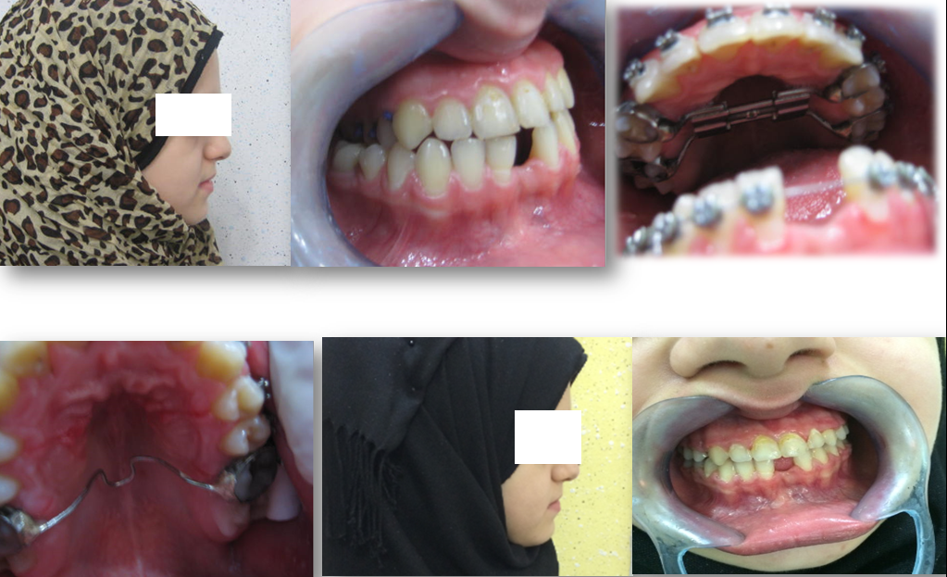
Figure 1: preoperative, hyrax insertion with fixed appliance, Trans-palatal bar insertion and postoperative photograph.

Alignment and Leveling phase continue using NiTi sequence archwires with cinch back posteriorly, after 2 months Hyrax activation stopped, left in position and locked with composite for 2 month for retention thus after 4 month Hyrax removed and take another impression with bands on maxillary first permanent molars to make Transpalatal bar (TPB) at the same time of hyrax removal (Figure 1) this is a procedure prepared for group (B), while for group(A) Hyrax removed and just take impression without TPB. TPB in retention patients were made with 1 mm stainless steel and had soldered to Orthodontic bands. Finishing performed with 19 × 25 mil NiTiarchwires and settling of occlusion completed then the orthodontic appliance removed in a 1.5 year of treatment duration and another study model made for data analysis. Second profile photographs were taken after the orthodontic treatment.
All casts transferred to united State of America for scanning by using 3 dimensional scannersto get 3 dimensional view of castfor each patient and then data analyzed by using AutoCad program 2008 to calculate linear measurement which are:
- Premolar inter-cusp distance: the distance between the palatal cusp tip of maxillary first premolarsaccording to Prado et al[10]. Fig. 2.
- Molar inter-cusp distance: the distance between the mesio-lingual cusps tips of maxillary first molars according to Prado et al. [10]. Fig 2
And the magnification is selfly adjusted by software of the 3 D scanner from motion’s view (Ortho. Insight 3D laser scanner).

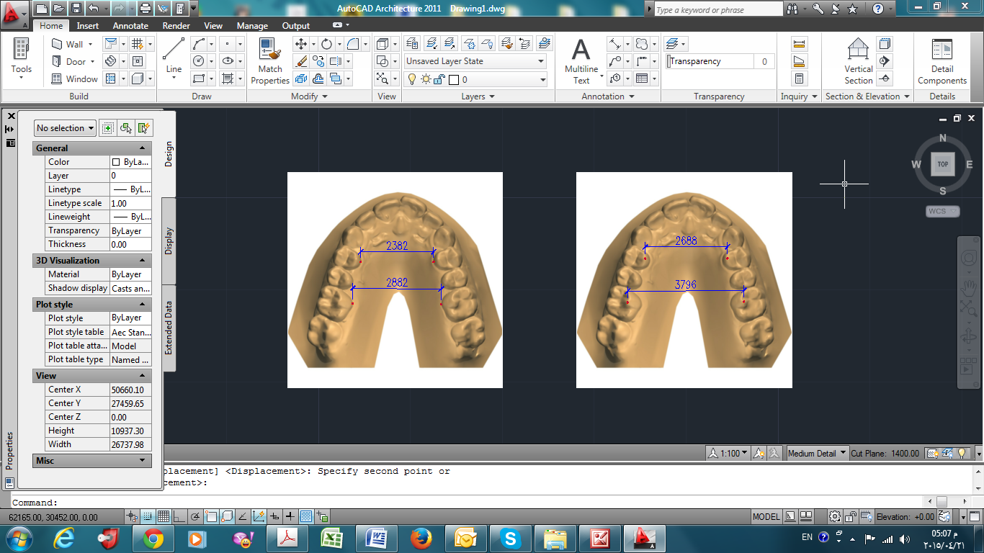

Figure 2: Data Stored and analyzed by Auto-Cad 2008

Results
Descriptive statistics in table 1 showed that the mean values for premolar inter-cusp (PID) distance in 4 month larger than that of 12 month and that preoperative respectively in both groups. While analytics statistics that representative by ANOVA test showed that there is significant difference related to relapse in PID in group A.PI measurement demonstrate an interaction effect between groups over the time frame with P value= 0.03.
Descriptive statistics in table 2 clarified that the mean values of Molar inter-cusp distance (MID) in 4 month more than 12 month and preoperative respectively in both groups. ANOVA test clarified high significant difference with P value <0.001 and no significant interaction between groups over time period.
PIDshowed significant relapse (1.79 mm) occurred in none retention group (A) between 4 and 12 month this is not present in retention group (B) amount of relapse was none significant (0.05), as shown in table 1. While there was significant difference in MID in group A equaled to (1.48mm) and group B equaled to (1.38), as clearly stated in table 2.
All assessment values significantly increased at the 4 month over time frame in comparison to preoperative assessment with P value <0.05 as shown in table 3.
Discussion
Relapse determination must be accounted for the effect of expansion which differed in anterior area and posterior area [11].Assessment of stability depended on relapse amount in millimeter after removal of fixed expander [11,12].Then relapse might be evaluated by average difference between 4 and 12 months. PID measurement increased between 4 and 12 months subsequently this result come in accordance with Sokucu et al[13], on the other hand significant relapse (1.79) found in 12 month time frame in group A only, this is may be due to lack of anterior extension of Trans-Palatal bar[10].
MID measurement was different between 4 and 12 months time frame in about 1.48 and 1.38 in group A and group B respectively and this amount of relapse logically accepted because in orthodontics overcorrection of 2mm always recommended to overcome relapse, this may be due to uses of TPB didn’t increase alveolar bone stability, and this result completely come in agreement with Prado et al[10].
In conclusion of this study the analysis of relapse in group A and group B clarifying that the use of Trans-Palatal arch as retention after fixed retainer didn’t increase dento-alveolar stability.

References

- Proffit WR, Fields HW, Sarver DM. Contemporary orthodontics. 5th ed. St Louis: Mosby; 2013, p: 211-212.
- Foster TD. A text book to orthodontics. 3rd ed. Blackwell scientific publications, oxford, London;1990, p: 35,40,63.
- Haas AJ. Palatal expansion: just the beginning of dentofacial orthopedics. Am J Orthod. 1970;57:219–255.
- Wertz RA. Changes in nasal airflow incident to rapid maxillary expansion. Angle Orthod. 1968;38:1–11.
- McNamara JA Jr. Maxillary transverse deficiency. Am J OrthodDentofacOrthop. 2000;117:567–570.
- Asanza S, Cisneros GJ, Neiberg LG. comparison of hyrax and bonded expansion appliance. Angle orthod. 1997;67(1): 15-22.
- Sarver DM, Johnston MW. Skeletal changes in vertical and anterior displacement of the maxilla with bonded rapid palatal expansion appliances. Am J OrthodDentofacOrthop. 1989;95:462–466.
- Chang JY, McNamara JA Jr, Herberger TA. A longitudinal study of skeletal side effects induced by rapid maxillary expansion. Am J OrthodDentofacOrthop. 1997;112: 330–337.
- Zablocki HL, McNamara JA Jr, Franchi L, Baccetti T. Effect of the transpalatal arch during extraction treatment. Am J OrthodDentofacOrthop. 2008;133:852–860.
- Prado GP, Furtado F, Aloise AC, Bilo JP, Ferreira LM and Pereira MD. Stability of surgically assisted rapid palatal expansion analyzed by 3 –dimensional imaging. Am J OrthodDentofacOrthop 2014; 145;5: 610-616.
- Aloise AC, Pereira MD,Hino CT,Filho AG, Ferreira LM. Stability of the transverse dimension of the maxilla after surgically assisted rapid expansion. J CranifacSurg 2007;18:860-5.
- Koudstaal MJ, Wolvius EB, Schulten AG, Hop WC, Van der wal KG.Stability, tipping and relapse of bone-borne versus tooth –borne surgically assisted rapid palatal expansion; aprospective randomized patient trial. Int. J. Oral MaxillofacSurg 2009; 38-15.
- Sokucu O, Kosger HH, Bicakci AA, Babacan H. stability in Dental changes in RME and SARME: a comparison of technique, response and stability. Angle Orthod 2009;79:207-13.

Table 1: Intercuspal Premolar Distance
Inter-Cuspal premolar distance | preoperative |  | 4 month |  | 12 month |  | ANOVA test
Inter-Cuspal premolar distance | Mean | SD | Mean | SD | Mean | SD | Interaction |  | Time
Group A | 25.5 | 3.65 | 32.47 | 3.35 | 30.68 | 2.85 | 0.003* | <0.001*
Group B | 26.91 | 3.11 | 32.9 | 2.66 | 32.95 | 3.16 | 0.003*
Table 2: Intercuspal Molar Distance

Inter-Cuspal Molar Distance | preoperative |  | 4 month |  | 12 month |  | ANOVA test
Inter-Cuspal Molar Distance | Mean | SD | mean | SD | Mean | SD | interaction | Time
Group A | 30.87 | 3.46 | 38.2 | 3.71 | 36.72 | 4.10 | 0.155 | <0.001*
Group B | 33.38 | 3.52 | 40.38 | 3.62 | 39 | 3.22 | 0.155 | <0.001*
Table 3: Comparison of Mean Values

T test (Table 3) | Comparison |  | Mean difference  Approximately | P Value
PID | 25.5 | 32.47 | -6.97 | <0.001*
PID | 25.5 | 30.68 | -5.18 | <0.001*
PID | 32.47 | 30.68 | 1.79 | <0.001*
PID | 26.91 | 32.9 | -5.99 | <0.001*
PID | 26.91 | 32.95 | -6.04 | <0.001*
PID | 32.9 | 32.95 | -0.05 | >0.989
PID | 25.5 | 26.91 | -1.41 | 0.805
PID | 32.47 | 32.9 | -0.43 | 0.749
PID | 30.68 | 32.95 | -2.27 | 0.046*
MID | 30.87 | 38.2 | -7.33 | <0.001*
MID | 30.87 | 36.72 | -5.85 | <0.001*
MID | 38.2 | 36.72 | 1.48 | 0.001*

