

Medical Journal of Babylon
Vol. 12- No. 3: 689-696, 2015
http://www.medicaljb.com
ISSN 2312-6760©2015 University of Babylon

Original Research Article
Effects of Laser Light on Vaccination with Hepatitis B Vaccine

Kaiser Nema Madlum* Majid Kadhum Abbas Nissren Jalal Mohammed
Rana Ayad Ghaleb Salman Mohammed Salman
College of Medicine , University of Babylon , Hilla , IRAQ

* E-mail: kaiser.madlum@gmail.com

Accepted 21 June , 2015
Abstract
Vaccination still the most important strategy in the prevention of infectious diseases, and the developing of powerful vaccine adjuvants is crucial to maximize the efficacy of these vaccines. Our objective was to introduce the laser adjuvant to increase the immunogenicity of Hepatitis B vaccine. Twelve wistar albino male rats were included in this study. The animals were divides into three groups; control, red laser, and infra- red laser groups. Rats were anesthetized by chloroform; the lower dorsal hair of the rats was shaved. The skin of laser groups was exposed next day to red laser (λ = 635 nm) or to IR laser (λ = 808 nm) for 60 seconds at 300mW after the rats were anesthetized similarly. The rats were then immunized by intradermal (i.d.) administration of (2 ug) of Hepatitis B virus surface antigen (HBsAg) into the laser-illuminated sites. Rats in control group were treated and immunized similarly except for no laser illumination.Laser therapies have diverse immunological effects; the most interesting effect is the change in the differential blood cells count after laser illumination which characterized by a significant increases in lymphocyte count and decreases in neutrophil count after one session of irradiation with red laser light.We found that 635 nm laser induce a significant increases in TNF-α level comparing with the other laser (808 nm) group or the control group. In conclusion the visible red laser has a significant boosting effect on HBsAg vaccine.

Key words : Hepatitis B vaccine, laser photobiostimulation, immunization, vaccination, laser adjuvant.

الخلاصة
لايزال التطعيم هو الإستراتيجية الاهم لمنع الامراض المعدية,ان تطوير مساعدات تطعيم فعالة يعد امرا حيويا لزيادة فعالية تلك اللقاحات. هدف عملنا الى تقديم المساعدالليزري لزيادة فعالية التمنيع للقاح التهاب الكبد الفايروسينوع ب. شملت الدراسة اثني عشر جرذا ذكرا نوع ويستر البينو. تم تقسيم الجرذان الىثلاثة مجاميع; سيطرة, الليزر الاحمر, ليزرالاشعة تحت الحمراء. تم تخدير الجرذان بالايثر وتم حلق شعر المنطقة الظهرية السفلى. في اليوم التالي عرض جلد الجرذان الى الليزر الاحمر (الطول الموجي 635 نانومتر) او لليزر الاشعة تحت الحمراء (الطول الموجي 808 نانومتر) لمدة 60 ثانية بقدرة 300 ملي واط بعد تخدير الجرذ بنفس الطريقة السابقة. بعد ذلك تم تطعيم الجرذان داخل الجلد ب (2 مايكروغرام) من المستضد السطحي لفايروس التهاب الكبد نوع ب في المناطق المشععة بالليزر. الجرذان في مجموعة السيطرةعوملت وطعمت بنفس الطريقة عدا انها لمتشعع بالليزر. كان للمعالجة بالليزر تأثيرات مناعية مختلفة, التأثير الاكثر اثارة للانتباه هو التغير في تعداد خلايا الدم التفريقي بعد التعرض لليزر والذي اتسم بالزيادة المعنوية في عدد الخلايا اللمفاوية ونقصان الخلايا المتعادلة بعد جلسة تعريض واحدة لليزر الاحمر. وجدنا كذلك ان الليزر ذو الطول الموجي 635 نانومتر سبب زيادة معنوية في مستوى عامل التنخر الورمي نوع الفا مقارنه مع مجموعة الليزر ذو الطول الموجي 808 نانومتر او مجموعة السيطرة. كاستنتاج فان الليزر المرئي الاحمر يمتلك قدرة تحفيزية ملحوظة على لقاح التهاب الكبد الفايروسي نوع ب.

Introduction
Vaccine development isone of the most cost-effective strategies for preventing viral infection that cause acute or chronic viral infection [1].Vaccinationisa biological preparation that stimulates immune response against some infectious diseases either bacterial or viral thus, enhances the active acquired immunity for specific disease, thereby, it is an effective way to prevent morbidity from infections and eradicate infectious disease [2, 3].
Historically, Vaccine adjuvants have been used to improve immune responses against non-living vaccines. The role of an adjuvant is to augment the effect of a vaccine viaincreasing antibody responses, inducing cell-mediated immunity, and thus providing intensified immunity to a specific disease[4, 5]. Several types of adjuvants have been developed with different modes of action. These include inorganic salts, oil emulsions, microbial derivatives, carbohydrates, liposomes, virus like particles and polymeric microparticle adjuvants and others[6]. The introduction of new adjuvants with potential effects on efficacy and safety is the new approach in the modern vaccines preparations[7].
The new generation of recombinant vaccines or synthetic antigens used nowadays is generally less immunogenic than previous attenuated or killed whole organism vaccines. This problem increased the need for more powerful improved sort of adjuvants for use with these vaccines[8].
Laser irradiations one of the recent strategies to be used with dermal vaccination to boosts immune response via enhancing the function of antigen presenting cells[9].Recent studies found that a short term laser irradiation of the vaccination site serves as a novel non – chemical vaccine adjuvant that can safely and efficiently enhance the humoral and cell mediated immune response via different routes mostly via activation the motility of antigen presenting cells (APCs) as a result of the induction of the expression of specific chemokine in the skin which in turn increase the antigen (vaccine) uptake[9, 10,11]. Laser biostimulation of immune response is believed to occur at very low irradiance and to belong to the group of photochemical interaction[12]. Laser irradiation at certain parameters stimulates the production of interleukins, tumor necrosis factors, interferons,and nitric oxide, and increases the activity of natural killer cells [13].
Hepatitis B virus is one of the most risky viral diseases that infect human worldwide[14]. Modern recombinant hepatitis B vaccines (HBsAg) are composed of purified moleculesof hepatitis B "s" antigen (a glycoprotein of outer envelope).The adjuvant used isaluminium phosphate or aluminium hydroxide. The protective efficacy of this vaccine is related to the induction of anti-HBs antibodies, in addition to theactivationof memory T-cells [15]. The aim of this study is to introduce the laser adjuvant to increase the immunogenicity of Hepatitis B vaccine.

Material and Methods
Animals
Twelve Wistar albino male rats, eight weeks of age with an average weight of 212±15 grams were used in this study. All rats were housed in conventional cages in the animal facility ofthe college of medicine/Babylon University for at least two weeks before the experiment.
Laser devices
A CW red laser light (λ=635 nm) with an adjusted output power of 300 mW and an IR laser light (λ=808 nm) with an adjusted output power of 300m W (Dragon laser, China) were used in this experiment. Average output powers were measured by a power meter (coherent, USA).
Immunizations
The rats were divides into three groups; control, red laser, and IR laser groups. Rats were anesthetized by chloroform and the lower dorsal hair of the rats was removed by shaving. The skin of laser groups was exposed next day to red laser (λ = 635 nm) or to IR laser (λ = 808 nm) for 60 seconds at 300mW after the rats were anesthetized similarly. The rats were then immunized by intradermal (i.d.) administration of (2 ug)of Hepatitis B surface antigen (HBsAg)(LG life sciences, Korea) in a single dose into the laser-illuminated site. Rats in control group were treated and immunized similarly except for no laser illumination.
Blood Collection and Immunological Tests
Rats were sacrificed by overdose of chloroform. Blood sample were collected directly from the heart of each anesthetized rat before death. Blood films were prepared directly after blood collection and blood smear kept at room temperature for 24 hours before staining. Gimsa stain was used to stain the blood smear;Leukocyteswere counted under microscope. Serum was prepared by centrifugation and kept at -20 ^{º}C till analysis. Serum interferon-α (IF-α) and tumor necrosis factor-α (TNF-α) concentrations were evaluated using Rat IF- α and TNF-α ELISA Kits (Creative Diagnostics, USA) respectively according to the manufacture protocols.
Histological Examination
One centimeter of full thickness of the skin at the site of (laser illumination +vaccine) or vaccine injection was excised after 21 days of vaccination, fixed in 10% formalin and subjected to a standard histological examination.
Statistical Analysis
Data were analyzed using Sigmaplot version 12.0 software. Statistical significance was tested using a Student's t-test for unpaired observations. P values less than 0.05 were considered as statistically significant.

Results
Effects of Laser Lights on Leukocyte Production
Low power laser therapy has been shown to have diverse immunological effects. One of the most interesting effect is the change in the differential blood count and decreases in neutrophil values after few hours of irradiation with red laser light[16]. Our study aimed to investigate the long term effects of red and near infra-red (NIR) lasers on the differential blood count. Figure (1) show the effect of 635 nm red laser and 808 nm NIR laser on blood cells count after 21 days of i.d. vaccination with HBsAg only or skin pre illumination with 635 nm or 808 nm laser lights for 60 seconds at 0.3 W output powers.

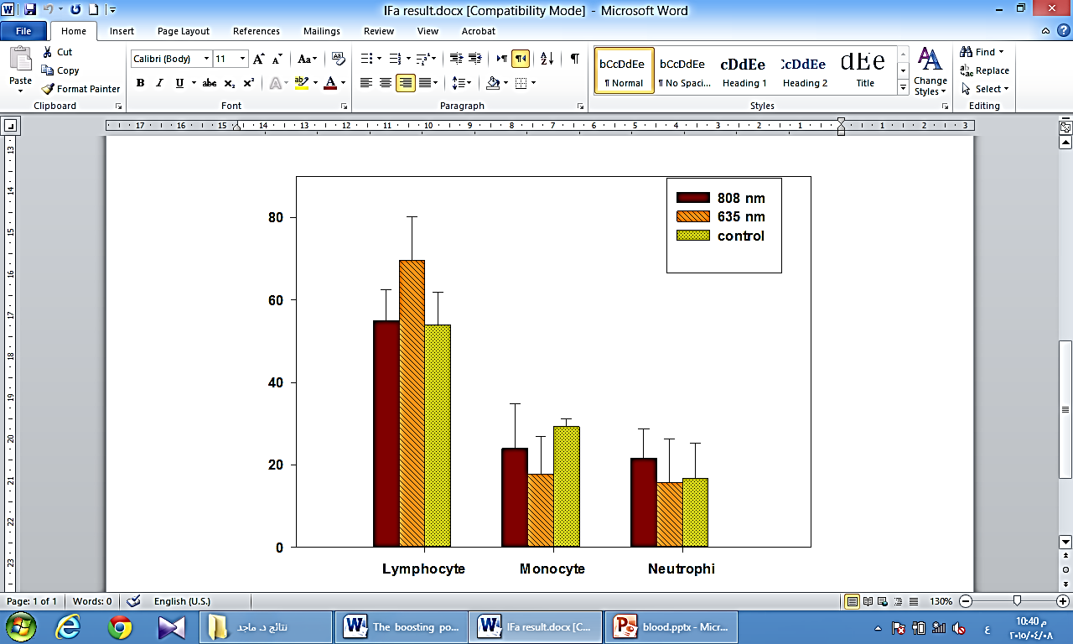
Figure 1: leukocyte infiltration in skin samples in control and laser treated skin samples shows a significant increase in lymphocyte migration at the vaccination site irradiated with 635 nm laser light at 45 J/cm2 energy density
Cell number per field

A significant increase was observed in lymphocyte number in the red laser treatment group (received the vaccine and the 635 nm laser) in comparison with control group (received the vaccine only) or NIR group (received the vaccine and the 808 nm laser) that show no significant change in lymphocyte count. Monocytes and Neutrophil showed no noticeable long term changes in all groups.
Effects of laser lights on leukocyteinfiltration in skin
Antigen presenting cells are the primary targets for most vaccine adjuvants[17]. Thus, the first step in our work was to verified that laser treatment activate lymphocyte motility and aggregation in the site of administration. Figure (2) shows the lymphocytes aggregation in skin samples after 21 days of i.d. vaccination with HBsAgaloneorafter skin pre illumination with 635 nm or 808 nm laser lights for 60 seconds at 0.3 W output powers. Results showed that laser treatment with 635 nm laser light significantly enhanced lymphocyte motility and confluence as appeared in the histologic images of rat skin samples.

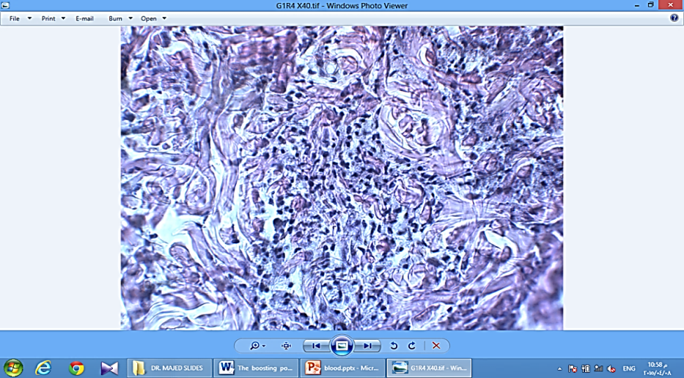
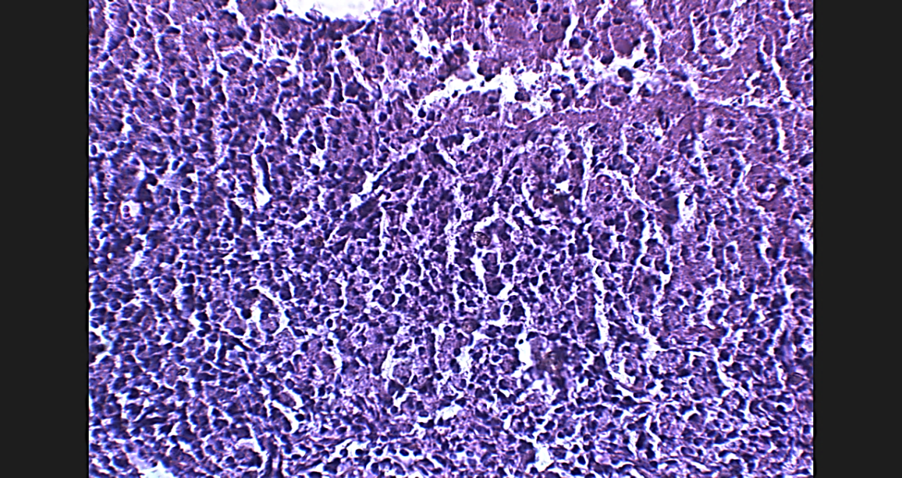
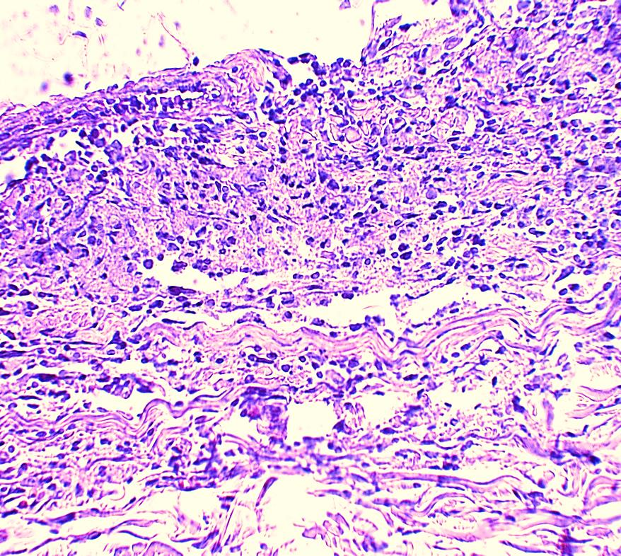
Figure 2: Full thickness of skin tissues stained with H&E stain (x40), show a significant increases in lymphocyte infiltration at the vaccination sites after the irradiation with 635 nm laser light in comparison with 808 nm irradiated site or the non-irradiated (control) site.
Control
635 nm
808 nm

Effects of Laser Lights on Cell-Mediated Immune Responses
One of the essential mechanisms by which the vaccine initiates immune response is via the induction of cell-mediated immunity; this is the responsibility of the adjuvant [4].In our study, laser light was used to trigger such response prior to the i.d.injectionwith the vaccine. We found that 635 nm laser induce a significant increases in TNF-α level comparing with the other laser (808 nm) group or the control group as depicted in figure (3).In the other hand, laser pre-illumination didn’t cause any marked changes in serum Interferon - α (IF-α) levels as shown in figure (4).

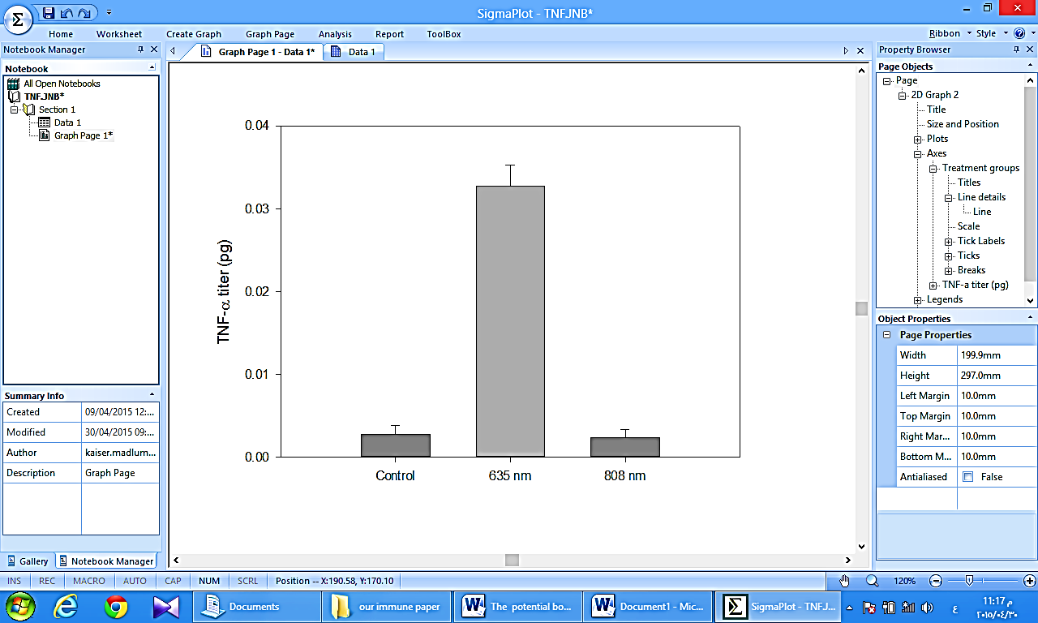
Figure 3: A significant increases in serum TNF-α after laser irradiation with 635 nm laser light at 0.3 W for 60 seconds in comparison with control and 808 nm laser irradiation at the same parameters.

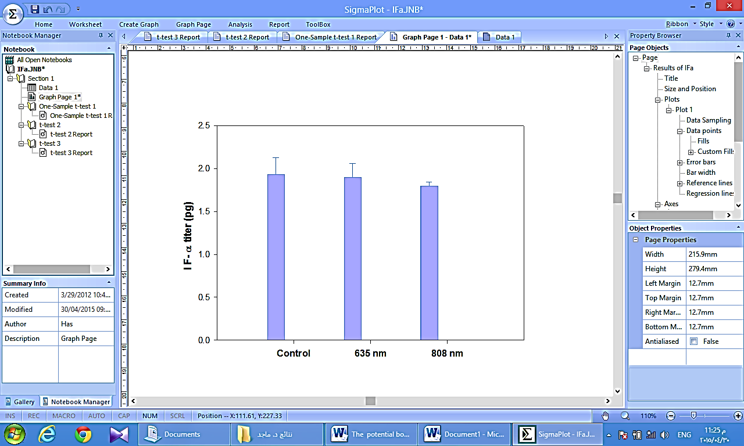
Figure 4:No significant increases in serum IF-α after laser irradiation with 635 nm and 808 nm laser lighst at 0.3 W for 60 seconds

Discussion
The main function of adjuvant in current vaccines is to maximize the immunological response and improve vaccine efficacy. Laser adjuvant was used in recent studies in the form of continuous wave near red laser as a safe, effective, low cost, simple to use with intradermal vaccine instead of conventional adjuvant[7]. The adjuvant action of laser is induced by brief illumination of asmall area of the skin with non-invasive laser light prior to intradermal injection of vaccine[18].
Generally it is accepted that mitochondria play the major role in the cellular photobiomodulation particularly in the red and infrared regions. Components of respiratory chains like NADH-dehydrogenases and cytochrome c oxidase absorb laser light and get excited. This in turn will cause an alteration in the redox states and acceleration of electron transfer [19].Cellular components of immune system are affected by laser light in the same way, causing lymphocyte proliferation [20], activation of macrophages in inflammation[21], marked increase in cytokines production [13], etc.
Laser adjuvant enhances the immunity system at the cellular level through increasing local inflammation, increasing the antigen presenting cells (APCs) mobility[9], and stimulating proliferation of non-specific lymphocytes[22]. This may explain the increase in lymphocytes count after 635 nm laser irradiation even after 21 days of treatment.
Also, the release of tumor necrosis factor (TNF-α) in the 635 nm laser group was significantly (p˂0.01) greater than that in the other two groups as illustrated in figure (3).TNF-α is a pro inflammatory cytokinessecreted by the peripheral blood mononuclear cells (PBMC)[20], its expression is strongly enhanced by laser irradiation[10]. Thus, 635 nm laser illumination of the skin caused this enhancementin TNF-α production.In our study, the irradiation with near infra-red laser showed no significant change in TNF-α level, although, in previous study with 780 nm laser light it was found that TNF-α tend to decrease after few days of irradiation. Because TNF-α is a pro-inflammatory cytokine, it is possible that it released at a higher concentrations in the initial stages of the treatment [21]. Near infra-red light penetrate deeply into the skin due to its low absorption by the living tissue including immune cells[22]. Thus, the effect of red laser at certain dose will be higher than that of infra-red laser at the same dose since the photobiomodulation depend mainly on the amount of energy absorbed by the cellular components.
The energy density or laser dose used in this study is equivalent to 45 J/cm² which is much higher than most energies used in previous studies. It was found that the elevation in the production of certain interleukins induced by low level laser irradiation is disappeared when the laser dose exceed certain threshold close to that used in our study[16]. Previous studies on the effect of low level He-Ne laser on the gene expression of IF-γ detected a significant inhibition in this gene after laser irradiation at higher doses[23]. This may explain the hypo-secretion of IF-α by PBMCs after irradiation with both types of lasers.

References
- Berzofsky J A, Ahlers J D, Janik J , Morris J, Oh S, Terabe M, and Belyakov I M. Progress on new vaccine strategies against chronic viral infections. The Journal of Clinical Investigation. (2004). 114 (4):450
- Grammatikos, A P, Mantadakis E, and Falagas M E. Meta-analyses on pediatric infections and vaccines. Infectious disease clinics of North America. (2009). 23(2), 431-457.‏
- Fiore A. E, Bridges C B, Cox N J. Seasonal influenza vaccines. Current Topics in Microbiology and Immunology. (2009). 333: 43–82
- O'Hagan, D T New generation vaccine adjuvants. eLS.(2007). John Wiley and Sons Ltd, Chichester
- Mohan T, Verma P, and Rao D N. Novel adjuvants and delivery vehicles for vaccines development: A road ahead. Indian J. Med. Res.(2013). 138(5): 779-795
- Sivakumar, S M, Safhi M M, KannadasanM, and Sukumaran N. Vaccine adjuvants–Current status and prospects on controlled release adjuvancity. Saudi Pharmaceutical Journal. (2011). 19(4): 197-206
- Kashiwagi S, Brauns T, Gelfand J, and Poznansky M C. Laser vaccine adjuvants. History, progress, and potential. Hum. Vaccin. Immunother.(2014). 10(7):1892-1907
- Petrovsky N and Aguilar J C Vaccine adjuvants: current state andfuture trends. Immunol. Cell Biol.(2004). 82: 488-496.
- Chen X, Kim P, Farinelli B, Doukas A, Yun S, Gelfand J A, Anderson R R, and Wu M X .A Novel Laser Vaccine Adjuvant Increases the Motility of Antigen Presenting Cells. Plose one (2010). 5, (10):1-7
- Chen X i and Wang J I. An update on the use of laser technology in skin vaccination. Expert Rev. Vaccines(2013). 1–11
- Kashiwagi S, Yuan J, Forbes B, HibertM L, Lee ELQ, et al. Near-Infrared Laser Adjuvant for Influenza Vaccine. PLoS ONE.(2013). 8(12):1-15
- Niemz, M H.Laser-tissue interactions: fundamentals and applications.(2007). Springer Science & Business Media.
- Novoselova E G, Cherenkov D A, Glushkova O V, Novoselova T V, Chudnovskii V M, Iusupov V I, and Fesenko, E E. Immune Response. Biofizika (2006).51(3): 509-518
- Mormile R and Pannullo G. Hepatitis B Vaccine Nonresponse: An Alarm Signal for Latent Type 1 Diabetes. J Diabetes Metab.(2013). 4. (6)
- World Health Organization. Hepatitis B vaccines. Weekly epidemiological record(2004).79:255–263
- Schindl L, Schindl M, Polo L, Jori G, Perl S and Schind A. Effects of Low Power Laser Irradiation on Differential Blood Count and Body Temperature in Endotoxin-Pre Immunized Rabbits. Life Sciences(1997). 60(19):1669-1677
- Reed S G, Bertholet S, Coler R N, and Friede M. New horizons in adjuvants for vaccine development. Trends Immunol. (2009). 30: 23–32.
- Chen X and Wu M X.Laser vaccine adjuvant for cutaneous immunization. Expert. Rev. Vaccines. (2011). 10(10):1397-1403
- Karu T. Low-Power Laser Effects, in: Lasers in Medicine/ edited by Ronald W. Waynant. (2001). CRC press.
- Stadler I, Evans R, Kolb B, Naim J O, Narayan V, Buehner N, and Lanzafame R J. In Vitro Effects of Low-Level Laser Irradiation at 660 nm on Peripheral Blood Lymphocytes. Lasers in Surgery and Medicine (2000), 27:255–261
- Souza NHC, Ferrari RAM, Silva DFT, Nunes FD, Bussadori SK, Fernandes KPS. Effect of low-level laser therapy on the modulation of the mitochondrial activity of macrophages. Braz J PhysTher., (2014). 18(4):308-314
- Vitoriano-Souza J, Moreira N, Teixeira-Carvalho A, Carneiro C M, Siqueira F A, et al. (2012). Cell recruitment and cytokines in skin mice sensitized with the vaccine adjuvants: saponin, incomplete Freund’s adjuvant, and monophosphoryl lipid A. PLoS ONE, 7 (7).
- Larsen C E, Xu J, Lee S, Dubey D P, Uko G, Yunis E J, and Alper, C A Complex cytokine responses to hepatitis B surface antigen and tetanus toxoid in responders, non-responders and subjects naive to hepatitis B surface antigen. Vaccine(2000)., 18(26), 3021-3030.
- Fukuda T Y, Tanji M M, Jesus J F, Sato M N, Duarte A JS, and Plapler H. Single Session to Infrared Low Level Diode Laser on TNF-α and IL-6 Cytokines Release by Mononuclear Spleen Cells in Mice: A Pilot Study. Lasers in Surgery and Medicine(2010). 42:584–588.
- Tsai C-L, Chen J-C, and Wang W-J. Near-infrared Absorption Property of Biological Soft Tissue Constituents. Journal of Medical and Biological Engineering(2001)., 21(1): 7-14
- Safavi S M , Kazemi B , Esmaeili M , Fallah A , Modarresi A and Mir M. Effects of low-level He–Ne laser irradiation on the gene expression of IL-1β, TNF-α, IFN-γ, TGF-β, bFGF, and PDGF in rat’s gingiva. Lasers in Medical Sciences(2008). 23:331–335

