

Medical Journal of Babylon
Vol. 12- No. 3: 780-791, 2015
http://www.medicaljb.com
ISSN 2312-6760©2015 University of Babylon

Original Research Article
Assessment of Antioxidant Status and Ceruloplasmin in Early and Advanced Stages of Sporadic Colorectal Cancer Patients whom Receiving Adjuvant Chemotherapy

Moaed Emran Al-Gazally* Alaa Sadiq Al-Awad Hamza Hashim Kzar
College of Medicine, University of Babylon, Hilla, IRAQ

*E-mail: moaedalgazally@yahoo.com

Accepted 15 July,2015
Abstract
One of most frequent malignant disease in the developed countries is colorectal cancer and it is the seventh most common cancers among population of Babylon province/Iraq. It was reported that oxidative stress status is being play a very important roles in development of carcinogenesis. The purpose from this study was assessment of antioxidant status in early and advanced stages of patients with sporadic colorectal cancer whom received adjuvant chemotherapy. This investigate was done by measuring of total antioxidant capacity(TAO-C), Ceruloplasmin and its related trace elements ,copper and Zink. All patients included in this study were receiving adjuvant chemotherapy regimen and subdivided into two groups according to Duke´s classification of malignant into early stages (A+B) and(C+D) advanced stages, cancer site (colon and rectum), and according to the number of dosage of chemotherapy regimen(half dosage and total dosage). ELISA methods were used to assess serum Cp concentration and colorimetric method for measurement of serum TAO-C ,while concentration of Cu and Zn were determined by atomic absorption spectrophotometer ( AAS). Cu/Zn and Cu/Cp ratio were calculated mathematically. The results were showed highly significant decreasing(p<0.05) in T-AOC and Zinc concentration in stages (C+D) subgroup compared to (A+B) and control group. Both Ceruloplasmin and copper were found markedly increased in stages (C+D) compared to (A+B) stages and control group. Cu/Zn ratio was increased significantly in advanced stages and controls while Cu/Cp ratio was markedly decreased in advanced stages compared to early stages and controls. In conclusion the results of present study suggests that TAO-C and/or Cp and its related elements are monitoring factors and prognostic indicators could be valuable during the treatment with adjuvant regimen for sporadic colorectal cancer patients.

Key words: Antioxidant status, Ceruloplasmin, Copper, Zinc, Sporadic colorectal cancer, Adjuvant chemotherapy.

تقييم مضادات الأكسدة الكلي في المراحل الأولية والمتقدمة للمرضى المصابين بسرطان القولون والمستقيم
الخلاصة
إن من أكثر الأمراض الخبيثة شيوعا في الدول المتقدمة هو سرطان القولون والمستقيم وهذا هو سابع أكثر أنواع السرطانات انتشارا بين سكان محافظة بابل / العراق. وأفادت الدراسات ألسابقه أن حالة الإجهاد ألتأكسدي تلعب أدوارا مهمة جدا في تطور التسرطن. أن الهدف من هذه الدراسة هو تقييم الحالة المضادة للأكسدة في المراحل المبكرة والمتقدمة من المرضى الذين يعانون من سرطان القولون والمستقيم المتفرقة الذين تلقوا العلاج الكيميائي المساعد. وقد تم من ذلك من خلال قياس إجمالي القدرة المضادة للأكسدة (TAO-C) ، السيرولوبلازمين وكذلك العناصر النزرة ذات الصلة كالنحاس والزنك. جميع المرضى المشمولين في هذه الدراسة كانوا يتلقون العلاج الكيميائي المساعد وتم تقسيمهم
إلى مجموعتين وفقا لتصنيف ( Duke´s ) إلي مراحل التسرطن (A + B) المبكرة والمتقدمة (C + D)، وحسب موقع السرطان (سرطان القولون أو سرطان المستقيم)، وكذلك وفقا لعدد الجرعات من العلاج الكيميائي المساعد (نصف الجرعة والجرعة الإجمالية).
تم استخدام طرق ELISA)) لقياس تركيز السيرلوبلازمين في مصل الدم والطريقة اللونية لقياس(TAO-C)، في حين تم قياس تركيز النحاس والزنك باستخدام جهاز طيف الامتصاص الذري (AAS) .تم حساب نسبة النحاس / نسبة الزنك والنحاس / CP رياضيا. وقد أظهرت النتائج انخفاض بشكل ملحوظ ذو دلاله احصائيه في تركيز TAO-C وتركيز الزنك في مراحل التسرطن ألمتقدمه (C + D)الفرعية مقارنة مع المراحل الاوليه (A + B) والمجموعة الضابطة. كذلك بينت النتائج ارتفاع كل من تراكيز السيرلوبلازمين والنحاس بشكل ملحوظ مع دلاله احصائيه في مصل الدم للمرضى في مراحل التسرطن ألمتقدمه (C + D) مقارنة مع المراحل (A + B) والمجموعة الضابطة. وجدت نسبة النحاس / نسبة الزنك في حالة ارتفاع كبير في المراحل المتقدمة من المرض قياسا بالمراحل الاوليه والضوابط في حين نسبة النحاس / CP وجدت منخفضة بشكل ملحوظ في المراحل المتقدمة بالمقارنة مع المراحل المبكرة والضوابط. وفي الختام تشير نتائج الدراسة الحالية أن قياس TAO-C والسيرولوبلازمين قد يكون مفيدا كنذير مبكروللمراقبة خلال مراحل العلاج لمرضى سرطان القولون والمستقيم المتفرقة.
ـــــــــــــــــــــــــــــــــــــــــــــــــــــــــــــــــــــــــــــــــــــــــــــــــــــــــــــــــــــــــــــــــــــــــــــــــــــــــــــــــــــــــــــــــــــــــــــــــــــــــــــــــــ

Introduction
One of most frequent malignant disease in the development countries is colorectal cancer. The third most common cause of cancer related death in western world is colorectal cancer (CRC). Colorectal cancer is the general term using to described the cancers that occurred in the colon and rectum. The one of a major cause of morbidity and mortality in the world is colorectal cancer [1, 2]. It is a disease emanating from the epithelial cells that lining of the colon and rectum [3]. The expanding of colorectal cancer either as a result from hereditary cancer syndromes, or sporadic, or inducing by inflammatory bowel diseases. Sporadic CRC forms 90% of patients with cancer of colon and rectum and the remaining 10% of patients having a family history of CRC [4]. Western culture caused of increasing in the incidence of sporadic CRC in developed countries [5]. The developing countries accounts for over 63% of all cases of colorectal cancer [6]. Iraqi population started to converted to developing countries by shifting towards the western- lifestyle that has probability leads to increasing of the colon and rectal cancer incidence [7]. In 2010, Iraqi cancer registry team was reported that CRC is the seven most common cancers in Babylon province [8]. One of the most important factors that associated with increased risk of CRC are life style and dietary components [9]. Some of the epidemiological studies were showed that systematically high intake of dietary fats, red meats and proteins is positively related to the increase risk of CRC [10]. CRC is currently treated with a chemotherapy regimen that is based on 5-fluorouracil (5-FU), or its oral prodrug analogue (capecitabine) in combination with oxaliplatin or irinotecan and rresponse rates (RR) did not exceeded 40-50%. In general, patients with CRC who are not treated have a median survival of 5-6 months. With the development of the first chemotherapeutic agent, 5-fluorouracil (5-FU), the median survival was extended to 11-12 months [11].
An imbalance between prooxidants and antioxidants in the cells caused by oxidative stress which is manifested by increased levels of free radicals [12]. The free radical mediate peroxidation of cell membrane lipids that leads to increasing of membrane fluidity and permeability with losing of its integrity and caused cell damage [13]. The defense system against oxidative stress is depending on the adequacy amounts of antioxidants that are derived either directly or indirectly from the diet [14]. Substances that present at low concentrations compared with that of an oxidized substrate, is called antioxidants that inhibits oxidation of this substrate [15]. Antioxidants including compounds that have a non-enzymatic and enzymatic nature. Enzymatic antioxidants including superoxide dismutase (SOD I, II, and EC), catalase (CAT), glutathione peroxidase (GPX) and many supporting enzymes .non- enzymatic antioxidants including vitamins such as E, A,C and K and some plasma proteins such as albumin [16].
One of the glycoproteins that is synthesized originally in the liver is Ceruloplasmin (Cp) that have a molecular weight of (132 KDa). Cp is the major copper-carrying protein in the plasma blood which transporting about 90% of the total copper in human plasma while albumin transport about 10% [17]. In addition, Ceruloplasmin has been shown to act as an enzyme (Cp ferroxidase activity), which playing a major role in oxidizing iron (II) (ferrous iron) to iron (III) (ferric iron)in serum and at the cell surfaces. Ceruloplasmin is converting the toxic ferrous (II) form to its non-toxic ferric form (III) [18]. Cp acts as an extracellular scavenger of free radicals and superoxide ions, and then endogenously modulates inflammatory responses and so synthesis and secretion of Cp can be markedly increased during inflammation, infection, and in many diseases such as cancers [19].
One of the redox-active transition metal that can participating in single electron reactions and catalyze formation of free radicals is a copper. It is play a important role in producing free oxygen metabolites due to oxidation and regeneration activity through involving as cofactor to enzymatic antioxidant (Cu/Zn SOD). One of the most essential metals in organisms is Zinc, which form Zinc-binding proteins that play an important roles in a variety of biological processes such as transcription regulation, cell metabolism and apoptosis. Zinc plays an important role in the functions of transcription factor, antioxidant defense system and DNA repair system [20].
The aim of study is assess the TAO-C, Cp and its related trace elements in serum of early and advanced stages of patients with sporadic colorectal cancer whom receiving adjuvant chemotherapy regimens.

Materials and Methods
Subjects
This study was performed at the laboratories of Biochemistry Department, College of Medicine, University of Babylon. The collection of samples was conducted during the period from 1st of December 2014 till 30th of March 2015. The patients group who subjected in this study were (52) persons in the age group ranging from 39 - 75 years , the mean ± standard deviation (SD) was (59.3 ± 10.68 years). This group comprised of males (58%), with their age ranging from 39-75 years old, the mean ± SD was (61.8 ± 11.4 years) , and females (42%) with age ranging from 39-73 years, and mean ± SD was (63.1 ± 11.3 years). The ages of patients group <50 years old were 22 (42%) and at ≥50 years old were 30 (58%).
All of those patients were screened and treated with adjuvant chemotherapy in the oncology centre of Merjan Teaching Hospital in Babylon province with clinical symptoms of colorectal cancer. The diagnosis of colorectal cancer were performed by Sigmoidoscopy ,colonoscopy or CT-scanning and clinical diagnosis was confirmed in all patients by histological examination. Fifty two apparently healthy individuals (without gastrointestinal diseases) were taken as a control group with the age ranging from 37-75 years, the mean ± SD was (57.8 ± 11.1 years). This group comprised of males (61%) their age ranging from 39 -73 years, mean ± SD was (60.4 ± 10.2 years), and females (39%) their age ranging from 37-75 years, mean ± SD was (64.5 ± 11.6 years).
The age and sex of this group were matched to age and sex of patient group, where statistical analysis showed non-significant differences in the age and sex between patient and control groups (p> 0.05). Each person who contributed in the control group underwent full history and physical examination including: address, age, gender, smoking, education, dwelling, past history of diseases and medications.
Ethical Issues
depends on the following:
a- Approval of scientific committee of the society medicine department of faculty Medicine (University of Babylon/Iraq).
b- The objectives and methodology was explained to all participants in the current study to gain their verbal acceptance.
Samples Collection
Venous blood samples were drawn from patient and control subjects. Five (ml) of blood were obtained from each subjects by vein puncture and put in the gel containing tubes, then allowed to clot at room temperature for 10-15 minutes and centrifuged at (2000 × g) for approximately 2-5 minutes then the serum were obtained was stored at -20˚C until analysis (measuring of Total antioxidant capacity, Ceruloplasmin, Copper, and Zinc concentration ).
Determination of Total Antioxidant Capacity(TAO-C)
Total antioxidant capacity TAO-C was measured depending on FRAP (Ferric Reducing Antioxidant Power) colorimetric assay [21]. At low pH, reduction of ferric tripyridyltriazine (Fe3+ -TPTZ) complex to ferrous form (Fe2+-TPTZ),that can be monitored by measuring the change in absorbance at 520 nm.
Determination of Ceruloplasmin
Human Ceruloplasmin assay was based on standard sandwich enzyme-linked immune-sorbent assay technology (ELISA)kit. This kit was provided from Elabscience®/USA (cat# E-EL-H0152) and the assay performed depending on the manufactured instructions .
Determination of Copper and Zink levels
Copper and Zinc concentration were determined by using Atomic Absorption Spectrometer (AAS). A SpectrAA-40 atomic absorption spectrometer, PSC-56 programmable sample changer, Epson LX-80 printer, Cu and Zn hollow cathode lamps from Varian were used in the procedure.
Copper /Ceruloplasmin ratio(Cu/Cp) was calculated mathematically as follows:
Cu/Cp ratio = Cu conc.*0.132/Cp conc. where Cu was in µmol/l and Cp in g/l [22].

Statistical Analysis
The results were analyzed by Student’s t-test using Statistical Package for the Social Sciences (SPSS) version 18. All data were expressed as mean ± SD. The comparison between groups was perfected with one way analysis of variance ANOVA. P-Value < 0.05 was considered significant and < 0.001 was highly significant.

Results
Clinic-pathological characteristics of patients with colorectal cancer whose included in this study were classified into two groups depending on (age, gender, chemotherapy treatment status, Dukes´ stages of cancer, tumor location, smoking status, obesity status, dwelling, and education status) (Table 1).

Table 1: Clinic-pathological characteristics of patients with sporadic CRC included in this study
Clinicopathological variables | No. | (%)
Total No. of patients | 52 | 100
- Age  - <50  - ≥50 | 22  30 | 42  58
- Sex  - Male  - Female | 30  22 | 58  42
- Dukes´ stage  - A+B  - C+D | 19  33 | 36.5  63.5
- Cancer site  - Colon  - Rectum | 37  15 | 71.1  28.9
- Chemotherapy status  - Total dosage  - Half dosage | 30  22 | 57.6  42.4
- Smoking status  - Ever  - Never | 30  22 | 57.6  42.4
- Obesity status  - Over weight  - Normal weight | 24  28 | 46.2  53.8
- Dwelling  - Rural  - Urban | 19  33 | 36.5  63.5
- Education status  - Educated  - Illiterate | 29  23 | 55.7  44.3

The results in table 2 showed that there were a significant decrease in the mean-/+SD of serum TAO-C and Zn

concentration and significant increase of serum Cp, Cu , Cu/Zn and Cu/Cp ratio of all patients group compared to controls.

Table 2: Comparison of mean-/+ SD of TAO-C, Cp, Cu, Zn, Cu/Zn and Cu/Cp between all patients with sporadic CRC and controls.

Parameters  groups | T-AOC  U/ml | Cp  mg/l | Cu  µg/dl | Zn  µg/dl | Cu/Zn | Cu/CP  µmol/g
patients  N=52 | 9.6±3.6** | 605±120* | 187±49* | 68±16* | 1.7±0.3* | 6±1.7*
control  N=52 | 17.3±2.1 | 419±89 | 137±19 | 114±14 | 1.0±0.1 | 7.5±1.5
*significant at p-value <0.05
** highly significant at p-value <0.001

In the current study the patients were divided into three subgroups depending on stage of colorectal cancer (A+B) and(C+D), chemotherapy status(half dose and total dose), and the site of cancer (colon and rectum). The mean and standard deviation of all parameters that studied were compared between theses subgroups (Table 3).

Table 3: Comparison of (mean-/+ SD) of TAO-C, Cp, Cu, Zn, Cu/Zn and Cu/Cp between subgroups of patients with CRC.

Parameters  subgroups | T-AOC  mean± SD  U/ml | Cp  mean± SD  mg/l | Cu  mean± SD  µg/dl | Zn  mean± SD  µg/dl | Cu/Zn  mean± SD | Cu/Cp  mean± SD  µmol/g
A+B n=19  C+D n=33 | 12.5±4.1  7.8±1.6** | 456±93  760±70** | 139±29  220±17** | 67±13  77±18* | 2.4±1.0  3.9±1.3* | 7.2±1.4  6.0±0.4*
Half dose n=22  Total dose n=30 | 7.7±1.2  7.8±1.1 | 744±56  748±44 | 215±14  218±12 | 60±22  61±24 | 3.7±0.9  3.8±0.7 | 5.9±0.7  6.0±0.5
Colon n=37  Rectum n=15 | 7.7±0.6  7.8±0.5 | 709±279  695±258 | 185±53  193±83 | 107±26  119±19 | 1.8±0.4  1.6±0.3 | 7.9±1.2  7.1±0.2
*Significant p- < 0.05
** highly significant at p <0.001

The correlation between Cp and copper levels in serum of subgroups A+B and C+D of colorectal cancer patients was found positive (r=0.624 and 0.353 respectively) (fig.1 and 2).

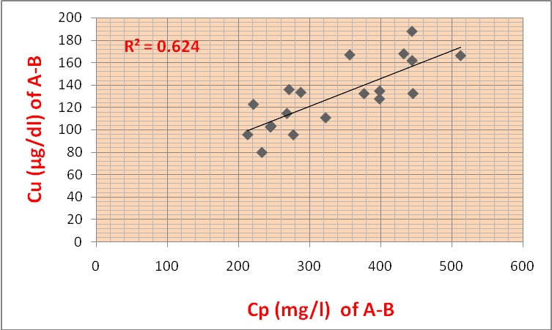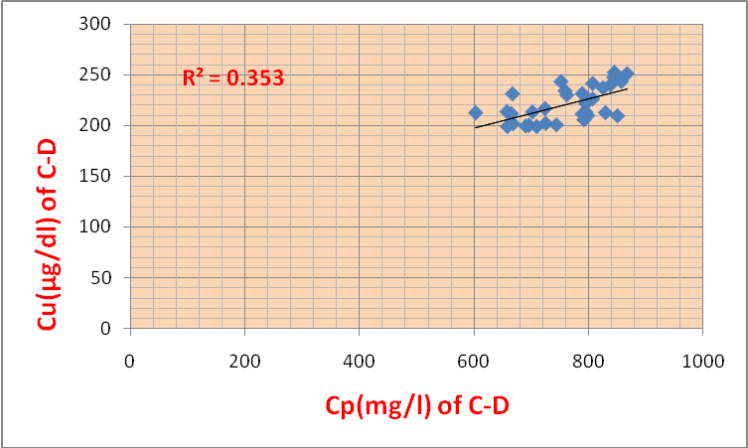
Figure 1: correlation between Cp and Figure 2: correlation between Cp and Cu levels Cu levels in Dukes (A+B) of in Dukes (C+D) of patients with CRC.
Patients with CRC.

The correlation between Cp and Zinc concentration in serum of A+B group of colorectal cancer patients was found to be negative (r =- 654) and returned to be positive correlation in serum of C+D group (r=0.113) (fig.3 and 4).

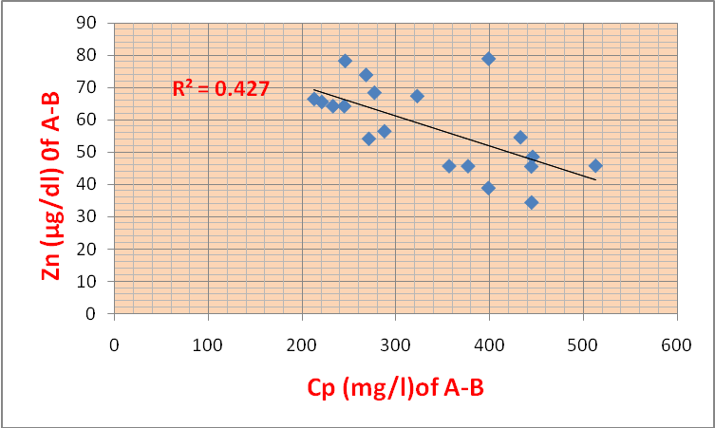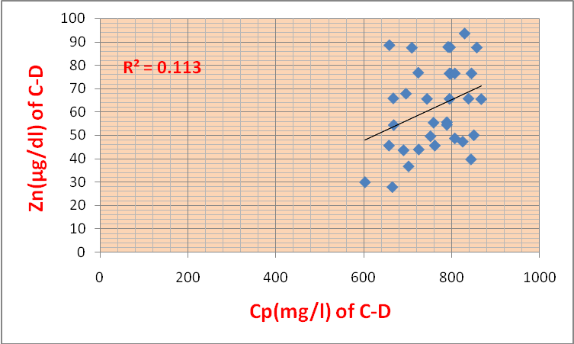
Figure 3: Correlation between Cp and Zn levels Figure 4: Correlation between Cp and Zn levels in Dukes (A+B) of patients with CRC. in Dukes (C+D) of patients with CRC.
.

The TAO-C and Cp concentrations in all groups in this study are illustrate in table (2) and (3) and showed in figure (4) and (5). The results of present study showed a significant decrease in serum TAO-C in all groups of patients (p<0.05) compared with controls. While serum Cp was increased in all patients and C+D groups but the results showed decreased in serum Cp concentration in A+B group compared to control. Also the results showed the concentration of serum Zn in advanced stages returned to be elevated and become significant compared to early stages (p < 0.05) but remain very low compared to control group (Table-3).

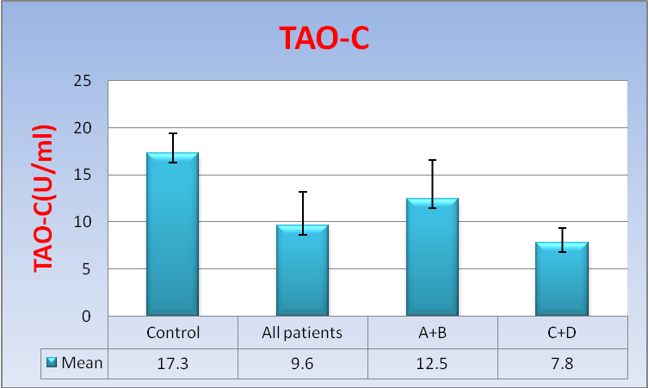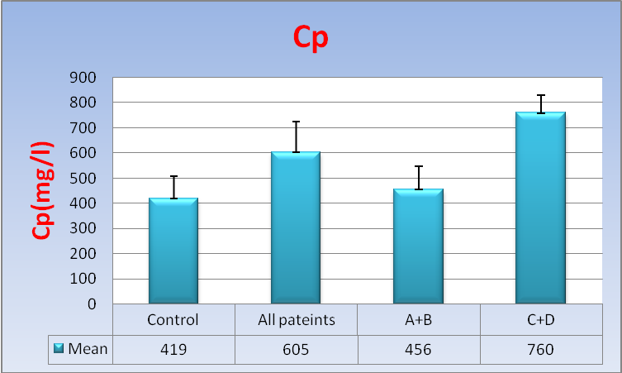
Figure 5: Serum (TAO-C) concentration Figure 6: Serum (Cp) in all patients,
in all patients C+D compared to control. A+B, C+D compared, A+B, to control group.

Discussion
One of the most common cancers worldwide is colorectal cancer. It was reported that the highest incidence rates of CRC occurred in western countries. Sporadic CRC is caused by different factors such as environmental conditions, lifestyle, dietary habits, obesity, smoking, and lowest physical activity [23]. The antioxidant defense system is consist of numerous antioxidants (enzymatic and nonenzymatic) which works together [24]. The total antioxidant capacity that measured in the present study represent of all enzymatic and nonenzymatic antioxidant agents. It was reported that the imbalance between oxidant and antioxidant agents and increasing of production of reactive oxygen species (ROS) and free radicals as a cellular macromolecules can leading to cancer [25]. Girgin et al found that the oxygen free radicals can be formed in excess in chronic disease of gastrointestinal tract system (GIT) [26]. Noah et al reported that the main source of free radicals and oxidant agents in the gut is probably phagocytes, which are accumulated in the mucus of subjects with bowel disease and could form free radicals that might cause of DNA damage and increased risk of cancer [27]. The defect in antioxidant defense system within and outside the cells can leads to full of protection to oxidative damage of cells components such as membrane phospholipids [28,29].
The results of present study showed a markedly decrease in concentration of TAO-C in serum of all patients with sporadic CRC compared to control (p<0.001) and found the TAO-C in sera of combination of advanced stage (C+D) of CRC patients was highly significant decreased compare to early stages (A+B) (p< 0.001). This difference in the levels of TAO-C indicate the oxidative stress and free radical in early stages are less than in advanced stages, consequence the consumption of antioxidants will increase to balance the effect of damage that result from oxidative stress that caused by cancer . It was known that high levels of oxidative stress as a results of increasing of production of free radicals or reactive oxygen species (ROS) and reactive nitrogen species (RNS) which can leads to colorectal cancer. This results is in agreement with several studies [30-33]. The current study was found a markedly increase in concentration of Cp in serum of all patients compared to healthy control group (p<0.001). Ceruloplasmin is a blue alpha-2 glycoprotein with molecular weight of 132 KDa . Cp bind and transfer to 90-95% of blood copper, therefore 6-7 copper ions binds with one molecule of Cp and acts as copper transport and has ferroxidase activity (convert of Fe+2 to Fe+1), thus it has homeostasis function [34]. In the present study, Cp concentration was found markedly increased in advanced stages (C+D) of sporadic CRC patients compare to Cp in early stages (A+B) (p<0.001). The recent studies found change in the levels of Cp activity (ferroxidase activity). Malathi, et al. found that decreasing in Cp activity(enzymatic activity) in head and neck cancer patients suggested that is an increased in oxidative stress being involved in pathogenesis of head and neck cancer [35]. Narjis et al. found increased in Cp activity but not significant (p-value is 0.4) in colon cancer patients [36]. The present study showed increasing of Cp concentration in serum of sporadic CRC patients and this results may be due to increasing of copper levels in serum of sporadic CRC (copper intoxication). Other study agreement with our investigation, that Cp concentration increased in serum of patients with lung cancer compared to healthy controls [37]. One of the acute phase proteins that increased response to infections, inflammations and the tumors is Ceruloplasmin. The concentration of these proteins is markedly increased in plasma after tissue injury. Acute phase proteins acts protecting the organism from free radicals that products after infections. Cp here not only as antioxidant protein and increased its level may be associated with increased synthesis of Cp in the liver as one of the positive acute phase proteins [38]. From our results, TAO-C and/or Cp levels may be useful as indicator to differentiation between early stages(A+B) and advanced stages (C+D) in patients with sporadic CRC. The results from current study were showed increased of copper levels in serum of patients with sporadic CRC compare to healthy control group.
Copper is an essential trace element, a redox-active metal that is mainly playing role to keep blood vessels, bones, nerves, and the immune system healthy [39]. Because of redox-active phenomena of copper, it is can share with a single electron reactions that catalyzed formation of free radicals. Copper is an essential for synthesis of many proteins such as myelin, collagen, melanin, and hemoglobin and many enzymes such as Cu/Zn SOD and electron transport chain enzymes such as cytochrome c oxidase and other copper –binding proteins [40]. The increment in copper levels in serum of patients with cancer may be induced migration of endothelial cells and angiogenesis [41] and this in agreement with the results of the present study. The elevated levels of copper in advanced stages is markedly than early stages and the results agreement with many studies in variety cancers such as breast, ovarian, gastric, bladder, and leukemia [42,43]. The recent studies suggested that using of copper-chelating and antiangiogenic agents is useful in cancer therapy because of this agents can bind with copper and prevent angiogenesis [44]. Copper and Zinc concentration were found inversely status, this may be due to changes in mobilization and decreased absorption of copper in colon cells. The results in current study also showed markedly decreased in Zinc levels in serum of all patients of sporadic CRC compare to healthy control and the full of Zinc levels in early stages is appear more than levels in advanced stages. Zinc is an essential mineral that involved in many enzymes and transcription factors and DNA damage repair system [45]. Many studies suggested that Zinc might essential for prevent cancer through its effect on angiogenesis and tumor progression. Zinc is essential to bind with angiogenesis inhibitors (both in vivo and in vitro) and increased of antiangiogenic activity of endostatin [46]. Zinc concentration found decreased in present study and the decreasing of zinc will induced cell proliferation in many cancers such as prostate, lung, esophageal, leukemia, GIT, and breast cancers and these results go hand in hand with previous study [47]. In present study, the decreased serum Zn concentration was may be due to defects in mobilization of circulating Zink because of higher oxidative stress applied on patients with sporadic CRC. Zowezak et al found that an increasing of serum Cu/Zn ratio in patients with cancers of lung, breast, GIT, and gynecological malignancy [37]. This in agreement with the present study that showed increased level of Cu/Zn ratio in all CRC patients and advanced stages compare to control and early stages, respectively. In current study, we found no statistically difference in levels of TAO-C, Cp, Cu, Zn, Cu/Zn, and Cu/Cp ratio between subgroup of patients have received half and total dose of adjuvant chemotherapy. This may be due to the drawing of blood from patients occur before receiving of treatment or due to prolonged duration between dose and other dose. The statistical difference in above parameters was not significant in site of cancer between colon and rectum patients. This may be due to same effect of malignant although the difference in site of tumor.

Conclusion
The antioxidant capacity, Ceruloplasmin, and its related elements can be used as prognostic indicators to assessment of early and advanced stages of patients with sporadic CRC whom received adjuvant chemotherapy. Further studies are require to investigate of TAO-C, Cp and its related elements to determine whether changes in these parameters represent independent risk factors for the developingt of sporadic colorectal cancer. The management of antioxidant capacity along with ceruloplasmin and related trace elements in order to reduce the extent of oxidative damage and the related complications in sporadic colorectal cancer patients major still need further evaluation.
Conflicts of Interest
The authors have no conflicts of interest to declare in relation to this article.
Acknowledgments
The present study was supported by clinical biochemistry department, college of medicine, Babylon university. The authors thanks staff of oncology centre in Merjan teaching hospital for their great contribution.

References
1. Cunnigham D ,Atkin, W., Lenz, H., et al. Colorectal cancer. Lancet 2010, 375:1030-47.
2. Perin, N. N. Global variation in cancer incidence and mortality. CURR. Sci., 2001, 5: 465.
3. Boyle P, Langman JS.ABC of colorectal cancer: Epidemiology. BMJ 2000; 321 (7264): 805-808.
4. Schottenfeld, D. and Winawer, S.J., Cancers of the large intestine, In: Epidemiology and prevention (eds. D. Schottenfeld and J.F. Fraumeni), Oxford University Press, New York, 1996, pp. 813-840.
5. Janout V, Kollarova H. Epidemiology of colorectal cancer. Biomed Pap Med Fac Univ. Palacku Olomouc Czech Repup 2001;145:5-10.
6. Adil H. Al-Humadi. Epidemiology of Colon & Rectal Cancer In Iraq. World Journal of Colorectal Surgery, Vol. 1, Iss. 1, 2008.
7. Iraqi Cancer Board ICRC. Results Iraqi Cancer Registry. Ministry of Health, Baghdad/ Iraq, 2010.
8. Boyle, P. and Langman, J.S., ABC of colorectal cancer. Br. Med. J., 2000, 321: 805-808.
9. West, D.W., Slattery, M.L., Robison, L.M., Schuman, K.L., Ford, M.H., Mahoney, A.W., Lyon, J.L. and Sorensen, A.W., Dietary intake and colon cancer: sex- and anatomic sitespecific associations. Am. J. Epidemiol., 1989, 130: 883-894.
10. Shivananda B., Vinutha R. and Srimathi S. Serum copper, ceruloplasmin and thiobarbituric acid reactive substance status in patients with ovarian cancer. Indian J Physiol Pharmacol., 2004, 48 (4): 486–488.
11. Giacchetti S, Perpoint B, Zidani R, Le BN, Faggiuolo R, Focan C, Chollet P, Llory JF, Letourneau Y, Coudert B, Bertheaut-Cvitkovic F, Larregain-Fournier D, Le RA, Walter S, Adam R, Misset JL and Levi F: Phase III multicenter randomized trial of oxaliplatin added to chronomodulated fluorouracil-leucovorin as first-line treatment of metastatic colorectal cancer. J Clin Oncol 18: 136-147, 2000.
12. Abdoljalal M., Gholamreza V. and Mohammad T. Serum lipid peroxidtion nd leptin level in ml end female type 2 diabetic patients in Gorgan, Iran. Journal of Chinese Clinical Medicine, 2010, 5 (1): 26–35.
13. Gotz M., Kunig G. and Reiderer Y. Oxidative stress: Free radical production in neural degeneration. Pharmacol Ther.; 1994, 63 (1): 37–122.
14. Sies H . (1997). Oxidative Stress: Oxidants and Antioxidants, Experimental Physiology; 82 (2): 291–295.
15. Sies H. Strategies of antioxidant defense. Eur. J. Biochem; 1993, 215: 213-219.
16. Ranji D., Bhawesh M., Parul S. Ceruloplasmin-an update. International Journal of Pharmaceutical Sciences Review and Research, vol. 9(2), 2011.
17. Mukhopadhyay, C.K., Mazumder, B., Lindley, P.F. and Fox, P.L. Identification of the pro-oxidant site of human ceruloplasmin: a model for oxidative damage by copper bound to protein surfaces. Proc. Natl. Acad. Sci. USA; 1997, 94:11546-11551.
18. Ogino M, Hiyamuta S, Takatsuji-Okawa M, Tomooka Y, Minoura S. Establishment of a prediction method for premature rupture of membranes in term pregnancy using active ceruloplasmin in cervicovaginal secretion as a clinical marker. J Obstet Gynaecol Res 2005; 31: 421-6.
19. Emre, O.; Demir, H.; Dogan, E.; Esen, R.; Gur, T.; Demir, C.; Gonullu, E.; Turan,N.; Özbay, M.F. Plasma Concentrations of Some Trace Element and Heavy Metals in Patients with Metastatic Colon Cancer, Journal of Cancer Therapy, 2013, 4, pp. 1085-1090.
20. Witkiewiez-Kucharczyk A, Bal W. Damage 0f zink fingers in DNA repair proteins. Toxicol Lett 2006; 162:29-42.
21. Benzie, I.F. and Strain, J.J., The ferric reducing ability of plasma (FRAP) as a measure of "antioxidant power": the FRAP assay. Anal Biochem, 239:70-76, 1996.
22. Patrick J., Adie V., Ivan M. Timothy M. and Anthony S. Copper: Ceroluplasmin ratio. J. Clin. Pathol. 2007: 60: 441-442.
23. M. E. Hope, G. L. Hold, R.Kain, and E. M. El-Omar. Sporadic colorectal cancer—role of the commensal microbiota, FEMS Microbiology Letters, vol. 244, no. 1, pp. 1–7, 2005.
24. M. Valko, D. Leibfritz, J. Moncol, M. T. D. Cronin, M. Mazur, and J. Telser. Free radicals and antioxidants in normal physiological functions and human disease. International Journal of Biochemistry and Cell Biology, vol. 39, no. 1, pp. 44–84, 2007.
25. Choudhari, S. K.; Gadbail, C. M.; Sharma, A.; Tekade, S. Oxidative and antioxidative mechanisms in oral cancer and precancer, A review. Oral Oncology, 2014, 50, pp. 10–18.
26. Girgin F, Karaoglu O, Erkus M, Tuzun S, Ozutemiz O, Dincer C, Batur Y, Tanyalcin T. Effects of trimetazidine on oxidant/ antioxidant status in trinitro-benzenesulfonic acid-induced chronic colitis. J Toxicol Environ Health; 2000, 59: 641-65.
27. Noah A. Mahmood. Oxidative Stress and Antioxidant Status in Colorectal Cancer and Healthy Subject. Iraqi Journal of Cancer and Medical Genetics. Vol. 3, No.1, 2010.
28. Martina Perse. Oxidative Stress in the Pathogenesis of Colorectal Cancer: Cause or Consequence? BioMed Research International. Volume 2013.
29. J.Guz, M. Foksinski, A. Siomek et al. The relationship between 8-oxo-7,8-dihydro-2-deoxy guanosine level and extent of cytosine methylation in leukocytes DNA of healthy subjects and in patients with colon adenomas and carcinomas. Mutation Research, vol. 640, no. 1-2, pp. 170–173, 2008.
30. E.M. J. van der Logt, H. M. J. Roelofs, T. Wobbes, F. M. Nagengast, and W. H. M. Peters. High oxygen radical production in patients with sporadic colorectal cancer. Free Radical Biology and Medicine, vol. 39, no. 2, pp. 182–187, 2005.
31. G. Kirkali,D.Keles,A. E.Canda et al., “Evidence for upregulated repair of oxidatively induced DNA damage in human colorectal cancer,” DNA Repair, vol. 10, no. 11, pp. 1114–1120, 2011.
32. T. Rainis, I. Maor, A. Lanir, S. Shnizer, and A. Lavy. Enhanced oxidative stress and leucocyte activation in neoplastic tissues of the colon. Digestive Diseases and Sciences, vol. 52, no. 2, pp. 526–530, 2007.
33. M. L. Slattery, A. Lundgreen, B. Welbourn, R. K. Wolff, and C. Corcoran. Oxidative balance and colon and rectal cancer: interaction of lifestyle factors and genes. Mutation Research, vol. 734, no. 1-2, pp. 30–40, 2012.
34. Varela, A. S.; Bosco, J.J.; Saez, L.; Senra, D.Q. Serum ceruloplasmin as a diagnostic marke of cancer. Cancer Letters, 1997, 2 (23) pp. 139–145
35. M. L. Slattery, A. Lundgreen, B. Welbourn, R. K. Wolff, and C. Corcoran. Oxidative balance and colon andrectal cancer: interaction of lifestyle factors and genes. Mutation Research, vol. 734, no. 1-2, pp. 30–40, 2012.
36. Narjis H, Moayed K, Zahraa H., 2014. Investigated of Ceruloplasmin Activity and Related elements in Patients with Colon Cancer. International Journal of Current Engineering and Technology. Vol.4, No.3, 2014.
37. Zowczak, M.; Iskra, M.; Paszkowski, J.; Mańczak, M.; Torliński L.; Wysocka, E. Oxidase activity of ceruloplasmin and concentrations of copper and zinc in serum of cancer patients, J Trace Elem Med Biol, 2001,15 (2-3), pp.193.
38. Fleming, R.E.; Whitman, I.P., and Gittin, J.D. (1991): Induction of ceruloplasmin gene expression in rat lung during inflammation and hypoxia, Am J Phsiol 266, L68-L74. cited in Roberto, A., The possible role of GPI-ceruloplasmin in hypoxia de novo creation and maintenance, Advances in Biochemistry, 2013, 1(2), pp.22-27.
39. Rajeswari, S. and Swaminathan, S., (2014), Role of copper in health and diseases, Int J Curr Sci .10, pp.94-107.
40. Sayir, F.; Kavak, S.; Meral, I.; Demir, H.; engiz, N.; and obanoğlu, U., “Effects of rush and Axotomy on Oxidative Stress and Some Trace Element Levels in Phrenic Nerve of Rats, Brain Research Bulletin, 2012, 92 (1), pp. 84-88.
41. Goodman VL, Brewer GJ, Merajver SD. Copper deficiency as an anti-cancer strategy. Endocr Relat Cancer. 2004; 11(2): 255-263.
42. Guo KF et al. Variation of urinary and serum trace elements (Ca, Zn, Cu, Se) in bladder carcinoma in China. Asian Pac J Cancer Prev. 2012; 13(5): 2057–2061.
43. Silva MP et al. Trace elements as tumor biomarkers and prognostic factors in breast cancer: a study through energy dispersive x-ray fluorescence. BMC Res Notes. 2012; 6(5):194
44. Sproull M, Brechbiel M, Camphausen K. Antiangiogenic therapy through copper chelation. Expert Opin Ther Targets. 2003; 7(3): 405–409.
45. Ho E. Zinc deficiency, DNA damage and cancer risk. J Nutr Biochem. 2004; 15:572–8.
46. Boehm T, O’Reilly MS, Keough K, Shiloach J, Shapiro R, Folkman J. Zinc binding of endostatin is essential for its antiangiogenic activity. Biochem Biophys Res Commun. 1998; 252:190–4.
47. Abnet CC, Lai B, Qiao YL, Vogt S, Luo XM, Taylor PR, et al. Zinc concentration in esophageal biopsy specimens measured by X-ray fluorescence and esophageal cancer risk. J Natl Cancer Inst. 2005; 97:301–6.

