

Medical Journal of Babylon
Vol. 12- No. 3: 592-602, 2015
http://www.medicaljb.com
ISSN 2312-6760©2015 University of Babylon

Original Research Article
Hypertensive Patients Compliance with Medications in Marjan Teaching Hospital/ Babylon
Safaa Hashim Abbas Alsallami¹ Ali Abdulridha Kadhim Abutiheen^{2*}
¹Babylon Health Directorate, Babylon , IRAQ
² College of Medicine , University of Karbala , Karbala , IRAQ

* E-mail: aliabutiheen@yahoo.com

Accepted 5 April , 2015
Abstract
Hypertension is a major public-health challenge worldwide and one in every three adults has high blood pressure poor or noncompliance produce uncontrolled hypertension that will lead to more complications. The objective of this study is to evaluate compliance of hypertensive adults with their treatment, this is a descriptive cross sectional study was conducted at the medical consultation clinics of Marjan Teaching Hospital during the period from January through July 2013, 323 hypertensive patients aged over 25 years were interviewed and assessed using a special questionnaire format based on Morisky 8-Item Medication Adherence Scale. Weight, height , and blood pressure were measured. The study showed that mean age of patients was 51.28 ± 9.81 years. Good compliance with treatment was present in only 24.8% of the sample and 57.9% had poor compliance. Nearly 90% of patients tend to measure their blood pressure at governmental clinics, 34.1% do not remember their last blood pressure reading; 33.4% do not know the normal reading and 21.3% tend to measure their blood pressure every 3 months or more and good control of blood pressure was present only in 22.3% of patients. In conclusion the study revealed a low rate of medication compliance and low level of blood pressure control with strong association between them. Compliance increased with higher level of education, presence of complication, longer duration of disease and the use of single medication.

Key words: Compliance, Hypertension, Blood pressure control, Noncompliance, Babylon.

التزام مرضى ارتفاع ضغط الدم بالعلاج الدوائي في مستشفى مرجان التعليمي- محافظة بابل

الخلاصة
يعد ارتفاع ضغط الدم مشكلة صحية على المستوى العالمي حيث يوجد مصاب واحد من كل ثلاثة اشخاص بالغين , ان عدم التزام مرضى ضغط الدم المرتفع بالدواء سيؤدي الى عدم السيطرة عليه ويؤدي الى مضاعفات وخيمة. ان الهدف من هذه الدراسة هو تقييم مدى التزام المرضى البالغين بالدواء.
هذه دراسة وصفية مقطعية اجريت في العيادة الاستشارية في مستشفى مرجان التعليمي للمدة من كانون الثاني الى تموز 2013 وشملت عينة عشوائية مكونة من323 من مرضى ارتفاع ضغط الدم الذين تتجاوز اعمارهم 25 سنة تم استجوابهم وفق ورقة استبانة (مقياس مورسكي 8 للالتزام بالدواء) , تم قياس ضغط دم المشاركين واطوالهم واوزانهم بالطرق القياسية, اظهرت النتائج ان معدل عمر المرضى 51,28سنة وان نسبة الملتزمين بالعلاج وبشكل جيد كانت 24,8% فقط وان غير الملتزمين به (57,7%), ان 90% من المرضى يقيسون
ضغط دمهم بمؤسسات صحية حكومية, 34,1% منهم لا يتذكرون مقدار اخر قياس للضغط , وان 33,4% لا يعرفون الحدود الطبيعية لضغط الدم , فقط 21,3% من المشاركين يقيسون ضغط الدم كل ثلاثة اشهر او اكثر وان 22,3% من العينة كان ضغط دمهم منضبطا بشكل طبيعي. نستنتج من هذه الدراسة ان معدل الالتزام بتناول العلاج الدوائي لمرضى ضغط الدم ومعدل السيطرة عليه كانتا منخفضتين ويوجد ترابط مهم بينهما. ان الالتزام بالدواء يرتبط ويزداد بازدياد التحصيل العلمي وطول مدة المرض ووجود مضاعفات وتناول دواء واحد.
الكلمات المفتاحية: الالتزام بالدواء, ارتفاع ضغط الدم, السيطرة على ضغط الدم, عدم الالتزام بالدواء, بابل.
ــــــــــــــــــــــــــــــــــــــــــــــــــــــــــــــــــــــــــــــــــــــــــــــــــــــــــــــــــــــــــــــــــــــــــــــــــــــــــــــــــــــــــــــــــــــــــــــــــــــــــــــــ

Introduction

Hypertension (HT) is a major public-health challenge worldwide because of its high prevalence and concomitant risks of cardiovascular, cerebral and kidney diseases, as well as being the leading risk factor for mortality and disability globally; and it is the most common primary diagnosis in United States (USA) with an estimated direct and indirect cost of HT is 46.4 billion $ in 2010 [1,2].

Globally, HT affect over one billion people, with an overall prevalence of around 40% in adults aged 25 and over in 2008, with the highest prevalence in Africa, while Europe recorded higher prevalence of HT than USA. Low and middle-income countries have higher prevalence and burden of HT, as the numbers of people with HT who are undiagnosed, untreated and un-controlled are high [3,4].

HT is also known as “raised blood pressure (BP) or silent killer "which is responsible for at least 45% of deaths due to heart disease and 51% of deaths due to stroke, it needs more attention to help patients having better life and outcome [4,5]. To focus attention on HT World health organization (WHO) in 2013 devote worlds health day to HT, and give it the logo of “Control your blood pressure”, referring to that “one in three adults has high blood pressure” [4].

Based on high prevalence and burden of HT, achieving best control rates of HT is top priority internationally, but control rates still low worldwide. Chow et al. 2013 in a multinational study indicate only 32.5% control rate of HT (Systolic Blood Pressure (SBP) <140 mmHg and Diastolic Blood pressure (DSP) <90 mmHg) and it was 20.7%, 33.6%, 38.5% in Africa, Middle East and North America and Europe respectively [6,7].

Compliance or adherence with medical recommendations, could be defined as extent to which a patient, follow the instructions that physician provide; compliance could be influenced by many patient’s characters as age, gender, race, socio-economic class and on healthcare providers knowledge, attitude as well as healthcare delivery system, health condition and finally compliance also affected by medications characteristics such as number, cost and adverse effect [3,5,6,8,9,10,11].

Compliance is a significant problem in HT and evidence shows that just half of patients who initiate drug therapy are adherent with treatment after 1year in USA, and poor or noncompliance produce uncontrolled HT that will lead to worsen condition and higher possibility for developing compli-cations including ischemic heart disease, renal failure and cerebrovascular accidents and others [5,11,12,13].

This study conducted at the medical consultation clinics of Marjan Teaching Hospital in Al-Hillah City that located in middle of Iraq 100 km south of Baghdad. The aim of this study was to evaluate the compliance of hypertensive adults with their treatment, and to assess the socio-demographic background of them in relation to compliance.

Patients and Methods
A descriptive cross sectional study was conducted at the medical consultation clinics of Marjan Teaching Hospitals. Ethical approval on study conduction was obtained from the Scientific Council of Family Medicine in Arab Board for Health Specialization\ Baghdad. Oral consent was taken from each patient prior to interview, after a brief explanation on the study and its objectives.
Data collection was done during the period from the beginning of January through July, 2013. Sample size was calculated using Epi-Info statistical software version7, depending on sum of all hypertensive patients in previous year, and take half of the total to fit with the 6 months duration of data collection, then the estimated sample size was 323 patients. Inclusion criteria of patients were diagnosis with essential HT for not less than 1 year, age of 25 years or more, taking antihypertensive treatment for not less than 1 year, and agreed to participate in the study. Pregnant women, those with secondary HT, severely ill, those with psychiatric diseases and those who are independent were all excluded.
A specially designed questionnaire including the socio-demographic part, disease history and Compliance to medication part based on Morisky 8-Item Medication Adherence Scale (MMAS) [14,15]. MMAS results classified into three categories:
Good compliance (score8), Medium compliance (score 6-7) and Low compliance (score less than 6).
Questionnaire have been reviewed and approved by two Community Medicine experts, then tested in a pilot study on 15 patients in order to notice the acceptance, understanding, and proper translation and to estimate time required to complete each form. Pilot study reveal excellent acceptance, with 100%
response rate, minor modifications on questions, and the time needed for each
interview was nearly 20 minutes, and the number of forms can completed was 6-8 forms / day.
A questionnaire form had been filled for each patient through direct interview, Simple random sampling procedure done to select the study participants that fit research criteria, by drawing a paper from a box by the patient himself, there were two papers with Yes and No. drawing a Yes paper make him enter study, interviews conducted in average of 2 days/week.
A measurement of BP for each patient was done using a mercury sphygmo-manometer. Measurement done on both arms and the highest reading taken [25]. Weight and height were measured for each patient in order to calculate the Body mass index (BMI).
Data entered and analyzed, using statistical package for social science program (SPSS software version 15), and data presented in figures, tables, frequencies, percentages and cross tabulation.
The chi-square (χ2) test used to test the associations between the variables with compliance score. The association considered statistically significant when the P-value is less than 0.05.

Results
The ages of respondents ranged between 25 to 69 years with a mean age 51.28 ± 9.81 years. The systolic blood pressure (SBP) ranged from 110-230 with a mean of 151.7± 24.4 mmHg, while the diastolic blood pressure (DBP) ranged from 70-120 with a mean of 92.9± 11.7 mmHg.
The characteristics of the study population are shown in Table (1) which showed that majority (62.9%) were in age group of 41-59 years; 63.5% of the patients were females; 81.4% were married and 71.8% lives in urban area. Of total population of study 44.6% were
housewives, 39.3% were illiterate or read and write and 56.3% were
overweight while no one was underweight.
Good compliance with treatment was present in only 24.8% of the sample, 17.3% had partial compliance and 57.9% had poor compliance to treatment, as shown in Figure-1.
Of the sample nearly 90% of patients tend to measure their BP at governmental clinics (primary health care centers or hospitals) while 5% measure it at private clinics and 5% at home. On the other hand, 34.1% do not remember their last BP reading; 33.4% do not know the normal reading of BP and 21.3% tend to measure their BP every 3 months or more, so good control of BP was present only in 22.3% of patients as shown in Fig.2.
As shown in Table.2 , there was significant association between
compliance and different socio-demographic characteristics of patient, where compliance with medication was higher among age group 40-59 years, male gender, urban residence, being married and higher levels of education and income.
In regards to association of compliance to medications with some HT risk factors and other related issues; compliance were significantly associated with normal BMI, presence of complications, longer duration, using single antihypertensive drug, and having good BP control as shown in Table.3.
The asymptomatic nature of HT disease was the first cause of non-compliance to medication (39.1%), followed by negligence and carelessness of patients (26.3%) then forgetfulness (23%) according to patients opinion was and as shown in Fig.3.

Table 1: Distribution of study population according to socio-economic status.
Variable |  | Number (N)  Total (323) | (%)
Age group\ years | ≤ 39 | 34 | 10.5
Age group\ years | 40-59 | 203 | 62.9
Age group\ years | ≥60 | 86 | 26.6
Gender | Male | 118 | 36.5
Gender | Female | 205 | 63.5
Marital status | Married | 263 | 81.4
Marital status | Single | 20 | 6.2
Marital status | Others | 40 | 12.4
Residence | Urban | 232 | 71.8
Residence | Rural | 91 | 28.2
Occupation | Government employee | 81 | 25.1
Occupation | Freework | 36 | 11.1
Occupation | Jobless\ retired | 62 | 19.2
Occupation | Housewife | 144 | 44.6
Education | Illiterate or read and write (<6 years) | 127 | 39.3
Education | Primary school (6-8 years) | 89 | 27.6
Education | Secondary school (9-12 years) | 28 | 8.7
Education | Higher (> 12 years) | 79 | 24.5
BMI (Kg/M²) | Normal ( < 25) | 115 | 35.6
BMI (Kg/M²) | Overweight (25-29.9) | 182 | 56.3
BMI (Kg/M²) | Obese ( ≥ 30) | 26 | 8.1

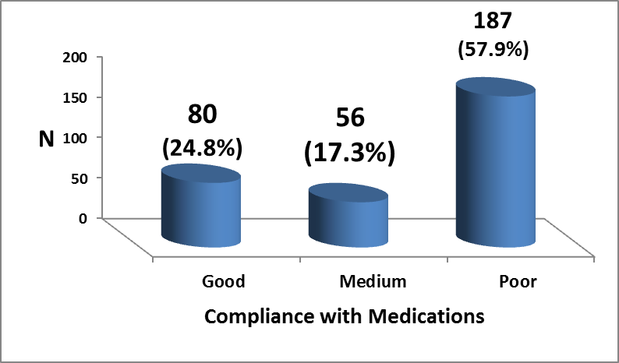

Figure 1: Compliance to medications according to 8 item scale among hypertensive patients.
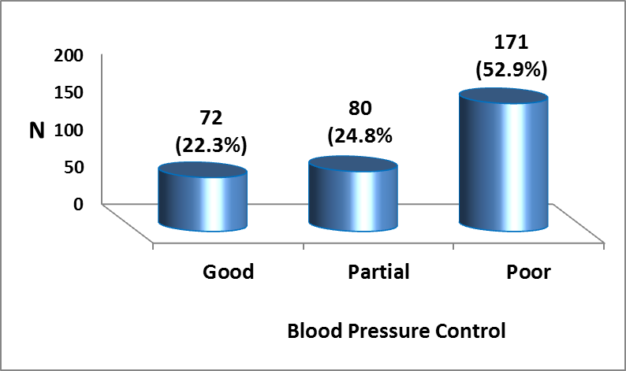
Figure 2: Blood pressure control level among patients with HT

Table 2: Association between compliance to medication and socio-demographic characteristics
 |  | Compliance to Medication |  |  |  | P value
 |  | Good | Partial | Poor | Total | P value
 |  | N %  80 24.8 | N %  56 17.3 | N %  187 57.9 | N %  323 100 | P value
Age groups in years | < 40 | 4 11.8% | 0 0.0% | 30 88.2% | 34 10.5% | 0.003
Age groups in years | 40-59 | 54 26.6% | 37 18.2% | 112 55.2% | 203 62.9% | 0.003
Age groups in years | ≥ 60 | 22 25.6% | 19 22.1% | 45 52.3% | 86 26.6% | 0.003
Gender | Male | 34 28.8% | 28 23.7% | 56 47.5% | 118 36.5% | 0.011
Gender | Female | 46 22.4% | 28 13.7% | 131 63.9% | 205 63.5% | 0.011
Residence | Urban | 66 28.4% | 36 15.5% | 130 56.0% | 232 71.8% | 0.037
Residence | Rural | 14 15.4% | 20 22.0% | 57 62.6% | 91 28.2% | 0.037
Marital Status | Married | 72 27.4% | 48 18.3% | 143 54.4% | 263 81.4% | 0.022
Marital Status | Single | 4 20.0% | 0 0 .0% | 16 80.0% | 20 6.2% | 0.022
Marital Status | Others | 4 10.0% | 8 20.0% | 28 70.0% | 40 12.4% | 0.022
Education In years | <6 | 18 14.2% | 24 18.9% | 85 66.9% | 127 39.3% | 0.001
Education In years | 6-8 | 20 22.5% | 20 22.5% | 49 55.1% | 89 27.6% | 0.001
Education In years | 9-12 | 11 39.3% | 4 14.3% | 13 46.4% | 28 8.7% | 0.001
Education In years | >12 | 31 39.2% | 8 10.1% | 40 50.6% | 79 24.4% | 0.001
Occupation | Employee | 32 39.5% | 8 9.9% | 41 50.6% | 81 25.1% | 0.002
Occupation | Free work | 12 33.3% | 4 11.1% | 20 55.6% | 36 11.1% | 0.002
Occupation | Jobless\  retired | 12 19.4% | 16 25.8% | 34 54.8% | 62 19.2% | 0.002
Occupation | Housewife | 24 16.7% | 28 19.4% | 92 63.9% | 144 44.6% | 0.002
Income level | High | 18 39.1% | 4 8.7% | 24 52.2% | 46 14.2% | 0.001
Income level | Middle | 30 36.1% | 12 14.5% | 41 49.4% | 83 25.7% | 0.001
Income level | Low | 32 16.5% | 40 20.6% | 122 62.9% | 194 60.1% | 0.001

Table 3: Association between compliance to medication with some HT risk factors and related conditions

 |  | Compliance to Medication |  |  |  | P value
 |  | Good | Medium | Poor | Total | P value
 |  | N %  80 24.8 | N %  56 17.3 | N %  187 57.9 | N %  323 100 | P value
BMI (Kg/M²) | < 25 | 40 34.8% | 24 20.9% | 51 44.3% | 115 35.6% | 0.002
BMI (Kg/M²) | 25-29.9 | 32 17.6% | 28 15.4% | 122 67.0% | 182 56.3% | 0.002
BMI (Kg/M²) | ≥ 30 | 8 30.8% | 4 15.4% | 14 53.8% | 26 8.1% | 0.002
Complication | Yes | 28 38.9% | 4 5.6% | 40 55.6% | 72 22.3% | 0.001
Complication | No | 52 20.7% | 52 20.7% | 147 58.6% | 251 77.7% | 0.001
Duration in years | < 5 | 32 17.8% | 32 17.8% | 116 64.4% | 180 55.7% | 0.007
Duration in years | 6-9 | 12 25.0% | 8 16.7% | 28 58.3% | 48 14.9% | 0.007
Duration in years | ≥ 10 | 36 37.9% | 16 16.8% | 43 45.3% | 95 29.4% | 0.007
N. of HT drugs | 1 | 47 34.3% | 26 19.0% | 64 46.7% | 137 42.4% | 0.001
N. of HT drugs | 2 | 14 18.7% | 17 22.7% | 44 58.7% | 75 23.2% | 0.001
N. of HT drugs | ≥ 3 | 19 17.1% | 13 11.7% | 79 71.2% | 111 34.4% | 0.001
Blood pressure control | Good | 52 72.2% | 12 16.7% | 8 11.1% | 72 22.3% | 0.000
Blood pressure control | Partial | 16 20.0% | 24 30.0% | 40 50.0% | 80 24.8% | 0.000
Blood pressure control | Poor | 12 7.0% | 20 11.7% | 139 81.3% | 171 52.9% | 0.000

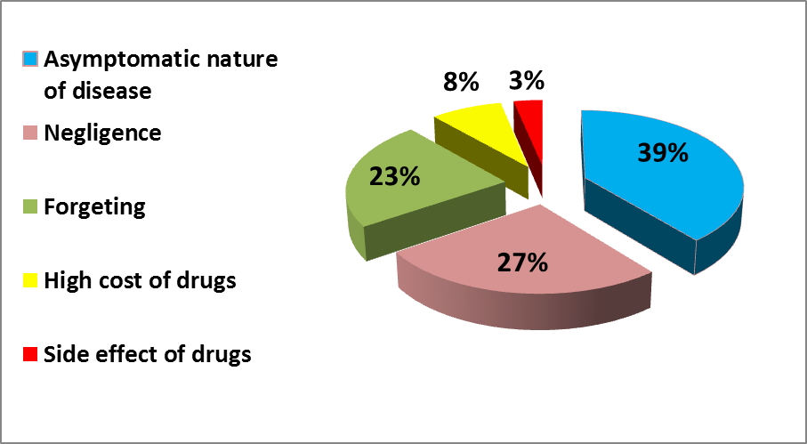
Figure 3: Reasons of poor compliance to medication

Discussion
This study shows low rate 24.8% of patients with good compliance with medication, whereas the majority of the patients 57.9% had poor compliance to medication according to 8 Item MMAS as shown in figure-1.
The low rate of compliance is less than that reported by different researchers that were 70%, 67.1%, 56.7%, 53.4%, 53%, 51%, 43.5%, 39.6%, 35.4%, 32.1%, 25.19 respectively [17,18,19,14,12,20,21, 22, 23,8,24]. While it was higher than the 13.24%
compliance rate reported by Dosee et al 2009 [9].
Though different methods used in different groups and countries, but still the problem of low compliance is
obvious in this study, with the fact of the direct association between better compliance to treatment with higher control rates of blood pressure make it a serious issue. So current low compliance
rate can explain the low BP control rate appeared in the study group.
This low control rate of 22.3% was lower than the overall compliance rate reported in a multinational study by Chow et al
2013 that was 32.5%, also it was lower than that reported in Middle East 33.6%
and close to the China figure of 23.8% in similar stud [7]. In addition, it was lower than other studies carried out by several

authors which were 80%, 75.6, 69%, 39.6%, 38.6%, 36%, 35.4% respectively
[25,18,26,22,27,28,23]. However, it was higher than 20.7% reported for Africa in Chow et al 2013 and the 15.5% reported by Petek-Šter 2007 [7, 29]. This variation in results from different societies could be related to difference in educational standards, cultures, beliefs about illness and treatment, as well health services development but still compliance to treatment and control of BP is weak worldwide.
Majority of sample (62.9%) was in age group of 40-59 years, this agrees with four other studies in Iraq [21,22,27,30], in which the majority of patients were in this age group, and this probably the most prevalent group of hypertensive patients in Iraq. In addition, this age group was significantly more compliant with treatment than other age groups in our study, while Al-Banna and Mohmed 2010 reported the reverse [29], but Abbas 2005 and Kadhim et al 2007 reported slightly higher compliance in this age group but there results were not statistically significant [22,27].
Males in our study appeared to have better medication compliance than females, this agrees with Strauch et al 2013 and Khan et al 2013 who found similar association [12, 23], while Chow et al 2013, Ramli et al 2012, Al-Banna and Mohmed 2010 and Heymann et al 2011 reported that females were more compliant with medications [7,19,21,26]. Low females compliance rate could be explained by the highest percent of sample was of low education (<6 years) and housewife was the predominant occupation and the majority of the sample (63.5%) were females, as it appeared that medication compliance was inversely associated with low education and housewives reported the least compliance rate as shown in table 2.
Single medication treatment for HT was used by 42% of the sample, and there was a strong statistical association between compliance to treatment and the use of monotherapy, and this reflects the superiority of single medication and dose of drugs to achieve better compliance, and results agrees with other studies conducted by several authors by [19,21,22,26,31,32].
Compliance to medication prescribed leads to better control of BP, and this relation was very obvious in this study as 72% of drug compliant had controlled BP, with highly significant statistical association, and this is similar to the findings of several other studies [14,19,22,23,28].
In our study, the main cause for poor compliance to medication as the patients indicates was the asymptomatic nature of disease that forms 39.1%, as taking treatment only when they develop symptoms such as headache and not take medication when they feel well. Another false belief is that “taking drug for a long time will turn disease into chronic”. Such belief influenced by the asymptomatic nature of HT and same idea present for diabetes. Poor knowledge of the disease and ignorance of need for long-term treatment was reported as main cause by Busari et al 2010 [8], whereas self-awareness of disease remission was second cause of noncompliance in Dong et al 2013 [18].
The second reason for noncompliance was negligence or carelessness of the patient followed by forgetfulness. Forgetfulness which appeared as third cause reported by nearly half of the subjects by Bastos-Barbosa et al 2012 [25], forgetfulness was also the main cause of non-compliance in other studies [18, 24, 28]. Side effects of drugs that appear as least cause in our study was reported as second cause by Al-Mehza et al 2009; forgetfulness was also the main cause of non-compliance in other studies [26].
From this it appears that reasons for non-compliance were, different in proportions from region to other and from culture to other though presence of some similarity in them.
In conclusion, our study shows a very low rate of medication compliance, and BP control with strong association between them, that reinforce the relation between them. Compliance was higher in age group 40-59 years, male gender, higher level of education, presence of complication, longer duration of disease and the use of single medication.
The main reasons for noncompliance were the asymptomatic nature of disease, followed by negligence then forgetfulness.

Acknowledgement
We would like to thank Dr. Hassan Alwan Baiee, Community Medicine Specialist (head of department of family and community medicine) at Babylon University–College of Medicine for his support and our grateful thanks to the staff of the medical consultation Clinic in Marjan Teaching Hospital for their cooperation to completing this work.

References
- Kearney P, Whelton M, Reynolds K, Whelton P, He J. Worldwide prevalence of hypertension: a systematic review. Journal of Hypertension 2004; 22 (1): 11-19.
- Alomar, M.J. and Strauch C.C. A Prospective Evaluation of Anti-hypertensie Medications Safety and Efficacy in United Arab Emirates Private Hospitals. Am. J. Pharmacol. Toxicol., 2010; 5: 89-94. DOI: 10.3844/ajptsp.2010.89.94
- Chobanian A, Bakris G, Black H, Cushman W, Green L, Izzo J, et al. The Seventh Report of the Joint National.
- Committee on Prevention, Detection, Evaluation, and Treatment of High Blood Pressure. USA, U.S. Department Of Health And Human Services; NIH Publication No. 04-5230 2004.
- World Health Organization. A global brief on hypertension- World Health Day 2013. 2013; [accessed Dec 20, 2013]. Available-at: http://www.who.int/cardiovascular_diseases/publications/global_brief_hypertension/en/
- Sulaiman SAS; Alomar MJ; Strauch CC. Variability in Antihypertensive Drug Therapy and Compliance: Results from a Random Survey in the United Arab Emirates; American Journal of Pharmacology & Toxicology.2009; 4(3): 38-47
- Kwan MW-M, Wong MC-S, Wang HH-X, Liu KQ-L, Lee CL-S. et al. Compliance with the Dietary Approaches to Stop Hypertension (DASH) Diet: A Systematic Review. PLoS ONE 2013; 8 (10): e78412.
- Chow CK, Teo KK, Rangarajan S, Islam S, Gupta R , Avezum A. et al. Prevalence, Awareness, Treatment, and Control of Hypertension in Rural and Urban Communities in High-, Middle-, and Low-Income Countries. JAMA. 2013; 310 (9): 959-968. doi:10.1001/ jama. 2013.184182
- Busari O A, Olanrewaju T O, Desalu OO, Opadijo OG, Jimoh AK, Agboola SM. et al. Impact of Patients’ Knowledge, Attitude and Practices on Hypertension on Compliance with Antihypertensive Drugs in a Resource-poor Setting TAF Prev Med Bull 2010; 9(2):87-92
- Dosse C, Cesarino CB, Martin JFV, Castedo MCA. Factors associated to patients’ noncompliance with hypertension treatment. Rev Latino-am Enfermagem 2009 March-April; 17(2): 201-206
- Rolnick SJ, Pawloski PA, Hedblom BD, Asche SE, Bruzek, RJ. Patient characteristics associated with medication adherence. Clinical medicine & research 2013; 11(2): 54-65.
- Edo TA. Factors affecting compliance with antihypertensive drug treatment and required lifestyle modification among hypertensive patients on Praslin Island [a thesis for master in public health. Praslin Island - University of South Africa; 2009 [accessed Oct 16, 2012]. Available at:
- Strauch B, Petrák O, Zelinka T, Rosa J, Somlóová Z, Indra T, et al. Precise assessment of noncompliance with the antihypertensive therapy in patients with resistant hypertension using toxicological serum analysis. Journal of Hypertension 2013 Dec; 31(12):2455-61.
- Ho PM, Bryson CL, Rumsfeld JS. Medication Adherence, It's Importance in Cardiovascular Outcomes. Circulation. 2009; 119(23): 3028-3035.
- Morisky D, Ang A, Krousel-Wood M, Ward H. Predictive Validity of a Medication Adherence Measure in an Outpatient Setting. The Journal of Clinical Hypertension .2008; 10(5): 348–354.
- Korb-Savoldelli V, Gillaizeau F, Pouchot J, Lenain E, Postel-Vinay N, Plouin PF et al. Validation of a French Version of the 8-Item Morisky Medication Adherence Scale in Hypertensive Adults. The Journal of Clinical Hypertension.2012; 14 (7): 429–434.
- Smith L. New AHA Recommend-ations for Blood Pressure Measurement. American Family Physician. 2005 Oct; 72 (7):1391-1398
- Mafutha GN and Wright SCD. Compliance or non-compliance of hypertensive adults to hypertension management at three primary healthcare day clinics in Tshwane. Curationis 2013; 36 (1): 52-56
- Dong CH, He MM, Fan CS, Wang D. Medication compliance status in patients with hypertension and its associated factors in urban China. Value in Health 2013; 16(3): A290-A290
- Ramli A, Ahmad NS, Paraidathathu T. Medication adherence among hypertensive patients of primary health clinics in Malaysia. Patient preference and adherence 2012; 6: 613-622
- Osamor PE, Owumi BE. Factors Associated with Treatment Compliance in Hypertension in Southwest Nigeria. J Health Popul Nutr 2011 Dec; 29(6):619-628
- Al-Banna HI, Mohmed LH. Compliance and Knowledge of Hypertensive Patients Attending Shorsh Hospital in Kirkuk Governorate. The Iraqi Postgraduate Medical Journal 2010; 9 (2): 145-150
- Abbas MF. Compliance Of Hypertensive Patients to Therapy, Al-Taqani Journal 2005; 18(1): 105-113
- Khan G, Thapa R, Khakurel, Shrestha G, Katila N, Bhurtel S. Medication Adherence and Blood Pressure Control among Hypertensive Patients of Pokhara Valley . JHAS 2013; 3(1): 64-67.
- Campbell PC, Oladeyi OO. Compliance To and Knowledge of Anti-Hypertensive Therapy amongst Hypertensive Patients Attending Lagos University Teaching Hospital (Luth), Idi-Araba, Lagos, Nigeria. IOSR-JDMS 2014; 13(5): 108-115
- Bastos-Barbosa RG, Ferriolli E, Morigutil J, Nogueira1 C, Nobre1 F, Ueta J. et al. Treatment Adherence and Blood Pressure Control in Older Individuals with Hypertension. Arquivos brasileiros de cardiologia 2012; 99(1): 636-641
- Heymann A, Revital GrossR, Tabenkin H, Porter B, Porath A. Factors Associated with Hypertensive Patients’Compliance with Recommended Lifestyle Behaviors. IMAJ.2011; 13(9): 553.
- Kadhim MJ, Jamil NF, Ramzi ZM. Compliance to Medical Therapy among Hypertensive Patients Attending the Out Patient Department of AL-Yarmouk Teaching Hospital. Iraqi J. Comm. Med., April. 2007; 20(2): 296-300
- Al-Mehza A, Al-Muhailije F, Khalfan M, Al-Yahya A. Drug Compliance Among Hypertensive Patients; an Area Based Study. Eur J Gen Med. 2009; 6(1):6-10
- Petek-Šter M, Kersnik J, Švab I. Compliance with hypertension guidelines in general practice in Slovenia. Srpski arhiv za celokupno lekarstvo 2007; 135(3-4), 191-196.
- Alwey SR. Assessment of Patients’Compliance with Essential Hypertension. Sci. J. Nursing 2008; 21(2): 1-10
- Lam P, Lum C., Leung M. Drug non-adherence and associated risk factors among Chinese geriatric patients in Hong Kong. Hong Kong Med J 2007; 13:284-92.
- Kabir M, Iliyasu Z, Abubakar S, Jibril M. Compliance to medication among hypertensive patients in Murtala Mohammed Specialist Hospital, Kano, Nigeria. Journal of Community Medicine & Primary Health Care. 2004; 16 (1):16-20.

