

Medical Journal of Babylon
Vol. 12- No. 3: 836-848, 2015
http://www.medicaljb.com
ISSN 2312-6760©2015 University of Babylon

Original Research Article
Evaluation of Cutaneous Approaches to The Orbital Skeleton in Management of Facial Injuries

Majeed Abd Al-Razzaq Baheer
Alwasity Teaching Hospital for Reconstructive Surgery, Baghdad, IRAQ

E-mail: dr.majeed111@gmail.com

Accepted June,2015
Abstract
The aim of the study was to evaluate the cutaneous approaches to the orbital skeleton & making a comparison among various types of these approaches into each aspects of the orbit with consideration of intraoperative visibility, functional & esthetic results. 24 patients requiring 47 incisions for repairing their orbital fractures, had been reviewed,and distributed as following; 10 eyebrow incisions (21.2%),7 temporal incisions (14.9%), 7subciliary incisions (14.9%),6 inferior rim incisions (12.7%), 5 subtarsal incisions (10.6%),4 lacerated wounds or previous scars (8.5%),2 crow's foot incisions (4.2%), 3superolateral incisions (6.4%), 2 lynchincisions (4.2%) and 1 bicoronal incision (2.1 %). These approaches were evaluated according to their visual field, functional, cosmetic&post-operative complications depending on type and position of the incision, intraoperative time consuming and period of tissue manipulation. Scar appearance for each incision was graded as invisible,barely visible & visible. The study recorded two cases of transient scleral show (16.6%) and one case of transient moderate ectropion (8.3%).The surgical access to various parts of the orbit, operating time, potential damage to adjacent anatomical structures, and acceptability of the scar and the development of postoperative complications are important factors which have to be considered when choosing the approach to the orbit.

Key words: orbital, Facial,Injury, Cutaneous
الخلاصة
أجريت هذه الدراسة لغرض تقييم المقتربات الجلدية الى الهيكل المحجري للعين في معالجة الأصابات الوجهية ولعمل مقارنه بين الانواع المختلفة لهذه المقتربات عند كل جانب من جوانب محجر العين مع الأخذ بنظر الاعتبار مجال الرؤية اثناء العملية و النتائج الوظيفية و الجمالية بعد العملية.في هذه الدراسة، تمت مراجعة اربعة وعشرون مريضا كانوا بحاجة الى سبعة واربعون قطعا جراحيا لترميم كسور محجر العين.وكان العلاج المختار لجميع هذه الكسور هو الارجاع المفتوح و التثبيت الداخلي مع او بدون بناء لأسفل محجر العين.تم استعمال سبعة واربعون من المقتربات الجلدية للحصول على منافذ الى كسور محجر العين و قد توزعت هذه المقتربات كالاتي: -
عشرة قطوع في حاجب العين (21,2%)، سبعه قطوع صدغية (14,9%‏)، سبعة قطوع تحت الأهداب (14,9%)، خمسة قطوع تحت غضروف الجفن السفلي (10,6%‏)، ستة قطوع عند حافة محجر العين السفلية (12,7%‏)، اربعة جروح تمزقية او ندب جروح سابقة (8,5%)، ثلاثة قطوع فوقية جانبية (6,4%‏)، قطعان اثنان في منطقة قدم الغراب (4,2%)، قطع لنش عدد اثنان (4,2%)‏وقطع ثنائي تاجي عدد واحد(2,1%).كانت حصيله تقييم هذه المقتربات الجلدية لمحجر العين طبقا الى مجال الرؤية اثناء اجراء العملية،النتائج الوظيفية والجمالية لكل منهم والمضاعفات بعد العملية، تعتمد على نوع ومكان القطوع الجراحية والوقت المستهلك لأستخدام الأنسجة اثناء العملية.مظهر الندب المتروكة لكل قطع جراحي تم تصنيفه غير مرئي،مرئي بالكاد ومرئي.وقد سجلت الدراسة حالتان من رؤية صلبة العين المؤقتة (16,6%) وحالة واحدة من الشتر الخارجي المتوسط للجفن السفلي للعين(8,3%). ‏
مفاتيح الكلمات :الجلدية ، الهيكل الحجري ،الاصابات الوجهية .

Introduction

The orbit is an anatomical region, which is of clinical and surgical interest to many disciplines. It may be regarded as "across-roads" where the "signposts", in the more complex injuries, clearly indicate the necessity for additional expertise which can only be provided by other specialties when there is direct injury to the eye or lacrimal apparatus, a reduction in visual acuity or neurological involvement [24] (Figure1).Surgical access to the orbital skeleton through the eyelids and anterior orbit has been accomplished byanarray of cutaneous incisions. Due to the superficial nature of the underlying anatomy albeit muscle, fat, tendon, or bone, many different incisional approaches will provide reasonable access to the desired structures. Despite a recent surge in the popularity of the transconjunctival technique, periorbital surgery by a cutaneous approach is still a valid means of access for a variety of esthetic and particularly trauma procedures[1,25]. In this study, the patients sustained facial injuries due to various etiological factors, and had been treated via cutaneous approaches rather than a transconjunctival approach due to their both of popularity and familiarity in our country.

Figure 1: The orbital skeleton; bones of the left orbit. (From McCminn et al, 1995. Colour atlas of Head and Neck anatomy).
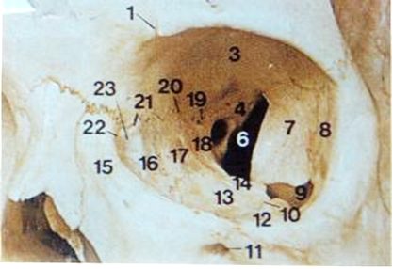

Patients and Methods
24 patients requiring 47incisions to gain an access to the orbital rims and / or walls for repairing of orbital skeleton fractures had been evaluated in this study. Excluding other types of fractures, these patients were suffering from one or multiple types of facial upper and middle third fractures involving the orbital skeleton, 22 patients were males (91.6%) and 2 were females (8.4%), ranging in age from 4-55 years (mean age,29 years).Various types of cutaneous approaches to the orbital skeleton had been used in our study and we can enumerate these types as shown in (figure 2).The period of follow up was ranged from 1-8 months.Preoperative and postoperative photographs were taken to document and evaluate postoperative outcome.

The Cutaneous orbital approaches of the study:

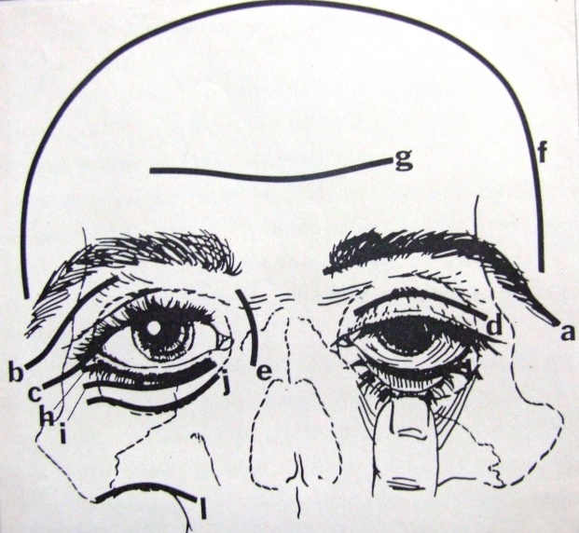
Figure 2:Orbital incisional choices
a, rim (upper); b, Wright; c, lateral canthotomy d, lidcreaese (upper); e, Lynch; f, bicoronal flap; g, forehead; h, subciliary; I, lid crease (lower); j, rim(lower); k;'"'conjunctival; I, vestibular.

Bicoronal Approach
Many papers have recommended the use of the coronal approach to cranio maxillofacial surgery[14,23]. They reported that through this one surgical approach, it is possible to expose the frontal, nasoethmoid, zygomatic process and orbital bones. In our study, we have only one case of trauma had been treated by raising a bicoronal flap for repairing of depressed fronto-orbital fracture and reconstruction of the orbital roof by team approach of maxillofacial and neuro surgeons.
Lateral Eyebrow Approach
Incision placed over the lateral eyebrow is a popular approach with long history of use to gain access to part of the lateral orbital rim and roof of the orbit with direct visualization of frontozygomaticsuture [5]. In our study, we had been used thisapproach in ten cases of zygomatico-maxillary complex and Le Fort II and III fractures. [6]
Superolateral(Wright)Approach
Wright approach had been employed in this series (three times) for repairing of orbital fractures by making an incision along the orbital rim beneath the lateral brow continued down to the level of the lateral canthus[28].

Crow's Foot Approach
An incision through skin creases or as called 'Crow's foot" wrinkles around the outer aspect of the eye were performed in two patients presented with malunion of old zygomatic fracture. Through this approach, we can reach into the zygomatico-frontal area as same as through an eyebrow and Wright incisions. But at the same time and through this type of incision we can gain better access in order to mobilize the zygomatic arch by an osteotomy procedure [4,20,21].
Lynch Approach
It is usually made in a curvilinear direction at the medial canthal area[12].Of forty-seven incisions in this series, we have two lynch incisions were used for one patient presented with bilateral telecanthus. Canthopexy was performed by transnasal wiring secured over " toggle" wire.
Inferior Orbital Approaches: a- subciliary b- Subtarsal c- inferior rim incisionsOf forty-seven approaches used in this study, eighteen approaches had been utilized for exposure of the lower half of the bony orbit. We have three types of incisions in this site, subciliary incisions (seven of eighteen), lower lid crease (subtarsal) incisions (five of eighteen) and inferior rim incisions (six of eighteen) The dissection techniques of sub ciliary and subtarsalapproaches were a skin-muscle flap (in eight cases) and a skin flap only (in four cases). While the inferior rim approach was relatively direct technique.
There should be no confusion regarding the exact location of the three inferior orbital incisions; subciliary incision was placed approximately 2mm below and parallel to the lower lid lash margin,subtarsal incision was placed through skin crease of the lower eyelid few millimeters inferior to subciliary incision but short of the inferior rim, while the orbital rim incision, from ifs name was through skin directly over the infra orbital rim. [10,13,27].

Result
Distribution of incisions among the Patients
In this study 47 incisions had been carried out for repairing of the orbital skeleton fractures in twenty-four patients.=> Ten patients (41.6%) required two incisions to gain access to the orbit.=> Nine patients (37.5%) had been treated through one incision.=> Surgical approaches via three incisions for three cases, were required (12.5%).=> One patient (4.2%) was treated through four incisions to gain access to the orbital fractures.=> One patient (4.2%) was involved witpanfacial fractures, had been treated through five periorbital incisions (Figure3).

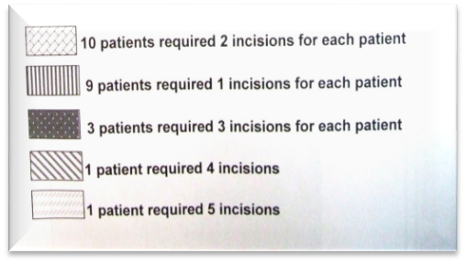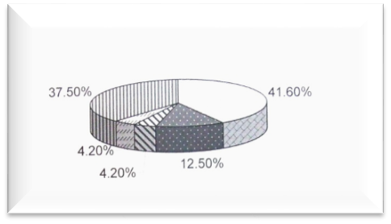
Figure 3: Distribution of Incisions among the patients

Various types of cutaneous approaches to the orbital skeleton had been used in our study and we can enumerate these types as following: (Figure4).
1- Out of 47 incisions, the number of eyebrow incisions was 10 (21.2%). 2- Temporal incisions (Gillies approach) were 7 (14.9%). 3- Subciliary incisions were 7 (14.9%).
4- Subtarsal (lower eyelid crease) incisions were 5 (10.6%).
5- Inferior rim incisions were 6 (12.7%).
6- An approach to the orbits through lacerated wound or previous scarwas used in four cases (8.5%).
7- Superolateral incisions were 3 (6.4%).
8- Crow's foot incisions were 2 (4.2%).
9- Lynch incisions were 2 (4.2%).
10- Bicoronal flap was used in one case (2.1%).
11- The total number of superior orbital approaches was 27 (47.5%), while the total number
of inferior orbital approaches was 20 (42.5%).

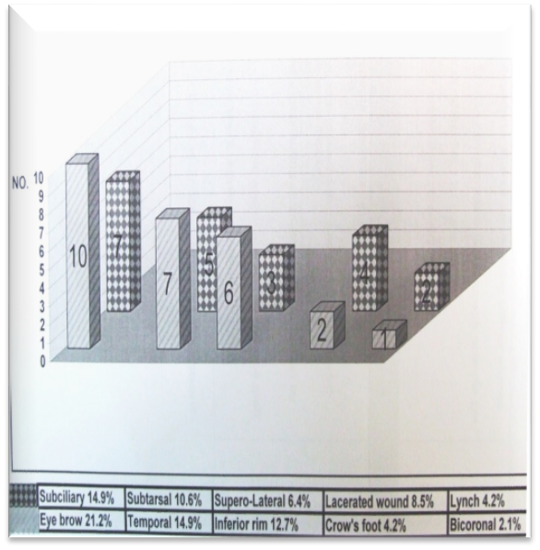
Figure 4: Cutaneous Approaches were performed in the study

Complications of Periorbital Incisions Among (47) incisions, which had been used in our study, there were several complications related to these incisions ; => Postoperative edema was complicated most of approaches.=> There was no hematoma or seroma collection of a considerable size complicating of any type of incisions because of good hemostasis intraoperatively and drain was inserted in few cases regarding a working time and tissue manipulation.
=> Minor complication such as partial wound dehiscence due to infection was occurred in one case. => Scar appearance for each incision was graded according to Holtman et al.[11] into;
(1) Invisible; (2) Barely visible; or (3) Visible. I- Bicoronal, temporal and eyebrow approaches resulted in grade (1) invisible scar appearance. II- Subciliary, subtarsal incisions(Figure5), crow's foot (for patient of mature years) and lynch incisions, resulted in a grade (2) barely visible scar appearance.III- Inferior rim, superolateral, crow's foot (for young patient) resulted ina grade (3) visible scar appearance.IV- Two patients developed an ugly scar appearance following one of superolateral and inferior rim incisions, in addition to the lacerated wound incisions. (Figure6)=>Out of (7) subciliary incisions and (5) subtarsal incisions, a transient lifting of the lower eyelid (mild retraction) occurred for (2) patients;(1) aftersubciliary incision, (preorbicularis technique) and other after subtarsal incision of postorbicularis technique (16.6%). (Figure7)=> Moderate ectropion complicated one subciliary incision (preorbicularis technique), 8.3%. (Figure8).

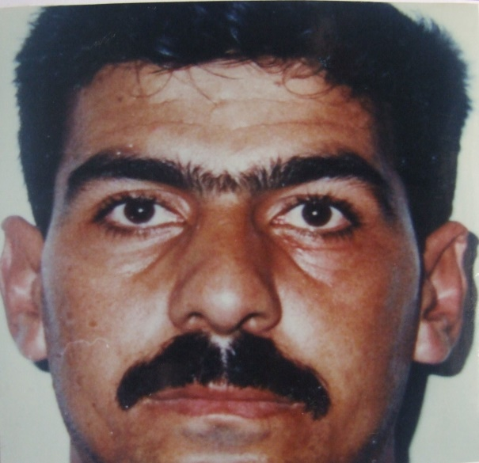
Figure5:Postoperative image of twenty-six years old patient with left Z.M.C. fracture treated through eyebrow and subciliaryincisions.This image after three months showing left subciliary incision with acceptable scar appearance

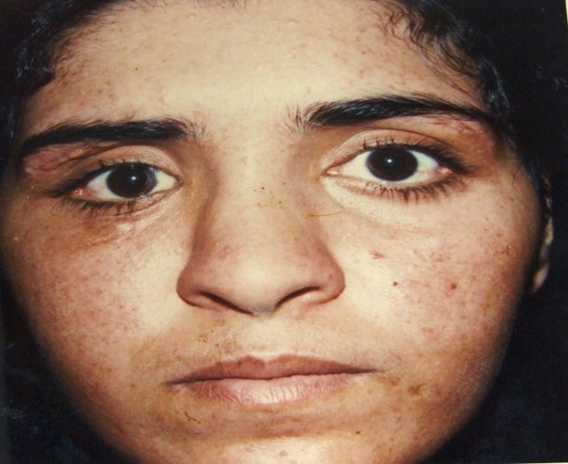
Figure6: Two months’ postoperative image showing an ugly scar of right superolateral incision with barely visible scar of subciliary approach at the same side.
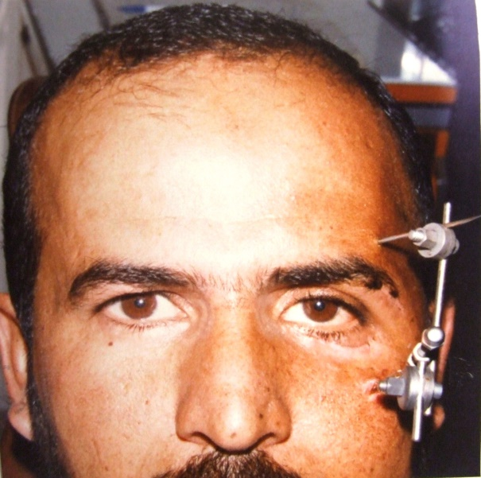
Figure7: Postoperative (after 10 days) image demonstrating mild retraction of the left lowereyelid (scleral show) after subtarsal incision.
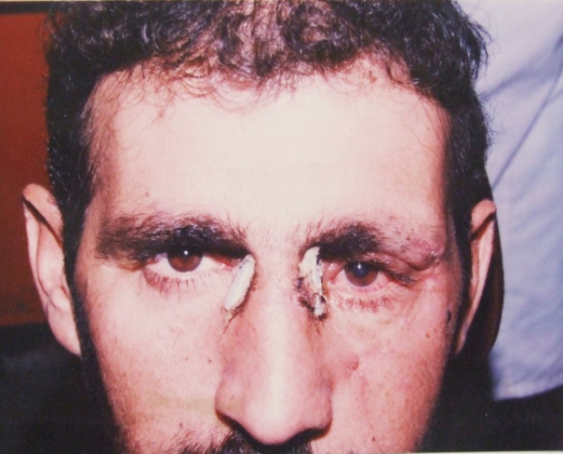
Figure 8: Postoperative image (after 15 days) demonstrating a moderate ectropion of the left eyelid after subciliary incision of preorbicularis dissection technique.

Discussion
The Cutaneous Approaches of the Study:Bicoronal Approach: (Figure 9)
We can state without hesitation that the surgical exposure achieved by this approach facilitated anaccurate reduction and repositioning of the orbital roof.

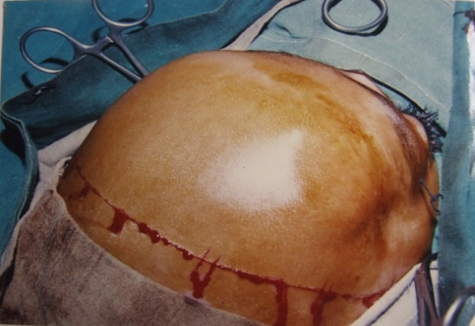
Figure 9:Bicoronal flap

This is attributed to the wide and direct visualization of the underlying skeleton anatomy gained by bicoronal flap, besides its generous gift for repairing of Dural tear by galeagraft. Therefore, this opinion coincides with Ellis[7] who stated that the coronal approach has become the "workhorse" of surgical approaches for complex facial trauma (Figure 10). Unquestionably, the coronal incision provides the most acceptable cosmetic result as the scar lines lie almost totally within the hairline, so that as we mentioned in our results, the coronal incision resulted in a grade (1) invisible scar appearance, however, this approach has an obvious disadvantage in patients with male pattern baldness and in black patient with short curly hair [15]. Fortunately, our patient was a female of four years old.

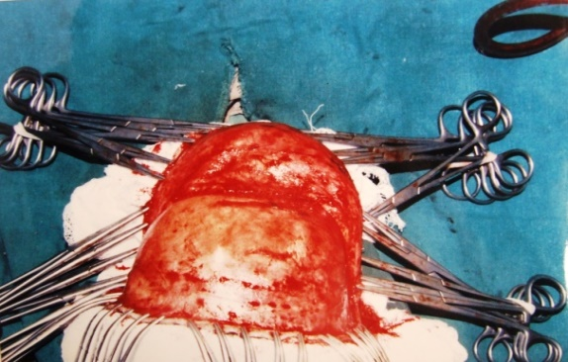
Figure 10: Raising of bicoronal flap

Lateral Eyebrow Approach: (Figure11)Zigmunt et al[30], advocated on using this approach to reduce a zygomatic fracture instead of using a Gillies procedure. Our comment on this opinion is that, the vector of force to elevate the zygomatic complex by using an eyebrow approach, is different from that in temporal approach, so it is difficult to elevate the complex in cephalic or upward direction, in addition to that, it may exert additional traumatic pressure on adjacent tissue due to limitation of access of brow incision.Therefore we agree with Banovetz and Duvall[11]and Ellis[7]that Gillies approach allows for application of great amount of controlled force to disimpact the depressed zygoma. However, in this study we preferred to use this approach rather than temporal one,in case of unstable zygomatic fracture.

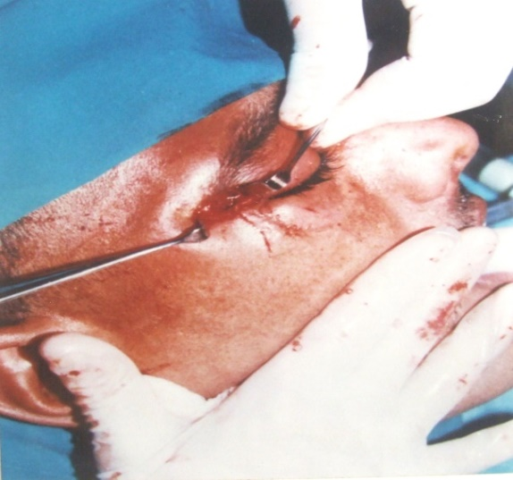
Figure 11: Lateral eye brow approach showing direct wiring of frontozygomaticfrucrure.

From esthetic point of view, an eyebrow incision resulted in a grade (1) invisible scar appearance. Therefore, we are going with opinion of Eppelyet al[9]and Ellis [7]that, since the incision is made within the confines of the eyebrow, a scar is usually imperceptible; it is better outcome than superolateral and crow's foot incisions.
Superolateral Approach:
The visual field obtained was the same of eyebrow incision, while the scar results from this incision was grade (3) visible scar appearance,Therefore in comparison of this incision with eyebrow incision from both intraoperative visual field and cosmetic appearance, we prefer the use of the eye brow incision because as Eppely and associates[9] noted that the superolateral incision is in a minimally shaded facial area, so that it will end with evident scar appear as unnatural skin line being higher than the supratarsal fold.
Crow's Foot Approach:
(Figure12)Through this approach, we can reach into the zygomaticofrontal area as same as through an eyebrow and Wright incisions. But at the same time and through this type of incision we can gain better access in order to mobilize the zygomatic arch by an osteotomy procedure, this is attributed to the direction of this incision that permitting us to exert more controlled force over a narrow surface area of the arch. Therefore, bya crow's foot and infraorbital approaches, refracturing and repositioning of the zygoma were easier and faster than with the eyebrow approach. Cosmetically, we have two results; a visible scar appearance occurred with the young patient because of under developing of crow's foot wrinkles, while the result of the older patient was barely visible scar due to well-developed skin creases.

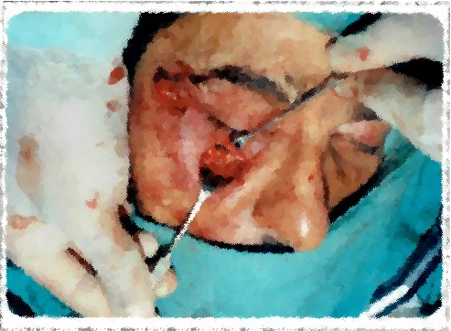
Figure 12: Crow’s foot approach demonstrating inter osseous wiring at the frontozygomatic junction bone graft augmentation of orbital floor through inferior rim approach.

Lynch Approach:(Figure13)
Through this approach we obtained an excellent direct exposure of the medial canthus and nasoethmoidal area.Regarding the scar appearance, we think that the area of this incision is shaded facial area due to its position at the paranasal region and as long as we didn't need for conjunction of the two incisions across the nasal bridge (open sky approach). Our incisions resulted in a grade (2) barely visible scar appearance.

Figure 13:Pan Facial Truma

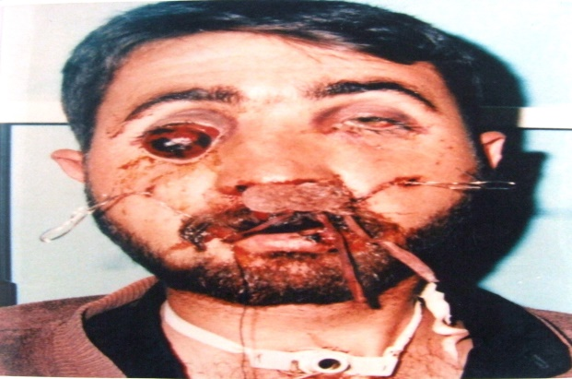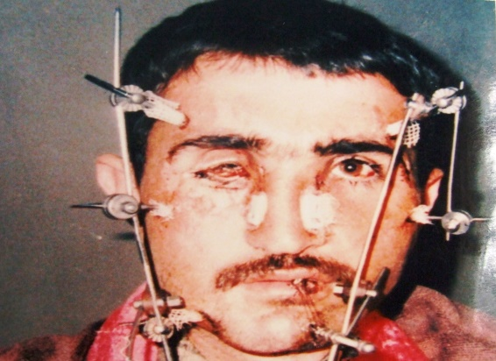

A.Preoperative Image (7 days after Injury) showing; avulsion of right eyeball, dishing of the face.
B. Postoperative image (2 weeks later) enucleation of the eyeball bilateral lynch incisions, right subciliary incision

Inferior Orbital Approaches
The dissection techniques of sub ciliary and subtarsal approaches were a skin-muscle flap in (8) patients and a skin flap in (4) cases, While the inferior rim approach was relatively direct technique. Concerning the operating time for achievement of these incisions, the inferior rim incision allowed more rapid exposure of the orbital fracture because of its shortest route between skin and bone, followed by subtarsal and subciliary incisions respectively. A skin flap technique (Figure 14) was more difficult and consuming more time than a skin-muscle flap dissection, this is attributed to adherence of skin to the orbicularis oculi muscle, which makes the dissection between skin and muscle so difficult. While in a skin-muscle flap technique, there is an areolar plane of dissection between the muscle and orbital septum. This is in agreement with Salgarelli et al[22], who stated that "the more direct approach of the lower eyelid and orbital rim incisions allowed more rapid exposure of the fracture". However, we believe that the experience and familiarity of the surgeons with
the above approaches play an important role in achieving them safer and faster. In conclusion; subciliary, subtarsal and inferior rim approaches give us the same access of exposure to the inferior rim and orbital floor.

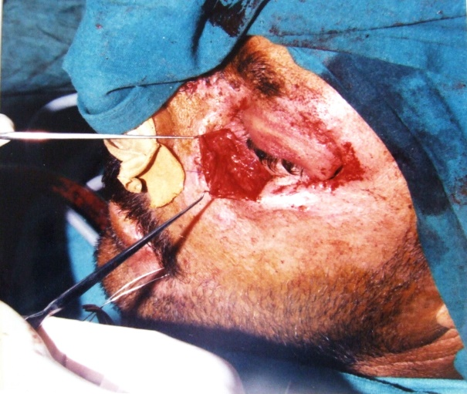

Figure 14:Pre-orbicularis dissecting technique of Subciliary approach

Complications of Periorbital Incisions:
Scar appearance ;we found, that bicoronal, temporal and well-designed eyebrow approaches can be graded as (1) invisible scar appearance because the line of scars embedded within the hairs. This is in agreement with Eppely et al[9]and Ellis [7]. Subciliary, subtarsal, crow's foot in mature years patient and Lynch incisions resulted in a grade (2) barely visible scar, (figure-15)

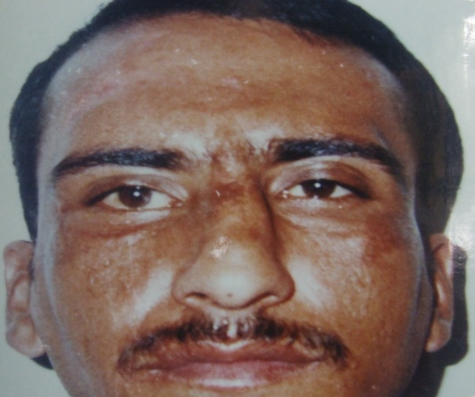
Figure 15:Postoperative image after two months) of the patient with right Z.M.C. fracture treated (through eyebrow and subtarsal incision This image demonstrating the position of right subtarsal incision with acceptable scar appearance.

this is due to; the first two incisions were made in the natural creases, also the crow's foot wrinkles were well demarcated, so that a scar appearance was acceptable. Although a Lynch incision is not exactly at the skin creases, but its position was relatively in shaded facial area, parallel with bilateral curvature of the nasal bridge. Visible scar appearance was the result of inferior rim, superolateral, Crow's foot (in young patient) incisions. The visibility of these scars were due to their placement in more exposed and prominent area of inferior rim, and clear scar line between supratarsal fold and eyebrow produced by superolateral incision, while a crow's foot of young patient was not well demarcated so that the natural result was grade (3) visible scar. An ugly scar appearance followed one of superalateral incisions, this was as we mentioned above due to wound dehiscence and infection. Also one of inferior rim incisions associated with an ugly scar (Figure.16),because closure of the tissue was in tightly suturing and subsequent removal of stitches was too late (after 10 days). Sutures in this skin area, as the eye lid should be removed 3-5 days following placement.[26]

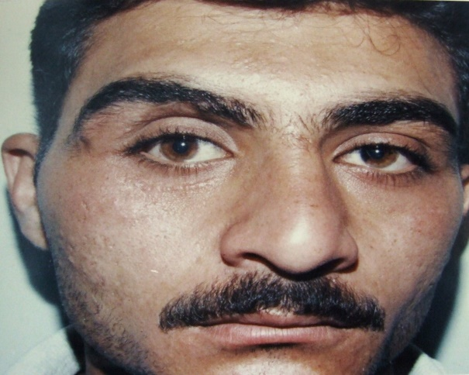
Figure 16:Grade 3 scare appearance of inferior rim incision 3 months postoperatively.

By this result we are going with the opinion of Clinton[5] who stated that the most common reasons for suture scar are closure under tension anddelayed removal, and the eventual width of the scar is proportional to the tension required for closure, so that the suture should be placed to allow slight elevation of the wound margin, and with the tying of surgical knots, it is important to remember to "approximate, not strangulate".
The most distressing problemsare the post-surgical deformity of the lower eyelid although most cases are self-limited [22]. Lid positional abnormality is different in severity; lid retraction, ectropion (mild, moderate, sever) and entropion. It is a multifactorial problem and depending on the following:
a-The degree of preoperative edema b- The degree of postoperative edemac- The age of the patientd- The form of dissection and the method of closure. [18]
In the present study, our results recorded two cases of mild retraction (scleral show); 16.6% (2 of 12 subciliary and subtarsal incisions). One of them was developed after subciliary incision of preorbicularis dissection technique, while the other was complicated of subtarsal incision of postorbicularis technique. The most possible causes of these complications were the degree of postoperative edema which persist for long time, especially if we know the type of operation of first patient was an osteotomy of zygomatic complex which consuming a lot of time and more tissue manipulation. Stretching of periorbita during suturing of the periosteum at the orbital margin might be occurred because of the dissection of periosteum in the second case was not extended below the inferior margin of the orbit. Therefore, we coincide with opinion ofRohrichet al[19],Ellis et al[8]and Mansonet al[14] who reported that "the use of periosteal sutures over the rim is to be avoided, since some shortening or tethering of the orbital septum frequently accompanies them, lowering the position of the lower eyelid relative to globe". Also this is in agreement with Yaremchuk and Kim [29] who confirmed that the morbidity associated with the blepharoplasty incision can be minimized by meticulous technique and correct soft tissue repositioning at closure.
However, the present study reported one case of moderate ectropion (shortening of the vertical height of the lid and lifting of the lid from the globe) was occurred after subciliary incision of pre orbicularis technique (8.3%). The possible explanation of this result is; the patient was 45 years old treated through a subciliary incision in addition to the lateral vertical lacerated wound in order to repair a comminuted orbital fracture at the lateral and inferior margins. The dissection under subciliary incision was so difficult between skin and muscle producing damage to the superficial muscle fibers.
As a result of that fibrosis was the cause of shortening of the lid in vertical height; also the lateral lacerated wound compromised a lymphatic drainage, as a result of that, lymphedema worsen the problem. Age of the patient might be a contributory factor because the previous studies suggested an association between development of post-surgical ectropion & tendency to develop simple senile ectropion [17].
Fortunately, there was a gradual improvement of this ectropion without surgical correction.
In conclusion, we prefer the skin-muscle flap technique (step incision) because it is easy performed and resulting in less complication of haematoma, skin necrosis and lid positional abnormalities. Although the lower lid crease (subtarsal) incision, in our study was five only, but we agree with Bahr et al[2], and Holtman et al,[11] that"the mid lower eyelid incision seems to combine the advantages of the inferior rim incision with the unnoticeable scar formation associated with the subciliary incision". While the subciliary incision captured the advantage of most acceptable scaring of any inferior orbital incisions, but it could be associated with postoperative complication such as prolonged edema, and lid positional abnormality. Although an inferior rim incision is still very popular and widely practiced, the main disadvantage of this approach was a noticeable scaring, so that we are in coincidence with Manson et al[14], that with inferior rim incision, more noticeable scaring, especially in young person, was the price paid for reduced complications of ectropion and scleral show.

References
1- Attilio Carlo Salgarelli ,Pierantonio Bellini, Barbara Landini, Alessandra Multinu,Ugo Consolo: A comparative study of different approaches to the orbit. j. Oral MaxillofacSurg (2010) 14:23–27.
2-Bahr, W; Bagambisa, F.B; Schlegel, G; et al: Comparison of transcutaneous incisions used for exposure of the infraorbital rim and floor. J. Plastic and Reconstructive Surgery; 1992, 90:585-91.
3-Banovetz, J.D; Duvall, A.J: Zygomatic fractures. Otolaryngol. Clin. North Am.; 1976, 9: 499.
4-Berke, R.N: A modified kronlein operation. Arch. Ophthalmol.; 1954 51: 609.
5-Clinton D. Humphrey, MD, J. David Kriet, MD: Surgical approaches to the orbit. Operative Techniques in Otolaryngology (2008) 19, 132-139.
6-Dingman, R.O; Natvig, P: Surgery of facial fractures. Philadelphia, W.B. Saunders. 1964.
7-Ellis, E: Fractures of the zygomatic complex and arch. In: Fonseca, R.J; Walker, R.W; Betts, N.J; Barber, H.D. (Eds). Oral and Maxillofacial Trauma. 2nd ed. Vol. 1. Philadelphia, W.B. Saunders Company.PP 571¬652. 1997.
8-Ellis E, Zide MF: Surgical Approaches to the Facial Skeleton (ed 2). Baltimore, Lippincott Williams and Wilkins, 2006.
9-Eppley, B.L; Custer, Ph. L; Sadove, A.M: Cutaneous approaches to the orbital skeleton and periorbital structures. J. Oral and Maxillofacial Surgery; 1990,48:842-54.
10- Heckler, F.R; Songcharoen, S; Sultani, F.A: Subciliary incisions and skin-muscle eyelid flap for orbital fractures. Ann. Plast. Surg; 1983, 10:309.
11- Holtman, B; Wray, R.C; Little, A.G: A randomized comparison of four incisions for orbital fractures. Plastic and Reconstructive Surgery; 1981, 67:731.
12- Katwitz, J.A; Welsh, M.G; Bersani, T.A: Lid crease approach for medial wall fracture repair. Ophthalmic Surgery; 1987, 18: 288.
13- Lacy, M.F; Pospisil, O.A: Lower blepharoplasty post-orbicularis approach to the orbit- A prospective study. Br. J. Oral and Maxillofacial Surgery; 1987, 25: 398-401.
14- Manson, P.N; Ruas, E; Miff, N; Yaremchuk, M: Single eyelid incision for exposure of the zygomatic bone and orbital reconstruction. Plastic and Reconstructive Surgery; 1987, 79: 120-26.
15-McCarthy, J.G; Jelks, G.W; Valaur, A.J; et al: The orbit and zygoma. In: McCarthy, J.G. (Ed.). Plastic Surgery. Vol. 2. Philadelphia, W.B. Saunders Company. PP 1574-1670. 1990.
16- McCminn, R; Hutchings, R.T; Logan, B.M: Colour atlas of head and neck anatomy. 2nd ed. London, Mosby-Wolf. P 32. 1995.
17- PatipaM: The evaluation and management of lower eyelidretraction following cosmetic surgery. Plast ReconstrSurg106:438–453,2000.
18- Rega AJ, Ziccardi VB, Granick M: Cosmetically favorable scars usingthe upper blepharoplasty incision. Oral Surg Oral Med Oral PatholOralRadiolEndod 98:627-628, 2004.
19- Rohrich RJ, Janis JE, Adams WP Jr: Subciliary versus subtarsal approaches to orbitozygomatic fractures. Plast ReconstrSurg111:1708-1713, 2003.
20-Rowe, N.L; Williams, L: Fractures of the zygomatic complex and orbit. In: Williams, J.L. (Eds.). Rowe and Williams’ Maxillofacial Injuries. 2nd ed. Vol. 1. London, Churchill Livingstone. PP 475-590. 1994.
21- Rubin, L.R: Langers lines and facial scars. J. Plastic and Reconstructive Surgery; 1948, 3:147.
22- Salgarelli AC, Bellini P, Multinu A, Landini B, ConsoloU: Tarsal strip technique for correction of malposition of the lower eyelid after treatment of orbital trauma. Br J Oral MaxillofacSurg(2009) 47:298–301.
23- Shumrick, K.A: Recent advances and trends in the management of maxillofacial and frontal trauma. Facial Plastic Surgery; 1993, 9: 16.
24- Waite, P.D: Orbital fractures. Atlas of Oral and Maxillofacial Surgery Clinics of North America; 1994, 2: 19-33.
25- Werther, J. R: Cutaneous approaches to the lower lid and orbit. Journal of Oral and Maxillofacial Surgery; 1998, 56: 60-5.
26-Wilson S, Ellis E: Surgical approaches to the infraorbital rim and orbital floor: the case for the subtarsal approach. J Oral MaxillofacSurg, (2006) 64:104–107.
27- Wray, R.C; Holtmann, B.R; Ribaudo, J.M; Keiter, J; Weeks, P.M: A comparison of conjunctival and subciiiary incisions for orbital.
28- Wright, J.E: Clinical presentation and management of lacrimal glandtumors. Br. J. Ophthalmology; 1979, 63: 600.
29- Yaremchuk, M.J; Kim, W.K:Soft tissue alterations associated with acute, extended open reduction and internal fixation of orbital fractures. J. Craniofacial Surgery; 1992, 3: 134-40. fractures. Br. J. Plastic Surgery; 1977, 30: 142.
30-Zigmunt, W.P; Koban, L.B; Guralnick, W.C: Fractures of the zygomatic complex: an evaluation of surgical management with special emphasis on the eyebrow approach.J.OralSurgery; 1973, 31: 141-48.

