Immunological and Hormonal Changes in Thyroid Goiter Patients in Correlation with Histopathological Types

Enas A. Abbas¹ Hadi M. AL-Mosawi ² Hussein N. Al-Shammary ³
¹ Merjan Teaching Hospital, Babylon
E-mail: enas.amir. 1979@gmail.com
^{2, 3} College of Medicine, Babylon University
E-mail: dr.hadialmosawi@yahoo.com



Received 22 January 2015 Accepted 18 February 2015
Abstract
The patients with thyroid goiter presented in hyperthyroidism, hypothyroidism or euothyroid state, included multinodular goiter (MNG), Hashimoto thyroiditis and thyroid tumor, these type of diseases suffering from different immunological changes in correlation with thyroid function test and histopathological types. The present study was conducted in Hilla city from November 2013 to August 2014. This study was included 101 cases dividing into three groups according to the histopathological diagnosis after total thyroidoctomy. The first group included sixty eight cases of MNG patients, the second group included nineteen cases of patients with thyroid tumor, and the third group included fourteen cases of patients with thyroiditis. For all cases, thyroid function test, the immunological analysis studies included immunoglobulins (Igs) and complement componants were done. Results of present study were showed that the IgM was highest among patients with MNG meanwhile; the mean IgA was highest among patients with thyroid tumor. The mean IgG was highest among patients with MNG. There were significant associations between thyroid diseases and IgA, IgG and C3, p<0.05. Other result show the mean C3 was highest among patients with tumor changes meanwhile; the mean C4 was highest among patients with tumor changes. Also other result show there was significant association between thyroid diseases with TSH, patients with thyroiditis were most likely to be hypothyroidism, p<0.05.
The aim of study to determine the types of immunological changes in correlation with histopathological types and hormonal changes. So as the immunoglobulin level (Ig) was high in different types of thyroid disease especially IgG. The complement component (C3) level was high in different thyroid disease, while the C4 level was low in different thyroid diseases.
Key words: Multinodulear goiter, Hashiomto thyroiditis, Immunoglobulin, Thyroid function test.

التغيرات المناعية والهرمونية في المرضى المصابين بتضخم الغدة الدرقية وعلاقته مع نوع التشخيص النسيجي
الخلاصة
أجريت هذه الدراسة على المرضى الذين يعانون من تضخم الغدة الدرقية (فرط نشاط الغدة الدرقية، خمول الغدة الدرقية أو استواء الغدة الدرقية)، وشملت الإصابة بتضخم الغدة الدرقية المتعدد العقيدات ، التهاب الغدة الدرقية نوع هاشيموتو واورام الغدة الدرقية، و المرضى المصابين بهذا النوع من الأمراض يعانون من مختلف التغيرات المناعية في علاقة مع اختبار وظيفة الغدة الدرقية وأنواع التشريحية المرضية. وقد أجريت هذه الدراسة في مدينة الحلة للفترة من نوفمبر 2013 إلى أغسطس 2014. ،. هذه الدراسة شملت 101 حالة مقسمة الى ثلاث مجموعات وفقا للتشخيص النسيجي المرضي بعد الاستئصال الكامل للغدة الدرقية: المجموعة الاولى تضم ثمانية وستون حالة من المرضى المصابين بتضخم الغدة الدرقية المتعدد العقد, في حين ضمت المجموعة الثانية تسعة عشر حالة من المرضى الذين يعانون من ورم الغدة الدرقية . و شملت المجموعة الثالثة أربعة عشر حالة من المرضى الذين يعانون من التهاب الغدة الدرقية نوع هاشيماتو. تم اجراء اختبارين لكل حالة وتشمل فحص اختبار وظائف الغدة الدرقية, وتضمنت دراسات التحليل المناعية الغلوبيولين المناعي والمكونات المكملة. وأظهرت النتائج أن متوسط الغلوبولين المناعي ((IgM كانت أعلى بين المرضى الذين يعانون من تضخم الغدة الدرقية المتعدد العقد. و في الوقت نفسه، كان متوسط الغلوبولين المناعي ((IgA ​​أعلى بين المرضى الذين يعانون من ورم الغدة الدرقية. متوسط ​​ الغلوبولين المناعي ((IgG كان أعلى بين المرضى الذين يعانون من تضخم الغدة الدرقية المتعدد العقد . كانت هناك علاقة ذات دلالة إحصائية بين أمراض الغدة الدرقية و الغلوبيولين المناعي (IgG, IgA) و المكون المكمل (C3) . نتيجة أخرى اظهرت متوسط ​​المكون المكمل ( (C3 كان أعلى بين المرضى الذين يعانون من اورام الغدة الدرقية. وفي الوقت نفسه، كان متوسط ​​C4 منخفض بين المرضى الذين يعانون من اورام الغدة الدرقية (42.1%). واظهرت النتائج الاخرى أيضا وجود ارتباط كبير بين أمراض الغدة الدرقية والهرمون المحفز للغدة الدرقية ((TSH، و وجد أن المرضى الذين يعانون من التهاب الغدة الدرقية نوع هاشيموتو الأرجح لأصابتهم بخمول الغدة الدرقية عن غيرهم.
تهدف هذه الدراسة إلى تحديد أنواع التغيرات الدموية و المناعية وعلاقتها مع أنواع التشخيص النسيجي المرضي والتغيرات الهرمونية.
ولذلك السبب فأن هذه الدراسة تبين ان مستوى الغلوبيولين المناعي (Ig ) كان عاليا في مختلف انواع أمراض الغدة الدرقية وخصوصا (IgG)، وكان مستوى المكون المكمل (C3) عاليا في مختلف أمراض الغدة الدرقية، في حين كان مستوى المكون المكمل (C4 ) منخفض في مختلف أمراض الغدة الدرقية.
ـــــــــــــــــــــــــــــــــــــــــــــــــــــــــــــــــــــــــــــــــــــــــــــــــــــــــــــــــــــــــــــــــــــــــــــــــــــــــــــــــــــــــــــــــــــــــــــــــــــــــــــــــــــــــ

Introduction
Thyroid diseases include wide range of disease like thyroid nodule, multinodular colloid goiter (MNG), thyroiditis and thyroid tumor, benign and malignant [1]. Clinically patients with Thyroid diseases presented with euthyroid, hyperthyroidism or hypo-thyroidism [2].
Thyroid hormones play a significant role in the pace of many processes in the body. Overproduction of thyroid hormone (hyperthyroidism) cause nervousness, irritability, anxiety, tremors, fine brittle hair and weakness in muscle, frequent bowel movements and loss of weight .While low secretion of thyroid hormones (hypothyroidism) cause hyporeflexia, weight gain, constipation, bradycardia and joint pain, the normal thyroid hormone secretion (euthyroid) associated with local thyroid pressure symptoms [3].
Thyroid nodule is very common about 4% of women and 2% of men in worldwide. A nodule is a swelling or lump which can be solitary or multiple, solid or cystic, about 95% benign and 5% cancerous [4]. MNG arise for a variety of reasons, including genetic predisposition, lack of iodine in the diet. It typically presents as a painless mass in the neck. Some goiters can grow behind the sternum bone and remain hidden from view. When a goiter is very large, it can interfere with swallowing and breathing in addition to causing unsightly fullness of the neck. Large goiters are typically removed surgically [5]. Hashiomato thyroiditis (H.T), also known as chronic lymphocytic thyroiditis, It is the immune thyroiditis with an underactive thyroid gland (hypothyroidism), it is the most common cause of hypothyroidism in the United States, it primarily affects middle-aged women, but also can occur in both sex of any age and in children [6]. Thyroid carcinoma is a relatively frequent thyroid disease includes the following: papillary carcinoma (>85% of cases), follicular carcinoma (5% to 15% of cases), medullary carcinoma (5% of cases), and anaplastic (undifferentiated) carcinoma (<5% of cases) [7].
Immunological changes especially in IgM, IgG, IgA, C3 and C4 seen in inflammatory thyroid disease like H.T and other thyroid disease [8]. Patients with preexisting autoantibodies are more susceptible to the exacerbation of thyroid autoimmunity probably since interferon enhances the level of autoimmunity [9].

Subjects and Methods:
The present study was conducted in the city of Hilla from November 2013 to August 2014. All cases were collected from different sites depending on presented data of age, sex, including consultant clinic and emergency in Al-Hilla Teaching Hospital and Al-Hayat Hospital. The practical side of the study was done at the laboratories of College of Medicine / University of Babylon and in Al- Hilla Teaching Hospital.
This study included 101 cases (13 male and 88 female) dividing into three groups according to the histopathological diagnosis. Criteria to be included (for the three groups) are: Patients are having hyperthyroidism. The diagnosis of hyperthyroid disease was made on the basis of clinical features such as diffuse goiter, exophthalmos, tachycardia, tremor and sweating, and laboratory data such as decreased level of serum TSH and elevated levels of serum T3 and T4 the levels(TSH<0.4 mIU /L, T3>2.33 nmol/L, T4>120 nmol/L), the existence of symptoms and signs of hypothyroidism patients, and laboratory data such as low levels of T3 and T4 and elevation levels of TSH were accepted as sufficient criteria in diagnosing of hypothyroidism (TSH >4.5 mIU /L, T3<1.2 nmol/L, T4<60 nmol/L). The patients who had normal thyroid functional tests and were thus registered as a euthyroid state (T3:0.99-2.33 nmol/L; T4:60-120 nmol/L; TSH: 0.35-4.5 mIU/L.
About three milliliters of venous blood was aspirated put in gel tube for separation of serum, and then take the serum into plane tube and stored in -20Cº until time of use.
For all cases, Thyroid hormonal study triiodothyronine (T3), thyroxin (T4), and thyroid stimulating hormone (TSH) were estimated using Mini-VIDAS technique (BioMerieux/Italy) with principle of combined an enzyme immunoassay sandwich method with a final fluorescent detection (ELFA). Immunological analysis studies included immunoglobulins (Igs) (IgM, IgA, and IgG) and complement components (C3, and C4). The (IgM, IgA, IgG, C3, and C4) levels were estimated by nephlometric method by using mindary technique (ACCENT- 200/ Poland). And all cases of thyroid disease patients underwent for total thyroidoctomy put in 10%formalin for fixation the processing was done then paraffin block was done and slides stained by hemotoxilin (H) and eosin (E) stain and examined by specialized pathologist for histopatho-logical diagnosis.
Statistical analyses
Statistical analysis was carried out using SPSS version 20. Categorical variables were presented as frequencies and percentages. Continuous variables were presented as (Means ± SD). Pearson’s chi square (X²) test and fisher exact test were used to find the association between the categorical variables. A p-value of ≤ 0.05 was considered as significant.

Results
(1) The mean age of patients with nodular changes was (43.38±12.87) years old, meanwhile it were (38.18±11.72) and (37.62±16.51) years old for tumor changes and thyroiditis, respectively was show in figure (1).

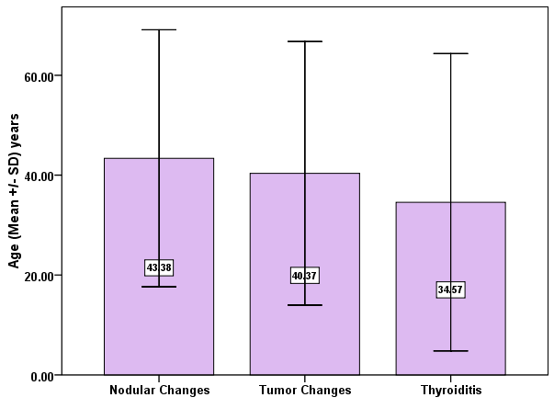

Figure (1): Distribution of thyroid patients by age

Figure (2): Distribution of thyroid patients by sex.

(2) The distribution of thyroid patients by sex, majority (46.20%) and (70.40%) of the male and female had nodular changes, respectively, was show in figure (2)

(3) The result showed that the mean IgM was highest among patients with nodular changes (2.75±4.98) g/L, meanwhile, the mean IgA was highest among patients with tumor changes (2.62±2.35) g/L. The mean IgG was highest among patients with nodular changes (17.43±6.53) g/L in figure (3).

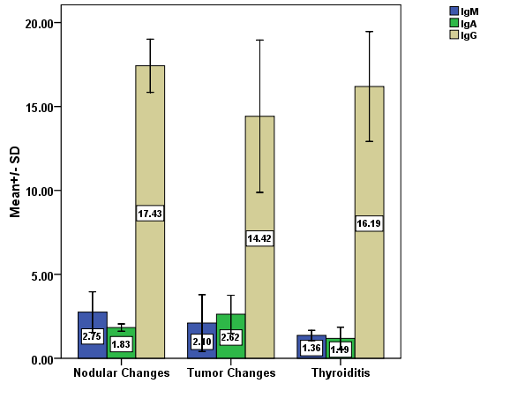
Figure (3): Distribution of thyroid patients by immunoglobulin

(4) Table (1): Shows the association of thyroid changes with TSH. There was significant association between thyroid changes with TSH, patients with thyroiditis were most likely to be hypothyroidism, p<0.05.

Table (1): Association of thyroid changes with TSH
Variable | Thyroid Changes |  |  | χ² | P  values
Variable | Nodular changes  (%) | Tumor changes  (%) | Thyroiditis  (%) | χ² | P  values
TSH  Hyperthyroidism  Euthyroid hypothyroidism | 9 (13.2)  51 (75.0)  8 (11.8) | 2 (10.5)  9 (47.4)  8 (42.1) | 1 (7.1)  5 (35.7)  8 (57.2) | 16.409 | 0.001ª*

*P value ≤0.05 is significant
^{a:} Fisher Exact test

(5) Histopathological pictures (slides)
1. Figure (4) Multinodular goiter high power × 40
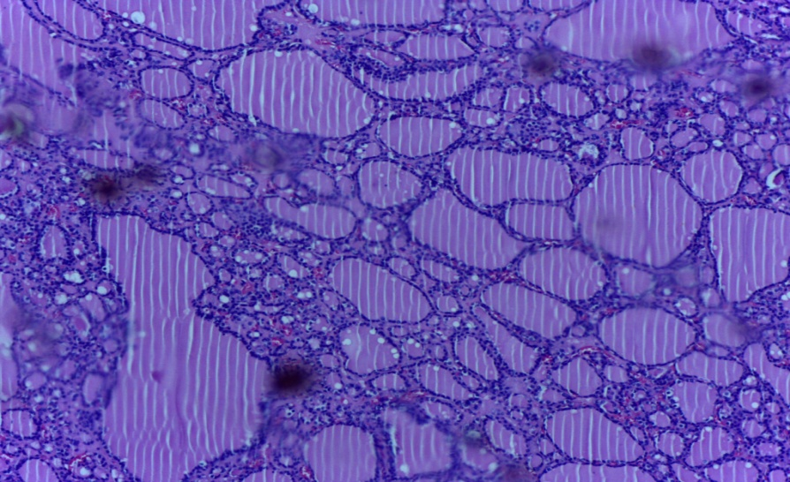
2. Figure (5) Toxic follicular adenoma high power × 40 shows at the right side intact capsule surrounding thyroid follicles with hyperplastic changes (no invasion of capsule).
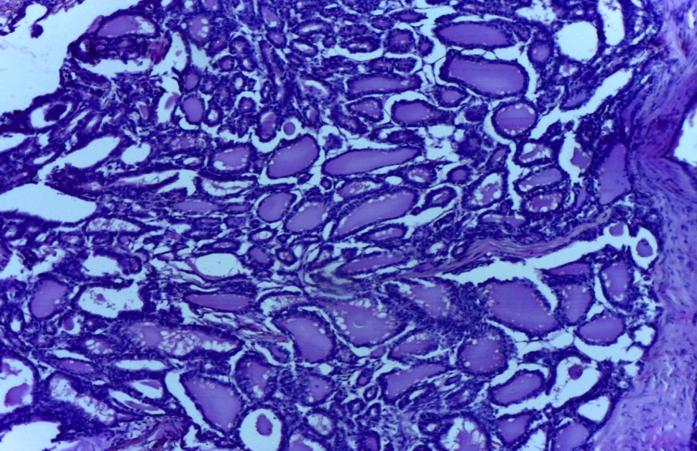
3. Figure (6) In this papillary carcinoma of thyroid note the small psammoma body in the center. The cells of this neoplasm often have nuclei with a central clear appearance from fixation.
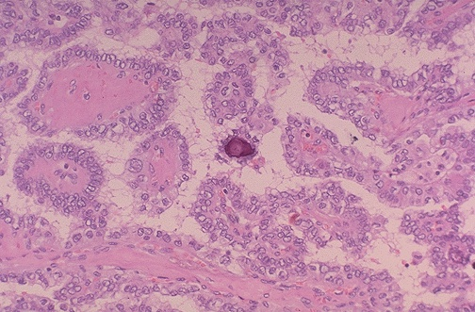

Discussion
In this cross sectional study Hashiomato's thyroiditis (H.T) is autoimmune disease associated with rearrangement or defect in immune system, and the patients with H.T suffering from hypothyroidism and disorders in immune system such as decreased weight and cellularity of lymphoid organs and decreased count of lymphocytes [10].
In the present study there is 14(13.8%) of cases H.T and this similar to Stai et al. in which 13.4% of goiter diagnosed as H.T but our study different from a series of (shinmed etal) where the H.T cases are 6.6% only. There is high incidence of H.T in present study may be due to most patients with H.T coming in hypo-thyroidism clinical state, so the surgery done for this patients and the small number groups included in this study [11].
In our work 64.5% of H.T patients clinically suffering from hypothyroidism, this result is slightly different from the result of (Pirainop et al.) in which the incidence of hypothyroidism in H.T is 81%., most of patients with HT coming to clinical attention after suffering of hypothyroidism clinical presentation, so most of thyroid follicles were damaged by lymphocytes and plasma cells.
The immunological changes in H.T patients are include increase in IgG level 78.6% of patients only while the IgM and IgA remain normal and this result is different from (Jafarzadeh et al.) where 67% IgG level increased. The IgG regard protein secreted from plasma cells play role in the immunity of body in chronic condition, the H.T is chronic auto immune disorder so associated with increase in IgG in most of cases [12]. The serum C3 level are low in 64.3% of patients this is different from (Jafarzadeh et al.) in which only 15% low levels. That has been reported as some inflammatory parameters such as C - reactive protein increase in H.T the same inflammatory mediators in H.T patients may inducing C3 and C4 production by hepatocytes epithelial cells and fibroblasts [13].
And in present study the MNG represent 67% of all cases and this result mildly more than (Cifter et al.) where 60.6%. This difference between two studies because of us added the hyperplastic nodule in background of goiter to Multinodular goiter. In our study the MNG patients presented with euothyroid is 75%, this result is slightly more than (Tadesse B et al.) where the 62.1% of MNG patients present in euothyroid state. The patient with MNG remain in euothyroid state even the iodine deficiency is present, so the thyroid gland enlarged and the TSH become above the normal to maintain the T3 and T4 within normal, then some of patient enter in hypothyroid condition when the MNG patients exposure to more metabolic demand and more iodine deficiency state and this may be explain the slight different between these studies [14].
The result of the present study of immunological profile in MNG patients show 72.1% are different from Jafarzadeh et al where the 38% of patients present with high IgG level, no significant change in other types of Igs (IgM, IgA). The result can be explained in the MNG, the patients clinically may be presented with hyperplastic nodule in MNG background and associated with hyperthyroidism and may be presented with hypothyroidism clinical manifestation, and in animal models it was found that the humoral immune response is positively modulated by thyroid hormones, the difference between two studies may be due to variation in sample number, the level of IgG is high it's may be related to other previous disease [15].
In present study, the MNG patients' 38.2% low level of C3 and this result differ from Jafarzadeh et al. where 15% of patients. While the serum C4 level except 44.2% low while the other cases remain within normal, it has been reported that the C3 synthesis is dependent upon interleukins (IL-1, IL-2) and tumor necrosis factor (TNF-ɣ), whereas C4 production is dependent upon IL-6 and TNF-α cytokines accordingly, the presence of a differently cytokine profiles in MNG patients may differentially induce C3 production [16].
Also In present study the immunoglobulins level are high in IgG and IgM as 63.2% and 21.1% respectively and this result is slightly lower than the study of (Jafarzadeh et al.) where the level of IgG is 73.7% while the IgM there is slight different between them. The level of IgG is high in different type of thyroid tumors this may be due to response of body immunity against the tumor, while the IgM level is slightly lower than (Jafarzadeh et al.) 22.5%, this increasing in the level of IgM may be related to immunological condition of the patients and the type of tumor, size and behavior of tumor metastasis or not, immunological status of patient if any other chronic disease or syndrome effects the immune system.
In our study the C4 level is high in about 36.8% of patients, this result is slightly higher than (Jafarzadeh et al.) the C4 34.3%, the C4 is a part of complement system may activated in thyroid tumor by different pathway the tumor cells secrete interleukin (IL-2) and interferon (IFN-&) while the IL4, IL5, IL10 stimulate the activation of C4 in minor way especially if there is hormonal changes [17]. C3 level is high in 5.3% only of patients but low in 10.5% , this variation may be explain in different in thyroid tumor and evoked immune response and activated T-cell.

References
1. Bendyug GD, Grinevich YA, Khranovskaya NN, et al. The state of the immune system found in thyroidectomized rats. Bull Exp Biol Med. 2003; 135:154-157.
2. Boelaert K., Newby P.R., Simmonds M.J. et al. Prevalence and relative risk of other autoimmune diseases in subjects with autoimmune thyroid disease," The American Journal of Medicine, vol. 123, no. 2, pp. 183. El-183. 9, 2010.
3. Studer H, Ramelli F: Simple goiter and its variants. Euthyroid and hyper-thyroidism Multinodular Goiters End-ocr Rev 202; 3: 40-61.
4. Hazard JB: thyroiditis: Areview AM Jclin Pathol 1995; 25: 289-298.
5. Vander Pump MP, Tunbridge WM, French JM, etal. The incidence of thyroid disorders in the community: a twenty-year follow-up of the Wickham Survey. Clin Endocrinol (oxf). Jul 1995; 43 (1): 55-68.
6. Takami HE Miyabe R, Kameyama K, Hashiomatos thyroiditis world J surg. 2008 may; 32:688-92.
7. Sobrinho-Simões M., Albores-Saavedra J., Tallini G., Santoro M., Volante M., Pilotti S., Carcangiu M. L., Papotti M., Matias-Guiu X., Guiter G. E., Zakowski M., Sakamoto A. (2004). “Poorly differentiated carcinoma,” in World Health Organization Classification of Tumors: Pathology and Genetics of Tumours of Endocrine Organs, eds DeLellis R. A., Lloyd R. V., Heitz P. U., Eng C., editors. (Lyon: IARC Press ;), 73–76.
8. Yamada T, Sato A, Komiya I, Nishimori T, Ito Y, Terao A, Eto S, Tanaka Y. An elevation of serum immunoglobulin E provides a new aspect of hyperthyroid Graves' disease. J Clin Endocrinol Metab. 2000; 85(8):2775-8.
9. Ford H.C. and Carter J.M., "The haematology of hyperthyroidism: abnormalities of leukocytes, thrombocytes and haemostasis," Postgraduate Med. J., vol. 64, no. 756, pp. 735-742, 1988.
10. L. Mehran,1 M. Tohidi,2 F. Sarvghadi,1 H. Delshad,1 A. Amouzegar,1 O. P. Soldin,3 and F. Azizi1:Management of Thyroid Peroxidase Antibody Euthyroid Women in Pregnancy: Comparison of the American Thyroid Association and the Endocrine Society Guidelines.
11. Francis S. Balucan, Syed A. Morshed, and Terry F. Davies Thyroid Auto-antibodies in Pregnancy: Their Role, Regulation and Clinical Relevance.
12. Cunha L.L., Ferreira R. C., Marcello M.A., Vassallo J., and Ward L.S. Clinical and Pathological Implications of Concurrent Autoimmune Thyroid Disorders and Papillary Thyroid Cancer.
13. Hueston WJ, King DE, Geesey ME. Serum biomarkers for cardiovascular inflammation in subclinical hypo-thyroidism. Clin Endocrinol (Oxf). 2005 Nov; 63(5):582-7.
14. Navin Rudolph, Claudia Dominguez, Anthony Beaulieu, Pierre De Wailly, and Jean-Louis Kraimps. The Morbidity of Reoperative Surgery for Recurrent Benign Nodular Goiter: Impact of Previous Unilateral Thyroid Lobectomy versus Subtotal Thyroidectomy.
15. Flecha AJ, Genaro AM, Lysione KAM, Caro RA, Coluccia AG, Cremaschi GA. Experimental evidence pointing to the bidirectional interaction between the immune system and the thyroid axis. Int J Immunopharmacol. 2000; 22:491–500.
16. Ardoh A, Fujiyama Y. Differential cytokine regulation of complement C3, C4, and factor B in human epithelial cell line. J Immunol. 1993; 151:4239-4247.
17. Ward LS, Fernandes GA. Serum cytokine levels in autoimmune and non-autoimmune hyperthyroid states. Braz J Med Biol Res. 2000; 33(1):65-9.

