Histopathological Assessment of Anti-Ulcerogenic Effect of Montelukast Against Acetyl Salicylic Acid Induced Gastric Ulcer in Male Rabbits

Ali Hassan Ijam* Nisreen J. Al-Bayati** Mufeed J. Ewadh**
Haider A. Al-Kaffaji**
**College of Medicine, Babylon University, Iraq
*Email: aliajam84@gmail.com



Received 31 December 2014 Accepted 18 January 2015
Abstract
The effects of anti-ulcerogenic drugs are dependent on the increase in prostaglandin production and reduction in leukotriene production in the gastric mucosa. This study aimed to evaluate the gastro-protective effect of montelukast both macroscopically and microscopically .Thirty local domestic male rabbits had been used in this study, divided randomly into 5 groups as follows: control group, acetylsalicylic acid (ASA) group, Omeprazole group, montelukast group and montelukast alone group. At the end of the experiment, the stomachs of rabbits were removed then the mucosa was examined to determine the ulcer parameters by means of dissecting microscope. Furthermore, stomach tissue sections were prepared for histological examination. The results of this study revealed as aministration of acetyl salicylic acid in dose of 500 mg/kg significantly increased the mean ulcer index and showed necrosis of gastric mucosa associated with submucosal edema and inflammatory cell infiltrate. But in presence of montelukast significantly decreased the ulcer index with antiulcerogenic activity about 81%, mild edema and inflammatory cell infiltration. In this study, it was observed that montelukast behaved as an anti-ulcerogenic drug both macroscopically and microscopically.

الفحص النسيجي المرضي لتأثير المونتيلوكاست على القرحة المعدية المستحدثة بحامض اسيتيل ساليسيلك في ذكور الارانب
الخلاصة
تأثير الادوية المضادة للتقرح يعتمد على زيادة انتاج البروستاكلاندين و قلة انتاج الليكوترين في الغشاء المخاطي المعدي . هذه الدراسة تهدف الىتقيم التأثير الوقائي لبطانة المعدة لعقار المونتيلوكاست على مستوى الفحص النسيجي المرضي. تم استخدام ثلاثين ارنبا محليا ذكرا في هذهالدراسة وقسمت عشوائيا الى خمس مجاميع كالاتي : مجموعة السيطرة ,مجموعة حامض اسيتيل ساليسيلك, مجموعة الاومبرازول, مجموعة المونتيلوكاست , مجموعة المونتيلوكاست فقط. في نهاية التجربة تم استخراج معد الارانب وفحصها تحت المجهر التشريحي لتحديد مؤشرات القرحة .بالإضافة الى تحضير مقاطع نسيجية للمعدة لاختبارها تحت المجهر الضوئي.وكانت النتائج عند اعطاء حامض اسيتيل ساليسيلك بجرعة 500 ملغم/كغم يسجل ارتفاعا معنويا في معامل القرحة و يظهر تلف في جدار المعدة المخاطي مترافقة مع وذمة في الطبقة تحت المخاطية و ارتشاحات خلوية التهابية لكن عند اعطاء عقار المونتيلوكاست هناك انخفاضا معنويا في معامل القرحة مع ارتشاحات خلوية التهابية قليلة .في هذه الدراسة نستنتج بأن عقار المونتيلوكاست له تأثير وقائي لبطانة المعدة من التقرح على مستوى الفحص النسيجي المرضي.
ـــــــــــــــــــــــــــــــــــــــــــــــــــــــــــــــــــــــــــــــــــــــــــــــــــــــــــــــــــــــــــــــــــــــــــــــــــــــــــــــــــــــــــــــــــــــــــــــــــــــــــــــــــــ

Introduction
Gastric ulcer is one of the most widespread diseases in the world. It is an erosion of the gastric mucosal layer or excavation of the surface of gastric tissue as a result of the sloughing of inflammatory necrotic tissue [1]. The pathophysiology of gastric ulcer involves an imbalance between offensive or injurious (acid, pepsin, leukotrienes, reactive oxygen species, alcohol, steroidal and non-steroidal anti-inflammatory drugs, stress and Helicobacter pylori) and defensive mucosal factors (mucus- bicarbonate barrier, prostaglandin, mucosal blood flow, antioxidant enzymes and some growth factors) [2].
Non-steroidal anti-inflammatory drugs (NSAIDs) are used widely throughout the world, but can produce significant gastrointestinal (GI) complications, varying from acute microscopic gastric mucosal changes to more serious ulcer bleeding or perforation [3]. NSAID’s are known as one of the most common pathogenic factors associated with gastric ulcer [4].
ASA is one of the NSAID which is widely used for the treatment of rheumatoid arthritis and related diseases as well as the prevention of cardiovascular thrombotic diseases [5]. It damages gastrointestinal mucosa by two mechanisms: (i) by direct local injury and (ii) by systemic inhibition of cyclo-oxygenase resulting in a relative deficiency of prostaglandins [6].
Montelukast, a selective reversible Cysteinyl leukotriene receptor 1 antagonist, is used in the treatment of allergic rhinitis and asthma [7]. Montelukast was reported to have beneficial effects in management of experimental gastric mucosal ulceration [8,9], colitis [10], spinal cord injury [11], burn- and sepsis-induced multiorgan damage [12,13], hepatic ischemia /reperfusion injury [14], testes ischemia /reperfusion injury [15] and intestinal ischemia/reperfusion- induced acute lung injury [16].

Aim of Study
Thepurpose of the present study was to investigatethe effect of montelukast on the ulcerated gastric tissues in comparison with omeprazole both macroscopically and microscopically

Materials and Methods
Drugs
ASA was obtained in the form of powder from schuchardt Company, Germany. Montelukast was obtained in the form of tablet (10 mg) from MSD Company, united kingdom. Omeprazol (40 mg) vial obtained from Cipla Company, India.

Experimental Animals:
Thirty local domestic male rabbits had been used in this study; their weight was between 1.5 to 2.5 kg. The rabbits were fed with standard chow diet and they had free access to drink water ad libitum.
Induction of Gastric ulcer:
Induction of gastric lesion was carried out on rabbits administrated ASA which is given orally through a stomach tube in a dose of 500 mg/kg body weight (b.w.) as single dose [17].
Experimental Protocol:
After 2 weeks adaptation period, the animals were randomly separated into 5 groups (6 rabbits in each group) as shown:
Group 1 (Normal control group): all rabbits in this group were received distilled water 5 ml orally through stomach tube during an experimental period.
Group 2 (Active control group): all rabbits in this group were given ASA (500 mg/kg b.w.) orally through stomach tube as single dose [17].
Group 3 (Omeprazole pretreated group): all rabbits in this group were given omeprazole (20 mg/kg b.w.) intraperitoneally (i.p) 1 hour before ASA administration [18].
Group 4 (Montelukast pretreated group): all rabbits in this group were given montelukast (20 mg/kg b.w.) orally through stomach tube 1 hour before ASA administration [9].
Group 5 (Montelukast alone treated group): all rabbits in this group were given montelukast (20 mg/kg b.w) orally through stomach tube 1 hour before administration of 5 ml DW.
The omeprazole and montelukast were continually given in a single daily dose for 3 days. One hour after the last dose (3rd day) of 36 hours fasted animals, ASA was administered orally to the animals (except group 1 and group 5) in a dose of (500 mg / kg b.w), then all the animals were sacrificed 5 hours later. All experiments were performed during the same time of the day to avoid diurnal variations of putative regulators of gastric functions.
Tissue sample preparation
At the end of the experiment, the animals were sacrificed by an overdose of chloroform vapors and their abdomens were opened through a mid-line incision and the stomach of each animal was separated from the surrounding viscera and removed, then stomach was washed with physiological saline solution and immersed in freshly prepared phosphate buffer with PH 7.4,then the mucosa was examined to determine the ulcer parameters by means of dissecting microscope [19]. The stomach then preserved in 10% of neutral formalin solution. The fixed specimens were then trimmed, washed and dehydrated in ascending grades of alcohol. Specimens were then cleared in xylene, embedded in paraffin, sectioned at 4-6 microns thickness and stained with Heamtoxylin and Eosin stain and mounted in DPX, to be examination under the light microscope [20].
Calculation of lesion parameters
- Total lesion length in (mm) for each stomach was measured and served as the ulcer index. The sum of the total length of long ulcers and petechial lesions in each group of rats was divided by its number to calculate the ulcer index (mm) [21].
- Anti-ulcerogenic activity (AUA) was calculated for each group using the following equation [22]:

U.I. of ASA group - U.I. of pretreated group
AUA = --------------------------------------------------------------- X 100 %
U.I. of ASA group

Statistical Analysis of Data
The results were expressed as mean ± standard deviation (mean ± SD). Statistical analysis was carried out using one way ANOVA followed by least significance difference (L.S.D.) test for multiple comparisons between groups by using the 19th edition of SPSS program. A value of p < 0.05 was considered to indicate a significant difference between groups.

Results
Effect of Studied Drugs on Gastric Ulcer Index in Male Rabbits.
The administration of ASA showed a significant increase in ulcer index (P< 0.05) (34.25 + 5.84 mm) when compared with the normal control group. While The administration of omeprazole and montelukast showed a significant decrease in ulcer index (P< 0.05) (2.53+ 0.58 mm) (6.7 + 0.37 mm) with antiulcerogenic activity 93%, 81% respectively when compared with the ASA received group, table 1.

Table (1): The effect of the studied drugs on ulcer index and antiulcerogenic activity in male rabbits

Groups | Ulcer index( mm)  Mean + SD | Anti-ulcerogenic activity
Normal control group | 0 | ……..
Acetylsalicylic acid treated group | 34.25 + 5.84 | 0%
Omeprazole pretreated group | 2.53 + 0.58 | 93%
Montelukast pretreated group | 6.7 + 0.37 | 81%
Montelukast alone treated group | 0 | ………

Gastric Lesions:
Macroscopic Gastric Examination
Normal Control Group:
The stomachs obtained from normal control group showed no gastric mucosal lesions as shown in (figure 1).

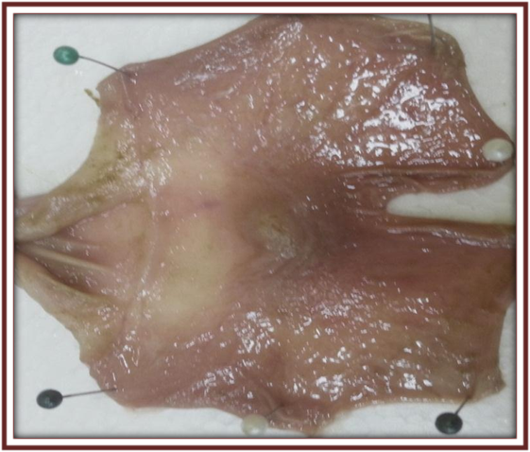
Figure (1): Stomach of normal control group .

Acetylsalicylic Acid Treated Group:
Oral administration of ASA produced marked gross mucosal lesions, including long hemorrhagic bands and petechial lesions. On gross examination these hemorrhagic bands are characterized by different sizes along the longitudinal axis of the glandular part of stomach (Figure 2) compared with normal mucosa.

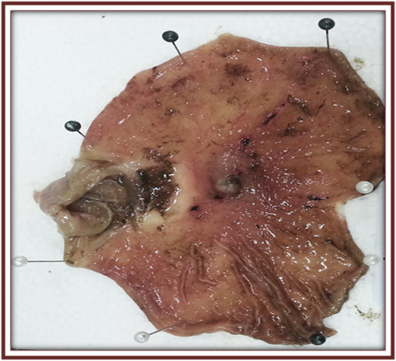
Figure (2): Stomach of acetylsalicylic acid treated group

Omeprazole Pretreated Group:
The degree of gastric mucosal damage in omeprazole pretreated group showed a less degree of ulceration with less mucosal necrosis and hemorrhage than that occur in acetylsalicylic acid treated group with percent protection 93% (figure 3, table 1).

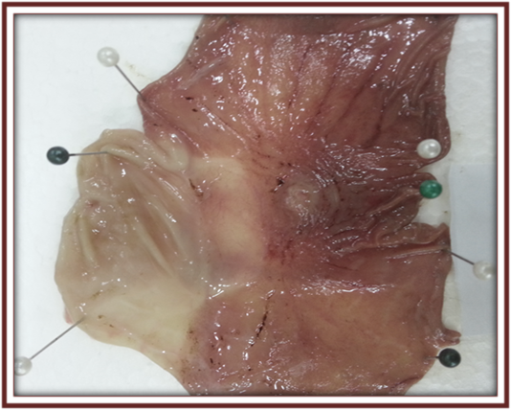
Figure (3): Stomach of omeprazole pretreated group

Montelukast Pretreated Group:
Oral administration of montelukast produced a hyperaemic areas and small lesions affect the gastric mucosa but less severe than lesion that observed in acetylsalicylic acid treated group and more than that occur in Omeprazole pretreated group with percent protection 81% (figure 4, table 1).

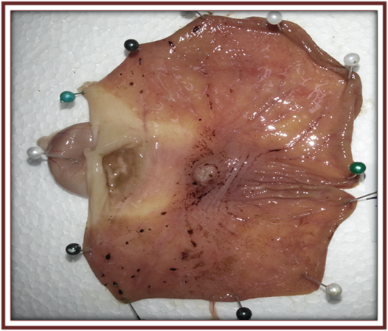
Figure (4): Stomach of montelukast pretreated group

Montelukast Alone Treated Group
The stomachs obtained from montelukast alone treated groupshowed normal appearance as normal control group (figure-5).

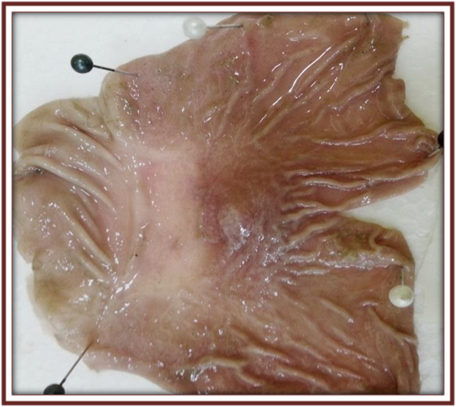

Figure (5): Stomach of montelukast alone treated group

Microscopic Gastric Examination
The histological differences between different treated groups were observed at the microscopical level as the following:
Normal Control Group:
The histological results showed normal gastric mucosal lining and there is no significant pathological changes appear at the mucosal level (figure 6).
Acetylsalicylic Acid Treated Group:
Administration of ASA resulted in disruption of the surface epithelium with necrosis of gastric mucosa, associated with submucosal edema and inflammatory cell infiltrations (figure 7).
Omeprazole Pretreated Group:
The administration of omeprazole at dose of 20 mg/kg markedly reduced the changes observed in ASA treated group as shown in (figure 8).

Montelukast Pretreated Group:
The administration of montelukast at dose of 20 mg/kg also reduced these lesions but less than omeprazole (Figure 9).
Montelukast Alone Treated Group:
Gastric tissue of this group showed intact appearance of histological structure as a normal control group (figure 10).

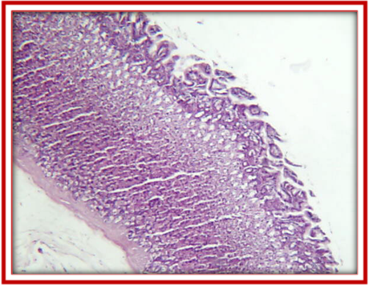
Figure (6): Microscopic appearance of normal stomach mucosa of the rabbits stained with hematoxylin and eosin at low power X 10.

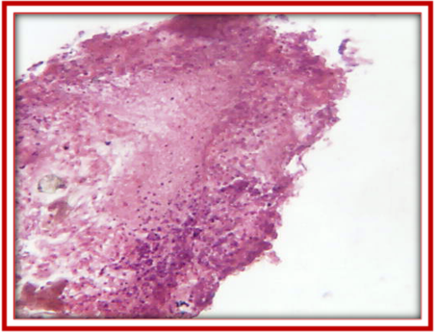
Figure (7): Light microscopy of gastric tissue of acetylsalicylic acid treated group stained with hematoxylin and eosin at low power X 10, showed necrosis of gastric mucosa associated with submucosal edema and inflammatory cell infiltrate (arrows).

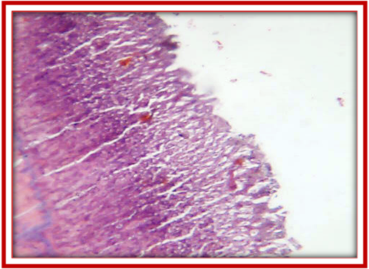
Figure (8): Light microscopy of gastric tissue of omeprazole pretreated group stained with hematoxylin and eosin at low power X 10, showed gastric mucosal protection, less disruption of the surface epithelium and mild inflammatory cell infiltrate .

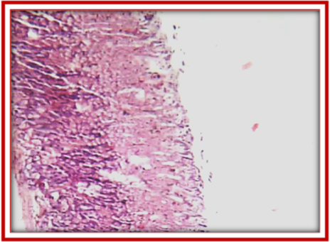

Figure (9): Light microscopy of gastric tissue of montelukast pretreated group stained with hematoxylin and eosin at low power X 10showed significant protection of surface epithelium with mild edema and inflammatory cell infiltrate.

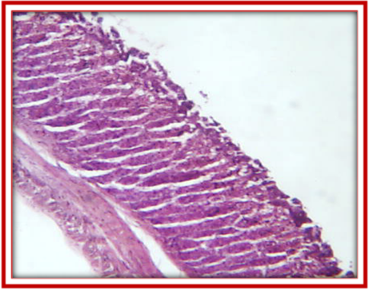
Figure (10): Light microscopy of gastric mucosa tissue treated with montelukast alone stained with hematoxylin and eosin at low power X 10 showed intact appearance of histological structure as normal control group.

Discussion
The present study evaluated both macroscopically and microscopically the gastroprotective effects of montelukast on ASA induced gastric damage in rabbits. The results were compared with omeprazole as a reference anti-ulcerogenic drug.
Non-steroidal anti-inflammatory drugs (NSAIDs), including ASAare widely used with major limitation due to their potentially serious risk of gastrointestinal side effects ranging in severity from mild dyspepsia to gastrointestinal hemorrhage and perforation [23,24]. Administration of ASA is considered as a classical model for induction of acute gastric mucosal injury [25, 26].
Macroscopically, the observations of the present study after administration of ASA showed a significant increase (p < 0.05) in ulcer index in comparison with normal control group and this in agreement with Sener-Muratogluet al., 2001 [27] who found that ASA induced gastric mucosal lesions in rat model.
Various mechanisms have been suggested to explain the increased in ulcer index in ASA treatment group, one of these mechanisms is local direct damage of gastric mucosa [28,29]. ASA acts locally through the release of salicylic acid in the stomach, salicylic acid un ionized in gastric juice. It enters and accumulates within the epithelial cells of stomach then ionized intracellulary and disturbs cell metabolic functions, increasing mucosal permeability and allowing the back diffusion of H⁺ ions [30, 31]. From the results of the present study, on gross examination there is a marked gastric mucosal damage induced by ASA as compared with normal control group (figure 2) this may be reflect the local direct action of ASA on gastric mucosa.
Another mechanism has been proposed to explain the gastric mucosal damage induced by ASA related to their ability to inhibit the cyclooxygenase (COX) enzyme that is responsible for conversion of arachidonic acid to prostaglandins (PG) that are needed to keep the gastric mucosal integrity [32]. However, there is an evidence that COX inhibition by NSAIDs diverting arachidonic acid metabolism to 5-lipoxygenase (5-LOX) pathway, suggests the possible role of leukotrienes (LTs) in gastric mucosal damage through their stimulatory effects on neutrophil adherence to vascular endothelium (chemotaxis ), affect vascular tone and its effects on vascular permeability promoting vascular stasis and subsequent reduction in tissue perfusion [33,34,35].
Also experimental studies have demonstrated that NSAIDs induce gastric mucosal damage via lipid peroxidation and ROS produced by recruited leukocytes and xanthine oxidase activity [36].
Recently, many authors have been used Omeprazole as a reference drug for drug screening studies [37,38]. According to the results of the present investigation, omeprazole significantly decreased gastric ulcer index with antiulcerogenic activity was equal to 93% when compared with normal control group. Omeprazole, a proton pump inhibitor (PPI), exhibits an anti-secretory effect through inhibition of the gastric H⁺/K⁺ ATPase at the secretory surface of parietal cell and gastro-protective effect through inhibition of neutrophil functions [39].
Various studies has been confirmed the antioxidant gastroprotective properties of omeprazole independent of its proton-pump inhibitory potential but attributed to a decrease in oxidative stress and an increase in antioxidants status [40,41].
Macroscopically, according to the results of the present investigation, montelukast significantly decreased the gastric ulcer index and its antiulcerogenic activity was equal to 81% when compared with normal control group. These results was in line with Dengizet al . [9] who reported that montelukast has gastroprotective and antioxidant activity against indomethacin induced gastric mucosal damage .
Microscopically, the results of this study showed that there is no lesion in the stomach in normal control group in contrast to the stomach in active control group that show severe ulceration and hemorrhage, upon omeprazole pretreatment, the mucosal epithelium had near normal architecture and it had less hemorrhage as against the ASA induced damages in the mucosal epithelium of the active control group. These observations on the cytoprotective nature of omeprazole against ASA induced gastric ulcers prove its antiulcer activity.
Regarding montelukast, the lesion of gastric mucosa show less severe effects with protection of the gastric mucosa from the effects of ASA less than the effects of omeprazole. This may be attributed to its ameliorating effect on oxidative damage and leukotriene activity. From the results of study we conclude that montelukast has antiulcerogenic activity on macroscopic and microscopic level.

References
- Yuan,Y. ; Padol, I.T. and Hunt, R.H. (2006). Peptic ulcer disease today. Nature Clinical Practice Gastroenterology and Hepatology, 3: 80–89.
- Hitesh, K.R.; Harish C.H.; Ramesh K.R. (2012). Antiulcer potential of ethyl cellulose floating microspheres containing ranitidine hydrochloride in experimental rodents. Asian Journal of Pharmaceutical and Clinical Research, 5(3): 205-209.
- Lee, K.N.; Lee, O.Y.; Choi ,M.G.; Choi ,S.R.; Lee, D.H.; Lee, Y.C.(2011). Prevention of NSAID-associated gastroduodenal injury in healthy volunteers-a randomized, double-blind, multicenter study comparing DA-9601 with misoprostol. Journal of Korean Medical Science, 26(8):1074-1080.
- Konturek , J.W. (2003). Discovery by Jaworski of Helicobacter pylori and its pathogenetic role in peptic ulcer, gastritis and gastric cancer. Journal of physiology and pharmacology, 54 (3): 23-41.
- Heibashy, M.I.; Mazen, G.M. and Ibrahim, M.A. (2014). Efficacy and Safety of some Medical Herbs on Gastric Ulcer Induced by Aspirin in Rats. Journal of Pharmacy and Biological Sciences, 9 (3): 19-27.
- Wallace, J.L. (2001). Pathogenesis of NSAID-induced gastroduodenal mucosal injury. Best Practice and Research Clinical Gastroenterology, 15(5): 691-703.
- Benninger, M.S.; Waters, H. (2009). Montelukast: Pharmacology, Safety, Tolerability and Efficacy. Clinical Medicine: Therapeutics, 1: 1253-1261.
- Sener, G.; Kapucu, C.; Çetinel, S.; Cikler, E. and Ayanoglu, G. (2005). Gastroprotective effect of leukotriene receptor blocker montelukast in alendronat-induced lesions of the rat gastric mucosa. Prostaglandins, Leukotriene and Essential Fatty Acids, 72: 1-11.
- Dengiz, G.O.; Odabasoglu, F.; Halici, Z.; Cadirci, E. and Suleyman, H. (2007). Gastroprotective and antioxidant effects of montelukast on indomethacin-induced gastric ulcer in rats. Journal of Pharmacological Science . 105: 94-102.
- Holma, R.; Salmenperä, P.; Virtanen, I.; Vapaatalo, H. and Korpela, R. (2007). Prophylactic potential of montelukast against mild colitis induced by dextran sulphate sodium in rats. Journal of Physiology and Pharmacology, 58(3):455-67.
- Cavus, G., Altas, M.; Aras, M.; Özgur, T.; Serarslan, Y.; Yilmaz, N. et al. (2014). Effects of montelukast and methylprednisolone on experimental spinal cord injury in rats. European Review for Medical and Pharmacological Sciences, 18: 1770-1777.
- Sener, G.; Kabasakal, L.; Çetinel, S.; Contuk, G.; Gedik, N.; Yeğen, B.Ç.(2005). Leukotriene receptor blocker montelukast protects against burn-induced oxidative injury of the skin and remote organs. Burns. 31: 587.
- Sener, G.; Sehirli, Ö.; Çetinel, S.; Ercan, F.; Yüksel, M.; Gedik, N.; et al. (2005). Amelioration of sepsis-induced hepatic and ileal injury in rats by the leukotriene receptor blocker montelukast. Prostaglandins ,Leukotriene and Essential Fatty Acids. 73: 453.
- Daglar, G.; Karaca, T.; Yuksek, Y.N.; Gozalan, U.; Akbiyik, F.; Sokmensuer, C. et al. (2009). Effect of Montelukast and MK-886 on Hepatic Ischemia-Reperfusion Injury in Rats. Journal of surgical research, 153(1): 31-38.
- Ozturk H, Ozturk H, Gideroglu K, Terzi H, Bugdayci, G. (2010). Montelukast protects against testes ischemia/reperfusion injury in rats. Candian Urological Association Journal, 4(3): 174-179.
- Terzi, E.H.; Duran,A.; Firat,T.; Ocak,T.; Kukner, A. (2014). Effect of montelukast on acute lung injury induced by intestinal ischemia and reperfusion in rats . ActaMedicaMediterranea, 30: 411- 417.
- Debnath, S. and Guha, D. (2007). Role of Moringaoleifera on enterochromaffin cell count and serotonin content of experimental ulcer model. Indian journal of experimental biology, 45(8): 726-31.
- Prasad, S.V.; Srinivas,A.; Ambareesh,K.; Nayak, B.B.; Shinde, B.B. and Ambadas, B. (2012). Protective role of oxitard in drug induced ulcers in rats. International journal of biological and medical research, 3(3): 1948 - 1951.
- Khalil, J.; Akhter, S.; Bhatti, S.A. and Bukhari, M.H. (2010). Gastric ulcer healing effects of nigella sativa; a comparative experimental study with cimetidine. Biomedica, 26: 61 – 65.
- Bancroft, J.D. and Spencer, L.T. (2012) .Microtomy: Paraffin and frozen. In: Bancroft, J.D.; Suvarna, S.K. and Layton, C. Bancroft’s Theory and Practice of Histological Techniques, Seventh edition, Churchill Livingstone Elsevier: 126-138.
- Alkofahi, A. and Atta, A.H. (1999). Pharmacological screening of anti-ulcerogenic effects of some Jordanian medicinal plants in rats. Journal of Ethnopharmacol, 67:341-345.
- Michael,R.; Younan, N.; Aziz ,M.; Mostafa, N.; Ghobriel, A. and Gintautas, J. (2001). Effect of a Non-Opiate Analgesic, Nefopam Hydrochloride, on Stress Gastric Ulcer in Rats. Proceedings of the Western Pharmacology Society, 44: 109-111.
- Fujimori, S.; Gudis, K. and Sakamoto, C. (2010). A Review of Anti-Inflammatory Drug-Induced Gastro-intestinal Injury: Focus on Prevention of Small Intestinal Injury. Pharmaceuticals, 3: 1187-1201.
- Vonkeman, H.E. and van de Laar, M.A. (2010). Nonsteroidal anti-inflammatory drugs: adverse effects and their prevention. Seminars In Arthritis And Rheumatism, 39:294-312.
- Jainu,M. and Devi, C.S. (2004) .Antioxidant effect of methanolic extract of solanumnigrum berries on aspirin induced gastric mucosal injury. Indian Journal of Clinical Biochemistry, 19 (1) 57-61.
- Khasaf, H.K.; Hassan, T. and Khudeir, A.N. ( 2012 ) . Study the effect of ethanolic extract of ( MatricariaRecutita and GlycyrrhrzaGlabra ) compared with cimetidine in treating gastric ulceration in rabbits induced by aspirin. Basrah Journal of Veterinary Research, 11 (2): 135-144.
- Sener-Muratoglu, G.; Paskaloglu, K.; Arbak, S.; Hürdag, C. and Ayanoglu-Dülger, G. (2001). Protective effect of famotidine, omeprazole, and melatonin against acetylsalicylic acid-induced gastric damage in rats. Digestive Diseases and Sciences, 46: 318-330.
- Schlansky, B. and Hwang, J.H. (2009). Prevention of nonsteroidal anti-infl amatory drug-induced gastropathy. Journal of Gastroenterology, 44:44–52.
- Matsui, H.; Shimokawa, O.; Kaneko, T.; Nagano, Y.; Rai, K. and Hyodo, I. (2011). The pathophysiology of non_steroidalanti_inflammatory drug (NSAID) induced mucosal injuries in stomach and small intestine. Journal of Clinical Biochemistry and Nutrition, 48(2):107–111.
- Kauffman, G. (1989). Aspirin-induced gastric mucosal injury: lessons learned from animal models. Gastroenterology, 96:606–614.
- Papatheodoridis, G.V. and Archimandritis, A.J. (2005). Role of Helicobacter pylori eradication in aspirin or non-steroidal anti-inflammatory drug users. World Journal of Gastroenterology, 11(25): 3811-3816.
- Lichtenberger, L.M. (2001). Where is the evidence that cyclooxygenase inhibition is the primary cause of non-steroidal anti-inflammatory drug (NSAID)-induced gastrointestinal injury? Topical injury revisited. Biochemical Pharmacology, 61: 631–637.
- Rainsford, K.D. (1987). The effects of 5-lipoxygenase inhibitors and leukotriene antagonists on the development of gastric lesions induced by non-steroidal anti-inflammatory drugs in mice. Agents and Actions, 21(3-4): 316-319.
- Martel Pelletier, J.; Lajeunesse, D.; Reboul, P.; Pelletier, J. (2003). Therapeutic role of dual inhibitors of 5-LOX and COX, selective and non-selective non-steroidal anti-inflammatory drugs. Annals of the Rheumatic Diseases, 62:501–509.
- Gandhi, M.N.; Challa, S.R.; Prasanth, P. and Gandhi, T.R. (2012). Role of leukotrienes in NSAID induced gastric ulceration and inflammation in wistar rats. Asian Pacific Journal of Tropical Disease, 2 (3): 215-219.
- Ohta, Y.; Kobayashi, T.; Nishida, K. and Ishiguro, I. (1999). Participation of xanthine-xanthine oxidase system and neutrophils in development of acute gastric mucosal lesions in rats with a single treatment of compound 48/80. a mast cell degranulator. Digestive Diseases and Sciences, 44(9):1865-1874.
- Takawale, H.; Mute, V.; Awari, D.; Hukkeri, V.I.; Mehta, P. and Vawhal, P. (2011). Screening of Antiulcer Activity of Caesalpiniapulcherrima L. Bark. Against Aspirin Induced Ulcer in Rats. World Journal of Medical Science, 6(4):168-172.
- Firdous, S.M.; Neraja, K.; Debnath, R.; Dipak, S. and Sravanthi, K. (2012). Evaluation of antiulcer activity of ethanolic extract of Sechiumedule fruits in experimental rats. International Journal of Pharmacology and Pharmaceutical Science , 4: 374-377.
- Morjan, S.; Al Laham, S. and Atieh, R. (2013). Gastroprotective Efficacy of Folic Acid and Omeprazole in Indomethacin-Induced Gastropathy in Rats. International Journal of Pharmacognosy and Phytochemical Research, 5(2): 113-119.
- Abdul-Aziz, K.K. (2011). Comparative Evaluation of the Anti-ulcer Activity of Curcumin and Omeprazole during the Acute Phase of Gastric Ulcer. Food and Nutrition Sciences, 2: 628-640.
- Ittiyavirah, S.P. and Shenika, M.S. (2014). Evaluation of antioxidant and anti-inflammatory activity of Omeprazole against experimentally induced colitis. Journal of Scientific and Innovative Research, 3(3): 352-356.

