Hemotological and Coagulatory Alteration in Splenectomized Versus
Non-Splenectomized Transfusion Dependant Β-Thalassemic Major Patients

Haider AL-Shamari ¹ Liqaa M. Majeed Al sharifi ² Farah A. Hussain ³
¹ College of Medicine, Baghdad University
² College of Medicine, Babylon University, E-mail: mohammedliqaa79@gmail.com
³Teaching Laboratories, Medical City, Baghdad


Received 22 January 2015 Accepted 18 February 2015
Abstract
β-Thalassemia is an inherited hemolytic disorder caused by a partial or complete deficiency of β- globin chain synthesis. Profound hemostatic changes have been observed in patients with β-thalassemia major with history of thromboembolic or haemorrahgic manifestation.
The aim of this study was to assess the coagulation parameters; PT, PTT, factor V, factor VIII level in β-thalassemia major and to compare the effect of splenectomy on each and to evaluate the patients for increased risk of thrombosis and/ or bleeding.
Sixty patients with transfusion dependent β-thalassemia major ;thirty of them splenectomized (16 females and 14 males), and thirty non-splenectomized (13 females and 17 males) aged between (3-38) years at different stages of the disease were included in this study from Babil hospital for maternity and pediatrics from the first of April 2012 to the 15th of July 2012. Seven milliliters of venous blood were collected from each patients and control persons included in this study by clear venipuncture under aseptic conditions from antecubital fossa with easy withdrawal of blood , subdivided as follows:
1*1.8ml in o.2 ml trisodium citrate with gentle mixing for coagulation testing include PT,PTT, factors V and VIII.
2*2ml in EDTA tube for routine haematological screening tests include: PCV,WBC, platelet count.
Normal pooled plasma for factor assay obtained from 20 normal healthy persons ,plasma was mixed and divided into aliquot each containing about 1ml stored at -40C⁰ for 3-4 weeks as a control for factor assay study. The mean age was 18.2 years in splenectomized patients and 8.9years in non splenectomized patients. The PCV level was low in both groups 26.8,24.6 in splenectomized and non splenectomized patients respectively with statistical significant difference between them (p value <0.05).
WBC and platelets count were both within normal limit ,however there was a statistical difference in platelets count between splenectomized and non splenectomized groups with mean value were 259.6 and 218.7 x10⁹ /L respectively, p value <0.05. WBC count mean were 8.2 and 7.0x10⁹ /L in splenectomized and non splenectomized patients respectively with no statistical significant difference between them p value >0.05.
These patients (splenectomized and non splenectomized) have normal mean PT,PTT, which were 14.4 sec, 33 sec for splenectomized and 14.1 sec,33.2 sec for non splenectomized patients respectively with no statistical significant difference between them p value >0.05. Factors V,VIII level were 103%,127.8% for splenectomized patients and 100.3, 128.9% for non splenectomized patients respectively with no statistical significant difference between them p value>0.05 ,but there was statistical significant difference between the control group and the total thalassemic patients (P value <0.05),however splenectomized patients had more episodes of bleeding and thrombotic manifestations than non splenectomized patients which might be due to causes unrelated to coagulation factors V and VIII level.
Splenectomy could affect PCV but had no effect on coagulation factors V and VIII.-Bleeding manifestations were more frequent in splenectomized patients with normal factor V,VIII and platelets count.-Thalassemics in Babylon thalassemic center were under transfused.
Keywords: beta thalassemia major,PT, PTT,factor V,factor VIII,Splenectomy

تغيير عوامل الدم والتخثر في رافعي الطحال مقارنة بغير رافعي الطحال لمرضى فقر الدم البحر الابيض المتوسط الكبرى

الخلاصة :
مرض فقر الدم البحر الابيض المتوسط(ثلاسيميا) الكبرى هو مرض وراثي ناتج عن نقص كلي او جزءى في سلسلة الكلوبين نوع بيتا مما ينتج عنه نقص في خضاب الدم داخل كريات الدم الحمراء.هناك تغيرات في توازن الدم كثيرة تحصل لدى المرضى قد تؤدي الى حدوث النزف او التخثر الدموي.
الهدف من الدراسة هو لتقييم عوامل التخثر الخامس والثامن وقت الثرومبين ووقت الثرومبوبلاستين ومقارنة تاثير رفع الطحال للمرضى على هذه العوامل وكذلك معرفة تاثير هذه العوامل في اعراض النزف الدموي او التخثر الدموي لدى المرضى.
60 مريض تم سحب الدم منهم ممن مسجلين في مركز الثلاسيميا في مستشفى بابل للولادة ولاطفال 30 منهم رافعي الطحال (16 اناث ، 14 ذكور)، 30 غير رافعي الطحال(13 اناث 17 ذكور) تتراوح اعمارهم بين 3 الى 38 سنة من الاول من نيسان 2012 الى الخامس عشر من تموز 2012.
7مل من الدم الوريدي تم سحبه وقسم الى 1.8 مل في انبوبة ثلاثي صوديوم ستريت لفحوصات التخثر و 2 مل في انبوبة EDTA لفحوصات كريات الدم البيضاء والصفيحات الدموية ونسبة الدم.كذلك جمع عينات من 20 شخص طبيعي مزجت معا وذلك لغرض مقارنة نتاءجهم مع نتاءج المرضى.
معدل عمر رافعي الطحال 18.2 سنة وغير رافعي الطحال 8.9 سنة نسبة الدم قليلة بالمجموعتين وهناك فرق احصاءي بينهم p اكبر من 0.05.كريات الدم البيضاء والصفيحات الدموية هي ضمن الحدود الطبيعية في المجموعتين مع وجود فرق احصاءي في الصفيحات الدموية بينما لايوجد فرق احصاءي في كريات الدم البيضاء.اما وقت الثرومبين ووقت الثرومبوبلاستين فهما ضمن الحدود الطبيعية للمجموعتين ولا يوجد فرق احصاءي بينهما.معدل عوامل التخثر الخامس والثامن هي 103% ، 127.8% حسب التسلسل وايضا لايوجد فرق احصاءي بين المجموعتين ولكن اعراض النزف الدموي اكثر لدى رافعي الطحال مقارنة بغير رافعي الطحال والتي قد تكون لاسباب اخرى غير عوامل التخثر الخامس والثامن.
رفع الطحال قد يؤثر على نسبة الدم ولكنه ليس له تاثير على العامل الخامس والثامن واعراض النزف الدموي اكثر حدوثا في رافعي الطحال مع نسب طبيعية لعوامل التخثر الخامس والثامن ولاقراص الدموية.
ــــــــــــــــــــــــــــــــــــــــــــــــــــــــــــــــــــــــــــــــــــــــــــــــــــــــــــــــــــــــــــــــــــــــــــــــــــــــــــــــــــــــــــــــــــــــــــــــــــــــــــــــــــــــــ

Introduction
β Thalassemia is a heterogeneous haemoglobin disorder characterized by a partial or complete deficiency of β. globin chain synthesis. The excess α-globin chain aggregates in red cell precursors forming the inclusion bodies, which results in the destruction of cells in the bone marrow. Consequently, the ineffective erythropoiesis causes anemia and results in intense proliferation and expansion of the bone marrow [1].
There is no specific therapy for the sever forms of the disease ,and the major symptomatic treatment consist of regular blood transfusion once every few weeks with consequent development of sever iron overload terminating in fibrosis, necrosis and impaired the functions of major organs, in addition to chronic viral infection that caused by repeated blood transfusion [2].
Profound hemostatic changes have been observed in patients with β.Thalassemia major with history of thromboembolic or haemorrahgic manifestations [2].
Several etiologic factors may play a role in the pathogenesis of the haemostatic changes in thalassemia. The specific changes in the lipid membrane composition of the abnormal red blood cells and the haemosidrosis may contribute to the activation of the coagulation process and the affection of other blood cells, including the platelets and may induce activation of the vascular endothelium, in addition to changes in the coagulation factors, coagulation factor inhibitors and the components of the fibrinolytic system [3,4].
The aim of this study was to assess the coagulation parameters PT, PTT, factor V, factor VIII level in β-thalassemia major patients and to compare the effect of splenectomy on each, and to evaluate thalassemic patients for increased risk of thrombo-embolism and/or bleeding manifestations and to assess the relation of factors V and VIII with these manifestations.

Patients, Materials and Method
During the period extending from 1st of April 2012 to the 15th of July 2012, across sectional study of a convenient sample of a total sixty patients with transfusion dependant β-thalassemia major; (30) splenectomized (16 females and 14 males), and (30) non-splenectomized (13 females and 17 males), aged (3-38) years were included in this study.
Patients were registered in Babylon thalassemia center as a regular blood transfusion dependent patients were the sample collected from them and the work of the study done in the laboratory of the same hospital. All patients had received multiple blood transfusions that had started since age of diagnosis which was between (6 months-1year).
The criteria of inclusion: 1-All patients were known cases of β-thalassemia major, diagnosed on clinical and laboratory bases and confirmed by Hb. Electrophoresis.
2-No limitation of age and sex (i,e all ages and both sexes were included, (from 6 months to 38 years).
3-The last blood transfusion was (3-4) weeks before blood sampling has been taken for this study. The data which were recorded for each patient include; age, sex, onset of disease, duration since splenectomy ,history of drugs intake, if any history of bleeding and thrombotic episode. Forty age and sex matched control samples were also collected from normal persons with exclusion of family members of the patients. A total venous blood sample of 4 ml was obtained from each patient and control included in this study by venipuncture under aseptic technique. The total venous blood sample divided into three smaller samples as follows:
- First sample was two ml in EDTA tube for PCV, WBC and platelets count [5].
B- Second sample was 1.8 ml of blood in 0.2 ml of trisodium citrate with gentle mixing. Platelets poor plasma were obtained by centrifugation of blood at room temperature with 3500 rpm for 15 minutes, plasma obtained and PT, PTT, Factor V, Factor VIII assay were done within 2 hour of blood collection and measured by one stage coagulation factor assay [6].
Normal pooled plasma was prepared by pooling of plasma from 20 normal healthy donors and plasma was mixed and divided into aliquots each containing about 1ml stored at (-40C⁰) for a period of (3 – 4 weeks).

Results
A- Clinical Data:- 1. Age:
Mean age was 18.2 year in splenectomized patients & 8.9 year in non splenectomized patients with over all range of age were (3-38 yr). Most splenectomized patients were older than non splenectomized patients with a highly statistical significance difference between the two groups (p value < 0.001) (figure 3.1).

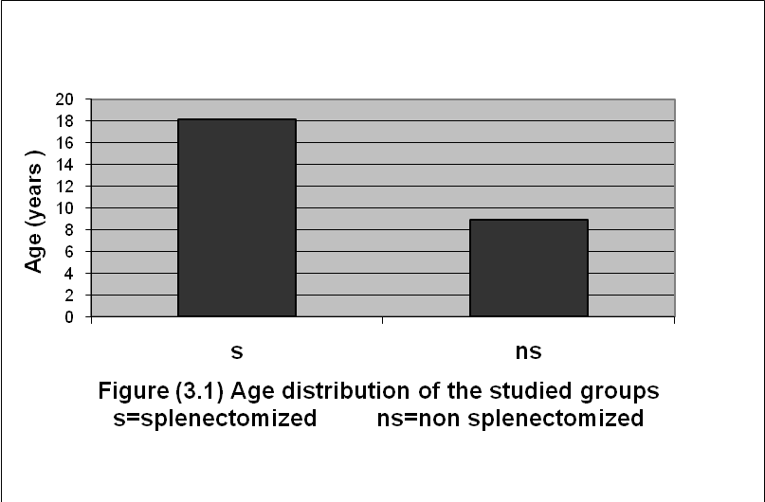

The hematological & coagulation parameters of the studied patients described in the table below.

Table (3.1) Summary of hematologic & biochemical parameters of the studied patients groups
 | Groups | Mean | SD | P Value
1 | PCVL/L s  ns  N | 26.86  24.60  39.22 | 2.029  2.09  0.973 | 0.001^{*a}  0.001^{*b}
2 | WBC s  X10⁹/L ns  N | 8.233  7.080  7.393 | 2.993  2.185  1.135 | 0.66ª  0.45^{b}
3 | Platelet s  X10⁹/L ns  N | 259.60  218.70  247.23 | 89.69  58.57  60.65 | 0.04 ^{*a}  0.075^{b}
4 | PT s  Second ns  N | 14.40  14.13  13.43 | 0.932  1.136  0.678 | 0.32ª  0.001^{*b}
5 | PTT s  Second ns  N | 33.03  33.20  35.36 | 3.42  3.31  2.53 | 0.84ª  0.007^{*b}
6 | Factor V% s  ns  N | 103.00  100.39  85.66 | 24.927  32.08  11.052 | 0.80ª  0.025^{*b}
7 | FactorVIII%s  ns  N | 127.866  128.966  86.800 | 32.905  27.819  13.293 | 0.88ª  0.001^{*b}
s=splenectomized ns= non splenectomized N= normol control group * :Significant p value< 0.05. a :P value between s and ns groups. b :P value between N and s,ns groups.

2. Bleeding manifestations:
In thalassemic patients the bleeding manifestations were mostly in form of epistaxis which occur in 14 patients out of 60 thalassemic patients included in this study (23.33%), 9 of them in splenectomized group (15%) of total thalassemic patients, 9/30 (30%) had bleeding history in splenectomized group; 5 patients in non splenectomized group (8.33%) of total thalassemic patients,5/30 (16.6%) in non splenectomized group.(ie) splenectomized patients had 2.1 times bleeding tendency more than that of non splenectomized patients ( table 3.2).

Table (3.2) Distribution of the studied groups by history of bleeding
 | GROUPS |  | TOTAL | OR (95% C.I.) | P value
 | ns (30) | s (30) | TOTAL | OR (95% C.I.) | P value
Non Bleeders | 25 | 21 | 46 | 2.1429 (0.6216  -7.3876). | >0.05
Bleeder | 5 (16.6%) | 9 (30%) | 14 (23.33%) | 2.1429 (0.6216  -7.3876). | >0.05
Total | 30 | 30 | 60
s=splenectomized ns=non splenectomized

A-3. Thrombotic manifestation:
occured in only one splenectomized patients (3.33%) in form of small vessel thrombosis in the hand with history of previous treatment with warfarin. The overall percentage of overt thrombotic manifestation in all patients included in this study was (1.66%) ( Table 3.3).

Table (3.3) Distribution of the studied groups by history of thrombosis
 | GROUPS |  | TOTAL | P value
 | ns (30) | s (30) | TOTAL | P value
No thrombosis  With thrombosis | 30  0 | 29  1 (3.3)% | 59  1 (1.66)% | >0.05
Total | 30 | 30 | 60

The proportion of patients with bleeding, thrombotic manifestation and patients with no any history of these manifestations described in a figure below (figure 3.2).

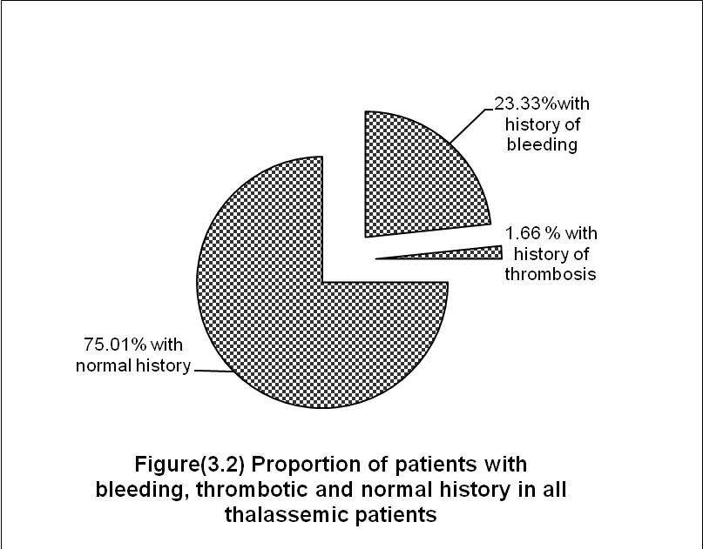

The proportion of patients with history of bleeding, thrombotic manifestation to patients without any history of bleeding or thrombotic manifestation in both splenectomized and non splenectomized groups described in a figure below. (figure 3.3 and 3.4)

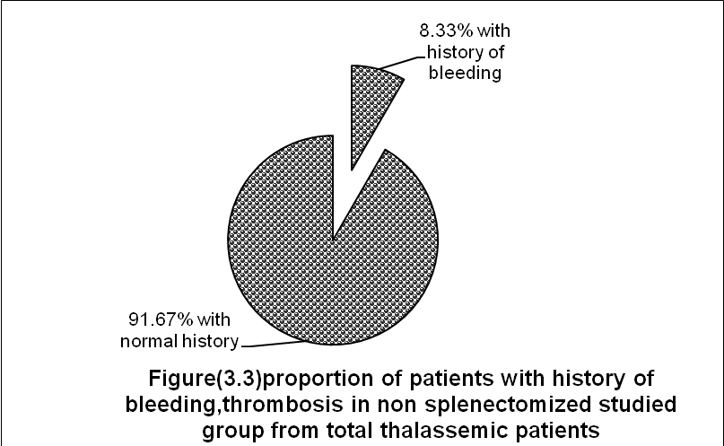
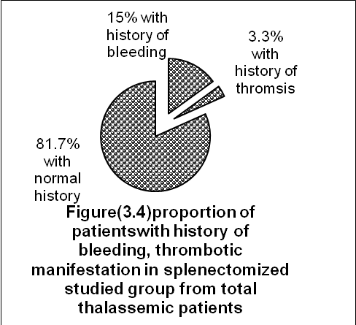

B- Haematologic Data
PCV, WBC and Platelets:
The mean value for PCV for splenectomized patients was 26.8 L/L with a range of (0.22-0.34) while for non splenectomized patients the mean value for PCV was 24.6 L/L with a range of 0.21-0.28 and there was statistical significant difference between the two groups( p value < 0.001).There was a statistical significant difference in PCV between total thalassemic patients and control group with mean PCV in latter group was 39.2 L/L,(p value < 0.001).
The mean value for WBC count in splenectomized patients was 8.23X10⁹/L with a range of (4.2-15.0X10⁹ /L) while in non splenectomized patients it was 7.0 X10⁹/L with a range of (2.2-14.3 X 10⁹/L) and there was no statistical significant difference between these two groups (P value 0.66). There was no statistical significant difference between total thalassemic patients and control group, mean WBC count was 7.3x10⁹/L in control group (P value 0.45) (table 3.1).
The mean value for Platelets count in splenectomized patients was 259X10⁹ /L with a range of (110-450 X 10⁹ /L) while in non splenectomized patients it was 218X10⁹ /L with a range of (140-380X10⁹L). There was statistical significant difference with a mild higher result in splenectomized group (P value 0.04). Mean platelets count in control group was 247.23 x 10⁹ /L. (Table 3.1). There was no statistical significant difference between the control group and the total thalassemic patients (P value 0.07) (table 3.1).
C- Coagulation Data:
1. PT, PTT:
The mean value for PT level was 14.4 seconds, 14.7 seconds in splenectomized and non splenectomized patients respectively & there was no statistical significant difference between the two groups (P value 0.32). Mean PT for control group was 13.4 seconds and there was a statistical significant difference between total thalassemic patients and control group (P value <0.001) (table 3.1). The mean value for PTT was 33.0 second, 33.2 second in splenectomized & non splenectomized patients respectively and there was no statistical significant difference between the two thalassemic groups (P value 0.8). Mean PTT for control group was 35.3 second and there was a statistical significant difference between total thalassemic patients and control group (P value 0.007) (table 3.1).
2. Coagulation factor V & VIII :
Regarding coagulation factor V level, its mean level was 103% in splenectomized group & 100% in non splenectomized group & there was no statistical significant difference between these two groups (P value 0.8),while mean factor V level in control group was 85.66% with statistical significant difference between total thalassemic patients and the control group (P value 0.025) (Table 3.1). Concerning coagulation factor VIII level, it was 127.8% in splenectomized group & 128.9% in non splenectomized group & again there was no statistical significant difference between these two groups (P value 0.8),while in control group factor VIII level was 86.66%, again there was statistical significant difference between total thalassemic patients and the control group.(P value <0.001) (Table 3.1).
3. Role and effect of coagulation factor V and VIII level on bleeding and thrombotic manifestation: Coagulation factor V & VIII level had no obvious role in bleeding manifestation of thalassemic patients because among bleeder splenectomized patients 6 out of 9 patients (66.6%) have normal factor V level, one patient only with a mild decrement in coagulation factor V in a level of 60% (normal range of coagulation factor V 70-120%), in contrast we had 2 bleeder patients out of 9 (22.2%) with a mild increment in factor V in a level of 130 and 170% (Table 3.5), while in non splenectomized group 5 patients had bleeding manifestation, all of them (100%) have normal coagulation factor V level (Table 3.5). Among 21 splenectomized non bleeder, 16 patients (76.1%) had normal coagulation factor V level & 5 patients had an increased coagulation factor V (23.8%) in a range of (125-160%), no one had a decreased coagulation Factor V. Regarding non splenectomized patients, 25 patients were non bleeder, 11 patients were with normal factor V (44%) & 11 patients were with increased level in a range of (130-155%) & 3 patients (12%) with a decrease in its level in a range of (60-68%) (table-3.4).

Table (3.4) Factor V and bleeding episodes
Level of factor V | Bleeders (n=14) |  | Non Bleeders (n=46) |  | Control
Level of factor V | s(9) | ns(5) | s (21) | ns (25) | 30
N | 6 (66.6%) | 5 (100%) | 16(76.1%) | 11 (44%) | 30 (100%)
Increased* | 2 (22.2%) | / | 5 (23.8%) | 11 (44%) | /
Decreased* | 1 (11.1)% | / | / | 3 (12)% | /
*The association was statistically not significant p value >0.05.

Regarding factor VIII level & bleeding manifestation, there was 8 patients out of nine (88.8%) had normal factor VIII level & only one patient with a mild increment in factor VIII in a level of 155% (normal range 60-150%) (table-3.6) in splenectomized group, while in non splenectomized bleeders group, 4 patient out of 5 (80%) had normal coagulation factor VIII level & only one patient with a mild increment in its level which in 160% (table 3.5).

Table (3.5) Factor VIII & bleeding episodes
Level of factor VIII | Bleeders (n=14) |  | Non Bleeders(n=46) |  | Control
Level of factor VIII | s(9) | ns(5) | s (21) | ns (25) | 30
N | 8  (88.8%) | 4  (80%) | 15  (71.4%) | 21  (84%) | 30  (100%)
Increased* | 1  (11.1%) | 1  (20%) | 6  (28.5%) | 4  (16%) | /
Decreased* | / | / | / | / | /
*The association was statistically not significant p value >0.05.

On the other hand,there was 15 splenectomized non bleeder patients out of 21 (71.4%) with normal coagulation factor VIII & 6 patients (28.5%) with an increase level in a range of (155-190%), no one had a decrease in factor VIII level (table 3.6).
While , 21 non splenectomized non bleeder patients (84%) out of 25 were with normal factor VIII level & only 4 patients (16%) out of 25 were with a mild increment in the level in a range of (160-180%).No one with a decrease in factor VIII level (table 3.6).
Regarding thrombotic manifestation, there was only one splenectomized patient with overt thrombotic manifestation, he had normal coagulation V and VIII level.

Discussion
Transfusion dependent β- thalassemia is a major health burden in many parts of the world, particularly in Mediterranean area and the middle east. The disease is encountered frequently in northern parts of Iraq [7].
The mean age of the studied patients was 18.2 years in splenectomized group & 8.9 years in non splenectomized group and from this it is obvious that patients in splenectomized group are older than non splenectomized group. This related to fact that splenectomy usually postponed as much as possible to reduce sepsis and improve outcome. The introduction of regular transfusion has significantly delayed the appearance of splenomegaly so that splenectomy is now postponded until the second decade of life or later to avoid the problem of post splenectomy sepsis with encapsulated organisms [8], especially Streptococcus pneumoniae, Heamophilus infleunzae and Neisseriae meningitides.
After splenectomy there is a rise in the total WBC count, a neutrophil leukocytosis in the immediate post operative period which is later replaced by a significant and permanent increase in both lymphocytes & monocytes. Usually the total WBC count stabilizes between 10 and 15 X 10⁹/L but occasionally it may rise to twice this level [9].
Thrombocytosis after splenectomy is usually transitory and falls to normal or near-normal values over the following 1-2 months [9].
In addition to that there is possibility of pooling of platelets in the spleen in non splenectomized group with shortening of their life spane [10]. It is widly recognized that patients with thalassemia are at increased risk of thrombosis and/or bleeding manifestation [11]. In this study, it was clear that the evidence of bleeding manifestation, (mostly epistaxis) occur more frequently than thrombotic manifestation (figure 3.2). a mild heamorragic tendency in group of β-thalassemia major patients which include easy bruising and frequent epistaxis, this was related to a consistent platelets anomalies manifested by diminished platelets aggregation to ADP, collagen, ristocitin and epinephrin which could be responsible for these haemorrahgic phenomena [12].
The thrombotic manifestation occured in one patient among splenectomized group of this study (3.3%) in form of thrombosis in the vessels of the hand for which the patient received treatment with warfarin. Thrombosis is typically an episodic complication associated with a temporary activation of hemostasis, in contrast, markers of platelets and coagulation activation are persistently and consistently elevated in most thalassemic patients (adults and children a like) even in the absence of overt thromboembobic events [13]. The presence of persistent hypercoagulation state combined with the infrequent occurrence of significant thrombotic events suggest that thrombosis is largely a subclinical process in thalassemia and has been associated with autopsy finding of platelets and fibrin thrombi in the microvasculature in the lung and brain [13,14]. Coagulation factor V & VIII level had neither obvious role in bleeding nor thrombotic manifestation of thalassemic patients and there is normal level of these two factors with no statistical significance results in association with these manifestations [15].
Although patient were receiving normal red blood cells from regular blood transfusion ,the thalassemic red cells still persisted due to splenectomy and these abnormal RBC posses procoagulant activity due to presence of negatively charged phosphatidylserin on their outer surface [16]. They might be the results of combined effect of the endothelial and red cell dearrangement, the former occurring as a consequence of the ongoing inflmmatory state associated with the disease and the latter as consequence of oxidative stress and/or exposure of negatively charged phospholipid (phosphotidylserine) on cell membrane, which are able to accelerate the conversion of prothrombin to thrombin [16,17]. A study done by Eldor et al. [3], found a mild heamorragic tendency in group of β-thalassemia major patients which include easy bruising and frequent epistaxis, this was related to a consistent platelets anomalies manifested by diminished platelets aggregation to ADP, collagen, ristocitin and epinephrin which could be responsible for these haemorrahgic phenomena [3]. Unfortunately these tests are not done for patients in this study because of limited laboratories facilities.

Conclusion
1.Thalassemic patients in Babylon province are under transfused, because of low PCV, but they have normal WBC and platelets count.
2. Thalassemic patients had mild bleeding episodes more than overt thrombotic episodes.
3. Splenectomized thalassemic patients had more bleeding and overt thrombotic episodes compared to non splenectomized patients.
4. Coagulation factors V and VIII have no obvious role in bleeding or thrombotic episodes.
5. Splenectomy reduce blood requirement, had no effect on coagulation factor V and VIII.

References
1. Steinberg MH, Forget BG, Higgs DR, Weatherall DJ. Disorder of hemoglobin: Genetics, Pathophysiology and Clinical Management. 2001 Cambridge: Cambridge University Press.
2. Amiram Eldor and Eliezer A. Rachmilewitz. The hypercoagulable state in thalassemia. The American Society of Hematology. Blood 2002; 99: 36-43.
3. Eldor A. et al. Abnormal platelet function in beta thalassemia. Scand J Haematol.2000;20:447-452.
4. Manodori AB, Barabino GA, Lubin BH, Kupers FA. Adherence of phospha-tidylserin-exposing erythrocytes to endothelial matrix thrombospondin. Blood, 2002; 95:1293-1300.
5. Lewis SM. Reference range and normal values In: Bain BJ, Lewis SM, Bates I Dacie and Lewis Practical Haematology,10thed.Philadelphia:Churchill Livingstone;2006;11-15.
6. Lewis SM. Principle of prothrombin Time In: Bain BJ, Lewis SM, Bates I Dacie and Lewis Practical Haematology,10thed.Philadelphia: Churchill Livingstone;2006;398-399.
7. Ahmad MK.A study of iron status in β- Thalassemic patients in Erbil. MSc Thesis Salahaddin University 2002.
8. Greenbergn Ch, Orthnern C L. Thalassemia and Related Disorder, splenectomy. In: Lee GR, Greer JP,Foerster J, Lukens J, Paraskevas F,editors.Wintrobe ,s Clinical Haematology.12th ed. Lippincott William and Wilkim; 2009; ch 38.
9. Paul AH Moss. The spleen. In: A. Victor Hoffbrand, Daniel Catovsky, Edward G.D et al. Hoffbrand Postgraguate Hematology. 6th ed. Massachusetts (USA): Blackwell Publishing; 2011: 377.
10. Hoffbrand AV, Pettit JE, Moss PAH, Platelets. Bleeding Disorder. In: Essential Haematology,5th ed. 2006, 285-286.
11. Mokhtar, Galila, Matter, Randa M, Shawki H., Abdel Aziz et al. Activatable Fibrinolysis Inhibitor: Relationship to Hemostatic Alteration in Patients with β-Thalassemia. Pediatric Hematology and Oncology, 2010, volume 27, p.363-373 (11).
12.Eldor A. Haemorrhagic tendency in β-Thalassemia, Haematol 2000.
13. Eldor A, Durst R, Hy-Am E, et al. Achronic hypercoagulable state in patients with beta-thalassemia major is already present in childhood. Br J Haematol.1999;107:739-746.
14. Manfre L, Giarratano E, Maggio A, Banco A, Vaccaro G, Lagalla R.MR imaging of the brain: finding in asymptomatic patients with thalassemia. Am J Roentgenol. 2000, 173.
15.Kyrle PA, Minar E, Hirchl M, Bialonczyk C, Stain M, Schneider B, et al. High plasma levels of factor VIII and the risk of recurrent venous thromboembolism. N Engl J Med 2000; 343:457-62.
16.Eldor A, Rachmilewitz EA. The hypercoagulable state in thalassemia. Blood 2002;99:36-43.
17. Kasemsat S, Wilairat P. Procoagulant activity in beta-thalassemia. In: Packer L, Traber MG,Xin W,editors.2000,162-6.

