Effects of Newcastle Virus Suspension on Some Organs of white Mice
(Balb/C)

Abbas Kadhim Al-Mansory¹ Ahmed Obaid Al-Zobaidy² Nemah H. Mehdi³
^{1,2} Al-Qasim Green University
Email: dr.abbas1966 @ yahoo.com
³ College of Medicine, Babylon University

Received 25 September 2014 Accepted 23 November 2014
Abstract
Newcastle disease is a contagious bird disease affecting wild avian species and many domestic, it may be transmissible to humans. Detection of Newcastle virus confirmed by rapid test technique (Immuno-chromatography). Ten samples (10%) out of 100 fasces samples collected from chickens were positive. Twelve mice used in this study divided into two groups, first group consist of six mice induced with 0.2 ml from one positive sample of Newcastle virus suspension to evaluate some histopathological changes in liver, lung and brain of mice, second group induced with 0.2 ml from phosphate buffer saline only. The results revealed that histopathological changes in liver were induced using 0.2 ml of Newcastle virus suspension ashyperpalsia in kufper cells. Lung of mice treated with this concentration of Newcastle virus has partial pnemonia and thickening the intra- alveolar walls. Brain of mice treated with same concentration induced increasing in number of glial cells (glialosis) and apoptosis in brain cells.

Key words : Newcasstle virus, mice (Balb/c), Immunochromatography.

تاثير فايروس نيوكاسل على بعض الاعضاء عند الفئران البيض

الخلاصة
يعد مرض النيوكاسل من الامراض المعديه والذي تتأثر به انواع الطيور الداجنة والبرية والذي بالإمكان انتقاله الى الانسان .تم التحري عن فايروس النيوكاسل باستخدام عدة تقنية الاختبار المناعي السريع. أظهرت النتائج عشرة عينات من أصل مئة عينة براز جمعت من الدواجن كانت موجبة. تم تجريع اثنى عشر فأرا" في هذه الدراسة حيث قسمت الى مجموعتين، المجموعة الاولى تتألف من ستة فئران أستحثت ب 0.2 مايكروليتر من معلق فايروس النيوكاسل لإحدى العينات الموجبة لتقييم التغيرات النسيجية التي سببها الفايرس في الامعاء والمعدة لهذه الفئران. المجموعة الثانية أستحثت ب 0.2 مايكروليتر من المحلول الملحي الدارئ .كما أظهرت النتائج أن التغيرات النسيجية في الكبد للفئران المستحثة بمعلق فايروس النيوكاسل فرط تسنج في خلايا كفر. أظهرت نتائج رئة الفئران المعاملة بتركيز الفايرس أعلاه أنها قد أصيبت بذات الرئة جزئيا وتثخن في جدار الحويصلات. أما الدماغ للفئران المصابة بتركيز معلق الفايرس أعلاه فقد اظهر أنتحار وزيادة في خلايا الدماغ.
ــــــــــــــــــــــــــــــــــــــــــــــــــــــــــــــــــــــــــــــــــــــــــــــــــــــــــــــــــــــــــــــــــــــــــــــــــــــــــــــــــــــــــــــــــــــــــــــــــــــــــــــــــ

Introduction
N
ewcastle disease is caused by avian paramyxovirus serotype-1 (APMV-1), which is also called Newcastle disease virus (NDV). It is a highly contagious viral diseases that affects domesticated and wild bird species throughout the world as well as NDV is a human pathogen and the most common sign of infection in humans is conjunctivitis that develops within hours of NDV exposure to the eye [1, 2] However, disease host species and in different geographical locations. NDV is classified in the genus Avulavirus within subfamily Paramyxovirinae, family Paramyxoviridae and order Mononegavirales [3]. This enveloped virus has a negative sense non-segmented, single stranded RNA genome has 15198 nucleotides in length [4]. The genome encodes six structural and two non-structural proteins Based on the fusion (F) gene strains are classified into lineages or genotypes; however the discrepancies between the two classification systems are nominal [5, 6, 7]. NDV is spread primarily through direct contact between healthy birds and the bodily discharges of infected birds. The disease is transmitted through infected birds' droppings and secretions from the nose, mouth, and eyes. Clinical manifestation or severity of the ND depends largely upon the isolates involved in disease outbreak [8]. Based upon pathogenicity, these strains are commonly categorized into velogenic (mesogenic and lentogenic types [9]. The varying level of pathogenicity is attributed to amino acid sequence motif present in protease cleavage site of the precursor F protein [10, 11]. The aim of the current study was to evaluate the histological changes induced by Newcastle virus infection in mice (Balb/c).

Materials and Methods
1-Samples collection:
A total of 100 faeces samples were collected from chicken suffering from clinical signs and symptoms of severe greeinsh watery diarrhea. Detection of Newcasstle virus performed by rapid test (Immunochromatography) supplied from Biochek company–USA. The positive samples for Newcastle were diluted with phosphate buffer saline or normal saline and stored at -20 ̊C in freeze. One positive samples of Newcastle was further used for the experimental study on laboratory animals (mice) for evaluation the effects of Newcastle disease on histological sections of these mice.
2-Experimental study:
A total of 12 males mice species Balb/c aged two month and weight 100-120 g divided into two groups , the first consist of six mice injected orally with 0.2ml of Newcastle virus suspension for one positive sample. The other control group received 0.2 ml of sterile phosphate buffer saline (PBS) according to methods of [12, 13]. After 4-6 days clinical signs were recorded in infected animals were observed experimental mice were sacrificed after anesthetization by chloroform and abdomen cavity was opened by medical scissors, tissue from small intestine, stomach, and liver were collected from the experimentally infected mice and placed in formalin 10% for histo-pathological examination. Histological sections and staining were prepared according to methods described by [14]. The histopathological changes were observed by Dr. Nemah. H. AL-Jabori /college of medicine/Babylon University under the magnification powers 10 X and 40 X of light microscope.

Results
Histological changes of current study observed in liver, lung and brain of mice infected with 0.2ml from Newcastle virus suspension, these changes shown in figures 1, 3, and 5. Figures 2, 4, and 6 represented control group of mice treated with 0.2ml phosphate buffer saline.
Figure-1 represented the liver of mice treated with 0.2ml from Newcastle virus suspension shows hyperpalsia in kufper cells.
The results in figure 3 indicated to lungs of mice treated with 0.2ml concentration from virus Newcastle suspension revealed to partial pneumonia and thinking the intra alveolar walls. Figure (5) revealed that the brain of mice treated with 0.2 ml concentration from Newcastle virus suspension showed increase in number of glial cells (glialosis) and apoptosis in brain cells. Figures 2, 4, and 6 revealed that liver, lung and brain respectively for control mice treated with phosphate buffer saline. No histological changes observed in liver, lung and brain of control mice group.

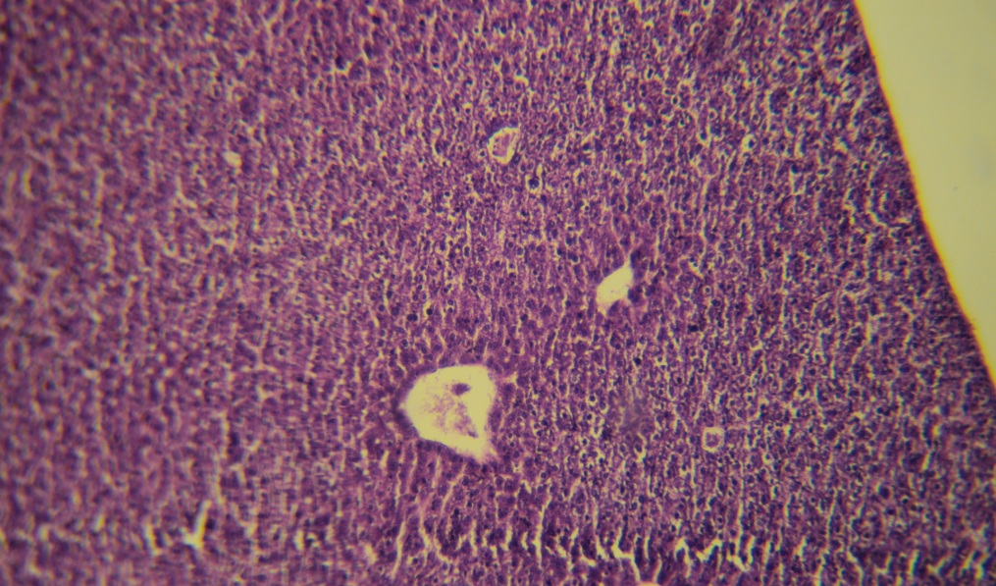
Figure (1): liver of mice treated with 0.2 ml of Newcastle virus suspension. The slide shows hyperpalsia in kufper cells. H&E 20X

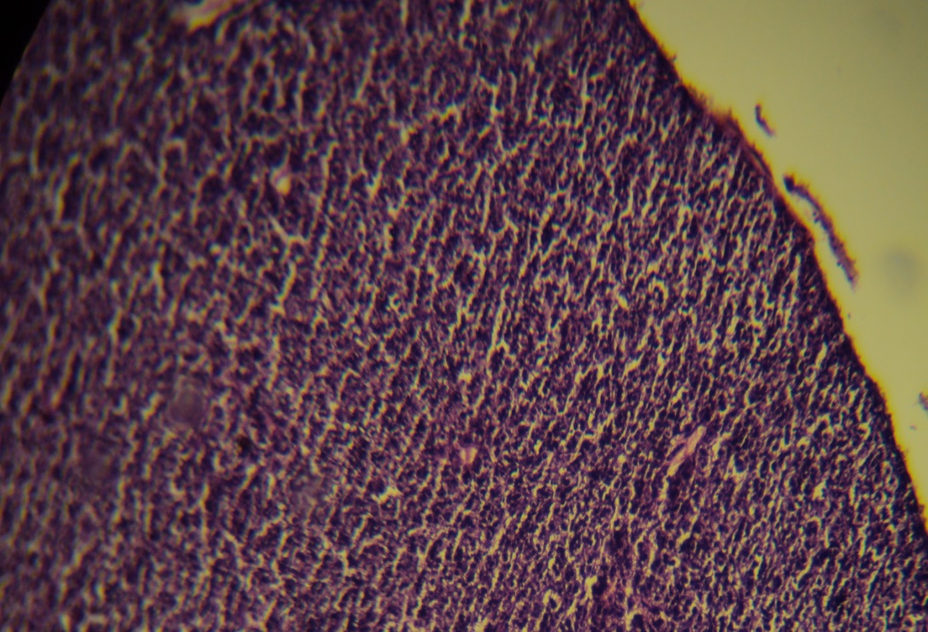
Figure (2) Control of liver mice treated with 0.2 ml phosphate buffer saline has normal hepatocytes. H & E 20X

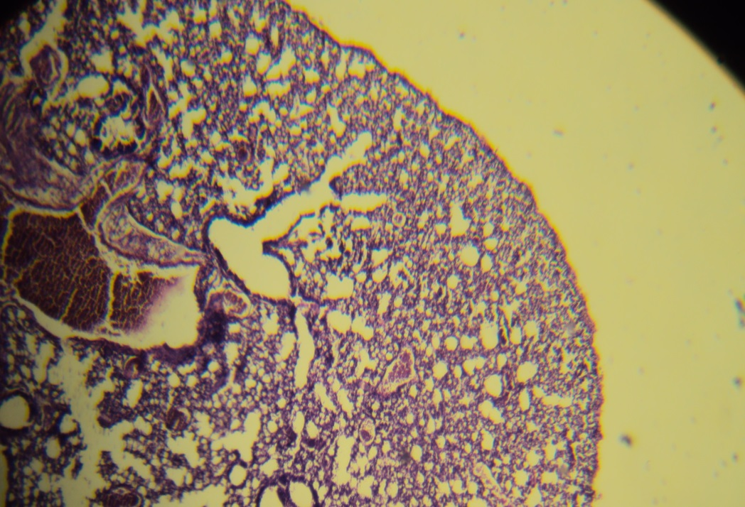
Figure (3) Lung of mice treated with 0.2 ml of Newcastle virus suspension. The slide shows partial pneumonia and thickening of intra- alveolar walls. H & E 20X

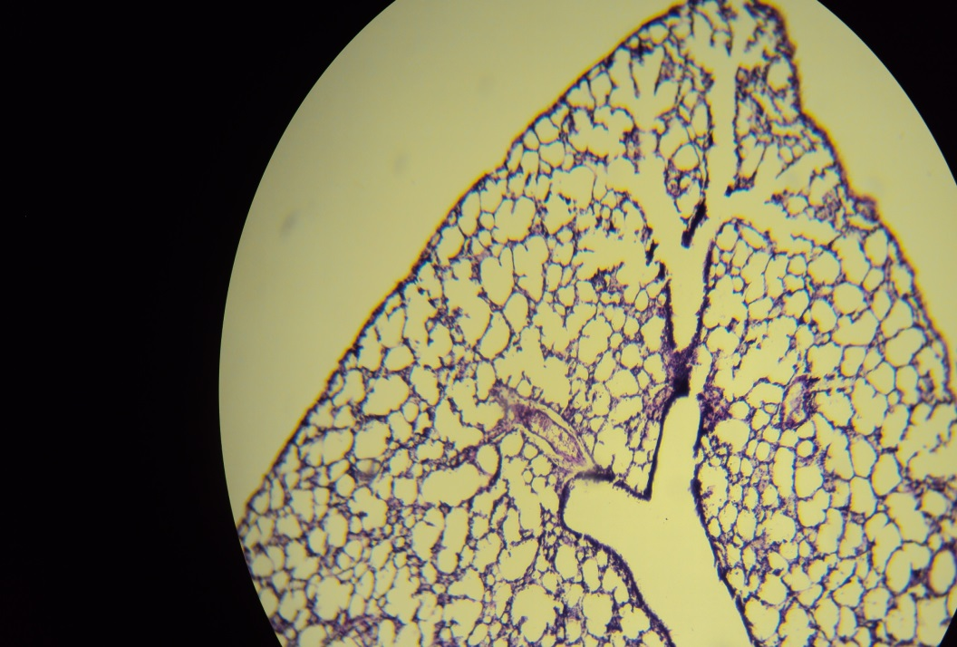
Figure (4) Control of lung mice treated with 0.2 ml phosphate buffer saline has normal intra alveolar walls. H & E 20X

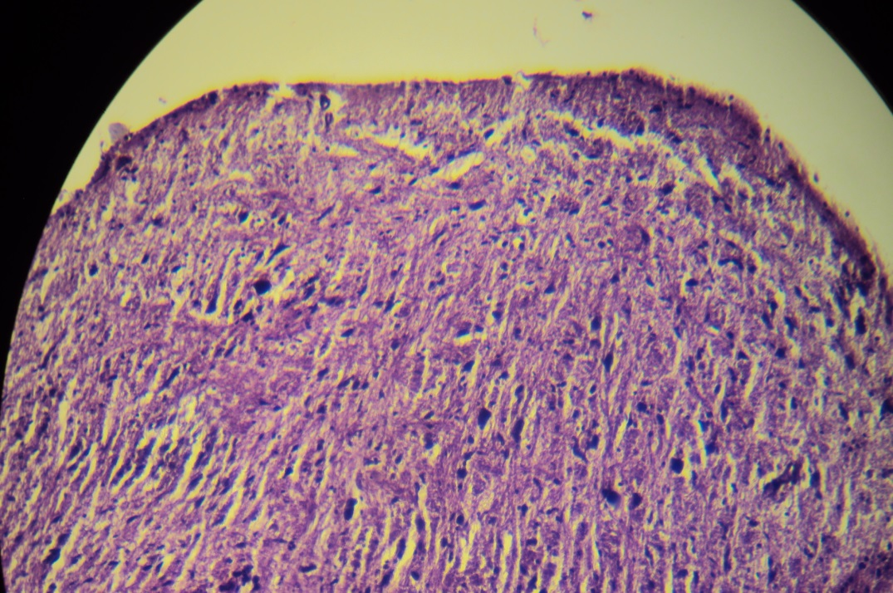
Figure (5) Brain of mice treated with 0.2 ml from of Newcastle virus suspension. The slide revealed to increase in number of glial cell (glialosis) and apoptosis in brain cells. H & E 20X

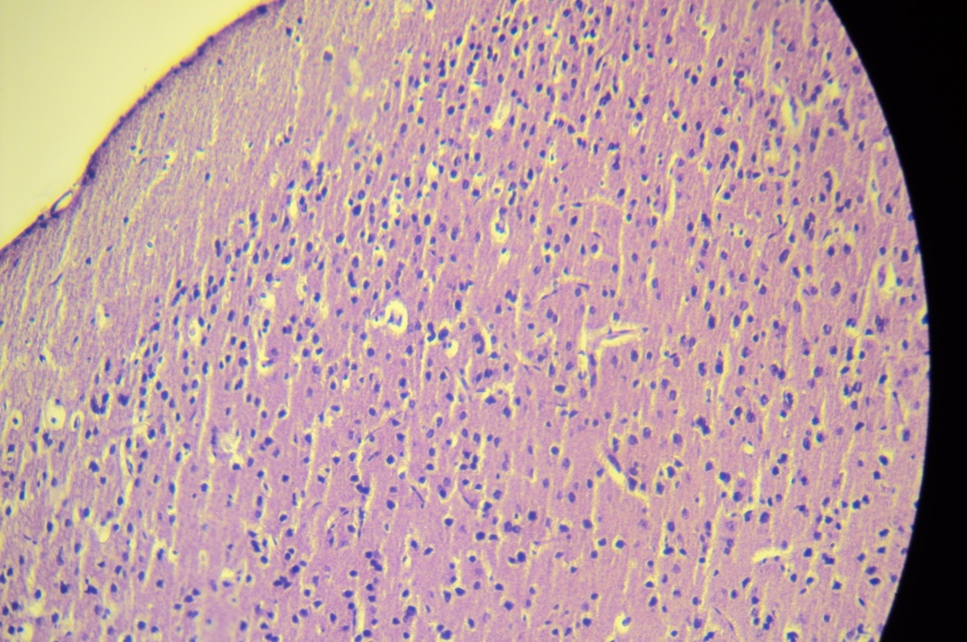
Figure (6) Control of brain mice treated with 0.2 ml phosphate buffer saline has normal brain cells. H & E 20X

Discussion
The lesions of Newcastle virus most prominent duodenum jejunum and ileum. Even in birds showing neurological signs prior to death, little evidence is found nervous system. Lesions are usually present in the respiratory tract when clinical signs indicate involvement [15]. The results of present study about effects of Newcastle virus suspension on liver, lung, and brain of mice which experimentally infected revealed to histopathological changes within liver ,lung and brain of mice infected with 0.2 ml from Newcastle virus suspension. These histopathological changes were observed in figure 1, 3, and 5. Figure-1 showed histological changes in liver represented in hyperpalsia in kufper cells. This results similar to recent studies mentioned that Newcastle virus outbreak in a poultry facility in Japan was characterized, among other lesions, by hepatic necrosis [16].
The results of lung mice infected with same concentration of this virus revealed partial pneumonia and thickening the intra- alveolar walls. This results accept with other reported mentioned that some Newcastle virus strains have been shown experimentally cause moderate lesions in the respiratory system, these changes were obtained only through aerosolization or use of very high viral titers direct air sac instillation of the virus [17].
Whilethe results of lung mice infected with same concentration from Newcastle virus suspension recorded increase in number of glial cells (glialosis) and apoptosis in brain cells. This results agreement with some studies mentioned finding Interactions between the Newcastle disease virus and mouse tissues [18].
Causes of histopathological changes in liver ,lung and brain of infected mice perhaps due to virulence of Newcastle virus and rapid replication effect on three systems are digestive system (e.g: liver), respiratory system (e.g: lung) and nervous system (e.g: brain) [15]. In conclusion the Newcastle virus suspension resulted in clear histological changes in liver, lung and brain of mice (Balb /c).

References
1- Swayne, D.E. and King, D.J. (2003). Avian influenza and Newcastle disease. J. Am. Vet. Med. Assoc., 222 (1): 1550-1534.
2- Seal, BS.; King, DJ. and Meinersmann, RJ. (2000). Molecular evolution of the Newcastle disease virus matrix protein gene and phylogenetic relationships among
the paramyxoviridae.Virus. Res,. 66:1–11.
3- Alexander, D. (2003). Newcastle disease, other avian paramyxoviruses and pneumovirus infections. In Diseases of Poultry. 4th edition. Edited by Saif YM, Barnes HJ; Glisson, JR; Fadly, AM LRM and Swayne, D.: Iowa State University: 63–99.
4- Kolakofsky, D.; Roux, L.; Garcin, D. and Ruigrok, RW. (2005). Paramyxovirus mRNA editing the “rule of six” and error catastrophe: a hypothesis. J. Gen. Virol., 86: 1877-1869.
5- Aldous, EW., Mynn, JK.; Banks, J. and Alexander, D.J. (2003). A molecular epidemiological study of avian paramyxo-virus type 1 (Newcastle disease virus) isolates by phylogenetic analysis of a partial nucleotide sequence of the fusion
protein gene. Avian. Pathol., 32:239–256.
6- Czegledi, A.; Ujvari ,D.; Somogyi ,E.and Wehmann, E. (2005) genome size category of avian paramyxovirus serotype 1 (Newcastle disease virus) and evolutionary implications. Virus. Res., 120:36–48.
7- Diel, DG.; Susta, L.; Cardenas ,G. and Killian, ML. (2012). Complete genome and clinicopathological characterization of a virulent Newcastle disease virus isolate from South America. J. Clin. Microbiol., 50:378–387.
8- Miller, PJ.; Decanini, EL. and Afonso CL. (2010). Newcastle disease: evolution of genotypes and the related diagnostic challenges. Infect. Genet. Evol. 35.-10: 26.
9- OIE: Newcastle disease (2004). In Chapter 2115 OIE Manual of Standards for Diagnostic Tests and Vaccines, in Manual of Diagnostic Tests and Vaccines for Terrestrial Animals: Mammals, Birds and Bees. Paris: Office. Int. des Epizooties: 270–282.
10- Herczeg, J.; Wehmann, E.; Bragg, RR. and Travassos, D. (1999). Two novel genetic groups (VIIb and VIII) responsible for recent Newcastle disease outbreaks in Southern Africa, one (VIIb) of which reached Southern Europe. Arch. Virol., 144: 2087–2099.
11- Munir, M.; Cortey, M.; Abbas, M. and Qureshi, ZU. (2012). Biological
Newcastle disease virus isolated from outbreaks in commercial poultry and from backyard poultry flocks in Pakistan. Infect. Genet. Evol., 12:1010–1019.
12- Debouck, P. and Pensaert, M. (1979). Experimental infection of pigs with Belgian isolates of the porcine rotavirus. Vet. Med B, 26, 517-526.
13- Bhrigu, K.; Nagendra, N.; Durlav, P. and Sudip, C. (2011). Experimental infection of pigs with group rotavirus and enterotoxigenic Escherichia coli in India gross, Histopathological and immune-pathological study, Veterinaria Italiana., 47 (2): 117‐128..
14- Luna, L.G (1968). Manual of histological staining methods of the Armed Forces Institute of Pathology, 3rd Ed. McGraw Hill. New York. 195-196.
15- Alexander, D. (2000). Newcastle disease and other avian paramyxoviruses. Rev. Sci. Tech. Off. int. Epiz., 19 (2): 443-462.
16- Nakamura, K; Ohtsu, N. and Nakamura, T. (2008) Pathologic and immune histochemical studies of Newcastle disease (ND) in broiler chickens vaccinated with ND: severe nonpurulent encephalitis and necrotizing pancreatitis. Vet. Pathol., 45: 928–9339.
17- Abdul-Aziz TA, Arp LH: 1983, Pathology of the trachea in turkeys exposed by aerosol to lentogenic strains of Newcastle disease virus. Avian Dis 27:1002–1011.
18- Joseph, S. (1961). Interactions of the Newcastle disease virus with mouse tissues. Arch. virol., 10 (1): 103-125.

.

.

