Effect of Gamma Radiation on Pathogenecity of Entamoeba Histolytica

Hayam K. Al-Masoudi* Zainab H. Al-Saadi* Saif A. Al-Shalaah
*College of Medicine, Babylon University
Email: phd_2006_76@yahoo.com, enas_lamis@yahoo.com



Received 21 October 2014 Accepted 23 November 2014
Abstract:
The present study was conducted to test the effect of gamma radiation on the pathogenicity of E. histolytica in vivo by using radiation with doses (5, 10, 15, 20, and 25) rad to attenuation cyst of E. histolytica. The results revealed that mortality rate in laboratory animals (rabbits) decrease when increase the dose of attenuated E. histolytica cyst in comparative with positive control group (non – attenuated group) it reach (60% ,40%,40% and 20%) when give the rabbits attenuated E. histolytica cyst (5,10 ,15, and 20 ) rad. respectively . also we found no any mortality in rabbit which given attenuated E. histolytica cyst with dose (25) rad. also increasing doses of attenuating E. histolytica cyst (5,10,15,20 and 25) rad caused a some of histopathological changes in rabbits liver such as infiltration of inflammatory cell with degeneration of hepatic cells in addition to congested blood vessels and hydropic degeneration of hepatocyte in compare with liver of control group which gave the normal saline which appear normal shape and size. The results noted that this changes were reduce when increase the doses of radiation which decrease the pathogenecity of E. histolytica. We concluded that gamma radiation have good effects on reduce the pathogenicity of E. histolytica.
Key words: Entamoeba histolytica, Radation, pathogenesis.

الخلاصة:
اجريت هذه الدراسه لاختبار تاثير اشعة كاما على امراضية الاميبا الحاله للنسيج في الجسم الحي باستعمال الاشعاع بالجرع (5، 10،15، 20 و25) راد لتضعيف الاطوار المتكيسه للاميبا الحاله للنسيج. وجد ان نسبة الهلاكات في الحيوانات المختبرية تقل عند زيادة جرعة الاشعاع بالمقارنه مع مجموعة السيطرة الموجبه (المجموعة غير المضعفة) وقد وصلت الى (60%، 40% ،40%و 20%) على التوالي عند اعطاء الارانب الاطوار المتكيسه للاميبا الحاله للنسيج والمضعفة بجرع (5، 10،15و 20) راد على التوالي. كذلك لم يلاحظ اي نسبه هلاكات عند في الارانب المعطاة الجرع (25) راد. الجرع التصاعدية للاميبا الحاله للنسيج ادت الى بعض التغيرات النسجيه في اكباد الارانب المعامله مثل ارتشاح الخلايا الالتهابيه وتحطم الخلايا الكبدية اضافة الى احتقان الاوردة الدمويه بالمقارنة مع مجموعة السيطرة اذ يظهر نسيج الكبد بالحجم والشكل الطبيعي.لوجظ ان هذه التغيرات تختزل عند زيادة جرعة الاشعاع ما يقلل من امراضية الاميبا الحاله للنسيج. نستنتج ان اشعة الكاما لها تاثير جيد في اختزال امراضية الاميبا الحاله للنسيج.
ــــــــــــــــــــــــــــــــــــــــــــــــــــــــــــــــــــــــــــــــــــــــــــــــــــــــــــــــــــــــــــــــــــــــــــــــــــــــــــــــــــــــــــــــــــــــــــــــــــــــــــــــــــــــــــ

Introduction
Diarrheal diseases continue to be the major cause of morbidity and mortality in the developing world [1]. Amoebiasis is defined as human infection caused by the parasitic protozoan, E. histolyica with or without clinical manifestation. [2,3], infection is acquired by ingestion of cyst form present in fecal contaminated water or food and by food handlers carrying the cyst ([4]. The cyst is resistant to environmental conditions including the concentration of chlorine used in water purification and gastric acid [4].
The clinical presentation of intestinal infections depends on the extent and anatomic location of the ulceration and mucosal damage [5]. Small, sparse ulcerations may be asymptomatic. As the involved area of the mucosa increase in size and/or in depth, motility disturbances occur, primarily diarrhea with cramping pain, Exudation from the denuded mucosa adds to intestinal content [6]. When the mucosal involvement becomes extensive, diarrhea is replaced by dysentery, with the passage of exudates, blood and mucus [7] Toxic mega colon and perforation are rare complications of extensive involvement [8]. The cytopathogenic effect caused by trophozoites is multifactorial, Intestinal flask-shaped ulcers, a hallmark of amoebic colitis, are characterized by severe damage to enteric cells as well as migration to the lamina propria and blood vessels [9]. The contact between trophozoites and target cells appears to be the first step for cell lysis and phagocytosis. Found several methods in the preparation of vaccines parasitic, such as the use of doses a few eccentric sexual parasite or antigens specific parasite and used directly or following the methods of genetic engineering for the preparation of these antigens, as well as attenuation which means weakening susceptibility Pathogens to stimulate the immune system methods of chemical, physical or use radiation, which is from one of the most important methods used in the multiplication of pathogens and production of vaccines for being easy and inexpensive, has been proven effective in many applications [10]. The use of X-ray gamma after numerous studies and knowledge of its impact on living materials and organic parasite that causing a series of physical changes and structural, which leads to weakening the ability of the parasite to the events of infection with maintaining its ability stimulating immunity host [11].

Materials and Methods
During the period, which lasted from March till September 2013, collected 1279 stool samples from people suffering from severe diarrhea to the average in most cases suffer from bloody diarrhea, taking into account the symptoms of other hospitals in the center of the Babylon province (laboratory of Teaching hospital of maternity and children).
Amoebic Suspension
collected the amount of stool sample about ( 1gm ) of infected people so that the sample contain the cyst stage for amoeba case tissue then diluted by 10 ml of normal saline and mix well and then filtered through a layer of sterile gauze to remove the large particles [12]. Cysts were washed with phosphate-buffered saline solution (PBS) at pH 7.2 several times and the number of cysts per ml was determined by Neubauer hemocytometer. VL6-LC (ETS Viber-Louramat, Marne La Vallaee, Cedex, France), of output at 254 nm was used for the cysts attenuation. A 15ml sample of PBS containing 1.5 × 104 cysts per ml was poured into a clear glass dish. After that the cyst was exposure to gamma radiation with (5, 10, 15, 20 and 25) rad.
Laboratory Animals
In this study, 21 New Zealand white rabbits from breeding cages in the animal house in the college of medicine/Babylon university were employed during experimental study. Rabbits were infected with E. histolytica through intra esophageal administration with cyst suspension by using syringe with fine small tube entre through mouth to esophagus and push the cyst suspension to stomach directly and examined the stool daily by direct smear method.
The rabbits grouped into seven groups each one consist of three rabbits, one group administration with E. histolytica cyst suspension .five groups administrated with one of the following dose of E. histolytica cyst attenuated with (5, 10, 15, 20 and 25) unite of gamma ray, in addition to control group which administration with normal saline.
Histopathological Study
Specimens were taken from liver of rabbits after 30 days of experimental infection by administration of live and attenuated E. histolatica cyst suspension .The tissues were fixed in 10% buffer formalin solution immediately after removal. Tissues are fixed with neutral formalin 10%, embedded in paraffin, and then manually sectioned with a microtome to obtain 4-5 μm-thick paraffin sections. Dew axed sections are then stained with hematoxylin and eosin (H and E) or can be used for other purposes. During this process, many steps and procedures are critical to ensure standard and interpretable sections [13].

Results and Discussion
Effect of Gamma Radiation on % of Mortality in laboratory Animals
The result in table-1 show that the percentage of mortality decrease when increase the dose of attenuated E. histolytica cyst in comparative with positive control group (non – attenuated group) it reach (60%, 40%, and 20%) respectively when the rabbits attenuated E. histolytica cyst given (5, 10, 15, and 20) rad respectively. Results also found that there was no mortality in rabbit with given attenuated E. histolytica cyst with dose (25) rad.
From this results revealed and improve that gamma radiation reduce the pathogencity of E. histolytica in vivo. This results its agreement with [14] who confirm that gamma radiation kill the E. histolytica cyst in vivo. [15] confirmed that radiation with 20, and 21 kilorad caused the reduce development sporozoit of Eimeria tenella in chiken. Also radiation gave protective against sporozoit of Plasmodium [16]. Other study found that attenuated oocyst of Cryptosporidium by using gamma radiation lead to reduce ability to coased disease in Buffalo [17].
Also we gave the animal (which administrated with different dose of attenuated E. histolytica cyst) a dose of non-attenuated E. histolytica as challenge test , founded that the animals tolerant this dose ,so the mortality percentage reach to 20% in animals group which administrated with attenuated E. histolytica cyst (25 rad). Figure-1.

Table (1): Effect of gamma radiation on mortality rate of rabbits
Mortality% in 2nd week | No. of dead rabbit in 2nd week | Mortality % in 1st week | No. of dead rabbit in first week | Dose  (1000 cyst /ml)
0 | 0 | 0 | 0 | Control group
60% | 3 | 20% | 1 | Non-attenuated group
60% | 3 | 0 | 0 | Attenuated with 5 Rad
40% | 2 | 20% | 1 | Attenuated with 10 Rad
40% | 2 | 0 | 0 | Attenuated with 15 Rad
20% | 1 | 0 | 0 | Attenuated with 20 Rad
0 | 0 | 0 | 0 | Attenuated with 25 Rad

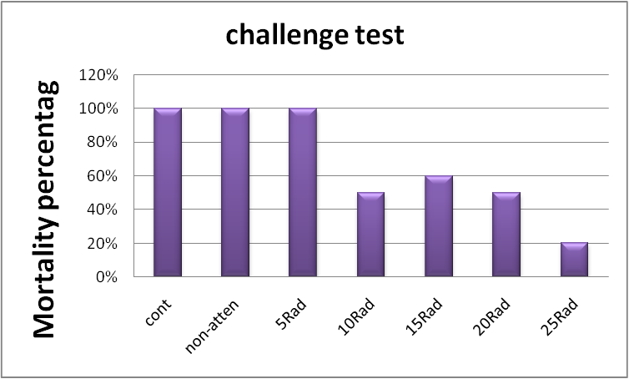
Figure (1): Challenge test

Effect of Gamma Radiation on Liver Histology
Administration of laboratory animals with increasing dose of attenuating E. histolytica cyst (5, 10, 15, 20 and 25) rad caused some of histopathological changes in rabbits liver such as infiltration of inflammatory cell with degeneration of hepatic cells in addition to congested blood vessels and hydropic degeneration of hepatocyte (Figures 2, 3, 4, 5, 6 and 7) in compare with liver of control group which gave the normal saline which appear normal shape and size (8). Also we noted that this changes was reduce when increase the dose of radiation which decrase the pathogenecity of E. histolytica. The congestion of blood vessels observed may be a response to the damage wrought by the parasite within the fabric of the liver where it lead to increase the amount of blood contained to areas of injury and increase the

process of leaching vascular studies indicated that infection with the parasite lead to an increased amount of blood reaching the liver [18]. It was also noted the large size of liver cells, as in the event of necrosis severe liver tissue may occur hyperplasia response compensatory and as a result grow liver cells and gets bloating swelling of these cells as observed concentration of cells inflammatory multiple forms of cores PMNS cells kupffer cells within the liver tissue as these cells effect whatever in reduce the pathogenicity as it works to devour and kill eccentric feeders within the liver tissue , and in this regard noted several studies into the role of immune resistance liver abscess amoebic in laboratory animals Karkheh multiple cells forms cores PMNS response to inflammatory preliminary and working to inform the amoeba in the focus of infection and kupffer cells play an important role in resistance hepatic programmed to die [19].

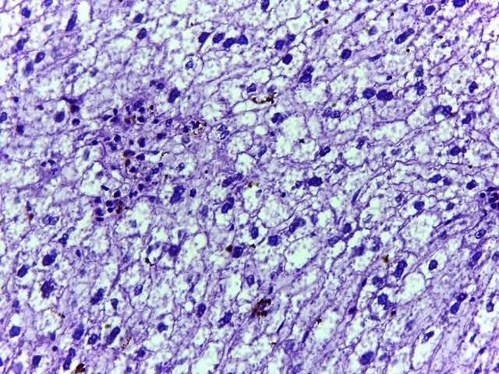
Figure 2: Histopathology of rabbit liver that administration of attenuated E.histolytica cyst by 5 Rad gamma radiation showed chronic inflammatory cell infiltration (red arrow) with hydropic degeneration of hepatocytes (black arrow) (clear cells) ( H and E X40 ).

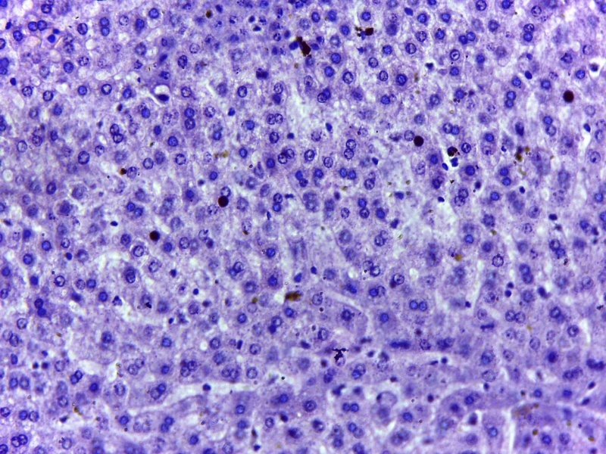
Figure 3: Histopathology of rabbit liver that administration of attenuated E. histolytica cyst by 10 Rad gamma radiation showed highly infiltration of inflammatory cell (black arrow) (H and E X40).
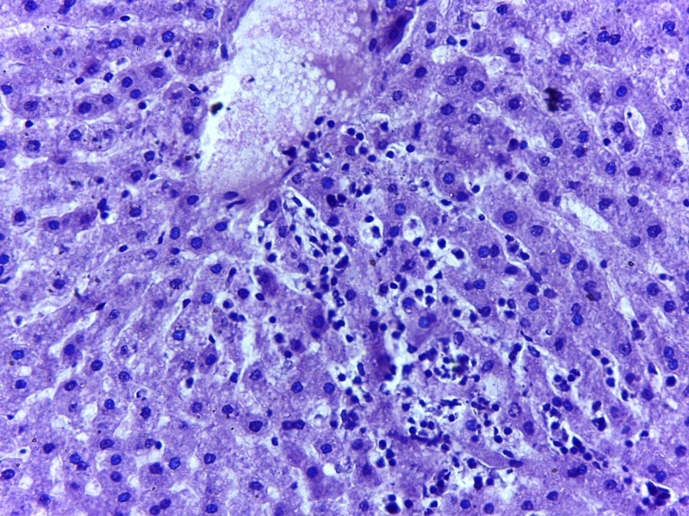
Figure 4: Histopathology of rabbet liver that administration of attenuated E. histolytica cyst by 15 Rad gamma radiation showed highly congested blood vessels (red arrow) with highly inflammatory cell infiltration (black arrow) (H and E X 40).

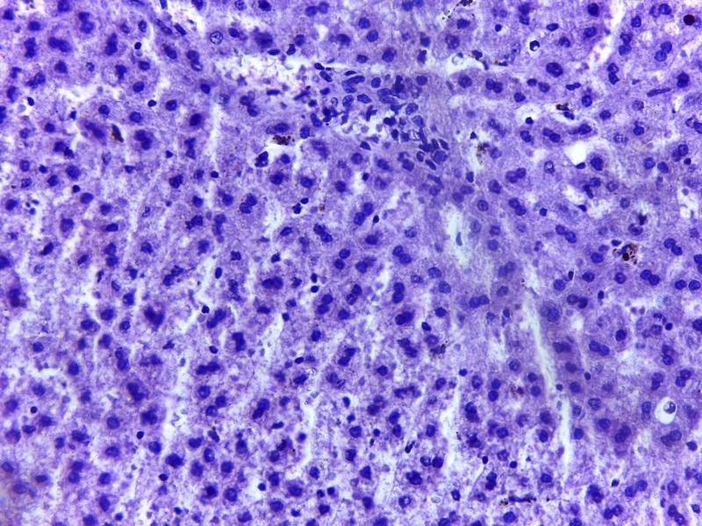
Figure 5: Histopathology of rabbet liver that administration of attenuated E. histolytica cyst by 20 Rad gamma radiation showed focal infiltration of inflammatory cell (red arrow), (H and E X40).
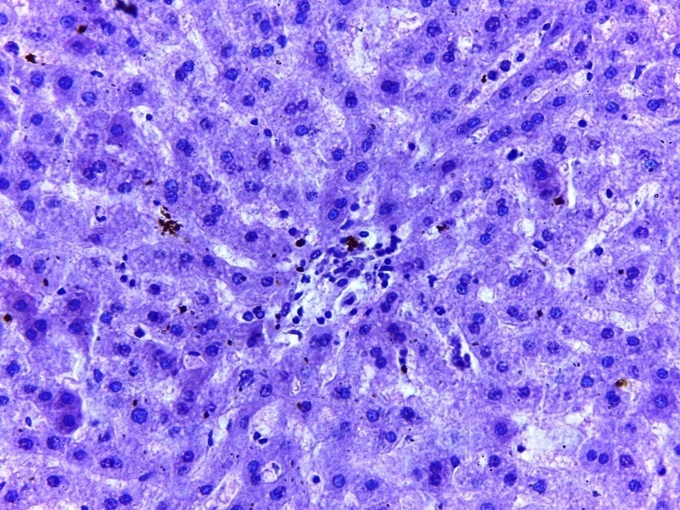
Figure 6: Histopathology of rabbit liver that administration of attenuated E. histolytica cyst by 25 Rad gamma radiation showed no clear histopathlogical lesion except focal infiltration of inflammatory cells (red arrow), (H and E X40).

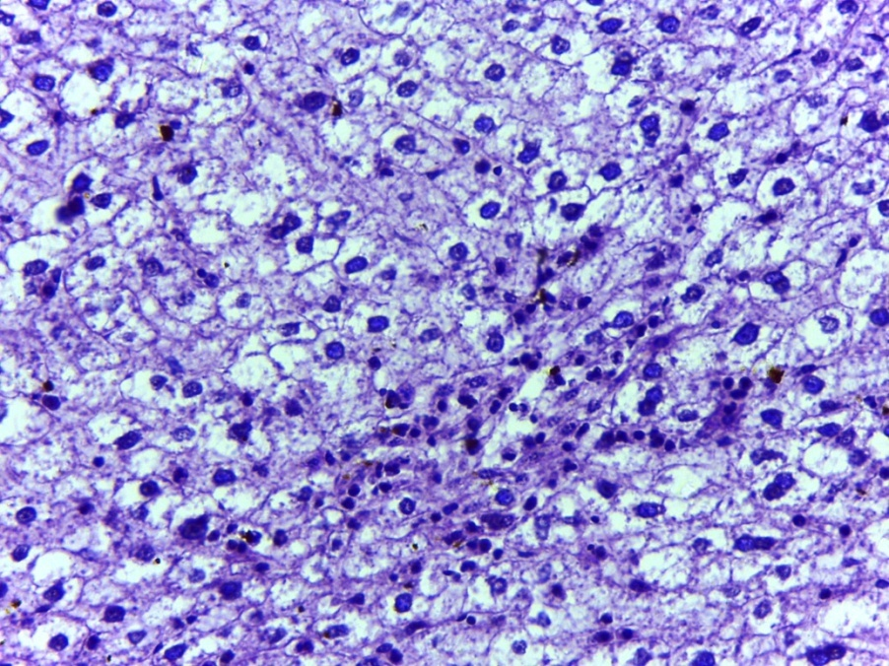
Figure 7: Histopathology of rabbit liver that administration of non attenuated E. histolytica cyst showed focal and diffuse infiltration of inflammatory cell (red arrow) with degeneration (black arrow) and necrosis (yellow arrow) of hepatic cell (H and E X40).
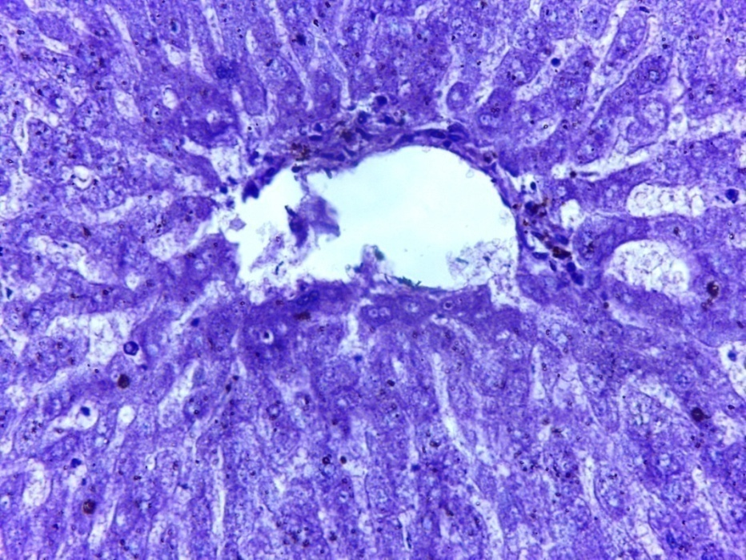
Figure 8: Normal appearance of liver, (H and E X40).

References
1-Bern, C.; Martines J.; dezoya I. and Glass R.I. (1992). The magnitude of the global problem of diarrheal disease: a ten year up date. Bull w. H. o. 70: 705–714.
2- World Health Organization, (1997). Amebiasis. Wkly Epidemiol REX 72:97–100.
3- Boon, N. A. (2006). Davidson's Principles and Practice of Medicine. Elsevier Heal Sci., 358p.
4- Chandy, C.; Robert, J. A.; Beherman, R. E; Kleigman, R.M.; Jenson, H.B. and Saunders, W.B. (2004). Amoebiasis in Nelson text book of pediatrics, 17 ed., company, 257, 1123–1125.
5- Leippe, M. and Muller-Eberhard, H. J. (1994). The pore-forming peptide of Entamoeba histolytica, the protozoan parasite causing human amoebiasis. Toxicol., 87: 5-18.
6-Boettner, D.R., Huston C. and Petri, W.A. (2002). Galactose/N–acetylga lactosamine lectin: the coordinator of host cell killing. J. Bio Sci. (Suppl. 3), 27 553 – 557.
7-Enrique, C-C. M.D. and Douglas, M. K. (2007) Intestinal Protozoal Diseases. enteropathy,” Journal of Infect Dis, 159. 3, 23.
8- Weber, C.; Blazquez, S.; Marion, S.; Ausseur, C.; Vats, D.; Krzeminski, M.;Rigothier, M.C.; Maroun, R.C.; Bhattacharya, A. and Guillen, N. (2008) Bioinformatics and functional analysis of an Entamoeba histolytica mannosyl transferase necessary for parasite complement resistance and hepatical infection. PLoS Negl Trop Dis 2, e165.
9-Ralston, K. S.; Petri, W.A. Jr. (2011). Tissue destruction and invasion by Entamoeba histolytica. Trends Parasitol. (6):254-63.
10- Walter, J.; Miller, H.; Bomford, C. K. and Breast, A. (1979). Ashort hand book of radiotherapy 4th. ed. Churchill Living Stone, 50 -58 .
11-Jovanovic, M.; Sokolic A.;Cuperlovic, K and Movsesijan, M. (1965). Immunization of sheep with irradiated larve of Dictyocaulus filaria.l. Brit. Vet. J. 121: 119 – 130.
12- Ramos, F.; Moran, P.; Gonzalez, E.; Garcia, G.; Ramiro, M., and Petri, W.A. (2011). Tissue destruction and patho-genesis of Antamoeba histolytica. 123-157.
13-Slaoui, M. and Fiette, L. (2011). Histopathology procedures: from tissue sampling to histopathological evaluation. Methods Mol Biol. 691:69-82.
14- Younis, N.N.( 2007). Parasitological and experimental study to infection by Entamoeba histolytica and attenuation parasite by gamma rays in mice. M.Sc thesis, College of Sci, Baghdad Univ. 124pp.
15- Kilmes, B. Z.; Tanielian A. C. and Ali, N. (1972). Excystation and development in call culture of irradiated oocysts of Eimeria tenella. J. Parazool, 19: 500-504 .
16- Mellouk, S., Lunel F.; Sedegah, M.; Beaudoin, R.L. and Drnihe, P. (1990). Protection against Malaria induced by irradiated sporoziotes. Lancet, 335-721.
17- Jenkins, M. C.; Higgins J. A.; Kniel K.; Trout, J. M. and Fayer, R. (2004). Protection of calves against Cryptosporidium parvum oocysts. J. Parasitol., 90 : 830 – 833.
18- Horga, M. A.; Naparst T.R.; Dhawn V. K., Nissen M. D., Konop R., Huston C.D., Boettner D.R., Miller-Sims, V. and Petri, W.A. (2004). Apoptotic killing and phagocytosis of host cell by the parasite Entamoeba histolytica, Infect. Immunol., 71: 964-972.
19-Seydel, K. B.; Smith, S. J. and Stanley, S. L. (2000). Innate immunity to amebic liver abscess is dependent on gamma interferon and nitric oxide in a murine model of disease. Infect Immun 68: 400–402.

