Asymptomatic Hypoglycemia After Hemodialysis in Non-Diabetic Patients with Use of Glucose- Free Dialysate Solutions

Ahmed Hussein Jasim¹ Haider Mehdi Mueen² Ameer Ahmed Aljubawii³
^{1,2,3} College of Medicine, University of Babylon


Received 8 July 2014 Accepted 30 September 2014
Abstract
Hypoglycemia (HG) has been demonstrated during chronic hemodialysis (HD). These events may become more frequent with the current use of glucose-free bicarbonate dialysis solution, the standard formula in most dialysis units in our hospitals.
The Aim of study is to evaluate the occurrence of HG in non-diabetic (NDM) end-stage renal failure patients during HD using dialytic solution without glucose. In Merjan teaching hospital from January to September 2013.
A hospital-based cross-sectional study design has been carried out on fifty non-diabetic patients with chronic renal failure randomly selected from the dialysis unit of Merjan Teaching Hospital after their setting for HD session of the glucose- free bicarbonate solution. Serum glucose has been measured at zero hour before dialysis session and 30 minutes after dialysis session. The study duration was from January to September 2013 Categorical variables were presented as frequencies and percentages. Continuous variables were presented as means with their 95% confidence interval (CI) and standard deviation. The Pearson's chi-square test (x²) was used to determine the associations between categorical variables. Independent sample t-test was used to compare between two means. A p-value of < 0.05 was considered as statistically significant.
Data were expressed No patient presented any clinical evidence of HG.40 patients(74.8%) of fifty patients express serum sugar levels changes before and after HD ,serum sugar levels after HD was <80mg/dl ,which is statistically significant P value <0.01.
Asymptomatic HG was frequent during HD when glucose-free dialysis solution was used. Glucose added dialysis solution at 90 mg/dl significantly reduced the number and severity of HG episodes and although it caused higher mean glycaemia in DM patients during HD, its use seems advisable in all patients.

انخفاض سكر الدم الغير الظاهري سريريا لدى مرضى العجز الكلية بعد جلسة الغسل الدموي باستعمال محاليل خالية من السكر
الخلاصة:
ظاهرة انخفاض السكر تتوضح جليا خلال عملية الغسل الدموي وهذه الظاهرة متكررة باستعمال محاليل الغسل الدموي الخالية من السكر والتي متوفرة بكثرة في ردهات الغسل الدموي في جميع مستشفيات العراق.
الهدف/ لتقيم حالات انخفاض السكر لدى مرضى غسل الكلية الدموي باستعمال محاليل الغسل الخالية من السكر ولتقليل من نسبة حدوث هذة الحالات.
طريقة العمل/ اختير خمسون مريضا مصابا بعجز الكلية المزمن وهو يمارس عملية غسل الكلية الدموي بانتظام مرتين اسبوعيا لمدة اربعة ساعات في كل جلسة من ردهة غسل الكلية في مستشفى مرجان التخصصي والقيم الاحصائية تم استخدامها في هذة الدراسة.
النتائج/ لوحظ ان اربعون مريضا من اصل خمسين مريضا يعاني من انخفاض غير ظاهري لمستوى السكر بعد عملية غسل الدموي مباشرة باستعمال محاليل خالية من السكر وكانت النتائج من الناحية الاحصائية مهمة وايجابية.

Introduction
For patients with end-stage renal disease, renal replacement therapy is achieved by dialysis (hemodialysis or peritoneal dialysis) or kidney transplantation. Although true and complete replacement of renal function is not provided by dialysis, this modality removes metabolic wastes and excess body water, and replenishes body buffers in order to sustain life.
The apparatus used to conduct hemodialysis includes a dialyzer, dialysis solution (dialysate), and tubing for transport of blood and dialysis solution and a machine to power and mechanically monitor the procedure [1].
Dialyzers are composed of a polyurethane capsule or shell within which hollow fibers or parallel membrane plates are suspended in dialysate. The fibers or plates function as a semipermeable membrane across which blood and dialysate flow in opposite directions. Hollow-fibers are the most common dialyzers currently in use [1, 2].
Dialyzer membranes include unmodified cellulose, (also called cuprophan or cuprophane), substituted cellulose, cellulo-synthetic, and synthetic noncellulose. Synthetic noncellulose membranes are more biocompatible than the cellulose membranes and include polyacrylonitrile (PAN), polysulfone, polycarbonate, polyamide, and polymethylmethacrylate (PMMA) membranes [3, 4].
Clearance of various solutes from blood is a function of dialyzer efficiency. Dialyzer clearances are routinely reported as urea or creatinine clearances (reflecting small solute clearance) and vitamin B12 clearance (reflecting large solute clearance). The reported clearance of urea may be used to compare different dialysis membranes. The KoA is the quantitative measure of a dialyzer's efficiency and is defined by membrane porosity and thickness, solute size, and flow rate of blood and dialysate. The KoA for urea varies from 200 to 1100: patients undergoing chronic hemodialysis therapy are usually treated with a dialyzer with a KoA between 300 and 600. Individuals requiring high-efficiency dialysis may be treated with dialyzers with KoAs of greater than 600 [2, 5].
The volume of fluid (in mL/h) that is transferred across the membrane per mmHg of pressure gradient is called the ultrafiltration coefficient (KUf) and is a measure of a dialyzer's permeability relative to water. The ultrafiltration coefficient of a dialyzer correlates directly with its permeability. The lower the permeability to water, the higher the TMP needed to achieve ultrafiltration [5].
Dialysis machines mix different components with water to produce the final solution of dialysate. Potential contaminants in water include aluminum, copper or chloramine, bacteria, and endotoxin and/or inflammatory cytokines. To help eliminate these and other contaminants, water is treated with a combination of various different purification methods, including reverse osmosis, deionization resins and activated charcoal [6].
Typical hemodialysis contains sodium, potassium, calcium, magnesium, chloride, bicarbonate, and glucose. Bicarbonate has replaced acetate as the typical source of buffer in dialysis solution. The buffering capacity of the various available bicarbonate products is not identical and while all bicarbonate-based dialysis products deliver additional buffer, the desired amount of total buffer delivered should be assessed in the context of the individual patient [6, 7].
A calcium concentration of 2.5 meq/L or 2.25meq/L has replaced the 3.5 meq/L concentration as the standard dialysate in most hemodialysis units [8].
Dialysis tubing consists of synthetic tubing designated as the "arterial" line, which carries blood from the arteriovenous access to the dialyzer where blood and dialysate interface at the membrane, and the "venous" line which carries dialyzed blood back to the patient [8].
The dialysis machine must include a blood pump to move blood between patient and the dialyzer, a delivery system to transport dialysis solution and monitoring devices. Monitoring devices include pressure monitors that detect excessive suction or resistance of blood flow, a venous air trap and air detector that prevents air from being returned to the patient, continuous measurement devices that monitor solute concentrate, dialysate temperature monitors, and a dialysate urea monitor [8].
Complications during hemodialysis
- Acute complications commonly occur during routine hemodialysis treatments. They include hypotension, cramps, nausea and vomiting, headache, chest pain, back pain, itching, and fever and chills. These complications are generally caused by multiple underlying mechanisms and are poorly understood [9, 10].
- Longer treatment times and/or ultrafiltration in association with a large degree of solute removal significantly enhance the incidence of headache, nausea, and vomiting during dialysis. A variant of the dialysis disequilibrium syndrome may underlie these symptoms in many patients. The syndrome should be considered in the noncompliant and/or inadequately dialyzed patient who develops nausea, vomiting, or headache while being aggressively dialyzed [9, 10]:
- Chest pain that occurs while a patient is being dialyzed may be associated with hypotension, dialysis disequilibrium syndrome, angina, hemolysis, and (rarely) air embolism. Furthermore, although extremely uncommon, pulmonary embolism may be observed after manipulation of thrombus and/or occlusion of the dialysis access [9, 10]:
- Ventricular arrhythmias are common during dialysis and between treatments; the published frequency ranges widely from 5 to 75 percent. Supraventricular arrhythmias are also common [9, 10]:
- Dyspnea on dialysis needs to be evaluated in the context of the patient’s volume status, other symptoms, and medications. Cardiovascular, infectious, allergic reactions to dialyzer or medications, and hematologic disorders such as heparin-induced thrombocytopenia should be considered [9, 10]:
- Hypoglycemia (HG) occurs in patients with chronic renal insufficiency [11]. In end-stage renal disease (ESRD), it has been reported more frequently than in the pre-dialytic period [12], especially during hemodialysis (HD) sessions [13], and even more frequently in diabetic (DM) subjects, but it is usually asymptomatic [14].

Methods
A hospital-based cross-sectional study design has been carried out on fifty non-diabetic patients with chronic renal failure randomly selected from the dialysis unit of Merjan Teaching Hospital after their setting for HD session of the glucose- free bicarbonate solution. Serum glucose has been measured at zero hour before dialysis session and 30 minutes after dialysis session.
All non-diabetic patients with chronic renal failure on regular haemodialysis for two times weekly, four hours each session have been involved in the study. The exclusion criteria were (diabetic patients, patients with systemic infection and patient on drugs that affect blood sugar).
Serum random blood sugar was collected at zero hour before dialysis (baseline) and thirty minute after dialysis session. Plasma glucose level was measured by an enzymatic method in a spectrophotometer. Dialysate fluid content that used in hemodialysis. The study duration was from January to September 2013.

Major Components Of H Emodialysate
COMPONENT* HEMODIALYSATE
RANGE TYPICAL RANGE
Sodium (mmol/liter) 135–155 140
Potassium (mmol/liter) 0–4.0 2.0
Calcium (mmol/liter) 0–2.0 1.25
Magnesium (mmol/liter) 0–0.75 0.25
Chloride (mmol/liter) 87–120 105
Bicarbonate (mmol/liter) 25–40 35

Data Analysis: Statistical analysis was carried out using SPSS version 18. Categorical variables were presented as frequencies and percentages. Continuous variables were presented as means with their 95% confidence interval (CI) and standard deviation. The Pearson's chi-square test (x²) was used to determine the associations between categorical variables. Independent sample t-test was used to compare between two means. A p-value of < 0.05 was considered as statistically significant.

Demographic Data:
Case Processing Summary
 |  | Count | Percent
GENDER | male | 27 | 54.0%
GENDER | female | 23 | 46.0%
Overall |  | 50 | 100.0%
Excluded |  | 1
Total |  | 51

Results
Study population
No significant differences were observed among the patients in the predialysis and post dialysis groups with respect to gender (Table 1).

Chi-Square Tests RBS * GENDER ( Table 1)
 | Value | df | Asymp. Sig. (2-sided)
Pearson Chi-Square | 5.171ª | 2 | .075
Likelihood Ratio | 5.543 | 2 | .063
Linear-by-Linear Association | 2.646 | 1 | .104
N of Valid Cases | 50
a. 2 cells (33.3%) have expected count less than 5. The minimum expected count is 3.22.

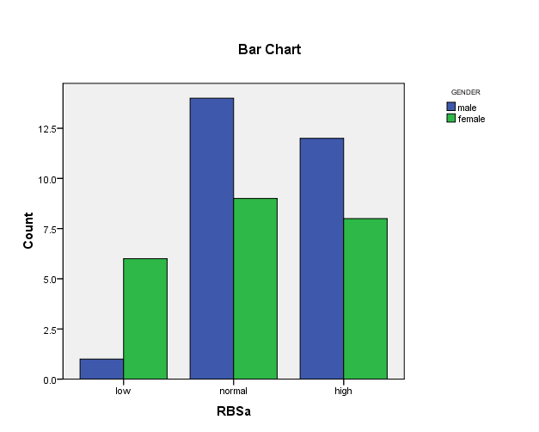
Blood sugar analysis:
There is statistically significant changes in blood sugar levels before and after hemodialysis session P value=0.01. (table2)

Chi-Square Tests(table2)
 | Value | df | Asymp. Sig. (2-sided)
Pearson Chi-Square | 13.084ª | 2 | .001
Likelihood Ratio | 14.288 | 2 | .001
Linear-by-Linear Association | 10.622 | 1 | .001
N of Valid Cases | 50
a. 3 cells (50.0%) have expected count less than 5. The minimum expected count is 1.40.

Tests of Homogeneity of the Odds Ratio
 | Chi-Squared | df | Asymp. Sig. (2-sided)
Breslow-Day | .000 | 0 | .
Tarone's | .000 | 0 | .

Symmetric Measures
 |  | Value | Asymp. Std. Errorª | Approx. T^{b} | Approx. Sig.
Nominal by Nominal | Contingency Coefficient | .455 |  |  | .001
Ordinal by Ordinal | Kendall's tau-b | .466 | .091 | 3.712 | .000
Ordinal by Ordinal | Spearman Correlation | .487 | .096 | 3.862 | .000^{c}
Interval by Interval | Pearson's R | .466 | .089 | 3.645 | .001^{c}
N of Valid Cases |  | 50
a. Not assuming the null hypothesis.
b. Using the asymptotic standard error assuming the null hypothesis.
c. Based on normal approximation.

Frequency Table1
RBS (before dialysis)
 |  | Frequency | % | Valid Percent | Cumulative Percent
Valid | low | 7 | 13.7 | 14.0 | 14.0
Valid | normal | 23 | 45.1 | 46.0 | 60.0
Valid | high | 20 | 39.2 | 40.0 | 100.0
Valid | Total | 50 | 98.0 | 100.0
Missing | System | 1 | 2.0
Total |  | 51 | 100.0

Blood Sugar Levels Before Dialysis:

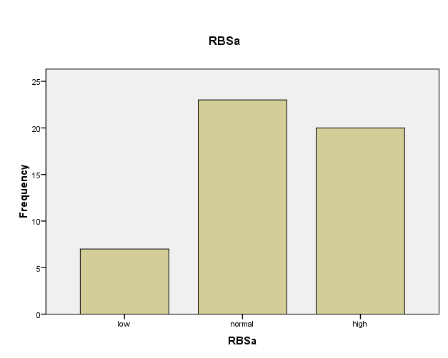

Frequency Table2
RBS (after dialysis)
 |  | Frequency | Percent | Valid Percent | Cumulative Percent
Valid | low | 40 | 78.4 | 80.0 | 80.0
Valid | normal | 10 | 19.6 | 20.0 | 100.0
Valid | Total | 50 | 98.0 | 100.0
Missing | System | 1 | 2.0
Total |  | 51 | 100.0

Blood Sugar Levels After Dialysis:
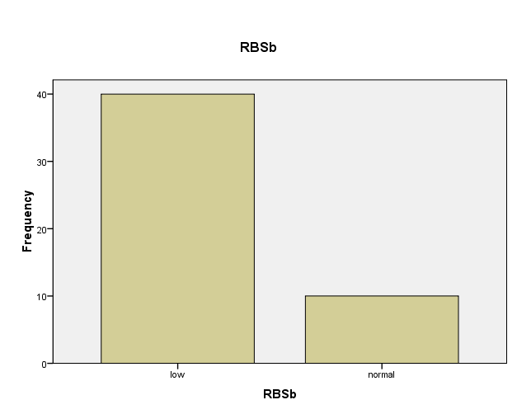

Discussion
The lowest normal value for fasting blood glucose in our laboratory is 65 mg/dl, but we established HG as under 70 mg/dl according to studies that showed this to be the level at which the first changes occur as a result, such as deterioration of the auditory evoked potential or initial physiological changes of the a and b-cells of the pancreas [15, 16].
When we used a glucose-free dialytic solution (40) patients78.4% of all (50) patients where blood sugar <80 mg/dl, Jackson et al. [17, 18] [found glycaemia measures below 72 mg/dl in nine patients (42.8%) of 21 no diabetic (NDM) and in seven (33.3%) among 21 diabetic (DM) during a single dialysis session with glucose-free solution. They observed that an NDM patient presented the lowest value (38 vs 50 mg/dl for a DM)] while in our patients it was <80 mg/dl for no diabetic (NDM) patients [13, 19]. Hypoglycemia (HG) without related symptoms was demonstrated to be more frequent in normal individuals when these hypoglycemic episodes were repeated [16]. There may be many other causes for these frequent HG episodes. Foss et al. [20] [demonstrated that insulin resistance characteristic of chronic uraemia is accompanied by impaired muscle glucose uptake and nonoxidative glucose metabolism, which are significantly improved by HD]. Takahashi et al. [13] described an excessive consumption of glucose as being the result of an accelerated anaerobic metabolism in these patients which, added to the loss of glucose itself through the effluent fluid from the dialyser, would increase the likelihood of HG—symptomatic or not.
In spite of the limitations of our trial (small number of patients, different number of times each dialyser was reused before the study, and limited number of blood glucose levels measurements) and whichever the mechanism of these asymptomatic HG episodes, it is our opinion that the use of a dialytic solution with 90 mg/dl glucose appears to offer more advantages than disadvantages. The propose to use of dialysate with glucose in order to reduce the anaerobic metabolism and interrupt a vicious circle that culminates in short-term HG and long-term neurological deficits [13, 14, 15, 21, 22]. Although it causes increased glycaemia in DM during dialysis, it significantly reduces the incidence of HG (which is usually asymptomatic) both in these patients and in NDM. Deleterious metabolic effects resulting from the presence of glucose in the dialytic solution were not found in short-term observations [14], but longer prospective studies would be necessary to evaluate this possibility.

References
- Keshaviah, P. Technology and clinical application of hemodialysis. In: The Principles and Practice of Nephrology, Philadelphia, 1991, p. 740.
- Salem M, Mujais, SK. Dialyzers. In: Dialysis Therapy, Philadelphia, 1993, p. 65.
- Ahmad S, Misra, M, Hoenich, N, Daugirdas, JT. Hemodialysis Apparatus. In: Handbook of Dialysis, 4th ed, Lippincott, Williams & Wilkins, Philadelphia 2007. p.59.
- Misra M. The basic of haemodialysis equipment. Haemodial Int 2005; 9: 30.
- Boure T, Vanholder R. Which dialyzers membrane to choose? Nephrol Dial Transplant 2004; 19: 293.
- Brunet P, Berland Y. Water quality and complication of Haemodialysis.Nephrol Dial Transplant 2000; 15:738.
- Levin A, Goldstein MB. The benefit and side effect of ramped hypertonic sodium dialysis. JAM Soc Nephrol 1996; 7:242.
- Pastan S, Bailey J. Dialysis therapy. NEngl Jmed 1998; 338: 1428.
- Bregman H, Daugirdas, JT, Ing, TS. Complications during hemodialysis. In: Handbook of Dialysis, Daugirdas, JT, Ing, TS (Eds), Little, Brown, New York, 1994, p. 149.

- Weiner DE, Nicholls AJ, Sarnak MJ. Cardiovascular disease. In: Handbook of Dialysis, Daugirdas, JT, Blake, PG, Ing, TS (Eds), Lippincott Williams & Wilkins, Philadelphia 2007. p. 626.
- Haviv YS, Sharkia M, Safadi R. Hypoglicemia in patients with renal failure. Ren Fail 2000; 22: 219–223.
- Loipl J, Schmekal B, Biesenbach G. Long-term impact of chronic hemodialysis on glycemic control and serum lipids insulin-treated type 2-diabetic patients. Ren Fail 2005; 27:305–308.
- Takahashi A, Kubota T, Shibahara N et al. The mechanism of hypoglycemia caused by hemodialysis. Clin Nephrol 2004; 62:362–368.
- Simic-Ogrizovic S, Backus G, Mayer A, Vienken J, DjUkanovic L, Kleophas W. The influence of different glucose concentration in haemodialysis solution on metabolism and blood pressure stability in diabetic patients. Int J Artif Organs 2001; 24: 863–869.
- DeFeo P, Gallai V, Mazzotta G et al. Modest decrements in plasma glucose concentration cause early impairment in cognitive function and later activation of glucose counter regulation in the absence of hypoglycemic symptoms in normal man. J Clin Invest 1988; 82: 436–444.
- Heller SR, Cryer PE. Reduced neuroendocrine and symptomatic responses to subsequent hypoglycemia after 1 episode of hypoglycemia in non-diabetic humans. Diabetes 1991; 40:223–226.
- Jackson MA, Holland MR, Nicholas J et al. Occult hypoglycemia caused by hemodialysis. Clin Nephrol 1999; 51: 242–247.
- Jackson MA, Holland MR, Nicholas J, Lodwick R, Foster D, MacDonald IA. Hemodialysis-induced hypoglycemia in diabetic patients. Clin Nephrol 2000; 54: 30–34.
- Jayme Eduardo Burmeister, Aline Scapini, Diego da Rosa Miltersteiner, et al. Glucose-added dialysis fluid prevents asymptomatic hypoglycaemia in regular haemodialysis. Nephrol Dial Transplant (2007) 22: 1184–1189.
- Foss MC, Gouveia LM, Moyses Neto M, Paccola GM, Piccinato CE. Effect of hemodialysis on peripheral glucose metabolism of patients with chronic renal failure. Nephron 1996; 73: 48–53.
- Heller SR, Macdonald IA. Physiological disturbances in hypoglycaemia: effect on subjective awareness. Clin Sci 1991; 81: 1–9.
- Maran A, Lomas J, Macdonald IA, Amiel SA. Lack of preservation of higher brain function during hypoglycemia in patients with intensively treated IDDM. Diabetologia 1995; 38:1412–1418.

