Assessment of Endogenous Erythropoietin Level in Sera Patients with Acute Ischemic Stroke

Suhayr Aesa Al-Qaysi¹ Afaf K. Shweekh² Zinah Abbass Ali³
^{1,3} College of Medicine, Babylon University
² Basic Education College, Babylon University
Email: suhayrissa@yahoo.com


Received 28 August 2014 Accepted 9 September 2014
Abstract
A stroke is the loss of brain function due to a disturbance in the blood supply to the brain. Ischemic type is the most common type of stroke in older adults, caused by either blockage of a blood vessel via thrombosis or arterial embolism, or by cerebral hypoperfusion. Erythropoietin (EPO) is a glycoprotein hormone that controls erythropoiesis, or red blood cell production. This study aimed to explore the EPO level in serum of ischemic stroke patients during the acute phase. This study was included 40 subjects, 20 patients with acute ischemic stroke and 20 apparently healthy persons act as a control group. Five milliliters of blood were collected in plane tube without anticoagulants for measuring EPO level in sera of patients and control by ELISA technique. In comparison with the control group, the patients with acute ischemic stroke showed a significant increase in EPO level (P ˂ 0.002). our data revealed that increase circulating endogenous EPO as a response to hypoxia and thereby increase oxygen supply by inducing erythropoiesis and/or other stimulatory factors that contribute the ischemic tolerance.
Key words: Erythropoietin, Acute Ischemic Stroke
الخلاصة
السكتة الدماغية هي فقدان وظيفة نسيج الدماغ بسبب اضطراب تدفق الدم اليه. السكتة الدماغية الاقفارية هي النوع الشائع من حالات السكتة الدماغية لدى البالغين وتنتج من انسداد الاوعبة الدموية او لحدوث الخثرة في الشرايين. ايريثروبويتين هو كلايكوبروتين هورمون مسؤول عن انتاج خلايا الدم الحمراء. الهدف من الدراسة هو حساب مستوى هرمون الاريثروبويتين في امصال المرضى المصابين بالسكتة الدماغية اللاقفارية في الطور الحاد. تضمنت الدراسة الحالية 40 شخص, 20 مريضا مصابا بالسكتة الدماغية اللاقفارية و 20 شخص معافى ظاهريا كمجموعة سيطرة. تم استخدام الأمصال التي تم الحصول عليها من دم المرضى والأصحاء لقياس تركيز هورمون الايريثروبويتين باستخدام تقنية الايلايزا.
اظهرت النتائج بالمقارنة مع مجموعة السيطرة فان مرضى السكتة الدماغية اللاقفارية اظهروا زيادة معنوية عالية P < 0.002)) في مستوى هورمون الايرثروبويتين. تشير نتائجنا الى ان زيادة مستوى هورمون الايرثروبويتين لدى مرضى السكتة الدماغية اللاقفارية هوكاستجابة لنقصان الاوكسجين والمساعدة في زيادة الاوكسجين بواسطة تحفيز عملية انتاج الخلايا الحمراء مع العوامل المحفزة الاخرى المشاركة في تحمل السكتة الدماغية.
مفاتيح الكلمات: ايريثروبويتين, السكتة الدماغية الاقفارية.
ــــــــــــــــــــــــــــــــــــــــــــــــــــــــــــــــــــــــــــــــــــــــــــــــــــــــــــــــــــــــــــــــــــــــــــــــــــــــــــــــــــــــــــــــــــــــــــــــــــــــ

Introduction
A stroke, sometimes referred to as a cerebrovascular accident (CVA), cerebrovascular insult (CVI), or colloquially brain attack is the loss of brain function due to a disturbance in the blood supply to the brain [1]. The two main types of stroke are ischemic and hemorrhagic, accounting for approximately 85% and 15%, respectively [2]. Ischemic type is the most common type of stroke in older adults, caused by either blockage of a blood vessel via thrombosis or arterial embolism, or by cerebral hypoperfusion [3]. While hemorrhagic stroke is caused by bleeding of blood vessels of the brain, either directly into the brain parenchyma or into the subarachnoid space surrounding brain tissue [4]. As a result, the affected area of the brain cannot function normally, which might result in an inability to move one or more limbs on one side of the body, failure to understand or formulate speech, or a vision impairment of one side of the visual field [5].
Erythropoietin, also called hemato-poietin or hemopoietin known as EPO. It is a glycoprotein hormone that controls erythropoiesis, or red blood cell production [6]. It is a cytokine for erythrocyte precursors in the bone marrow. Human EPO has a molecular weight of 34 kD, and composed of 165 amino acids and four carbohydrate groups [7]. An important structural feature of EPO, is that it has two disulphide bonds, one linking the cysteine at amino acid 6 with the cysteine at amino acid 161, and the other linking cysteine 29 and 33. The former is functionally more important, because it acts as a tether, ensuring that the whole molecule is held in the correct shape for binding to the erythropoietin receptor (EPOR) [8]. Human EPO produced by interstitial fibroblasts in the kidney in close association with peritubular capillary and tubular epithelial tubule. It is also produced in perisinusoidal cells in the liver. The liver production predominates in the fetal and perinatal period; while renal production is predominant during adulthood. In addition to erythropoiesis, EPO also has other known biological functions. For example, it plays an important role in the brain's response to neuronal injury [7], and also involved in the wound healing process [9].
EPO is present in low amounts in the circulation under homeostatic conditions, whereas erythropoietic stress, such as hypoxia or anemia, can stimulate a dramatic increase in EPO production in the kidney, leading to a significant rise in circulating hormone amounts and subsequently increased erythropoiesis [10], EPO also stimulates red blood cell production by binding and activating a high affinity receptor EPOR that is expressed predominantly on the surface of immature erythroid cells [11]. Over the last decade it has become clear that EPO acts as growth and survival factors for multiple tissues expressing the EPOR [12]. The number of described targets of EPO action continues to grow. EPO and its receptor are both present in the central nervous system with erythropoietin alpha capable of crossing the blood brain barrier via active transport. The presence of EPO within the spinal fluid of infants and the expression of EPOR in the spinal cord, suggesting a role by EPO within the CNS [13].
This study aimed to evaluate the serum EPO levels of ischemic stroke patients during the acute phase.

Materials and Methods
This study was included (40) subjects, (20) patients with acute ischemic stroke and (20) apparently healthy persons act as a control group. The collection of samples was conducted during the period from 1st of December 2012 till 30th of June 2013.
The age of patients group who subjected to this study were ranging from (46-86) years, and comprised of (10) males, and (10) females. All of those patients were admitted to Merjan Teaching Hospital in Hilla city with clinical symptoms of acute ischemic stroke. The diagnosis and the type of stroke were confirmed by computed tomography CT- scanning or magnetic resonance imaging MRI- imaging techniques.
The age of control group was ranging from (25-34) years, this group comprised of (11) males and (9) females.
Five milliliters of blood were collected in plane tube without anticoagulants for measuring EOP using ELISA kit (USA) [14].
Erythropoietin level estimated in sera of patients and control by ELISA technique and the standard curve for estimation of erythropoietin were represented in figure (1).

Optical density
µ
Figure (1): Standard curve of erythropoietin.

Statistical Analysis
Data were expressed as mean ± S.D. Comparisons of means were performed using Student t-test. All statistical analysis were performed by using SPSS 16.0 software. A value of P < 0.05 was considered statistically significant and less than (0.01) was considered highly significant.

Results

The characteristics features of study samples summarized in table 1:

Table (1): characteristics of study samples
Parameters | Patient group | Control group
Age ( years )  Mean ± SD* | 63.35± 12.82 | 28.1 ± 3.04
Age range ( years ) | 46 - 86 | 25 - 34
Gender ( male : female ) | 10 : 10 | 11 : 9

* SD = Standard deviation.

The acute ischemic stroke patients mean age in present study was higher than the control with highly significant statistical differences (P< .000) as demonstrated in figure-2.

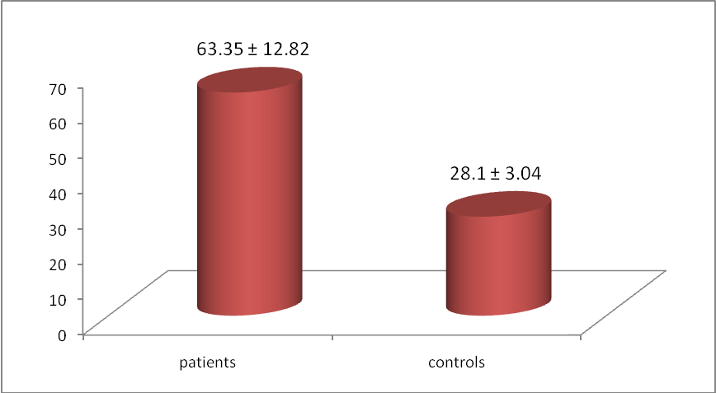
P < 000
Figure (2): Age of studied groups (expressed as a mean ± SD)

Also, the present study showed a highly significant (P ˂ 0.002) increase in EPO level in sera of patients with acute ischemic stroke compared with healthy control subjects as shown in figure (3).

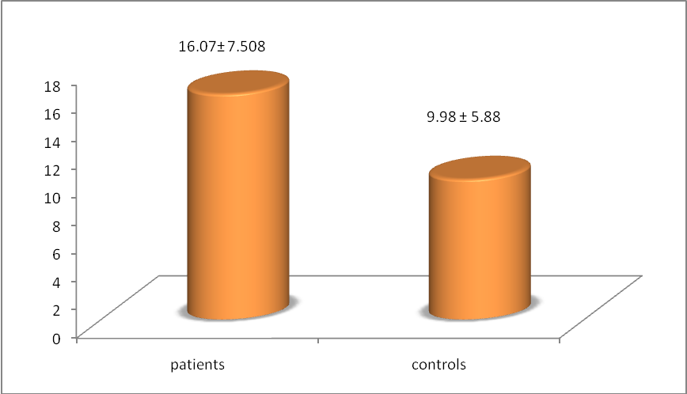
P ˂ 0.002
Figure (3): Erythropoietin concentration in patients with ischemic stroke compared with control group (expressed as a mean ± SD)

Discussion
Ischemic stroke is a serious disease caused by a thrombus (blood clot), which can result in permanent neurological damage, complications, and even death [15].
Patients taken for this study had mean age of 62.3 ± 11.3 years. The minimum and maximum age were 44 and 86 years respectively, Although acute stroke may occurs at any age, but it occurs mainly in the age between 55- 85 years of old [16].
The present results are consistent with those reported that stroke incidence is increased with age. About two thirds of all strokes happen after 65 years old. Men are slightly more affected than women [17]. Also, a new analysis from the Helsinki Young Stroke Registry finds the frequency of ischemic stroke rises sharply beginning at the age of 40, partly because traditional stroke risk factors started to accumulate around the age of 44 [18]. In addition to that, Margaret et al. [19] suggests that incidence of disability after ischemic stroke increases dramatically with advancing of age and older age at stroke onset, not gender or stroke subtype, was associated with greater disability.
In current study the EPO level in patients with acute ischemic stroke higher than the control group with highly significant difference at (p< 0.002). EPO is a pleiotropic factor. Both EPO and EPOR are expressed by astrocytes and neurons, and EPO is present in the cerebrospinal fluid (CSF). Furthermore EPO is a neuroprotective factor [20], which improves functional recovery and reduces neuronal apoptosis [21], and inflammation [22]. In response to ischemia, mammalian cells express a variety of proteins, including hypoxia inducible factor 1a (HIF-1a). Expression of HIF-1a increases exponentially, as cellular O2 concentration decreases [23]. Downstream effects of increasing levels of HIF-1a are upregulation of various proteins such as EPO, EPO acts as a major regulator of erythropoiesis, by promoting the survival and proliferation of erythroid precursor cells [24]. Also in response to hypoxia the kidney produces EPO, which in turn increases the number of red blood cells and thereby increasing the tissue oxygen supply.
The EPO also has a mitogenic and positive chemotactic effect on endothelial cells and endothelial progenitor cells [25]. The mechanisms underlying the anti-ischemic action of EPO have been proposed to involve anti-apoptotic processes [26], neovascularization, mobilization of endothelial progenitor cells, and angiogenesis [27]. Also, due to significantly higher concentrations of EPO in the blood than in the central nervous system (CNS), a hematopoietic function of brain-derived EPO is doubtful. The weak constitutive expression in the adult brain can be rapidly increased by hypoxia and acute metabolic stress as evidenced by detection of EPO in CSF or postmortem brain tissue after traumatic brain injury, subarachnoid hemorrhage, and stroke [28]. Hypoxia-induced expression of EPO and the classical EPOR in brain cells may contribute to ischemic tolerance [29] whereas neutralization of the brain endogenous EPO augments ischemic damage.
In addition to that, one potential mechanism to increase oxygen delivery to the ischemic tissue is induction of angiogenesis [30]. Actually, EPO has pleiotropic effect on brain function, including neuroprotection, and promotion of angiogenesis and neurogenesis [9], EPO stimulates angiogenesis in vitro as well as in vivo as described in previous study [31]. Therefore, the EPO/EPOR system is implicated in the process of neuroprotection and restructuring (such as angiogenesis) after ischemia [32]. Previous research on stroke has largely focused on EPO treatment in reducing infarct volumes and in improving recovery of neurological function, and no studies recorded measured the circulation EPO after stroke incidence. our result in current study, suggested that increase level of EPO in sera of stroke patients as a response to hypoxia and other stress conditions result from infracted area of brain that consist with [33,34], they have been shown the expression of endogenous EPO and its receptor are expressed in the developing brain and adult liver is induced by hypoxia. However, local expression of normoxic and hypoxia-induced expression in brain is magnitudes lower than that outside of the (CNS).

Conclusion
Our data revealed that in ischemic stroke patients the circulating endogenous EPO which may increase in response to hypoxia and thereby increase oxygen supply by inducing erythropoiesis and/or other stimulatory factors that contribute to the ischemic tolerance.

References
- Sims NR., Muyderman H. (2009). "Mitochondria, oxidative metabolism and cell death in stroke". Biochimica et Biophysica Acta; 1802 (1): 80–91.
- Meyers PM., Schumacher HC., et al. (2010). Cerebrovascular Section, Society of NeuroInterventional Surgery, Society of Vascular and Interventional Neurology. Performance and training standards for endovascular ischemic stroke treatment. AJNR Am J Neuroradiol; 31:E8–11. [PubMed]
- Dan L., Longo, et al. (2012). Harrison's principles of internal medicine. (18th ed). In Donnan GA., Fisher M., Macleod M., Davis SM. (2008). "Stroke". Lancet; 371 (9624): 1612–23.
- Feigin VL., Rinkel GJ., Lawes CM., Algra A., Bennett DA., van Gijn J., Anderson CS. (2005). "Risk factors for subarachnoid hemorrhage: an updated systematic review of epidemiological studies". Stroke; 36 (12): 2773–80.
- Kumar, Vinay, et al. (2010). Robbins and Cotran pathologic basis of disease. (8th ed.). Philadelphia, PA: Saunders/Elsevier: 1290–1298.
- Sirén AL., Fratelli M., Brines M., Goemans C., Casagrande S., Lewczuk P., Keenan S., Gleiter C., Pasquali C., Capobianco A., Mennini T., Heumann R., Cerami A., Ehrenreich H., Ghezzi P. (2001). "Erythropoietin prevents neuronal apoptosis after cerebral ischemia and metabolic stress". Proc Natl Acad Sci USA; 98 (7): 4044–4049.
- Lai PH., Everett R., Wang FF., Arakawa T., Goldwasser E. (1986). Structural characterization of human erythropoietin. J Biol Chem; 261: 3116–3121.
- Lappin T. (2003). the Cellular Biology of Erythropoietin Receptors. The Oncologist; (8): 115-18
- Haroon ZA., Amin K., Jiang X., Arcasoy MO. (2003). "A novel role for erythropoietin during fibrin-induced wound-healing response". Am J Pathol; 163 (3): 993–1000.
- Watowich, Stephanie S. (2011). The Erythropoietin Receptor: Molecular Structure and Hematopoietic Signaling Pathways. Journal of Investigative Medicine; (59): 1067-1072.
- Broudy VC., Lin N., Brice M., et al. (1991). Erythropoietin receptor characteristics on primary human erythroid cells. Blood; 77: 2583-2590.
- Juul SE., Anderson DK., Li Y., Christensen RD. (1998). "Erythropoietin and erythropoietin receptor in the developing human central nervous system". Pediatr. Res.; 43 (1): 40–9.
- Grimm C., Wenzel A., Groszer M., Mayser H., Seeliger M., Samardzija M., Bauer C., Gassmann M., Remé CE. (July 2002). "HIF-1-induced erythropoietin in the hypoxic retina protects against light-induced retinal degeneration". Nat. Med; 8 (7): 718–24.
- Human erythropoietin ELISA kit (USA).Creative diagnosis.
- Nam KN. et al. (2010). Genipin inhibits the inflammatory response of rat brain microglial cells. International Immunopharmacology;10: 493–499. [PubMed]
- Morris DL., Schroeder EB. (2000). Stroke Epidemiology, Foundation for education and research in neurological emergencies; pp 1-9.
- Bilić I., Dzamonja G., Lusić I., Matijaca M., Caljkusić K. (2009). Risk factors and outcome differences between ischemic and hemorrhagic stroke. Acta Clin Croat; 48: 399–403.
- Putaala J., Metso AJ., Metso TM., et al. (2009). Analysis of 1008 consecutive patients aged 15 to 49 with first-ever ischemic stroke. The Helsinki Young Stroke Registry.
- Kelly-Hayes M., et al. (2003). The influence of gender and age on disability following ischemic stroke. Journal of Stroke and Cerebrovascular Diseases .Volume 12, Issue 3; 119–126 .
- Buemi M., Cavallaro E., Floccari F., Sturiale A., Aloisi C., Trimarchi M., Corica F., Frisina N. (2003).The pleiotropic effects of erythropoietin in the central nervous system. J Neuropathol Exp Neurol;62(3):228-36.
- HayleyS., and Litteljohn D. (2013). Neuroplasticity and the next wave of antidepressant strategies.
- Mengozzi M., Cervellini I., Villa P., Erbayraktar Z. (2012). Erythropoietin-induced changes in brain gene expression reveal induction of synaptic plasticity genes in experimental stroke. PNAS; 12 (109) : 24 9617–9622.
- Wang GL., Jiang BH., Rue EA., et al. (1995). Hypoxia-inducible factor 1 is a basic-helix-loop-helix-PAS heterodimer regulated by cellular O2 tension. Proc Natl Acad Sci USA; 92: 5510–4.
- Jelkmann W. (1992). Erythro-poietin: structure, control of production, and function. Physiol Rev; 72:449–89.
- Kretz A., Happold CJ., Marticke JK. et al. (2005). Erythropoietin promotes regeneration of adult CNS neurons via Jak2/Stat3 and PI3K/AKT pathway activation. Mol Cell Neurosci; 29:569–579.
- Hirata A., Minamino T., Asanuma H., Fujita M., Wakeno M., Myoishi M., Tsukamoto O., Okada K., Koyama H., Komamura K., Takashima S., Shinozaki Y., Mori H., Shiraga M., Kitakaze M., Hori M. (2006). Erythropoietin enhances neovascularization of ischemic myo-cardium and improves left ventricular dysfunction after myocardial infarction in dogs. J Am Coll Cardiol; 48:176-184.
- Yip H., Tsai T., Lin H., Chen S., Sun C., Leu S. et al. (2011). Effect of erythropoietin on level of circulating endothelial progenitor cells and outcome in patients after acute ischemic stroke Critical Care ;15:R40
- Subiros N. Barco DG., Rosa M. Coro-Antich. (2012). Erythropoietin: still on the neuroprotection road. Ther Adv Neurol Disord; 5 (3): 161–173.
- Siren AL., Fasshauer T., Bartels C., Ehrenreich H. (2009) Therapeutic potential of erythropoietin and its structural or functional variants in the nervous system. Neurotherapeutics; 6:108–127.
- Mărgăritescu O., Pirici D., Mărgăritescu C. (2011). VEGF expression in human brain tissue after acute ischemic stroke. Rom J Morphol Embryol; 52 (4): 1283-92.
- Zhu H., Wan D., Xu X., et al. (2010). Catalpol Increases Brain Angiogenesis and Up-Regulates VEGF and EPO in the Rat after Permanent Middle Cerebral Artery Occlusion. International Journal of Biological Sciences; 6(5):443-453.
- Jaquet K., Krause K., Tawakol-Khodai M. et al. (2002). Erythropoietin and VEGF exhibit equal angiogenic potential. Microvasc Res; 64: 326–333.
- Asadi B, Askari GR., Khorvash F., Bagherpur A., Mehrabi F., Karimi M. (2013). Neuroprotective Effects of Erythropoietin in Acute Ischemic Stroke. Int J Prev Med. May; 4(2): S306–S312.
- Kilic E., Kilic U., Soliz J., et al. (2005). Brain-derived erythropoietin protects from focal cerebral ischemia by dual activation of ERK-1/-2 and Akt pathways. FASEB; 19 (14):2026-8.

