Er :YAG Laser Skin Resurfacing for Perioral Wrinkles

Bahir Sabah Abood Allawi
College of Medicine, Babylon University
Email:bahir_allawi@yahoo.com


Received 18 August 2014 Accepted 30 September 2014
Abstract

During the last decade, resurfacing lasers advanced from relative obscurity to the forefront of cosmetic and aesthetic surgery, and many surveys revealed that most plastic surgeons performing aesthetic surgical procedures incorporated laser resurfacing in their practices.

The introduction of short-duration Er:YAG lasers in the mid-1990s offered another option for resurfacing,

The objective of this study Was to evaluate the use of 2940nm Er:YAG laser system for the rejuvination of perioral wrinkles..

A total of 20 patients with perioral wrinkles were selected for Er:Yag 2940 nm (Contour, Sciton Inc., St Palo Alto, CA) Laser resurfacing. The erbium square scan was used, with 30 to 50 percent pattern overlap at 15 to 20 J/cm^{2 ,} if wrinkles are still apparent, use a single 3-mm spot, at 7 J/cm² and 5 Hz, to further decrease the wrinkle shoulders.

The results was The range of the average grades of the wrinkles before treatment was between 4-2.1 while after treatment was between 1.2-2.7.

There was 1.5 total average grade improvement in the perioral wrinkles after Er:Yag laser skin resurfacing. The Erbium:YAG laser is safe and effective it can be recommended for perioral skin resurfacing, with noticeable improvement in wrinkles, it causes tissue ablation with minimal tissue desiccation and minimal residual thermal damage. The Erbium:YAG laser associated with a shorter duration of posttreatment erythema than with carbon dioxide laser.

الخلاصة
خلال العقد الأخير، تقدمتُ ليزراتً شد البشره مِنْ الغُمُوضِ النسبيِ إلى طليعةِ الجراحةِ التجميليةِ، وكَشفتْ العديد مِنْ الإستطلاعاتِ الى أن أكثر الجرّاحين التجميليين يقومون بدَمجَ العمليات التجميليةَ مع أستخدام ليزراتً شد البشرهِ في ممارساتِهم. منح أدخال ليزرEr:YAG بنبضات قصيره في منتصف التسعينات اختيار جديد لشد البشره، اما لوحده أو مع استخدام ليزر CO2.
الهدف من هذه الدراسه هو تقييم أستخدام ليزر Er:YAG 2940 nm في شد التجاعيد حول الفم. هذه الدراسةِ أجريت بين الفترةِ مِنْ الأوّل من تشرين الثّاني 2009 إلى العشرينِ مِنْ آذارِ 2010. عشرون مريض اختيروا لعلاج التجاعيد حول الفم بأستخدام ليزر Er:YAG nm 2940 (شركة سيتون المحدودة) .تم اَستعمالُ المَسْحَ المربّع الشكل، بنسبة30 إلى 50 بالمائة تداخلِ وبطاقة 15 - 20 جْول / سنتيمتر المربع فأذا كانت التجاعيد لاتزال واضحه تستخدم النبضات النقطية الشكل بقطر 3ملم و 7جول/سم2 و 5 هرتز لعلاج اكتاف التجاعيد المتبقيه.
كانّ مدىِ درجاتَ التجاعيدِ قبل المعالجةِ تتراوح بين 2.1-4بينما بعد المعالجةِ بين 1.2-2.7.وكان التحسن في معدلِ الدرجةِ الكليِّ في التجاعيد حول الفم ِ 1.5 بعد أستخدام ليزر Er:YAG 2940 nm في شد التجاعيد حول الفم.

Introduction
During the last decade, resurfacing lasers advanced from relative obscurity to the forefront of cosmetic and aesthetic surgery and many surveys revealed that most plastic surgeons performing aesthetic surgical procedures incorporated laser resurfacing in their practices. Laser resurfacing with high-energy, short -duration carbon dioxide (CO2) and erbium:yttrium-aluminum-garnet (Er:YAG) lasers has been proved to be efficacious in improving photodamaged skin and acne scarring, and technological advances have reduced the level of experience formerly required to perform dermabrasion or chemical peels.[1]
Albert Einstein was the first to describe the concept behind the laser in the theory of stimulated emission of radiation in 1917. In 1960, Theodore Maimon' developed the first laser light with use of a ruby crystal. Lasers have been used in medicine for several decades, The uniform wavelength of light generated by a laser is absorbed by a specific target, or chromophore, usually causing its destruction. This phenomenon, termed selective photothermolysis, is the theoretical foundation that allowed the development of lasers designed to target specific tissues [1].
Ultra pulse technology provided an increase in power seven times that of the super pulse lasers, and the pulse width was decreased to less than 1 msec. These advances helped limit the thermal damage and associated scar formation, allowing the CO₂ laser to be used effectively as a resurfacing tool. In 1991, Fitzpatrick and Goldman' used this laser to treat actinic damage of the face and actinic cheilitis and noted an improvement in wrinkles. Since then, laser resurfacing with short-pulsed, high-energy CO₂ lasers has been used to treat photodamaged skin and acne scars [1].
Multiple studies have been published describing multiple methods of treatment with different high-energy, short-pulse CO₂ laser systems[2-5] histologic evaluation of the impact of different laser systems;[6] clinical results; and the short and long-term⁽⁷⁾side effects of CO₂ laser resurfacing. Despite the dramatic results seen with high-energy, short-pulse CO₂ laser resurfacing of facial skin, the enthusiasm for these systems has been diminished by the prolonged recovery time, the persistent erythema seen in many patients, and the limited safety margins leading to permanent side effects, even in the hands of experienced laser surgeons. The introduction of short-duration Er:YAG lasers in the mid-1990s offered another option for resurfacing, either alone or in combination with the CO2 laser.[1]
The Aim of this Study is to evaluate the efficiency of 2940 nm Er:YAG laser radiation as adjuvant modality of laser resurfacing for rejuvenation of perioral wrinkles.
The lips are two musculo-membranous moveable folds that form the lower wall of the oral cavity and surround the oral orifice. Their limits are as follows: at the top, the base of the nose; at the bottom, the mentolabial furrow; and toward the sides, the nasolabial-genian furrow. Their junctions at the sides form the commissures of the mouth. Each lip consists of a cutaneous portion called white lip and a mucosal part known as red lip[8].
They have a primary aesthetic function, forming part of the total facial harmony including the whole mimic expression. Currently, laser resurfacing is used in the treatment of lip wrinkles. When small wrinkles and deeper defects are treated, the aim is to recover all of the aesthetics of young skin, but the goal should also be to recover the characteristic anatomy of youthful lips. To achieve this, it is important to understand the concept of beauty and the anatomic relationship of the lips, as the proportions and aesthetics of the face can be enhanced by laser resurfacing [8].

Wrinkles Terminology
A discussion of wrinkles, furrows, and folds is difficult because there is no commonly accepted classification or body of terminology that is based on anatomic, dimensional, or etiologic criteria. Words such as wrinkles, lines, furrows, and folds are used with heavy reliance on the intuitive grasp of such terms (Fig.1) [9].

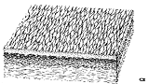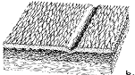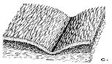

Figure 1: Textural changes of the facial skin: (above) wrinkling, (center) mimetic wrinkles, and (below) fold [9].

Wrinkle lines are associated with textural changes of the skin surface caused by intrinsic aging and photoaging of topographically defined areas. usually limited to superficial dermal creasing; thus, they are amenable to treatments such as chemical peeling, dermabrasion, and laser resurfacing. Mimetic wrinkles, commonly referred to as lines (partial thickness) or furrows (full thickness), are the visible effects of deep dermal creasing caused by repeated facial movement and expression combined with dermal elastosis. They are therefore perpendicular to the direction of the underlying facial muscles. Therapeutically, mimetic wrinkles or furrows do not respond well to resurfacing procedures, but react preferentially to muscle resection, botulinum toxin, or injectable skin filler materials as in radial lips lines. Folds are the result of overlapping skin caused by genetic laxity, intrinsic aging, and loss of tone, bony atrophy, gravity, and consequent sagging. They occur as nasolabial folds in midface sagging. The correction of folds requires tightening procedures such as face lift, direct skin excision, or Augmentation of the bony skeleton. Combinations of mimetic wrinkles and folds are commonly present [9].
Er: YAG Laser Tissue Interaction
The affinity of the Er:YAG laser (wavelength of 2940 nm) to water is 10 times that of the CO2 laser (wavelength of 10,600 nm).[1] Laser energy is absorbed by water and converted to heat. The more water present in the target tissue, the more the energy is purely ablative without significant diffusion of thermal energy. Because the epidermis is composed of 90% water, this layer is ablated with minimal diffusion of thermal energy. However, the dermis contains many structural proteins, and the water content is less than 50% this creates a zone of vaporized or ablated tissue and an adjacent zone of thermally damaged tissue. Some of the tissue is irreversibly damaged and must be sloughed. However, tissue receiving less thermal damage can be remodeled during the inflammatory phase of wound healing this process leads to remodeling of collagen, which improves skin texture and reduces rhytids [1].
Rhytids may be reduced or eliminated in two ways: first, there is immediate laser ablation of the shoulders of the wrinkle and thermal collagen shortening; second, there is the delayed process of dermal and collagen remodeling. Collagen shrinkage leading to dermal tightening may also be related to both immediate and long-term effects. Some immediate shrinkage appears to be caused by heat diffusion· However, there is also evidence to suggest that permanent skin shrinkage is caused by collagen deposition and remodeling (Fig.2) [1].

Figure 2: Multicenter study has shown new collagen formation of up to 600% postoperative thickening of the Grenz zone at 90 days. A. Before treatment. B. At 90 days after treatment.[1]

Increased laser energy correlates linearly with tissue injury; higher energy delivered is directly proportional to tissue injury. Multiple passes cause additive injury, and the total injury is most closely related to the total energy delivered. In other words, whether the total energy is delivered in one pass or several passes, the long-term results are similar.
Histologic evaluation immediately after laser resurfacing with various microsecond pulsed CO₂ laser systems shows tissue ablation of approximately 35 µm with 20 to 50 µm of Non specific thermal damage after one passes at 350 mJ. Thermal damage can increase in depth up to 150 µm with increasing passes. Er: YAG laser vaporization with one pass at 10 to 20 J/cm' produces similar ablation of 10 to 40 µm and thermal damage not exceeding 50 µm. In distinct contrast to the CO₂ laser, however, increasing passes with the Er: YAG laser at settings of 14 to 24J/cm' do not change the depth of thermal necrosis, which remains relatively constant (15 to 40µm) even as the total depth of vaporization increases. However, the histologic effects seen from CO2 and Er: YAG laser treatments are not comparable side by side because of the differing levels of ablation and thermal injury as resurfacing proceeds to deeper levels [1].

Materials and Methods
This study was between the periods from 1st of November 2009 to 20th of March 2010. twenty patients with perioral wrinkles were selected for Er: YAG Laser resurfacing. All patients were female. The average age of our patients was 54.3 years. Table 1 shows the distribution of the age groups;

Table 1: Distribution of the patient's age groups
Patients age group | No. | %
40-50 years | 6 | 30
50-60 years | 8 | 40
60-70 years | 3 | 15
>70 years | 3 | 15
Total | 20 | 100

All patients selected to be with no history of any previous resurfacing procedures, whether by conventional or laser resurfacing. these patients showed different classes I-V of rhytides, Ideal candidates for laser resurfacing have fair skin of Fitzpatrick skin types I to III. But all patients may be candidates for laser resurfacing, all the selected patients have Fitzpatrick skin phenotypes I-III.
The preoperative evaluation included a complete history and physical examination, History of previous wound healing, pigmentary problems and previous history of viral and bacterial infections were obtained. Patients with any medical condition (cardiovascular, respiratory, psychological, or immunologic deficiency), history of hypertrophic scarring or keloid formation, A thorough history of previous and current medications ,history of isotretinoin therapy less than 6 months prior to treatment, or history of any recurrent or chronic viral disease were not considered for the study. the patients were instructed that tobacco, alcohol, aspirin, nonsteroidal, anti-inflammatory, or anticoagulant medications were to be avoided for 10 days prior to the procedure All treated patients, despite an absence of a previous history of bacterial or viral infections were given Valtrex (Valacyclovir) 500 mg twice daily for 1 week and Cefalexin 250 mg four times a day for 10 days starting on the day before treatment. All patients applied topical tretinoin every night for at least 2 weeks before laser.
The patients had given only topical anesthesia EMLA (lidocaine 2.5% and prilocaine 2.5%) for laser resurfacing and all the patients treated wore eye googles during the procedure.
After 24 hours, all patients were encouraged to apply topical antibiotic ointments twice daily, total sun avoidance was encouraged for 6 weeks. Patients were instructed to come for the 1st visit at the end of the 1st week when the reepithelialization occurred as determined by confluent erythema without erosion, and followed weekly until disappearance of erythema. After reepithelialization was observed, all patients were started on a tinted 60 SPF sun block and followed for l-6 months.
All patients were photographed before treatment, and a 3-4 months after procedure. All pictures were evaluated by two different blinded observers who had to determine the before and after pictures, and had to categorize the improvement using the wrinkles assessment scale.

Table 2: Er:YAG specifications

Laser Type | High Power, Dual Mode Er:YAG
Wavelength | 2940 nm
Power | 45 Watts
Pulse Energy | Automatically set to correct fluence - Joules per second: 45
Beam handling | Articulated Arm
Pattern generation | Large area-pattern generator in the scanning handpiece, is both collimated & telecentric making it insensitive to working distance
Repetition Rate | 50 Hz
Delivery System | Articulated Arm
Utilities | 220VAC, 30A
Weight | 200 lbs.
Spot Size | Automatically adjusted for ablation, coagulation, incision
Scan Field Size | variable up to 3.5 cm X 3.5 cm
Beam | Collimated and Telecentric
Control | System touch screen
Auto Repeat | 0.5, 1, 1.5 ,2, 2.5 seconds

Laser System

The Er:YAG laser system 2940 nm (Contour, Sciton Inc., St Palo Alto, CA) has been used in this study and it has the following specifications (Table 2).

Technique and Laser Dose Parameters
When performing resurfacing with the erbium: YAG laser, a homogeneous appearance must be obtained to produce an acceptable aesthetic result. If non-scanning erbium lasers are used, it is difficult to maintain the same overlap, especially at higher repetition rates. The result may be too much overlap, leading to excessively deep penetration, or too little overlap, producing a "polka dot" appearance. For this reason, the newer scanning systems, where fixed pattern overlap is precisely obtained, result in a homogeneous appearance. Single-spot nonscanning lasers can be used for treating small skin lesions and the shoulders of wrinkles.
Usually prefer to use the scanning erbium: YAG laser with maximum overlap of the pattern, which in most systems is 30 to 50 percent. To avoid printing any pattern in the skin, the orientation of the pattern should be changed after each pass. Ideally, two to three passes should be made to maximize homogeneity and be time efficient.
When resurfacing with the erbium: YAG laser, clear visualization of the end points makes the procedure extremely accurate. Using magnifying glasses helps. When the upper reticular dermis is reached, bleeding may become splotchy, and the transudate

becomes more profuse. Follicle openings become much wider, and the collagen bundles become coarser and more haphazard
in orientation. At this point, it is generally best to proceed no further.

For superficial wrinkles, the erbium square scan used, with 30 to 50 percent pattern overlap at 15 to 20 J/cm². Two passes are made. If wrinkles are still apparent, a single 3-mm spot, at 7 J/cm² and 5 Hz, used to further decrease the wrinkle shoulders.
For deep wrinkles, Also the scanner at Fluencies of 15 to 20 J/cm² used, but three passes are made.also the Remaining wrinkles are treated with a single 3-mm spot, at 7 J/cm² and 5 Hz, until the wrinkle shoulders are flatter.
The wavelength remains constant, but the adjustable pulse duration can be greatly lengthened (300 µsec) to exceed the thermal relaxation time. This provides hemostatic control and allows thermal effects to penetrate more deeply, causing more collagen tightening.

Evaluation Criteria
A wrinkle assessment scale was developed as a simple tool for use by plastic surgeons, dermatologists, and aesthetic surgeons who want to assess the changes resulting from using rejuvenating procedures in their patients. By correlating the grade of the wrinkle in the reference photographs with the wrinkle in a patient’s face, a classification of 0 to 5 is assigned as in Table 3[9].

Table 3: Grades of Facial Wrinkles [9]
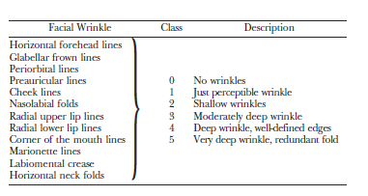

The photographs of the Wrinkle Assessment Scale were used “live” in direct comparison with the corresponding wrinkle or fold in the patient’s face or “indirectly” by comparing a patient’s photograph with the pictures of the scale. The assessment was always made at the same location by use of anatomic landmarks for the perioral wrinkles [9] Fig. 3

Figure 3: Perioral wrinkles⁽⁹⁾

The depth of the wrinkle at its reference point was considered and compared, not its length or overlapping skin fold. Some elderly patients have a pronounced skin fold or redundancy of skin rather than a wrinkle or crease in the dermis. In such cases, only the wrinkle was classified [1].
Results
Below are the photographs of four patients under this study before and after Er: YAG laser perioral skin resurfacing (Figures 4-7)

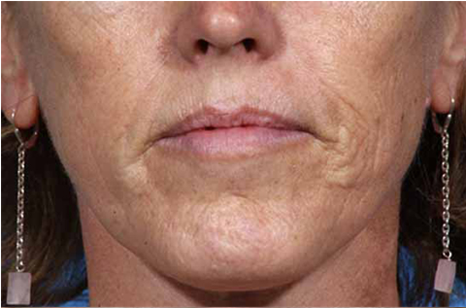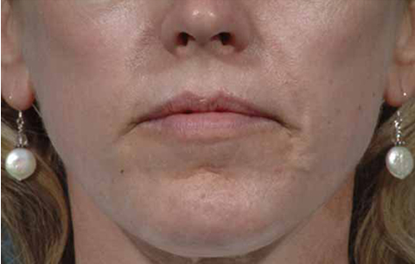
Figure 4: before (left) & After Treatment (right).
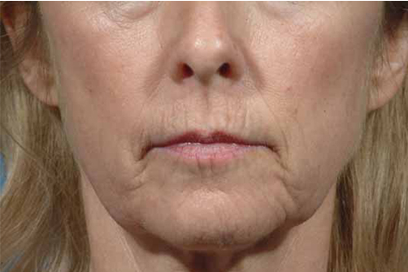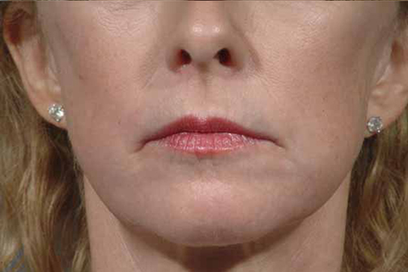
Figure 5: before (left) & After Treatment (right).

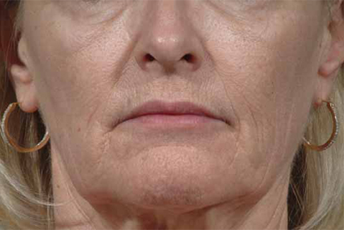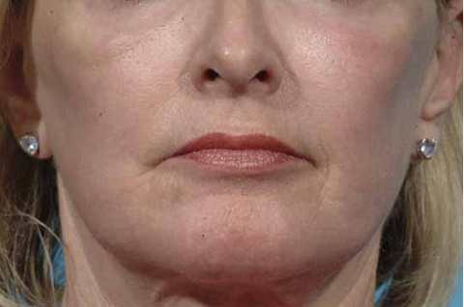
Figure 6: before (left) & After Treatment (right).

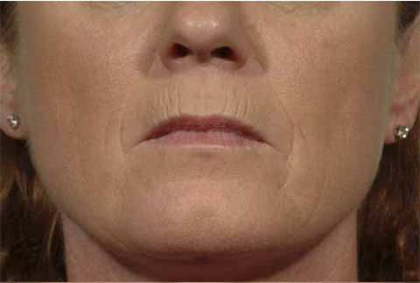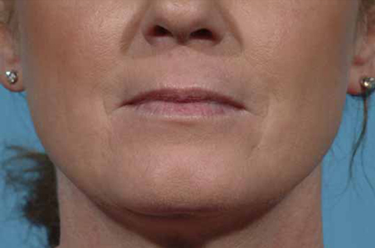
Figure 7: before (left) & After Treatment (right).

Two different blinded observer persons chosen to determine the wrinkles grades before and after treatment for each patient, By correlating the grade of the wrinkle in the reference photographs of the wrinkles assessment scale with the wrinkle in a patient’s face, “live” in direct comparison with the corresponding wrinkle or fold in the patient’s face or “indirectly” by comparing a patient’s photograph with the pictures of the scale. assessment was always made at the same location by use of anatomic landmarks for the perioral wrinkles[4], then table 4 written after obtaining the average of wrinkles grades for each anatomic landmark from all the patients.

Table 4: Averages of Grades of perioral wrinkles before and after treatment

 | Before Treatment |  |  |  |  |  | After Treatment
Area | NL | UL | LL | CM | ML | LM | NL | UL | LL | CM | ML | LM
Average | 3.5 | 2.8 | 2.1 | 4 | 3.2 | 3 | 1.4 | 1.2 | 1.2 | 2.7 | 1.2 | 1.8

The range of the average grades of the wrinkles before treatment was between 4-2.1 while after treatment was between 1.2-2.7
From substracting the average of the wrinkles grade (of single area from all the patients) after treatment from their average before treatment, we got the grades of improvement for each area in the perioral wrinkles. Table 5.
Also by substracting the average of averages after treatment (1.5) from its average before treatment (3.1) we got 1.5 which is the improvement in the total grade average in the perioral wrinkles after Er:YAG laser skin resurfacing(Table-5).

Table 5: Average of grades before and after treatment and grades of improvements

Areas | Before | After | Improvement
NL | 3.5 | 1.4 | 2.1
UL | 2.8 | 1.2 | 1.6
LL | 2.1 | 1.2 | 0.9
CM | 4 | 2.7 | 1.3
ML | 3.2 | 1.2 | 2
LM | 3 | 1.8 | 1.2
Average | 3.1 | 1.5 | 1.5

Table 6: Incidence of complications

Complications | %
Prolong Erythema | 15
Hyperpigmentation | 15
Hypopigmentation | O
Milia | 15
Infection | O
Scaring | O
Total | 45

Discussion
Rejuvenation of the skin is an important element of cosmetic surgery, especially for people living in warmer climates. Rhytidectomies, blepharoplasties, varied-penetration chemical peels and dermabrasion, liposuction, and injection of filler and Botox substances are a few of the treatments ’ sought to improve imperfections of the skin and to regain a youthful appearance [10-13]. This study done in Dallas city-Texas-USA, where a lot of people are of Fitzpatrick skin phenotypes I-III, and all patients were female, due to the women everywhere more than men have the desire to attain beauty. The average age of our patients was 56.2 years, which is the age when most of people seek for modern expression of an ancient desire to attain beauty and recapture a youthful appearance.
The Erbium: YAG (Er: YAG) laser, with its 2940-nm wavelength, produces energy in the mid infrared invisible light spectrum. This wavelength has 10 -15 times greater water absorption than a CO₂ laser at the 10,600-nm wavelength. The Er: YAG laser produces

a pulse of 250-350 µsec that is less than the thermal relaxation time of the skin, which is 1 msec. Also, the Er: YAG laser causes tissue ablation with very little tissue vaporization and desiccation. The ablation threshold of the Er: YAG laser for human skin has been calculated at 1.6 J/cm2, as compared with 5 J/cm², calculated for high-energy, short-pulse CO₂ laser systems. Because the Er: YAG laser is so exquisitely absorbed by water, it causes l0-40 μm of tissue ablation and as little as 5 μm of thermal damage (depending on the parameters used). ln contrast, the high-energy, short-pulse CO₂ lasers cause l00-120 μm of tissue damage, which is composed of 50-60 μm of apparent tissue desiccation (ablation or coagulation) and an additional 50-75 μm of thermal damage. Because of the predictable penetration of the Er: YAG laser, more passes are required to achieve an equal level of penetration into the dermis as compared with the high-energy, short-pulse CO₂ laser systems. However, for this comparable level of tissue ablation, there is significantly less thermal damage. This allows for more precise control for tissue ablation and less residual thermal damage for Er: YAG laser [14].
Because of the high affinity of the Er;YAG laser for water, there is true ablation even in the dermis, and successive passes proceed more deeply in a nearly linear fashion. However, increasing ablative depth is hindered in the deep papillary and upper reticular dermis because of bleeding and heavier exudates. Early experience led many to believe that insufficient thermal Injury was generated to cause significant collagen remodeling. The dual-mode and variable-pulsed Er; YAG lasers overcome the limitations of little or no thermal buildup. The depth of treatment is controlled by changing the energy density, increasing the number of passes, and lengthening the pulse duration. The level of thermal injury can be controlled. With low energy (5 to 8 J/cm'), there is minimal thermal injury; at higher energy (12 to 25 J/cm'), there is a moderate amount of thermal injury. However, for a given level of ablation with the short-pulsed Er;YAG laser, total thermal injury should always be less than that with the CO2 laser[1].
The laser: tissue interaction produces ablative effects with "sharp" edges, as compared with the carbon dioxide laser and its gaussian curve. To ensure a homogeneous appearance, significant (i.e., 30 to 50 percent) overlap of pulses is necessary.
Unlike with the CO₂ laser, for which color changes give a visual endpoint and a dermis devoid of water gradually prevents deeper resurfacing, there is no visual endpoint and no limit to the ablation depth of the dual-mode and variable-pulsed Er: YAG lasers. Therefore, one must carefully find the balance between ideal treatment depth and extent of nonspecific damage to avoid complications. Procedures using these types of lasers are ideally planned on the basis of the rhytids present and the areas to be treated. Knowledge of skin thickness is helpful preoperatively in determining the depth of planned treatment.[1]
Further advantages of the erbium laser over the carbon dioxide laser include quicker healing, and less textural alterations.

All resurfacing techniques have some limitations, including the erbium:YAG laser. These include the following:
Multiple passes. The erbium:YAG laser is absorbed superficially in the skin due to its high water absorption. Higher fluences and multiple passes are necessary to obtain improvement in deeper wrinkles and acne scars, making the procedure slower than with the carbon dioxide laser. To overcome this problem, large scan patterns and higher fluence erbium machines have been developed.
Bleeding. When deeper resurfacing is being performed, dermal bleeding will occur, making the procedure more cumbersome and messy.
Noise level. Because the erbium laser:tissue interaction is strong and explosive, the noise level in the operating room can become oppressive; ear muffs are recommended.
Plume. Because significant tissue ablation occurs with the Erbium :YAG laser, a large amount of plume containing live tissue is released. A powerful smoke evacuation system is needed to cope with the plume. Live viruses are a potential problem for operating room staff [15].

Table 4 shows the grades of the wrinkles before and after treatment with Er: YAG Laser perioral skin resurfacing by correlating the grade of the wrinkle in the reference photographs of the wrinkle assessment scale with the wrinkles in a patient’s face, before and after treatment. And it reveals that the range of the grades average of the wrinkles before treatment is between 2.1-4 while after treatment is between 1.2-2.7.
From substracting the average of the wrinkles grade (of single area from all the patients) after treatment (1.5) from their average before treatment (3.1) we get 1.5 which is the improvement in the total grade average in the perioral wrinkles after Er: YAG laser skin resurfacing (Table 5).
This table also shows that the highest improvement in perioral wrinkles after treatment is in the Nasolabial folds (NL) (2.1) and Marionette lines (ML) (2), and this may be due to the effect of facelift procedures which allows uplifting of the ptotic soft tissues of the cheek and with laser resurfacing gives the highest improvement grades in this study.
The grades average of the wrinkles in the lower lips (LL) before treatment (2.1) (table 4) is the lower (less sun exposure) between the other perioral wrinkles, this makes it has the lowest improvement grade (0.9) (Table 5), but its average wrinkle grade after treatment is similar to that of the upper lips (UL) (1.2) Table 4.
The grades of the improvements in the corner of the mouth (CM) (1.3) is less than the average improvement, because it has the most higher grades before treatment and because it’s the most mobile area around the mouth ( it pulls by both the upper and lower lips).
Regarding the labiomental (LM) area, the improvement is (1.2) is also lower than the average, because most of the patient have some lower lip soft tissue ptosis which cannot be corrected by facelift.
All of The documented complications arise after Er:Yag laser skin resurfacing shown in table 6 as written in the references. The percentage of the complications was 15%, for each, which is variably different (higher for prolong erythema, lower for Hyperpigmentation. And approximately the same for Milia) than the percentages of the same complications for Er: Yag lasers in the published articles (3%,40%,10% respectively), this is due to low number of cases introduced in this study, and so we cannot make a good comparison between these percentages with that’s of CO2 laser. ⁽¹⁰⁾
Prolong Erythema (more than 1 month) which occurs in 3 patients , who they have Fitzpatrick skin phenotypes I, and with thick, sebaceous skin are more likely to have prolonged erythema [1] than the greater phenotypes, while in all of the other patients the erythema last for 2-4weeks.
Hyperpigmentation occurred also in 3 patients, with Fitzpatrick skin phenotypes III, which is more susceptible to develop Hyperpigmentation than the lesser phenotypes.
The other complications like Hypo-pigmentations, scaring and infections not reported in this study because it need longer duration for patient follow up and larger number of patients to be under the study.

Conclusion
1- The erbium:YAG laser is safe and effective it can be recommended for perioral skin resurfacing, with 1.5 improvement in the wrinkle grades.
2- The Er: YAG laser causes tissue ablation with minimal tissue desiccation and residual thermal damage .
3- The accuracy of the erbium: YAG laser allows excellent depth control, which is of considerable advantage in skin.
4- Higher fluences and multiple passes are necessary to obtain improvement in deeper wrinkles, making the procedure slower than with the carbon dioxide laser. To overcome this problem, large scan patterns and higher fluence used.
5- The erbium: YAG laser associated with a shorter duration of post treatment erythema than the carbon dioxide laser as in the published studies.
6- Better results for rejuvenating the deep perioral wrinkles with soft tissue ptosis are to combine lifting procedures with laser skin wrinkles resurfacing.

References
1. John. Alexander, Mitchel P. Goldman, Thomas L. Roberts. Facial Resurfacing, Mathes Plastic Surgery, 2007,Vol 2, Part I, chapter 51, p339-381.
2. Fitzpatrick RE, Goldman Ml, Satur NM, Tope WD. Pulse carbon dioxide laser resurfacing of photoaged facial skin. Arch Dermatol 1996; 132: 395-402.
3. Waldorf HA, Kauvar ANB, Geronemus RG. Skin resurfacing of fine to deep rhytides using a char-free carbon dioxide laser in 47 patients. Dermatol Surg 1995; 21: 940-6.
4. David L, Ruiz-Esparza J. Fast healing after skin resurfacing. The minimal mechanical trauma technique. Dermatol Surg 1997;23: 359-61.
5. Alster TS, West TB. Resurfacing of atrophic scars with a high energy, pulsed carbon dioxide laser. Dermatol Surg 1995;22: 151-5.
6. Kauvar AN, Geronemus RG, and Waldorf HA. Char tissue ablation: a comparative histopathological analysis of new carbon dioxide laser systems. Lasers Surg Med 1995; 16 (suppl): 50.
7. Bernstein LJ, Kauvar AN, Grossman M, Geronemus RG. The short- and long-term side effects of carbon dioxide laser resurfacing. Dermatol Surg 1997; 23: 519-25.
8- Mario A. Trelles, M.D., Ph.D., Lourdes Pardo, M.D., Mariano Ve´lez, M.D., Luisa Garcı´a-Solana, M.D., and Josepa Rigau, M.D., Ph.D., The Search for a Youthful Upper Lip via Laser Resurfacing, Cambrils and Valencia, Spain, plastic and reconstructive surgery, March 2000, 105(3), p 1162-1172.
9- Gottfried Lemperle, M.D., Ph.D., Ralph E. Holmes, M.D., Steven R. Cohen, M.D., and Stefan M. Lemperle, M.D., A Classification of Facial Wrinkles, San Diego, Calif, PLASTIC AND RECONSTRUCTIVE SURGERY, November 2001,p1735-1750.
10. Friedland J. Rhytidectomy: the superficial plane. Plast Reconstr Surg 1995; 2: 84-90.
11. Hanke CW, Bernstein G, Bullock S. Safety of tumescent liposuction in 15,336 patients: national survey results. Dermatol Surg 1995;21: 459-62.
12. Coleman SR. Long-term survival of fat transplants: controlled demonstrations. Aesthet Plast Surg 1995; 19421-5.
13. Fitzpatrick RE, Tope WD, Goldman MP, Satur NM. Pulsed carbon dioxide laser, trichloroacetic acid, Baker-Gordon phenol, and dermabrasion: a comparative clinical and histologic study of cutaneous resurfacing in a porcine model. Arch Dermatol1996;132:
469-71.
14- Maritza I. Perez, David E. Bank, David Silvers, Skin Resurfacing of the Face with the Erbium:YAG Laser, Dermatol Surg 1998;24:653-659.
15- Weinstein, Cynthia Erbium Laser Resurfacing: Current Concepts, Melbourne, Australia,1999;103(2),602-617.

