Prevalence of VIM Metallo ß –Lactamase among Clinical
Isolates of Klebsiella pneumoniae in Hilla
Hospitals
Eman Mohammad Jarallah* Fatima Moeen Abbas**
* College of science, Babylon university
E-mail: Emanm.Jarallah@yahoo.com
** College of science for women, Babylon university
E-mail: Fatima.abas99@yahoo.com



Received 27 May 2014 Accepted 6 August 2014
Abstract
This study investigated the presence of bla_{VIM} in clinical isolates of Klebsiella pneumoniae. During the period from April to August 2011, a total of 801 various clinical samples were collected from different hospitals in Hilla city. Of these,117 isolates were diagnosed as K.pneumoniae . High prevalence of K.pneumoniae isolates were detected in stool samples 38 (27%) followed by sputum 19 (15%). All 117 K.pneumoniae isolates were primarily screened for$β$- lactams resistance, 91 (78%) showed positive results for beta lactams . β- lactam resistance isolates were underwent antimicrobial susceptibility to 26 antibiotics by Kirby-Bauer disk diffusion methods .High resistance rate was recorded for penicillins (carbenicillin and ampicillin) (99%) and (94.5%),respectively .Carbapenem resistance was reported in 17 (18.7%) of K. pneumoniae isolates. Phenotypic detection of metallo β- lactamase by imipenem-EDTA disk identified a proportion of 65% as metallo β-lactamase producers. The presence of bla_{VIM} gene was checked by Polymerase Chain reaction (PCR) and confirmed in 14(82.3%) of isolates.
Keywords: Klebsiella pneumoniae ,VIM metallo β-lactamase, Polymerase Chain Reaction.
الخلاصة
تهدف الدراسة الحالية الى التحري عن موروث البيتالاكتام نوع VIMبين عزلات بكتيريا الكليبسيلا الرئوية.تم الحصول على 117 عزلة بكتيرية تابعة للنوع K. pneumoniae من مجموع 801 عينة سريريه ومن مختلف مستشفيات مدينة الحلة وللفترة من بداية نيسان إلى نهاية آب 2011.أظهرت النتائج إن أكثر عزلات K. pneumoniae تم عزلها من عينات البراز38 (%27) تلتها عينات القشع19 (%15) . وقد اظهر المسح الأولي لحساسية العزلات لمضادات البيتالاكتام ان 19 عزلة (78%) كانت مقاومة لمضادي الامبسيلين والاموكسيسلين.
اختبرت حساسية العزلات المقاومة لمضادات البيتالاكتام للمضادات الحيوية بطريقة انتشار القرص( كيربي- باور) وتبين إن أعلى نسبة للمقاومة كانت لمضادات البنسلين،(99%) لمضاد الكاربنسلين و(94.5%) لمضاد الامبسلين. .فيما أبدت 17(18.7%) عزلة من بكتيريا K. pneumoniae مقاومة لمضادات الكاربابنيم وقد تم اختبار قابلية هذه العزلات على انتاج انزيمات البيتالاكتام المعدنية مظهريا بطريقة قرص ال EDTA مع الاميبنيم وتبين إن 65% من العزلات كانت منتجة لهذه الانزيمات .تم التحري عن مورث bla_{VIM} بتقنية سلسلة تفاعلات البلمرة (Polymerase Chain Reaction) وكشفت النتائج إن 14 (82.3%) من العزلات كانت حاملة للمورثbla_{VIM}.
ــــــــــــــــــــــــــــــــــــــــــــــــــــــــــــــــــــــــــــــــــــــــــــــــــــــــــــــــــــــــــــــــــــــــــــــــــــــــــــــــــــــــــــــــــــــــــــــــــــــــــــــــــــــــــــــــــــــــــــــــــــــــــــــــــــــــــــــــــــــــــــــــــــــــــــــــــــــــــــــــــــــــــــــــــــــــــــــــــــــــــــــــــــــــــــــــــــــــــــــــــــــــــــــــــــــــــــــــــــــــــــــــــــــــــــــــــــــــــــــــــــــــــــــــــــــــــــــــــــــــــــــــــــــــــــــــــــــــــــــــــــــــــــــــــــــــــــــــــــــــــــــــــــــــــــــــــــــــــــــــــــ

Introduction
Although a ubiquitous pathogen ,yet capable of causing both community and healthcare-associated infections that range from mild urinary tract infection to sever bacteremia and pneumonia, Klebsiella pneumoniae has a remarkable ability to up regulate or acquire resistance determinants, making it one of the most feared organisms threatening the current antibiotic era [1,2,3].It has recently emerged as a major cause of hospital- acquired infections because of its propensity to accumulate mechanisms of antimicrobial resistance leading to pandrug resistance , and causing outbreaks that often involve multiple facilities in hospitals [4,5].
Antimicrobial resistance is a growing threat worldwide. The foundation of modern medicine is built on the availability of effective antibiotics, especially in economically deprived areas of the world where the disease burden due to bacterial infections remain high .Antibiotic resistance is predominantly fueled by antibiotic use[6].With their broad spectrum activity for Gram-positives , Gram-negatives and anaerobic bacteria ,carbapenems are frequently used as a last line of therapy [7,8].
Metallo β- lactamase are resistant to well- known $β$- lactamase inhibitors like clavulanic acid , sulbactam, and tazobactam and confer resistance to all $β$- lactam antibiotics except monobactam [9].Of greater importance are the acquired or transferable families of MBLs which include IMP (active on imipenem), VIM ( Verona integron – encoded metallo $β$- lactamase ) , GIM (German imipenemase ), SIM ( Seoul imipenemase), SPM ( Sao Paulo MBL ) and NDM (New Delhei Metallo $β$- lactamase) which are located within gene cassettes as a part of integron structures[9,10,11,12]. These integron structures may then associate with transposons and plasmids which then can be easily transferred between bacteria [13].
VIM class 1 integron associated MBL was first observed in a P. aeruginosa isolate in Verona , Italy in 1997 [14].It is closely related to BCII from Bacillus cereus sharing 39% amino acid identity [15].These types are mainly borne on integrons on plasmid, they are the second most dominant group of transferable MBLs. VIM enzymes are resistant to a number of beta lactams like piperacillin, cefazidime, imipenem and aztreonam. These enzymes are dependent on metal ions, which is indicated by loss of activity on addition of EDTA and restoration up on addition of Zn⁺⁺ [12].
The current study aimed to determine carbapenem –resistance isolates of K. pneumoniae isolated from various clinical specimens in Hilla city and to detect bla_{VIM} gene by Polymerase Chain Reaction (PCR) method.

Materials and Methods
Bacterial isolates

In the present study, a total of 801 clinical samples were collected during the period of five months from April to August 2011 ,from patients hospitalized / or attended to different hospitals in Hilla city / Babylon Province, included: Babylon Teaching Hospital for Maternity and Pediatric, AL- Hilla Teaching Hospital, Merjan Teaching Hospital and Chest Diseases Center. All samples were cultured on MacConkey's agar (Himedia) and incubated at 37 C˚ for 24 hrs. Bacterial isolates of K. pneumoniae were identified to the level of species by using the standard biochemical tests according to methods described by Collee et al and MacFaddin [16,17],confirmatory identification was carried out by VITEK 2 system following manufacturers instructions.

Screening Test for $β$-lactam Resistance
Preliminary screening of K.pnenmoniae isolates being resistant to$β$-lactam antibiotics was carried out using pick and patch method [18].Results were compared with E.coli ATCC 25922(College of medicine ,University of Kufa) as a negative control.

Antimicrobial susceptibility testing
Antimicrobial susceptibility testing of $β$-lactam resistant K.pneumoniae isolates was performed on Mueller-Hinton agar (Oxoid) plates by using Kirby-Bauer disk diffusion method [19]. The isolates were tested against the following antibiotics: Ampicillin (10µg), Carbenicillin (100 µg), Piperacillin (100 µg), Amoxicillin-clavulanic acid (30 µg), Cefotaxime (30 µg), Ceftazidime (30 µg), Ceftriaxone (30 µg), Cefepime (30 µg), Cefoxitin (30 µg), Aztreonam (30 µg), Cefaclor (10µg), Cefprozil (30µg), Imipenem (10 µg), Meropenem (10 µg), Ertapenam (10µg), Gentamicin (10 µg), Amikacin (30µg); Kanamycin (30µg) , Nalidixic acid (30 µg) , Ciprofloxacin (5µg) ; Levofloxacin (5µg) ; Trimethoprim- Sulfamethoxazole (25µg) Nitrofurantion (30µg), Chloramphenicol (30µg) ,Tetracycline (30µg) and Doxycycline (30µg). The cultures were incubated at 37 Cº for 18 hrs under aerobic conditions and bacterial growth inhibition zones diameter were measured and interpreted in accordance with the Clinical and Laboratory Standards Institute (CLSI) guidelines [20]. E. coli ATCC 25922 was used as the standard strain for antibiotic susceptibility testing.
Phenotypic detection of Metallo β- lactamase
Imipenem – EDTA Double Disk Synergy Test
Metallo $β$-lactamases detection was performed by double disk synergy method according to lee et al .[21].

Genotypic detection of bla_{VIM} gene
DNA preparation
DNA preparation from bacterial cells was performed by salting out method as described by Pospiech and Neuman with some modification and used as a template for PCR reaction [22].

PCR amplification of bla_{VIM} gene.
Polymerase chain reaction was used to amplify the entire sequence of bla_{VIM} gene. The primer (Bioneer) used for the amplification of this gene was : VIM/F (5⁻-AGTGGTGAGTATCCGACAG-3⁻) and VIM/R (5⁻- ATGAAAGTGCGTGGAGAC-3⁻).Amplification reaction mixture was carried out in a 25 µl reaction volume using 12.5 µl Go Taq Green Master Mix 2X (Promega), 5 µl DNA template, 2.5 µl of 10 pmol/ µl of specific up stream primers and, 2.5 µl of 10 pmol/ µl of specific down stream primers, 2.5 µl nuclease-free water. Cycling parameters of bla_{VIM} were as follows: an initial denaturation at 94 C˚ for 5 min, followed by 30 cycles of denaturation at 94 C˚ for 25 sec, anneling at 52 C˚ for 40 sec, extension at 72 C˚ for 50 sec. and a final extension step of 72 at 6 min. The resulting PCR product was run in 1.5 % agarose gels and electric current was allowed at 70 volts for 2 hr. DNA bands were observed using UV- Transilluminator and photographed with Gel documentation system. 100 bp DNA Ladder (Bioneer) was used to assess PCR product size.

Results

Bacterial isolates
A total of 117 K.pneumoniae isolates were obtained from 801 clinical samples over a period of five months. The distribution of K. pneumoniae isolated from various clinical specimens was 38(27%), 19(15%),18(15.5%), 18(11.7%), 10(10%) ,8 (13.3%), 3(5%) ,2(6.6%) and 1(12.5%)were recovered from stool ,sputum, vagina , burn , urine, wound, blood, ear and eye samples , respectively.
(Table- 1).

Primary Screening Test of $β$- Lactam Resistant Isolates
All 117 K. pneumoniae obtained from different clinical samples were primarily screened for $β$- lactams resistance. Results from Table (2) revealed that a total of 91/117(78%) K. pneumoniae isolates were able to grow normally in the presence of ampicillin and amoxicillin.

Antibiotic susceptibility test All 117 K. pneumoniae isolates were screened for their antibiotic resistance against selected antibiotic agents of different classes (Fig.1).
In the present study a high resistance was observed for penicillins (carbenicillin and ampicillin) with rates of resistance 90(99%) and 86(94.5%),respectively, whereas 75(82.4%) of isolates were resistance to piperacillin. Isolates showed high resistance to ceftazidime 79(86.8%) , 76(83.5%) to cefotaxime ,75(82.4%) to ceftriaxone and 73(80.2%) to cefepime. The results also revealed that were high resistant rates for amoxi-clav 74(81.3%) and cefoxitin 71(78%). A 72(79.1 %) and 72(79%) resistance were noticed to cefaclor ,cefprozil and aztreonam antibiotics, respectively.
Among the carbapenem ,imipenem displayed a lower resistance rate 9(10%),than meropenem 16(17.6%) and ertapenem 17(18.7%). Aminoglycosides resistance was variable ,46(50%) to kanamycin , 37(40.6%) to gentamicin and 26 (28.6 %) to amikacin. The resistance to quinolones, nalidixic acid ,ciprofloxacin and levofloxacin was detected 39 (42.8%), 30(33%), 26(28.5%), respectively. Percentages of resistance of isolates to the remaining antibiotics were as follows : tetracycline 57(62.6%), doxycycline and nitrofurantoin 54(59.3%), trimethoprim-sulfamethoxazole 51(56%) and chloramphenicol 36(39.6%).

Phenotypic detection of metallo β-lactamase
Results of the present study revealed that out of 17 carbapenem – resistant isolates, 11 (65%) showed an increase in the zone diameter around the IMP – EDTA disk, suggesting the production of metallo $β$-lactamases ( Fig -2 )

PCR detection of bla_{VIM} gene
PCR was carried out on the DNA of 17 carbapenem resistance K. pneumoniae isolates for bla_{VIM}, using specific primer for bla_{VIM} forward and bla_{VIM} reverse, PCR revealed amplification of 261 bp fragment corresponding to the bla_{VIM} gene among the majority of isolates 14 (82.3%) (Fig.3).

Table (1): Number and percentage of Klebsiella pneumoniae isolates among different clinical samples.
No. (%) of K. pneumoniae isolates | No. of samples | Clinical sample
38 (27%) | 141 | Stool
19 (15%) | 128 | Sputum
18 (15.5%) | 116 | Vagina
18 (11.7%) | 153 | Burn
10 (10%) | 97 | Urine
8 (13.3%) | 60 | wound
3 (5%) | 58 | Blood
2 (6.6%) | 30 | Ear
1 (12.5%) | 8 | Eye
0(0%) | 10 | Throat
117(14.6%) | 801 | Total

Table (2): $β$- lactam resistant Klebsiella pneumoniae isolates recovered from different clinical samples.

No. of K. pneumoniae isolates | Susceptibility to ampicillin and amoxicillin
No. of K. pneumoniae isolates | No. (%) of resistant isolates | No. (%) of  sensitive isolates
117 | 91 (78%) | 26 (22%)
K10

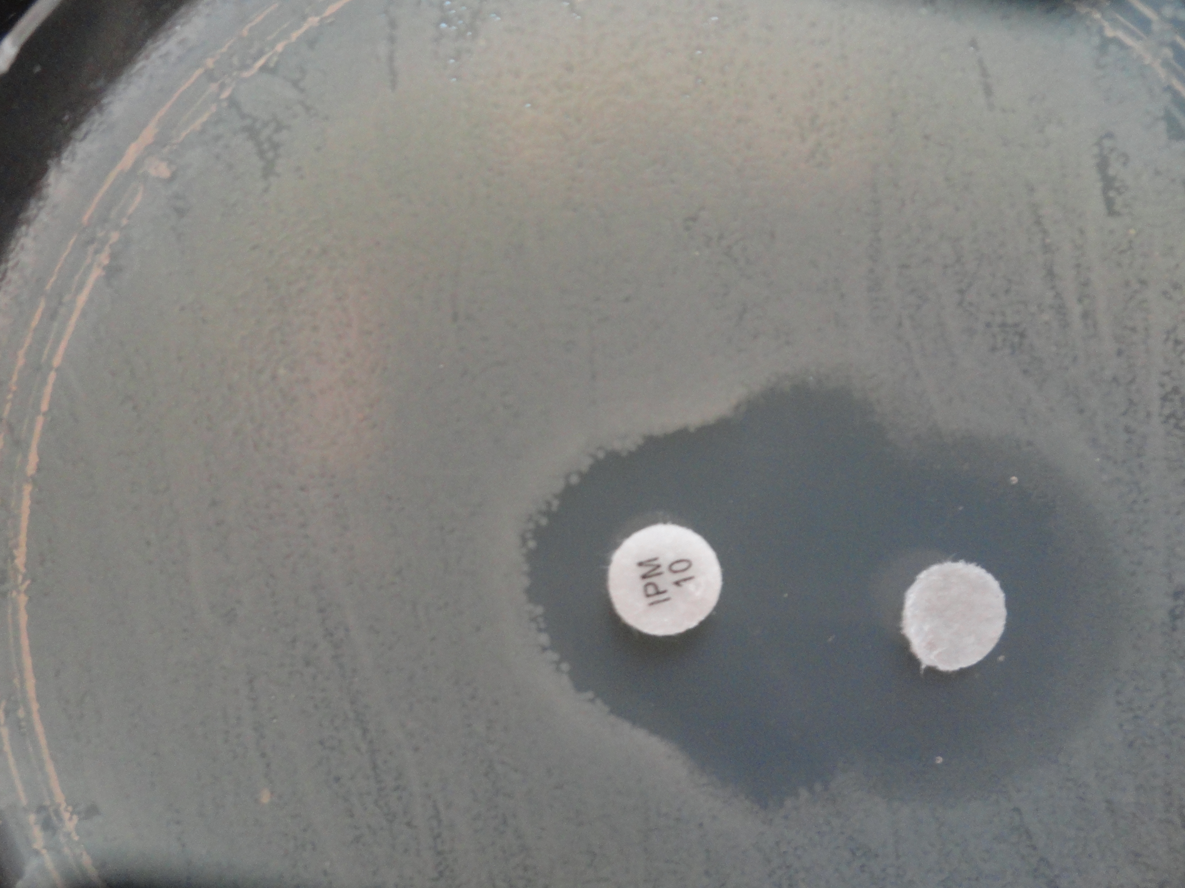
K10

Figure (2): Phenotypic appearance of MBL – producing K. pneumoniae by imipenem – EDTA double disk synergy test. K10 test isolate showing large synergistic inhibition zone between IMP disk and EDTA disk (positive result).

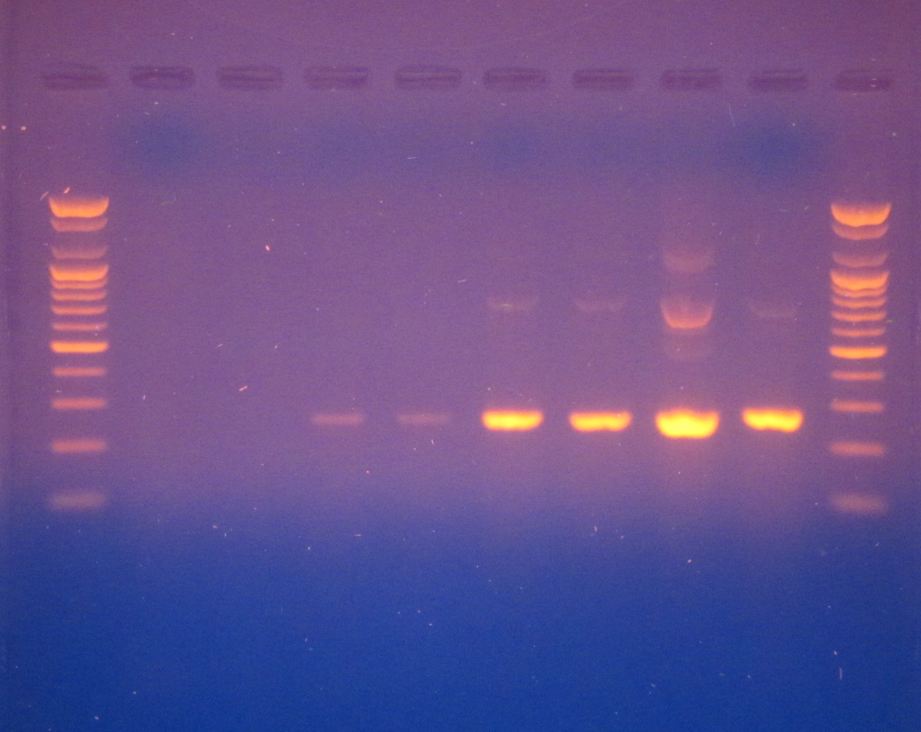
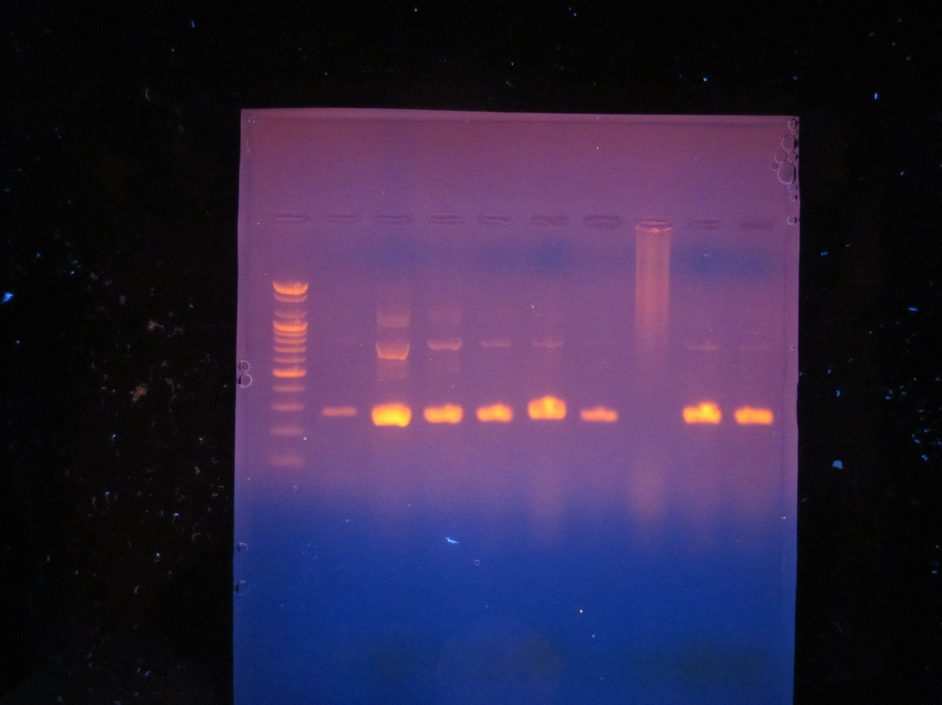
261 bp
L
K1
K2
K3
K4
K5
K6
K7
K8
L
L
K11
K12
K13
K14
K15
K16
K17
K9
K10
261 bp
2000
1600
1200
1000
900
800
700
600
500
400
300
200
100
2000
1600
1200
1000
900
800
700
600
500
400
300
200
100
2000
1600
1200
1000
900
800
700
600
500
400
300
200
100
bp
bp
bp

Figure (3): Agarose gel electrophoresis (1.5%agarose,70 % volt for 2-3 hrs) for bla_{VIM} gene product (ampilified size 261 bp) using DNA template of carbapenem-resistant K. pneumoniae isolates extracted by using salting out method. Lane (L), DNA moleculer size marker (100- bp Ladder).Lanes (K3, 4, 5, 6, 7, 8, 9,10,11,12,13,14, ,16 and 17) of K. pneumoniae isolates show positive results with bla_{VIM} gene , lanes (K1,2and 15) show negative results with bla_{VIM} gene.

Discussion
Results from Table (1) showed that 117 (14.6%) isolates were identified as K. pneumoniae .This result is in agreement with a previous local study in Hilla by Al-Saedi (2000) who found that K. pneumoniae isolates comprised (15.3%) from 725 clinical samples [23]. In another study, Al-Sehlawi reported that the detection rate of K. pneumoniae was (14%) among all pathogens isolated from clinical samples in Najaf hospitals [24].
However, the majority of K. pneumoniae isolates 38/141(27%) were obtained from stool samples (Table-1). K. pneumoniae are Gram- negative bacteria which are part of the normal human intestinal flora and are frequently spread via fecal-oral contamination. High prevalence of K. pneumoniae in stool samples was demonstrated by other researchers , Al-Saedi in Hilla , (14%) , Ali et al. in Jordon, (20%) and Sarojamma and Ramakrishna in India, (50%) [23 ,25,26]. In sputum , K.pneumoniae was detected in 19/128 (15%) of samples . Increasing prevalence of K.pneumoniae in sputum was observed by other researchers ,Al- Muhannak, (15.7%) and Al-Sehlawi, (16%) [24,27].
Result from table (2) revealed that , 91/117 (78%) of K. pneumoniae isolates were resistant to ampicillin and amoxicillin. This result is in accordance with a previous study in Hilla by Al- Charrakh who stated that 73.8% Klebsiella isolates obtained from clinical samples were resistant to both ampicillin and amoxicillin [28]. In Najaf, Al- Muhannak found that 98.2% of K. pneumoniae were resistant to both antibiotics [27] . High percentage of resistant for these antibiotics could be attributed not only to the production of $β$- lactamases, but also other resistance mechanisms , Amyes mentioned that there are three further resistance mechanisms include conformational changes in pencillin binding proteins (PBPs), permeability changes in the outer membrane, and active efflux of the antibiotic [29].
Results from Figure (1) revealed that higher resistant rate was found for carbenicillin (99%) , ampicillin (94.5%) , piperacillin (82.4 %) . This result in agreement with a pervious study in Hilla by Al- Asady (2009) who found that all 15 (100%) β-lactam resistant Enterobacteriaceae isolates were resistant to ampicillin , piperacillin and carbencillin [30]. Al –Hilli stated that all K.pneumoniae isolates were resistant to carbenicillin (100%) and (81%) to piperacillin [31]. High resistance to this class of antibiotics may be due to widespread use of these antibiotics in Hilla hospitals.
The resistance rate to imipenem was (10 %). In spite of the low level of resistance, this result is higher than that reported by other local studies contacted in Iraq which reported that the susceptibility of K.pneumoniae isolates collected from clinical and environmental samples to imipenem was (100%) [27, 30,,31,32] . Pathak et al demonstrated 2% resistance to imipenem by K.pneumoniae in a surveillance study in two hospitals In India [33]. Reasons behind resistance may be due to inappropriate duration of antibiotic therapy and subtherapeutic concentrations of the drug [34,35].
The present study revealed that the resistance against meropenem (17.6%) was more than imipenem . Meropenem is well –tolerated and offers several potential advantages , including greater in vitro activity against Gram –negative pathogens and the option of bolus administration [36].Beside these , problem of renal metabolism of imipenem , and risk of seizures [37],and availability of meropenem only in Hilla hospitals might be the reasons behind possible greater use of meropenem over imipenem and hence the high prevalence of resistance.
Regarding resistance to ertapenem , the resistance rate was (18.7%).Ertapenem is the least active carbapenem against most strains producing carbapenemase and therefore the first marker that indicates the likelihood of carbapenemase occurrence [38,39].Specificity is questioned because enterabacteria with ESBL and porin mutations are also resistant to ertapenem [40].

All carbapenem –resistant isolates were screened by phenotypic test for carbapenemase production. The present study showed that 11(65%) of the isolates gave positive results by imipenem- EDTA disk test . Different studies which have used the IMP-EDTA to detect MBL production in K.pneumoniae reported a very wide range of prevalence varying from 2.97% to 50% [24,41]. However, there are six isolates which gave negative results with EDTA disk synergy test. This means that EDTA may not inhibit the activity of all β-lactamases suggesting the absence of a class B1 enzyme (Like IMP and VIM) or these isolates may produce other enzymes (Like IMI,GES and KPC) that were not inhibited by EDTA. Moreover , they may have other mechanisms of carbapenem resistance like hyperproduction of AmpC β-lactamases associated with a loss of outer membrane proteins , efflux pumps, and mutations that alter the expression and /or function of porins and PBPs [42,43].
Results revealed that among 17 carbapenem –resistant K. pneumoniae isolates , 14(82.3%) had a bla_{VIM} gene (Figure-3) . One study preformed in India, Shahid et al. found that among 16 carbapenem- resistant E.coli and K.pneumoniae , bla_{VIM} was detected in only 3(18.6%) isolates, all were K.pneumoniae [44].In another study in Greece, Giakkoupi et al. stated that all K.pneumoniae isolates carried bla_{VIM} that also harbored KPC carbapenemase [45]. Birgy et al. reported the first case of imported health care -associated fecal carriage of an Egyptian infant VIM-1-producing K.pneumoniae strain in France [46]. The bla_{VIM} – genes are located in class 1 integrons as a gene cassttes and have been identified on plasmid with different replicon types [47], increasing the possibility of dissemination and linkage to other antibiotic resistance genes. However, this constitutes the first report on prevalence and detection of bla_{VIM} in Hilla hospitals.

References
1-Brisse, S.; Grimont, F. and Grimont, P. A. D. (2006). The Genus Klebsiella. Prokaryotes. 6: 159-196.
2- Robin, F.; Hennequin, C.; Gniadkowski, M.; Beyrouthy, R.; Empel, J.; Gibold, L. and Bonnet, R. (2011). Virulence factors and TEM- Type $β$- lactamases produced by two isolates of an epidemic Klebsiella pneumoniae strain. Antimicrob. Agents Chemother. 56(2): 1101-1104.
3- Cabral, A.B.; Melo, R.C.A. ;Maciel , M.A.V. and Lopes, A.C.S. (2012). Multidrug resistance genes, including bla_{KPC} and bla_{CTX-M-2} among Klebsiella pneumoniae isolated in Recife, Brazil.Rev. Bras. Med.Trop. 45(5) :572-578.
4- Bush, K. (2010). Alarming β-lactamase –mediated resistance in multidrug-resistant Enterobacteriaceae.Curr.Opin.Microbiol.13 (5):558-564.
5- Snitkin,E.S .;Zelazng, A.M.; Thomas,P.J. ;Stock,F.; NISC comperative sequencing program;.Henderson,D.K.;Palmore,T.N.and Segre,J. A.(2012).Traking a hospital outbreak of carbapenem –resistant Klebsiella pneumoniae with whole-genome sequencing .Sci.Transl.Med.4:148ra-116.
6- Goossens , H .;Ferech ,M. ; Vander Stichele ,R. and Elseviers , M. (2005). Outpatient antibiotic use in Europe and association with resistance :a cross-national database study.Lancet.365 (9459):579-587.
7- Ejikeuqwu, P. C.; Ugwu, C. M.; Araka, C. O.; Gugu, T. H.; Iroha, I. R.; Adikwu, M. U. and Esimone, C. O. (2012). Imipenem and meropenem resistance amongst ESBL producing Escherichia coli and Klebsiella pneumoniae clinical isolates. Int. Res. J. Microbiol. 3(10): 339-344.
8- Kosmidis, C.; Poulakou, G.; Markogiannakis, A. and Daikos, G. L. (2012). Teratment options for infections caused by carbapenem-resistant Gram-negative bacteria. Eur. Infect. Dis. 6(1): 28-34.
9- Misra, R. N. (2012). Metallo $β$- lactamases: a prespective and implications. Med. J. 5: 10-13.
10- Walsh, T. R.; Toleman, M. A; Poirel , L. and Nordmann, P. (2005). Metallo- $β$- lactamases: the quiet before the storm? Clin. Microbiol. Rev. 18(2): 306-325.
11- Queenan, A. M. and Bush, k. (2007). Carbapenemases: the versatile $β$- lactamases. J. Clin. Microbiol. Rev. 20 (3): 440-458.
12- Dugal ,S. and Fernandes ,A. (2011) Carbapenem hydrolyzing metallo-β - lactamases :A. Review .Int .J.Curr. Pharm. Res .3 :9-16.
13- Tailor, F. (2011). Characterization of Escherichia coli and Klebsiella pneumoniae with resistance or reduced susceptibility to carbapenems isolated from Canadian hospitals from 2007- 2010. M. Sc. Thesis. University of Manitoba.
14- Cornagila, G,; Mazzarilo ,A; Lauretti,L .;RossoliniG ,M. and Fontana, R. (2000).Hospital outbreak of carbapenem –resistant Pseudomonas aeruoginosa producing VIM -1,a novel transferable metallo β-lactamase. Clin.Infect.Dis.31:1119-11125.
15- Yong,D.Toleman,M.A.;Giske,G.C.;Cho,H. S.;Sundman ,K.;Lee,K. and Walsh, T.R. (2009).Characerization of a new metallo-beta-lactamase gene bla_{NDM} and a novel erythromycin esterase gene carried on a unque genetic structure in Klebsiella pneumoniae sequence type 14 from India.Antimicrob .Agents Chemother. 53(12):5046-5054.
16- Collee, J. G.; Fraser, A. G.; Marmiom, B. P.; and Simmon, A. (1996). Mackie and McCarteny Practical Medical Microbiology. 4th ed. Churchill Livingstone Inc., USA.
17- MacFaddin, J. F. (2000). Biochemical tests for identification of medical bacteria. 3rd ed. Lippincott Williams and Wilkins, USA.
18- National Committee for Clinical Laboratory Standards (NCCLS). (2003). Performance standards for antimicrobial disc susceptibility testing. Disc diffusion. 8th ed. Informational supplement. M100-S13. NCCLS. Wayne, Pa.
19- Bauer, A. W.; Kirby, W.M.M.; Sherris, J.C and Track, M. (1966). Antibiotic susceptibility testing by standardized single disc method .Am.J. Clin.Pathol.45: 493-496.
20- Clinical and Laboratory Standards Institute (CLSI). (2010). Performance standards for antimicrobial susceptibility testing; 20th. Informational Supplement. Approved standard M07-A8. Clinical and Laboratory Standards Institute.
21- Lee, K.; Lim, Y. S.; Yong , Yum, J. H. and Chong, Y. (2003).Evaluation of the Hodge test and the imipenem-EDTA double-disk synergy test for differentiating metallo-$β$- lactamase- producing isolates of Pseudomonas spp. and Acinetobacter spp. J. Clin. Microbiol., 41(10): 4623-4629.
22- Pospiech, T. and Neumann, J. (1995). In genomic DNA isolation Kieser eds. John Innes Center. Norwich NR4 7UH. U.K.
23- Al-Saedi, I.A.B. (2000).Isolation and identification of Klebsiella pneumoniae from various infection in Hilla Province and detection of some virulence factors associated in their pathogenicity .M.Sc.Thesis.College of Sciences ,Babylon University.
24- Al-Sehlawi,Z.S.R.(2012).Occurrence and characterization of AmpC$β$- lactamases in Klebsiella pneumoniae from some medical centers in Najaf .Ph.D.Thesis. College of Sciences ,Babylon University.
25- Ali, S. Q.; Zehra, A.; Naqvi, B. S.; Shah, S, and Bushra, R. (2010). Resistance pattern of ciprofloxacin against different pathogens. Oman. Med. J. 25: 294-298.
26- Sarojamma, V. and Ramakrishna, V. (2011). Prevalence of ESBL- producing Klebsiella pneumoniae isolates in tertiary care hospital. I.S.R.M. Microbiol.
27- AL- Muhannak, F. H. N. (2010). Spread of some extended spectrum beta-lactamases in clinical isolates of Gram-negative bacilli in Najaf. M. Sc. Thesis. College of Medicine. Kufa University.
28- Al- Charrakh, A. H. (2005). Bacteriological and genetic study on extended- spectrum $β$ - lactamases and bacteriocins of Klebsiella isolated from Hilla city. Ph. D. Thesis. College of Sciences, Baghdad University.
29- Amyes, S.G. (2003). Resistance to beta-lactams-the permutations.J. Chemother. 15 (6): 525-535.
30- Al-Asady , F.M.H.(2009) .Bacteriological study on extended-spectrum beta- lactamases produced by Enterobacteriaceae isolated from children with bacteremia in Hilla city .M.Sc. Thesis .College of Medicine,Babylon University.
31- Al- Hilli, Z. B. (2010). Dissemination of $β$ - lactamases in Escherichia coli and Klebsiella spp. isolated from Merjan teaching hospital in Hilla city. M. Sc. Thesis. College of Sciences, Kufa University.
32- Hadi, Z. J. (2008). Detection of extended- spectrum beta-lactamases of Escherichia coli and Klebsiells spp. isolated from patients with significant bacteriuria in Najaf. M. Sc. Thesis. College of Medicine. Kufa University.
33- Pathak, A.; Marothi, Y. ; Kekre, V.; Mahadik, K.; Macaden, R. and Lundborg, C. S. (2012). High prevalence of extended- spectrum $β$- lactamase-producing pathogens: results of a surveillance study in two hospitals in Ujjain, India. Infect. Drug. Resist. 5: 65-73.
34- Baquero F., Negri MC, Morosini Ml and Blazquez J.(1997). The antibiotic selective process: Concentration- specific amplification of low- level resistant populations. Ciba. Found. Symp .207:93-111.
35- Philippe ,E. ;Weiss, M. ;Shultz, JM.; Yeomans, F. and Ehrenkranz, NJ.(1999). Emergence of highly antibiotic- resistant Pseudomonas aeruginosa in relation to duration of empirical antipseudomonal antibiotic treatment. Clin. Perform. Qual. Health Care. 7: 83-87.
36- Verwaest, C.; Belgian Multicenter Study Group. (2000). Meropenem versus imipenem / cilastatin as empirical monotherapy for serious bacterial infections in the intensive care unit. Clin .Microbiol. Infect. 6: 294-302.
37- Prakask, S. (2006). Carbapenem sensitivity profile amongst bacterial isolates from clinical specimens in Kanpur city. Indian J. Crit. Care. Med. 10: 250-253.
38- Overturf, G.D. (2010). Carbapenemases: a brief review for pediatric infectious disease specialists. Pediatri. Infect. Dis. J. 29: 68-70.
39- Thomson, K. S. (2010). Extended- spectrum -$β$- lactamase, AmpC, and carbapenemase issues. J. Clin. Microbiol. 48(4): 1019-1025.

40- Flonta, M.; Lupse, M.; Craciunas, C.; Almas, A. and Carstina, D. (2011). Ertapenem resistance among extended- spectrum- $β$- lactamase producing Klebsiella pneumoniae isolates. Therapeu. Pharmacol. Clin. Toxicol. 15(2): 121-125.
41- Deshmukh, D. G.; Damle, A. S.; Bajaj, J. K. and Bhakre, J. B. (2011). Metallo $β$- lactamase producing clinical isolates from patients of a teriary care hospital. J. Lab. Physicians. 3 (2). 93-97.
42- Cao,V.T.B.; Arlet,G.; Ericsson,B-M.; Tammelin,A.; Courvalin,P. and Lambert,T. (2000).Emergence of imipenem resistance in Klebsiella pneumoniae owing to combination of plasmid mediated CMY-4 and permeability alteration. J.Antimicrob. Chemother.46:895-900.
43- Papp-WallaceK.M;Endimiani,A;Taracila,M.A.and Bonomo, R.A.(2011). Carbapenem past, present and feature. Antimicrob. Agents Chemother.55(11):4943-4960.
44- Shahid, M.; Umesh; Sobia, F.; Singh, A.; Khan, H. M.; Abida Malik and Shukla, I. (2012): Molecular epidemiology of carbapenem- resistant Enterobacteriaceae from a North Indian tertiary hospital . N. Z. J. Med. Lab. Sci. 66: 5-7.
45- Giakkoupi, P.; Pappa, O.; Polemis , M.; Vatopoulos, A. C.; Miriagou, V.; Zioga, A.; Papagiannitsis, C. C. and Tzouvelekis , L. S. (2009). Emerging Klebsiella pneumoniae isolates coproducing KPC-2 and VIM-1 carbapenemases. Antimicrob. Agents Chemother. 53(9): 4048-4050.
46- Birgy, A.; Doit, C.; Mariani- Kurkdjian; P.; Genel, N.; Faye, A.; Arlet, G. and Bingen, E. (2011). Early detection of colonization by VIM-1 producing Klebsiella pneumoniae and NDM-1 producing Escherichia coli in two children returning to France. J. Clin.Microbiol. 49(8): 3085-3087.
47- Carattoli, A. (2009). Resistance plasmid families in Enterobacteriaceae. Antimicrob. Agents Chemother. 53:2227-2238.

Percentage of resistant isolates
Type of antibiotic
Figure (1): Antibiotics susceptibility profile of Klebsiella pneumoniae isolates by disk diffusion method (n=91).
AMP,Ampicillin;PRL,Piperacillin;PY,Carbenicillin;AMC,Amoxi-clav;CTX,Cefotaxime;CAZ,Ceftazidime;CRO,Ceftraiaxone;FEP
Cefepime; Fox,Cefoxitin; ATM,Aztreonam; CF,Cefaclor; CPR,Cefprozil; IMP,Imipenem; MEM,Meropenem; ETP,Ertapenem; CN,
Gantamicin ; AK, Amikacin ; K, Kanamycin ; NA , Nalidixic acid ; CIP, Ciprofloxacin ; LE⁵,Levofloxacin ; SXT, Trimethoprim- Sulfamethoxazole;C,Chloramphenicol;F,Nitrofurantion;TE, Tetracycline;DO,Doxycycline.

