Isolation and Identification of Mycoplasma Pnumoniae, Mycoplasma Primatum and Mycoplasma Pirum from Women Urogenital Tract

Ghaeda J. Al-Gizawi
College of Education, University of Basrah , Basrah , Iraq



Received 5 June 2014 Accepted 16 June 2014
Abstract
The Mycoplasma found most frequently in genital tract and play their putative roles urogenital tract of women. In this study, three species of mycoplasma represented by M. pnumoniae, M. primatum and M. pirum were isolated from urogenital tract. In this study, one hundred vaginal swabs were taken from pregnant, non pregnant and control women. Cultures were made in Monophasic Diphasic Culture Setup (MDCS). The purpose of this study was to determine association of M. pnumoniae with genital tract infection, and isolation rate of M. primatum and M. pirum form three population of women in Basrah.
Keywords: Genital tract infection, Genital mycoplasma, MDCS.

الخلاصة:
تتواجد بكتريا المايكوبلازما بكثرة في الجهاز التناسلي وتلعب دوراً كبيراً في إصابة الجهاز التناسلي لاسيما النساء. تم في هذه الدراسة عزل ثلاثة أنواع من المايكوبلازما من الجهاز التناسلي لدى النساء في العراق تمثلت بالانواع M. pnumoniae, M. primatum and M. pirum . أخذت 100 مسحة مهبلية من نساء حوامل وغير حوامل بالإضافة إلى مجموعة السيطرة. زرعت المسحات المهبلية بواسطــــة وسط أحادي وثنائي الطور. الهدف من هذه الدراسة هو لمعرفة مدى علاقة جرثومة M. pnumoniae (والتي تعزل عادةً من الجهاز التنفسي) في بعض الإصابات التناسلية بالإضافة إلى تحديد معدل عزل جرثومتي M. primatum و M. pirum من خلال اخذ مسحات مهبلية من ثلاث عينات من النساء في محافظة البصرة.
ــــــــــــــــــــــــــــــــــــــــــــــــــــــــــــــــــــــــــــــــــــــــــــــــــــــــــــــــــــــــــــــــــــــــــــــــــــــــــــــــــــــــــــــــــــــــــــــــــــــــــــ

Introduction:
Mycoplasmas are a unique group of bacteria, characterized by their small cell size (0.3-0.8 µm), small genome size and lack of rigid bacterial cell wall[1]. Although mycoplasmas are generally commensal parasites in human, some species are real pathogens and are capable of causing a wide variety of disease[2]. They can be isolated as commensals or pathogens from plants, insects, animals and humans[1]. Of these M. hominis M. genitalium. M. pentrans and Ureaplasma Urealyticum are of particular interest, as is M. pirum and M. primatium which are also found in the genital tract[3]. M. pnumoniae is an important cause of human respiratory disease, accounting for 19 to 25% of total pneumonia[4, 5]. A study indicated that M. pneumonia also infect urogenital tract[6]. M. pnumoniae and M. pirum posses a specialized terminal organelle (tip-structure) by which they adhere to the fallopian tube epithelium[7]. However, M. primatium has been detected by PCR in the lower genital tract of 7-20% of women [8]. Patients with AIDS are of great risk factor for infection by these organisms[9]. Finally, the mycoplasmas found most frequently in the genital tract and their putative role have been described. The aim of the present study was to investigate whether the presence of M. pnumoniae , M. primatium and M. pirum in the lower genital tract of women is associated with infection.

Materials and Methods
Population:
A total of 100 vaginal swabs were collected from women whose age ranged between (<19-≥40) years old who admitted to the gynecology department of the Al-Fayhaa hospital were included in this study. They were divided in three groups, 33 pregnant women, 33 non pregnant women and 34 healthy women being used as control.
Collection of specimens
Vaginal swabs were collected by aiding gynecologists. and inoculated in modified casein digested medium by Monophasic-Diphasic Culture Setup(MDCS) method[5].
Identification of Mycoplasmas
The differentiation amongst species of genital mycoplasmes was achieved through biochemical tests represented by fermentation of carbohydrate, Arginine deaminase, Tetrazolium reduction, Hemolysis, Hemadssorption[10], Gelatin liquefaction, film and spot in egg yolk[11], coagulated serum digestion and phosphatase test[12].
Results
Characterization and Identification of isolated mycoplasmes were based on morphological traits which included colonial morphology, growth properties and slides prepared with negative staining , Giemsa stain and Gram stain. The differentiation between species of mycoplasmas was achieved through biochemical tests as mentioned in materials and methods [figs. 1 , 2 , 3]. In this study, M. primatium and M. pirum represent the first isolation in Iraq and with the Monophasic-Diphasic Culture Setup (MDCS) system. Beside, that, the first isolation for M. pnumoniae from genital tract by the same system. The colonial growth was observed on the upper of the slant. However, approximately 96 hrs. period was necessary for full development of colonies on MDCS to show the fried egg appearance. One hundred women were included in the study and were divided into four groups (table 1). The results indicated that there is a correlation between genital mycoplasma and age compared with control group.

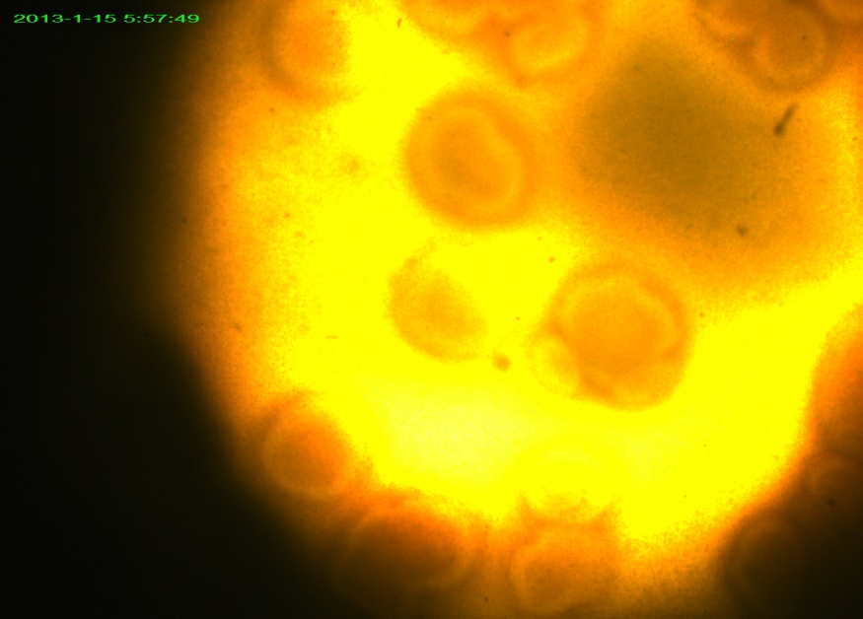
Fig. 1. The fried-egg colonies of M. primatium (X65)

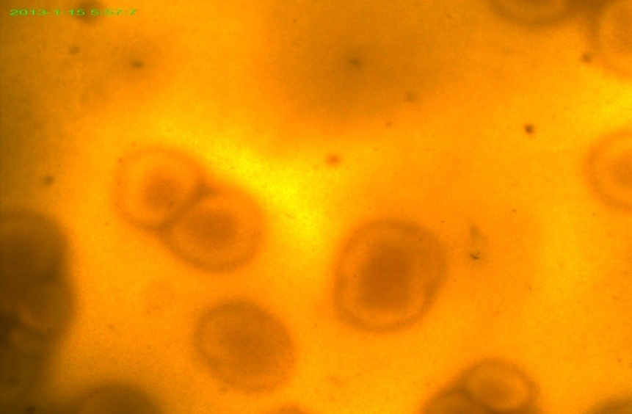
Fig. 2. The fried-egg colonies of M. pirum (X65)

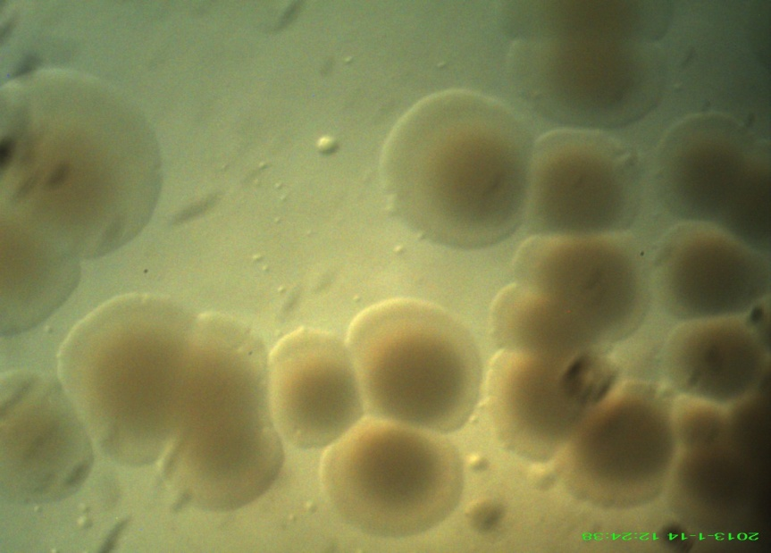
Fig. 3. The fried-egg colonies of M. pnumoniae (X100)

Table (1): Distribution of genital mycoplasmas according to different age group
Age-year | No. of tested women | No. (%) of Mycoplasma
Age-year | No. of tested women | M. pnumoniae | M. primatium | M. pirum
≤19 | 7 | 1 (14.2) | 2 (28.5) | 0 (0)
19-29 | 24 | 2 (8) | 4 (16) | 2 (8)
30-39 | 20 | 1 (5) | 4 (20) | 1 (5)
≥40 | 15 | 1 (6.6) | 2 (13.3) | 0 (0)
Total | 66 | 5 (7.4) | 12 (17.9) | 3 (4.4)

In total 2 genital mycoplasme isolation in pregnant women more than other groups .

Table (2): Isolation of genital Mycoplasmas frequency according to social status
Groups | M. pnumoniae | M. primatium | M. pirum
Pregnant women 33 | 3 (9) | 7 (21.2) | 1 (3)
Non-pregnant women 33 | 2 (5.8) | 5 (14.7) | 2 (5.8)
Control group 34 | 0 (0) | 0 (0) | 0 (0)

The isolation rate of genital mycoplasme from low moderate level of socioeconomic status rather than high level (table 3).

Table (3): Distribution of genital mycoplasmes in relation of socioeconomic status
Level of socioeconomic status | No. of patients | No. and (%) of women tve in
Level of socioeconomic status | No. of patients | M. pnumoniae | M. primatium | M. pirum
Low | 30 | 2 (6.6) | 9 (30) | 2 (6.6)
Moderate | 21 | 2 (9.5) | 2 (9.5) | 1 (4.7)
high | 15 | 1 (6.2) | 1 (6.2) | 0 (0)
Total | 66 | 5 | 12 | 3

Discussion
Diagnosis of mycoplasmal infection by isolation of the organisms is difficult [13]. The use of diphasic medium increased the number of isolates by 26% compared with direct isolation on plates[4]. The MDCS method was used successfully in the present study for the primary isolation of genital mycoplasmas from clinical specimens, also this method exhibited several advantages[14].
Other study was found that there is a tendency for mycoplasma infected patients to have poorer cervical mucous than control group[15]. Comparison of women and it was suggested that low recovery rate are found in post menopausal women suggested that the occurrence of genital mycoplasmas[16]. Certainly, reports of the isolation of M. pneumoniae from genital tract are rare[17]. This exemplified by the isolation of M. pneumoniae from the lower genital tract of women[6]. The degree of colonization with genital mycoplasmas is related to sexual activity and to the number of sexual partners[18].
Isolation of these bacteria remains important, as they are sexually transmitted and can be associated with an increased risk of pathogenic condition and pregnancy abnormalities in women[3]. Genital mycoplasmas were recovered equally from pregnant and non pregnant women[18].
However, colonization of these microorganisms in human are linked to younger age, lower socioeconomic status and sexual activity[19, 20]. In the light of the results of the present study, the pathogenic role
of these bacteria in women genital tract disease remain questionable.

References
1- Pannekoek, Y.; Trum, J.; Bleker, O.; Veen, F.; Spanjaard, L. and Danker, J. (2000). Cytokine concentrations in seminal plasmas from subfertile men are not indicative of the presence of U. urealyticum M. hominis in the lower genital tract. J. Med. Micro. 49: 697-700.
2- Kenny, G.; Hooton, T.; Roberts, M.; Cartwright, F. and Hoy, J. (1989). Susceptibilities of genital mycoplasmas to the newer quinolones as determined by the agar dilution method. 33: 103-107.
3- Taylor-Robinson, D. and Furr, P. (1990). Update on sexually transmitted mycoplasmas. Lan. 351: 12-15.
4- Kenny, G.; Kaiser, G.; Cooney, M. and Foy, H. (1990). Diagnosis of M. pneumoniae pneumonia : sensitivities and specificities of serology with lipid antigen and isolation of the organism on soy peptone medium for identification of infections. 28(9): 2087-2093.
5- Al-Ghzawi, G.(2001). Typical and a typical pneumonia: characteristics and bacterial profile of community and hospital acquired cases Ph.D. Thesis. College of education Basrah University.
6- Goulet, M.; Dular, R.; Tully, J.; Billowes, G. and Kasatiya, S. (1995). Isolation of M. pneumoniae from the human urogenital tract. J. Cin. Micro. 33: 2823-2825.
7- Razin, S. and Jacobs, E. (1992). Mycoplasma adhesion. J. Gen. Micro. 138: 407-422.
8- Tully, J.; Taylor-Robinson, D.; Cole, R. and Rose, D. (1981). A newly discovered mycoplasma in the human urogenital tract. Lan. 1288-1291.
9- Lo, S.; Davdson, M.; Newton, P.; Sonoda, M.; Shih, J.; Engler, W.; Wang, R. and Wear, D. (1989). Association of the virus-like infections agent organelle reported in patients with AIDS with a cut disease in previously healthy non AIDS patients. Am. J. Trop. Med. Hyg. 41: 364-376.
10- Marmion, B. and Harris R. (1996). M. pneumoniae and other medically important members of the family mycoplasmataceae in: Mackie Macrtiney practical medical microbiology. 14th ed. Churchill Livingstone New York. 591-595.
11- Collee, J.; Duguis, J.; Fraser, A.; Marmion, B. and Simmons, A. (1996). Laboratory strategy in diagnosis of infective syrdrom in: Mackie Macartney practical medical microbiology.14th ed. Churchill Livingstone New York. 62-66.
12- Cowan, S. (1974). Cowan and steel manual for identification of medical bacteria 2nd ed. Cambridge University Press. London.
13- Kenny, G. (1992). Serodiagnosis. J. Man. 505-512.
14- Al-Mosawi, R. (2005). Genital mycoplasma among women attending Basrah general hospital with an evaluation of role in selected clinical cases. M. Sc. Thesis. College of education. Basrah University.
15- Idriss, W.; Patton, W. and Taymor, L. (1978). The etiologic role of U. urealyticum infection in infertility. Fer. Ster. 30: 393-396.
16-Iwasaka, T.; Wada, T.; Kidera, Y. and Sugimori, H. (1986). Hormonal status and mycoplasma and mycoplasma colonization in the female genital tract. Obs. Gyn. 86: 263-267.
17- Furr, P. and Taylor-Robinson, D. (1999). Colonization of the respiratory and genital tracts of female mice with M. pneumoniae and protection afforded to the genital tract by prior respiratory colonization. Int. J. Exp. Path. 80: 35-39.
18- Taylor-Robinson, D. and McCormuck, W. (1979). Mycoplasmas in human genitourirany infection. In: The mycoplasmas. Academic Press Inc. USA. 307.
19- Ramirez, L.; Gil, C.; Zago, I.; Yane, A. and Giono, S. (2000). Association of M. hominis and U. urealyticum with some indicator of nonspecific vaginitis. Rev. Lat. Micro. 42: 1-6.
20- Al-Bahli, S. (1993). Prevalence of genital mycoplasma in women with selected obstetric and gynecological conditions. M Sc. Thesis, College of medicine, Basrah. University.

