Imaging and Diagnosis of different kind of Viruses by using (FITC,Evans blue ,and RB ) by Fluorescence Microscope

Entiedhar Jasim Khamis Al -Yasari
College of Medicine, University of Babylon, Iraq.
E-mail: Intidher@yahoo.com



Received 21 January 2014 Accepted 2 September 2014
Abstract:
The use of fluorescence microscopy for imaging biomedical specimens has been expanded into all fields of diagnosis for different kinds of viruses , three viruses were imaged and diagnosed by the fluorescence microscope at Al-Sadr teaching hospital at Kufa city . The human metapneumo viruse hMPV , the respiratory syncytial viruse RSV and the measles chicken emberyo fibroblast viruse have been imaged and diagnosed by the fluorescence microscope in Al-SADR Educational hospital at Kufa city . Three types of dyes were added to the specimen solutions separately ,Rhodamine B , Fluorescene and Evans blue in order to obtain high resolution and contrast images. The absorption and fluorination spectra of these dyes were measured by EUV-visible spectrophotometer and fluorospectrophotometer respectively .
الخلاصة:
استخدمه المجهر الفلورسين في التصوير النماذجِ الطبيّة الحيويةِ وقد تم تصوير وتشخيص ثلاثة أنواع مختلفة من الفيروسات البشرية . في هذا العمل وسعت في تشخيص أنواع مختلفة من الفيروسات , ثلاثة أنواع من الفيروسات صورة وشخصت بوسطه مجهر الفلوريسنت في مستشفى الصدر التعليمي وهي، الفيروس الميتانيمو البشري (hMPV) human Metapneum Virus والذي يصيب الجهاز التنفسي السفلي للأطفال في مستشفى الصدر التعليمي , والفيروس المخلوي التنفسي (RSV) Respiratory Syncytial Virus الذي يعتبر من أهم مسببات التهابات الجهاز التنفسي السفلي عند الإنسان بصورة عامة والأطفال بصورة خاصة , وفيروس الحصبة . ثم تم تحضير ثلاثة أنواع من الصبغات (الرودامين، الفلورسين والايفا نس بلو) لغرض أظهار المستضد للفيروسات الثلاثة لكي نحصل على درجة الوضوح العاليةِ واكثر تباين للصورةَ ,وتم قياس أطياف الامتصاص لمحاليل هذه الصبغات الثلاث باستخدام جهاز Spectrophotometer (سبكتروفوتوميتر), والذي يعمل بالأطوال الموجيه UV –Visible والمرئية ، كذلك تم قياس أطياف الفلورة باستخدام جهاز Fluorospectrophtomete(فلوروسبكتروفوتوميتر).
ــــــــــــــــــــــــــــــــــــــــــــــــــــــــــــــــــــــــــــــــــــــــــــــــــــــــــــــــــــــــــــــــــــــــــــــــــــــــــــــــــــــــــــــــــــــــــــــــــــــــــــــــــــــــــــــــــــــــــــــــــــــــــــــــــــــــــــــــــــــــــــــــــــــــــــــــــــــــــــــــــــــــــــــــــــــــــــــــــــــــــــــــــــــــــــــــــــــــــــــــــــــــــــــــــــــــــــــــــــــــــــــــــــــــــــــــــــــــــــــــــــــــــــــــــــــــــــــــــــــــــــــــــــــــــــــــــــــــــــــــــــــــــــــــــــــــــــــــــــــــــــــــــــــــــــــــــــــــــــــــــــــــــ

Introduction
The major viruses that infect the upper respiratory system among adults and children in Al – Sadr teaching hospital were the human metapneumo virus hMPV and that infects the lower respiratory system were the syncytial
virus (RSV) which was also found in the children's hospital at Hill city .
In this paper two experimental works have been developed :The first experiment was the determination of the absorption and fluorination spectra for three types of dye solutions ( Rhodamine B , Fluorescen and Evans blue). The objectives of this experiment was to add these dyes to the specimen's
slide of the fluorescence microscope . In order to excite the sample and to increase the contrast of the resulted images keeping the l cells survived. The second experiment was devoted to the hospital diagnosis of three mentioned types of viruses by using the fluorescence microscope.
Multicolor images of the viruses were obtained with high resolution and contrast. The hMPV was first discovered in 2001 by Van den Hogen et.al[1] . The active medium of a dye laser consists of a strongly fluorescing organic compound dissolved in an appropriate solvent. Included in this is third a number of commercial dyes (Rhodamin B of the tuning Range(590-700nm), Fluorscein (520 -570) and evns blue (449 -490 ). The first milestone is an experiment : The chemical structure of R_{B} .Laser action from R_{B} was first observed by Schmidt and Schafer [2]. The xanthenes dye R_{B} is frequently used as a fluorescence standard for determining absolute fluorescence quantum yield C.A. Parker and W.T. Rees(1960) [3]. The absorption λ_{max} of R_{B} at 5nm in acidic ethanol, has a fluorescence emission maxima. λ_{em} at 580nm, and shows highest lasing efficiency at 627nm in the same solvent [4]. R.F. Kubin. The fluorescence yield is reported to be 0.65 in basic ethanol [5]. They are used as a dye and as a dye laser gain medium. In (1990) F. P. Schafer. They are often used as a tracer dye within water to determine the rate and direction of flow and transport. Rhodamine dyes fluoresce and can, thus, be detected easily and inexpensively with instruments called fluorometers.
Rhodamine dyes are used extensively in biotechnology applications such as fluorescence microscopy,
flowcytometry, fluorescence correlation spectroscopy and ELISA.[6][7] .The second milestone is an experiment by T-1824 or Evans Blue, often incorrectly rendered as Evan's Blue, is an azo dye which has a very high affinity for serum albumin. so, it can be useful in physiology in estimating the proportion of body water contained in blood plasma. Evans blue dye has been used as a viability assay on the basis of its penetration into non-viable cells, although the method is subject to error because damaged cells may be capable of repair A., Crutchfield,K Diller,J Brand (1999) [8]. BT Hawkins,RD Egleton (2006) "Fluorescence imaging of blood-brain barrier disruption Evans blue is also used to assess the permeability of the blood-brain barrier to macromolecules. Because serum albumin cannot cross the barrier, and virtually all Evans Blue is bound to albumin, normally the neural tissue remains unstained.[9] .J, Hed, C ,Dahlgren, and .I ,Rundquist, (1983). "A Simple Fluorescence Technique to Stain the Plasma Membrane of Human Neutrophils. It fluoresces with excitation peaks at 470 and 540 nm and an emission peak at 680 nm.[10]. It was named after Herbert McLean Evans, an American chemist. The third milestone is an experiment by Noga E. J., Udomkusonsri, P.(2002),fluorescein dye is a synthetic organic compound available as a dark orange/red powder soluble in water and alcohol. It is widely used as a fluorescent tracer for many applications. Fluorescein is a fluorophore commonly used in microscopy, in a type of dye laser as the gain medium, in forensics and serology to detect latent blood stains, and in dye tracing. Fluorescein has an absorption maximum at 494 nm and emission maximum of 521 nm (in water). The major derivatives are Fluorescein Isothiocyanate (FITC). Fluorescein was first synthesized by Adolf von Baeyer in 1871 .Fluorescein also has an isosbestic point (equal absorption for all pH values) at 460 nm. Fluorescein is also known as a color additive . Color of its aqueous solution varies from green to orange as a function of the way it is observed by reflection or by transmission, as it can be noticed in bubble levels in which fluorescein is added as a colorant to the alcohol filling the tube to increase the visibility of the air bubble and the precision of the instrument.More concentrated solutions of fluorescein can even appear red[11]. Burgess and Kevin (2004) ,et.al. In cellular biology, the isothiocyanate derivative of fluorescein is often used to label and track cells in fluorescence microscopy applications (for example, flow cytometry). Additional biologically active molecules (such as antibodies) may also be attached to fluorescein, allowing biologists to target the fluorophore to specific proteins or structures within cells. This application is common in yeast display [11] .
Experimental Part :
The objectives of this experimental work is the determination of absorption and fluorination spectra for three dyes ( Rhodamine B , Fluorescene and Evans blue . Five samples were taken from children of different ages ( 6 months - to–3years)male and female.
The samples were (drop blood , smear nose and traces from the pharyngeal swab ) in the period Jan. 2012 – to – Aprile 2012 .The chemical structures , molecular weights and the state of these dyes are shown in table(A1).in appendix A
- Three kinds of solvents were used (distilled water ,ethanol and phosphate buffer saline ). the chemical structures and physical properties of these solvents are listed in table(A2). dissolved in ethanol . the concentration of the two dyes were calculated according to the following formula [2]
$$W=\frac{Mw.V.C}{1000}$$
Where
M_{w}: Molecular weight of the solute (gm/mol)
W: weight of the solute(gm/mol)
V: Volume of the solvent (ml)
C: Concentration of the solute (mol/l).
- The prepared solutions were diluted by the same solvents using the following formula C1V1=C2V2
Dye Sample Preparation :
Rhodamine B and fluorescen are in liquid state they can be prepared as follows :
- The Rhodamine and fluorescen samples were weighted by digital sensitive balance.
- The weighted Rhodamine B dye was dissolved in distilled water mean while fluorescen dye was Where:
C1:Primary concentration.
V1: Volume before dilution .
C2 : New concentration
V2 : volume after dilution
- The diluted solution was sucked by a pipette and poured in the cell of the
spectrophotometer. The resulted absorption spectra for the three dyes was (190-900 nm).The peak values of these dyes were
- Rhodamine B (530 nm)
- Fluorescen (492 nm)
- Evans blue (598nm).
Preparation of Evans blue dye
The buffered solution of phosphate saline was prepared as follows:
- The contents of the phosphate buffered saline (PBS) were dissolved in distilled water (950 ml)
- 10 ml of the Tween 20 solution was added to the PBS and mixed thoroughly.
- The mixture was kept in a clean labeled container and caped tightly then stored at room temperature.
Evans blue dye was in liquid state with blue color . a droplet of the dye was dissolved in the phosphate buffered saline solution .The concentrations were (${10}^{−1},{10}^{−2},{10}^{−3}$)mol/L.

Diagnosis By Fluorescence Microscope:
The diagnosis of the three viruses can performed according to the following steps:
- The test slide and reagent were kept in equilibrium at room temperature
- One drop of Evans blue dye was added to the slide glass
- The slide then was incubated at 37 ˚C for 15 minutes in a humid chamber
- The slide was rinsed gently with PBS/Tween 20 solution for 10-15 minutes to remove the excess monoclonal antibody solution.
- The excess reagent from the slide was shaked and the area surrounding the cell spot was dried carefully then mounted under a cover slip using an aqueous mounting fluid.
- The excess fluid was wipe from the edges of the slide.
- The slides were examined under the fluorescence microscope at objectives (10-20x) and 40x for cells exhibiting fluorescence. A detailed examination was performed at 60x magnification.
- The resulted pictures were imaged by CCD digital camera.
The devices and equipments used in this experiment are listed in table (A3) in appendix A. And the materials and solutions used are listed in table(A4).

Results and discussion :
The absorption spectra of the three dyes Rhodamine B , Fluorescen and Evans blue as measured by the spectrophotometer are shown in figure(1,a,b, and c) respectively. with different concentrations (${5.10}^{−5}$, ${1.10}^{−4}$,${1.10}^{−6}$,${5.10}^{−4}$),and${1.10}^{−5}$M/L. and the respective fluorination spectra as measured by the fluorospectrophotometer are shown in figure(2 a,b and c) .It can be seen from fig(1-a) that the intensity of the absorption spectrum of Rhodamine B dye increases with the concentration to the peak value at wavelength (553 nm) then decreases steadily to zero. where the maximum concentration values was about ${5∗10}^{−4}\frac{M}{L}.$ The absoption spectrum of the fluorescen dye is shown in fig(1-b). The peak values of the spectrum can be estimated from this figure that the maximum was 493 nm at concentration of ${5∗10}^{−5}\frac{M}{L}$. The absorption spectrum of Evans blues dye by using the phosphate buffered saline solution is shown in fig(1-c).the estimated peak value at wavelength of 592nm and the concentration of the solution was ${1∗10}^{−6}$ M/L.The fluorination spectrum of the Rhodamine B dye as measured by the fluorospectrophotometer is shown in fig(2-a)for different concentrations (${10}^{−4}$,${1∗10}^{−5}$, ${1∗10}^{−6}$) M/L. The maximum peak value occurs at wavelength 583 nm. The measured fluorination spectrum of the fluorescence dye dissolved in ethanol for different concentrations(${5∗10}^{−5}$,${1x10}^{−4}$,${1∗10}^{−6}$)M/L is shown in fig(2-b).The maximum fluorescence intensity at wavelength of 522 nm .The corresponding spectrum of Evans blue dye for different concentrations(${1∗10}^{−5}$,${1∗10}^{−4}$,${1∗10}^{−3}$,${1∗10}^{−2}$, ${1∗10}^{−1}$)M/L.is shown in fig(2-c). The estimated peak value occurs at wavelength 675 nm . The diagnosed image of the human metapneumo virus as inspected by the fluorescence microscope is shown in fig(3-a). The arrow line pointed to the location of the virus under test which looks like a green spot in the scene .fig(3-b) shows the resulted image of the measles chicken embryo fibroblast virus. The arrow points to the location of the virus which looks yellow spot .fig(3-c) shows the resulted image of the respiratory syncytial virus (RSV) that infects the lower respiratory system of children at the hospital which looks like dark green spheres .

Conclusions:
The first one was the determination of the absorption and fluorination spectra of three kinds of dyes Rhodamine B ,Fluorescen and Evans blue, the Fluorination Spectra of the three dyes have peak values of (590,515,700)nm. This means that the excitation of the samples under the microscope will occur at the these wavelengths. These dyes to be employed in the second experiment which is the diagnosis of three type of viruses that infects adults and children in Kufa city using the fluorescence microscope .The human metapneumo virus hPMV, the RSV virus that infects the lower respiratory system of the children and the measles virus. The images of the three viruses obtained by the CCD digital camera of the system was characterized by high contrast and resolution.

Acknowledgement:
The authors would like to acknowledge the medical staff at Al-Sadr educational hospital . Dr. Haider jebar from Al-sader Hospital Educational- Kufa , the dean and staff of the Laser institute of higher studies Bagdad university for using their equipments and the dean and staff of the college of science for girls at Babylon University for using their labs.

References:
[1] K. R. Davidson "Introduction to Fluorescence Microscopy" Nikon Microscopy U. Retrieved (spring 2008)
[2] J. Hed ,C. Dahlgren and I. Rundquist , (1983), "A simple Fluorescence technique to stain the plasma membrane of human Neorophils", Histochemistry 79 (1) ,10-105 .
[3] B.T. Hawkins and R.D. Egleton (2006) ,"Fluorescence of blood brain barrier disruption "J. Neuro Science Methods ,151(2) ,7-262.
[4] E.J. Noga and P.Udomkusonsri (2002) " Fluorescein : A rapid sensitive Nonlethal method for detecting skin ulceration in fish " , Vet. Pathol. 39(6) , 726-731
[5] Burgess ,Kevin ,Ueno , Yuichiro Jiano and Guan-Sheng (2004) ," Preparation of 5- and 6- Carboxylfluorescein ", Synthesis 15,2591-2593 .
[6] F. P. Schäfer (Ed.), Dye Lasers, 3rd Ed. (Springer-Verlag, Berlin, 1990).
[7] F. J. Duarte and L. W. Hillman (Eds.), Dye LaserPrinciples (Academic, New York, 1990).
[8] Crutchfield A, Diller K, Brand J (1999). "Cryopreservation of Chlamydomonas reinhardtii (Chloropkhyta)" (HTML). European Journal of Phycology 34 (1):pp . 43–52.
[9] B.B. Snavely and O.C. Schafer; Phys. Lett. 28A, 728, 1969.
[10] C.A. Parker and W.T. Rees; Analyst 85, 587, 1960.
[11] M. I. Macda, “Laser Dyes”, Academic press Inc., 1984.

Appendix A
Table (A1):- The chemical structures and properties of the three dyes used in the experiments
The state | Molecular weight(Mw) | Chemical formula | Dye
solid | 479.02 | $$C_{29}H_{31}N_{2}O_{3}Cl$$ | Rhodamine B
solid | 389.39 | $$C_{20}H_{12}O_{5}$$ | Fluorescein
Liquid | 960.81 | $$C_{34}H_{24}N_{6}{Na}_{4}O_{14}S_{4}$$ | Evans blue

Table (A2):The chemical and physical properties of the solvents used in the experiments
Refractive index | Molecular weight | Chemical formula | Scientific name | Solvent
1.3614 | 46.07 | $C_{2}H_{5}$OH | Ethyl alcohol | Ethanol
1.3323 | 18 | $H_{2}$O | water | Water
1.3478 | 20 | PBS | Distilled water +Tween 20/sodium | Phosphate Buffered saline

Table (A3): Devices and equipments used in this study
country | company | The device
Germany | Sartorius | balance
Japan | Olympus | Fluorescence microscope
Hettich  America LLP  U.S.A | Hettich MIKRO  120 microfuge | Eppendorf bench centrifuge
JAPAN | CONCORD | Freezer (-20 ˚C)
TOMY-Seiko Co. Ltd. Japan | Tomy GRX-250 | Cooling centrifuge
Japan | Canon | Digital camera
Eppendorff Inc. Germany | Eppendorff P2.5 , P20 ,P200,  P1000 and P5000 | Micro pipette

Table(A4): List of chemical materials and solutions

Chemical material
MPV Reagent
Control slides
Tween 20
Mounting fluid
Washing solutions
microtitre
alcohol
Distilled water
Phosphate buffered saline
Acetone

Absorption spectra
The absorption spectrums of the Rhodamine B dye ,Fluorescencin dye and Evense Blue dissolves in ethanol is shown in figs.(1-a,b,c) for different concentrations(($5∗{10}^{−5},1∗{10}^{−4},1∗{10}^{−6},5∗{10}^{−4}$and 1*${10}^{−5}M/l.$ ($1∗{10}^{−5}M/l$.It can be seen from this figure that the fluorescence intensity increases gradually up to the peak value at (590nm) , then decreases monotonically to 2. The fluorination spectrum of the fluorescen dye dissolved in ethanol of different concentrations($5∗{10}^{−5},1∗{10}^{−4},1∗{10}^{−6}M/l$.It can be seen from this figure(2-b), that the fluorescen spectra increases gradually to the peak value at wavelength(525nm),the decreases steadily to zero. The corresponding spectrum of Evens blue dye is shown is figure (2-c) for different concentrations(1${10}^{−5},1∗{10}^{−4},1{,1∗{10}^{−3},1∗{10}^{−2}∧1∗10}^{−1}M/l$.The peak occur at wavelength of excitation (680 nm ).

Fig.(1-a) absorption of spectra the dye RhdaminB

Fig.(1-b) absorption of spectra the dye Fluorescein

Fig.(1-c) spectra of absorption of the dye Evens Blue

Fluorination spectra:
The fluorination spectrum of Rhodamine B dye is shown in fig.(2-a) for different solution $\left(10 | | −4,1∗{10}^{−5},1∗{10}^{−6}M/l\right)$.The maximum peak value occurs at wavelength (590 nm) at concentrations of

Fig.(2-a) Fluorination spectrum by using the dye Rhodamine B (water)

Fig.(2-b) Fluorination spectra by using the dye Fluorescen
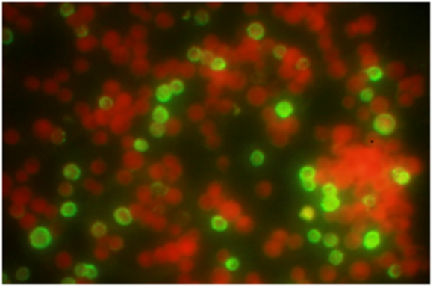
Fig.(3-a):The Fluorescence microscopy Image of the human Metapneumo virus (hMPV).(arrow referred to virus)

Fig.(2-c) Fluorination spectra by using the dye Evens Blue

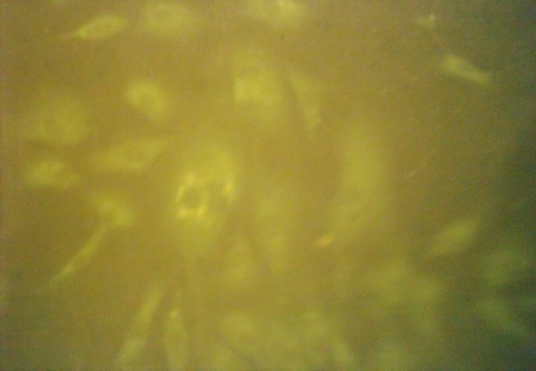

Fig.(3-c): The Fluorescence microscopy Image of the Measles Chicken embryo fibroblast virus

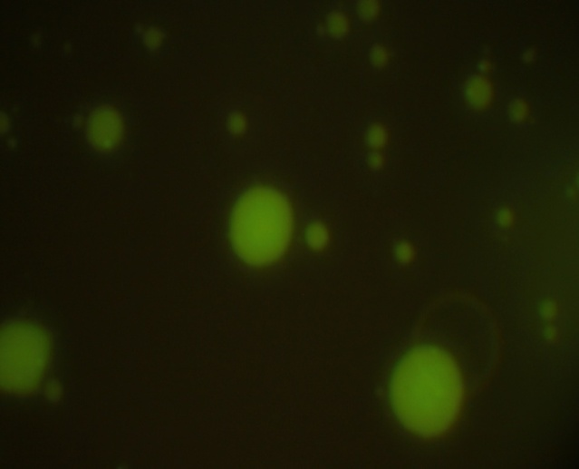

Fig.(3-b) TheFluorescence microscopy image of
the Respiratory syncytial virus(RSV)

