Correlation of New Vitamin C Derivatives with Alanine Amino Transferase and Aspartate Amino Transferase Activities

Mufeed J.Ewadhª Seenaa Badrª Ibtesam H. Al Musawi^{b}
Hamid G. Hasan^{c} Hiba Resheed Behayaaª
ª College of Medicine, University of Babylon, Hilla, Iraq
^{b} Nahrain Forensic DNA Training Center, Nahrain University, Baghdad, Iraq.
^{c} College of Education, University of Baghdad, Baghdad Iraq,



Received 8 January 2014 Accepted 10 February 2014
Abstract
Background: Liver enzymes are commonly found in liver cells and when the liver is damaged, liver cells release their enzymes into the blood stream. Vitamin C is a low-weight molecular antioxidant and is effective in the aqueous phase in protecting different parts of cells against free radicals. An enzyme inhibitor is a molecule, which binds to enzymes and affect their activity.
Objective: This study was carried out to investigate the effect of new vitamin C derivative on serum liver enzymes.
Research design and methods: Eight samples were used. Liver enzymes activity measured with and without vitamin C derivative.
Results: The result showed a reduced activity of aspartate aminotransferase (AST), and alanine transferase (ALT) after addition of vitamin C derivative.
Conclusion: It is concluded that the decrease in ALT, and AST activities were due to noncompetitive inhibition of enzymes by vitamin C derivative.
Key Words: Alanine aminotransferase, aspartate aminotransferase, vitamin C derivative, enzyme inhibition.
الخلاصه
أنزيمات الكبد موجودة عادة في خلايا الكبد وعند تلف الكبد يتم الإفراج عن الانزيمات الخاصة في مجرى الدم. فيتامين C هو منخفض الوزن الجزيئي للأكسدة وفعال في المرحلة المائية في حماية أجزاء مختلفة من الخلايا ضد الجذور الحرة. مثبط الإنزيم هو جزيء، الذي يرتبط بالانزيمات ويؤثر على نشاطهم. أجريت هذه الدراسة لمعرفة تأثيرمشتق فيتامين C الجديد على انزيمات الكبد في الدم. استخدمت ثمانية عينات. النشاط قياس انزيمات الكبد بدون ومع فيتامين C المشتق. أظهرت النتيجة انخفاض نشاط ASTو ALT بعد إضافة فيتامين C المشتق. ويستنتج من ذلك أن الانخفاض في ALT، AST نتيجة التثبيط غير التنافسي على الانزيمات الذي اظهره مشتق فيتامين C.
ــــــــــــــــــــــــــــــــــــــــــــــــــــــــــــــــــــــــــــــــــــــــــــــــــــــــــــــــــــــــــــــــــــــــــــــــــــــــــــــــــــــــــــــــــــــــــــــــــــــــــــــــــــــــــــــــــــــــــــــــــــــــــــــــــــــــــــــــــــــــــــــــــــــــــــــــــــــــــــــــــــــــــــــــــــــــــــــــــــــــــــــــــــــــــــــــــــــــــــــــــــــــــــــــــــــــــــــــــــــــــــــــــــــــــــــــــــــــــــــــــــــــــــــــــــــــــــــــــــــــــــــــــــــــــــــــــــــــــــــــــــــــــــــــــــــ

Introduction
Liver is a large, complex organ that is well designed for its central role in carbohydrate, protein and fat metabolism. It is the site where waste products of metabolism are detoxified. It maintains a stable blood glucose level by taking up and storing glucose as glycogen (glycogenesis), breaking this down to glucose when needed (glycogenolysis) and forming glucose from noncarbohydrate sources such as amino acids (gluconeogenesis) [1].
Viral hepatitis is liver inflammation due to a viral infection. It may present in acute (recent infection, relatively rapid onset) or chronic forms. The most common causes of viral hepatitis are the five unrelated hepatotropic viruses: Hepatitis A [2], Hepatitis B, Hepatitis C, Hepatitis D, and Hepatitis E. In addition to the nominal hepatitis viruses, other viruses that can also cause liver inflammation include Herpes simplex, Cytomegalovirus, Epstein-Barr virus, or Yellow fever [3]
In developing countries, and in regions with poor hygiene standards, the incidence of infection with virus is high and the illness is usually contracted in early childhood. As incomes rise and access to clean water increases, the incidence of viral hepatitis decreases [5]. Worldwide, HAV is responsible for an estimated 1.4 million infections annually [6]. HBV causes more than 4 million cases of acute hepatitis per year throughout the world, and it is estimated that approximately 350 million people are chronically infected with the virus [7]. HBV leads to 1 million deaths annually as a result of viral hepatitis–induced liver disease. The worldwide annual incidence of acute HCV infection is not easily estimated, because patients are often asymptomatic. An estimated 170 million people are chronically infected with HCV worldwide [8].
Liver enzymes are commonly found in liver cells and when the liver is damaged, liver cells release their enzymes into the blood stream; thus, increased levels of these enzymes are a symptom of liver damage. The first step in the diagnosis of liver damage is a simple blood test that shows the presence of certain liver enzymes in the blood. Aminotransferases are the most sensitive liver enzyme. The two transaminases commonly measured are ALT and AST [9]. Which previously were called glutamate-pyruvate transaminase (SGPT) and glutamate-oxaloacetate transaminase (SGOT) respectively [10].
Oxidative stress, to some extent, is seen in most diseases and certainly all inflammatory diseases. Liver disease is without exception in this case [11]. Many liver diseases have high levels of reactive oxygen species (ROS) and reactive nitrogen species (RNS) with substantial evidence that the magnitude of oxidative protein and lipid modifications correlates with disease severity and is also linked to disease progression [11, 12]. This has led to an enthusiasm for the possibility of antioxidant therapy in liver diseases. Vitamin C is a low-weight molecular antioxidant and is effective in the aqueous phase in protecting different parts of cells against free radicals.The biological role of ascorbate is to act as a reducing agent, donating electrons to various enzymatic and a few non-enzymatic reactions. The one- and two-electron oxidized forms of vitamin C, semidehydroascorbic acid and dehydroascorbic acid, respectively, can be reduced in the body by glutathione and NADPH-dependent enzymatic mechanisms [13,14]. The presence of glutathione in cells and extracellular fluids helps maintain ascorbate in a reduced state [15].
An enzyme inhibitor is a molecule, which binds to enzymes and decreases their activity. Since blocking an enzyme's activity can kill a pathogen or correct a metabolic imbalance, many drugs are enzyme inhibitors. The binding of an inhibitor can stop a substrate from entering the enzyme's active site and/or hinder the enzyme from catalyzing its reaction. Inhibitor binding is either reversible or irreversible [16].
Types of reversible inhibitors
There are four kinds of reversible enzyme inhibitors. They are classified according to the effect of varying the concentration of the enzyme's substrate on the inhibitor [16].
- Competitive inhibition
- Uncompetitive inhibition
- Mixed inhibition
- Non-competitive inhibition

Aims of the Study
Assessment of the kinetic effect of vitamin C derivatives on ALT and AST.
Subjects and Methods
The study was conducted in the city of Hilla, from August 2013 to October 2013; this study enrolled 4 patients with viral hepatitis which attended Marjan medical city and 4 apparently healthy subjects. Informed consent was obtained from all participants; the practical side of the study was performed at Biochemistry Department / College of medicine / University of Babylon.
ALT and AST measured for all participants using enzymatic colorimetric method-Randox company (United Kingdom) [17]
Different concentration of substrate (2,4 dinitrophenylhydrazine) were used alone first then procedure repeated using vitamin C derivative (2,3,5,6 tetra acetic acid L-ascorbic acid) in same concentration as substrate ,the activity was measured in presence and absence of vitamin C derivative to know the effect of vitamin C derivative on enzyme activity in vitro.
Different concentration of 2,3,5,6 tetra acetic acid L-ascorbic acid were prepared by serial dilution with diluted mineral acid (sulphoric acid).

Results
The activity of ALT and AST enzyme with and without vitamin C derivative for selected samples were mentioned in table -1and 2.

Table 1 The activity of ALT enzyme with and without vitamin C derivative for selective patient and healthy subject.
Subjects | Concentration of substrate  (mmol/l) | Activity of enzyme  (U/l) | Activity of enzyme in presence of vitamin C derivative  (U/l)
Patient | 0.5 | 0.13 | 0.07
Patient | 1 | 0.24 | 0.10
Patient | 1.5 | 0.27 | 0.19
Patient | 2 | 0.44 | 0.24
Patient | 2.5 | 0.44 | 0.24
Patient | 3 | 0.44 | 0.24
Patient | 3.5 | 0.44 | 0.24
Patient | 4 | 0.44 | 0.24
Healthy | 0.5 | 0.12 | 0.06
Healthy | 1 | 0.26 | 0.14
Healthy | 1.5 | 0.3 | 0.22
Healthy | 2 | 0.35 | 0.26
Healthy | 2.5 | 0.35 | 0.26
Healthy | 3 | 0.35 | 0.26
Healthy | 3.5 | 0.35 | 0.26
Healthy | 4 | 0.35 | 0.26

Maximum velocity (Vmax), Micheleas–Menten constant (Km) for enzymes measured by using Lineweaver–Burk plots by applying the different concentrations of substrate and the obtained activities for each samples as figures 1,2,3and 4 revealed.

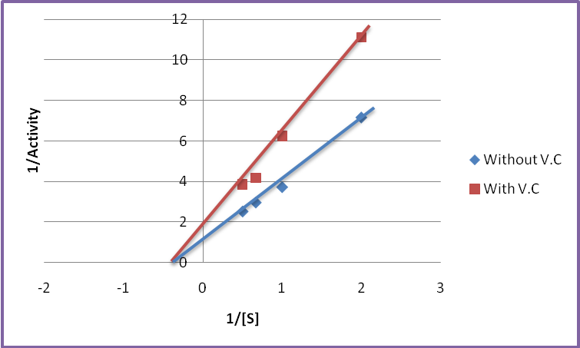
Figure 1 Lineweaver–Burk plots of ALT in healthy subject with and without vitamin C derivative.
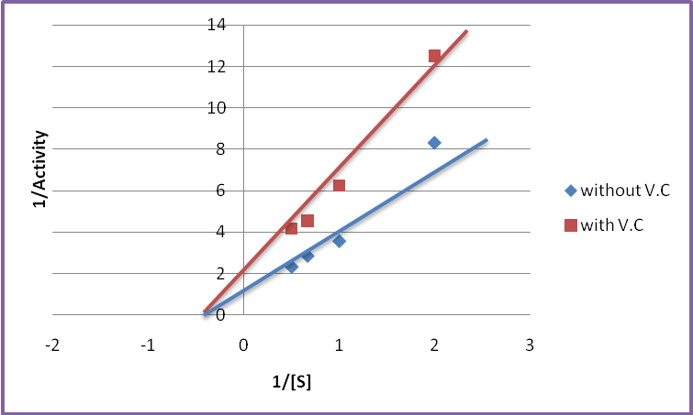
Figure 2 Lineweaver–Burk plots of ALT in hepatic patient with and without vitamin C derivative.

Table 2 The activity of AST enzyme with and without vitamin C derivative for selective patient and healthy subject.
subjects | Concentration of substrate  (mmol/l) | Activity of enzyme  (U/l) | Activity of enzyme in presence of vitamin C derivative  (U/l)
Patient | 0.5 | 0.12 | 0.07
Patient | 1 | 0.29 | 0.16
Patient | 1.5 | 0.35 | 0.23
Patient | 2 | 0.41 | 0.29
Patient | 2.5 | 0.41 | 0.29
Patient | 3 | 0.41 | 0.29
Patient | 3.5 | 0.41 | 0.29
Patient | 4 | 0.41 | 0.29
Healthy | 0.5 | 0.44 | 0.17
Healthy | 1 | 0.63 | 0.27
Healthy | 1.5 | 0.83 | 0.5
Healthy | 2 | 0.91 | 0.59
Healthy | 2.5 | 0.91 | 0.59
Healthy | 3 | 0.91 | 0.59
Healthy | 3.5 | 0.91 | 0.59
Healthy | 4 | 0.91 | 0.59
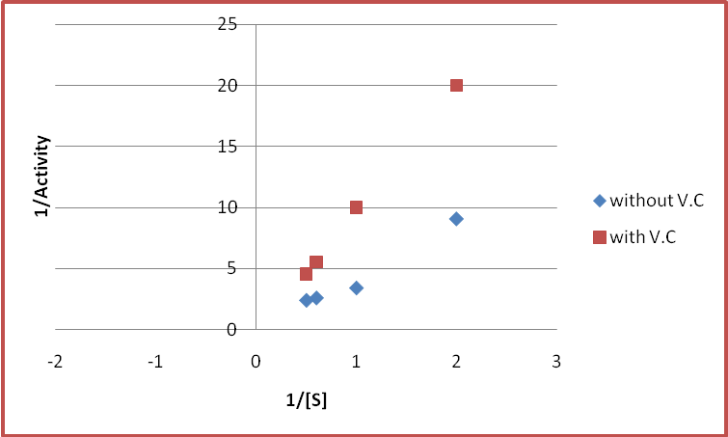
Figure 3 Lineweaver–Burk plots of AST in healthy subject with and without vitamin C derivative.
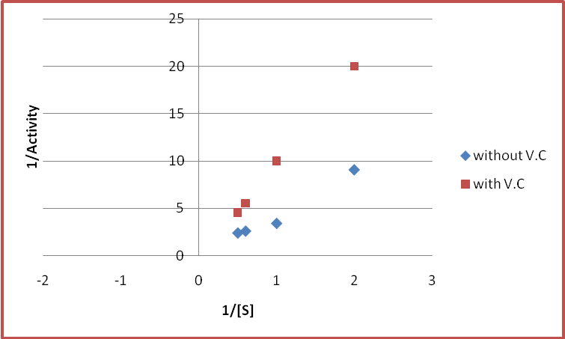
Figure 4 Lineweaver–Burk plots of AST in hepatic patients with and without vitamin C derivative.

Discussion
This study found that Vmax of ALT and AST decrease by presence of vitamin C derivative while Km remain constant, which indicate that this compound act as non-competitive inhibitor because competitive inhibitors bind to enzyme (E), but not to enzyme substrate complex (ES). Competitive inhibition increases K_{m} (i.e., the inhibitor interferes with substrate binding), but does not affect V_{max} (the inhibitor does not hamper catalysis in ES because it cannot bind to ES) while non-competitive inhibitors have identical affinities for E and ES (K_{i} = affect substrate binding) but decreases V_{max} (i.e., inhibitor binding hampers catalysis. Mixed-type inhibitors bind to both E and ES, but their affinities for these two forms of the enzyme are different (K_{i} ≠ K_{i}'). Thus, mixed-type inhibitors interfere with substrate binding (increase K_{m}) and hamper catalysis in the ES complex (decrease V_{max}).So this compound may use in pharmacological aspect and follow up study needed to prove its effect in vivo rather than in vitro.

Conclusion
Vitamin C derivative (2,3,5,6 tetra acetic acid L-ascorbic acid) act as non-competitive inhibitor for ALT and AST enzymes.

References
1.Burkitt HG, Young B, Heath JW. Wheater’s functional histology: a text and colour atlas. 3rd ed. Edinburgh: Churchill Livingston, 1993.
2. Ryan KJ, Ray CG. Sherris Medical Microbiology ,4th ed. McGraw Hill. 2004; 541–4
3.Miguet JP, Coaquette A, Bresson-Hadni S, Lab M. The other types of viral hepatitis. 1990;40 (18): 1656–9
4. Steffen R. "Changing travel-related global epidemiology of hepatitis A". Am. J. Med. 2005;118: 46S–49S.
5. Jacobsen KH, Koopman JS. "The effects of socioeconomic development on worldwide hepatitis A virus seroprevalence patterns". Int J Epidemiol . 2005;34 (3): 600–9.
6.Schmilovitz-Weiss H, Ben-Ari Z, Sikuler E, Zuckerman E, Sbeit W, Ackerman Z, et al. Lamivudine treatment for acute severe hepatitis B: a pilot study. Liver Int. 004; 24(6):547-51.
7. Previsani N, Lavanchy D. World Health Organization. Hepatitis B. 2002.
8.Fattovich G, Giustina G, Sanchez-Tapias J, Quero C, Mas A, Olivotto PG, et al. Delayed clearance of serum HBsAg in compensated cirrhosis B: relation to interferon alpha therapy and disease prognosis. European Concerted Action on Viral Hepatitis (EUROHEP). Am J Gastroenterol. Jun 1998; 93 (6): 896-900.
9. American Family Physician "Mildly Elevated Liver Transaminase Levels in the Asymptomatic Patient - 2005
10.Giboney PT. "Mildly elevated liver transaminase levels in the asymptomatic patient". Am Fam Physician 2005.1 (6): 1105–10.
11.Muriel P. Role of free radicals in liver diseases. Hepatol Int. 2009;3:526–536.
12.Medina J, Moreno-Otero R. Pathophysiological basis for antioxidant therapy in chronic liver disease. Drugs. 2005;65:2445–2461.
13. Meister A. "Glutathione-ascorbic acid antioxidant system in animals". J. Biol. Chem. 1994; 269 (13): 9397–400.
14. Michels A, Frei B. "Vitamin C". In Caudill MA, Rogers M. Biochemical, Physiological, and Molecular Aspects of Human Nutrition (3 ed.). Philadelphia: Saunders.2012. 627–654.
15 Gropper SS, Smith JL, Grodd JL . Advanced nutrition and human metabolism. Belmont, CA: Thomson Wadsworth. 2005. 260–275.
16.Berg J., Tymoczko J. and Stryer L. Biochemistry. W. H. Freeman and Company. 2002.
17. Reitman S.and Frankel S.,Amer.J. Clin.Path.,1957;28:56.

