External fixation in the Treatment of Intertrochentric Fractures in Elderly Patients

Firas Mohammed Abdul Ghani
Dept. of Surgery, Collage of Medicine, Al-Naharain University, Baghdad, IRAQ.



Received 23 February 2014 Accepted 20 March 2014
Abstract
Objective: To evaluate the results of external fixation for intertrochentric hip fractures in elderly patients with high anesthetic risk.
Patients and methods: Prospective study conducted at Department of Orthopedic surgery in Al-Kadhemia Teaching Hospital from January 2007 to October 2013 to evaluate 31 patients, with intertrochentric fracture and high risk for anesthesia, 19 females and 12 males, age between (47 – 90) years. All fractures were stabilized with external fixator under spinal, epidural, general and even local anesthesia.
Results: The average time of operation was 35 minutes (25-50), no one needs blood transfusion.
No mortality in immediate post operative period .but three died after 10 days of operation because of co morbid disease. Bony union is obtained in the rest of patients, in 16 weeks, most patients had excellent and good results according to judget functional score, Pin tract infection and Deep vein thrombosis is the commonest complication.The use of external fixator was associated with significant less blood loss, shorter operative time, reduction in post operative pain, shorter hospitalization.
Conclusion: External fixation in elderly patients with high anesthesia risk is fast, minimally invasive procedure in the treatment of intertrochentric fracture, resulting in fewer pre and post operative complication.
Keywords: intertrochentric fractures, external fixation, elderly.
عملية التثبيت الخارجي في علاج كسر بين المدورين الفخذي عند المرضى المسنين
الخلاصة
يعتبر كسر بين المدورين الفخذي من الكسور الشائعة بين كبار السن.
ونضرا للإمراض المرافقة والمزمنة عند المريض التي تجعل تخدير المريض خطرا وصعبا ,قمنا باستعمال طريقة التثبيت الخارجي في تثبيت الكسر باستعمال جهاز الاشعه وبطريقه مغلقه.
أجرينا العملية على واحد وثلاثون من المرضى كبار السن في ردهة الكسور في مستشفى ألكاظميه التعليمي المصابين بكسر بين المدورين والمصابين بإمراض مزمنة وتحتم استخدام طريقه علاج سريعة وأمينه
أثبتت المتابعة لمده ستة أشهر إن 100% من الكسور قد التأمت في الوقت المحدد وان التقييم الو ضيفي للنتائج كان كالآتي:
ممتازة 21%,جيده 43%,مقبوله29%,ضعيفة 7%
إن تثبيت الكسر بين المدورين بالتثبيت الخارجي هي عمليه بسيطة ومعتمده لتثبيت هذا النوع من الكسور خصوصا للمرضى كبار السن والمصابين بإمراض أخرى ويمكن اعتبارها بديلا جيدا للتثبيت الداخلي.
ــــــــــــــــــــــــــــــــــــــــــــــــــــــــــــــــــــــــــــــــــــــــــــــــــــــــــــــــــــــــــــــــــــــــــــــــــــــــــــــــــــــــــــــــــــــــــــــــــــــــــــــــــــــــــــــــــــــــــــــــــــــــــــــــــــــــــــــــــــــــــــــــــــــــــــــــــــــــــــــــــــــــــــــــــــــــــــــــــــــــــــــــــــــــــــــــــــــــــــــــــــــــــــــــــــــــــــــــــــــــــــــــــــــــــــــــــــــــــــــــــــــــــــــــــــــــــــــــــــــــــــــــــــــــــــــــــــــــــــــــــــــــــــــــــــــ

Introduction
Intertrochentric fractures generally occur as result of low energy trauma (such as simple fall) in advanced age, where as they are caused by high energy trauma in young individuals [1].
Union in a good position, low mortality, minimal discomfort for the patient and minimal cost are essential in the surgical treatment of intertrochentric fractures [2]
Open reduction and internal fixation is the standard treatment; the most widely implants are the sliding hip screw, and intramedullary hip screw, but both techniques are associated with high rates of implant failure (range: 5 to 20 %) [3].
The technique of closed reduction and external fixation offers an alternative Treatment method of intertrochanteric fractures in elderly and high-risk patients. [15]
Early experience with external fixation for intertrochentric fractures was associated with post operative complications, such as pin loosening, infection, and varus collapse. [15]
However ,the ability to treat intertrochentric fractures with short operative time, minimal blood loss and potentially with local or regional anesthesia have led some to advocate its use in selected patients.[4]
The patients most suitable for such treatment include that unacceptably high risk for complications related to general or regional anesthesia [4]
The aim of study to assess the role and effectiveness of this simple minimally invasive procedure in treatment of intertrochentric fractures in high –risk geriatric patients with high risk of conventional anesthesia.
Pathological anatomy [16]
Intertrochanteric fractures are divided into stable and unstable varieties. In essence, unstable fractures are those where:
1. There is poor contact between the fracture fragments, as in four-part intertrochanteric types (greater and lesser trochanter, proximal and distal femoral fragments), or if the posteromedial cortex is comminuted.
2. the fracture pattern is such that forces of weightbearing continually displace the fragments further, as in those with a reverse oblique pattern or with a subtrochanteric extension.
3. Osteoporosis leading to poor quality grip by the fixation implants.
The importance of fracture pattern is detailed in the classification by Kyle (1994) which distinguishes four basic patterns that reflect increasing instability and increasing difficulty at reduction and fixation.

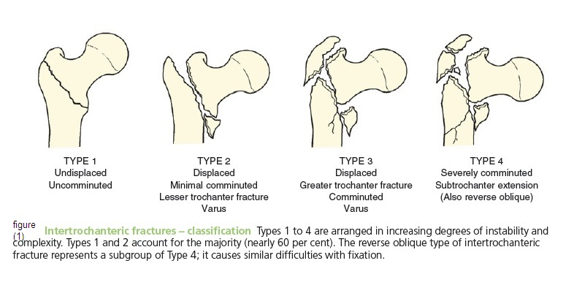
Figure 1 Kyle classification for intertrochentric fractures [1]

Material and Methods
Thirty one patients 12 males and 19 females, with intertrochentric fracture of the femur were treated by external fixator between 2007 and 2013 in Al Kadhemia teaching hospital.
Thirteen patients had right and eighteen had left intertrochentric area .the mean age of the patients was 65.9(47 to 90) years.
Most patients had simple fall as cause of fracture
The patients had high surgical and anesthetic risk factors for an open surgical procedure or for extended anesthesia because they had more than one accompanying disease.
The patients were operated on average 5.7 days (2 to 11 days) following admission.
During the operation, 19 patients under gone spinal, 6 general 3 epidural and 3 local anesthesia together with narcotic analgesia support.

Table 1 types of anesthesia:

Type of anesthesia | Number of patients
spinal | 19
general | 6
Epidural | 3
Local anesthesia | 3

The patient was placed on an orthopedic table and reduction was checked by fluoroscopy .closed reduction by abduction the limb 20-30 degree and internal rotation 15-20 degree.
Two schanz pins of 4.5 or 5 mm width and 200-250 mm length were passed across the fracture site percutaneously along the axis of the neck of femur with the shaft using a hand drill (T-handle) ,both pins were parallel in Anterio- posterior view and central in lateral view.
The superior pin was passed just above the center of the neck and head and the inferior pin was passed along the inferior part of the neck and head .pins are advanced 5 mm short of the sub chondral bone of the head, once the trochentric fracture site was stabilize; three 4.5 mm cortical schanz screws of 150 mm were introduced at a right angle to the shaft of femur as close to the fracture site as possible
Time of operation was measured from time of incision for the insertion of the first pin to when the fixator was completely mounted.
After surgery, patients were assisted in sitting, knee bending and quadriceps exercise from second day of surgery.
Patients were allowed non weight bearing crutch walking with only toe touching for the first 6 weeks.
After which patients were allowed partial weight bearing for the next four weeks as per pain tolerance. And full weight bearing was allowed after adequate clinical and radiological signs of fracture union were seen.
Appropriate physiotherapy was advised for hip and knee motion
Pin sites were dressed daily with saline and families of the patients were given instructions for continuing care after discharge.
All patients are reviewed every other week ; observation regarding shortening, malunion, varus angulation ,pain in the hip and knee range of motion of the hip and knee and evidence of infection and union were recorded
The fixator was removed at average 16 weeks interval in outpatient basis.

Results
Our results show that female affected more than males as in graph (1):

Graph (1):

The average age in our series was 65 years
The average time of operation was 35 minutes (25-50), no one needs blood transfusion.
No mortality in immediate post operative period .but three died after 10 days of operation because of co morbid disease.
The rest of patients were evaluated for rate of union by clinical and radiological signs, skin infections, varus mal alignment, hardware failure and hip and knee range of motion, and developing general complication as DVT (deep veins thrombosis) and bed sores
All patients had limited flexion of the knee in post operative period; however recovery was seen during follow up.
7 patients developed DVT and treated by low molecular weight heparin and warferin for 6 months.
Two of them need hospital admission
Twelve patients had bed sores, all are treated successfully with daily dressing and local antibiotics
14 patients developed pin tract infection
Just two patients developed severe soft tissue infections and needs parental antibiotics.
9 patients had an average limb shortening of 15 mm (10-30) mm shortening resulted from impaction, varus angulations.

Table 2 types of complications
% | Numbers of patients | Types of complications
50 | 14 | Pin tract infections
25 | 7 | DVT
43 | 12 | Bed sores
32 | 9 | Shortness and malunion
0 | 0 | Hardware failure

The functional results were graded using Judet's point system [14].
Table (3) functional scoring system

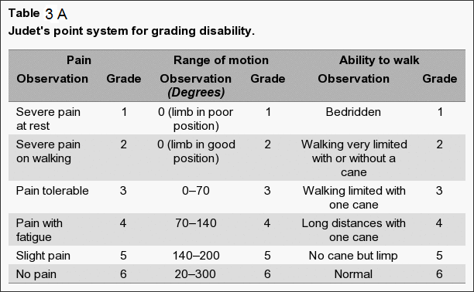
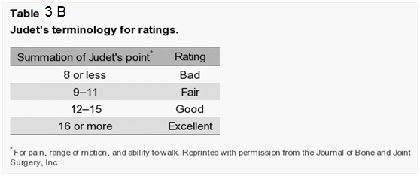

Table 3c: percentage of patients according to the functional results.

% | Number of patients | Results
21 | 6 | Excellent
43 | 12 | Good
29 | 8 | Fair
7 | 2 | bad
100 | 28 | Total

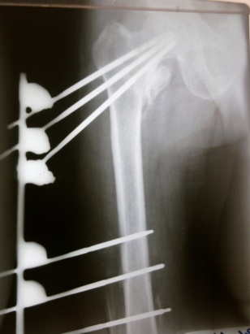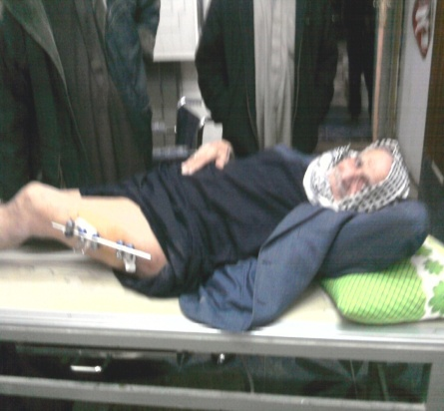
Picture 1 elderly patient with intertrochentric fracture and external fixation

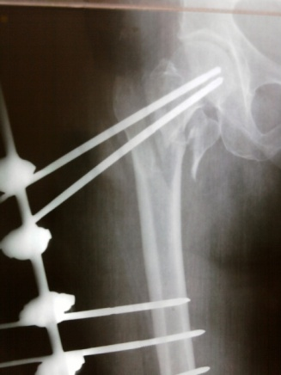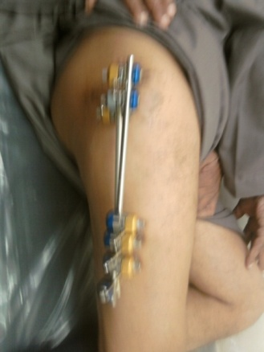
Picture 2 patient with comminuted inter trochentric fracture and external fixation.

Discussion
Intertrochentric fractures are one of the most important fractures of the lower extremity.
The prevalence of hip fractures is increasing owing to the increase in life expectancy and in effective measures to treat osteoporosis, which still is the basic factor for such fractures.[6,7]
Owing to advanced age, the first goal is patient survival. The main objective of the treatment is to minimize the complications related to age and immobilization.
Open reduction and internal fixation of trochentric fractures is the routine procedure, but in patients at risks with accompanying pathology, such as ischemic cardiac disease, chronic obstructive pulmonary disease, diabetes mellitus, there is high risk of anesthetic or post operative complication[8].
External fixation in intertrochentic fractures can be considered to be semi –conservative method [9]
It may be reasonable alternative for patients who are advance age, have poor general condition and cannot tolerate long operations [10]
External fixation preserves the fracture hematoma, which is of importance for union. Complete fracture healing occurred in all our patients. The average time to complete union was 90 days as compared to 4 to5 months after open reduction and internal fixation Procedures [9, 11].
Christodoulou et al. have compared the results in patients who were treated by external fixation or internal fixation. According to their study, in the external fixation group, operating time was 35 minutes, hospital stay was 6 days, varus deformity was detected in 5 patients. Three of them were corrected by fixator. They have reported operating time as 75 minutes, hospital stay 16 days, varus deformity in three patients in the internal fixation group [8]. The average hospital stay in our cases was 8 days.
Satisfactory healing rates (95% to 100%) have recently been reported in several European studies of External Fixation for treatment of intertrochentric femur fracture [9, 12, 13].
Possible complications of treatment of intertrochanteric fractures using external fixation are pin-tract infection, varus deformity and shortening.
However, the literature review shows that such complications occur with a low rate.
Our results goes with other similar research with good healing percentage
And somewhat high percentage of pin tract infection [10,17].
The fear that the external fixator pins transfixing the fracture could cause infection at that site. Our experience has shown that this does not occur [7].
The fear that penetration of the pins could lead to septic arthritis of the hip, we have had no case with this complication [17].

Conclusion
In conclusion, external fixation of intertrochanteric fractures is less invasive than internal fixation and does not evacuate the fracture hematoma, which is of great importance for union.
It is easily applied in a short surgical session and can be performed under local anesthesia when necessary.
It allows early mobilization, and the fixator can be removed easily under outpatient conditions. Pin - tract infection which can be considered as a disadvantage can be prevented or minimized by introducing the nails with a manual perforator (T handle) and appropriate pin-tract care. Therefore, it may be considered to be an alternative treatment modality for high-risk geriatric patients with selected fracture types. This technique is simple, safe and can be performed under regional and even local anesthesia together with narcotic analgesic support when required.

References
- Laskin l.S,Gruber M.A. Zimmerman A.J. intertrochentric fractures of the hip in elderly. Rrtrospective analysis of 236 cases.clin orthop 1979,141,188-195.
- James ETR,Hunter GA. The treatment of intertrochentric fractures-a review articles.injury 1983;14:421-431.
- Simpson AH,Varty K,Dodd CA .sliding hip screws:mode of failure.injury 1989;20:227-231.
- Rockwood and Green,s ,fractures in adults,6th edition.2013
- Stinchfield FE,Cooperman B,Shea CE, replacement of the femoral head my judet or Austen moore prosthesis .J Bone Joint surg 1957;39A:1043-58.
- Dhal A.,Varghese M. ,Bhasin V.B. external fixator of intertrochentric fractures of the femur.J.Bone Joint surg.,1991,73-B,955-958.
- Healy H.S.,Lane M.S., osteoporosis. Manual of rheumatology and out patient orthopedic disorders. Little Brown ,Boston,1993,pp. 338-339.
- Christodoulou N.A.,Sdrenias C.V.external fixator of intertrochentric fractures with single hip screw. Clin.Orthop.,2000,381,204-211.
- Eksioglu F.,Gudemez E., Cavusoglu T.,Sepici B. treatment of intertrochentric fractures by external fixation.Bull.Hosp.joint. dis.,2000,59,131-135.
(10) Haentajens P.,Casteleyn P.P.,De Boeck.,Handelberg F., Opdecam P. treatment of unstable inter trochentric and sub trochentric fractures in elderly patients.primary bi polar arthrplasty compared with internal fixation.j.Bone joint surg.,1989,71-A,1214-1225.
(11) Barquet A., Francescoli L., Rienzi D., Lopez L. Intertrochanteric –subtrochanteric fractures : Treatment with the long Gamma nail. J. Orthop. Trauma, 2000, 14, 324-328.
(12) Moroni A, Faldini C, Pegraffi F, et al. External fixation revisited: a new treatment option for elderly patients with trochanteric fractures. Annual OTA Meeting, 2003.
(13) Subasi M, Kesemenli C, Kapukaya A, et al. Treatment of intertrochanteric fractures by external fixation. Acta Orthop Belg 2001;67:468-474
(14) Naseem ul Gani;Khursheed Ahmed Kango et al.;2009 orthopedic Reviews 2009; 1:e18 doi:10.4081/ or 2009 e 18
(15) Petsatodis G, Maliogas G, Karikis J, Christodoulou AG, Venetsanakis G, Sachinis N, Hatzokos I, Chalidis B.
External fixation for stable and unstable intertrochanteric fractures in patients older than 75 years of age: a prospective comparative study. 1st Orthopaedic, Department of Aristotle, University of Thessaloniki, Thessaloniki, Greece. 2008
(16) Lous Solomon,David warwick, Selvadurai Nayagman, Appley's system of orthopedics and trauma 9th edition, 2010.
(17) Anil Dhal, Mathew Varghese, V. B. Bhasin , External Fixation Of Intertrochanteric Fractures Of The femur from Maulana Azad Medical College, New Delhi 1991 British Editorial Society ofBone and Joint Surgery J Bone Joint Surg [Br] 1991 ; 73-B

