Effect of Denture Cleansers on Sorption and Solubility of Soft Denture Lining Materials Immersed in Different Time Interval

Nidhal Sahib Mansoor
Prosthetic Dentistry Technologies Department, College of Health and Medical Technology, Foundation of Technical Education, IRAQ.



Received 30 December 2013 Accepted 3 March 2014

Abstract
Chemical denture cleansers have been considered to be an efficacious method to prevent denture plaque formation. However, daily use of those cleansers in clinical practice can damage soft denture lining materials.
The purpose of this study is to evaluate the effect of two types of denture cleansers on sorption, solubility of soft denture lining materials at different time intervals.
Twenty one specimens of the soft liners (silicon based) were prepared (50mm±1mm in diameter and 0.5mm ± 0.05mm in thickness) in dimension was distributed into three groups according to the immersion solution each group consist of seven specimens immersed daily as the following:
Group 1: Samples immersed in distilled water for 24 hours (control group).
Group 2: Samples immersed in alkaline peroxide (corega) for 15 min. denture cleanser solution.
Group 3: Samples immersed in 4% citric acid denture cleanser solution for 10 minutes.
The specimen were tested at different time intervals, specimens of sorption were tested after l and 3 weeks; while those for solubility were tested after 3 weeks only.
The results of sorption of Ufi Gel soft lining in this study using (ANOVA) test showed that, there were high significant changes with the immersion time interval and the different immersion solutions used. Also the results of solubility using (ANOVA) test showed that a high significant difference among tested group after 3 weeks only.
Generally; it is concluded that deterioration of soft liners in the denture cleansers appeared to be more significant with time.
الخلاصة
المنظفات الكيمياوية لأطقم الاسنان تعتبر الطريقة الفعالة لمنع تكوين البلاك (plaque ) على الطقم, الاستعمال اليومي للمنظفات يمكن ان يؤدي الى تلف مادة تبطين الطقم.الهدف من هذه الدراسة هو تقييم نوعين من منظفات طقم الاسنان على القدرة على الامتصاص والقابلية الذوبانية لمادة التبطين اللدنة للطقم بعد غمرها في مادة التنظيف لفترات زمنية مختلفة.
حضرت احدى وعشرون عينة من مادة التبطين اللدنة ذات التركيب السيليكوني بأبعاد (50 ملم± 1ملم قطر و0,5ملم ±0,05 ملم سمك) وزعت الى ثلاث مجاميع حسب محاليل الغمر وكل مجموعة تحتوي على سبع عينات غمرت يوميا وكما يلي:
المجموعة الاولى: غمرت في الماء المقطر لمدة 24 ساعة ( المجموعة القياسية).
المجموعة الثانية: غمرت في محلول الكورجا القاعدي لمدة 15 دقيقة.
المجموعة الثالثة: غمرت في محلول حامض الستريك لمدة 10 دقائق.
فحصت العينات بعد الغمر لفترات زمنية مختلفة, تم فحص عينات القدرة على الامتصاص بعد اسبوع وثلاثة اسابيع أما القابلية الذوبانية للعينات فحصت بعد الاسبوع الثالث فقط.
أضهرت النتائج الأحصائية في هذه الدراسة لفحص القدرة على الامتصاص وجود فارق معنوي عالي جداعند غمر العينات في مختلف المحاليل المستخدمة و لفترات زمنية مختلفة كما وأضهرت النتائج فارق معنوي عالي جدا في القابلية الذوبانية للعينات بعد الاسبوع الثالث فقط.
ــــــــــــــــــــــــــــــــــــــــــــــــــــــــــــــــــــــــــــــــــــــــــــــــــــــــــــــــــــــــــــــــــــــــــــــــــــــــــــــــــــــــــــــــــــــــــــــــــــــــــــــــــــــــــــــــــــــــــــــــــــــــــــــــــــــــــــــــــــــــــــــــــــــــــــــــــــــــــــــــــــــــــــــــــــــــــــــــــــــــــــــــــــــــــــــــــــــــــــــــــــــــــــــــــــــــــــــــــــــــــــــــــــــــــــــــــــــــــــــــــــــــــــــــــــــــــــــــــــــــــــــــــــــــــــــــــــــــــــــــــــــــــــــــــــــ

Introduction
The accuracy of denture fit is an important factor in the retention of denture [1]. The base of the denture is largely responsible for providing the prosthesis with retention, stability and support by being closely adapted to the oral mucosa [2]. However, the process of bone resorption is irreversible and may lead to an inadequate fit of the prosthesis [3].
Gradual changes of oral tissues require that complete or partial dentures be relined to improve their adaptation to the supporting tissue [4]. Therefore, the use of soft denture lining materials has become increasingly popular and useful in removable prosthodontics because of their capability of restoring health to inflamed mucosa [5]. They act as cushion for the denture bearing mucosa through absorption and re- distribution of forces to the stress bearing areas avoiding local stress concentration and improving denture retention by engaging undercut [6,7]. These materials can be divided in two major groups: plasticized acrylic resin and silicone rubber. Both types are available in self-cured or heat – cured forms) [8].
The soft lining materials have disadvantages related to their physical properties and their response to microorganisms. During clinical use, soft liners present several problems one of these problems sorption solubility with different solutions. They are also subjected to colonization and infection by Candida albicans and other Candida species [9, 10]. Hence, effective denture plaque control is essential for soft liners, because bacterial and yeast plaque is the major factor in the etiology of denture stomatitis. In addition, microbial growth on soft lining materials can result in their degradation [11].
Care must take in choosing an appropriate method of denture hygiene as inappropriate cleaning regimes can have deleterious effect on soft lining materials [12]. Denture cleansers are a popular method used by denture wearers for cleaning [13]. However, daily use of denture cleansers can affect the properties of denture acrylic resin bases and soft liners. Thus, the selection of denture cleansers should be considered to avoid or minimize changes in the properties of soft lining materials [11].
The purpose of this study is to evaluate the effect of two denture cleansers on sorption, solubility denture lining material after immersed for different time intervals.

Aim of the study
Evaluation of the effect of two types of denture cleansers (citric acid) and (alkaline peroxide) on sorption, solubility of silicone – based soft denture lining material at different time intervals.

Materials and equipments
Some of materials and equipments used in this study:
- Ufi Gel P, Room temperature curing silicone (Direct, indirect reline) VOCO, Germany, (Fig .1).

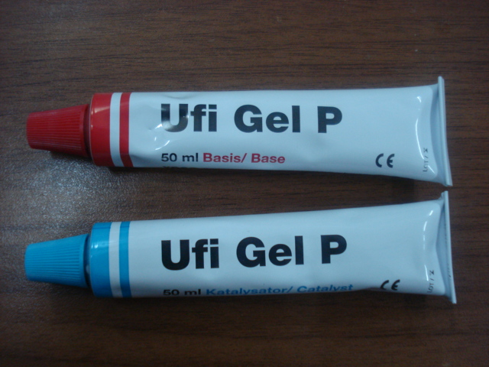

Figure 1 Ufi Gel P soft liner

2. Denture cleanser materials:-
a. Alkaline peroxide tables, Corega, Ireland.
b. Citric acid solution (Citric acid, Isopropyl alcohol), South Australia, 5013.
3. Dental stone type III model, Elite Model thixortropic, Zermack- Italy.
4. Silica gel, BDH Chemicals Ltd. England, (Fig .2, a).
5. Filter paper, Filteron ,England, ( Fig .2,b).
6. Dental metal flask, Broden, Sweden, (Fig .3, a).
7. Tension device, local made, (Fig .3, b).

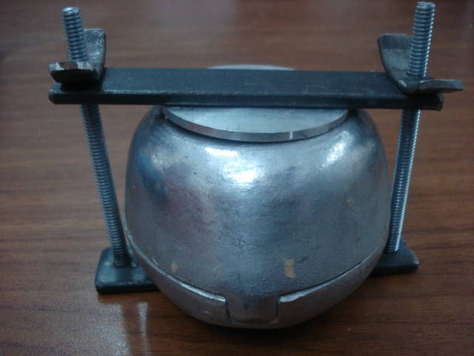
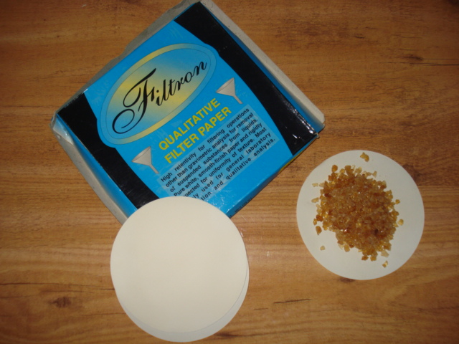
b
a

(Fig. 2) a. Silica gel b. Filter paper (Fig .3) a. Dental metal Flask
b. Tension device
8. Stainless steel disc (50 mm± 1 in diameter and 0.5 mm± 0.05 thickness, local made, (Fig.4).
9. Precision electronic balance, (accuracy 0.0001) china, (Fig .5).
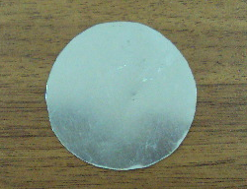
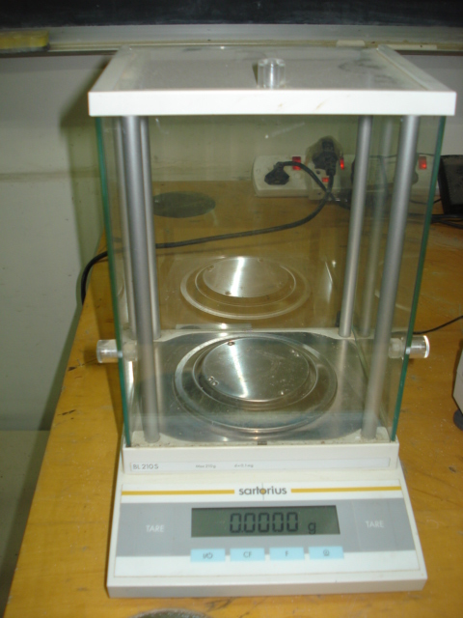

(Fig.4) Stainless steel disc (Fig .5) Precision electronic balance

10. Ivomate pressure pot, Ivoclar, Germany.
11. Incubator, BOD, Germany.
12. Desiccator, Germany.
13. Flat glass surface.
14. Cold mould seal, ISO DENT, Turkey
15. Distilled water, Baghdad, Iraq..
16. Hydraulic press, Bego, Germany.

Method
Samples grouping
Sample grouping was distributed into 3 groups according to the immersion solution each group 7 sample.
Group 1: Samples immersed in distilled water.
Group 2: Samples immersed in alkaline peroxide (corega) denture cleanser solution.
Group 3: Samples immersed in 4% citric acid denture cleanser solution.
Mould Preparation:
A Preformed stainless steel disc was prepared to obtain the silicon based soft lining material ( Ufi Gel P) in form a disc (50mm±1mm in diameter and 0.5mm ± 0.05mm in thickness) according to [14].
The stainless steel disc was mounted in the lower half of the flask, and formed against flat glass surface, to create a flat smooth surface at the same level with each of dental stone and the border of the lower half of the flask, the flat glass surface was removed after the stone was set, then the stone surface was coated with separating medium. The upper half of the flask was then positioned on the top of the lower half and filled by a diestone mixture, after it set; the two halves separated from each others and removed the stainless steel disc.
Before packing the soft lining material, the two parts of the mould was thoroughly coated by a 90% alcohol and then coated by separating medium.
Sample preparation:
21 samples were prepared from Ufi Gel P silicon based soft liner material. This material was supplied as base/ catalyst system, the equal parts of base and catalyst were mixed according to their manufacturer’s instructions ( working time was 2 min. after starting of mixing) the mixture was spatulated using cement spatula and placed in the mould, which was covered and place inside the tension device
(composed from two plates and two long screw) and left without tighten their screws (Fig .3), and then placed (the flask with tension device) into the hydraulic press and press up to 50kg for(5 min.) according to manufacturer’s instructions, after that tighten the screws of tension device and the pressure of hydraulic press was relived and flask with tension device placed inside ivomate pressure pot for (15 min.) under heat(40-45Cº) and pressure (3bars) according to manufacturer’s instruction too complete polymerization of soft lining material .
After that, took tension device out and left to cool down for approximately (20 min.). Then, the cover of flask was removed and specimen removed from the mould and the excess material cut off by a scissor. Also, each time, the mould must be coated with 90% alcohol before packing the material and the painted by separating medium.
Preparation of cleanser solution
I- Alkaline peroxide solution (Gorega denture cleaning solution):
The solution prepared according to the manufacturer’s instruction by addition of
one tablet alkaline peroxide to (150ml) of warm distilled water (50Cº).
The solution should be prepared every (12 h) when it needs to be used for longer
than (12 h).
II- The experimental denture cleanser solution:
Afresh denture cleanser solution was prepared by dissolving the citric acid in isopropyl alcohol (the isopropyl alcohol) was chosen as solvent to the acid powder due to its antiseptic (15) as followed:-

4gm of + 100ml of 4% w/v of citric acid denture
Citric acid IsopropyI cleanser solution

Then, prior to the use, each prepared denture solution was diluted with an equivalent volume of distilled water, such as 50ml.of prepared denture cleanser solution to 50ml of distilled water to get 100ml. of fresh diluted denture cleanser solution.

50ml of + 50ml 100ml.of fresh diluted
Distilled water prepared cleanser solution denture cleanser solution

Drying specimens
After processing and finishing, the discs were weighted and dried in a desiccators containing dried silica gel. Desiccators were transferred to an inculcator at (37Cº±2Cº) for 24h, the specimens were weighted every (24h) for (3-4days) by analytical balance of accuracy 0.001g. weight was determined. This weight value considered as the initial weight of specimens (W1).
Sorption test:
The disc was labeled according to the cleanser solution used and the specimen in each group was also numbered. Each disc of group 2 ( G2) were immersed daily in fresh denture cleansers (15minutes in Corega denture cleaning solution according to the manufacturer instruction) and group 3 (G3) were also immersed daily in fresh prepared denture cleanser solution (10 min. in Citric acid solution) [16]; then, the samples of each groups washed thoroughly with tap water for 1min and then with distilled water ( solution) [17] while the disc in group1 (G1) were only immersed in a distilled water at (37Cº) that was changed every day.
At periods 1 and3 week; the discs of all groups were removed from their containers with tweezers, excess water was removed by blotting with filter paper until they are free from visible moisture, waved in air for 15sec. and weighted one minute after removal from the water. This was the weight of the specimen after absorption or adsorption (W2) (The sorption of test specimen was calculated after 1 and 3 weeks).
Solubility test
The amount of solution soluble lost was measured only after 3weeks by placing the specimens back in the diessicator and then weighting them at regular intervals until a constant weight was reached. This weight was the final weight after dessication (W3) (the solubility behavior of test specimens was determined only after 3weeks) [18].Water sorption and solubility were measured both in mg/cm2 followed revised [14] and as a present.
Calculation was made following next formula:

W₂-W₁

Surface area
W₂- W₁

W₁

Sorption (mg/cm2) = or Percent = X100
Sorption

W₁ –W₃

Surface area
W₁-W₃

W₁

Solubility (mg/cm2) = or Percent = X100
Solubility

Statistical Analysis
The suitable statistical methods were used in order to analyze and assess the results, they include the followings:
1- Descriptive statistics:
A) Statistical tables including observed frequencies.
B) Summary statistic of the readings distribution (Mean, SD, SEM, Minimum & Maximum).
C) Graphical presentation (Bar- Chart).
2-Inferential statistics:
These were used to accept or reject the statistical hypotheses, they include the followings:
A) Analysis of variation ANOVA (f-test).
B) Least significant difference LSD (f-test).

Results
Sorption test
Table (1) shown the descriptive statistics of sorption test values of the tested groups including arithmetic means, standard deviation standard error, maximum and minimum values.

Table 1 Descriptive statistics of sorption test.

Immersion solutions | Intervals | Mean | Std.  Deviation | Std. error | Range
 |  |  |  |  | Minimum | Maximum
Distilled water | After 1 week | .134486 | 1.52389  E-02 | 5.76E-03 | .1221 | .1629
Distilled water | After 3 weeks | .255971 | 4.91283  E-02 | 1.86E-02 | .1781 | .3054
Corega denture cleanser | After 1 week | .153357 | 4.20335  E-02 | 1.59E-02 | .1069 | .2290
Corega denture cleanser | After 3 weeks | .194871 | 2.81051  E-02 | 1.06E-02 | .1374 | .2189
Citric acid solution denture cleanser | After 1 week | .183229 | 3.21719  E-02 | 1.22E-02 | .1527 | .2341
Citric acid solution denture cleanser | After 3 weeks | .356300 | 4.53247  E-02 | 1.71E-02 | .3003 | .4127
Sorption test (mg/cm2)

The same sample in each group had two reading after 1 and 3 weeks, and the descriptive and inferential statistics of sorption test values of the tested groups shown in figure (1).

Studied groups

D.w.: Distilled water.
C.D.C.: Corega denture solution.
C.A.S.D.C.: Citric acid solution denture cleanser.
Figure 1 Bar graph represented Descriptive statistics of sorption test.

Effect of immersion time
Statistical analysis for sorption test using ANOVA test (Analysis of variance) shown that there were a statistically highly significant differences among the tested groups after 1 and 3 weeks immersion, table (2). In order to statistically verify the significance among the different groups, a {(LSD) least significant differences} was performed to compare between cleanser solutions in different interval after 1 and 3 weeks (W1- W3), (Table 3).

Table 2 ANOVA test for sorption test.

ANOVA test  (p-value) | Sig.
.000 | HS

Table 3 Comparison between cleanser solutions in different interval (W1-W3).

The immersion materials |  | LSD
 |  | P-value | Sig.
Distilled water-1 week | Distilled water-3 week | .000 | HS
Corega denture cleanser- 1 week | Corega denture cleanser- 3week | .044 | S
Citric acid solution denture cleanser-1week. | Citric acid solution denture cleanser-3week | .000 | HS
Dependent variable: Sorption test (mg/cm2)

Effect of immersion solution
Table (4) shown a comparison among 3 groups after 1 week using a (LSD) to verify statistical significance among groups.

Table 4 Shown a comparison among 3 groups after 1 week.

The immersion materials |  | LSD
 |  | P-value | Sig.
Distilled water-1 week | Corega denture cleanser- 1week  Citric acid solution denture  cleanser-1 week | .349  .019 | NS  S
Corega denture- 1 week | Citric acid solution denture  cleanser-1 week | .141 | NS
Dependent variable: Sorption test (mg/cm2)

Also, in table (5) a (LSD) was used to appear a statistically significance among different groups to compare among 3 groups after 3 weeks.

Table 5 Comparison among 3 groups after 3 weeks.

The immersion materials |  | LSD
 |  | P-value | Sig.
Distilled water-3week | Corega denture cleanser- 3 week  Citric acid solution denture cleanser-3week | .004  .000 | HS  HS
Corega denture-3 week | Citric acid solution denture  cleanser-3week | .000 | HS
Dependent variable: Sorption test (mg/cm2)

Solubility test
Table (6) shown the descriptive statistics of solubility test values of the tested groups including arithmetic means, standard deviation, standard error maximum and minimum values

.
Table 6 shown the descriptive statistics of solubility test.

Immersion solutions | Mean | Std.  Deviation | Std. error | Range
 |  |  |  | Minimum | Maximum
Distilled water | 9.45E-02 | 2.67364E-02 | 1.01E-02 | .0560 | .1170
Corega denture cleanser | 6.69E-02 | 3.09918E-02 | 1.17E-02 | .0407 | .1170
Citric acid solution denture cleanser | .146871 | 1.25761E-02 | 4.75E-03 | .1221 | .1578
Solubility test (mg/cm2)

And Figure (2) shown the descriptive statistics of the solubility test for the tested groups.

Studied groups

Figure 2 Bar graph represented the descriptive statistics of the solubility test.

Also, statistical analysis for solubility test using ANOVA test shown that there were a statistically highly significant differences among the tested groups, table (7).

Table 7 ANOVA test for solubility test.

ANOVA test  (p-value) | Sig.
.000 | HS

While in table (8) a (LSD) using to verify the statistical significance among the tested groups only after three weeks.

Table 8 Comparison among 3 groups only after 3 weeks.

The immersion materials |  | LSD
 |  | P-value | Sig.
Distilled water | Corega denture cleanser  Citric acid solution denture cleanser | .051  .001 | NS  HS
Corega denture cleanser | Citric acid solution denture cleanser | .000 | HS
Dependent variable: solubility test (mg/cm2)

Discussion
Effect of immersion time
The Ufi soft liner material immersed in all solutions, showed a general increase in sorption with time (when compared between 3 weeks and I week) .This is due to the fact that the sorption or gain of water (solution) exceeded the loss of soluble components which could be attributed to the presence of fillers in the materials which were responsible for its absorption characteristics, in addition, the materials does not contain plastizer and residual monomer in its structure to reach out. The silicone rubber will take longer time to reach equilibrium in absorption, but less time to reach equilibrium in adsorption [19].
The result in agreement with the results obtained by [20], and disagreed with the result of [21, 22] who reported a decrease in resilient lining weight after specific immersion in denture cleansers or disinfectants.
Effect of the type of immersion solution
This material showed a high significant increase in sorption after period 3weeks of immersion in different types of cleanser solutions (when compared citric acid solution with the Corega solution and compared them together with the distilled water), table (3), (4).
The explanation for these results related to the fact that the water uptake of elastomeric materials was dependent on the water soluble components and /or hydrophilicity of the matrix leading to formation of solution droplets[ 22].
Therefore, it was found from the result of table (5), (6) that the material immersed in citric acid demonstrated higher solubility value (higher loss of soluble components in citric acid) which in turn lead to more water uptake. Another important cause for the high sorption value in citric acid is the small size of the proton (H+) of the acid which facilitates its penetration between the polymer chains.
The Solubility of Ufi Gel material was significantly higher in citric acid compared with distilled water and Corega solution.This can be explained either according to[22] who suggested that storage in solvents may accelerate changes that cause loss of leachable materials, or could depend on another explanation which might be due to that the proton (H+) of acid attached the (OH-) group which were present in the polymer chain leading to liberate of H2O molecule, and then chain breaking; therefore, lowering the molecular weight of the polymer which lead to more solubility. On other hand a non significant differences was observed when Ufi Gel material immersed in Corega solution compared to that immersed in distilled water.

Conclusion
1- In general, deterioration of soft denture lining materials in the two denture cleansers studied appeared to be more significant with the time.
2- Soft denture lining became more sorption to the distilled water and both Citric acid and Corege denture cleansers when compared three week with one week immersion.
3- Corege denture cleanser had less effect on soft denture lining when compared it with distilled water and citric acid denture cleanser after one week immersion.
4- Citric acid denture cleanser had significant effect on the soft denture lining when compared with distilled water after one week immersion.
5- Soft denture lining was undergone maximum change in sorption when immersed in citric acid and compared it with Corega denture cleanser and distilled water after three weeks immersion, while it was less effected when immersed in Corega denture cleanser and compared with distilled water.
6- Distilled water had less effect on solubility of soft denture lining when compared with Corega denture cleanser, while it had a high significant increased in solubility when compared with citric acid denture cleanser.
7- Soft denture lining appeared maximum increased in solubility when compared between citric acid and Corega denture cleansers.

References
- Craig RG.& Powers JM.,( 2002) "Restorative Dental Materials", 11th Edition. St.Louis: The C.V, Mosby Co, Missouri. Ch: 7:21, P: 195, 636-656.
- Radford DR., Watson TF., Walter JD., Challacombe SJ.( 1997) "The effect of surface machining on heat cured acrylic resin and two soft denture base materials: A scanning electron microscope and confocal microscope evaluation" J Prosthet Dent, 78(2), P.p.200-208.
- Budtz-Jorgensen E.(1999)"Prosthodonties for the elderly diagnosis and treatment"Chicago Quintessence 42.
- Aydin AK, Terzioglu H, Akinav AL Ulubayram K, Hasirci N. (1999) "Bond strength and failure analysis of lining materials to denture resin" Dent Mater, l5 (3), P.p.211-218.
- Goll G., Smith DE., Plein JB. (1983) "The effect of denture cleansers on temporary soft liners" J Prosthet Dent, 50, P.p.466-472.
- El-Hadary A., Drummond JL.(2000)"Comparative study of water sorption, solubility, and tensile bond strength of two soft lining materials" J Prosthet Dent, 83(3), P.p.356-361.
- Mese A., Guzel KG., Uysal E. (2005)"Effect of storage duration on tensile bond strength of acrytic or silicone-based soft denture liners to a processed denture base polymer" Acta Odontol Scand, 63, P.p.31-35.
- Anusavice KJ. 2003 Phillips Science of Dental Materials, Philadelphia: W.B Saunders Co.. P.p. 588-93.
- Pinto JRR., Mesquita MF., Henriques GEP., Nobilo MADA. (2002) "Effect of thermocycling on bend strength and elasticity of 4 long-term soft denture liners" J Prosthet Dent, 88(5), P.p.5l6- 521.
- Amit N, Jabade JL. (2005)"Comparison of tensile bond strength of resilient soft liners to denture base resins" J Indian Prosthodont Soc., 5(2), P.p. 86-88.
- Nikawa H., Iwanaga H., Hamada T., Yuhta S.( 1994) "Effects of denture cleansers on direct soft denture lining materials" J Prosthet Dent, 72(6), P.p.657- 662.
- Jagger DC., Harrison A.,(1997) "Complete dentures-the soft option. An update for general dental practice" Br Dent J, 182(8), 313- 317,.
- Sheen SR., Harrison A.(2000) "Assessment of plaque prevention on dentures using an experimental cleanser" J Prosthet Dent, 84(6), P.p.594-601.
- ADA American National Standard/American Dental Association Specification No. 12(1999) for Denture Base Polymers: Council on Dental Material and Devices Chicago.
- Hatim NA., Salem SA., Khayat IK.( 2003) "Evaluating the effect of denture cleansers on some properties of acrylic resin denture base material (An in vitro study)" Al Rafidain Dent., 3(1), P.p.31-38.
- Al-Khafaji AMA.,(2004) The effect of prepared denture cleansers on some properties of stained acrylic resin denture base material cured by two different techniques. A master thesis, Prosthetic Department, University of Baghdad.
- Jin C., Nikawa H., Makihira S., Hamada T., Furukawa M., Murata H.(2003) "Changes in surface roughness and color stability of soft denture lining materials caused by denture cleansers" J Oral Rehabil, 30, P.p.125-130.
- Hekimoglu C., Anil N.(1999) "Sorption and solubility of soft denture liners after accelerated aging" Am J Dent, 12(1), P.p.44-46.
- Braden M, Wright PS.(1983)"Water absorption and water solubility of soft lining materials for acrylic dentures" J Dent Res, 62(6), P.p.764-768.
- Yanikuglu ND., Duymus ZY.(2004) "Comparative study of soft lining materials in the different solutions" Dent Mater J, 23(2), P.p.233-239.
- Garcia RCMR., Leon BLT., Oliveira VMB., Cury AADB.(2003)"Effect of a denture cleanser on weight, surface roughness, and tensile bond strength of two resilient denture liners" J Prosthet Den, 89(5), P.p.489-494.
- Yilmaz H,. Aydin C., Bal BT., Ozcelic B.(2005) "Effect of disinfectants on resilient denture-lining materials contaminated with Staphylococcus aureus, Streptococcus sobrinus, and Candida albicans" Quintessence Int, 36(5), P.p.373-381.

